Original Research Article

Assessment of the Spatiotemporal Variations of Soil Moisture Content in Louisiana from 2020 to 2025 Hydrological Year Using Remote Sensing (NDMI Method)

Abstract
Moisture variability plays a critical role in land–atmosphere interactions, ecosystem health, and environmental sustainability, particularly in regions experiencing increasing climatic variability. This study assesses the spatiotemporal variation of surface moisture conditions using remote sensing techniques and the Normalized Difference Moisture Index (NDMI). Multispectral satellite imagery was acquired and processed to generate NDMI maps that capture changes in vegetation and surface moisture over the study area. Image processing and spatial analysis were carried out using geographic information system (GIS) tools to examine temporal trends and spatial patterns of moisture distribution. The results reveal distinct spatial heterogeneity and temporal fluctuations in moisture conditions across the study area. Areas with higher NDMI values indicate relatively high moisture content and healthier vegetation, while lower NDMI values correspond to moisture-stressed zones, bare surfaces, or areas undergoing land-use change. Seasonal variations reflect the influence of rainfall patterns, vegetation phenology, and anthropogenic activities on surface moisture dynamics. The analysis demonstrates that NDMI effectively captures moisture variations and provides a reliable means of monitoring environmental conditions over time. This study highlights the usefulness of satellite-based NDMI for assessing moisture variability at regional scales and underscores its potential application in environmental monitoring, land-use planning, agricultural management, and climate-related studies. The findings contribute to improved understanding of surface moisture dynamics and support evidence-based decision-making for sustainable environmental management.

Keywords: Normalized Difference Moisture Index (NDMI); Remote sensing; surface moisture variability; GIS; Spatiotemporal analysis; Environmental monitoring

HP
2026-03-13 22:11:13
--------------------------------------------
The introduction has not yet emphasized what makes this research different from previous research. need to add a few sentences about this
Introduction
HP
2026-03-13 22:05:49
--------------------------------------------
The introduction has explained the importance of soil moisture and NDMI. However, the research gap is not clearly articulated. After the sentence in this paragraph, a research gap is usually added by explaining the shortcomings of previous research
HP
2026-03-13 22:08:14
--------------------------------------------
The literature review in the introduction is still limited, and the references used are outdated. It is necessary to include more recent literature studies (the last 5–10 years) related to NDMI-based soil moisture monitoring and the application of Sentinel-2 data.

Soil moisture content refers to the amount of water present in the unsaturated zone of the soil, including both liquid water and water vapor in the soil pores (An et al., 2018). It is a critical hydrological variable influencing environmental phenomena (flood risk and drought), agricultural productivity, and ecosystem health, particularly in Louisiana. This is due to the state’s low-lying topography, proximity to the Gulf of Mexico, and mixed land use (urban, agricultural, and wetlands) making it highly sensitive to soil moisture fluctuations. It also affects the stability of sand and plays a crucial role in shaping the landscape due to its influence on the rate of aeolian sediment transport (Yang, 2003; Yvonne et al., 2019; Caroline et al., 2023).
Studies have shown that understanding and managing soil moisture content is essential for optimizing plant health, food security, structural stability, and supporting land and water management resources (Hillel, 1998; Allen et al., 1998). However, traditional ground-based soil moisture monitoring is limited by sparse spatial coverage and labor-intensive data collection hindering large-scale hydrological modeling. Also, the increasing frequency of extreme weather events, coupled with coarse resolution (10–40 km) of existing satellites like SMAP necessitates the need for robust soil moisture tracking using remote sensing, particularly the Normalized Difference Moisture Index (NDMI), which offers a scalable solution by leveraging satellite-derived spectral indices to estimate moisture levels.

Aim and objectives
HP
2026-03-13 22:15:52
--------------------------------------------
This section needs to be strengthened with:
Analysis of the spatial distribution and temporal variability of soil moisture derived from the NDMI across Louisiana during the 2020–2025 hydrological year.
This study aims to apply remote sensing techniques to assess the soil moisture content of Louisiana from the 2020 hydrological year to 2025, using the NDMI method.
The specific objectives are to:

    - Develop high-resolution soil moisture maps to support agricultural and flood management

    - Analyze spatiotemporal trends in soil moisture across Louisiana from 2020 hydrological year till 2025.

HP
2026-03-13 22:10:17
--------------------------------------------
In many international journals, Justification is usually not made into a separate subchapter, but is included in the Introduction.

Justification for Using Remote Sensing (NDMI) for the Study

Traditional point-based sampling for monitoring hydrological parameters like soil moisture content using soil moisture probes is limited in capturing comprehensive spatiotemporal variations across systems and is tedious and costly. Remote sensing techniques thus overcome these challenges by leveraging advancements in sensors and methodologies, wide area coverage, and continuous monitoring of soil moisture content and patterns through methods like the Normalized Difference Moisture Index (NDMI) using multispectral data. This enables high-resolution monitoring (sentinel 2: 10 – 20 m) critical for Louisiana’s fine-scale hydrological processes and
the superiority of the NDMI to detect vegetation and soil moisture minimizing interference from leaf structure.

It also offers significant advantages like continuous monitoring capabilities, cost-effectiveness, and valuable
insights for evidence-based decision-making essential for disaster preparedness and resilience in flood-prone regions. (Bid and Siddique, 2019).

Study area

The study area covers the entire state of Louisiana, located in the south-central region of the United States, along the northern coast of the Gulf of Mexico. Louisiana lies approximately between latitudes 28°56′N and 33°01′N and longitudes 88°49′W and 94°03′W, with a total land area of about 135,659 km². The state’s low- lying topography, extensive river networks, wetlands, and coastal plains make it highly sensitive to variations in soil moisture conditions.
Louisiana experiences a humid subtropical climate, characterized by hot, humid summers and mild winters. The state receives abundant rainfall throughout the year, with mean annual precipitation ranging between 1,200 mm and 1,600 mm, making it one of the wettest states in the United States. Rainfall peaks during late spring and summer due to convective storms and tropical weather systems, while relatively drier conditions occur during winter months. These climatic conditions strongly influence soil moisture availability, evapotranspiration rates, and hydrological processes across the region.
The hydrology of Louisiana is dominated by the Mississippi River system, along with numerous tributaries, floodplains, and coastal estuaries. Large portions of the state consist of wetlands, swamps, and alluvial plains, which play a critical role in water storage and soil moisture regulation. Seasonal flooding, storm surges, and extreme weather events such as hurricanes and occasional winter snowfall contribute to pronounced temporal variations in soil moisture levels. Land use in Louisiana is diverse and includes agricultural lands, forested areas, wetlands, urban centers, and coastal zones. Agricultural activities, particularly crop production and pasture farming, are highly dependent on soil moisture availability, while urban expansion alters natural

drainage patterns. These contrasting land-use types create significant spatial heterogeneity in soil moisture distribution, making Louisiana an ideal region for large-scale spatiotemporal soil moisture assessment using remote sensing techniques.
HP
2026-03-13 22:32:56
--------------------------------------------
The methodology section has explained the basic procedures for NDMI analysis, but further explanations regarding image preprocessing, classification criteria, and temporal analysis methods are needed. Additional validation data is needed to improve the reliability of the research results.
The selection of Louisiana as the study area is based on its environmental vulnerability, exposure to flooding and drought events, and the need for continuous, large-scale monitoring of soil moisture conditions. Understanding soil moisture dynamics across the state is essential for effective agricultural planning, flood risk management, ecosystem conservation, and climate resilience strategies.
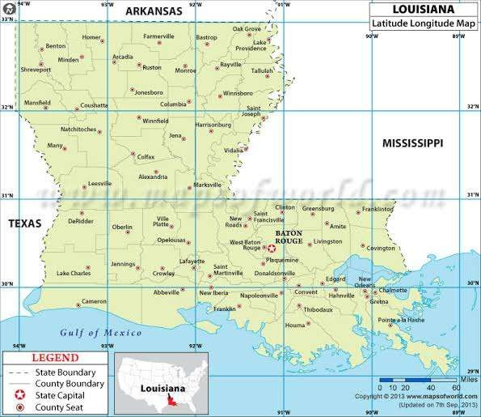

Fig. 1 Map of the study area

Methodology

Data Source

The study uses multispectral remote sensing Sentinel 2 data (Corpenicus/S2_Sr_Imagery for Louisiana) obtained from the Google Earth Engine to create classified soil moisture maps (NDMI composite) and document the areas of variable concentration for each hydrological year using ArcGIS Pro software (Table 1). It also creates and plots the mean NDMI values per year using Excel (Figure 1). The data set for the study is based on the hydrological year (a 12-month period that runs from October 1st to September 30th of the following calendar year) e.g. the hydrological year for 2025 commenced on October 1st, 2024, and will end on September 30th, 2025. The hydrological year was chosen because it aligns with the natural cycle which begins in October after the peak of the summer growing season and before the winter snowmelt season, thus facilitating a more complete review of the annual water cycle.
HP
2026-03-13 22:31:04
--------------------------------------------
For spatiotemporal analysis, is the number of time steps unlimited, since remote sensing research typically uses monthly or seasonal composites?
HP
2026-03-13 22:30:49
--------------------------------------------
The methodological description of the temporal analysis is relatively simple. Additional statistical analyses could improve the robustness of the interpretation of NDMI variability.
Consequently, a total of 12 images with less than 15% cloud cover were downloaded and used for the study corresponding to the six (6) hydrological years from 2020 to 2025 (Table 2). Though the hydrological year of 2025 was still ongoing, but due to the significant weather event that occurred in Louisiana in January (Snowfall), the January data was selected in order to document if there will be any significant changes in soil moisture content at the end of the 2025 hydrological year

Table 1. Dataset Characteristics

Platform | Sensor | Spatial Res. (m) | Spatial Extent (km) | Number of Bands | Temporal Res. (e.g. daily) | Temporal Res. (Start Year –  End Year) | Source
Sentinel 2 | MSI | 10 m | 290 km (field of view) | 12 | 5 days | 2020 –  2025 | Google  Earth Engine

Table 2. Dates of Data Acquisition for Analysis

S/N | Hydrological Year | Commencement | End
1 | 2020 | October 2019 | September 2020
2 | 2021 | October 2020 | September 2021

3 | 2022 | October 2021 | September 2022
4 | 2023 | October 2022 | September 2023
5 | 2024 | October 2023 | September 2024
6 | 2025 | October 2024 | January 2025

Satellite Image Analysis

The multispectral analysis (NDMI) was used to calculate the Normalized Difference Moisture Index (NDMI) based on signature statistics, mean, and standard deviations of the NDMI values (Townshend and Justice 1986; Tucker and Sellers 1986; Sharma et al. 2014). NDMI is a ratio using the Near-Infrared (NIR) and Shortwave Infrared (SWIR). For Sentinel-2, NDMI is computed as (B8 − B11) / (B8 + B11), where B8 is the NIR band and B11 is the SWIR1 band. The NDMI is commonly used to map and determine moisture levels in vegetation and soil in order to monitor droughts/flooding (which are natural but also economically devastating disasters) by comparing the NIR and SWIR reflectance values (Gao, 1996; McFeeters, 1996).

Image Classification Method

For each hydrological year from 2020 through 2025, the image collection was filtered for that month, the cloud mask was applied and the NDMI for each image was calculated. The image collection for the month was reduced into a single composite image (using the median to get a representative, cloud-free pixel value). Each resulting composite of an NDMI image for that month and year was clipped to Louisiana’s boundaries. The resulting image of the NDMI image was exported as a Geo Tiff file into ArcGIS Pro, and classification using the quantile method was performed to group the classes of turbidity considered in the lake for each month.
NDMI values typically range from -1 to +1. The negative values of NDMI (values approaching -1) correspond to barren land soil or low moisture areas, while values ranging from - 0.2 to 0.4 generally correspond to water stress, and high positive values (0.4 to 1) represent high canopy without stress and high moisture content. Color palette from yellow (dry) to dark blue (wet) to display these values. Each layer is named by month and year for clarity. For each year, the mean NDMI value within Louisiana was also calculated. These values were used to analyze yearly trends. Using the prepared data, a line chart comparing the mean NDMI in September vs. October for each year was constructed.

Result

The following NDMI soil moisture content maps were produced with yellow indicating low soil moisture content areas, green and blue representing medium/intermediate/variable soil moisture water areas, and dark blue representing high soil moisture content areas (Figure 3).
Data related to different moisture classes (low, medium, and high) for the 2020 to 2025 hydrological year are presented (Table 3). This map shows the spatial distribution of the Normalized Difference Moisture Index (NDMI) across Louisiana for October 2019. NDMI, computed as (NIR – SWIR)/(NIR + SWIR), is a proxy for surface and vegetation water content: low or negative values indicate dry soils or senescent (water-stressed) vegetation, whereas high positive values flag moist soils, standing water, or lush, turgid vegetation.
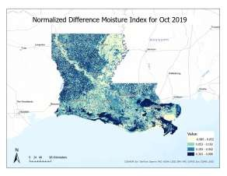
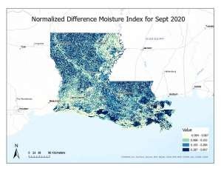
October, 2019 September, 2020

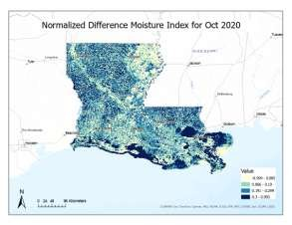
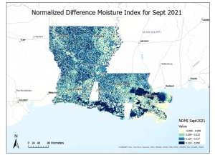

October,2020 September, 2021
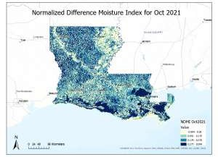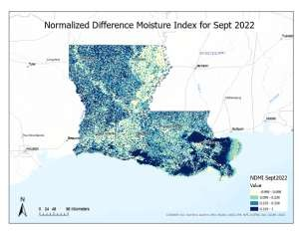
October, 2021 September, 2022

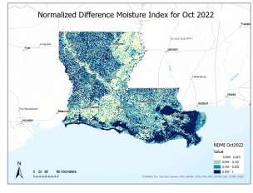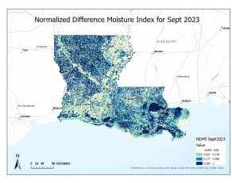
October, 2022 September, 2023
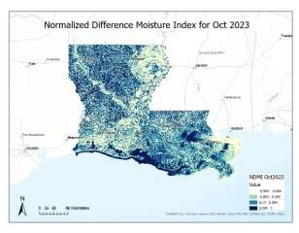
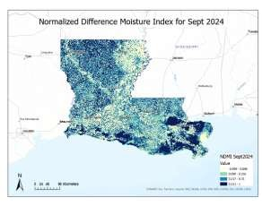
October, 2023 September, 2024
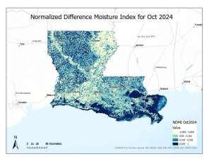
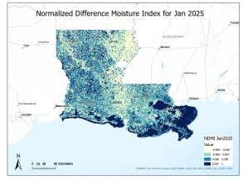

October, 2024 January, 2025

Fig. 2 NDMI Maps of Louisiana for 2020 to 2025 Hydrological Year

Soil Moisture Content Ranges (Upper-Class Values) and Variation for the 2020 to 2025 Hydrological Year Calculated based on NDMI Values
Table 3. Mean NDMI Values from 2020 Hydrological Year to 2025

S/N | Hydrological Year | NDMI Values (October) | NDMI Values (September)
1 | 2020 | 0.1849 | 0.1726
2 | 2021 | 0.1837 | 0.2059
3 | 2022 | 0.1697 | 0.1983
4 | 2023 | 0.1804 | 0.1420
5 | 2024 | 0.1415 | 0.1955
6 | 2025 | 0.1796 | 0.02014 (January 2025)

Mean NDMI Values from 2020 Hydrological Year to 2025
NDMI_Oct
NDMI_Sept
Year
2024
2023
2022
2021
2020
2019
0.1
0.14
0.18
0.22
Mean NDMI from 2020 - 2025
NDMI Values

Fig. 3 Mean NDMI from 2020 - 2025

Spatiotemporal Variations of Soil Moisture Content across Louisiana for 2020 to 2025 Hydrological Year
The September - October NDMI snapshots for 2020 through 2025 hydrological year, reveal the classic fingerprint of Louisiana’s hydrology. Dark blues in coastal marshes and river bottoms; greens and yellows in drier uplands and urban areas, however, the extent of those blues and yellows pulses varies with seasonal rainfall and tropical storms and significant weather events.

2020 Hydrological Year

October 2019

The darkest‐blue zones near the Gulf coast (especially the Atchafalaya Basin and the chenier marshes east of New Orleans) are classic high‐moistue wetlands. The Mississippi River corridor (through Baton Rouge and north toward Monroe) also lights up in deep blue, reflecting both the river itself and adjacent inundated floodplain. While Large swaths of northwestern and central Louisiana (around Shreveport, Alexandria and Lake Charles) show a mosaic of light green and medium blue, indicating generally adequate moisture in October, which is consistent with actively growing row crops or mixed pine–hardwood forests. Patches of pale yellow in these regions correspond to recently harvested fields, fallow ground, or pockets of drought stress. Cities like New Orleans, Baton Rouge and Lafayette appear as patchy, having lower NDMI values (greens to yellows), owing to impervious surfaces (roads, rooftops) and sparse vegetation cover

September 2020

Moderately high moisture (0.193–0.286) dominates both the coast and interior forests/crops, reflecting abundant late-summer rains plus residual soil wetness from Hurricane Laura (Aug 27). While the driest fringes (−0.994– 0.067) are confined to far NW uplands and around major cities (Houston–Beaumont corridor, Shreveport urban footprint).

2021 Hydrological Year

October 2020

A second tropical influx (Delta, Oct 9) pushes vast areas into the highest NDMI class (0.287–0.997). Coastal marshes from Lake Charles eastward, the Atchafalaya Basin, and the Mississippi floodplain light up in dark blue. Interior still moist (blues), with only isolated pale-yellow pockets in agricultural fields.

September 2021

Hurricane Ida’s late-Aug deluge leaves extensive dark-blue saturation (0.318–0.999) in Plaquemines, Jefferson, St. John the Baptist parishes and the lower Atchafalaya basin. Interior uplands also skew toward medium–high blues (0.224–0.317), a wetter than average start to fall.

2022 Hydrological Year

October 2021

As floodwaters recede and autumn dries, the very highest NDMI shrinks: more areas slip into 0.176–0.276 (mid- blue) and 0.051–0.175 (light green) while patches of dry ground re-emerge in north LA and around urban zones.

September 2022

With no major landfall, the coast remains wet but less extreme: dark blues (0.319–1.0) are mostly in true marsh/wetland tracts, while interior forests and fields sit in the 0.099–0.224 and 0.225–0.318 bands. Noticeably more light-greens (−0.999–0.098) creeping into upland agriculture reflecting signs of modest moisture deficits.

2023 Hydrological Year

The 2023 Hydrological year is marked by a sharp decline in moisture content due to severe drought experienced in the state. This significantly impacted the soil moisture content, including the Mississippi Basin leading to below the normal discharge into the Gulf of Mexico. The drought also contributed to unexpected surge in prices of fishery and agricultural produce (crawfish)

October 2022

Typical fall rains bump up interior NDMI into 0.193–0.302, but the majority of the highest class remains smaller than in 2020/21 hydrological year. Dry margins also persist in NW LA and around the urban corridors

September 2023

Coastal parishes again show strong saturation (0.287–1.0), but the interior reflects low moisture content (−0.999–0.02) to high (0.177–0.286) indicating spotty late-summer rains. Northeast LA remains the driest corner this year.

2024 Hydrological Year

October 2023

A good fall rain pulse restores much of the coast and river bottom to medium/high blues (0.17–0.294), with only isolated dry patches. Uplands similarly shift darker.

September 2024

An early-Sep tropical splash (T.S. Gordon) concentrates dark blues (0.311–1.0) around Vermilion Bay and the lower Mississippi corridor, while the interior still a mix of moderate blues (0.217–0.31) and light-greens (−0.999–0.098).

2025 Hydrological Year

October 2024

Fall rains push huge swaths—from Lake Charles all the way east through Plaquemines into the 0.303–1.0 bracket again. Even some upland pockets in central LA touch the highest class, a level of saturation we haven’t seen so uniformly since 2020.

January 2025

Virtually all of the chenier marshes (Vermilion Bay eastward), the Atchafalaya Basin and the lower Mississippi floodplain sit in the darkest‐navy class (0.287–1.0) reflecting both permanent inundation and winter high‐water tables. West of Alexandria and north toward Monroe/Shreveport you see a ―mosaic‖ of light blue (0.068–0.286) interspersed with light green (–0.066–0.067). Baton Rouge, Lafayette and the Houston–Beaumont corridor show up as light green–pale yellow, where rooftops, roads and minimal vegetation depress the NDMI. Also, due to the significance of the occurrence of snowfall in January, there was a measurable snow across much of north/central LA. Snow has very high NIR reflectance relative to SWIR (and the meltwater further boosts the moisture signal), in the medium‐high (0.068–0.286) to highest (0.287–1.0) classes.

Inter-annual Variability
HP
2026-03-13 22:52:31
--------------------------------------------
The discussion would benefit from a deeper comparison with previous studies on NDMI-based soil moisture monitoring to highlight similarities or differences in the observed patterns
__________________________________________
HP
2026-03-13 22:52:40
--------------------------------------------
The Results have explained the main findings, and the Discussion explains the causes of the phenomenon.
However, the analysis could still be strengthened with a more quantitative approach.

Years with late-summer hurricanes (2020 Laura / Delta, 2021 Ida) show dramatic spikes in the darkest-blue class come September and October. In 2022 and to a lesser extent 2023 the high-moisture ―footprint‖ retreats to classic marshes and floodplains, while upland and peri-urban fields hover at moderate moisture. However, no matter the year, the coastal marshes and major river corridors always anchor the top NDMI class revealing high moisture content. Dry patches in the upland quadrants highlight potential irrigation needs. However, the 2023 hydrological year stands out as the driest

Spatial Distribution of NDMI
The NDMI results reveal clear spatial variability in surface moisture conditions across Louisiana. Areas characterized by dense vegetation cover, wetlands, and floodplains exhibit consistently high NDMI values, indicating elevated moisture availability. These zones are predominantly concentrated along the Mississippi River corridor, coastal wetlands, and forested regions of southern Louisiana, where surface water retention and groundwater interaction are strong.
Conversely, low NDMI values are observed in urbanized areas and regions dominated by exposed or sparsely vegetated surfaces. Built-up zones, particularly around major metropolitan areas, display reduced moisture levels due to impervious surfaces that limit infiltration and enhance surface runoff. Agricultural lands show moderate NDMI values, reflecting seasonal variations in crop growth, irrigation practices, and soil exposure.
HP
2026-03-13 22:52:45
--------------------------------------------
The Results have explained the main findings, and the Discussion explains the causes of the phenomenon. However, the analysis could still be strengthened with a more quantitative approach.

Discussion

  - Temporal Variation of Surface Moisture
Temporal analysis of mean NDMI values from the 2020 to 2025 hydrological years reveals noticeable interannual variability in surface moisture conditions across Louisiana (Table 3; Figure 3). The highest mean NDMI values were recorded during the 2021 hydrological year, coinciding with enhanced precipitation associated with Hurricane Ida, while the lowest values were observed in 2023, reflecting the severe drought conditions experienced across the state.
A general pattern of seasonal fluctuation is evident between October and September observations. In most hydrological years, September NDMI values were higher than October values, indicating peak late-summer moisture accumulation driven by convective rainfall and tropical systems. However, the 2023 hydrological year deviated from this pattern, with significantly reduced NDMI values in both months, highlighting the intensity of

drought-induced moisture deficits. The January 2025 observation presents a unique case, where snowfall and subsequent meltwater contributed to localized increases in NDMI values, particularly across northern and central Louisiana. Overall, the temporal analysis confirms that surface moisture conditions in Louisiana are highly responsive to seasonal rainfall variability, extreme weather events, and climatic anomalies, reinforcing the effectiveness of NDMI as a tool for multi-year moisture monitoring.

Influence of Climate and Hydrology
The observed NDMI patterns are strongly influenced by Louisiana’s humid subtropical climate and complex hydrological setting. Frequent precipitation events, coupled with extensive river networks and wetlands, contribute to sustained moisture availability in many regions. Seasonal flooding along major river systems further enhances surface moisture levels, particularly in low-lying floodplain areas.
Extreme weather events, including heavy rainfall and tropical storms, may also contribute to localized spikes in NDMI values by increasing surface water presence and soil saturation. These hydrological controls underscore the importance of continuous monitoring of moisture conditions in flood-prone environments such as Louisiana.

Implications for Environmental Management
Understanding spatiotemporal moisture variability has important implications for agriculture, flood risk management, and ecosystem conservation. Areas exhibiting persistent low NDMI values may be more vulnerable to moisture stress and land degradation, while regions with consistently high NDMI values require careful management to mitigate flooding and waterlogging risks. The results provide valuable information for land-use planning and support the use of remote sensing tools in climate resilience and environmental decision- making.

Summary and Conclusion

This study employed multispectral remote sensing data and the Normalized Difference Moisture Index (NDMI) to assess the spatiotemporal variability of surface moisture conditions across Louisiana. The results reveal significant spatial heterogeneity and seasonal fluctuations in moisture distribution, driven primarily by climatic conditions, hydrological processes, and land-use characteristics. Regions dominated by wetlands, dense

vegetation, and river floodplains consistently exhibited higher moisture levels, while urbanized and sparsely vegetated areas showed lower NDMI values indicative of moisture stress.
Temporal analysis demonstrated that surface moisture conditions are strongly influenced by seasonal rainfall patterns, with elevated NDMI values during wetter periods and reduced values during drier months. These findings highlight the sensitivity of NDMI to changes in precipitation, evapotranspiration, and vegetation dynamics, confirming its effectiveness as a tool for regional-scale moisture monitoring. This study advances soil moisture monitoring and planning strategy. It also demonstrates the NDMI’s utility for high resolution, regional scale analysis. This provides actional data for flood mitigation, drought response and crop optimization for promoting sustainable water management in a climate vulnerable region.
Despite the effectiveness of the NDMI in assessing spatiotemporal moisture variability, this study has certain limitations that should be acknowledged. Firstly, the analysis relies solely on satellite-derived indices, which may be affected by atmospheric conditions, sensor noise, and residual cloud contamination, despite the application of cloud filtering and preprocessing techniques. These factors can introduce uncertainty in NDMI values, particularly in regions with persistent cloud cover. Secondly, the study does not incorporate ground- based soil moisture or meteorological measurements for validation. Although NDMI has been widely validated in previous studies, the absence of in-situ data limits the ability to quantitatively assess the accuracy of the derived moisture estimates. Future studies could improve reliability by integrating field observations, soil moisture sensors, or precipitation datasets.
Additionally, NDMI primarily reflects surface and vegetation moisture and may not fully capture deeper soil moisture conditions. Variations in land cover, vegetation type, and soil properties can also influence NDMI responses, potentially leading to spatial heterogeneity that is not solely driven by moisture availability. Future research should incorporate in-situ soil moisture measurements and meteorological data to validate and enhance the accuracy of satellite-derived NDMI results. Also, the analysis should cut across multiple years would improve understanding of long-term moisture trends and the impacts of climate variability and extreme weather events. Additionally, further studies should examine the influence of land-use change and urban expansion on moisture dynamics to support sustainable development planning. Additionally, environmental agencies and policymakers should consider adopting NDMI-based remote sensing approaches for routine monitoring of moisture conditions, particularly in flood-prone and agriculturally important regions.
Overall, the study provides valuable insights into large-scale moisture dynamics and demonstrates the usefulness of NDMI for regional environmental monitoring where ground data are limited or unavailable. The

study demonstrates that NDMI provides a reliable, cost-effective, and spatially continuous approach for monitoring surface moisture dynamics in humid subtropical environments. The generated moisture maps offer valuable insights into environmental conditions and support informed decision-making related to land-use planning, agricultural management, flood risk assessment, and climate adaptation strategies.

References
- R. G. Allen, L. S. Pereira, D. Raes, and M. Smith, Crop evapotranspiration: Guidelines for computing crop water requirements, FAO Irrigation and Drainage Paper No. 56. Rome, Italy: Food and Agriculture Organization of the United Nations, 1998.
- N. An, C. S. Tang, S. K. Xu, X. P. Gong, B. Shi, and H. I. Inyang, ―Effects of soil characteristics on moisture evaporation,‖ Engineering Geology, vol. 239, pp. 126–135, 2018. https://doi.org/10.1016/j.enggeo.2018.03.021
- S. Bid and G. Siddique, ―Spatio-temporal assessment of surface moisture using NDMI and remote sensing techniques,‖ Journal of Environmental Geography, vol. 12, no. 3–4, pp. 23–31, 2019.
- H. Caroline, V. I. Christa, H. Jan-Markus, and S. de Vries, ―Simulating surface soil moisture on sandy beaches,‖ Coastal Engineering, vol. 185, art. no. 104357, 2023. [Online]. https://doi.org/10.1016/j.coastaleng.2023.104357
- B. C. Gao, ―NDWI—A normalized difference water index for remote sensing of vegetation liquid water from space,‖ Remote Sensing of Environment, vol. 58, no. 3, pp. 257–266, 1996. https://doi.org/10.1016/S0034-
4257(96)00067-3
- D. Hillel, Environmental soil physics. San Diego, CA, USA: Academic Press, 1998.
- S. K. McFeeters, ―The use of the Normalized Difference Water Index (NDWI) in the delineation of open water features,‖ International Journal of Remote Sensing, vol. 17, no. 7, pp. 1425–1432, 1996. https://doi.org/10.1080/01431169608948714
- R. C. Sharma, R. Tateishi, K. Hara, and K. Iizuka, ―Global mapping of flood-affected areas using multi-temporal MODIS data,‖ Journal of Water Resource and Protection, vol. 6, pp. 110–118, 2014.
- J. R. G. Townshend and C. O. Justice, ―Analysis of the dynamics of African vegetation using the normalized difference vegetation index,‖ International Journal of Remote Sensing, vol. 7, no. 11, pp. 1435–1445, 1986. [Online]. Available: https://doi.org/10.1080/01431168608948946
- C. J. Tucker and P. J. Sellers, ―Satellite remote sensing of primary production,‖ International Journal of Remote Sensing, vol. 7, no. 11, pp. 1395–1416, 1986. [Online]. Available: https://doi.org/10.1080/01431168608948944
- Y. Yang and R. Davidson-Arnott, ―Rapid measurement of surface moisture content on a beach,‖ Journal of Coastal Research, vol. 21, no. 3, pp. 447–452, 2005. https://doi.org/10.2112/03-0146.1
- S. Yvonne, J. J. A. Jasper, J. J. A. Donker, and G. Ruessink, ―Spatiotemporal surface moisture variations on a barred beach and their relationship with groundwater fluctuations,‖ Hydrology, vol. 6, no. 1, art. no. 8, 2019. https://doi.org/10.3390/hydrology6010008

