Application of Geospatial Technologies and KOBO Tool for Site Suitability Assessment of Soil and Water Conservation Measures within Wasari WatershedIndia

------------------------------------------------------------------------------------------------------------------------------
Abstract
Integrated watershed management is essential for conserving soil and water resources under increasing climatic variability. The present study focuses on the application of Geospatial technology and the KOBO tool for identifying soil and water conservation measures within Wasari Watershed, Yavatmal District, Maharashtra, India. The watershed covers 914.19 ha and has an elevation range of 207 m to 323 m above mean sea level. The integration of GIS analysis with the mobile-based KOBO tool enabled accurate geo-tagging, field data collection, and technical planning of soil and water conservation structures in the watershed. Spatial datasets, including the SRTM Digital Elevation Model (DEM), land use/land cover, soil characteristics, geology, lineaments, slope, drainage density, and topography, were analysed using GIS techniques. A weighted overlay method was applied to prepare the land capability classification map by assigning weights to slope (30%), soil (25%), land use/land cover (20%), topography (15%), geology (10%), and lineament density (10%). The results indicate that a significant portion of the watershed falls under Class II land capability, suggesting moderate suitability for agriculture with proper conservation practices. Soil analysis revealed a neutral to slightly alkaline pH, low to moderate organic carbon content, and dominance of sandy clay loam and clay soils with variable depths. The suitable land area and drainage line treatments were proposed. Measures such as contour bunding based on the ridge-to-valley approach, farm bunding, afforestation, water-absorption trenches, loose boulder structures, gully plugs, and gabion structures were recommended to reduce runoff, control soil erosion, and enhance groundwater recharge. The study concludes that integration of Remote Sensing, GIS, and KOBO tool provides a scientific and practical framework for prioritizing soil and water conservation measures and supports climate-resilient watershed development.
Keywords: Remote sensing, GIS, DEM, lineament, topography, contour bunding, ridge-to-valley
Introduction
Watershed development is important for conserving natural resources including: soil, vegetation, and water (Manivannan et al., 2017). These resources are degrading rapidly due to various natural and human-induced factors. Among them, water is essential for all forms of life. It is used for food production, drinking, domestic needs, industrial activities, and power generation. In India, rainfall shows high spatial and temporal variability. This variability is influenced by climate change and the country’s diverse topography, including mountains and different landforms. About 80% of the total annual rainfall occurs during the monsoon months of July, August, and September. The remaining 20% of rainfall is received during the other nine months of the year. This rainfall is unevenly distributed across regions and seasons. Such uneven distribution creates challenges in water availability and highlights the need for effective watershed management.(Singh et al., 2009)
India has a large population, which creates high demand for water resources (Bhan, 2013). Rainfall has become increasingly erratic and unevenly distributed due to climate change. Continuous demand and over-exploitation of water resources have resulted in a significant decline in groundwater levels in many regions. A large proportion of agricultural land in India depends primarily on rainfall. In these rainfed areas, crop production is highly sensitive to variations in rainfall. Even a small additional supply of water during critical growth stages can substantially increase crop yields and reduce the risk of crop failure. (Kolekar et al., 2017).
The increasing gap between water demand and availability has become a serious concern in Maharashtra. The state ranks third in India in terms of both population and geographical area. Increasing population, urbanization, and agricultural expansion have intensified pressure on available water resources. As a result, efficient water management and the optimal use of this limited and valuable resource have become essential to minimize the risk of future water crises. Rising water demand and continuous degradation of natural resources have led to a decline in per capita water availability and agricultural productivity. In this context, soil and water conservation through a watershed-based approach has gained increasing importance. The impacts of climate change are expected to further aggravate these challenges.
The objectives and technologies of soil and water conservation are highly location-specific. Technologies developed for one region cannot be directly applied to other areas due to differences in physiography, environmental conditions, technical feasibility, and socio-economic factors (Ramakrishnan et al., 2009). Site selection for conservation measures depends not only on annual rainfall but also on terrain characteristics, soil permeability, land use, and their spatial and temporal variations (Kolekar et al., 2017). Recent advances in remote sensing and Geographic Information Systems have provided valuable tools for integrated resource analysis and improved planning of watershed interventions. (Varade et al., 2013). Satellite remote sensing provides reliable and accurate information on natural resources, which is pre-requisite for planned and balanced development at the watershed level. (Durbude and Venkatesh, 2004)
Geographic information systems techniques are increasingly used for planning, development, and management of natural resources at the regional, national, and international levels (Regulwar and Ambhore, 2017). They have been applied for the assessment of several water related environmental challenges including: soil erosion, degradation of land by water logging, ground and surface water contamination, and ecosystem changes (Syst et al., 2011)
The ridge to valley watershed management is planned at Wasari villages in Ghatanji tehsil of Yavatmal district, Maharashtra. The major issues in this village include degradation of natural resources, which leads to increased soil erosion and water scarcity. Agricultural productivity is low due to the continued use of traditional farming practices. Inappropriate water management further worsens the situation, while climate variability adds additional stress on water and agriculture systems. There is also a strong need to mobilize the community to adopt improved water management practices and advanced technological solutions to balance water demand and supply. The integration of GIS and Remote Sensing is used for the selection of suitable sites for soil and water conservation measures in Wasari, following a ridge-to-valley approach.
Material and Methods
Study Area
Yavatmal district is a district located in the Vidarbha region of Maharashtra, India, and is recognized as one of the agriculturally distressed districts of the region. The district is situated approximately 125 km from Nagpur city. Geographically, it lies between latitudes 19°26′ and 20°42′ N and longitudes 77°18′ and 79°09′ E. The location map of the study area is shown in Fig 1.
Agriculture is the primary occupation in the district, with major crops including cotton, soybean, tur (pigeon pea), jowar, wheat, and pulses. Approximately 80% of the families in the district are engaged in agricultural activities, and more than 70% of these families depend on rain-fed agriculture for their livelihoods. Findings from focused group discussions with farmers indicate that agricultural productivity in the district is relatively low. Table 1 shows the detail description of the watershed area. The average yield of cotton ranges from 5 to 6 quintals per acre, while soybean yields vary between 4 and 6 quintals per acre. The primary reason for this low productivity is the heavy dependence on rainfall, leading to frequent water stress. Therefore, the implementation of effective water and soil conservation measures is critically important for improving agricultural sustainability and productivity in the study area.
NABARD Supported Watershed Development Fund (WDF) Programme was launched on 8th July 2022 in Wasari village in Yavatmal distressed districts of Vidarbha region of Maharashtra. The Watershed development measures are being taken up to enhance the micro level infrastructure development with regard to sustainable management of soil and water resources.

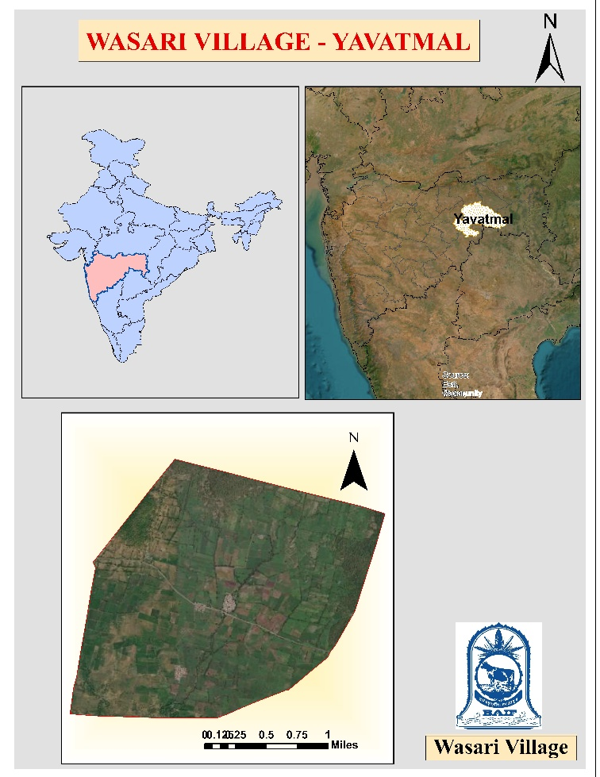
Fig 1. Location map of Wasari village – Yavatmal district

Table 1 General description of the watershed area
S. N. | Particular | Details
i | Name of Watershed | Wasari
ii | Watershed Code | 4E4C4
iii | Latitude | 20.10198N
iv | Longitude | 78.347451E
v | Length (Km) | 4.00
vi | Breadth (Km) | 2.70
vii | Village Covered | 1
viii | Panchayat (GP) | 1
ix | Block | Ghatanji
x | District | Yavatmal
xi | Major Drainage system of which Watershed | Waghadi River
xii | Identification code of Watershed | 4E4C4b1n, 4E4C4b1k
xiii | Highest Elevation in the Watershed (MSL Metre) | 386
xiv | Lowest Elevation in the Watershed (MSL Metre) | 285
xv | Height difference (Metre) | 101
xvi | Village covered under CBP | Wasari
 | Details of the area of the watershed- (As per Govt Records)
 | Description | Total Area (Ha)
 | PUBLIC LAND
1 | Government Forest Land | 75.97
2 | Revenue Land | 0.00
3 | Panchayat Land | 0.60
4 | Gaothan (Land Occupied by households) | 6.19
5 | Submergence area due to tanks /Ponds | 13.78
 | Sub Total (A) | 96.540
 | Private land
 | Seasonally Irrigated | 28.00
 | Perennially Irrigated | 12.00
 | Rainfed | 777.65
 | Fallow Area (Culturable Waste) | 0.00
 | Unculturable Waste area | 0.00
 | Sub Total (B) | 817.65
 | Total (A+B) | 914.19
 | Treatable Area | 893.62
 | Geographical Area in Ha | 914.19

Climate
The climate of Yavatmal district is characterized by a hot summer and general dryness throughout the year, except during the southwest monsoon season, which occurs from June to September. The temperature begins to rise rapidlyin March, reaching its peak in May, which is the hottest month. During this period, the mean maximum temperature is approximately 41.8°C, while the mean minimum temperature is around 28.3°C.

Purpose of GIS and Remote Sensing technology in DPR preparation and Remote Sensing technology
The integration of GIS and Remote Sensing in the preparation of DPRs is essential for the following reasons:
- Accurate Spatial Mapping: To delineate watershed boundaries, identify land use patterns, and understand topographical variations.
- Hydrological Analysis: To assess drainage patterns, water flow, and erosion-prone areas.
- Resource Assessment: To monitor vegetation cover, soil moisture, and surface water resources.
- Decision-Making Support: To aid in site selection for interventions such as check dams, contour bunds, and plantation activities.
- Monitoring and Evaluation: To ensure data-driven planning, implementation, and post-project assessment.

Detailed methodology with flow chart
The methodology for preparing a GIS-based suitable site for soil and water conservation measures involves several key steps. Below is a detailed description of each stage, followed by a flow chart in fig 2.
Step 1: Base Map Preparation
Base maps were prepared using Survey of India (SOI) topographic sheets, cadastral maps, and recent satellite imagery. All maps were georeferenced to a common coordinate system (WGS 84 / UTM) to maintain spatial accuracy. The georeferenced maps were digitized to extract essential features such as administrative boundaries, drainage networks, roads, and settlements, which formed the spatial framework for further analysis.
Step 2: Watershed Delineation
Digital Elevation Model (DEM) data which were processed in a GIS environment was used to delineate watershed boundaries (More et al., 2023). DEM preprocessing included sink filling, flow direction, and flow accumulation analysis. Based on flow accumulation thresholds, drainage networks were generated, and the watershed was subdivided into sub-watersheds and micro-watersheds for detailed planning of conservation measures.
Step 3: Thematic Layer Creation
Relevant thematic layers were prepared using remote sensing datasets and GIS techniques. These layers included land use/land cover (LULC), soil type, slope, drainage density, and hydrological characteristics. The slope map was derived from DEM data, LULC classification was carried out using supervised classification of satellite imagery, and soil maps were digitized from available soil survey reports.
Step 4: Land Suitability Map Preparation
A land suitability map was generated by integrating key thematic layers such as soil characteristics, slope, land use/land cover, and drainage conditions. Each thematic layer was classified into suitability classes based on standard criteria for agricultural land and soil and water conservation practices. Weighted overlay analysis was performed to produce a land suitability map categorizing the area into highly suitable, moderately suitable, and less suitable zones. This map provides a spatial basis for prioritizing conservation interventions.
Step 5: Resource Assessment
The land suitability map and thematic layers were analyzed to assess natural resource conditions within the watershed. Areas vulnerable to soil erosion, runoff generation, land degradation, and water stress were identified through overlay analysis. This assessment helped in delineating critical zones that require immediate soil and water conservation measures.

Step 6: Net Planning using KOBO tool
In order to support detailed field-level planning and systematic data collection, the KOBO tool was utilized as a mobile-based application for watershed intervention planning. The tool enables the entry of socio-economic information of beneficiaries, including landholding size, cropping pattern, irrigation status, and livelihood details. It is integrated with GPS functionality, which allows accurate recording of the geographic coordinates of each proposed intervention site. The application supports real-time field data collection and ensures spatial accuracy of the planned conservation structures.
The KOBO tool also facilitates the entry of technical parameters such as the length, width, and height of proposed structures, which can be measured directly at the site. These measurements assist in estimating earthwork volume, water storage capacity, and overall cost of construction. In addition, geo-tagged photographs of intervention sites can be captured and stored within the application for proper documentation and monitoring. The integration of GIS-based spatial analysis with KOBO-based field data enhances transparency, improves accuracy, and increases efficiency in watershed planning. Overall, the application supports participatory planning, evidence-based decision-making, and effective implementation of soil and water conservation measures.
Step 7: Identification of Suitable Sites for Soil and Water Conservation Measures
A final site suitability analysis was performed using multi-criteria decision analysis (MCDA) techniques. Thematic layers were assigned weights and ranks based on their relative importance in soil and water conservation planning. The final suitability map classified the study area into highly suitable, moderately suitable, and less suitable zones for implementing soil and water conservation measures, providing scientific support for sustainable watershed management.
Land suitability / Use Capability Classification (LUCC)
The Land Use Capability Classification (LUCC) for the Wasari watershed was conducted using a multi-criteria decision-making approach integrated with Geographic Information Systems (GIS). The primary objective was to evaluate the land's potential for agricultural development. The process relied on the Weighted Overlay Method.
Land Use Capability Classification (LUCC) of the Wasari watershed was prepared using the weighted overlay method in a GIS environment. Thematic layers such as slope, topography, land use/land cover (LULC), soil map, lineament density, and geology were used for the analysis. Each layer was converted into raster format and reclassified into suitability classes based on its influence on land capability. Ranks were assigned to each class, where higher ranks indicated better suitability for agriculture.
Weighted Overlay Analysis
With all layers standardly formatted, ranked, and weighted, the Weighted Overlay tool in the GIS environment was executed (Kadam et al., 2022). The tool multiplied the class rank of each pixel by the assigned weight of its parent thematic layer and summed the values across all six layers using the following conceptual model:
LUCC Score = $\sum{Rank i*Weight i}$

where 'i' represents each of the six thematic layers
The cumulative scores resulting from the overlay analysis were grouped into specific Land Use Capability Classes.
Suitable Sites for Soil and Water Conservation Measures
The land capability classification map was used to identify suitable sites for soil and water conservation measures in the Wasari watershed. Based on the different capability classes, appropriate land treatment and drainage line treatment measures were proposed. Higher capability classes require minimal intervention, whereas lower capability classes need intensive conservation practices to control soil erosion and improve land productivity. Areas with gentle slopes and adequate soil depth are suitable for agricultural land treatments, while moderately steep and steep areas require structural and vegetative conservation measures. Drainage line treatments are recommended along natural streams and runoff channels to reduce soil loss and enhance groundwater recharge. Tables 2 and 3 present the criteria used for site suitability assessment of soil and water conservation measures in the watershed, following the ridge-to-valley approach.
Table 2. Site suitability criteria for land treatment
Sr. No. | Treatment | Suitability
1 | Agronomical Measures | - Land slope: up to 3 %  - LULC: Agriculture  - Rainfall: Entire AAR range  - Soil Texture: for both soil textural classes in Wasari  - Suitability: highly and moderately suitable
2 | Compartment Bunding | - Land slope: up to 5 %  - LULC: Agriculture  - Rainfall: AAR up to 1000 mm  - Texture: for both soil textural classes in Wasari  - Suitability: highly and moderately suitable
3 | Contour bunding | - Slope: up to 6 %  - Rainfall: up to 600 mm  - Soil: loamy soil  - LULC: Agriculture  - Suitability: highly and moderately suitable
4 | Continuous Contour Trenches | - Land slope: up to 15 %  - LULC: Barren  - Rainfall: AAR up to 1000 mm  - Soil Texture: for both soil textural classes in Wasari  - Suitability: highly and moderately suitable
5 | Staggered Contour Trenches | - Land slope: 10-30%  - LULC: Barren  - Rainfall: > 1200 mm  - Soil Texture: for both soil textural classes in Wasari  - Suitability: highly and moderately suitable
6 | Bench Terracing | - Land slope: 10-35 %  - LULC: Agriculture  - Rainfall: Entire AAR range  - Texture: for both soil textural classes in Wasari  - Suitability: highly and moderately suitable
7 | Afforestation | - Land slope: Slope more than 11 %  - LULC: Barren  - Rainfall: Entire AAR range  - Soil Texture: for both soil textural classes in Wasari  - Suitability: highly and moderately suitable

Table 3. Site suitability criteria for drainage line treatment
Sr.  No. | Structure | Stream Order | Catchment Area (Ha) | Slope (%) | LULC | Reference
1 | Temporary Structures (Loose Boulders, gully plugs etc.) | 1st | 5 | 5-20 | Barren | Ramakrishnan et al. (2008), Saha et al. (2018), Badhe et al. (2019)
2 | Semi- Permanent/Gabian Structures | 2nd | 10-50 | 1-15 | Barren | Pandey et al. (2011), Saha et al. (2018), (Rejani et al., 2015)
3 | Permanent check dams | 3rd | >25 | <15 | Barren | Ramakrishnan et al. (2008), Shashikumar et al. (2018)
4 | Earthen Nala Bund | 4th | 40-1000 | 1-3 | Agricultural | Saruk and Londhe (2018), (Saruk, 2018)
5 | Cement Nala bund | 5th | 40-100 | 0.5-3 | Scrub/Agri. | Gadakh et al. (2023)

Fig. 2 Stepwise flow chart methodology of GIS based site selection of soil and water conservation in study area.
Result and Discussion
The wasari village is located in yavtmal district. The toposheet is used to demarcate the topography of the watershed. In the study area highest elevation is 323. whereas, lowest elevation is 207. The length of the watershed is 4 km and breadth of watershed is 2.70 km. The watershed span area is 914.19 ha. The fig 3 and fig 4 shows the administrative and topographic map of the study area.
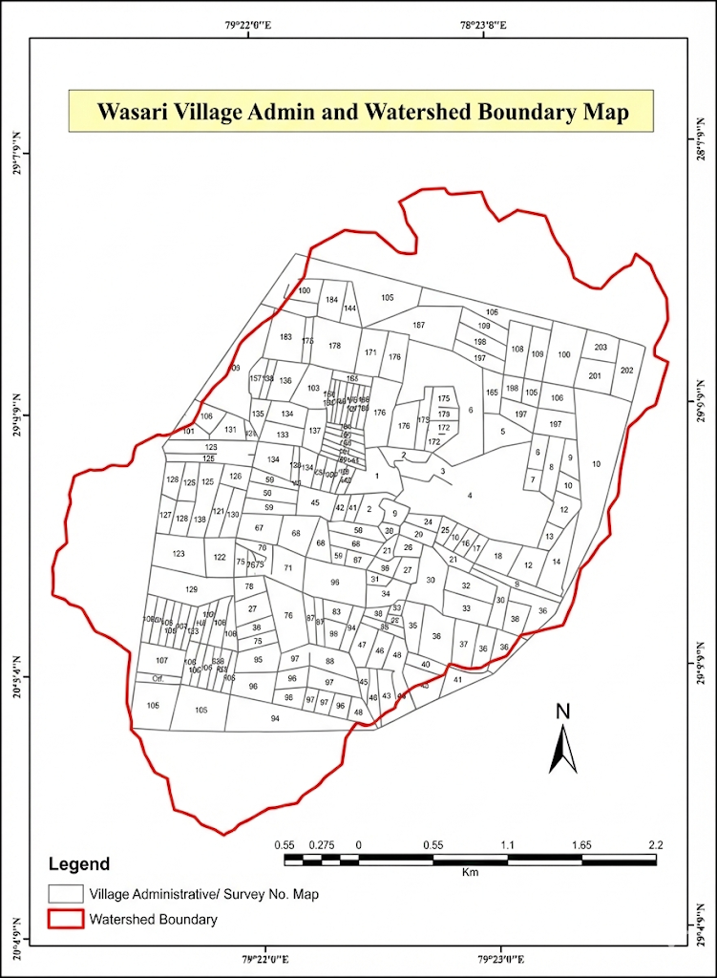 | 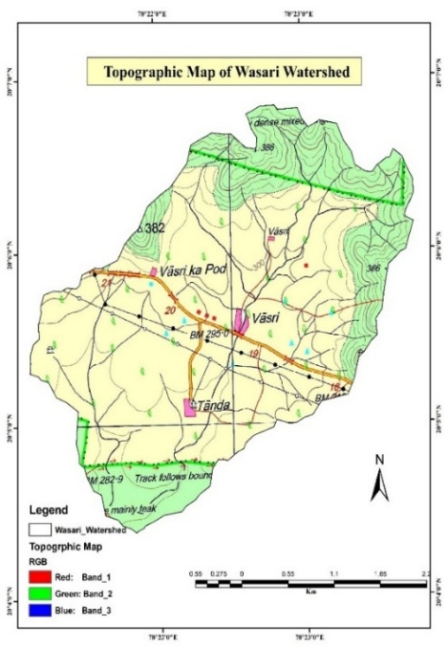
Fig. 3 Administrative Map of the study area | Fig. 4 Topographic map of the study area
Drainage, Contour Map of the study area.
The contour maps generated from the SRTM DEM (Digital Elevation Model) reveal the topographic characteristics of Wasari village and its surrounding landscape. The elevation values across the study area range approximately from 323 m to 207 m above mean sea level, indicating moderate relief typical of this region of Yavatmal District. The contour lines illustrate a general north–south gradient in elevation, with the northern portion of the study area appearing slightly elevated compared to the southern part. Contour intervals at regular 10 m spacing show gently sloping terrain in the central and northern zones, whereas the southern extremity exhibits closer contour spacing, signifying steeper slopes. The terrain configuration suggests that the village predominantly lies on a gentle to moderate slope, which transitions toward steeper zones in the south and southeast. Such topographic variation is consistent with the broader foothill and plateau-like features present in eastern Maharashtra.
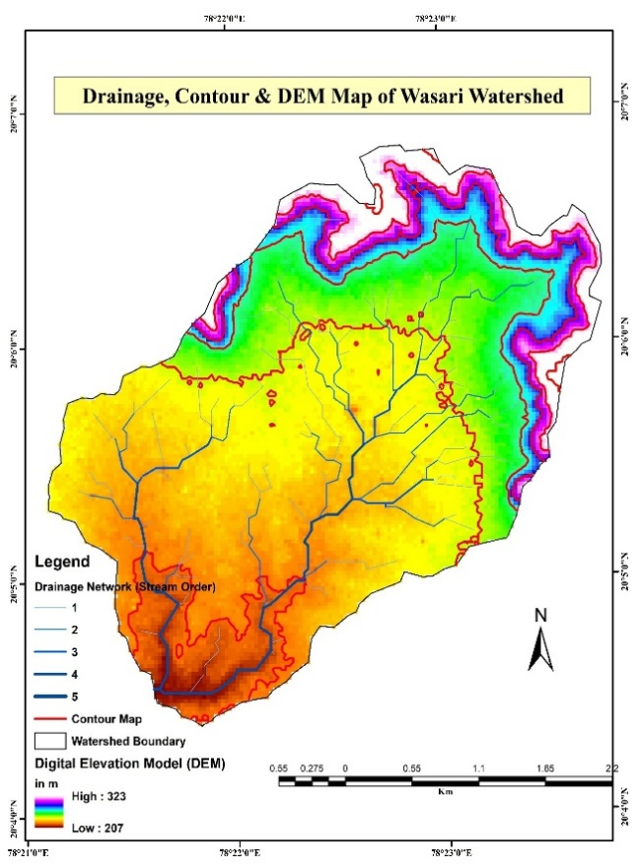
Fig. 5 Drainage, contour and DEM Map
Drainage, Drainage density map
The fig. 6 represents the drainage network and drainage density distribution of the Wasari watershed, Yavatmal district, derived from SRTM Digital Elevation Model (DEM) data using GIS techniques. The analysis shows several primary and secondary streams converging toward the main drainage line running in a southerly/southeasterly direction. Most tributaries exhibit gentle curvature, reflecting structural simplicity and a prevailing influence of topographic gradients rather than geological controls. The network includes primarily 1st and 2nd order channels, with a few 3rd order segments near the mid-southern part of the study area. The low stream order suggests a young or moderately developed drainage system, consistent with the gentle relief.
The drainage density map of the Wasari watershed shows moderate to very high drainage density in the central and lower parts of the basin, indicating steeper slopes, impermeable subsurface material, and high surface runoff. Low drainage density along the peripheral areas reflects gentle slopes, deeper soil cover, and higher infiltration capacity. This variation suggests differential runoff behavior across the watershed and highlights areas prone to soil erosion and rapid water flow.
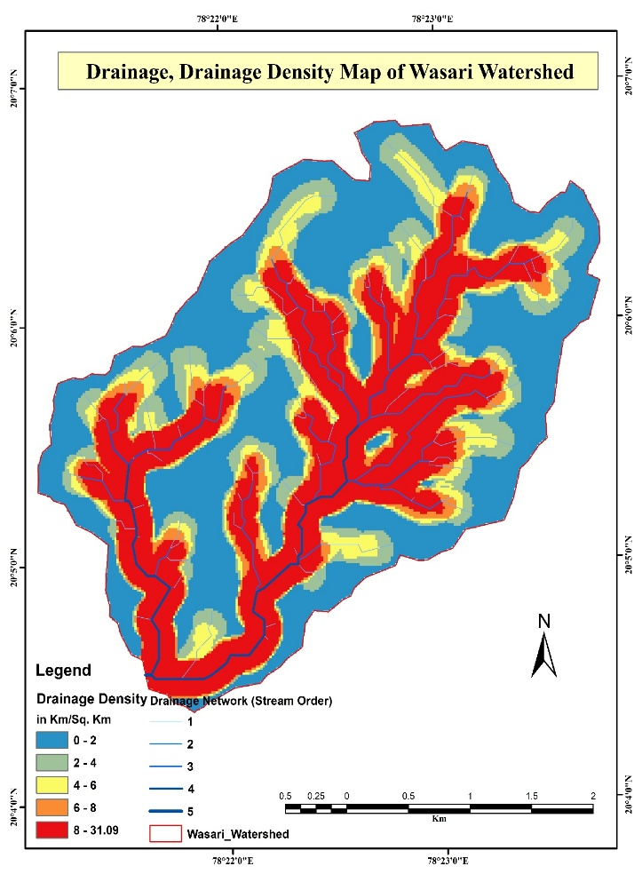
Fig. 6 Drainage (GIS: Drainage density, drainage order, drainage length etc.)
Land use land cover (LULC)
The Land Use/Land Cover map of the Wasari watershed shows that agriculture is the dominant land use, covering most of the central part of the watershed. Forest land is mainly found along the outer and higher altitudes of the watershed and plays an important role in controlling soil erosion, reducing surface runoff, and supporting groundwater recharge. Barren land occurs in small patches around the watershed boundary and represents areas with little or no vegetation that may be prone to land degradation. Built-up land occupies a very small area, showing limited settlement and low urban development within the watershed. Water bodies are few and scattered, indicating limited surface water availability, though they are important for irrigation and local water needs. The fig. 7 shows the LULC map of the Wasari village.
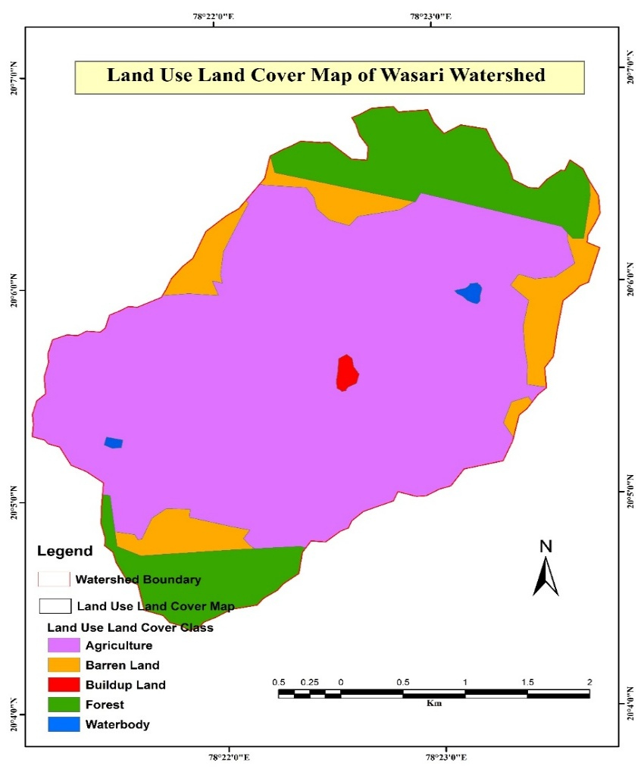
Fig 7. Land use Land cover pattern of the study area (GIS: LULC map)
Geology
The geology map (fig. 8) of the Wasari watershed indicates that the entire area is underlain by basaltic lava flows, typical of the Deccan Trap formation. This uniform geological setting suggests limited structural control on drainage development, with surface runoff primarily governed by topography. The basaltic terrain generally exhibits moderate permeability through joints and fractures, influencing groundwater movement and drainage density. Overall, the homogeneous geology contributes to the dendritic drainage pattern observed in the watershed.

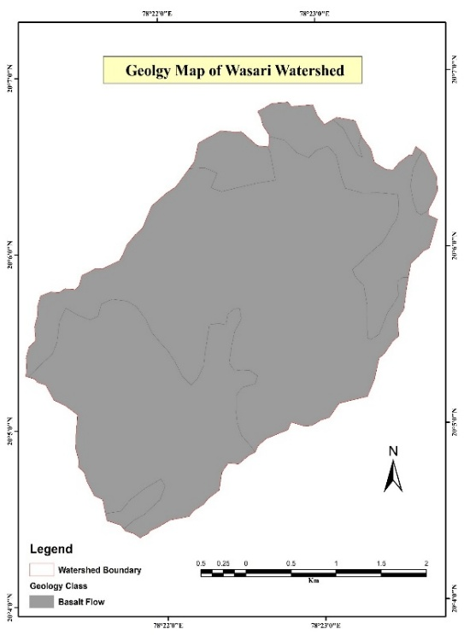
Fig. 8 Geology map
Lineament
The lineament map (fig. 9) of the Sakhara watershed reveals the presence of a prominent linear feature trending in a northeast–southwest direction, indicating structural control such as fractures or faults. This major lineament may influence groundwater movement and subsurface flow paths within the watershed. The limited number of lineaments suggests structural simplicity of the area, consistent with the uniform basaltic geology. Such lineaments play an important role in enhancing secondary porosity and groundwater potential along their zones.
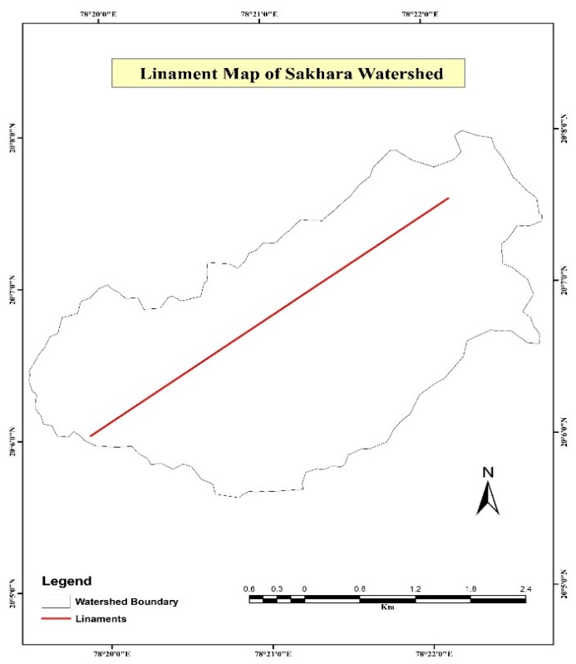
Fig. 9 Lineament map
Slope
The fig 10 shows a slope map of the wasari watershed indicates variation in terrain from nearly level to very steep slopes. The major portion of the watershed is covered by very gentle (0–3%) and gentle (3–8%) slopes, mainly distributed in the central and southern parts, which are suitable for agriculture due to low runoff and higher infiltration. Moderate slopes (8–15% and 15–30%) are observed in the northern and northeastern regions, where the risk of soil erosion is comparatively higher and conservation measures are required. Steep slopes (30–45%) and very steep slopes (above 45%) are limited in extent and are mainly confined to the upper ridges and boundary areas of the watershed. These areas are highly prone to erosion and are less suitable for cultivation. Overall, the watershed is predominantly characterized by gentle slopes with localized steep zones, indicating good potential for watershed-based soil and water conservation planning.

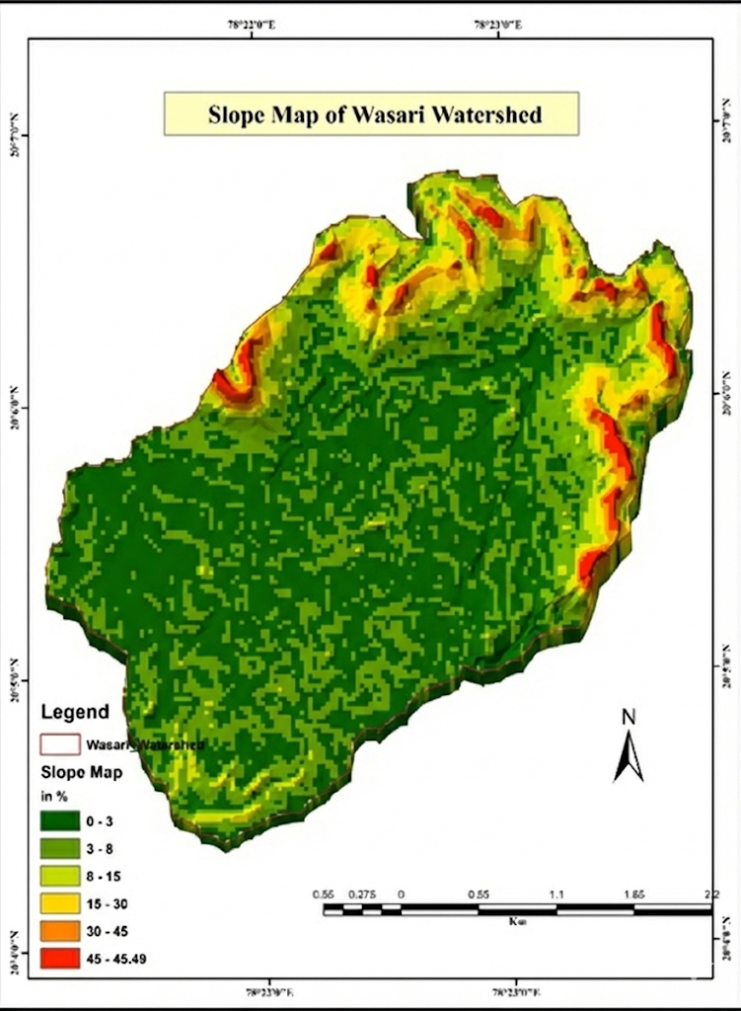
Fig 10 Slope map of the study area
Soil survey study
The soil survey results indicate that the soil pH of the study area ranges from 7.47 to 7.88, showing that the soils are neutral to slightly alkaline in nature. The organic carbon (OC) content varies between 0.36% and 0.84%, suggesting low to moderate organic matter status in the watershed. Textural analysis reveals that sandy clay loam is the dominant soil type, followed by clay, sandy clay, and sandy loam. Gravel content ranges from 8.3% to 27.4%, indicating a moderate presence of coarse fragments in some locations. Sand content varies widely from 10.7% to 55.9%, showing significant variation in soil texture across different sites. Silt content ranges from 7.8% to 22.2%, contributing to differences in soil structure and moisture retention. Clay content ranges from 13.3% to 56.2%, with higher clay percentages observed in several samples, which indicates good water-holding capacity but may also result in poor drainage in certain areas. Table 4, and fig 11 and 12 shows the soil status of the Wasari village.

Table 4 Soil survey of the Wasari village
Sr. No | Lab Ref | Test Report | Gat No | Village | pH | OC (%) | Texture | Gravel (%) | Sand (%) | Silt (%) | Clay (%)
1 | OL/S/24-25/22 | TR/24-25/S/022 | 1 | Wasari | 7.47 | 0.58 | Sandy Clay Loam | 16.7 | 46.1 | 13.7 | 23.5
2 | OL/S/24-25/23 | TR/24-25/S/023 | 68 | Wasari | 7.59 | 0.69 | Sandy Clay Loam | 16.3 | 47.2 | 16.1 | 20.4
3 | OL/S/24-25/24 | TR/24-25/S/024 | 77 | Wasari | 7.51 | 0.84 | Sandy Clay Loam | 11.8 | 55.9 | 12.9 | 19.4
4 | OL/S/24-25/25 | TR/24-25/S/025 | 31 | Wasari | 7.67 | 0.65 | Sandy Clay | 27.4 | 34.1 | 11.6 | 26.9
5 | OL/S/24-25/26 | TR/24-25/S/026 | 132 | Wasari | 7.62 | 0.57 | Sandy Loam | 14.6 | 49.9 | 22.2 | 13.3
6 | OL/S/24-25/27 | TR/24-25/S/027 | 138 | Wasari | 7.57 | 0.71 | Sandy Clay Loam | 21.1 | 50.8 | 7.9 | 20.2
7 | OL/S/24-25/28 | TR/24-25/S/028 | 199/2 | Wasari | 7.58 | 0.64 | Sandy Clay | 16.4 | 38.3 | 7.8 | 37.5
8 | OL/S/24-25/29 | TR/24-25/S/029 | 150 | Wasari | 7.85 | 0.36 | Sandy Clay Loam | 8.3 | 48.9 | 12.2 | 30.6
9 | OL/S/24-25/30 | TR/24-25/S/030 | 73 | Wasari | 7.49 | 0.52 | Sandy Clay Loam | 22.7 | 41.5 | 19.8 | 16.0
10 | OL/S/24-25/31 | TR/24-25/S/031 | 145 | Wasari | 7.88 | 0.46 | Clay | 19.7 | 16.9 | 15.5 | 47.9
11 | OL/S/24-25/32 | TR/24-25/S/032 | 15/1 | Wasari | 7.7 | 0.69 | Clay | 13.0 | 24.0 | 12.0 | 51.0
12 | OL/S/24-25/33 | TR/24-25/S/033 | 191 | Wasari | 7.74 | 0.66 | Clay | 12.3 | 18.0 | 13.5 | 56.2
13 | OL/S/24-25/34 | TR/24-25/S/034 | 178 | Wasari | 7.71 | 0.43 | Clay | 24.9 | 10.7 | 10.7 | 53.7
14 | OL/S/24-25/35 | TR/24-25/S/035 | 81 | Wasari | 7.83 | 0.46 | Clay | 18.5 | 16.3 | 13.4 | 51.8

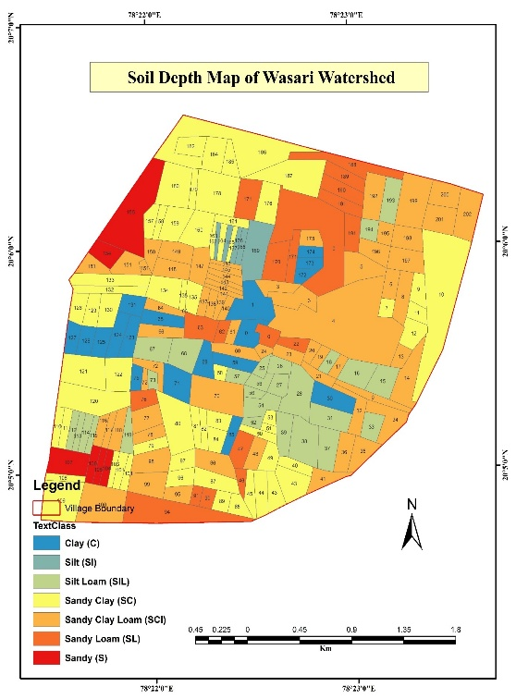 | 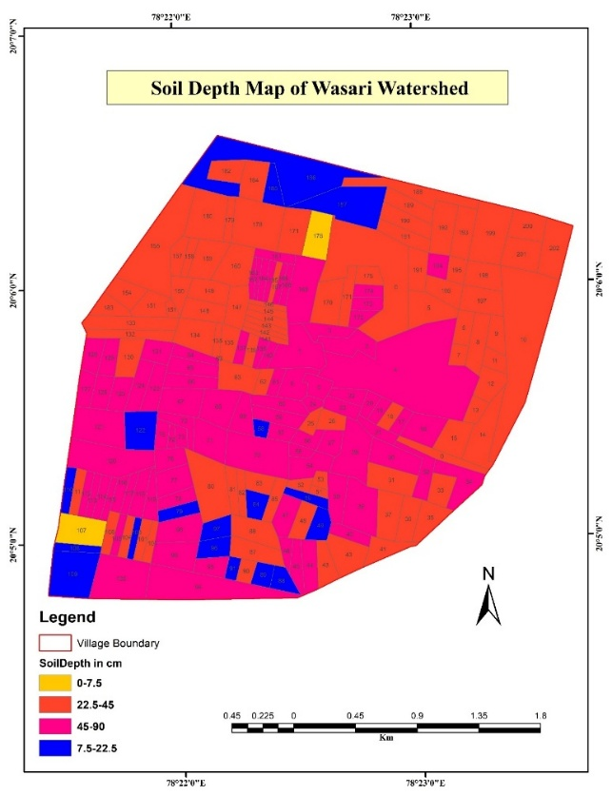
Fig 11 Soil texture map of the study area | Fig 12 soil depth map of study area

Fig. 12 shows that the soil depth in the Wasari watershed varies considerably across the study area. A major portion of the watershed is covered by moderately deep to deep soils (45–90 cm), mainly located in the central and southern parts, which are favorable for crop cultivation due to higher moisture retention capacity. Shallow soils (0–7.5 cm and 7.5–22.5 cm) are found in scattered patches, particularly along the northern and peripheral regions, indicating limited rooting depth and reduced water-holding capacity. Moderately shallow soils (22.5–45 cm) occur in several intermediate zones. Overall, the spatial distribution of soil depth highlights the need for suitable land use planning and soil conservation measures in shallow soil areas.
Land use capability classification
Table 5 presents the weights assigned to different thematic layers used for the preparation of the land use capability classification map through the weighted overlay method. Among all the factors, slope was assigned the highest weight (30%) because it directly controls runoff velocity, soil erosion, and overall land suitability for agriculture. Soil was given 25% weight due to its significant influence on fertility status, moisture retention capacity, and crop productivity. Land Use/Land Cover (20%) was considered important as it reflects the present condition and utilization pattern of land. Topography was assigned 15% weight since it affects drainage characteristics and surface runoff behavior. Geology and lineament density were each assigned 10% weight because they influence soil formation, groundwater occurrence, infiltration, and recharge potential.
Table 5 Weights Assigned for land use capability classification
Sr. No | Thematic Layer | Weight (%) | Justification
1 | Slope | 30 | Controls erosion risk and land suitability
2 | Soil | 25 | Influences fertility and moisture retention
3 | Land Use/Land Cover (LULC) | 20 | Represents existing land condition
4 | Topography | 15 | Affects drainage and runoff pattern
5 | Geology | 10 | Influences soil formation and groundwater
6 | Lineament Density | 10 | Indicates infiltration and recharge potential

Fig. 13 shows the Land Capability Classification of the Wasari watershed, indicating variation in land suitability for agricultural use. A major portion of the watershed falls under Class II, suggesting good agricultural potential with moderate limitations that require proper management practices. Class I areas are observed in scattered patches and represent land with very few limitations, suitable for a wide range of crops. Class III land is present in limited areas and has greater limitations, requiring careful soil and water conservation measures. Small patches of Class IV land are mainly found along the peripheral regions, indicating severe limitations and restricted suitability for cultivation. Overall, the map highlights that most of the watershed is moderately suitable for agriculture with appropriate conservation practices.
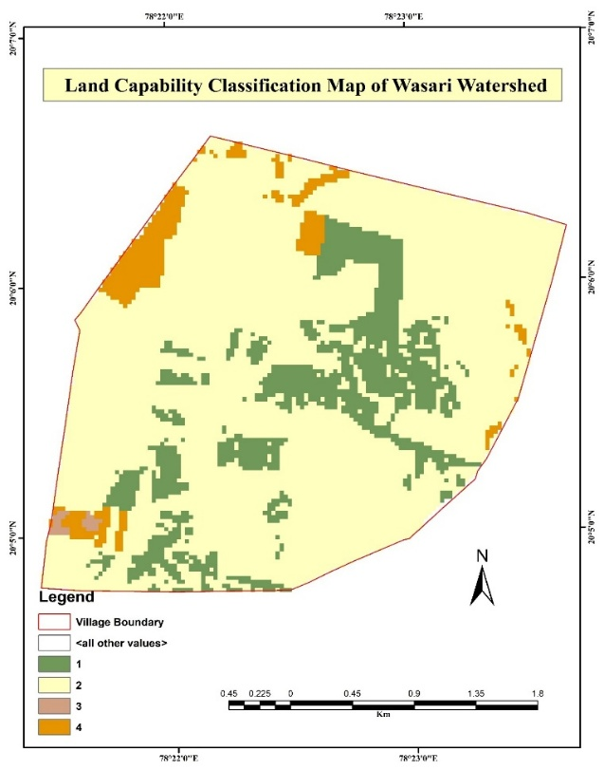
Fig 13 land capability classification map of Wasari watershed

The weighted overlay analysis shows that a major portion of the watershed falls under moderately suitable land capability classes. Areas with gentle slopes, deep soils, and favorable land use are classified under higher capability classes. These regions are suitable for agricultural activities with proper management practices. Areas with moderate slopes and medium soil depth fall under moderate capability classes and require soil and water conservation measures. Limited areas with steep slopes, shallow soils, and less favorable geological conditions are classified under lower capability classes. These lands have severe limitations and are less suitable for cultivation. Overall, the analysis indicates that slope and soil are the most influential factors controlling land capability in the watershed.
Suitable Sites for Soil and Water Conservation Measures
Based on the weighted overlay analysis and land use capability classification, suitable sites for soil and water conservation measures were identified in the Wasari watershed. The analysis shows that slope and soil are the most influential factors controlling site suitability, as they were assigned the highest weights. Areas classified under higher capability classes (Class I and II) are mainly located on gentle slopes with favorable soil conditions and are suitable for agricultural land treatments such as contour farming, graded bunding, and farm ponds. These areas require minimum structural intervention but benefit from improved moisture conservation practices.
Moderate capability areas (Class III) are generally associated with moderate slopes and medium soil depth, where erosion risk is higher. In these zones, measures such as contour trenches, vegetative barriers, and nala bunds are recommended to reduce runoff and soil loss. Lower capability areas (Class IV), found on steeper slopes and shallow soils, require intensive structural and vegetative measures, including continuous contour trenches, afforestation, and check dams. Drainage line treatments are mainly suggested along natural streams and runoff channels following the ridge-to-valley approach to enhance groundwater recharge and reduce sediment transport. Overall, the results indicate that integrated planning based on weighted thematic analysis provides a scientific basis for prioritizing soil and water conservation measures in the watershed.
Land area treatment
Considering the land capability classification, slope, soil characteristics, and criteria suggested by various researchers, suitable land area treatments were proposed for the Wasari watershed following the ridge-to-valley approach. The selection of treatment measures was based on the severity of slope, soil depth, and erosion risk in different capability classes. Upper ridge areas with steeper slopes and shallow soils were prioritized for vegetative and structural measures such as continuous contour trenches and afforestation to reduce runoff and soil loss. Middle slope areas with moderate capability were suggested for contour bunding, graded bunds, and vegetative barriers to improve moisture conservation. Lower valley areas with gentle slopes and deeper soils were recommended for agricultural land treatments such as field bunding and farm ponds. The following table no 6 presents the proposed land area treatment measures for the Wasari watershed.
Table 6 Proposed land area treatment
Area Treatment | Area (Ha) | Length | Section  (Depth) | Quantity (Volumn/Nos./Ha.)
CC | 678.07
Farm Bunding |  | 57698.78 | 0.60 | 34619.27
Repair of Farm Bund |  | 2167.84 | 0.30 | 650.35
Stone Outley |  | 434.00 | 1.00 | 434.00
Gabion SO |  | 8.00 | 1.00 | 8.00
SEEDING | 678.07 |  |  | 678.07
Subtotal of CC | 678.07 | 60308.62 |  | 36389.69
Afforestation | 9.23
Water Absorption Trench |  | 791.42 | 1.00 | 791.42
Plantation |  | 395.00 | 1.00 | 395.00
SEEDING | 9.23 |  |  | 9.23
Subtotal of AF | 9 | 1186 |  | 1196
TOTAL | 687.30 | 61495 |  | 37585

Drainage line treatment
The proposed drainage line treatments for the Wasari watershed were planned based on stream order, runoff intensity, slope conditions, and erosion severity following the ridge-to-valley approach. Table 7 shows that a total of 17 loose boulder structures (8 m) are proposed, indicating their suitability in upper and middle reaches where runoff is moderate and gully formation is at an early stage. These structures help in reducing flow velocity and promoting sediment deposition.
Gully plugs of 5 m (2 numbers) and 6 m (11 numbers) are suggested in small drainage channels to control active gully erosion and stabilize stream banks. Gabion structures of varying sizes (6 m, 8 m, and 10 m) are proposed in limited numbers, mainly in sections experiencing higher discharge and deeper channel erosion. Core wall gabion structures (8 m and 10 m) are recommended at critical locations where stronger structural support is required to withstand high runoff during peak rainfall events. Additionally, two desilting cement nala bunds are proposed in lower reaches to enhance water storage capacity, reduce sediment transport, and improve groundwater recharge. The drainage line treatment plan emphasizes erosion control, runoff management, and groundwater recharge. The combination of vegetative and structural measures ensures stabilization of drainage channels and contributes to long-term watershed sustainability under changing climatic conditions. The figure 14 shows the proposed drainage line treatment for Wasari watershed.
Table 7 Proposed drainage area treatment
Drainage line Treatment | Quantity (Volumn/Nos./Ha.)
Loose Boulder Structure 8m | 17
Gulley Plug 5m | 2
Gulley Plug 6m | 11
Gabion structure 6m | 1
Gabion structure 8m | 1
Gabion structure 10m | 2
Core Wall Gabion structure 8m | 1
Core Wall Gabion structure 10m | 1
Desilting Cement Nala Bund | 2

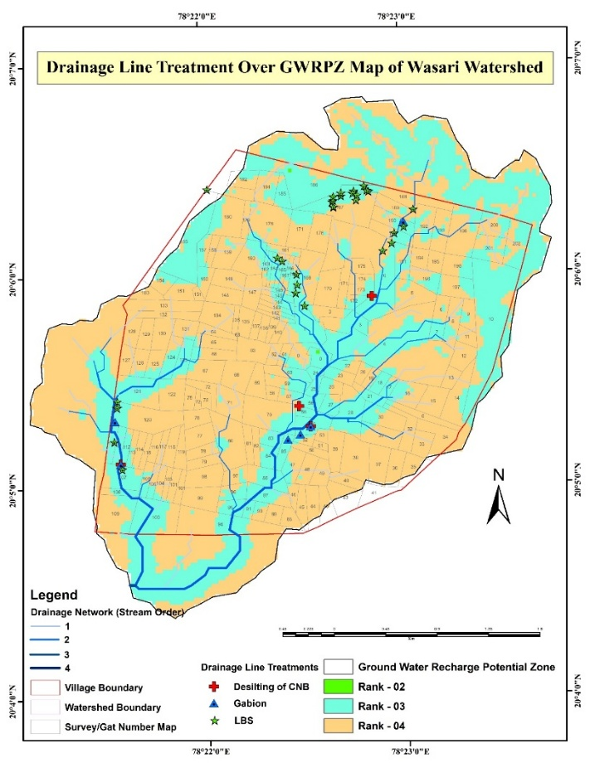
Fig 14 Drainage line treatment of Wasari watershed

Conclusion
The present study demonstrated the application of Remote Sensing and GIS techniques for watershed characterization and soil and water conservation planning in the Wasari watershed of Yavatmal district. The morphometric and topographic analysis revealed moderate relief with elevation ranging from 207 m to 323 m above mean sea level. The drainage network consists mainly of first- and second-order streams with a few third-order segments, indicating a moderately developed drainage system controlled primarily by topography.
The integration of the KOBO tool with GIS-based analysis improved the accuracy and reliability of field data collection for watershed intervention planning. Its GPS-enabled geo-tagging and real-time entry of technical and socio-economic information ensured precise location mapping and more accurate estimates of structural dimensions and costs. The use of the KOBO tool strengthened participatory planning, transparency, and effective implementation of soil and water conservation measures in the watershed.
Land Use/Land Cover analysis indicated that agriculture is the dominant land use. At the same time, forest areas are confined to higher elevations and play a significant role in erosion control and groundwater recharge. The geology of the area is predominantly basaltic (Deccan Traps), which contributes to a dendritic drainage pattern and moderate groundwater potential through fractures and joints. Soil analysis showed neutral to slightly alkaline pH, low to moderate organic carbon content, and dominance of sandy clay loam and clay textures with variable soil depth across the watershed.
The land capability classification prepared using the weighted overlay method identified slope and soil as the most influential factors controlling land suitability. A significant portion of the watershed falls under Class II, indicating moderate suitability for agriculture with appropriate management practices. The soil and water conservation measures were proposed using the ridge-to-valley approach. Land area and drainage line treatment, such as contour bunding, farm bunding, afforestation, water-absorption trenches, loose-boulder structures, gully plugs, gabion structures, and cement nala bunds, were recommended to control erosion, reduce runoff, and enhance groundwater recharge. The study provides a scientific basis for integrated watershed management and prioritization of conservation measures under changing climatic conditions.

COMPETING INTERESTS DISCLAIMER:
Authors have declared that they have no known competing financial interests OR non-financial interests OR personal relationships that could have appeared to influence the work reported in this paper.

References

Badhe, Y., R. Medhe and T. Shelar. 2019. Site suitability analysis for water conservation using AHP and GIS techniques: a case study of upper Sina River catchment, Ahmednagar (India). Hydro spatial Analysis, 3(2):49-59.
Bhan, S., 2013. Land degradation and integrated watershed management in India. Int. Soil Water Conserv. Res. 1, 49–57. https://doi.org/10.1016/S2095-6339(15)30049-6
D. D. More, Dr. S. B. Nadgude and S. A. Gade. 2023. Assessment of geomorphological characteristics of Mula-Pravara River basin using geospatial technology. The Pharma innovation. 2023: SP-12(7).
Durbude, D.G., Venkatesh, B., 2004. SITE SUITABILITY ANALYSIS FOR SOIL AND WATER CONSERVATION STRUCTURES. J. Indian Soc. Remote Sens. 32, 399–405.
Gadakh, S., S. S. Wandre, M. A. Patil and P. Dalavi. 2023. Remote sensing and GIS-based site selection for effective soil and water conservation measures in the Warana river basin. The Pharma Innovation Journal 2023. 12(6): 5220-5232.
J P Singh, D.S., P K Litoria, 2009. Selection of Suitable Sites for Water Harvesting Structures in Soankhad Watershed , Punjab using Remote Sensing and Geographical Information System ( RS & GIS ) Approach- A Case Study. J. Indian Soc. Remote Sens 37, 21–35.
Kadam, A.K., Kale, S.S., Sankhua, B.N.U.R.N., 2022. Assessing site suitability potential for soil and water conservation structures by using modified micro ‑ watershed prioritization method : geomorphometric and geomatic approach. Environ. Dev. Sustain. 24, 4659–4683. https://doi.org/10.1007/s10668-021-01627-2
Kolekar, S., Chauhan, S., Raavi, H., Gupta, D., 2017. Site Selection of Water Conservation Measures by Using RS and GIS : A Review 10, 805–813.
Manivannan, S., Thilagam, V.K., Khola, O.P.S., 2017. Soil and water conservation in India: Strategies and research challenges. J. Soil Water Conserv. 16, 312. https://doi.org/10.5958/2455-7145.2017.00046.7
Pandey, B.K., D. Khare, A. Kawasaki and T.W. Meshesha.2021. Integrated approach to simulate hydrological responses to land use dynamics and climate change scenarios employing scoring method in upper Narmada basin, India. Journal of Hydrology. 598 (2021) 126429. https://doi.org/10.1016/j.jhydrol.2021.126429
Ramakrishnan, D., Durga Rao, K. H. V. and Tiwari, K.C. (2008). Delineation of potential sites for water harvesting structures through remote sensing and GIS techniques: a case study of Kali watershed, Gujarat, India. Geocarto Intern., 23:2, 95-108.
Regulwar, D.G., Ambhore, R.M., 2017. Site suitability analysis of soil and water conservation structures in watershed using GIS 187–192.
Rejani, R., Rao, K. V, Osman, M., Chary, G.R., Reddy, K.S., 2015. Location specific insitu soil and water conservation interventions for sustainable management of drylands 17, 55–60.
Saha, A., M. Ghosh and S. C. Pal.2021. Identifying suitable sites for rainwater harvesting structures using runoff model (SCS-CN), remote sensing and GIS techniques in Upper Kangsabati Watershed, West Bengal, India. Book Chapter in Geostatistics and Geospatial Technologies 54 for Groundwater Resources in India:119-150. http://dx.doi.org/10.1007/978-3-030-62397-5_7
Saruk, D., 2018. Earthen nala bund as a water conservation structure 20–25.
Syst, E., Attribution, C.C., Weerasinghe, H., 2011. Water harvest- and storage- location assessment model using GIS and remote sensing. Hydrol. Earth Syst. Sci 3353–3381. https://doi.org/10.5194/hessd-8-3353-2011
Varade, A.M., Khare, Y.D., Mondal, N.C., 2013. Identification of Water Conservation Sites in a Watershed ( WRJ-2 ) of Nagpur District , Maharashtra using Geographical Information System ( GIS ) Technique 41, 619–630. https://doi.org/10.1007/s12524-012-0232-5

