Study on Constant Pressure Characteristics of Pump Group for Hydraulic Hoist of Plane Lifting Gate

Abstract: The hydraulic hoist for plane lifting gates is a specialized lifting machinery for steel gates in water conservancy and hydropower projects, with its core being a parallel constant pressure variable displacement piston pump group. A constant pressure variable pump is a type of hydraulic pump that maintains a constant output pressure by regulating its flow. When three constant pressure variable displacement piston pumps are connected in parallel to form a pump group, the pressure setting of the constant pressure valves in each pump may be inconsistent. Although the error is minimal, it can still affect the dynamic response of the parallel pump group. This study takes the parallel constant pressure variable pump group of a hydraulic hoist for plane lifting gates in a large flood control wall channel gate project as the research object. It conducts a theoretical analysis of the working principle of constant pressure variable pumps, establishes an AMESim software simulation model for the parallel constant pressure variable pump group of the gate hydraulic hoist, and analyzes the influence of different spring pre-tightening forces of the constant pressure valve on the dynamic response of the parallel pump group.

Keywords: Parallel pump group; Constant pressure variable; System response; Dynamic characteristics; AMESim simulation

Chinese Library Classification: TH137 Document Identification Code: A

Introduction
Heavy-duty gates are indispensable equipment in projects such as river regulation, urban flood disaster response, irrigation, water storage, and power generation. The opening and closing of these heavy gates rely on specialized hoisting equipment. Hydraulic hoists serve as the lifting machinery for heavy gates [1]. The operating principle of a hydraulic hoist is as follows: when the gate needs to be opened, the hydraulic pump is started to output pressurized oil. This oil passes through suction filters, pressure control valve groups, and oil delivery pipelines, entering the lower chambers of the oil cylinders on both sides of the gate. This causes the piston rod to rise, thereby lifting the gate. Simultaneously, the oil from the upper chambers of the cylinders returns to the hydraulic tank. When closing the gate, the hydraulic oil pump is started to generate pressurized oil. Valves connected to the pipeline of the cylinder's lower chamber are opened, allowing oil from the lower chamber to flow into the upper chamber via the pipeline, while pressurized oil is supplemented from the tank to the upper chamber, achieving gate closure [2].

The core component of the hydraulic gate hoist is the parallel constant pressure variable displacement piston pump group. The piston pump is a key element in the hydraulic system, responsible for providing high pressure, precise flow control, and conveying various media. It converts the mechanical energy generated by electricity into hydraulic energy for the hoist's operation, supplying power to the hydraulic system [3]. Piston pumps offer advantages such as high-pressure output, precise flow control, adaptability to high-viscosity media, corrosion resistance, high-temperature performance, reliability, and long service life, making them widely used in water conservancy, hydropower, industry, agriculture, and other fields [4].
A constant pressure variable pump is a type of piston pump that maintains a constant output pressure by adjusting its flow rate [5]. The pressure of a constant pressure variable displacement piston pump has a set value. When the pressure is less than this set value, it functions as a fixed displacement pump. This pressure value is determined by the spring of the constant pressure valve. When the pressure reaches the set value and remains within the adjustment range, the pump regulates its flow to keep the output pressure constant. Its flow variable mechanism adjusts the pump's output flow based on the difference between the pump's outlet pressure and the set pressure value, thereby maintaining a constant outlet pressure [6].
Constant pressure variable displacement piston pumps serve different functions:
（1）They play a pressure-maintaining role in the hydraulic system; leakage flow in the system is compensated by the constant pressure pump's flow.
（2）They exhibit good dynamic response characteristics and are used as constant pressure power sources in electro-hydraulic servo systems.
（3）They are used in hydraulic throttling speed control systems, reducing power consumption and heat generation in hydraulic system applications.
A parallel pump group refers to connecting the output ports of all piston pumps into a single outlet, serving as the overall output port [7]. When multiple pumps operate in parallel, the flow rate of the pumps is determined by the workload and operating conditions of the hydraulic system. The pump group not only ensures efficient operation even at speeds below the pump's rated speed, significantly improving the efficiency of the hydraulic system and reducing the overall system cost, but also lowers energy consumption, improves energy utilization, and makes an important contribution to energy-saving operation of the hydraulic system [8].
When multiple constant pressure variable displacement piston pumps are connected in parallel to form a pump group, the setting of the constant pressure valves in each pump may be inconsistent. Even if the setting error for each valve is small, it can still affect the dynamic response of the parallel piston pump group. This paper takes the parallel constant pressure variable pump group of a gate hydraulic hoist as the research object, conducts a theoretical analysis of the working principle of constant pressure variable pumps, builds an AMESim simulation model for the parallel constant pressure variable pump group of the gate hydraulic hoist, and analyzes the influence of different spring pre-tightening forces of the constant pressure valve on the dynamic response of the parallel pump group.
1 Working Principle of Hydraulic Hoist for Plane Lifting Gate
A certain flood control wall channel gate project on a river dike features three hidden plane lifting gates. Each gate is controlled by two sets of hydraulic hoists, totaling six sets of hydraulic hoists for the three gates. All gates share one common hydraulic pump station, which simultaneously controls the opening or closing of the three gates. The hydraulic pump group consists of three variable displacement piston pumps working together with electric motor sets. Within the full stroke range of the gate, the synchronous operation accuracy of the six oil cylinders does not exceed 5mm. The rated working pressure of the hydraulic system is 17.8 MPa, the maximum output flow is 800 L/min, and the gate opening/closing speed is 0.7 m/min. The working principle of the hydraulic system for one gate's hydraulic hoist is shown in Figure 1.
The control circuit of this hydraulic system uses proportional directional valves, counterbalance valves, and cartridge relief valves for coordinated control, resulting in a simple and reliable structure that is easy to install and maintain. During the gate opening or closing process, cylinder synchronization is achieved through the proportional directional valves. The hydraulic system is equipped with comprehensive monitoring and protection components. A pressure sensor capable of outputting one 4-20mA analog signal and two switching signals is installed on the pump station's pressure oil pipeline for system pressure monitoring, overpressure protection, and under-voltage protection.
Figure 1 Working principle of the hydraulic hoist of the plane lifting gate
The hydraulic pump group for the gate hoist uses constant pressure variable displacement piston pumps, arranged as three variable pump-motor units working simultaneously. The pressure oil from the three groups is combined and then output to the various control valves. The working principle of a constant pressure variable pump is shown in Figure 2. A constant pressure variable pump mainly consists of a constant pressure control valve, a variable mechanism, and the piston pump.
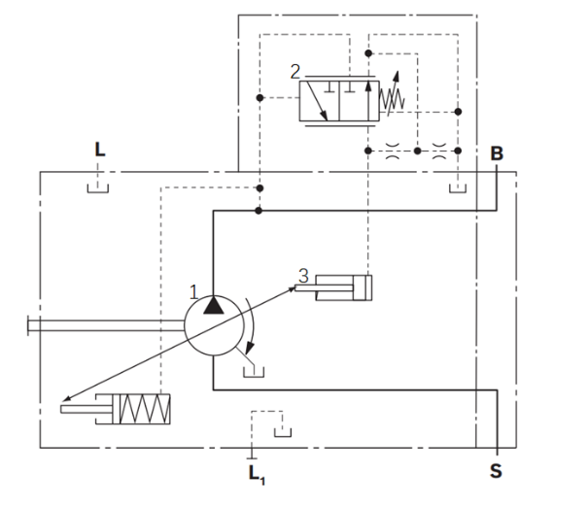
Figure 2 Working principle diagram of constant pressure variable pump
1-Piston pump; 2-Constant pressure control valve; 3-Variable mechanism
In the system, a spring pre-compression is applied to the constant pressure valve 2, resulting in a pre-compression force P_{n}​. The pump's output pressure isP_{b}​, and the output flow is Q. When P_{b}<P_{n}​, the constant pressure valve moves left under the force P_{n}​, connecting the left port of the constant pressure valve. The oil at the piston head flows back to the tank through the constant pressure valve, and the variable piston moves to the right end of the variable cylinder. At this point, the swashplate angle is at its maximum, and the pump displacement is maximum. IfP_{b}​ remains less than P_{n}​, the pump stays at maximum displacement, operating as a fixed displacement pump with maximum displacement. As the swashplate angle increases, the system output pressure P_{b}​ increases. If P_{b}>P_{n}​, the spool of the constant pressure valve moves right, connecting the left port. The flow output by the pump enters the right end of the variable cylinder through the constant pressure valve. Due to the differential connection of the variable cylinder, the oil returning from the left side also enters the right side. Therefore, the variable cylinder piston moves left, simultaneously reducing the swashplate angle of the piston pump. The displacement decreases, and the hydraulic system pressure drops. When the pressure drops to P_{b}-P_{n}​, the variable cylinder stops moving, and the system pressure becomes constant. The flow rate varies according to the external load demand. When the load flow is zero, the pump displacement is essentially zero, but the pump's working pressure remains largely unchanged.
2 Digital Modeling of Hydraulic Hoist Pump Group
AMESim is a multi-domain system modeling and simulation software developed by LMS, featuring extensive model and component libraries. It offers advantages such as multi-domain modeling, high performance, flexibility, and ease of use. AMESim is widely applied in fields like automotive engineering, energy systems, aerospace engineering, mechanical systems, fluid dynamics, and control systems. Its multi-domain modeling capability and rich application libraries make it a powerful tool for engineers in system-level modeling and simulation.
The parallel pump group of the gate hydraulic hoist consists of three constant pressure variable pumps. Using AMESim software to model and simulate this parallel pump group can more effectively investigate their dynamic characteristics.
2.1 Modeling of Constant Pressure Variable Displacement Piston Pump
The constant pressure variable displacement piston pump selected is the Vickers PVB pump. Its main technical parameters are shown in Table 1.

Table 1 Main technical parameters of piston pump
Plunger Diameter/mm | Plunger Radius of Rotation /mm | Motor Speed/r·min⁻¹ | Plunger Diameter Clearance /mm | Cylinder Block Inertia /kg·m²
17 | 28 | 1500 | 0.1 | 0.001
Based on the above technical parameters, the digital simulation models for the piston pump, pressure control valve, and variable mechanism were constructed using the AMESim HCD library as follows:
2.1.1 Piston Pump Submodel
Conducting simulation research on a piston pump requires building an accurate model and considering relevant details as much as possible. This paper uses the HCDAXPP0 submodel from the AMESim HCD library. This submodel overcomes issues in traditional modeling methods, such as unintuitive parameter settings, indirect leakage configuration, and complex parameter modification. The HCDAXPP0 submodel from the AMESim HCD library is shown in Figure 3.
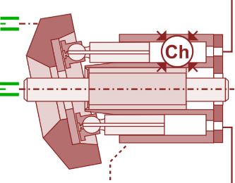
Figure 3 HCDAXPP0 submodel
After building the overall piston pump model, parameters for the AXPP0 submodel need to be set. This primarily involves setting the mechanical parameters of the piston pump, including: number of pistons, piston diameter, initial swashplate angle, swashplate axis offset, piston pitch circle diameter, piston length, and contact length between piston and sleeve.
2.1.2 Pressure Control Valve Submodel
Based on the structure and parameters of the pressure control valve, a corresponding AMESim simulation model was built, as shown in Figure 4.
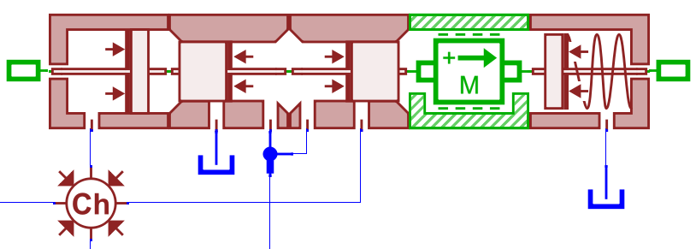
Figure 4 Simulation model of constant pressure valve

2.1.3 Variable Mechanism Submodel
The variable control mechanism of the piston pump mainly consists of a control piston and a return spring. When building the simulation model for the piston pump variable control mechanism, the displacement of the control piston is converted into an angle signal via a function expression submodel from the Signal Library, which is then passed to the pump's swashplate. As the swashplate angle changes, the displacement of the control piston is simulated by setting the maximum and minimum displacement of a mass block. The established simulation model is shown in Figure 5.
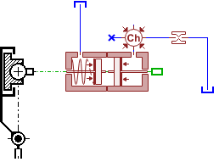
Figure 5 Simulation model of the variable control mechanism of the piston pump
2.1.4 Constant Pressure Variable Displacement Piston Pump Model
In AMESim, the piston pump submodel, pressure control valve, and variable mechanism simulation models were combined to form the constant pressure variable displacement piston pump simulation model, as shown in Figure 6. In this model, the flow required by the load is simulated by changing the opening of a flow control valve, while the pressure required by the load is simulated using a proportional relief valve.
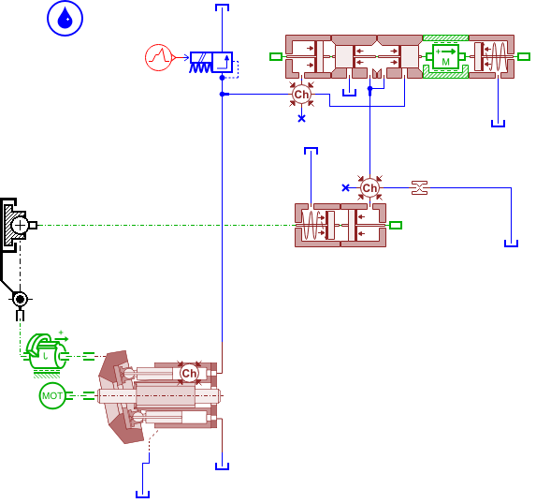
Figure 6 Simulation model of parallel pump set of gate hydraulic hoist

2.2 Simulation Model Experimental Validation
This test uses a certain model of hydraulic pump test bench. The schematic diagram of the test is shown in Figure 7. In this test, the outlet of the piston pump is directly connected to the control piston, and the resistance of this pipeline can be neglected. The pump outlet is also connected to a 2-position, 3-way valve. During the test, moving the valve from one position to another induces a dynamic response in the piston pump. A pressure sensor is connected at the pump outlet to measure the pressure change at the pump outlet.
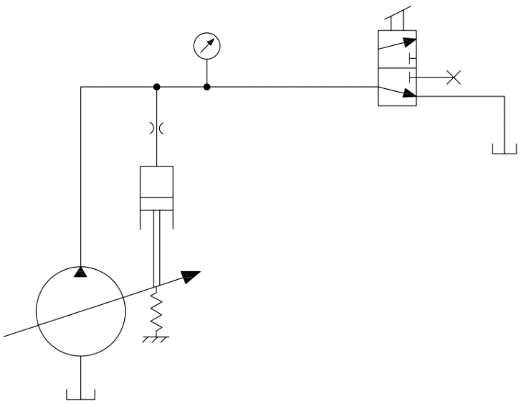
Figure 7 Hydraulic pump test bench test schema
The test utilized a data acquisition card from National Instruments, primarily used for monitoring hydraulic control systems. LabVIEW software was used as the testing tool. LabVIEW is software focused on graphical programming, widely used in both industry and academia as a common instrument control software. During the test, care must be taken to ensure the horizontal installation of the piston pump, guaranteeing that the axis is not tilted.
To verify the accuracy of the simulation model, the valve was moved rapidly during the test to measure the relationship between pump outlet pressure and time. A step signal was applied to the constant pressure variable piston pump simulation model to simulate two conditions: the valve changing from closed to open and from open to closed.
With the valve initially set in the closed position, a step signal was generated approximately 0.5 seconds after the test started, with a control signal magnitude of 10 mA. Both the test and simulation were conducted under these conditions, and the output pressure of the piston pump was obtained, as shown in Figure 8.
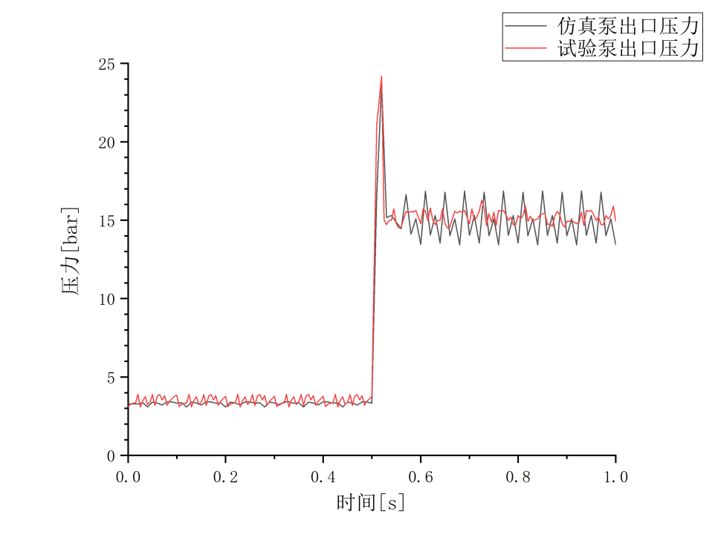
Figure 8 The valve is opened to closed

With the valve initially set in the open position, the same procedure was followed. Both the test and simulation were conducted, and the output pressure of the piston pump was obtained, as shown in Figure 9.
Comparing the test curves and simulation curves in Figures 8 and 9, it can be seen that before the valve received the step signal, the system was in a standby state, with its output displacement being very small under the action of the constant pressure valve. In both operating conditions (valve opening to closing and valve closing to opening), the dynamic response of the pump outlet pressure in the simulation and test states is basically consistent and accurately reflects the control characteristics of the constant pressure variable piston pump. This indicates that the established piston pump simulation model is relatively accurate.
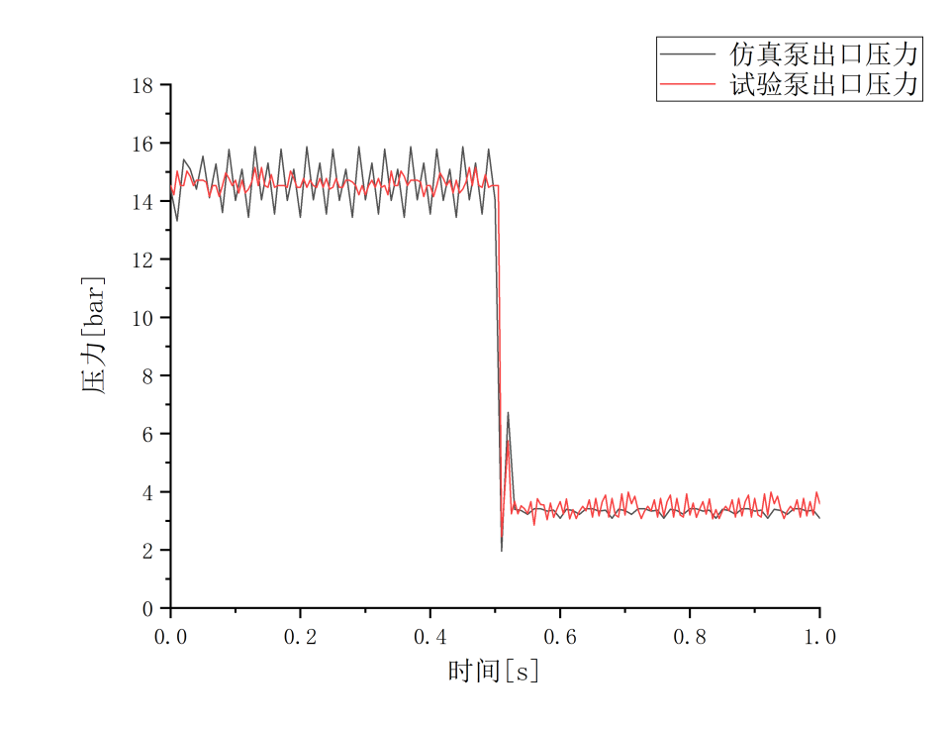
Figure 9 The valve goes from closing to opening
2.3 Hydraulic Pump Group Digital Model
Three constant pressure variable pumps were combined to form the parallel pump group model for the gate hydraulic hoist, as shown in Figure 10.
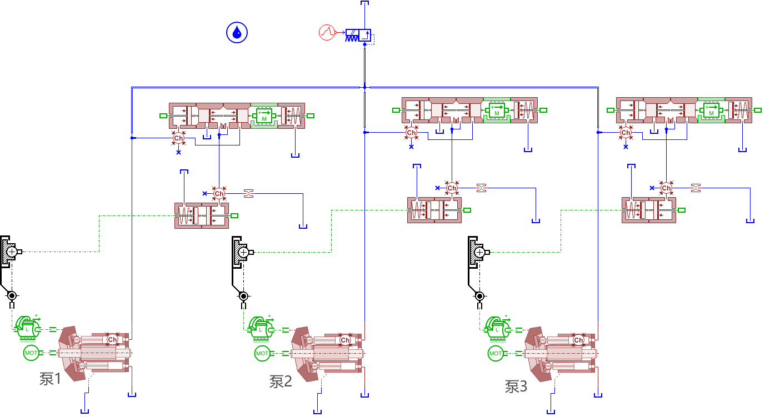
Figure 10 Simulation model of parallel pump set of gate hydraulic hoist

3 Dynamic Characteristic Analysis of Hydraulic Pump Group
The dynamic process of a hydraulic system refers to the process where, due to external influences, the equilibrium state of the system changes, oscillating from the original working equilibrium state until reaching another new working equilibrium state. During this process of changing equilibrium states, the variation of various parameters within the hydraulic system can be observed, and the characteristics of these parameters during this change can reflect the different dynamic properties of the system.
In the simulation model, the spring pre-tightening forces of the constant pressure valves for pumps 1, 2, and 3 were all set to 50 N. A step signal was applied to the proportional relief valve to simulate the process of changing load flow demand, as shown in Figure 11.
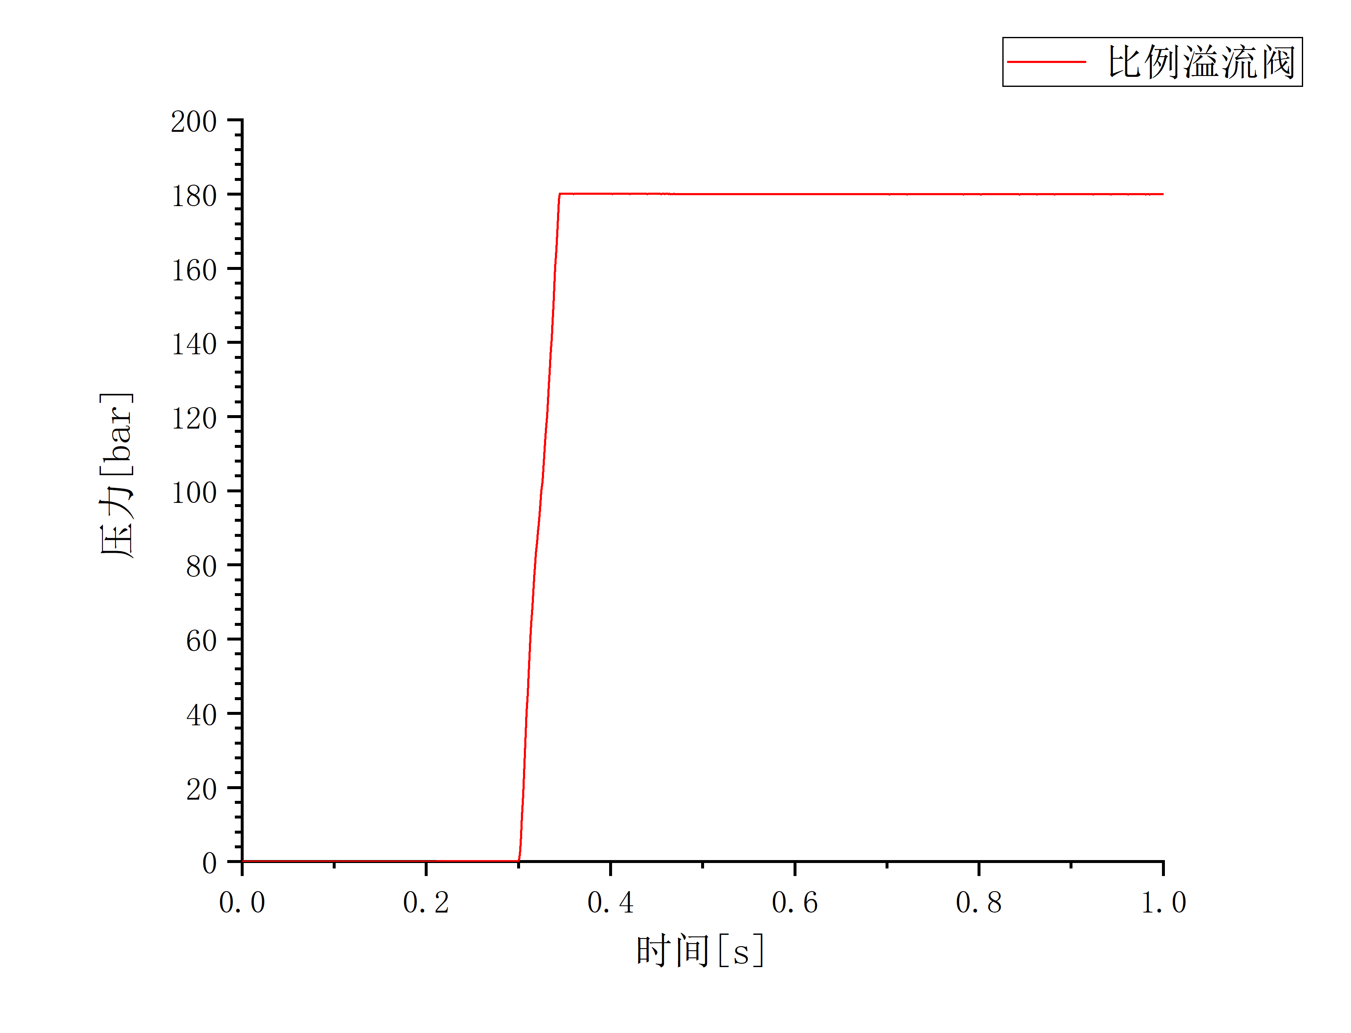
Figure 11 Proportional relief valve step signal

The output flow curve of the parallel pump group obtained from the simulation is shown in Figure 12. As illustrated, when three constant pressure variable pumps are connected in parallel and the spring pre-tightening forces of their constant pressure valves are set identically, the final output flow rates of the three pumps are the same.
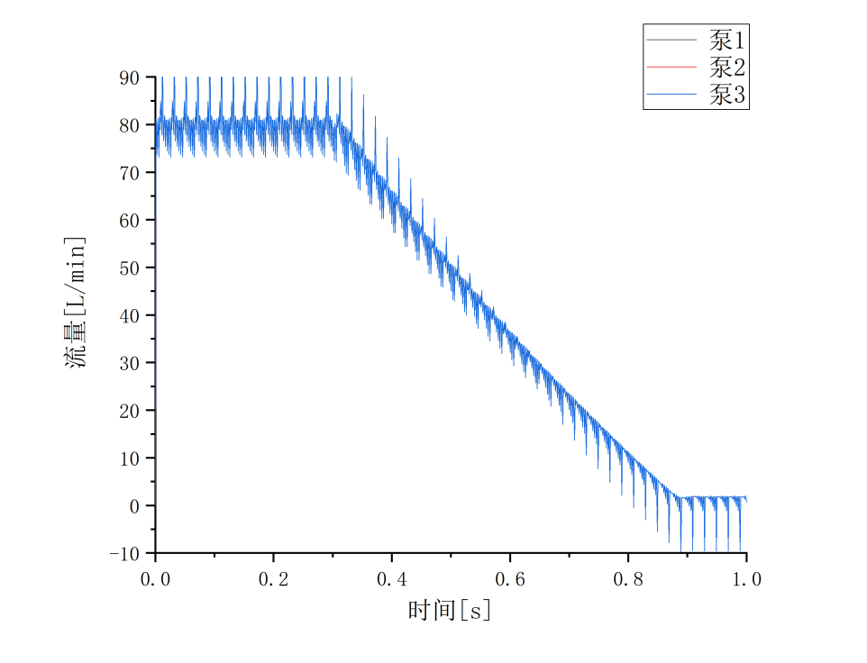
Figure 12 Parallel pump set output flow
In actual work processes, operational errors can lead to inaccuracies in setting the spring pre-tightening forces of the three pumps' constant pressure valves. Suppose in the simulation model, the spring pre-tightening forces for pumps 1, 2, and 3 are set to 45 N, 50 N, and 55 N, respectively. The resulting output flow curves of the parallel pump group from the simulation are shown in Figure 13. Due to the inaccurate setting of the constant pressure valve spring pre-tightening forces, although the differences are relatively small, the resulting differences in pump output flow are significant. The figure shows that when settings are inaccurate, the pump with a slightly smaller pre-tightening force responds faster after a load step, its swashplate angle decreases more rapidly, and its output flow decreases faster. Conversely, the pump with a slightly larger spring pre-tightening force does not respond after the load step; its swashplate angle remains unchanged, and its output flow stays at the maximum value. This is because the larger spring pre-tightening force means the hydraulic pressure generated by the pump output flow is insufficient to activate the constant pressure valve.
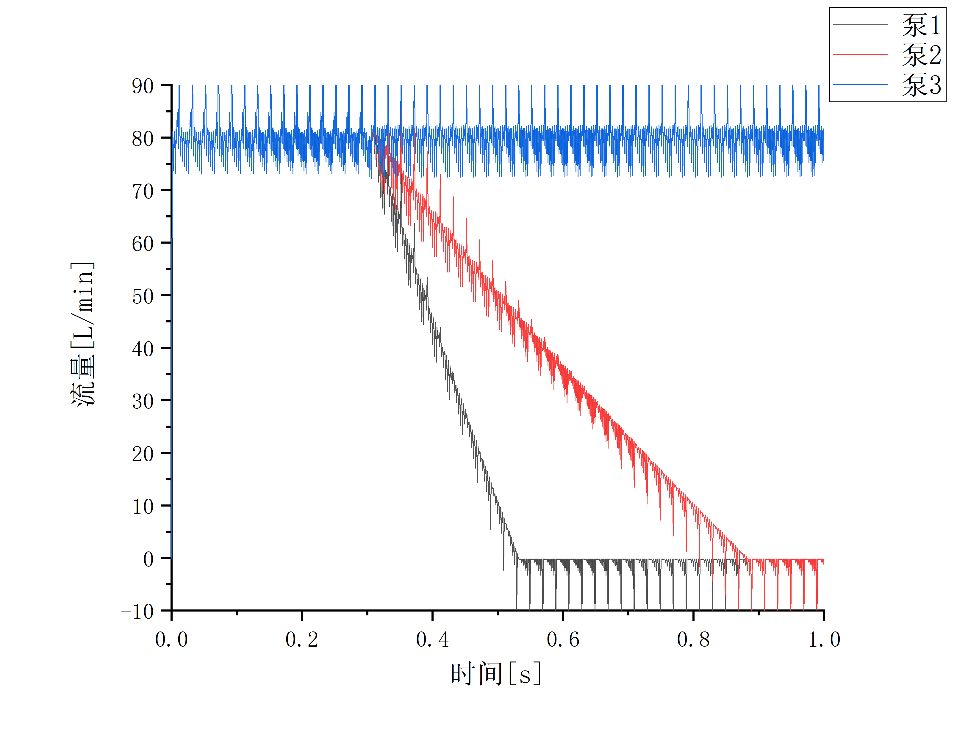
Figure 13 Output flow curve of a parallel pump set
4 Conclusion
This paper takes the parallel constant pressure variable pump group of a hydraulic hoist for plane lifting gates in a large flood control wall channel gate project as the research object. It theoretically analyzes the working principle of constant pressure variable pumps, establishes an AMESim simulation model for the parallel constant pressure variable pump group of the gate hydraulic hoist, and investigates the impact of slight, inconsistent settings among the constant pressure valves of the three pumps on the dynamic response of the parallel pump group. Through dynamic response analysis, it was found that when there is an error in the constant pressure valve settings of the three pumps, a spring pre-tightening force set too small causes the constant pressure valve response speed to increase, while a spring pre-tightening force set too large results in no response after a load step.

References:
- Li Jun, Yang Shangping, Guan Hongyan. Analysis of Typical Hydraulic Hoist Hydraulic Systems [J]. Machine Tool & Hydraulics, 2008, (05): 96-98.

- Yang Huayong, Zhang Bin, Xu Bing. Technological Development of Axial Piston Pump/Motor [J]. Journal of Mechanical Engineering, 2008, 44(10): 1-8.

- Yang Hengle, Guo Jianbin. Fault Diagnosis Method for Hydraulic Hoist Based on Fault Tree and Bayesian Network [J]. Chinese Hydraulics & Pneumatics, 2015, (01): 44-48.

- Luo Wei, Zou Dapeng, Xiao Tigong, et al. Modeling and Simulation Analysis of Constant Pressure Variable Piston Pump Based on AMESim [J]. Machine Tool & Hydraulics, 2017, 45(05): 100-103.

- Tian Yong, Shen Zuyi. Synchronization Method and Strategy for Hydraulic Hoist of Double-Hoist-Point Gate [J]. Chinese Hydraulics & Pneumatics, 2004, (05): 59-61.

- Zhang Baokun, Zhao Jianjun, Liu Wei. Research on Optimal Design of Aircraft Hydraulic Load Power System [J]. Computer Simulation, 2017, 34(05): 82-87.

- Zhan Lei. Design and Research of a New Type Double-Hoist-Point Hydraulic Hoist [D]. Kunming University of Science and Technology, 2011.

- Xiong Shaojun, Zhou Peng, Li Jichuan, et al. Practice and Analysis of Synchronous Control for Hydraulic Hoist of Hydraulic Gates [J]. Hydraulics Pneumatics & Seals, 2007, (03): 17-20.

