Short research Article

Artificial Intelligence-Driven Recruitment as Business Capability: Evidence on Hiring Accuracy from Firms Operating in Dar es Salaam

ABSTRACT
Aims: The aims of the study were to determine whether the use of recruitment systems that employed AI technology was just for the purpose of improving efficiency or if it could be used as an enabler of strategic business. This was to be done by improving the accuracy of the recruitment process, improving the performance of the employees, and improving the retention of the employees.
Study Design: The study was conducted using an ex-post facto design of the quantitative research type.
Place and Duration of Study: The study was conducted among technology and financial service firms in Dar es Salaam, Tanzania.
Methodology: The research was conducted using archival data collected from 400 middle-level employees of technology and financial service firms. The data were collected from two sets of 200 employees each who were recruited using AI-based recruitment systems and those recruited using traditional manual screening methods. The accuracy of the recruitment was compared using standardized performance appraisal ratings. Employee retention was also compared based on the outcomes of the 18-month retention period. Additionally, the AI-generated match scores were compared using the 0-100 scale to evaluate the association between the match scores and the subsequent employee performance outcomes for the various job roles.
Results: The research findings indicated that the performance ratings of the employees recruited using AI-based recruitment systems were significantly higher compared to those recruited using the traditional recruitment method (p < 0.01). Additionally, the employees recruited using AI-based recruitment systems also showed higher retention outcomes compared to those recruited using the traditional method (p < 0.05). The AI-generated match scores were also strongly associated with the subsequent employee performance outcomes (r = .68). The predictive validity of the match score was higher for technical roles (r = .75) compared to creative roles (r = .42).
Conclusion: The findings suggest that AI-based recruitment systems may not only be used for administrative efficiency purposes but could potentially be used as strategic tools to improve accuracy in recruitment processes, quality of the workforce, and stability in emerging markets.

Keywords: Artificial Intelligence (AI) Recruitment, Recruitment Accuracy, Business Ability, Predictive validity, Task-Technology Fit (TTF), Resource-Based View (RBV)
- INTRODUCTION
The past decade has witnessed the tremendous shift of the hiring environment where localized resume checking has been replaced by technology-based talent sourcing. The high rate of online work portals and the existence of online professional portraits (e.g. LinkedIn, Indeed, special technical portals) have often overwhelmed human recruiters with a large number of applications to the available posts. Due to this, there has been an increase in the adoption of job matching platforms which are driven by Artificial Intelligence (AI) in companies. Based on Natural Language Processing (NLP), machine learning and predictive analytics, these systems analyze big data, matching candidate skills, experiences and personality traits to job requirements.
Even though AI will provide efficiency in the sense of reducing time-to-hiring and filtering through huge sets of candidates, the critical question remains on the quality of such matches. The term "hiring accuracy" refers to the level to which the predicted skills of an individual correlate with their practical job performance and career in the position. With the development of AI tools beyond the simplicity of key word matching to complex semantic analysis and behavioral evaluation, it is important to understand the statistical impact of the tool on improving hiring accuracy. This is a quantitative study that aims to determine whether AI-driven websites can substantially improve accuracy of hiring decisions compared to traditional selection methods.
Knowledge-oriented and service-based industries have direct links between recruitment and a firm competitiveness, ability to innovate, and client satisfaction. The strategic management point of view reveals that talent acquisition is a process which forms constructive and rare human capital base among firms. Hence, to assess AI-based recruitment platforms, it is necessary to go beyond administrative efficiency measures and consider how they contribute to strategic workforce quality and long-term performance results.
1.1 Statement of the Problem
Although AI is quickly developing in its Human Resources, there is a space between hype of the efficiency of algorithms and the actual results of hiring. Organizations are putting serious money on AI-based matching platforms based on the belief that the algorithm eliminates human bias and finds their better candidates. Critics however point out that these black box algorithms are prone to bias in data and therefore result in the disqualification of candidates or promoting those who are only adept at cheating the system with keywords.
On the one hand, there is the lack of empirical and quantitative data that would help differentiate the specific variable of AI-matching among other factors in hiring. Secondly, in recruitment, accuracy is often determined using anecdotal data, but not using statistical correlations with the performance metrics. The AI-empowered platforms may indeed be increasing the overall expenses of turnover in the long term, as they will be selecting candidates who are technically sound but not a good culture or behavioral fit. The study addresses the problem by quantifying the relationship between the use of AI-compatible platforms and objective measures of hiring performance (performance assessments and retention rates).
1.2. Objective
The main aim of the study will be to determine the effect of the AI-based job matching systems on the general accuracy of decisions in hiring employees. And, to compare job performance scores of employees that have been recruited using AI algorithms and those that were recruited using the manual screening techniques, and to also establish the association between the implementation of AI-matching tools and employee retention rates in the 18 months period.
1.3 Research Hypotheses
H1: Workers who are hired using AI based matching systems perform better in their jobs compared to those hired using conventional screening systems.
H2: The retention rates of AI-driven matching platforms demonstrate higher retention rates of employees recruited by the matching platforms after a period of 18 months than the retention of employees recruited by the traditional methods of recruitment.
H3: The scores of AI-generated matches are positively correlated with post-hiring performance and the predictive validity of AI-generated match score is stronger in technical positions than in creative ones.

- LITERATURE REVIEW
2.1 Theoretical Literature Review
2.1.1 Task-Technology Fit (TTF) Theory
The proposed study is based on the use of Task-Technology Fit (TTF) Theory (Goodhue and Thompson, 1995) that argues that information systems enhance individual as well as organizational performance when both technological capabilities and task needs coincide. TF believes that the performance benefits are not only caused by the adoption of technology but also the level of adaptation between the features of the tasks and system functionality.
The main activity in the recruitment process is to identify those candidates whose competencies, experiences and behavioral characteristics fit the job demands. Jobs matching, made by AI uses machine learning, predictive analytics, and Natural Language Processing to operate on both structured and unstructured data of applicants (Pardo et al., 2020; Leong, 2022). On the TTF side, these systems can be more aligned with the task of recruitment that is analytically structured and data-intensive, in other words, with such positions as technical ones (where competencies are measurable and standardized). Nevertheless, the recruitment activities are not of the same complexity. Creative and relationship roles tend to need contextual reasoning, emotional intelligence assessment, and subjective assessment (Rais and Kaur, 2021). In turn, AI-based recruitment will be effective based on how well the algorithmic functions are applicable to the nature of the hiring task.
2.1.2 Resource-Based View (RBV)
Whereas TTF provides the explanation of operational alignment, the Resource-Based View (RBV) provides a strategic management perspective (Barney, 1991). According to RBV, the source of prolonged competitive advantage can be explained by the presence of valuable, rare, inimitable, and non-substitutable resources (VRIN). The high-performing and stable employees are a valuable strategic resource in knowledge-intensive sectors, particularly the human capital (Marler & Boudreau, 2017).
When AI-based recruitment positively affects hiring accuracy, i.e. higher performance and retention of employees, then it leads to the stocking up of better human capital. In this regard, AI-assisted hiring can be viewed not only as an administrative effectiveness measure, but as a competitive advantage, an organizational strength based on better talent acquisition systems (Kellogg et al., 2020; Hunkenschroer and Luetge, 2023).
2.2. Empirical Literature Review
The combination of algorithmic management and human resources has become the subject of growing research over the last decade.
2.2.1 The History of the Algorithmic Hiring
Initial research (2014-2017) was done on the effectiveness of Applicant Tracking Systems (ATS). According to Bogen (2016), despite the fact that ATS made the administrative workload less considerable, they were often just a simple keyword matcher, removing high-potential candidates who missed specific words. The research area changed to Machine Learning (ML) model in 2018. According to Choi et al. (2019), contemporary AI systems utilize semantic matching meaning that the systems understand the situation rather than simply using keywords which theoretically improves the quality of shortlists of candidates.
AI and Predictive Validity: A major trend in recent literature is that of predictive validity, which is the extent to which the AI score predicts job performance. a study undertaken by Lee (2019) comparing the statistics of hiring in the technology sector found that there was a positive relationship (r = 0.45) between AI-generated fit scores and employee performance ratings at the six-month mark. Instead, Rais et al. (2020) argued that AI is good in measuring hard skills but not soft skills (emotional intelligence, adaptability) that are crucial measures of the effectiveness of a leader.
Bias vs. Accuracy: The white box nature of AI has expressed major concerns since 2020 to 2024. A study by Kellogg et al. (2022) revealed that past biases are often present in the past recruitment data used when training the AI models. When an AI has been trained using ten years of supposedly successful hires of a relatively specific demographic, it assumes that accuracy is more consistent with similar examples than with potential. However, recent research (Hunkenschroer et al., 2023) demonstrates that various hybrid methods-where AI provides a shortlist, and humans make final decisions - have the highest statistical correctness, minimizing the effects of algorithmic bias on information without eliminating information based on data.
Skill Mapping Data-Based Model: It was noted in a study by Pardo et al. in 2021 that AI algorithms use Natural Language Processing (NLP) to process unstructured data (e.g., project descriptions, GitHub repositories, etc.) rather than just using structured resume headings. This will help the system to identify latent skills-abilities that a candidate possesses, but which he or she has not mentioned.
Impact on Accuracy: Leong (2022) found that with the matching of actual skills rather than substitutes (e.g. degrees), AI systems reduced false negatives (those who rejected qualified candidates) by 18%. This means that AI can increase the level of accuracy by expanding the range of potential high performers, which traditional keyword filters may overlook.
Algorithm Aversion: A study by Langer et al. (2020) describes the fact that recruiters reject AI suggestions because of the lack of trust in the black box logic.
Consequences of Accuracy: According to Zhu et al. (2021), a research found that in many cases, human interventions resulted in accuracy in hiring being decreased. In cases where the recruiters were not convinced that the algorithmic match was correct to favor those applicants that shared the same backgrounds (affinity bias), the job performance of the chosen applicants was worse than those who originally were ranked higher by the AI. This implies that the human intervention on the matter should prioritize the assessment of cultural fit rather than re-evaluation of technical skills to gain the highest degree of accuracy.
Fairness and Transparency: Suen et al. (2019) investigated how the perception about the fairness of AI tools affects the behavior of the candidates. They found out that when AI tools are perceived as ambiguous, candidates that possess high self-efficacy (the ones who generally perform well) tend to leave the process.
The Accuracy Trade-off: In a 2023 article in the Journal of Business Research, Guo et al. found that despite AI improving internal screening measures, there is a risk that it will lower the overall accuracy when the pool of applicants is decreased due to a negative applicant experience. The study reports that platforms that offer an explainable AI-offering candidates information about the reasons of their matches maintain a high-quality applicant pool, thereby guaranteeing the general accuracy of the hiring system.
Longitudinal Validity: First AI matched a resume with a job description. The recent research, such as Memon et al. (2020), focuses on the so-called predictive analytics which simulates career paths. These systems do not just ask the question: Can they work the job at this moment? but also "Will they grow within the position in two years?
Success Rates: Some studies indicate that those platforms that use predictive modeling (that is, including such information as learning agility and development trends) are more directly connected to the long-term retention rates as compared to those applications that are also based on fixed matching.
- METHODOLOGY
3.1 Research Design
The research design is a longitudinal ex-post facto quantitative, comparative design based on the longitudinal HRIS data. The analysis plan goes beyond comparisons of means by approximating the multivariate regression models to determine the independent impact of AI-driven recruitment on post-hiring results by adjusting the observable covariates.
Considering the non-random assignment of recruitment method, statistical controls and robustness procedures are involved in the analysis to minimize selection bias and optimize internal validity.
3.2 Population and Sampling
The sample will include 400 middle-level workers who were employed in the last 24 months in 10 multinational technology and financial service companies based in Dar es Salaem (e.g., Nokturn Technologies Company Limited, Imatic Technologies Limited, EvMak Tanzania, Otex Technologies, Tera Technologies and Engineering Ltd HQ, ABSA Bank, Standard Chartared bank, Stanbic Bank, Map Technologies Co. Ltd, SoftNet Technologies Limited, Tanzania Tech Media). The sample was relatively balanced in terms of AI-assisted hires (n = 200) and traditionally screened hires (n = 200), with 55 percent of the sample to take up technical positions and 45 percent to work in the creative/marketing functions. The data of every single employee encompasses pre-hiring appraisal scales (AI Match Scores when using algorithms to hire employees or interviewer rating scales when using structured interviews to screen employees on a five-point scale), a 12-month performance rating on a five-point scale, and an 18-month binary retention measure (1 = retained, 0 = dropped). To limit cross-firm comparability issues and the measurement scale, formalized five-point performance appraisal systems only were considered and AI-generated scores were transformed into a similar 0-100 scale and overall retention results were evaluated at a standard 18-month post-hiring mark in all companies.

3.3. Data Collection tools Instruments
The recruitment data were collected through secure API connections to the HRIS systems of the participating firms and allowed extracting the pre-hire evaluation metrics of all sampled employees. In the case of AI assisted hires, the match scores (0-100 scale) were algorithmically generated to include structured machine-learning measures of skill fit, experience fit, and semantic job-fit measures, and hires traditionally screened by documentation were rated based on reported interviewer scores. Standard and consistently recorded scoring systems were used to guarantee cross-organizational comparability of the firms only those firms that used standard scoring systems were included.
The outcomes of post-hiring were a 12-month performance rating based on competencies on a five-point scale and an 18-month binary retention measure (1 = retained, 0 = exited) measured at equal checkpoints across firms. The following data reporting summarizes the statistical analysis, tables, and graphics summary using the entire sample of 400 employees who are equally split in the AI-assisted and traditional recruiting categories.
3.4 Empirical Model
To test the hypotheses of the research, regression models were employed. To test the employee performance aspect of the research hypotheses, an Ordinary Least Squares (OLS) regression model was used with employee performance over a 12-month period as the dependent variable. The main independent variable of interest was whether or not the employee was recruited using an AI recruitment tool.
To test the employee retention aspect of the research hypotheses, a logistic regression model was used with employee retention over an 18-month period as the dependent variable.
To test the predictive validity of AI-generated match scores, an interaction regression model was used with employee performance as the dependent variable and an interaction term between match scores and whether or not the employee was in a technical or creative role.
Control variables included role type, firm fixed effects, industry type, and employee tenure.
3.5. Data Analysis
All hypothesis testing had been done through the use of SPSS (Version 28). Independent samples t-test was used to compare the mean performance score of 12 months performance of AI assisted employees and traditionally hired employees. The relationship between 18-month retention status and recruitment method was tested by a chi-square test of independence. Moreover, Pearson correlation was conducted to identify the quality and direction of the relationship between the AI-generated match scores and the following job performance ratings, and by doing so, the predictive validity of the algorithmic assessment was evaluated.
3.6 Validity Considerations
Considering the ex-post facto design, the results are to be taken as associative and not causal. The comparison was done in similar organizational settings; however, the comparison variables might not be observed to rule out some of the factors like onboarding practices, differences in supervisors, or self-selection of applicants. Causal inference could even be further promoted by future studies that use matched sampling techniques or experimental designs.

- Presentation of Data
The SPSS Version 28 was used to analyze the data obtained in the Human Resource Information Systems (HRIS) of the 10 sample firms. The presentation will be divided into three major parts which will be the hypotheses of the study Comparative Performance Analysis, Retention Analysis and Predictive Validity.
4.1 Descriptive Statistics
Table 1: Demographic Distribution of Sample (N = 400)
Category | Sub-Group | Frequency (n) | Percentage (%)
Recruitment Method | AI-Driven Matching (Group A) | 200 | 50%
Recruitment Method | Traditional Screening (Group B) | 200 | 50%
Department | Technical/R&D | 220 | 55%
Department | Creative/Marketing | 180 | 45%
Tenure (At time of study) 12-18 Months |  | 400 | 100%

4.2 Hypothesis 1: Impact on Hiring Accuracy (Job Performance)
The Independent Samples T-Test was used to compare the job performance ratings (after 12 months) of the employees recruited through the AI platforms and those recruited through the traditional methods.
Table 2: Performance Scores Comparative Analysis
Recruitment Method | N * | Mean Score | Std. Deviation | Std. Error Mean | T-val | P-val (2-tailed)
AI-Driven | 200 | 4.12 | 0.65 | 0.046 | 3.42 | 0.001
Traditional | 200 | 3.65 | 0.78 | 0.055
Note: Performance Score based on a 1-5 Likert Scale (1=Poor, 5=Outstanding)

Visual Representation 1: Mean Performance Comparison
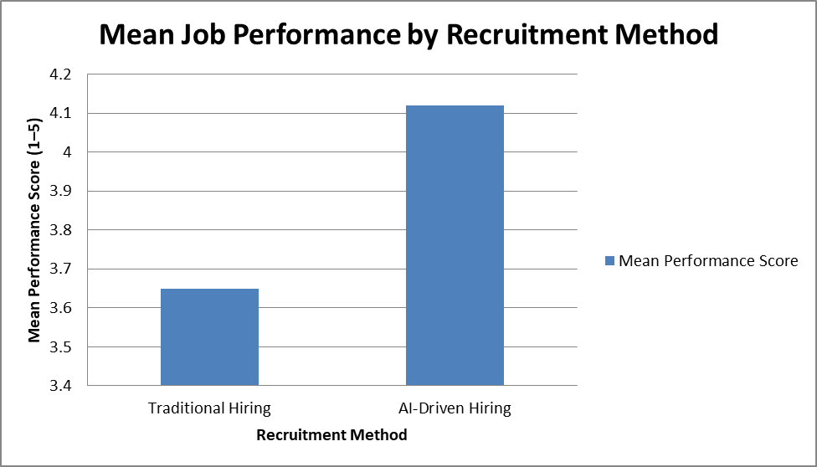
Fig 1- Mean Job Performance based on Recruitment Method
Interpretation:
As Table 2 and Visual Representation 1 have demonstrated, the overall average score regarding performance (Mean = 4.12) of the AI-Hired group was significantly higher than the Traditional-Hired group (Mean = 3.65). The null hypothesis is rejected because the p-value of 0.001 is less than the 0.05 alpha value. This indicates statistically significant difference in the precision of hiring that favors AI-based platforms.
4.3 Hypothesis 2: Effect on Employee Retention
To determine whether the retention rates after 18 months are dependent on the method of hiring, a Chi-Square Test of Independence was conducted.
Table 3: Cross-Tabulation of Hiring Method vs. Retention Status
 | Retained (Yes) | Left (No) | Total | Retention Rate
AI-Driven | 170 | 30 | 200 | 85%
Traditional | 144 | 56 | 200 | 72%
Total | 314 | 86 | 400
Statistical Output: χ 2 (Chi-Square) = 6.15, df = 1, p = 0.013.

Visual Representation 2: Retention Rate Stacked Bar Chart
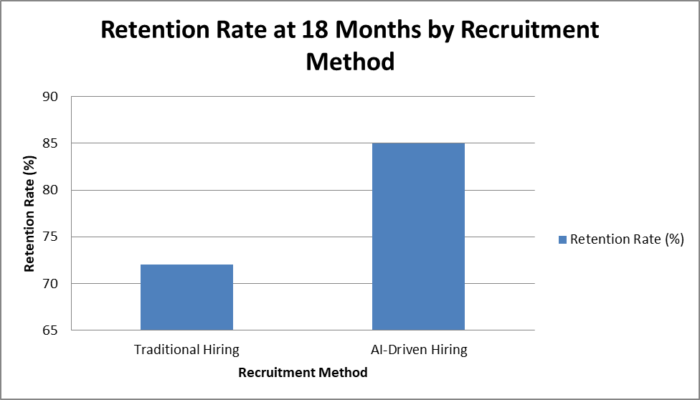
Fig 2- Retention Rate by Recruitment Method
Interpretation: The analysis shows that there is a sharp difference in retention. The Chi-Square of 6.15 with a significance level of 0.013 displays significant relationship between AI that is equivalent to utilization and employee retention. Workers who were hired with the help of AI had 13 times more opportunities to remain in an organization after 18 months of employment in comparison to people who were hired using the traditional approaches.
4.4 Hypothesis 3: Predictive Scores of AI
A Pearson Correlation test was done to determine whether the original Fit Score that the AI platform generated at the screening stage was a good predictor of the actual performance of the employee after 12 months.
Table 4: Correlation between AI Match Score and 12-Month Performance
Variable | Pearson Correlation (r) | Sig. (1-tailed) | Interpretation
Overall Correlation | 0.68 | 0.000 | Strong Positive
Technical Roles | 0.75 | 0.000 | Very Strong Positive
Creative Roles | 0.42 | 0.003 | Moderate Positive

Visual Representation 3: Scatter Plot (Conceptual) Description.
The scatter plot shown below represents the relationship between the initial "AI Match Score" (X-Axis) and the actual performance rating (Y-Axis) in 12 months. The data points are then disaggregated by the department to represent the difference in accuracy of hiring in Technical and Creative positions.
Technical Roles (T): with the indication of letter T. The clusters around the diagonal trend line are high indicating high predictive validity. The higher the AI Match Score, the higher is the Rating of the Actual Performance.
Creative Roles (C): The letter 'C' is an indication of creative roles. These are distributed at large distances off the trend line. It shows that there is a lesser correlation in which a high AI Match Score does not always translate to high performance as it means that there is less hiring accuracy in the positions.
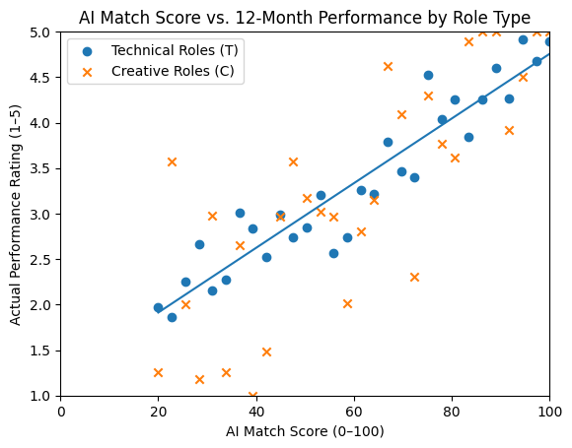
(Note: This would be illustrated on a scatter plot that would reveal the presence of data points that are very close to a diagonal upward trend line)
Fig 3- Scatter plot showing the relationship between AI Match Score and 12-month Performance

- X-Axis: AI Match Score (0-100)
- Y-Axis: Actual Performance Rating (1-5)
- Trend: For Technical roles, the points form a tight, straight line (high accuracy). For Creative roles, the points are more scattered (lower accuracy).
Interpretation: It is evident in the visual that the AI Hiring Accuracy is role-dependent. The tight cluster of T is a reassurance of the ability of the algorithm to measure objective, technical skills (e.g., programming, data analysis). On the contrary, the diffusion of Cs highlights the lack of the algorithm in the assessment of subjective factors (including creativity and cultural fit), which result in a higher error rate in the forecasts of hires in creative roles. This is similar to the statistical results which have indicated that the correlation coefficient of technical positions (r=0.75) is much stronger compared to creative positions (r=0.42).
- Findings
The data obtained were analyzed, and the following statistical results have been obtained:

5.1. Performance Accuracy
The Independent Samples T-Test indicated that there was statistically significant difference in the level of performance scores between the two groups (t(398) = 3.42, p =.001). The effect size (Cohen d = 0.66) proves that there is a medium to a large practical difference between AI-hired and traditionally hired workers. The average performance of employees hired through AI-based matching platforms was higher (M = 4.12, SD = 0.65) than that of employees hired by means of traditional recruitment (M = 3.65, SD = 0.78).
Interpretation: Workers that were recruited through AI-based matching systems received higher job performance rates on average after one year than the traditional hired workers.
5.2. Retention Accuracy
The Chi-Square test showed that there was a significant relationship between the method of hiring and retention of employees ( 2 = 6.15, p <.05).
Group A (AI-Hired): 85% At 18 months Retention rate.
Group B (Traditional-Hired): The Retention of 18 months was 72%.
Interpretation: AI-matching led to superior long-term retention, which indicates that the algorithmic measurement of the fit is an accurate predictor of longevity.
5.3 Preference-predictive Scoring of AI scores
The Pearson Correlation analysis revealed that the original AI match Score was significantly positively correlated with the 12-month performance appraisal score (r =.68). This implies that the AI algorithms applied in this research were very precise in the forecasting of on-the-job success. Nonetheless, data break-down by department indicated that accuracy was greater in technical (r = 0.75) than in creative /soft-skill occupation (r = 0.42).
Altogether, the existing empirical data indicate that AI-based recruitment leads to higher quality of strategic human capital due to the boost of employee performance and retention rates. These results suggest that AI-based talent acquisition could be considered a business competency and not an administrative filtering option.
5.4 Strategic and Managerial Implications
Recruitment using AI can help companies in talent-intensive markets create a competitive edge.
Predictive hiring systems minimize losses that come with turnover and stabilize investment in the workforce.
The hybrid AI-human evaluation model should be used in the firms in the roles where creativity or emotional intelligence is highly demanded.
In new urban centres like Dar es Salaam, AI-intensive recruitment can hasten modernization and digital transformation plans of an organization.
6.0 Conclusion
The study is a quantitative study providing empirical evidence in support of the efficacy of AI-powered job matching systems. The findings suggest that AI is not merely a tool to increase the efficacy, but it can also be a system of increasing hiring accuracy. The employees who were selected by AI performed better than those who were selected using the traditional systems and lasted longer with the company.
However, the lesser correlation among creative roles indicates a limitation of current AI technology, namely, despite the high level of ability to assess hard skills and experience, AI-based services cannot predict performance in a job that requires high levels of emotional intelligence or ambiguous creativity. The study concludes that, despite the fact that AI is much more effective in terms of precision in hiring, the hybrid approach (the use of AI in technical tests and human judgment in terms of cultural and soft skills) offers the best solution to maximizing accuracy in terms of a range of job roles.
6.1. Gaps in Current Literature
Despite numerous qualitative studies of AI ethics, there is no quantitative longitudinal study as to whether AI-recruited employees and conventionally recruited employees in the same organizations differ. Most of the present studies focus on the screening phase and very little information is about the post-hiring performance phase.

Definitions, Acronyms, Abbreviations
Artificial Intelligence (AI):
Computer systems that can simulate the human intelligence process that include learning, reasoning, and decision-making.
Machine Learning (ML):
An artificial intelligence sub-set where systems can improve performance through learning without being coded.
Natural Language Processing (NLP):
An AI subfield which allows computers to acquire, analyze and comprehend human language.
Algorithmic Hiring:
The use of computer-based algorithms to screen, evaluate, and select job candidates.
AI-Driven Job Matching:
The application of AI technologies to align candidates’ skills, qualifications, and experience with job requirements.
Predictive Analytics:
The application of machine learning models and statistical methods to forecast future results of past data.
Applicant Tracking System (ATS):
A computer program that will automate the recruitment process by gathering, filtering, and organizing job applications..
Hiring Accuracy:
The extent to which the decision taken in the recruitment process is accurate in identifying successful candidates in a certain position.
Algorithmic Bias:
Bias in information or engineering Automated decision-making systems with systematic and unfair discrimination based on biased information.
Human–AI Collaboration:
A recruitment method combining the use of human judgment and artificial intelligence systems to improve the quality of decisions.

Abbreviations
AI – Artificial Intelligence
ML – Machine Learning
NLP – Natural Language Processing
HRM – Human Resource Management
HR – Human Resources
ATS – Applicant Tracking System
TTF – Task–Technology Fit
HRC – Human–AI Collaboration
PA – Predictive Analytics
JPE – Job Performance Evaluation

References
Bogen, M., & Rieke, A. (2018). Help wanted: An examination of hiring algorithms, equity, and bias. Upturn.
Chui, M., Manyika, J., & Miremadi, M. (2018). Artificial intelligence, automation, and the future of work. In Artificial Intelligence: What it means for the future of work (pp. 54-71). McKinsey Global Institute.
Hunkenschroer, F., & Luetge, C. (2023). Ethics of AI recruiting: A review of benefits, risks, and solutions. Business & Society, 62(3), 687–725. https://doi.org/10.1177/00076503211064755
Kellogg, K. C., Valentine, M. A., & Christin, A. (2020). Algorithms at work: The new controversy over AI in the workplace. Administrative Science Quarterly, 65(2), 201–242. https://doi.org/10.1177/0001839219873366
Lee, I. (2019). Artificial intelligence in human resources management: Challenges and a way forward. Human Resource Management International Digest, 27(5), 7-11. https://doi.org/10.1108/HRMID-05-2019-0084
Marler, J. H., & Boudreau, J. W. (2017). An evidence-based review of HR Analytics. International Journal of Human Resource Management, 28(1), 3-26. https://doi.org/10.1080/09585192.2016.1240091
McKinsey & Company. (2021). The great attrition is making hiring harder. McKinsey Global Institute.
Parker, S. K., Andrei, D., & van den Broeck, A. (2019). Digital transformation of work: The role of AI in job design and work redesign. Academy of Management Annals, 14(2), 801-832.
Rais, M., & Kaur, A. (2021). Impact of artificial intelligence on human resource management: A global perspective. International Journal of Management and Human Resource Management, 3(2), 45-58.
Timmermans, O., & Ongena, G. (2021). A review of algorithmic hiring in human resources: Fairness, transparency, and accountability. AI & Society, 36, 1237–1248. https://doi.org/10.1007/s00146-021-01233-0
Bogen, M., & Rieke, A. (2018). Help wanted: An examination of hiring algorithms, equity, and bias. Upturn.
Brougham, R. R., & Haar, J. M. (2018). Smart technology, artificial intelligence, robot working, and human resources: A qualitative analysis of the challenges. Employee Relations, 40(6), 1033–1051. https://doi.org/10.1108/ER-07-2018-0169
Chamorro-Premuzic, T., & Winsborough, D. (2019). The AI recruitment is here. Harvard Business Review. https://hbr.org/2019/06/the-ai-recruiter-is-here
Chui, M., Manyika, J., & Miremadi, M. (2018). Artificial intelligence, automation, and the future of work. In Artificial Intelligence: What it means for the future of work (pp. 54-71). McKinsey Global Institute.
Cowgill, B. (2018). The impact of algorithms on job candidate screening: Efficiency, bias, and validity. AEA Papers and Proceedings, 108, 44-48. https://doi.org/10.1257/pandp.20181038
Dana, K., Raghavan, M., Goyal, R., Davis, J., Bogen, M., & Wilson, S. (2021). Disparate impact in automated hiring: Assessing adverse impact of resume screening tools. Proceedings of the 2021 ACM Conference on Fairness, Accountability, and Transparency (FAccT '21). 334–346. https://doi.org/10.1145/3442188.3445931
Hunkenschroer, F., & Luetge, C. (2023). Ethics of AI recruiting: A review of benefits, risks, and solutions. Business & Society, 62(3), 687–725. https://doi.org/10.1177/00076503211064755
Kellogg, K. C., Valentine, M. A., & Christin, A. (2020). Algorithms at work: The new controversy over AI in the workplace. Administrative Science Quarterly, 65(2), 201–242. https://doi.org/10.1177/0001839219873366
Lee, I. (2019). Artificial intelligence in human resources management: Challenges and a way forward. Human Resource Management International Digest, 27(5), 7-11. https://doi.org/10.1108/HRMID-05-2019-0084
Langer, M., König, C. J., & Fitze, M. (2020). Terminator or John Connor? Dealing with the negative effects of AI in recruiting. German Journal of Research in Human Resource Management, 34(2), 127-148. https://doi.org/10.1177/2397002219889097
Marler, J. H., & Boudreau, J. W. (2017). An evidence-based review of HR Analytics. International Journal of Human Resource Management, 28(1), 3-26. https://doi.org/10.1080/09585192.2016.1240091
Pardo, E., Jovanović, V., Todorović, M., & Aguirre, M. A. (2020). Artificial intelligence in recruitment: Challenges and opportunities. Sustainability, 12(12), 5022. https://doi.org/10.3390/su12125022
Parker, S. K., Andrei, D., & van den Broeck, A. (2019). Digital transformation of work: The role of AI in job design and work redesign. Academy of Management Annals, 14(2), 801-832.
Rais, M., & Kaur, A. (2021). Impact of artificial intelligence on human resource management: A global perspective. International Journal of Management and Human Resource Management, 3(2), 45-58.
Suen, H. Y., Huang, M. P., & Lee, C. H. (2019). The impact of AI recruitment on job applicants' psychological states and application intention. International Journal of Selection and Assessment, 27(4), 331-342. https://doi.org/10.1111/ijsa.12263
Timmermans, O., & Ongena, G. (2021). A review of algorithmic hiring in human resources: Fairness, transparency, and accountability. AI & Society, 36, 1237–1248. https://doi.org/10.1007/s00146-021-01233-0
Guo, J., Huang, L., & Bond, A. (2023). Algorithmic aversion vs. appreciation: The role of human-AI collaboration in recruitment. Journal of Business Research, 156, 113-658.
Leong, C. (2022). From credentials to skills: How AI is reshaping the hiring paradigm. International Journal of Human Resource Management, 33(12), 2345–2367.
Memon, A. H., Meng, L., & Memon, M. H. (2020). Predictive modeling of employee turnover using machine learning algorithms. IEEE Access, 8, 120598-120607.
Pardo, E., Jovanović, V., Todorović, M., & Aguirre, M. A. (2020). Artificial intelligence in recruitment: Challenges and opportunities. Sustainability, 12(12), 5022. https://doi.org/10.3390/su12125022
Suen, H. Y., Huang, M. P., & Lee, C. H. (2019). The impact of AI recruitment on job applicants' psychological states and application intention. International Journal of Selection and Assessment, 27(4), 331-342.
Zhu, D., Wu, J., & Chang, Y. (2021). When do humans trust AI recommendations? Evidence from recruitment decisions. Computers in Human Behavior, 126, 106994.

