Journal Name: | Journal of Experimental Agriculture International
Manuscript Number: | Ms_JEAI_153837
Title of the Manuscript: | ASSESSMENT OF GENETIC PARAMETERS OF RICE (Oryza sativa L.) GENOTYPES UNDER LATE KHARIF CONDITION IN HYDERABAD-KARNATAKA REGION
Type of the Article

General guidelines for the Peer Review process:
Artificial Intelligence (AI) generated or assisted review comments are strictly prohibited during peer review.
This journal‟s peer review policy states that NO manuscript should be rejected only on the basis of „lack of Novelty’, provided the manuscript is scientifically robust and technically sound. To know the complete guidelines for the Peer Review process, reviewers are requested to visit this link:
https://r1.reviewerhub.org/general-editorial-policy/

Important Policies Regarding Peer Review
Peer review Comments Approval Policy: https://r1.reviewerhub.org/peer-review-comments-approval-policy/
Benefits for Reviewers: https://r1.reviewerhub.org/benefits-for-reviewers

PART 1: Comments
 | Reviewer’s comment  Artificial Intelligence (AI) generated or assisted review comments are strictly prohibited during peer review. | Author’s Feedback (It is mandatory that authors should write his/her  feedback here)
Please write a few sentences regarding the importance  of this manuscript for the scientific community. A minimum of 3-4 sentences may be required for this part. | The subject of the study presented by the authors is interesting and topical, with scientific and practical importance.
Is the title of the article suitable?  (If not please suggest an alternative title) | The title of the article is appropriate, in relation to the topic addressed.
Is the abstract of the article comprehensive? Do you  suggest the addition (or deletion) of some points in this section? Please write your suggestions here. | The article summary is comprehensive, a little too extensive, and the keywords are representative of the article's subject.
Is the manuscript scientifically, correct? Please write here. | The subsections and structure of the manuscript are appropriate, in accordance with the General Guideline for Authors.  Scientifically, the article has a correct approach.
Are the references sufficient and recent? If you have  suggestions of additional references, please mention them in the review form. | The scientific literature, to which the reporting was made, is recent and representative in the field.

Is the language/English quality of the article suitable for scholarly communications? | The English language and the quality of the article are suitable for academic communications, and the article is accessible to readers.
Optional/General comments | 1.  Introduction  The Introduction chapter could be supported by more consistent documentation. Only three bibliographical sources are cited in this chapter. Revision is recommended.  2.  Article content outside of page settings . e.g.  Table 1 is outside the page settings. Revision is recommended.  3.  Unit of measurement on the y-axis of figures e.g.  Figure 1, and Figure 2  4.  Some figures are not available in the article. e.g.  Plate 1, Plate 2a, Plate 2b, Plate 3 (print screen)  Revision and presentation of figures with accessible content is recommended.  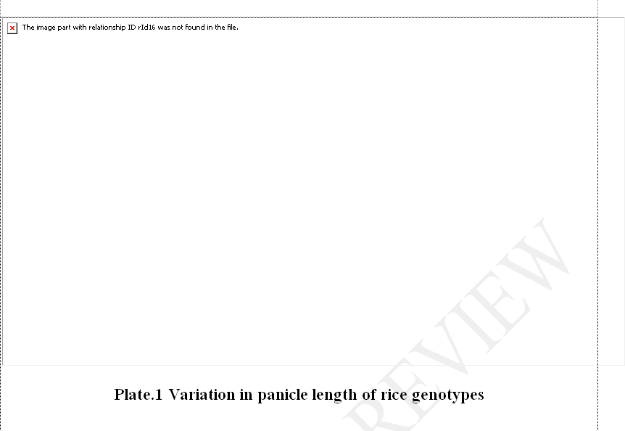  5.  References  The content of the References chapter is outside the page settings. Revision is recommended.  The subject of the study is interesting and topical, with high scientific and practical importance.  The Introduction chapter could be supported by more consistent documentation. Only three bibliographical sources are cited in this chapter. Methodology of the study was clearly presented, and appropriate to the proposed objectives.  The obtained results are important and have been analyzed and interpreted correctly, in accordance with the current methodology.  The discussion of the results is appropriate, in relation to other studies in the field of the subject addressed. The scientific literature, to which the reporting was made, is recent and representative in the field.  I appreciate that the article can be accepted for publication after minor corrections.

PART 2:
 | Reviewer’s comment | Author’s Feedback (It is mandatory that authors should write his/her  feedback here)
Are there ethical issues in this manuscript? | (If yes, Kindly please write down the ethical issues here in detail)  Not identified, not the case.
Are there competing interest issues in this manuscript? | It's not necessary.
If plagiarism is suspected, please provide related proofs or web links. | The evaluation was not done by the reviewer. It's not necessary.

PART 3: Declaration of Competing Interest of the Reviewer:
I declare that I have no competing interest as a reviewer

PART 4: Objective Evaluation:
Guideline | MARKS of this manuscript
Give OVERALL MARKS you want to give to this manuscript  ( Highest: 10 Lowest: 0 )  Guideline:  Accept As It Is: (>9-10) Minor Revision: (>8-9) Major Revision: (>7-8)  Serious Major revision: (>5-7)  Rejected (with repairable deficiencies and may be reconsidered): (>3-5)  Strongly rejected (with irreparable deficiencies.): (>0-3) | 8.5

Editorial Comments (This section is reserved for the comments from journal editorial office and editors):
Author‟s Feedback

Reviewer Details:
This section is mandatory to prepare the Reviewer Certificate.
Please complete this section carefully. Reviewer Certificate will be generated by using this information only. Your Certificate will be wrong, if you provide incorrect information.
Please note modification of certificate will not be possible after generation. Certificate will not be issued if incomplete information is provi ded.

Name of the Reviewer | Florin SALA
Department of Reviewer | Soil Sciences
University or Institution of Reviewer | University of Life Sciences “King Mihai I” from Timisoara
Country of Reviewer | Romania
Position: (Professor/lecturer, etc.) of Reviewer | Professor
Email ID of Reviewer | florin_sala@usvt.ro  florin_sala@usvt.ro
WhatsApp Number of Reviewer (Optional)
Write 5-8 Keywords regarding expertise of  Reviewer | soil sciences, fertilizers, crop sciences, plant nutrition, imaging analysis, modeling

