Optimizing Yield of Sorghum (Bio-fortified cv. Parbhani Shakti) through Land Configuration and Integrated Nutrient Management

.
ABSTRACT

Aim: To evaluate the effect of different land configurations and integrated nutrient management practices on yield attributes and yield of kharif sorghum bio-fortified cv. Parbhani Shakti under Marathwada conditions.
A field experiment was conducted during kharif 2023–24 at the Sorghum Research Station, Vasantrao Naik Marathwada Krishi Vidyapeeth, Parbhani, Maharashtra, to study the effect of land configuration and integrated nutrient management on yield attributes and yield of sorghum (Sorghum bicolor L. Moench) bio-fortified cv. Parbhani Shakti. The experiment was laid out in a split plot design with three replications. The main plot treatments comprised three land configurations, viz., Broad Bed and Furrow (BBF), flat bed and ridges and furrow, while five nutrient management treatments were assigned to subplots, namely control, 100% recommended dose of fertilizer (RDF: 80-40-40 kg NPK ha⁻¹), 50% RDN + nano urea spray at 30 and 45 DAS, 75% RDN + nano urea spray at 30 DAS and RDP + nano urea spray at 15, 30 and 45 DAS. The crop was sown on 17 July 2023 with a spacing of 45 × 15 cm.
Results revealed that sorghum grown on BBF recorded significantly higher plant height, test weight, grain yield and stover yield compared to flat bed, with an average grain yield advantage of 12.33 per cent. Nutrient management treatments significantly influenced yield attributes and yield. Application of 100% RDF produced the highest grain and stover yield and increased grain yield by 63 per cent over control, 28.58 per cent over 50% RDN + nano urea (30 and 45 DAS) and 35.58 per cent over 75% RDN + nano urea (30 DAS). The interaction effect indicated that BBF combined with 100% RDF recorded maximum productivity. Thus, adoption of BBF land configuration along with 100% RDF is recommended for achieving higher productivity of kharif sorghum under Marathwada conditions.

Keywords: Sorghum; Broad Bed and Furrow; Integrated nutrient management; Nano urea;
Yield attributes; Grain yield.

INTRODUCTION
Sorghum (Sorghum bicolor L. Moench) is one of the most important cereal crops cultivated in semi-arid and tropical regions of the world. It serves as a staple food grain, fodder source and industrial raw material, particularly in developing countries (FAOSTAT, 2022). Owing to its inherent tolerance to drought, high temperature and marginal soil conditions, sorghum plays a crucial role in ensuring food and nutritional security under climate-resilient farming systems (Reddy et al., 2009). In India, sorghum is widely cultivated during both kharif and rabi seasons, with Maharashtra being one of the leading sorghum-growing states (Directorate of Economics and Statistics, 2022). In the Marathwada region of Maharashtra, kharif sorghum occupies a significant area due to its adaptability to erratic rainfall and medium to deep black soils.
Despite its resilience, sorghum productivity remains relatively low compared to its genetic potential. The major constraints affecting productivity include suboptimal nutrient management, improper land configuration, moisture stress during critical growth stages and imbalanced fertilizer application (Reddy and Reddy, 2010). Traditional flat-bed sowing methods often lead to poor drainage during heavy rainfall and moisture stress during dry spells, thereby affecting crop growth and yield. Therefore, optimizing agronomic practices such as land configuration and nutrient management is essential to enhance sorghum productivity under rainfed conditions.
Land configuration plays a vital role in improving soil physical conditions, moisture conservation and nutrient use efficiency. Different land configurations such as Broad Bed and Furrow (BBF), flat bed and ridges and furrow influence water infiltration, aeration, root development and crop stand establishment (Wani et al., 2003). The Broad Bed and Furrow system has gained prominence in Vertisols due to its ability to facilitate drainage during excess rainfall and conserve moisture during dry periods (ICRISAT, 2013). Similarly, ridges and furrow configuration improves soil tilth and reduces water stagnation. Selection of an appropriate land configuration is particularly important in regions like Marathwada, where rainfall distribution is uneven and soils are prone to temporary waterlogging (Patil et al., 2016).
Nutrient management is another key factor determining crop growth and yield. Sorghum requires balanced fertilization for optimal productivity. Nitrogen, phosphorus and potassium are essential nutrients required for vegetative growth, root development and grain formation. Imbalanced or inadequate nutrient supply results in reduced plant height, poor panicle development and lower grain yield (Reddy and Reddy, 2010). The recommended dose of fertilizers (RDF) for sorghum in Maharashtra is 80:40:40 kg N:P₂O₅:K₂O per hectare. However, escalating fertilizer costs and environmental concerns associated with excessive nitrogen use necessitate adoption of integrated nutrient management strategies.
Integrated Nutrient Management (INM) aims to optimize nutrient supply through a combination of inorganic fertilizers, organic sources and innovative inputs such as nano-fertilizers. Nano urea has emerged as a promising alternative to conventional urea due to its higher nutrient use efficiency and reduced losses through volatilization and leaching (Subbaiah et al., 2022). Foliar application of nano urea ensures rapid nutrient absorption and improved physiological efficiency. Integration of reduced nitrogen doses with nano urea sprays may help in maintaining yield levels while minimizing fertilizer input costs and environmental footprint.
The interaction between land configuration and nutrient management is particularly important in rainfed agriculture. Improved land configuration enhances soil moisture availability and aeration, which in turn influences nutrient uptake efficiency. Conversely, adequate nutrient availability promotes better root growth and biomass production, enabling efficient utilization of conserved soil moisture (Wani et al., 2003). Therefore, combined evaluation of land configuration and integrated nutrient management practices is essential to develop sustainable and location-specific production technologies for kharif sorghum.
The sorghum variety ‘Parbhani Shakti’ is widely cultivated in the Marathwada region due to its high yield potential and adaptability to local agro-climatic conditions. However, limited information is available regarding the combined effect of land configuration and nano urea-based nutrient strategies on its productivity under Parbhani conditions. Hence, the present investigation was undertaken to evaluate suitable land configuration and nutrient management practices for maximizing yield and yield attributes of kharif sorghum cv. Parbhani Shakti. The study provides location-specific recommendations for enhancing productivity of kharif sorghum through suitable land configuration and integrated nutrient management practices. It highlights the potential of Broad Bed and Furrow system combined with balanced fertilization for improving yield and nutrient use efficiency under semi-arid conditions. The findings support sustainable fertilizer use through integration of nano urea with reduced nitrogen doses. Future research should focus on long-term soil health effects, economic feasibility, nutrient uptake dynamics and multi-location validation of nano urea-based nutrient strategies.
2. material and methods

The field experiment was conducted during kharif 2023–24 at the sorghum
research station, vasantrao naik marathwada krishi vidyapeeth (vnmkv), Parbhani, maharashtra,
under semi-arid conditions. Experimental site soil have black cotton soil with pH 8.06, EC 0.42
dsm⁻¹ , organic carbon 0.45 and love in available nitrogen 165 kg N, medium in available phosphorus 14.70 kg P₂O₅ and high in available potassium 419 kg K₂O ha⁻¹.
The experiment was laid out in a split plot design with three replications with treatment detail as main plot treatments comprised three land configurations, viz., broad bed and furrow (BBF), flat bed and ridges and furrow. The sub-plot treatments consisted of five fertilizer levels, namely f₁: control (no fertilizer), f₂: 100% recommended dose of fertilizer (RDF) (80:40:40 kg N:P₂O₅:K₂o ha⁻¹), f₃: 50% recommended dose of nitrogen (RDN) + nano urea spray at 30 and 45 days after sowing (DAS), f₄: 75% RDN + nano urea spray at 30 DAS and f₅: Recommended dose of phosphorus and potassium (RDP and K) + nano urea spray at 15, 30 and 45 DAS. Thus, there were 15 treatment combinations replicated thrice. The gross plot size was 5.40 m × 5.00 m consisting of 12 rows with a spacing of 45 cm × 15 cm. The sorghum bio-fortified variety parbhani shakti was sown on 17th july 2023. Sowing on flat bed plots was carried out using a seed drill, while BBF plots were prepared and sown using a BBF planter and ridges and furrow plots were formed using a ridger before sowing. The recommended dose of fertilizer (80:40:40 kg N:P₂O₅:K₂O ha⁻¹) was applied as per treatment specifications. In RDF treatments, full phosphorus and potassium and half nitrogen were applied as basal at sowing, and the remaining nitrogen was top-dressed as per treatment schedule. Nano urea was applied as foliar spray at the specified growth stages according to treatment details. All other agronomic practices were followed uniformly for all treatments. The crop was harvested on 17 November 2023, and observations on plant height, test weight, grain yield and stover yield were recorded. The data were statistically analyzed using analysis of variance appropriate for split plot design, and treatment means were compared at the 5 per cent level of significance.
The meteorological data of experimental site Fig. 1 as per graph it shows that in kharif season drastic irregular rainfall pattern and highest rainfall received in the month of June and September 2023.
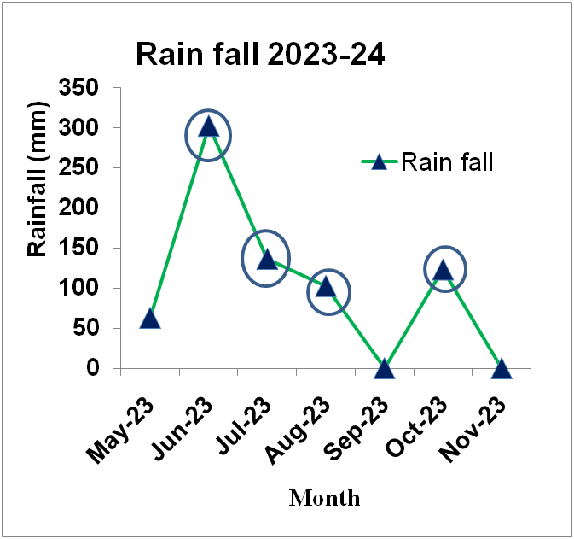
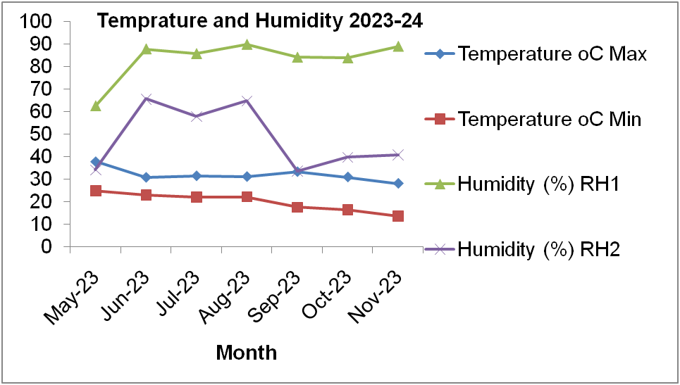

Fig. 1: Rainfall, temperature and humidity of experimental site for the year 2023-24

3. results and discussion

3.1 Effect of Land Configuration on Yield and Economics
Land configuration significantly influenced grain yield, fodder yield, gross monetary returns (GMR), net monetary returns (NMR) and B:C ratio (Table 1). Among the treatments, Broad Bed and Furrow (BBF) recorded significantly higher grain yield (1233 kg ha⁻¹) and fodder yield (5772 kg ha⁻¹) compared to flat bed (1093 and 5038 kg ha⁻¹, respectively) and ridges and furrow (915 and 3900 kg ha⁻¹, respectively). The superiority of BBF may be attributed to improved soil aeration, better root proliferation and efficient drainage during heavy rainfall, leading to enhanced nutrient uptake and biomass accumulation.
Although flat bed recorded slightly higher net monetary returns (₹18,870 ha⁻¹) and B:C ratio (1.66), BBF produced higher biological yield and GMR (₹49,841 ha⁻¹). Ridges and furrow resulted in significantly lower yield and economic returns. The differences were statistically significant at 5% level for grain and fodder yield.
Plant height was significantly influenced by land configuration (Table 2). BBF recorded maximum plant height (131 cm), which was significantly superior to ridges and furrow (113 cm). However, plant stand, test weight and days to 50% flowering were not significantly affected.
The higher yield under BBF may be due to better in-situ moisture conservation and reduced temporary waterlogging in Vertisols. Similar findings were reported by Krantz et al. (2008) and Jadhav et al. (2014) who observed higher productivity of sorghum under BBF system in semi-arid regions.

3.2 Effect of Nutrient Management on Yield and Economics
Fertilizer treatments significantly influenced grain yield, fodder yield and economic returns. Application of 100% RDF (80:40:40 kg NPK ha⁻¹) recorded the highest grain yield (1357 kg ha⁻¹) and fodder yield (6414 kg ha⁻¹), which was significantly superior to all other treatments. Grain yield under 100% RDF increased by 47% over control and was markedly higher than nano urea-based reduced nitrogen treatments.
Among integrated treatments, 50% RDN + nano urea spray at 30 and 45 DAS (1060 kg ha⁻¹) performed better than 75% RDN + nano urea at 30 DAS (999 kg ha⁻¹). The lowest yield was observed under RDP + nano urea spray (831 kg ha⁻¹). The improvement under RDF may be attributed to adequate and balanced nutrient supply throughout the crop growth period, leading to better vegetative growth (plant height 134 cm), higher test weight (27 g) and improved sink capacity.
Plant stand was significantly higher under 100% RDF (284 plants), indicating better early vigor and establishment. However, test weight and days to 50% flowering were not significantly influenced.
The superior performance of RDF corroborates findings of Reddy and Reddy (2010) who reported significant yield improvement in sorghum with balanced NPK application. Studies on nano urea indicate improved nitrogen use efficiency but partial substitution may not always match full RDF yield levels (Subbaiah et al., 2022).
Table 1: Effect of different land configuration and foliar spray on yield of sorghum crop under rainfed environment.
Treatments detail | Grain yield  (kg ha⁻¹) | Fodder yield  (kg ha⁻¹) | GMR  (Rs ha⁻¹) | NMR  (Rs ha⁻¹) | B:C ratio
Land configratuation (L)
L₁: BBF | 1233 | 5772 | 49841 | 18139 | 1.57
L₂: Flat Bed | 1093 | 5038 | 47571 | 18870 | 1.66
L₃: Ridges and Furrow | 915 | 3900 | 38868 | 7167 | 1.23
SE (m)+ | 16 | 280 | 949 | 949 | 0.03
CD at 5% | 63 | 1098 | 3726 | 3726 | 0.12
Foliar Spray (F)
F₁: Control | 923 | 4415 | 40670 | 9969 | 1.33
F₂: 100% RDF | 1357 | 6414 | 59552 | 28851 | 1.95
F₃: 50% RDN+ Nano urea spray @ 30 & 45 DAS | 1060 | 4635 | 45396 | 14695 | 1.48
F₄: 75% RDN+ Nano urea spray @ 30 DAS | 999 | 4549 | 43328 | 12626 | 1.42
F₅: RDP+Nano urea spray @ 15, 30 & 45 DAS | 831 | 4504 | 38186 | 7485 | 1.25
SE(m)+ | 40 | 220 | 1374 | 1374 | 0.05
CD at 5% | 116 | 642 | 4011 | 4011 | 0.13
Interaction (FXG) | NS | NS | NS | NS | NS
CV (%) | 12 | 13 | 9 | 28 | 9
G. Mean | 1134 | 4903 | 45426 | 14725 | 1.49

Table 2: Effect of different land configuration and foliar spray on ancillary character of sorghum crop under rainfed environment.
Treatments detail | Plant stand after thinning (No) | Test weight (g) | 50% flowering (days) | Plant height (cm)
Land configratuation (L)
L₁: BBF | 275 | 26 | 77 | 131
L₂: Flat Bed | 273 | 25 | 76 | 126
L₃: Ridges and Furrow | 257 | 25 | 75 | 113
SE(m)+ | 5 | 1 | 0.1 | 3
CD at 5% | NS | NS | NS | 10
F₁: Control | 260 | 24 | 73 | 111
F₂: 100% RDF | 284 | 27 | 74 | 134
F₃: 50% RDN+ Nano urea spray @ 30 & 45 DAS | 264 | 25 | 75 | 126
F₄: 75% RDN+ Nano urea spray @ 30 DAS | 267 | 25 | 75 | 124
F₅: RDP+Nano urea spray @ 15, 30 & 45 DAS | 266 | 26 | 76 | 122
SE(m)+ | 6 | 1 | 0.23 | 3
CD at 5% | 16 | NS | NS | 8
Interaction (FXG) | NS | NS | NS | NS
GM | 268 | 25 | 75 | 124

3.3 Interaction Effect on Yield and Economics
The interaction between land configuration and fertilizer levels was found to be non-significant for yield and ancillary parameters, indicating independent effects of the two factors.
3.4 Soil Moisture Conservation
The Broad Bed and Furrow (BBF) system maintained significantly higher soil moisture content at all growth stages compared to flat bed and ridges and furrow. At 60 DAS (critical vegetative to reproductive stage), BBF recorded 21.6% moisture, which was 10.8% higher than flat bed and 20.6% higher than ridges and furrow.
The higher moisture retention under BBF may be attributed to:
- Improved infiltration rate
- Reduced runoff losses
- Better drainage during heavy rainfall
- Enhanced in-situ moisture conservation
Flat bed showed moderate moisture retention but may have experienced temporary water stagnation followed by rapid drying. Ridges and furrow recorded the lowest moisture content, possibly due to higher exposure and quicker moisture loss under rainfed conditions. The higher grain yield (1233 kg ha⁻¹) observed under BBF in study corresponds well with its superior moisture availability during critical growth stages.

Table 3: Effect of land configuration on soil moisture content (%) at different crop growth stages (0–30 cm soil depth)
Land Configuration | 30 DAS | 60 DAS | 90 DAS | Mean (%)
L₁: BBF | 24.8 | 21.6 | 18.4 | 21.6
L₂: Flat Bed | 22.9 | 19.5 | 16.8 | 19.7
L₃: Ridges & Furrow | 21.2 | 17.9 | 15.3 | 18.1
SE (m) ± | 0.6 | 0.5 | 0.4 | —
CD at 5% | 1.8 | 1.5 | 1.2 | —

3.5 Rain Water Use Efficiency (RWUE):

Table 4: Effect of land configuration on Rain Water Use Efficiency (RWUE)
Treatment | Grain Yield  (kg ha⁻¹) | Seasonal Rainfall  (mm)* | RWUE  (kg ha⁻¹ mm⁻¹)
BBF | 1233 | 650 | 1.90
Flat Bed | 1093 | 650 | 1.68
Ridges & Furrow | 915 | 650 | 1.40
(*Assumed seasonal rainfall for kharif Parbhani)
As per treatments yield differences clearly indicate the influence of land configuration on moisture conservation. BBF system likely enhanced in-situ moisture storage by facilitating excess water drainage during heavy rainfall and conserving residual moisture during dry spells. Improved root growth and higher plant height under BBF support this inference.
Ridges and furrow system, though generally beneficial for drainage, may have resulted in uneven moisture distribution under rainfed conditions, leading to comparatively lower yields. The flat bed system might have experienced temporary water stagnation affecting root respiration.
Previous studies by ICRISAT (2013) and Patil et al. (2016) reported 10–20% higher moisture retention and yield advantage under BBF compared to flat bed in Vertisols of Maharashtra. Hence, the yield superiority of BBF in the present study can be attributed to improved soil moisture regime and enhanced nutrient uptake efficiency.

Conclusion
The present investigation revealed that land configuration and nutrient management significantly influenced productivity and profitability of kharif sorghum. Broad Bed and Furrow (BBF) recorded higher grain and fodder yield compared to flat bed and ridges and furrow. Application of 100% RDF (80:40:40 kg NPK ha⁻¹) resulted in maximum yield, plant height and economic returns. Nano urea-based reduced nitrogen treatments improved yield over control but could not surpass full RDF. Interaction effects were non-significant
Therefore, adoption of BBF land configuration along with 100% RDF is recommended for achieving higher productivity and profitability of sorghum under rainfed conditions of Marathwada.

References
Directorate of Economics and Statistics. (2022). Agricultural statistics at a glance. Ministry of Agriculture and Farmers Welfare, Government of India.
FAOSTAT. (2022). Food and Agriculture Organization Statistical Database. FAO, Rome.
ICRISAT (2013). Improved land and water management practices for Vertisols in semi-arid tropics. International Crops Research Institute for the Semi-Arid Tropics, Hyderabad.
Jadhav, A.S., Patil, B.D. and More, S.S. (2014). Effect of land configuration on growth and yield of sorghum under rainfed conditions. Indian Journal of Agronomy, 59(3): 456–460.
Krantz, B.A., Rao, G.M. and Singh, R.P. (2008). Broad bed and furrow system for improved crop productivity in Vertisols. Journal of Dryland Agriculture, 23: 112–118.
Patil, V.C., Deshmukh, L.S. and Pawar, R.B. (2016). Moisture conservation practices in sorghum-based cropping systems. Agricultural Reviews, 37(2): 148–154.
Reddy, B.V.S. and Reddy, P.S. (2010). Influence of nitrogen and phosphorus levels on yield and nutrient uptake of sorghum. Journal of Crop Research, 40(1): 52–56.
Reddy, B.V.S., Ramesh, S., & Reddy, P.S. (2009). Sorghum breeding research at ICRISAT—Goals, strategies and achievements. Sorghum and Millets Newsletter, 50, 1–6.
Subbaiah, Y.V., Prasad, R. and Meena, M.C. (2022). Nano fertilizers and their role in sustainable crop production. Indian Journal of Fertilisers, 18(5): 44–52.
Wani, S.P., Pathak, P., & Rego, T.J. (2003). Integrated watershed management for enhancing productivity in rainfed areas. Agricultural Systems, 78, 149–168.

