
UNDER PEER REVIEW

Prevalence of Dysmenorrhea Among Overweight Female College
- Students

UNDER PEER REVIEW


25

26 Abstract:

27

Background:

- Dysmenorrhea is a periodic and cramping pain sensation mostly in the

- lower abdomen before or during menstruation. It is one of the most common

- gynecologic issues among female students. It is a regular cause of absence from
- college in this age group and can negatively impact academic performance. In addition,
- overweight and obesity are also common health concerns among females in general.

Objectives:

- The purpose of this study is to find the relationship between overweights and
- dysmenorrhea. Some studies suggest there may be a connection between them, but
- the evidence remains uncertain due to gap in knowledge. Therefore, the purpose of this
- study is to ascertain the incidence of dysmenorrhea among female college students in
- Sulaymaniyah who are overweight and explore correlations between BMI and intensity
- of dysmenorrhea along with associated risk factors.

Methodology:

- A cross-sectional study was conducted among female college students (n=362) who
- were assessed for data through a self-administered questionnaire for BMI, prevalence
- and intensity of dysmenorrhea, and associated risk factors. The BMI levels and risk
- factors were compared according to presence and severity of dysmenorrhea.

Results:

UNDER PEER REVIEW

- Females with severe dysmenorrhea had the lowest normal mean BMI level, followed by
- those with moderate dysmenorrhea, mild dysmenorrhea, and then those with no
- dysmenorrhea. Those with no dysmenorrhea had the highest normal BMI level. The
- mean BMI level in females with severe dysmenorrhea was (n = 150; 22.57 ± 4.05
- (standard deviation) kg/m2), with moderate dysmenorrhea (n = 177; 22.95 ± 3.78
- kg/m2) , in those mild dysmenorrhea (n = 24; 23.21± 3.76 kg/m2) dysmenorrhea, and in
- those with no pain (n=11; 24.08± 3.89).

Conclusion:

- There was no relation between BMI and prevalence of dysmenorrhea, further research
- is needed to confirm this finding.

57

Keywords:

- Dysmenorrhea, Overweight, College Students.

60

Introduction

- Dysmenorrhea is the term used to describe the pain experienced before or during
- menstruation which is a very common gynecological problem. Usually the pain is mild
- for women, however it can be severe pain for some women and hinder their normal
- activities for several days. Every month, for about 1 to 2 days, it affects over 50% of
- women during menstrual cycles [1]. In a systematic review and meta-analysis of
- research that included more than 20,000 young women from 38 different countries it
- reported that the prevalence of dysmenorrhea was 71.1% [6]. In addition, especially in
- severe cases of dysmenorrhea, there may be other associated symptoms such as
- diarrhea, nausea, vomiting, headaches, and dizziness. [1]. The repercussions of
- dysmenorrhea encompass physical, social, emotional, educational and economic
- domains. According to a survey targeting women aged 18 and above with primary
- dysmenorrhea, over half experienced symptoms that hindered their activities, while 17%

UNDER PEER REVIEW

- missed school or work due to these effects [2]. Dysmenorrhea stands as the primary
- cause of short-term school absences among girls. Statistics show that 1 in 8 girls aged
- 14 to 20 miss school or work due to this condition [3]. In the US approximately 600
- million working hours or $2 billion are lost each year due to debilitating dysmenorrhea
- when sufficient relief is lacking. Studies indicate that women who persevere with work or
- classes during dysmenorrhea tend to exhibit reduced productivity or performance
- scores [4]. Furthermore, in a systematic analysis that included 33 researches the
- connection between primary dysmenorrhea and mental health was studied and it was
- found that stress-related illnesses, anxiety, and depression were the most frequently
- examined conditions in individuals with dysmenorrhea [5]. Women with dysmenorrhea
- also state that it has a detrimental effect on their social functioning, leading to poor
- social and athletic activities as well as strained relationships with family and friends [6].
- Moreover, it is crucial to stress that untreated or improperly managed dysmenorrhea
- can predispose to nociceptive priming, which increases the risk of developing chronic
- pelvic pain [5]. Overweight and obesity are conditions of excess fat accumulation inside
- the body that can deteriorate health. To identify overweight and obese people
- measurements of height and weight are acquired to calculate body mass index (BMI).
- Excessive weight is a result of imbalance in calorie intake and expenditure and it can
- lead to increased risk of diabetes, heart disease, and cancer [7]. In a research done in
- Iraq the BMI of 76% of Iraqi women were either overweight or obese which means only
- one-quarter of the females studied were of normal weight. This indicates that further
- attention to the issue is urgently needed [8]. One of the factors that has been associated
- with dysmenorrhea is increased weight in young females. The physiological production
- of prostaglandin by the endometrium is increased in primary dysmenorrhea and
- increased prostaglandin leads to uterine contractions, which ultimately cause primary
- dysmenorrhea. It has been suggested that as a result of increased prostaglandin
- production in obese and overweight individuals dysmenorrhea occurs [9]. However,
- other researches do not include obesity in the list of associated factors for
- dysmenorrhea [10]. Given the prevalence of the problems and the mixed findings on
- their relationships, this study has been undertaken to investigate the association

UNDER PEER REVIEW

- between BMI and dysmenorrhea, find the prevalence of dysmenorrhea and the
- associated risk factors in female college students in Sulaimani city.

106

Materials & Methods

- An analytical and observational cross sectional study was conducted from January 2024
- to March 2024 in Sulaimani city. The sample size was 362 female college students
- aged 18-25 years from the departments of Medicine, Veterinary, Engineering, Nursing,
- Pharmacy, Sciences, Dentistry, Medical Lab Sciences, Humanities, and Law from all 8
- universities in Sulaimani: University of Sulaimani, Komar University, Cihan University,
- Tishk International University, Sulaimani Polytechnic University, University of Human
- Development, Qaiwan International University, and American University of Iraq
- Sulaymaniyah.

- Convenience and snowball sampling techniques were used to select participants. The
- data was collected through a semi-structured self-administered questionnaire. The
- questionnaire was pre-tested for clarity and was provided in both English and Kurdish
- languages. There was both an online questionnaire where data was collected through
- Google Forms (n=150) and a paper-based handout questionnaire (n=212) as well that
- was distributed on campus for participants to fill out. The questionnaire consisted of two
- sections. The first part was related to socio-demographic data of the participants and
- the second part inquired about detailed menstrual information such as age at menarche,
- quantity of menstrual flow, menstrual regularity, duration of menstrual cycle, severity of
- pain (dysmenorrhea) and associated symptoms, family history of dysmenorrhea, etc.,
- and physical exercise and dietary habits also the techniques they used to relieve pain .
- For assessment of menstrual pain visual analogue scale (VAS) which is a standard pain
- assessment tool of numerical rating scale of 10-point scale was used, with higher
- scores indicating stronger pain. The point scales 1 to 3, 4 to 7, and 8 to 10 were
- classified into mild dysmenorrhea, moderate dysmenorrhea, and severe dysmenorrhea
- respectively. In addition, BMI was calculated by the formula Kg/Height2 in meter. For
- the on-ground cases (n=212) anthropometric measurements have been undertaken

UNDER PEER REVIEW

- where height with tape measure and weight with a digital scale of 1.0g accuracy were
- measured for precise calculation of the participants’ body mass index (BMI) while for the
- online data collection cases the subjects reported their own height and weight by
- measuring them themselves. Based on the World Health Organization (WHO)
- guidelines the subjects were divided into four groups: underweight, normal, overweight,
- and obese groups. Females with BMI less than 18.5kg/m2 were categorized as
- underweight, BMI of 18.5kg/m2 to 24.9kg/m2 as normal, BMI of 25kg/m2 to 29.9kg/m2
- as overweight, and BMI of more than 30kg/m2 as obese.

- Ethical clearance was obtained from the clinical sciences department of College of
- Medicine in University of Sulaimani. Participation by subjects was strictly voluntary and
- informed consent was taken from all the students before their participation in the study.
- Participants’ confidentiality of their personal information was reassured.

- The data was then entered into Microsoft Excel and then transferred into statistical
- package for social science software (SPSS) version 27 for analysis. The eligibility
- criteria were females above the age of 18 and younger than 25 that were university
- students competent in Kurdish or English language. Females that were younger than 18
- years, non-student females, students who study in universities outside Sulaimani, and
- those who refused or failed to fill the questionnaire were excluded. Frequencies,
- percentages, means, standard deviation, and p-values were found and Chi-Square test
- was used. P-value of under 0.05 was considered significant.

153

Results

- A total of 362 female cases aged 18 years and above were collected to evaluate the
- relationship between Dysmenorrhea and BMI.

- Sociodemographic data was shown in Table.1

- The menstrual characteristics of females was shown in Table.2.

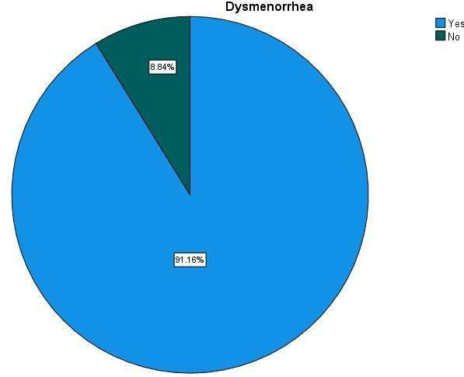
UNDER PEER REVIEW

- And as we see most common site of pain is lower abdomen and back, and 96.3% of
- their pain were cramping pain, 78.7% had positive family history .

- In Fig.1. We see that 91.16% (330) of females had dysmenorrhea .

- Also we demonstrated the percentage of Severity of dysmenorrhea and BMI in pie
- charts Fig.2 and Fig.3 respectively.

- In data analysis using Chi-square test the family history was the main factor associated
- with dysmenorrhea and according to P value there’s no statistically significant
- correlation BMI and prevalence and severity of dysmenorrhea (Table 4 and 5).

- Other factors like age of menarche, marital status, exercise, smoking and alcohol
- consumption were found not to be significant.

- Fig.1 According to our study 91.2% of females had dysmenorrhea and in rest 8.8%
- there was no dysmenorrhea.

171

172

173

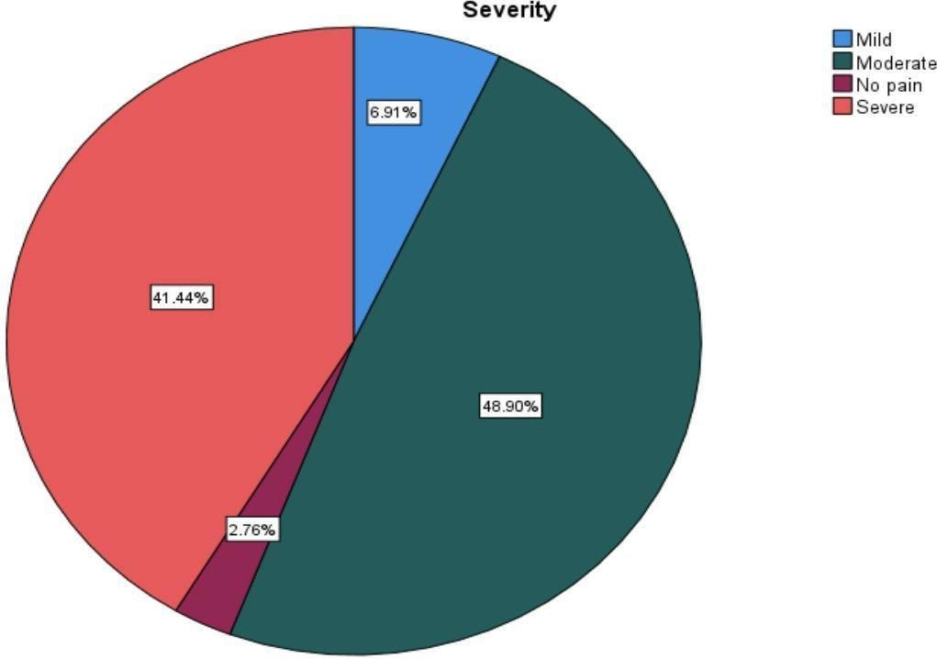
UNDER PEER REVIEW

- Fig.2 shows that among those that had pain 7%, 49%, and 41% were suffering from
- mild, moderate and severe dysmenorrhea respectively.

176

177

178

179

180

181

182

183

184

185

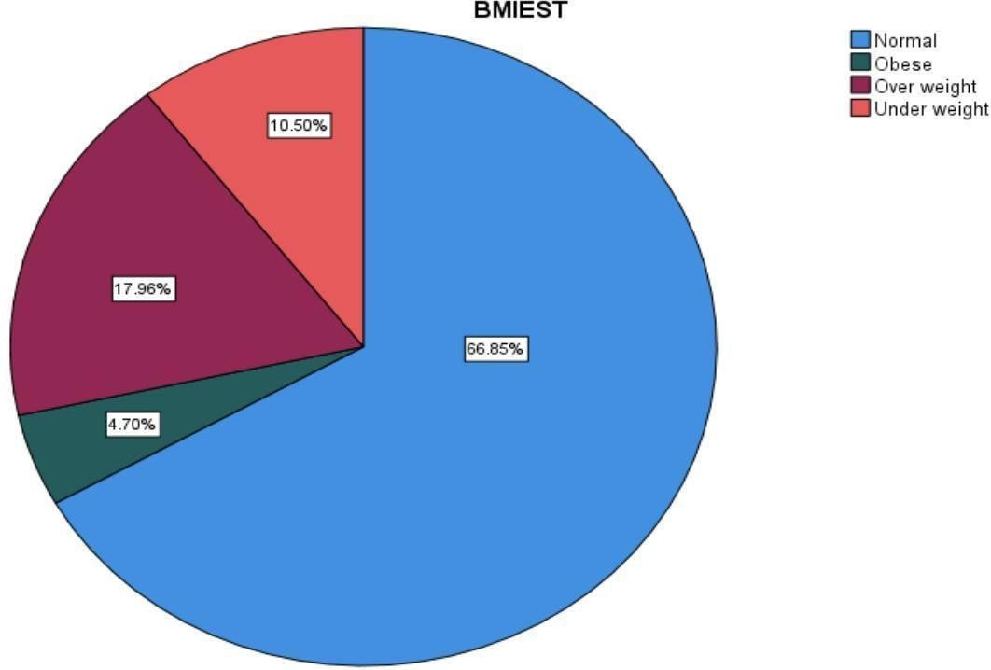
UNDER PEER REVIEW

- Fig.3 shows percentage of BMI among students that 10%, 66%, 17% and 4% were
- underweight, normal, overweight and obese respectively.

188

189
190

191

- Most of our participants 236 out of 362 were from the College of Medicine in University
- of Sulaimani, the majority of them were single and had moderate economic status
- (Table 1).

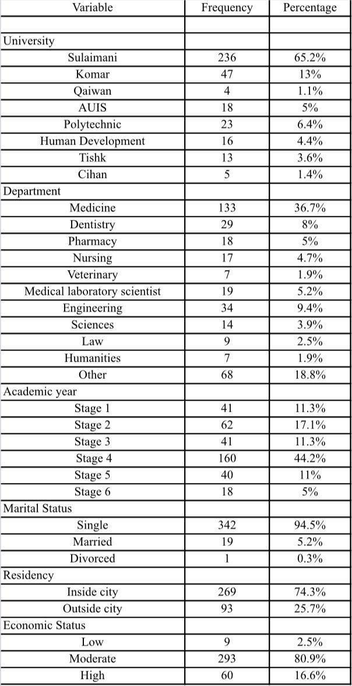
UNDER PEER REVIEW

195

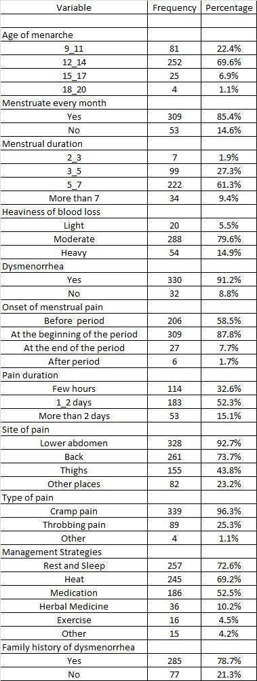
UNDER PEER REVIEW

- Table 1. Sociodemographic characteristics of participants.

- Among management strategies the most common methods that are used were Rest
- and Sleep (72.6%), Heat (69.2%) and Medication (52.5%) respectively (Table.2).

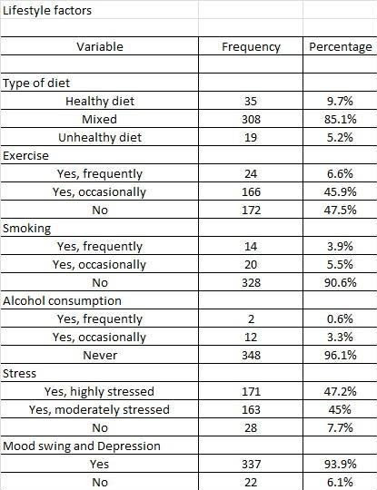

199
- Table 2. Menstrual characteristics of participants.

UNDER PEER REVIEW

- This table shows us that most participants had mixed type of diet (85.1%), non smoker
- (90.6%) most of them were not alcohol l consumers (96.1%), but many of them live with
- stress (47.2%) and get mood swing and depression premenstrually (47.4%) (Table 3).

204

205
206

207 Table 3. Lifestyle characteristics of participants.

208

209

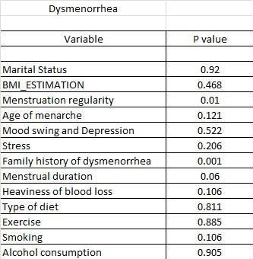

UNDER PEER REVIEW

- In this table, P value is between prevalence of dysmenorrhea and menstruation
- regularity is (0.01) which is statistically significant, and there’s a strong relationship
- between prevalence of dysmenorrhea and positive family history (P value is highly
- significant = 0.001).

214

215

Irregularity

216 .

- Table 4. Factors associated with dysmenorrhea.

- As shown in this table the P value is highly significant between severity of
- dysmenorrhea and heaviness of blood loss (0.002) and family history of dysmenorrhea
- (0.006) (Table 5).

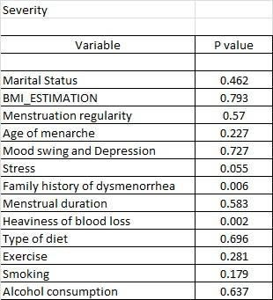

UNDER PEER REVIEW

221

222

Irregularity

223

224

- Table 5. Factors associated with severity of dysmenorrhea.

- The main purpose of our research is to determine the relationship between BMI and
- severity of dysmenorrhea, as shown below the mean of BMI in all types of severity were
- normal, but the lowest BMI were associated with severe dysmenorrhea (Table 6).

229

230

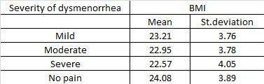
UNDER PEER REVIEW

231

232

- Table 6. Association between Severity of dysmenorrhea and mean of BMI.

DISCUSSION

- Before or during menstruation, dysmenorrhea is a severe cramping feeling in the lower
- abdomen that is frequently accompanied by headaches, nausea, vomiting, diarrhea,
- and sweating [30]. It is a common gynecological issue that has a detrimental impact on
- women's everyday activities and quality of life [11]. According to the results of our study,
- 91.2% of female college students in Sulaimani had dysmenorrhea. In line with our
- findings, a research conducted in Jordan found that 90.1% of women had
- dysmenorrhea [12]. A prospective study conducted on female college students in China
- found that 56.4% of them had dysmenorrhea; the reason for this discrepancy in the
- reported prevalence might be attributed to genetics, dietary differences, and cultural
- attitudes in the various regions [21]. But it also needs to be taken into consideration that
- this finding depends on the females’ perception of pain. The most prevalent type of pain
- reported by participants was cramping (96.3%). Additionally, the most frequent site of
- pain for the majority of the female participants (92.7%) was lower abdomen; in a
- research done in Northern Ethiopia amongst university students most participants also
- reported the most frequent site of pain to be lower abdomen [13]. The most frequently
- reported sites of pain beyond the lower abdomen were the back (73.7%) and thighs
- (43.8%). While the lower abdomen is the primary location of cramping during
- dysmenorrhea, radiating pain to the back and thighs is a recognized symptom. These

UNDER PEER REVIEW

- findings of our research align with the established symptoms of dysmenorrhea
- described in medical literature. Furthermore, 58.5% of participants reported
- experiencing the onset of menstrual pain premenstrually, which is consistent with the
- typical pattern of dysmenorrhea pain starting before menstruation [34]. Positive family
- history of dysmenorrhea (p =0.001) was significantly associated with prevalence and
- intensity of dysmenorrhea in our analysis and a similar result was obtained from India,
- and Iran [14, 28]. Positive family history that is shown to be a risk factor for
- dysmenorrhea could be due to genetic predisposition. It can also be due to visual
- learning behavior between mother and daughter [22]. Our analysis concluded that there
- was no significant association between BMI and dysmenorrhea according to results
- obtained from the chi-square test we conducted and in two researches from Turkey and
- Iran they also found no association between dysmenorrhea with BMI [19, 28]. On the
- contrary, in a study in India they found them to be significant and related [18]. Also
- according to our results the prevalence of dysmenorrhea was higher in those with
- normal BMI, this goes along with a study done in Iran where they found that the
- frequency of dysmenorrhea was higher in the normal weight group [16]. However this
- finding is not consistent with a Japanese study where frequency of dysmenorrhea was
- greatest amongst the underweight group [15]. And also not consistent with a study done
- at a university in Turkey where they found the prevalence of primary dysmenorrhea to
- be higher among young women who were overweight or obese [17]. These
- discrepancies could be explained by the hypothesis that quality of diet and not just the
- total calories leading to a certain BMI might be a more relevant factor in dysmenorrhea.
- The link between BMI and dysmenorrhea might be influenced by diet composition within
- each BMI category. For example, people with normal BMI who consume a healthy diet
- might experience less dysmenorrhea compared to those with normal BMI who have a
- diet high in processed foods and unhealthy fats. In fact, a cross-sectional study
- amongst Iranian women concluded that high fruit and vegetable intake reduces the risk
- of dysmenorrhea [28]. We also inquired about the dietary type of the participants, only
- 35 participants reported adherence to a healthy eating pattern.

- This limited sample size for participants following a healthy diet restricted our ability to
- further study any possible association between a healthy diet and the risk of

UNDER PEER REVIEW

- dysmenorrhea. In China, increased menstrual blood flow during menstruation has been
- shown to be associated to severity of dysmenorrhea and this goes in accordance with
- our highly significant association (p-value =0.002) that we found between heaviness of
- blood loss and severity of dysmenorrhea amongst our research participants [21]. This
- association might be due to the fact that the synthesis of prostaglandins in endometrial
- tissue and prostaglandin release in menstrual fluid are both elevated in many of these
- dysmenorrhea patients. The uterine muscle becomes uncontrollably hyperactive due to
- an increase in prostaglandins, which causes uterine ischaemia and pain [33]. Therefore
- heavier bleeding might be associated with a thicker endometrium potentially leading to
- more prostaglandin and stronger contractions resulting in worse cramp and pain. Our
- study also identified a significant association between irregularity of menstrual cycles
- and dysmenorrhea prevalence (p-value=0.01). The participants with irregular menstrual
- cycles experienced dysmenorrhea more. Previous research has also found irregular
- menstrual cycles to be a significant risk factor for dysmenorrhea and this supports our
- findings [36, 37]. Regular menstrual cycles depend on hormonal balance including
- estrogen and progesterone; irregular cycles often indicate hormonal imbalance and this
- imbalance can lead to overproduction of prostaglandins and enhance uterine
- contractions and contribute to dysmenorrhea. In addition, both irregular cycles and
- dysmenorrhea can happen due to an underlying gynecological disease like polycystic
- ovarian syndrome, endometriosis,..etc. and this can also explain the association
- between menstrual irregularity and dysmenorrhea. Our study also aligns with results
- obtained from a study amongst female college students in Northern Ethiopia in finding
- no significant association between age at first menarche and prevalence of
- dysmenorrhea [13]. However, this contradicts findings from an Egyptian study amongst
- adolescents [20]. The difference in age groups between our study and the Egyptian
- research could be the reason for the conflicting results. The hormonal fluctuations that
- occur in that period of life that could impact menstrual experiences potentially lead to
- association between early menarche and dysmenorrhea in adolescents compared to
- college students. Alcohol drinking has previously been associated with prevalence of
- dysmenorrhea [13]. However, in this study no association was found between drinking
- alcohol and prevalence or severity of dysmenorrhea, but the cause of no association

UNDER PEER REVIEW

- finding may be due to only 14 subjects submitting that they were alcohol consumers.
- Exercise also showed no relation to prevalence and intensity of dysmenorrhea in our
- study. A number of studies have also failed to find any relation between intensity of
- dysmenorrhea and participation in exercise [13, 23, 25, 28]. A number of other studies
- found that physically active groups reported lower prevalence of dysmenorrhea and
- positive influence on dysmenorrhea; this could be due to exercise being a moderator of
- stress and stress is known to increase sympathetic activity and to dysmenorrhea
- through increasing severity of uterine contraction. Physical activity also causes release
- of endorphins by the brain and this may increase pain threshold [24, 26]. Smoking also
- showed no significant association with dysmenorrhea or its severity in our study
- although it has been shown to be associated in two studies and a meta-analysis of
- observational studies [25, 29, 31]. Yet, only 34 of our participants reported being
- smokers and this may be the reason for the outcome of our analysis. A significant
- portion of our subjects (premenstrually 47.4% and during menstruation 32.6%) reported
- mood swings and depression. This aligns with this study showing pooled prevalence of
- PMS worldwide was 47.8% [32].

- These mental health symptoms can contribute to repetitive absenteeism reported in
- previous research on school and work absences in this age group [2, 3, 4, 5, 29].
- Among the management strategies employed by our subjects rest and sleep were
- mostly used reported by 72.6% of the female participants. Heat therapy followed closely
- with a prevalence of 69.2%. Medication use was reported by 52.5% of participants while
- herbal remedies and exercise were used by 10.2% and 4.5% of participants,
- respectively. Our findings suggest a preference for non-pharmaceutical management
- strategies for dysmenorrhea amongst the participating female college students. In
- addition, a high proportion of the females (41% severe, 49% moderate) reported
- experiencing moderate to severe dysmenorrhea. This preference of non-pharmaceutical
- approaches could have a potential association with this finding because medication
- drugs like NSAIDs are highly effective in treating dysmenorrhea [35].

343

Strengths and Limitations:

UNDER PEER REVIEW

- Our research design employed several strategies to ensure the validity and reliability of
- the findings. The most important point of our survey is that this is the first study to
- explore the relationship between dysmenorrhea and BMI in this region, thus it will serve
- as a reference for future research and programs. In addition, this study sheds light on
- an important health issue that affects the quality of female students’ lives, and if it
- becomes severe it might lead to inefficiency. The Visual Analogue Scale (VAS), a
- standard pain assessment tool for assessing the severity of dysmenorrhea, was one of
- the comprehensive data collection methods used in our study. We also measured
- participant height and weight using a scale to obtain a reliable estimate of BMI, and the
- majority of our questionnaires (n = 212) were given to participants in printed paper. Two
- languages, English and Kurdish (local language) were used to write the questionnaire in
- order to make it easier for respondents to understand. To comprehensively evaluate the
- findings, it is important to acknowledge the limitations of this study. This study was
- restricted to the area of Sulaymaniyah, Iraq. Future studies can be designed with a
- broader scope to encompass a larger region within Kurdistan to enhance
- generalizability. Furthermore, data collection time constraints limited the sample size.
- Also, the study relied on self-reported data, which can be susceptible to biases like
- social desirability or recall bias. A convenience sampling technique was employed,
- potentially limiting the representativeness of the sample. A formal sample size
- calculation was not performed. Future studies can benefit from a priori sample size
- calculation to ensure adequate statistical power. This study employed a cross-sectional
- design, which cannot establish causal relationships between variables. The study
- participants were all university students. Future research can be designed to include
- participants with varying educational backgrounds. Further studies and research need
- to be conducted to explore these potential connections and to confirm the findings.

370

Conclusion

- Based on the findings of the present study it can be concluded that there is a high
- prevalence of dysmenorrhea among the study subjects which denotes that
- dysmenorrhea is a significant public health problem among girls. According to our

UNDER PEER REVIEW

- research there is no significant relationship between dysmenorrhea and body mass
- index, marital status and Mood swing and Depression . Otherwise the P value was
- significant between prevalence of dysmenorrhea and chronic illness,Positive family
- history.The mean BMI was normal in all groups with mild, moderate, severe and even
- those with no pain, that’s why we consider that there’s no relation between severity of
- dysmenorrhea and BMI. Further research is needed to confirm the findings.

381

Recommendations

- We recommended that further research should be conducted on the relationship
- between dysmenorrhea and BMI, to find the exact cause and risk factor of
- dysmenorrhea, and also to find management of dysmenorrhea. Further studies on
- greater sample size, involving people from both public and private institutions and using
- random techniques in selecting sample size in order for the results and outcomes
- become more accurate. General awareness about dysmenorrhea being published
- among the population, to attend to the condition. Health education programs regarding
- menstruation, proper nutrition and healthy lifestyle should be established in the schools
- to give students age-appropriate information regarding these important issues.

392

Ethical considerations

- This study was approved by the Ethics Committee of Sulaimani University college of
- Medicine. The work was implemented in accordance with international guidelines and
- 2008 Declaration of Helsinki.Informed consents were obtained from the participants.
- Student were assured about the confidentiality of their personal information and they
- voluntarily participated in the study. to be conducted to explore these potential
- connections and to confirm the findings.

Consent for publication:

- The authors give permission for publishing the materials of the study.


UNDER PEER REVIEW

402

403 Availability of data:

404 The data used to support the findings of this study are included within the article.

405 Competing interests

406 The authors confirm that there are no competing interests.

References

- 1. The American College of Obstetricians and Gynecologists. Dysmenorrhea: Painful Periods.
- (2022). Available at: https://www.acog.org/womens-health/faqs/dysmenorrhea-painful-periods
- (Accessed: 18 April 2024).

- 2. Burnett MA, Antao V, Black A, Feldman K, Grenville A, Lea R, Lefebvre G, Pinsonneault O,
- Robert M. Prevalence of primary dysmenorrhea in Canada. Journal of Obstetrics and
- Gynaecology Canada. 2005 Aug 1;27(8):765-70.

- 3. Ferries-Rowe E, Corey E, Archer JS. Primary dysmenorrhea: diagnosis and therapy.
- Obstetrics & Gynecology. 2020 Nov 1;136(5):1047-58.

UNDER PEER REVIEW

- 4. Dawood, YM., Dysmenorrhea, Glob Libr Womens Med Website. (2008) Available at:
- https://www.glowm.com/section-view/heading/Dysmenorrhea/item/9#.YHevoBNKjOQ
- (Accessed: 18 April 2024)

- 5. MacGregor B, Allaire C, Bedaiwy MA, Yong PJ, Bougie O. Disease burden of dysmenorrhea:
- Impact on life course potential. International journal of women's health. 2023 Dec 31:499-509.

- 6. Armour M, Parry K, Manohar N, Holmes K, Ferfolja T, Curry C, MacMillan F, Smith CA. The
- prevalence and academic impact of dysmenorrhea in 21,573 young women: a systematic
- review and meta-analysis. Journal of women's health. 2019 Aug 1;28(8):1161-71.

- 7. World Health Organization (WHO). Obesity and Overweight. World Health Organization.
- 2024. Available at: https://www.who.int/news-room/fact-sheets/detail/obesity-and-overweight

- 8. Al Tawil NG, Abdulla MM, Abdul Ameer AJ. Prevalence of and factors associated with
- overweight and obesity among a group of Iraqi women. EMHJ-Eastern Mediterranean Health
- Journal, 13 (2), 420-429, 2007. 2007.

- 9. Docanto MM, Ham S, Corbould A, Brown KA. Obesity-associated inflammatory cytokines and
- prostaglandin E2 stimulate glucose transporter mRNA expression and glucose uptake in
- primary human adipose stromal cells. Journal of Interferon & Cytokine Research. 2015 Aug
- 1;35(8):600-5.

- 10. Amirkhani Z, Akhlaghdoust M, RABIE SG, Jangholi E, SADEGHI MR, Ghenaat F, Zarbati N,
- Jafarabadi M. Relation between fluoxetine and menstrual cycle disorders.

- 11. Wong LP. Attitudes towards dysmenorrhoea, impact and treatment seeking among
- adolescent girls: A rural school-based survey. Australian Journal of Rural Health. 2011
- Aug;19(4):218-23.

- 12. Mukattash TL, Tahaineh L, AlRawi N, Jarab A, Hammad H, Nuseir K. Behaviors and
- attitudes towards dysmenorrhea; a crosssectional survey of 2,000 jordanian university students.
- Jordan Medical Journal. 2013 Mar 31;47(1):26-34.

- 13. Yesuf TA, Eshete NA, Sisay EA. Dysmenorrhea among university health science students,
- northern Ethiopia: impact and associated factors. International Journal of Reproductive
- Medicine. 2018 Jan 21;2018.

UNDER PEER REVIEW

- 14. Kiran B, Sandozi T, Akila L, Chakraborty A, Meherban RR. A study of the prevalence,
- severity and treatment of dysmenorrhoea in medical and nursing students. Int J Pharm Bio Sci.
- 2012 Jan;3(1):P161-70.

- 15. Hirata M, Kumabe K, Inoue Y. Relationship between the frequency of menstrual pain and
- bodyweight in female adolescents. [Nihon koshu eisei zasshi] Japanese Journal of Public
- Health. 2002 Jun 1;49(6):516-24.

- 16. Khodakarami B, Masoomi SZ, Faradmal J, Nazari M, Saadati M, Sharifi F, Shakhbabaei M.
- The severity of dysmenorrhea and its relationship with body mass index among female
- adolescents in Hamadan, Iran. Journal of midwifery and reproductive health. 2015 Oct
- 1;3(4):444-50.

- 17. Aktaş D, Külcü DP, Şahin E. The relationships between primary dysmenorrhea with body
- mass index and nutritional habits in young women. J Educ Res Nurs. 2023 Jun 1;20(2):143-9.

- 18. Chauhan M, Kala J. Relation between dysmenorrhea and body mass index in adolescents
- with rural versus urban variation. The journal of obstetrics and gynecology of India. 2012
- Aug;62:442-5].

- 19. Gujral T. Association of primary dysmenorrhea with stress and BMI among undergraduate
- female students-a cross sectional study. Turkish Journal of Physiotherapy and Rehabilitation.
- 2022 Jun 16;32(3).

- 20. Mohamed EM. Epidemiology of dysmenorrhea among adolescent students in Assiut City,
- Egypt. Life Sci J. 2012;9(1):348-53.

- 21. Zhou H, Yang Z. Prevalence of dysmenorrhea in female students in a Chinese university: a
- prospective study. Health. 2010;2(4):311-4.

- 22. Aktaş D. Prevalence and factors affecting dysmenorrhea in female university students:
- effect on general comfort level. Pain Management Nursing. 2015 Aug 1;16(4):534-43.

- 23. Blakey H, Chisholm C, Dear F, Harris B, Hartwell R, Daley AJ, Jolly K. Is exercise
- associated with primary dysmenorrhoea in young women?. BJOG: An International Journal of
- Obstetrics & Gynaecology. 2010 Jan;117(2):222-4.

- 24. Izzo A, Labriola D. Dysmenorrhoea and sports activities in adolescents. Clinical and
- experimental obstetrics & gynecology. 1991 Jan 1;18(2):109-16.

UNDER PEER REVIEW

- 25. Kritz-Silverstein D, Wingard DL, Garland FC. The association of behavior and lifestyle
- factors with menstrual symptoms. Journal of women's health & gender-based medicine. 1999
- Nov;8(9):1185-93.

- 26. Mahvash N, Eidy A, Mehdi K, Zahra MT, Mani M, Shahla H. The effect of physical activity on
- primary dysmenorrhea of female university students. World Applied Sciences Journal.
- 2012;17(10):1246-52.

- 27. Wang L, Wang X, Wang W, Chen C, Ronnennberg AG, Guang W, Huang A, Fang Z, Zang
- T, Xu X. Stress and dysmenorrhoea: a population based prospective study. Occupational and
- environmental medicine. 2004 Dec 1;61(12):1021-6.

- 28. Tavallaee M, Joffres MR, Corber SJ, Bayanzadeh M, Rad MM. The prevalence of menstrual
- pain and associated risk factors among Iranian women. Journal of Obstetrics and Gynaecology
- Research. 2011 May;37(5):442-51.

- 29. Burnett MA, Antao V, Black A, Feldman K, Grenville A, Lea R, Lefebvre G, Pinsonneault O,
- Robert M. Prevalence of primary dysmenorrhea in Canada. Journal of Obstetrics and
- Gynaecology Canada. 2005 Aug 1;27(8):765-70.

- 30. Lobo RA, Gershenson DM, Lentz GM, Valea FA. Comprehensive gynecology E-book.
- Elsevier Health Sciences; 2016 Jun 22.

- 31. Qin LL, Hu Z, Kaminga AC, Luo BA, Xu HL, Feng XL, Liu JH. Association between cigarette
- smoking and the risk of dysmenorrhea: A meta-analysis of observational studies. PloS one.
- 2020 Apr 15;15(4):e0231201.

- 32. Direkvand-Moghadam A, Sayehmiri K, Delpisheh A, Kaikhavandi S. Epidemiology of
- premenstrual syndrome (PMS)-a systematic review and meta-analysis study. Journal of clinical
- and diagnostic research: JCDR. 2014 Feb;8(2):106.

- 33. Dawood MY. Dysmenorrhoea and prostaglandins: pharmacological and therapeutic
- considerations. Drugs. 1981 Jul;22(1):42-56.

- 34. Viljoen MJ. General Nursing-Medical and Surgical Textbook. Pearson South Africa; 1988.

- 35. Gumanga SK, Kwame-Aryee R. Prevalence and severity of dysmenorrhoea among some
- adolescent girls in a secondary school in Accra, Ghana. Postgraduate medical journal of Ghana.
- 2012;1(1):9-14.

UNDER PEER REVIEW

- 36. Alim¹ RZ, Annas BU. RELATIONSHIP BETWEEN DURATION AND REGULARITY OF
- MENSTRUAL CYCLE WITH PRIMARY DYSMENORRHEA IN ADOLESCENTS.

- 37. Acheampong K, Baffour-Awuah D, Ganu D, Appiah S, Pan X, Kaminga A, Liu A. Prevalence
- and predictors of dysmenorrhea, its effect, and coping mechanisms among adolescents in Shai
- Osudoku District, Ghana. Obstetrics and gynecology international. 2019 May 20;2019.

