Diagnosis and genetic diversity of rice stripe necrosis virus (RSNV) infecting rice in Burkina Faso.

Abstract: Rice stripe necrosis virus (RSNV) is a threat to rice cultivation in Burkina Faso, causing huge crop losses. The objective of this work was to carry out a molecular characterization of the diversity of RSNV viral isolates originating in Burkina Faso in order to develop and propose effective control strategies against this virus to producers. Rice diseased leaves Diseased rice leaves showing symptoms of exhibiting symptoms of stunting and chlorotic scratches taken from the field were crushed (1 g of leaves) using porcelain mortars and pestles, sterilized at 120°C for 2 hours and kept overnight stored overnight at -80°C to extract the RNA. The shredded plants were then treated with Trizol to allow the lysis of the cells while maintaining the integrity of the RNA. Amplifications for virus characterization were performed using the capsid protein (CP). They have been reintranscribed retranscribed into cDNA before being amplified by Polymerase chain reaction (PCR). Thus, the RSNV diversity has been analyzed through the sequencing of the capsid protein. Phylogenetic analysis, based on the partial sequence of the capsid protein gene, was highlighted emphasized. The results obtained indicate results indicated obtained indicated a grouping of isolates into three (03) groups but regardless of their geographical origin. Inter-isolate nucleotide diversity ranged from 0.2% to 5.5%. This represents the first study of RSNV diversity based on capsid protein sequences in Burkina Faso.
Keywords: RSNV, rice, diversity, PCR, Burkina Faso

INTRODUCTION
Rice is a food of great importance in the world and in particular in sub-Saharan Africa. In Burkina Faso, it ranks 4th among cereals produced, both in terms of cultivated area, quantity produced and annual per capita consumption (FAO, 2014). However, its cultivation is subject to many constraints. In particular, attacks by pathogens, the most important of which are viruses. In recent years, another viral disease of rice has emerged. This represents rice stripe necrosis (RSNV). This disease was first reported in 1977 in Côte d'Ivoire but remained almost insignificant (Fauquet and Thouvenel, 1983). The disease has also been identified in Brazil, Colombia (Morales et al., 1999) and Mali. Crop losses are estimated at 40% (Gutiérrez et al., 2010). RSNV was recently discovered by Sereme et al. (2014) in Burkina Faso in the rice-growing area of the Vallée du Kou, however, data on this pathogen remains scarce. It is classified in classified within the genus Benyvirus of plant viruses and is capable of causing able to cause losses of around 80 ± 5% of crops (Sereme et al., 2014). Symptoms of the disease appear as bright yellow stripes on the leaves with excessive tillering, but the tillers remain stunted. The young shoots often have young shoots frequently exhibit a tendril appearance. In some cases, infected plants die or form malformed flowers and panicles. Stripe necrosis of rice is transmitted by a soil fungus Polymyxa graminis, which is itself a pathogen of rice and other plants (Jaffre, 2022). The disease is not spread through seeds from diseased plants. Disease control is primarily based on the use of fungiside fungicide against the fungus vector to treat soil and seeds, and the use of resistant varieties to limit the spread of the disease in the field. Previous work suggests that sources of resistance exist in the African rice Oryza glaberrima (Correa et al., 2002). These sources of resistance are being used for the genetic improvement of Asian rice varieties (O. sativa) for resistance to RSNV. However, in plant-pathogen relationships, for effective control, the identification and molecular characterization of the pathogen are decisive. The rice stripe necrosis virus (RSNV), due to its physical characteristic, is classified in classified within the genus Benyvirus (Gilmer, 2017). The genomic organization of this rod-shaped virus (A1) is formed by RNA1 encoding a single ORF and RNA2 containing six (06) ORFs, namely for the capsid protein gene, the read protein gene, a triple gene encoding three different proteins and a cysteine-rich protein. RNA1 is 6614 nucleotides (nt) long and RNA2 is 4631 nt in length (A2) (Lozano et Morales, 2009). In addition, molecular analyses have been carried out in some countries such as Benin (Oludare et al., 2015), Colombia (Lozano and Morales, 2009) and Argentina (Maurino et al., 2018). In addition, the phylogeny obtained from these authors often differs from the classification of isolates into specific groups. The work of (Bagayoko, 2021), on molecular analyses mainly based on the cp gene (RNA2) reveals that to date, only 19 entire RNA2 sequences are publicly available and until 2019, only one entire genome of the RSNV (RNA1+RNA2) of a Colombian isolate has been made public in GenBank. Recently, four additional genomes from Brazil have been published, including, two sequences from Mali. In Burkina Faso, few data exist on the characterization and genetic diversity of viral isolates present on the territory of Burkina Faso associated with a fragmentary knowledge of said pathogen due to its recent discovery.
The objective of this work is to contribute to filling the knowledge gap on the RSNV genetic diversity through a molecular characterization of the RSNV genetic diversity of viral isolates originating in Burkina Faso.

- MATERIALS AND METHODS
1.1 Samples collected
One hundred isolates of rice stripe necrosis virus already collected on the basis of characteristic symptoms of the disease have been used were used for this study. These samples have been collected were collected in the four locations, Bama, Banfora, Bagre and Karfiguela, of Sudanian zone of Burkina Faso and were kept in a freezer at -80°C at INERA's virology and plant biotechnology laboratory.

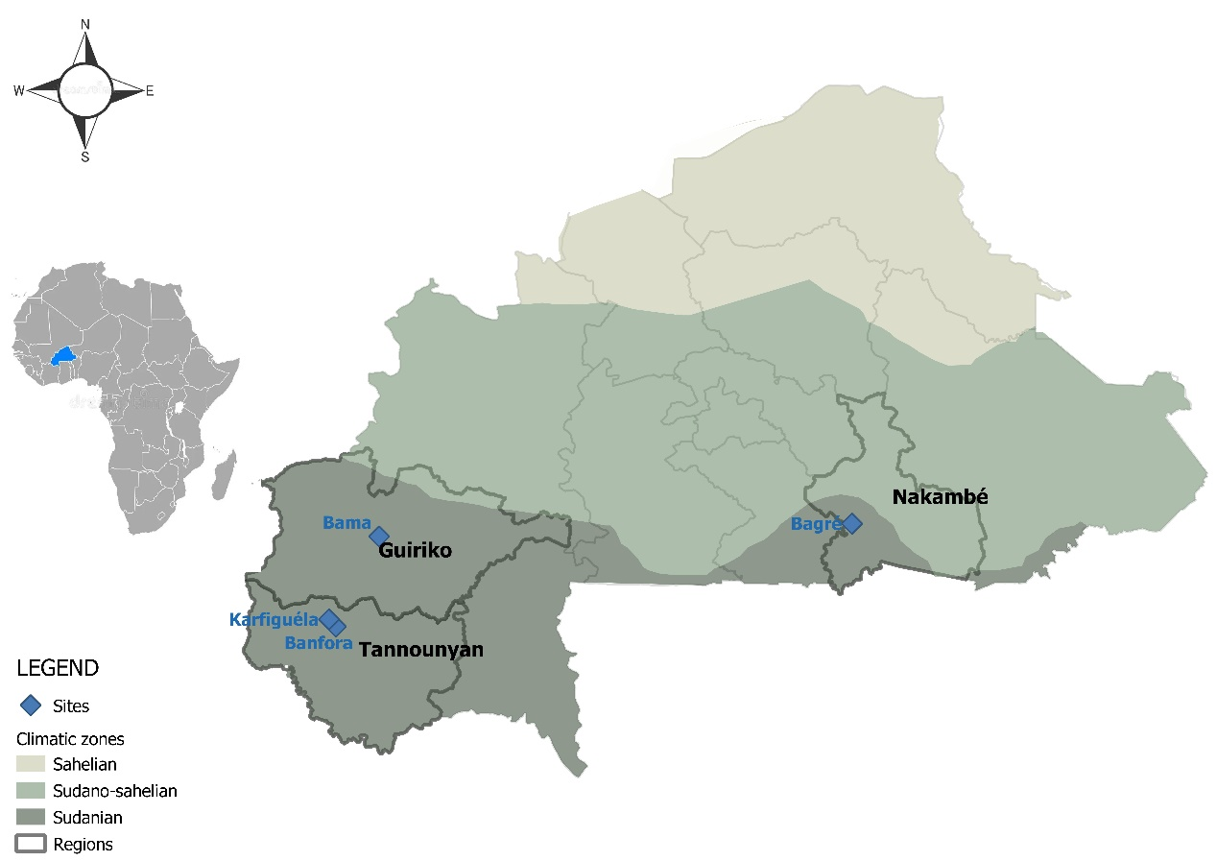
Figure 1 : Map showing sample collection sites

1.2 Extraction of total RNAs
Total RNAs have been extracted were extracted through using the Trizol extraction protocol (Eurogentec, Belgium) according to the supplier's recommendations. Rice leaf scales have been ground were ground with porcelain mortars and pestles, sterilized at 120°C for 2 hours and kept overnight stored overnight at -80°C. The shredded materials have been treated with Trizol to allow the lysis of the cells while maintaining the RNA integrity and the mixture was immediately placed on ice. Then, chloroform was added to the mixture followed by centrifugation at 14000 rpm for 15 min at 4°C. Then the supernatant was transferred to a new 1.5 mL RNase free tube. The total RNAs were precipitated with cold isopropanol and then stored at -20°C for 30 min. The mixture was centrifuged at 14000 rpm for 10 min at 4°C. The recovered pellet containing the total RNAs was then washed by adding 75% cold ethanol and centrifuged at 12000g for 5 minutes at 4°C. Finally, after removing the ethanol and drying the pellet, these total RNAs were eluted from the columns by adding 30 μL of sterile water for use in RT-PCR assays. Subsequently, the extracted RNAs were assayed by spectrophotometry at 260 nm using the Nanodrop 2000 spectrophotometer to determine the optical density of the viral samples.

1.3 Amplification of the capsid protein (CP) gene
At the level of the RSNV, the gene encoding the capsid protein (ORF1) is located at the level of the RNA2 of the virus. Amplifications for virus characterization are feasible from the capsid protein (CP). There are no data on the RSNV for the use of CP for amplification yet. As a result, this gene was selected in the present study for the study of diversity. The primer pair of sens SDrsnv_F2 (5’-GCGTGCGGGTGTCACCG-3’) and antisense SDrsnv_R3 (5'-GGTACATGTCCTGTGTGTT-3') specific to the RSNV (Sereme et al., 2014) were used. These primers generate a 549 bp amplification product of the CP.

1.3.1. Reverse transcription (RT)
The ORF1 of the RNA2 encoding the capsid protein was transcribed into complementary DNA (cDNA) using the antisense primer SDrsnv_R3 and enzyme from Moloney's murine leukemia virus (MMLV-RT) according to the method described by Pinel et al. (2000).
The total RNA extracted from the leaves was transcribed using reverse transcriptase, an enzyme from Moloney's murine leukemia virus (MMLV-RT) according to the supplier's recommendations (Promega). Briefly, an aliquot of 9 μL of total RNA was first denatured by incubation at 70°C for 5 min in the presence of 1 μL of SDrsnv_R3 primer (5'-GGTACATGTCCTGTGTGTGTT-3') at 100 μM. A mixture containing 10 μl of the previous (RNA + primer SDrsnv_R3) at 10 mM, 1 μl of dNTP at 10 mM (dATP, dGTP, dCTP, dTTP), 0.75 μl of the MMLV-RT enzyme 200 U/μl and 5 μl of 5x RT buffer was supplemented with sterile water for a total reaction volume of 25 μl. Reverse transcription was performed at 42°C for 1 h followed by incubation at 4°C for 5 min to stop the reaction.

1.3.2. PCR Amplification
The PCR reaction was performed with the Go Taq promega. For this purpose, a mixture containing 6 μl of retro-transcription product, 1 μl of each of the primers SDrsnv_F2 (5'-GCGTGCGGGTGTCCACCG-3') and SDrsnv_R3 (5'-GGTACATGTCCTGTGTGTGTT-3') at 10 Mm, 10 μl of Taq 5x Buffer, 0.1 μl of Go Taq Promega and 1 μl of dNTP for a total volume of 50 μl was prepared. Amplification was performed in a PTC-100 thermal cycler. The amplification program consisted of the following steps: initial denaturation (5 min, 94°C) followed by 30 denaturation cycles (1 min, 94°C), hybridization (30 sec, 55°C), elongation (1 min, 72°C) and a final elongation (10 min, 72°C).

1.4 Agarose gel electrophoresis
The amplification products were migrated to 1% agarose gel prepared in Tris-Acetate-EDTA buffer (TAE) and containing ethidium bromide (BET) at 0.5 μg/ml to verify the RT-PCR amplification reaction. A volume of 10 μL of each amplification product previously mixed with filler buffer (0.040% bromophenol, 7% glycerol, 6 mM EDTA) was deposited in the gel wells to allow migration at 100 V for 30 min. A 1kb molecular weight marker was deposited in parallel to assess the band size. After migration under an electrical voltage of 100 V in the TAE 0.5 x buffer, the DNA fragments were visualized using a UV trans-illuminator and then photographed using a digital camera (SAMSUNG ES74; 14.2 Mp).

1.5 Sequence analysis
When amplification was effective, the products were directly sequenced by the company GENEWIZ, using the same primers as for the PCR reactions. The resulting contigs were assembled using Seqman software to determine the entire gene sequences. These sequences were then translated using the EditSeq software and aligned in MegAlign. These software programs are bioinformatics programs that are part of DNASTAR's Lasergene package. Phylogenetic analyses were performed using the maximum likelihood method with the PHYML software (Guindon and Gascuel, 2003). Published sequences of CPc isolates taken from databases (accession No. EU099845) and RSNVbf (accession No. LK023710) from Colombia and Burkina Faso respectively were added to the sequences of the isolates tested for phylogenetic tree construction. One thousand (1000) replications were performed during the analysis in order to obtain the phylogenetic tree.

2. RESULTS
2.1 Analysis of RT-PCR products
The molecular characterization consisted of extracting the virus, the RNA. On these RNAs, RT-PCR experiments were conducted using the SDrsnv_R3 primers for retrotranscription and the SDrsnv_F2/SDrsnv_R3 primer pair for the amplification of retrotranscription products by PCR. A unique amplification product is detected at the expected size of about 500 bp (Figure 2) for RSNV. The specificity of the analyses was conferred by the primers used for amplification on RT-PCR products.
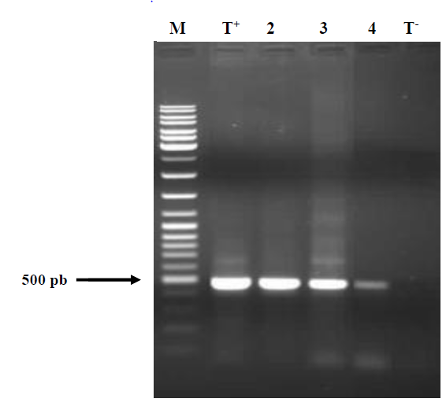
Figure 2: Amplification product, on 1% agarose gel of RSNV samples. Line M: Weight marker 1kb (MBI Fermentas, SM#033), lines T+: positive control (purified virus), line 2-4: RSNV samples collected in Banfora, Bagré and Karfiguéla respectively, line T-: Negative control made of healthy rice paper.

2.2 Distribution of RSNV positives isolates
Molecular analysis by RT-PCR confirmed the effective presence of RSNV in these 14 samples located in the Sudanian zone of Burkina Faso. The majority of these isolates come from Banfora, where the virus was first detected in Burkina Faso. Indeed, of the 14 positive samples, 6 (42.86%) come from Banfora (Tannounyan), 3 (21.43%) from Bagre (Nakambé), 3 (21.43%) from the Bama (Guiriko) and finally 2 (14.28%) from Karfiguela (Tannounyan). Table I presents the isolates obtained and their locations.

Table I: Localities of isolates tested positive by RT-PCR.
Code/isolate | Code/sequence | Place of origin
1 | SDR11 | Banfora
2 | SDR13 | Banfora
3 | SDR16 | Banfora
4 | SDR20 | Vallée du Kou
5 | SDR22 | Banfora
6 | SDR25 | Banfora
7 | SDR26 | Bagré
8 | SDR12 | Bagré
9 | SDR8 | Karfiguéla
10 | SDR15 | Vallée du Kou
11 | SDR23 | Bagré
12 | SDR3 | Banfora
13 | SDR1 | Karfiguéla
14 | SD27 | Vallée du Kou

2.3 Nucleotide divergences
Table II was made on the basis of the sequence alignment carried out under MegAlign. It shows the results of the alignment of the CP sequences of isolates carried out by the distance method. It highlights the similarities between the CP sequences of the characterized isolates. These results reveal a fairly variable nucleotide divergence between the different sequences. The nucleotide divergences between the sequences taken in pairs varied between 0.2% and 5.5%. The highest rate of divergence was recorded between sequences corresponding to isolates from Colombia and those from the Bama (cSDRCP/SDR20) and those from Karfiguela and Colombia (SDR8/cSDRCP). The lowest rate was recorded between sequences corresponding to isolates from the Bama and Banfora (SDR20/SDR16) and those from Bagre and Bama (SDR23/SDR20). Looking at the nucleotide divergence within isolates from Burkina Faso, we note a diversity of about 0.2% to 5.1% between isolates. The highest rate (5.1%) was recorded between the Banfora and Karfiguela sequences (SDR25/SDR8). It was lower (0.2%) between the sequences from the Bama and Banfora (SDR20/SDR13) and those from Bagre and the Bama (SDR23/SDR20) (Table II).

Table II: Nucleotide discrepancies (%) between RSNV isolates from Burkina Faso and Colombia.
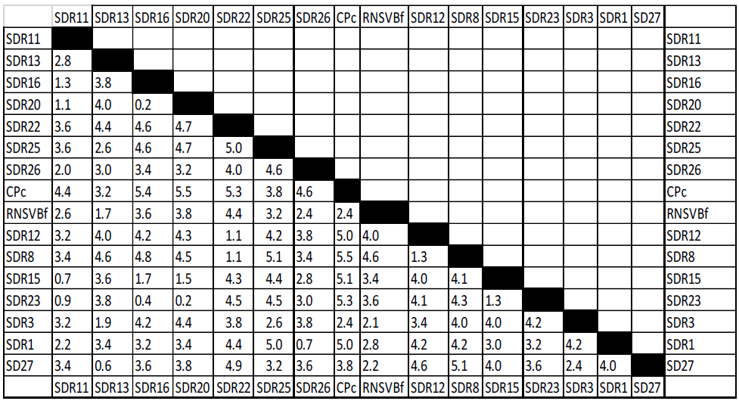

2.4 Phylogenetic tree
The phylogenetic tree derived from the analysis of the CP gene sequences of RSNV isolates is shown in Figure 2. The topology of the phylogenetic tree constructed from isolates from Burkina Faso highlighted three distinct groups. However, these groupings were not based on the geographic origin of individual isolates. The first group consists of isolates from Banfora (SDR16, SDR23, SDR15, SDR11 and SDR22), Vallée du Kou (SDR20), Bagre (SRFR23, SDR26 and SDR12) and Karfiguela (SDR1 and SDR8). The second group consists of isolates from Banfora (SDR3), the published isolate from Banfora (RSNVbf) and Colombia (CPc). Finally, the third group consists of isolates from Banfora (SDR13 and SDR25) and isolates from the Bama (SD27).
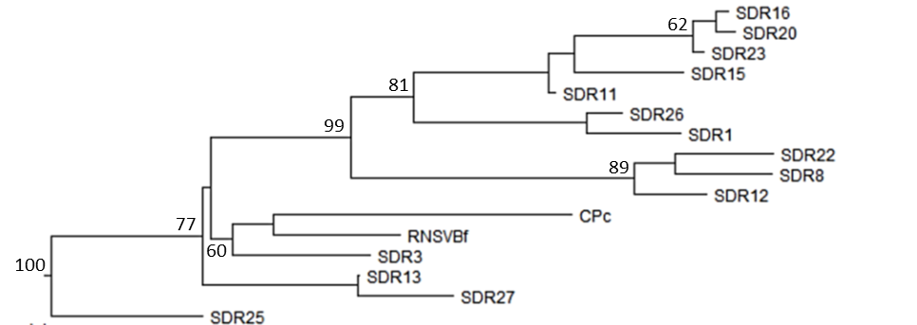
Figure 3: Phylogenetic tree indicating the affiliation of RSNV isolates. The tree was built using the so-called "Neighbor-Joining" method with 1000 bootstrap repetitions.

- DISCUSSION
The analysis of nucleotide diversity carried out from the capsid protein gene revealed a fairly large diversity with nucleotide divergences varying from 0.2% to 5.5%. These results are similar to those obtained by Maurino et al (2018). These authors obtained approximate divergence rates that varied from 0.1% to 4.6%. Our study consisted of studying the phylogeny of RSNV isolates from Burkina Faso. The phylogenetic tree constructed showed a filiation of the isolates in three groups. The isolate from Colombia is part of the second group consisting of isolates from Banfora and the Bama. These results are at odds with those of Maurino et al. (2018). These authors highlighted emphasized the isolation of the Colombian isolate from West African isolates, including those from Burkina Faso. These results could be explained on the one hand by the fact that these authors used different isolates from several countries (Argentina, Benin, Burkina Faso, Mali and Colombia) with different climates. On the other hand, this could be explained by the gene used for the study of genetic diversity which was the helicase gene (RNA2) for Maurino et al. (2018) and the CP gene (RNA2) in our study. However, the study of the nucleotide divergence of RSNV isolates from Burkina Faso shows that there is a diversity between the isolates characterized during our study. These results corroborate those of Maurino et al. (2018) who show diversity between RSNV isolates from Argentina, Benin, Burkina Faso, Mali and Colombia. Also, phylogenetic analysis showed a grouping of isolates regardless of their geographical origin. These results are contrary to those obtained in the RYMV by Pinel-Galzi et al. (2015); Trovão et al. (2015). Indeed, these authors showed that isolates from the same area formed a monophyletic group. Our results suggest transmission of the virus through seeds. When a pathogen is transmissible through seeds, it is easily spread from one area to another, resulting in the spread of strains from one area to another.

CONCLUSION
RSNV is a virus that has recently emerged and is mainly present in the Saudi area of the country where rice is widely grown. Molecular analysis identified 14 isolates from this area. It would be interesting to increase the number of sequences by sequencing a larger number of sequences. Also, our work highlighted a difference between the phylogeny performed with CP and that obtained from the helicase gene. Therefore, it will be interesting to fully sequence the genome of RSNV isolates and to compare the phylogenies made from partial sequences (CP, Helicase, Polymerase etc.) and the one obtained with the whole sequence. This will allow us to identify the best marker of diversity.

REFERENCES
Bagayoko I., Celli M.G., Romay G., Poulicard N., Pinel-Galzi A., Julian C., Filloux D., Roumagnac P., Sérémé D., Bragard C. and Hébrard E. (2021). Genetic Diversity of Rice stripe necrosis virus and New Insights into Evolution of the Genus Benyvirus. Viruses 2021, 13, 737. https://doi.org/10.3390/ v13050737
Correa F., Martínez C., Echeverry J., Valdez S., and Prado G. (2002). Rice Stripe Necrosis Virus: identification of resistance sources to the RSNV (crinkling orentorchamiento) under greenhouse inoculations. Annual Report 2001, Centro Internacional de Agricultura Tropical (CIAT), Cali, Colombia pp 162-166.
Emma-Louise Jaffré, (2022). Analyses of the pathogenesis of viruses transmitted by Polymyxa graminis and identification of sources of resistance in rice. Thesis project, University of Montpellier.
FAO (2014). Analysis of Price Incentives for Rice in Burkina Faso for the Period 2005-2013, 58p.
Fauquet C., and J.C. Thouvenel. (1983). Association of a new rod virus with striped necrosis f rice disease in Côte d'Ivoire. Séances Comptes Rendus de l'Académie des Sciences Paris 3: 575–580.
Gilmer D., and Ratti C. (2017). ICTV Report Consortium. ICTV virus taxonomy profile: Benyviridae. J. Gen. Virol., 98, 1571–1572.
Gutiérrez A.G., Silvio J.C., Olga X.G., César P.M., Fernando C., Gustavo P., Joe T., and Mathias L. (2010). Identification of a Rice Stripe Necrosis Virus resistance locus and yield component QTLs using Oryza sativa × O. glaberrima introgression lines. BMC Plant Biology, 10: 6 http://www.biomedcentral.com/1471-2229/10/6.
Lozano I. et Morales F. (2009). Molecular characterisation of Rice stripe necrosis virus as a new species of the genus Benyvirus. European Journal Plant Pathology. 124 (4) : 673680.
Maurinoa M. F., Peccib M., P., G., Krugerc R., D., Cúndomd M., A., Gutierrezd S., A. et Cellia M., G. (2018). First report of Rice stripe necrosis virus in Argentina, Crop protection, 114 :143–147.
Oludare A., Sow M., Afolabi O., Pinel-Galzi A. Hébrard E. et Silué D. (2015). First Report of Rice stripe necrosis virus Infecting Rice in Benin. Plant disease, 99 (12) : 2155p.
Pinel-Galzi A., Traoré O., Séré Y., Hébrard E., Fargette D. (2015). The biogeography of viral emergence: Rice yellow mottle virus as a case study. Current Opinion in Virology, 10 :7–13.
Sérémé D. Neya J.B., Bangratz M., Brugidou C. et Ouedraogo I. (2014). First report of rice strip necrosis virus infecting rice in Burkina Faso. Plant Disease 98: 1451
76.
Trovão N. S., Baele G., Vrancken B., Bielejec F., Suchard M. A., Fargette D., Lemey P. (2015). Host ecology determines the dispersal patterns of a plant virus. Virus Evolution Journal, 1, vev016. Virology, 145: 1621-1638. https://doi.org/10.1093/ve/vev016.

