Tree Vegetation Structure and Carbon dynamics of Himalayan community forests under the Van Panchayat system, Uttarakhand, India

Abstract
Community-managed forests play a critical role in biodiversity conservation, ecosystem functioning, and climate change mitigation in the Himalayan region. Under the Van Panchayat system of Uttarakhand, forests are managed through local institutions with varying degrees of protection and intervention, yet their contribution to carbon sequestration remains insufficiently quantified. This study assessed tree vegetation structure, biomass allocation, and ecosystem carbon stocks in two community forests, Akhandwali Bhilang (ABCF) and Rikhauli (RCF) of Uttarakhand, India. Vegetation sampling was conducted using line transects with 10 × 10 m quadrats, and phytosociological attributes were analyzed alongside non-destructive biomass estimation methods. Carbon stocks were quantified across aboveground, belowground, litter, and soil pools following IPCC guidelines. Results revealed substantial variation in stand structure and carbon storage between the two forests. ABCF exhibited higher tree density and stored significantly greater total biomass and carbon than RCF, despite lower species diversity. The findings demonstrate that Himalayan community forests function as effective carbon sinks even under low-intensity management, with carbon storage strongly regulated by stand density rather than species richness alone. Integrating basic silvicultural interventions with community governance could further enhance carbon sequestration and support REDD+ implementation in the region.
Keywords: Community forestry; Van Panchayat; Carbon stock; Biomass; Himalayan forests; REDD+

Introduction
Forests play a significant role in regulating the global carbon cycle by sequestering atmospheric carbon dioxide and storing it in biomass and soils. In tropical and subtropical regions, forest ecosystems account for a substantial proportion of terrestrial carbon stocks and contribute significantly to climate change mitigation (Pan et al. 2011). However, increasing anthropogenic pressure, land-use change, and forest degradation have altered forest structure and reduced carbon storage potential, particularly in human-dominated landscapes such as the Himalayan region (Lal 2005). In the Indian Himalaya, certain forested landscapes are governed under community-based management systems, of which the Van Panchayat system of Uttarakhand represents one of the oldest and most extensive institutional frameworks. Established in the early twentieth century, Van Panchayats entrust local communities with collective rights and responsibilities over forest management, primarily to meet subsistence needs while maintaining forest cover (Pathak et al. 2021). Long-term human–forest interactions under this system have resulted in forests that differ widely in stand density, species composition, regeneration status, and disturbance intensity, thereby influencing ecosystem processes and carbon dynamics. Studies suggested that community-managed forests can deliver dual benefits by supporting rural livelihoods and enhancing carbon sequestration, particularly when efficient management is in effect (Chhatre and Agrawal 2009; Pandey et al. 2014). However, evidence from the Himalayan region indicates that many Van Panchayat forests remain weakly managed, experiencing chronic pressures from grazing, fuelwood extraction, and selective harvesting. Such pressures often lead to reduced regeneration, simplified stand structure, and limited soil carbon recovery, potentially constraining long-term carbon sink capacity (Sharma et al. 2010; Gairola et al. 2015). Despite growing policy interest in integrating community forestry into climate mitigation initiatives such as REDD+, empirical data on vegetation structure and multi-pool carbon stocks from Van Panchayat forests remain limited and site-specific. In particular, comparative assessments that link stand structural attributes with ecosystem carbon storage are scarce for the western Himalayan foothills. In light of this, the present study aims to (i) analyze tree vegetation structure and species composition in selected Community forests (Van Panchayat) of Uttarakhand, (ii) quantify biomass and carbon stocks across major ecosystem pools, and (iii) evaluate how differences in stand density and structure influence carbon sequestration potential. By providing field-based evidence from Himalayan community forests, this study seeks to inform sustainable forest management strategies and support the integration of Van Panchayat systems into regional and national climate mitigation frameworks. This study provides empirical, field-based evidence on how stand structure and community-level management influence biomass and carbon storage in Himalayan Van Panchayat forests, a governance system that remains underrepresented in carbon accounting literature. By integrating detailed vegetation analysis with carbon pool estimation, the research advances understanding of density- versus structure-driven carbon sequestration pathways in community-managed forests. The findings are directly relevant for improving forest management strategies, strengthening Van Panchayat institutions, and informing REDD+ and state-level climate mitigation initiatives in the Indian Himalaya. Importantly, the study highlights the potential of low-intensity, community-based management to deliver measurable climate benefits while maintaining local livelihood functions, thereby contributing to the broader discourse on sustainable forest governance and nature-based solutions.

Materials and Methods
Study area
Dehradun is situated in the western Himalaya, between 29°58′–30°32′ N latitude and 77°34′–78°18′ E longitude, bounded by the Lesser Himalaya in the north and the Shivalik ranges in the south. Elevation ranges from approximately 300 to 1,000 m above mean sea level (Champion and Seth 1968), and the region experiences a humid subtropical to sub-temperate monsoonal climate, with hot summers, cool winters, and mean annual rainfall of about 2,000–2,200 mm, largely concentrated between June and September (India Meteorological Department 2020). The natural vegetation is dominated by tropical moist deciduous and subtropical forest types, with Shorea robusta (sal) as the principal species, accompanied by Mallotus philippensis, Terminalia tomentosa, and Syzygium cumini (Champion and Seth 1968; Singh and Singh 1992). Soils are primarily alluvial and colluvial, varying from sandy loam to silty clay loam, generally well-drained, slightly acidic to neutral, and relatively rich in organic carbon under forest cover (Sharma et al. 2010; Bargali et al. 2018). The study was carried out during 2024-25 in community-managed forests (CF), locally known as Van Panchayat, of Uttarakhand, India. Dehradun tehsil has total 103.43 ha area managed under five Van Panchayats since year 2005. These van panchayats fall in Raipur and Mussoorie Forest Ranges. One Van Panchayat from each range namely Akhandwali Bhilang (30.175914° N, 78.04686° E) and Rikhauli (30.253870° N, 78.04979° E) were selected for the study covering an area of 37.37 ha and 11.38 ha, respectively (Table I; Figure 1).

Table I: Characteristics of Community Forests
Particulars | Akhandwali-Bhilang Community Forest (ABCF) | Rikhauli Community Forest (RCF)
Total Area (ha) | 37.37 | 11.38
Elevation (m) | 568 | 525
Land type | Hilly | Hilly
Forest type | Mixed | Mixed
Year of establishment | 2005 | 2005
Management | Not active | Not active
History | Open government forest land | Open government forest land
Activity | Grazing, firewood collection | Grazing, firewood collection

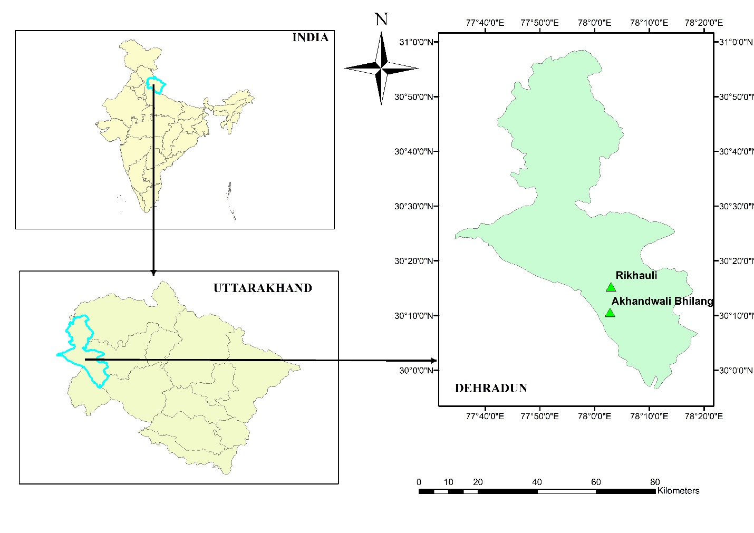
Figure 1: Map of study area
Sampling
Using the Line transect, ten quadrats of 10 × 10 m² were laid, separately, in both the sites. A minimum distance of 100 m was maintained between consecutive points. Within each quadrat, 1 × 1 m² sub-quadrat was placed for litter collection (Causton 1988; Buckland et al. 2007). The soil samples were collected from each quadrat and composite samples were obtained for two soil layers i.e. 0–15 cm and 15–30 cm.
Vegetation analysis
All trees with GBH > 10 cm were measured at 1.37 m height following Parthasarathy & Kartikeyan (1997), and GBH was converted to DBH using the factor π (3.14). Quantitative vegetation parameters i.e. frequency and density were determined. Species diversity was assessed using the Shannon-Wiener Index (Shannon and Weaver 1949), Margalef’s Richness Index (Margalef 1958), Simpson’s Dominance Index (Simpson 1949), and Pielou’s Evenness Index (Pielou 1966). The Important Value Index (IVI) was derived by summing relative frequency, relative density, and relative basal area (Phillips 1959). The distributional pattern of the of the species was calculated as regular (<0.025), random (0.025-0.05) and contagious (>0.05) distribution (Curtis and Cottam 1956). Species identification was carried out using Uniyal et al. (2007), whereas the status of each plant binomial was confirmed by using the Plants of the World Online Database (https://powo.science.kew.org/).
Tree Biomass
Non-destructive method was used to quantify tree biomass. The Above Ground Biomass (AGB) of tree was determined using the allometric equation (Rawat and Singh 1988).
$ln AGB =0.349+1.316 lnGBH$
Below Ground Biomass (BGB) was estimated as AGBx0.246 (IPCC 2019), and total tree biomass was obtained as AGB + BGB (Brown et al. 1989).
Litter biomass
Litter biomass was quantified by collecting all the dead plant material (leaves, twigs, bark) from 1m × 1m sub-quadrats. The collected litter oven-dried at 60±5 °C to constant weight, and litter biomass was computed as dry weight per unit area (Brown et al. 1989).
Carbon stock estimation
Tree carbon stock was calculated by multiplying tree biomass with IPCC default value 0.5 (IPCC 2019). The litter carbon was obtained by multiplying litter biomass with the factor 0.37 (Smith and Heath 2001; IPCC 2006). Soil Organic Carbon (SOC) was estimated using the Walkley and Black (1934) wet digestion method. The measured organic carbon percentage was corrected using a factor of 1.33. Bulk density was measured by the soil core method (Blake 1965).
SOC stock in Mgha⁻¹ was computed following Mohanrana et al. (2021)
$$SOC stock=\frac{SOC\% x BD Mg m-3 x Depth m x 104 m2 ha-1}{100}$$
The total carbon stock of each Van Panchayat was obtained by summing the contributions from trees, litter, and soil in Mgha⁻¹. This provided an integrated estimate of the carbon storage potential of the community-managed forests. The carbon stock converted into CO₂ equivalent using the factor 3.67(IPCC 2006, 2019).
Statistical Analysis
The sum and mean of the different parameters were computed using descriptive analysis tools. The differences in soil, vegetation, biomass, and carbon stock between the community forests were analyzed using a student’s t-test. Values were declared significant at P<0.05. Statistical analysis was performed using R Studio Software Version 4.5.2.

Results and Discussion
Stand structure and species composition
The two Himalayan community forests, Akhandwali–Bhilang Community Forest (ABCF) and Rikhauli Community Forest (RCF), exhibited marked differences in stand structure and species dominance (Table II and III) consistent with variability reported across Van Panchayat forests of Uttarakhand reported by Gairola et al. (2015) and Pathak et al. (2021). In ABCF, dominance of fast-growing multipurpose broadleaved species such as B. variegata and F. auriculata resulted in high Importance Value Index (IVI) and dense stocking, a pattern typical of moderately protected Van Panchayat forests. In contrast, RCF was characterized by fewer but larger-girth individuals (A. procera, M. longifolia, T. bellirica, T. ciliata), indicating a structurally mature stand with limited recruitment, an increasingly common condition in Himalayan community forests experiencing grazing and selective harvesting. F. auriculata, A. procera & M. philippensis were uniformly distributed in study sites whereas most of the tree species showed clumped distribution in ABCF and random distribution in RCF. ABCF supported substantially higher tree density (760 trees ha⁻¹) than RCF (380 trees ha⁻¹), whereas RCF displayed higher species diversity (H′ = 2.57) and evenness (J = 0.95). Similar density–diversity results have been documented in community-managed Himalayan forests subjected to differing levels of protection and extraction pressure (Adhikari et al. 2007; Sharma et al. 2010).
Table II: Tree Density (D), Important Value Index (IVI) & A/F of tree species in community managed forests of Uttarakhand

Species | Family | ABCF |  |  | RCF
Species | Family | D | IVI | A/F | D | IVI | A/F
Albizia procera (Roxb.) Benth. | Fabaceae | - | - | - | 20 | 22.23 | 0.02
Bauhinia variegata L. | Fabaceae | 250 | 105.90 | 0.04 | 20 | 11.12 | 0.10
Bombax ceiba L. | Malvaceae | - | - | - | 10 | 7.25 | 0.05
Celtis australis L. | Cannabaceae | 70 | 24.11 | 0.04 | - | - | -
Citrus maxima (Burm.) Osbeck | Rutaceae | 20 | 7.89 | 0.05 | - | - | -
Ficus auriculata Lour. | Moraceae | 110 | 51.61 | 0.02 | 50 | 38.12 | 0.01
Ficus benghalensis L. | Moraceae | 10 | 5.08 | 0.10 | - | - | -
Ficus religiosa L. | Moraceae | 10 | 3.79 | 0.10 | 10 | 7.29 | 0.05
Grewia optiva J.R.Drumm. ex Burret | Malvaceae | 70 | 17.25 | 0.70 | 10 | 6.96 | 0.05
Lannea coromandelica (Houtt.) Merr. | Anacardiaceae | 10 | 3.74 | 0.10 | 20 | 9.73 | 0.10
Madhuca longifolia var. latifolia (Roxb.) A.Chev. | Sapotaceae | - | - | - | 10 | 7.68 | 0.05
Mallotus philippensis (Lam.) Mull.Arg. | Euphorbiaceae | 10 | 3.73 | 0.10 | 20 | 13.98 | 0.02
Mangifera indica L. | Anacardiaceae | 40 | 19.33 | 0.04 | 30 | 22.00 | 0.03
Phanera vahlii (Wight & Arn.) Benth. | Fabaceae | - | - | - | 30 | 21.65 | 0.03
Phyllanthus emblica L. | Phyllanthaceae | 10 | 3.74 | 0.10 | 10 | 7.37 | 0.05
Premna mollissima Roth. | Lamiaceae | 30 | 9.99 | 0.08 | - | - | -
Prunus cerasoides Buch.-Ham. ex D.Don | Rosaceae | 20 | 5.39 | 0.20 | - | - | -
Pterospermum acerifolium (L.) Willd. | Malvaceae | 10 | 3.80 | 0.10 | - | - | -
Saraca asoca (Roxb.) Willd. | Fabaceae | 10 | 3.95 | 0.10 | - | - | -
Senna siamea (Lam.) H.S.Irwin & Barneby | Fabaceae | 50 | 18.96 | 0.03 | - | - | -
Syzygium cumini (L.) Skeels | Myrtaceae | 10 | 3.95 | 0.10 | 30 | 23.14 | 0.03
Syzygium jambos (L.) Alston | Myrtaceae | 10 | 3.73 | 0.10 | - | - | -
Terminalia bellirica (Gaertn.) Roxb. | Combretaceae | - | - | - | 70 | 61.32 | 0.08
Terminalia chebula Retz. | Combretaceae | 10 | 4.08 | 0.10 | - | - | -
Toona ciliata M.Roem. | Meliaceae | - | - | - | 40 | 34.83 | 0.05

Table III: Phytosociological parameters of community-managed forests in Uttarakhand

Parameters | ABCF | RCF
No. of species | 19 | 15
No. of genus | 16 | 13
No. of Families | 12 | 10
Tree density (trees ha⁻¹) | 760 | 380
Shannon diversity index (H') | 2.31 | 2.57
Simpson dominance index (D) | 0.16 | 0.09
Margalef species richness (d) | 4.16 | 3.84
Pielou’s evenness index (J) | 0.78 | 0.95

Biomass allocation and ecosystem carbon stocks
Total ecosystem biomass and carbon stock differed significantly between the two forests (Table IV, V, VI). ABCF accumulated 350.76 Mg ha⁻¹ of total biomass and 175.77 Mg C ha⁻¹, compared to 261.81 Mg ha⁻¹ and 131.37 Mg C ha⁻¹ in RCF, representing approximately 34% higher carbon storage in ABCF. These values fall within the reported range for mid-elevation Himalayan broadleaved forests (Sharma et al. 2010; Gairola et al. 2015). Correspondingly, total carbon stock was higher in ABCF than in RCF, translating to CO₂ equivalents of 645.09 and 482.14 Mg ha⁻¹, respectively. Aboveground biomass constituted the dominant carbon pool in both forests (>79%), while belowground biomass contributed ~19%, consistent with biomass partitioning patterns observed across Himalayan Forest ecosystems (Lal 2005; Sharma et al. 2010). Litter and soil carbon pools were comparatively small, reflecting continued biomass extraction and grazing pressure, which constrain litter accumulation and soil carbon stabilization in Van Panchayat forests (Pandey et al. 2014). At the species level, B. variegata, F. auriculata, M. indica, and S. siamea contributed disproportionately to biomass and carbon storage in ABCF, while T. bellirica, T. ciliata, and S. cumini were major contributors in RCF.
Species-level analysis further revealed contrasting carbon allocation strategies. In ABCF, carbon storage was distributed across multiple medium- to large-sized individuals, enhancing cumulative ecosystem carbon. In RCF, carbon was concentrated in a limited number of large trees, restricting overall carbon accumulation despite higher evenness. Consequently, ABCF stored higher CO₂ equivalents (645.09 Mg ha⁻¹) than RCF (482.14 Mg ha⁻¹), underscoring the importance of stem density in regulating landscape-scale carbon stocks (Chhatre and Agrawal 2009; Kaushal and Bhaishya 2021). Soil carbon contribution was relatively low but varied significantly between sites (0.85 Mg C ha⁻¹ in ABCF and 0.70 Mg C ha⁻¹ in RCF).
Table IV: Species-wise GBH (cm), AGB, BGB, TB, CS, CO₂ Equivalent (Mg ha⁻¹) and cluster analysis in Akhandwali-Bhilang Community Forest (ABCF)

Species | GBH | AGB | BGB | TB | CS | CO₂ EQ. | Cluster
Bhauhinia variegata | 57.84 | 76.24 | 18.30 | 94.54 | 44.43 | 163.07 | 2
Celtis australis | 58.75 | 24.37 | 5.85 | 30.22 | 14.20 | 52.13 | 2
Citrus maxima | 63.00 | 6.66 | 1.60 | 8.26 | 3.88 | 14.25 | 2
Ficus auriculata | 73.45 | 45.33 | 10.88 | 56.20 | 26.42 | 96.95 | 2
Ficus bengalensis | 210.00 | 16.12 | 3.87 | 19.99 | 9.40 | 34.48 | 3
Ficus religiosa | 54.00 | 2.70 | 0.65 | 3.35 | 1.57 | 5.77 | 1
Grewia optiva | 60.71 | 22.49 | 5.40 | 27.89 | 13.11 | 48.10 | 2
Lannea coromandelica | 38.00 | 1.70 | 0.41 | 2.11 | 0.99 | 3.64 | 1
Mallotus philippensis | 32.00 | 1.36 | 0.33 | 1.68 | 0.79 | 2.90 | 1
Mangifera indica | 117.50 | 30.60 | 7.34 | 37.94 | 17.83 | 65.44 | 2
Phyllanthus emblica | 35.00 | 1.53 | 0.37 | 1.89 | 0.89 | 3.26 | 1
Premna mollissima | 73.00 | 8.03 | 1.93 | 9.96 | 4.68 | 17.18 | 2
Prunus cerasoides | 55.00 | 5.53 | 1.33 | 6.86 | 3.22 | 11.84 | 1
Pterospermum acerifolium | 56.00 | 2.83 | 0.68 | 3.51 | 1.65 | 6.06 | 1
Saraca asoca | 89.00 | 5.21 | 1.25 | 6.46 | 3.04 | 11.14 | 2
Senna siamea | 60.40 | 15.86 | 3.81 | 19.67 | 9.24 | 33.93 | 2
Syzygium cumini | 89.00 | 5.21 | 1.25 | 6.46 | 3.04 | 11.14 | 2
Syzygium jambos | 32.00 | 1.36 | 0.33 | 1.68 | 0.79 | 2.90 | 1
Terminalia chebula | 110.00 | 6.88 | 1.65 | 8.54 | 4.01 | 14.72 | 2

Table V: Species-wise GBH (cm), AGB, BGB, TB, CS, CO₂ Equivalent (Mg ha⁻¹) and cluster analysis in Rikhauli Community Forest (RCF)

Species | GBH | AGB | BGB | TB | CS | CO₂ EQ. | Cluster
Albizia procera | 163.50 | 23.31 | 5.59 | 28.91 | 13.59 | 49.86 | 3
Bauhinia purpurea | 87.33 | 15.29 | 3.67 | 18.96 | 8.91 | 32.70 | 2
Bauhinia variegata | 74.50 | 8.34 | 2.00 | 10.34 | 4.86 | 17.84 | 1
Bombax ceiba | 86.00 | 4.98 | 1.20 | 6.17 | 2.90 | 10.65 | 2
Ficus auriculata | 65.40 | 17.55 | 4.21 | 21.77 | 10.23 | 37.54 | 1
Ficus religiosa | 89.00 | 5.21 | 1.25 | 6.46 | 3.04 | 11.14 | 2
Grewia optiva | 63.00 | 3.31 | 0.79 | 4.10 | 1.93 | 7.07 | 1
Lannea coromandelica | 85.50 | 9.91 | 2.38 | 12.29 | 5.78 | 21.20 | 2
Madhuca longifolia | 112.00 | 7.05 | 1.69 | 8.74 | 4.11 | 15.08 | 2
Mallotus philippensis | 46.50 | 4.48 | 1.08 | 5.56 | 2.61 | 9.58 | 1
Mangifera indica | 90.00 | 15.99 | 3.84 | 19.83 | 9.32 | 34.20 | 2
Phyllanthus emblica | 94.00 | 5.60 | 1.34 | 6.94 | 3.26 | 11.97 | 2
Syzygium cumini | 98.00 | 18.20 | 4.37 | 22.57 | 10.61 | 38.94 | 2
Terminalia bellerica | 98.86 | 42.38 | 10.17 | 52.55 | 24.70 | 90.65 | 2
Toona ciliata | 110.25 | 28.07 | 6.74 | 34.81 | 16.36 | 60.05 | 2

Table VI: Total biomass (Mg ha⁻¹) and carbon stock (Mg C ha⁻¹) in different pools of community-managed forests of Uttarakhand

Carbon pools | Biomass |  | Carbon |  | CO2 equivalent
Carbon pools | ABCF | RCF | ABCF | RCF | ABCF | RCF
Aboveground | 279.99* | 209.68* | 140.00* | 104.84* | 513.80* | 384.76*
Belowground | 67.20* | 50.32* | 33.60* | 25.16* | 123.31* | 92.34*
Litter | 0.35 | 0.36 | 0.13 | 0.14 | 0.49 | 0.49
Soil | - | - | 0.85* | 0.70* | 3.13* | 2.58*
Total | 350.76 | 261.81 | 175.77 | 131.37 | 645.09 | 482.14
*Indicates significant difference between the values of same row at P<0.05

Cluster analysis
Hierarchical cluster analysis was employed to evaluate the degree of similarity among the studied tree species based on the biomass. The dendrogram revealed a clear hierarchical structure, indicating significant interspecific variation for biomass hence carbon sequestration and the presence of distinct similarity groups among the species in both sites (Figure 2a, 2b). Albizia procera & Ficus bengalensis formed a separate cluster, exhibits the greatest dissimilarity in comparison to the remaining species, suggesting unique characteristics in terms of biomass contribution in RCF and ABCF, respectively. Such divergence may be attributed to species-specific morphological, anatomical, or physiological characteristics, highlighting its unique ecological or functional attributes. The remaining species in both sites were grouped into two major cluster, species within a cluster suggests high degree of similarity, which reflect shared growth patterns. The separation of the two major cluster indicates distinct differences in the biomass, possibly associated with variations in wood properties, ecological preferences, or physiological responses. The hierarchical clustering demonstrated clear differentiation among species and confirmed the effectiveness of the biomass in capturing meaningful biological variation. This information is valuable to understand species behavior, ecological adaptation, and for informing forest management and conservation strategies.

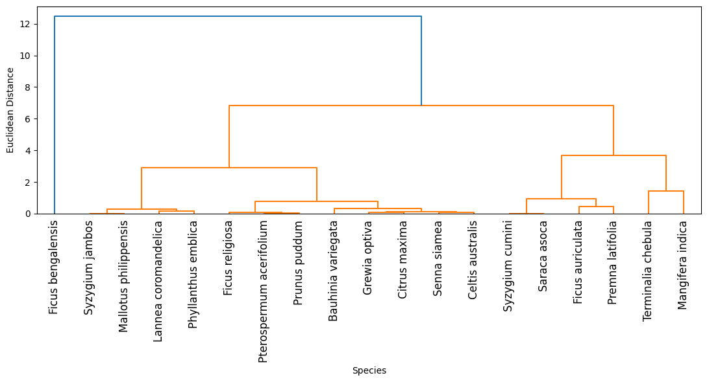
Figure 2a: Dendrogram showing cluster of tree species on the basis of biomass produced in ABCF

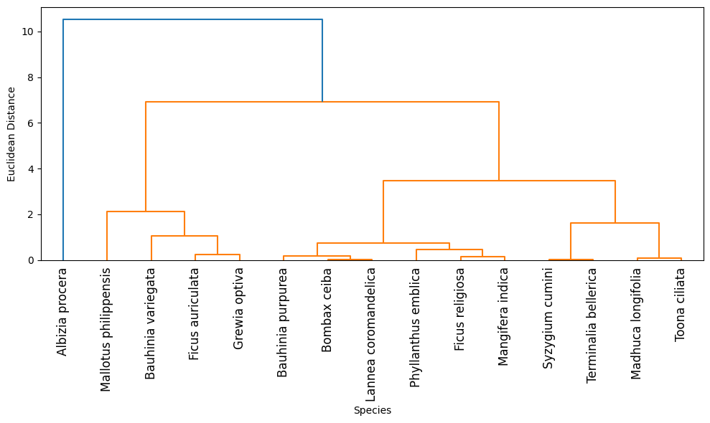
Figure 2b: Dendrogram showing cluster of tree species on the basis of biomass produced in RCF

Cause-mechanism-implication synthesis
The differences in carbon storage observed between the two forests appear to be driven mainly by stand density rather than species richness, a finding consistent with previous studies from community forests in the central Himalaya (Sharma et al. 2010; Gairola et al. 2015). In ABCF, the high density of stems and the dominance of fast-growing broad-leaved species contributed to greater overall biomass accumulation. This indicates a density-driven carbon sequestration mechanism, where a larger number of trees collectively store more carbon. In contrast, RCF represents a size-driven mechanism, where carbon storage is constrained by low stocking density despite the presence of large trees. Both forests function as net carbon sinks, highlighting the climate mitigation value of Van Panchayat forests even under low-intensity management. However, the limited soil carbon contribution suggest that protection alone may lead to carbon saturation over time (Luyssaert et al. 2008; Pan et al. 2011). Management strategies such as assisted natural regeneration, grazing regulation, and selective thinning have been shown to enhance biomass productivity, improve soil carbon inputs, and increase long-term carbon permanence in Himalayan community forests (Pandey et al. 2014; Skutsch and Ba 2010).
Conclusion
This study demonstrates that Himalayan Van Panchayat forests store substantial ecosystem carbon and function as effective community-based carbon sinks, corroborating earlier regional assessments. Forests with higher stem density stored up to 34% more carbon than structurally mature but sparsely stocked stands, emphasizing the critical role of regeneration and stocking density in determining carbon outcomes. However, the relatively small soil carbon pool indicates persistent ecological constraints may linked historical disturbance and ongoing resource use like grazing (Lal 2005). Importantly, the higher carbon stock in ABCF demonstrates that even low-intensity community protection can significantly enhance carbon sequestration, even in the absence of intensive silvicultural management. When aligned with broader Himalayan evidence, these results support the view that unmanaged or weakly managed community forests act as passive carbon sinks, relying on stem density and legacy biomass. Strategic interventions—such as assisted natural regeneration, grazing regulation, and selective thinning—could further improve stand structure, enhance soil carbon inputs, and stabilize long-term carbon storage. Strengthening Van Panchayat governance while retaining community access thus represents a viable pathway for climate mitigation and livelihood co-benefits in the Himalayan region. From a policy perspective, these findings strongly support the inclusion of Van Panchayat forests within REDD+ and state-level forest carbon initiatives (Bayrak and Marafa 2016). Community protection alone generates measurable climate benefits, but integrating low-cost silvicultural interventions and strengthening local governance can substantially enhance additionality, permanence, and co-benefits (Skutsch and Ba 2010; Pandey et al. 2014). Himalayan community forests should therefore be recognized not only as conservation landscapes but as high-potential, climate-responsive socio-ecological systems.

COMPETING INTERESTS DISCLAIMER:
Authors have declared that they have no known competing financial interests OR non-financial interests OR personal relationships that could have appeared to influence the work reported in this paper.

References
Adhikari B, Williams F, Lovett JC (2007) Local benefits from community forests in the middle hills of Nepal. Forest Policy and Economics 9:464–478.
Bargali SS, Bargali K, Singh L, Ghosh L, Lakhera ML (2018) Acacia nilotica based agroforestry system: Effect on soil properties and biological activities in semi-arid region of India. Journal of Forestry Research 29:1–12.
Bayrak MM, Marafa LM (2016) Ten Years of REDD+: A Critical Review of the Impact of REDD+ on Forest-Dependent Communities. Sustainability 8(7):620.
Blake GR (1965) Bulk density. In: Black CA, editors. Methods of Soil Analysis: Part 1 Physical and Mineralogical Properties, Including Statistics of Measurement and Sampling New York: Academic Press. pp 374–390.
Brown S, Gillespie AJR, Lugo AE (1989) Biomass estimation methods for tropical forests with applications to forest inventory data. Forest Science 35(4):881-902.
Buckland ST, Borchers DL, Johnston A, Henrys PA, Marques TA (2007) Line Transect Methods for Plant Surveys. Biometrics 63(4):989–998.
Causton DR (1988) An introduction to vegetation analysis: Principles, practice and interpretation. London: Academic Division of Unwin Hyman Ltd
Champion HG, Seth SK (1968) A Revised Survey of the Forest Types of India. New Delhi: Government of India Press.
Chhatre A, Agrawal A (2009) Trade-offs and synergies between carbon storage and livelihood benefits from forest commons. Proceedings of the National Academy of Sciences of the United States of America 106:17667–17670.
Curtis JT and Cottam G (1956) Plant ecology work book. Laboratory Field Reference Manual. Minnesota: Burgees Publication.
Gairola S, Sharma CM, Ghildiyal SK, Suyal S (2015) Live tree biomass and carbon variation along an altitudinal gradient in moist temperate valley slopes of the Garhwal Himalaya (India). Current Science 100(12):1862–1870.
India Meteorological Department (IMD) (2020) Climatological Tables of Observatories in India. Pune: IMD.
IPCC (2006) Good Practice Guidance for Land Use, Land-Use Change and Forestry. Intergovernmental Panel on Climate Change.
IPCC (2007) The physical science basis. Contribution of Working Group I to the Fourth Assessment Report of the Intergovernmental Panel on Climate Change. Cambridge, United Kingdom and New York: Cambridge University Press. pp113-119.
IPCC (2019) 2019 Refinement to the 2006 IPCC Guidelines for National Greenhouse Gas. Volume 4: Agriculture, Forestry and Other Land Use. https://www.ipcc-nggip.iges.or.jp/public/2019rf/vol4.html
Kaushal S, Baishya R (2021) Stand structure and species diversity regulate biomass carbon stock under major Central Himalayan Forest types of India. Ecological Processes 10:14.
Lal R (2005) Forest soils and carbon sequestration. Forest Ecology and Management 220(1-3):242–258.
Luyssaert S, Schulze E-Detlef, Borner Annett, Knohl Alexander, Hessenmoller Dominik, Law Beverly E, Ciais Philippe and Grace John (2008) Old-growth forests as global carbon sinks. Nature 455:213–215.
Moharana Pravash Chandra, Jena Roomesh Kumar, Kumar Nirmal, Singh Ram Sakal, Rao Sajjan Singh (2021) Assessment of soil organic and inorganic carbon stock at different soil depths after conversion of desert into arable land in the hot arid regions of India. Carbon Management 12(2):153-165.
Margalef R (1958) Information Theory in Ecology. General Systems Yearbook 3:36–71.
Ministry of Environment, Forest and Climate Change (MoEFCC) (2020) Annual Report 2019–20. New Delhi: Government of India.
Pan Yude, Birdsey Richard A, Fang Jingyun, Houghton Richard, Kauppi Pekka E, Kurz Werner A, Phillips Oliver L, Shvidenko Anatoly, Lewis Simon L, Canadell Josep G, Ciais Philippe, Jackson Robert B, Pacala Stephen W, McGuire A David, Piao Shilong, Rautiainen Aapo, Sitch Stephen, Hayes Daniel (2011) A large and persistent carbon sink in the world’s forests. Science 333: 988-993.
Pandey SS, Maraseni TN, Cockfield G (2014) Carbon stock dynamics in different vegetation dominated community forests under REDD+: A case from Nepal. Forest Ecology and Management 327:40-47.
Pathak Ravi, Thakur Shinny, Negi Vikram S, Rawal Ranbeer S, Bahukhandi Amit, Durgapal Kamini, Barola Anjali, Tewari Deep, Bhatt Indra D (2021) Ecological condition and management status of Community Forests in Indian western Himalaya. Land Use Policy 109:105636.
Phillips E A (1959) Methods of vegetation study. Holt, Rinehart and Winston.
Pielou EC (1966) The measurement of diversity in different types of biological collections. Journal of Theoretical Biology 13(1):131-144.
Rawat GS, Singh JS (1988) Structure and functions of montane subtropical forest ecosystems of north‐western Himalaya, India. Vegetation 73(2-3):97-112.
Shannon CE, Weaver W (1949) The Mathematical Theory of Communication. Urbana: University of Illinois Press.
Sharma CM, Baduni NP, Gairola S, Ghildiyal SK, Suyal S (2010) Tree diversity and carbon stocks of some major forest types of Garhwal Himalaya, India. Forest Ecology and Management 260(12):2170–2179.
Simpson EH (1949) Measurement of diversity. Nature 163(4148):688.
Singh JS, Singh SP (1992) Forest of Himalaya: Structure, Functioning and Impact of Man. Nainital: Gyanodaya Prakashan.
Skutsch M, Ba L (2010) Crediting carbon in dry forests: The potential for community forest management. Forest Policy and Economics 12:264–270.
Smith JE, Heath LS (2001) Identifying influences on model uncertainty: an application using a forest carbon budget model. Environmental Management 27:253–267.
Uniyal BP, Sharma JR, Chaudhery U, Sing D K (2007) Flowering Plants of Uttarakhand (A Checklist). Dehradun: Bishen Singh Mahendra Pal Singh.
Walkley A, Black IA (1934) An examination of the Degtjareff method for determining soil organic matter, and a proposed modification of the chromic acid titration method. Soil Science 37(1):29-38.

