Fertilization of Two Triticum aestivum L. Varieties with Compost and Mycorrhizae under the High Guinean Savannah Climate of Cameroon

Abstract
The present study aimed to evaluate the effect of various natural fertilizers on growth and seed yield of wheat plants. Field experiments were conducted out during the 2023 cropping season. A split-plot experimental design with three replications. The first factor was fertilization, with five treatments (negative control: seedlings receiving no fertilizer (T0), positive control: synthetic chemical fertilizer 20-10-10 + Urea 46% (T1), compost derived from cow dung manure (T2); mycorrhizal inoculum (T3), compost derived from poultry litter (T4)); the second factor was variety, with 02 wheat varieties (IRAD1 and IRAD2). Wheat growth parameters and seed yield were evaluated. The results showed that the growth and seed yield of wheat varied significantly (p<0.05) depending on the fertilizer, overall, no significant differences were observed between wheat varieties for the studied parameters. Plants that received the T2 treatment exhibited significantly (p ˂ 0.05) the highest values of the studied parameters (plant height, foliar production, number of ear per plant, seed yield, and incidence of wheat diseases). The wheat seed yield of T2 plants of IRAD1 variety was 2.66-fold and 1.66-fold higher than that of T0 and T1 plants respectively. T2 organic fertilizer improved the seed yield of IRAD2 variety at 71.17% and 92.29% compared to chemical fertilizer and unfertilized plants respectively. The supply of 500 g of compost derived cow dung manure per hole at sowing time significantly improved wheat grain yield in improving the wheat plant seed yield and therefore, can be used as an alternative to replacing the mineral fertilizers usually employed for the cultivation of this cereal crop.
Keywords: wheat, Compost, Mycorhizae, seed yield, Ngaoundere-Cameroon

Introduction
Cereals play an important role in food production, and represent the primary food resource for both human consumption and livestock feed. The cereal sector is of crucial importance to the world's food supply (Choueiri, 2003). Among the most widely consumed cereals (rice, maize and wheat), wheat occupies a prominent position as a source of food for human populations (Bajji, 1999). African countries have the highest wheat consumption, and wheat provides up to 50% of daily calorie and protein intake (Macauley et al., 2015). However, wheat production faces several constraints, including declining soil fertility, rising costs of agricultural inputs, climate change, increasing pests and diseases, (Belabed, 2015).
To improve crop yields, farmers in the Adamawa region of Cameroon generally rely on chemical fertilizers. The use of chemical fertilizers has an immediate beneficial effect on plant growth, but their high cost makes them almost inaccessible to small-scale farmers Useni et al., (2013). Its exclusive use leads to an increase in acidity, degradation of soil physical status and a drop in soil organic matter, (Mulaji, 2011).
In this context, the implementation of low-cost agricultural practices aimed at increasing crop production while respecting ecological functionalities is necessary (Megueni et al., 2011). In this respect, fertilizing wheat in the Adamawa region of Cameroon with natural fertilizers (compost and mycorrhizal inoculum) could optimize yields and promote the efficient use of available animal waste (Bos taurus dung and poultry litter) in agriculture, while protecting the environment. Compost improves soil quality and reduces losses caused by phytoparasites (Chabalier et al., 2006). Compost is rich in various mineral elements necessary for plant growth. It improves the physical characteristics of the soil, as well as its biological composition (Vilmar et al., 2012). According to Dalpé (2003), mycorrhizal symbiosis also improves plant productivity.
Mycorrhizae facilitate the nutrition of the host plant in poorly mobile mineral elements, particularly phosphorus. In fact, mycorrhizal inoculum and compost for wheat cultivation may contribute to improved productivity. The overall aim of this study is to improve wheat productivity while preserving environmental health. Specifically, the objectives are; to evaluate the effect of compost and mycorrhizae on the growth parameters of soft wheat in Bini-Dang; to determine the impact of different biofertilizers (compost and mycorrhizae) on the yield of two soft wheat varieties; to study the influence of natural fertilizers on epidemiological parameters in wheat. The interest and usefulness of this work lies in the fact that the biofertilizer with the best productivity will be disclosed.

Materials and methods
Experiment location
The experiment was conducted during 2023 cropping season in the experimental field, Faculty of Science, University of Ngaoundere, Cameroon. The area belongs to the agro-ecological zone II of Cameroon and is characterized by a High Guinean Savannah with six months rainy season (May to October) and six months dry season (November to April) (Mandassia et al., 2025). The vegetation of the study area is an herbaceous savannah dominated by Imperata cylindrica, Pennisetum purpureum, Annona senegalensis and Piliostigma thonningii. The geographical parameters of the field are the following: 1155.80 m altitude, 7°24’61’’ North latitude, and 13°34’24’’ East longitude.

Soft wheat seeds
Two varieties of soft wheat (Triticum aestivum L.) were used (Figure 1). These were the local soft wheat sub-varieties IRAD 1 and IRAD 2, derived from pure lines adapted by IRAD and released into the field in 2022. Both wheat varieties are popularized by the IRAD Ngaoundere-Cameroon, because of their high seed yield, soil adaptability and disease resistance.
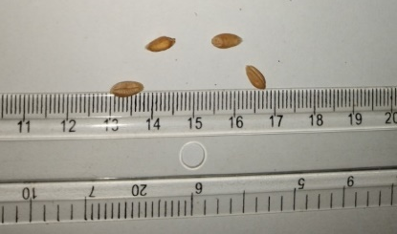 | 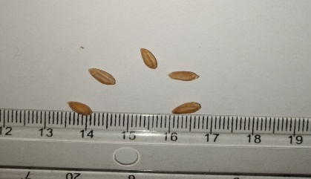
1A: Seeds of IRAD1 variety | 1B : Seeds of IRAD 2 variety
Figure 1 : Seeds of IRAD 1 (1A) and IRAD 2 (1B) variety of Triticum aestivum L.

Fertilizers
Fertilizers used include: chemical fertilizer, compost and mycorrhizae inoculum. The chemical fertilizer used as a positive control in this trial was granulated (Figure 2). The main nutrients of used chemical fertilizers are N, P, and K. They are referred to as urea (46% N) and NPK (20-10-10) chemical fertilizer, meaning that it contained 20% N, 10% P₂O₅, and 10% K₂O. These chemical fertilizers were purchased from a phytosanitary store in Dang locality (Adamawa-Cameroon).
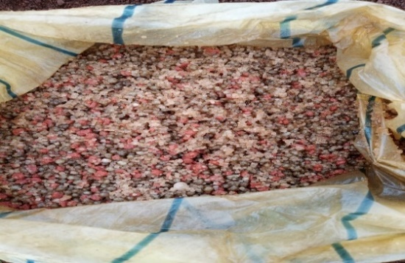 | 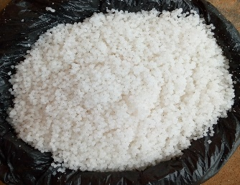
2A: NPK: 20-10-10 | 2B: Urea 46% N
Figure 2 : Chemical fertilizers: NPK 20-10-10) (2A), and Urea (46% N) (2B)

Two qualities of compost are used as organic fertilizer. These are composts derived poultry litter and cow dung manure. Dung manure from Boss spp. was collected on the school farm of the Faculty of Veterinary Medicine in the campus of the Ngaoundere University. While litter from Gallus domesticus subspecies comes from a local livestock farm in Bini-Dang. The heap composting method according to Tchuenteu et al. (2018) was used. The composting process lasted 05 months. Figure 3 presents mature compost derived cow dung manure, and poultry litter.
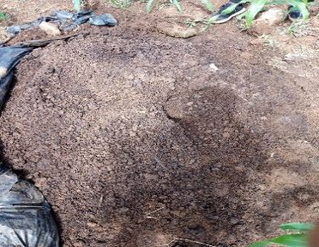 | 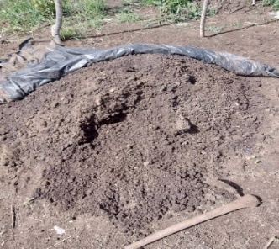
3A: Compost derived cow dung manure | 3B: Compost derived poultry litter
Figure 3: Mature composts derived cow dung manure (3A), and poultry litter (3B)

The mycorrhizal biofertilizer used were supplied by the Laboratory of Soil and Microbiology of the Biotechnology Center of the University of Yaounde I (Cameroon). Selected isolates were multiplied by sorghum and peanut plants (host plants) and tested on maize and sorghum (Nwaga et al. 2007). It contains infective spores and propagules of three genus Glomus, Scutellospora, and Gigaspora species with a concentration of approximately 20 spores/g of substrate.

Evaluation of the responses of wheat to mycorrhizae and composts
Land preparation, experimental design, and sowing
Field experimentation was carried out during the cropping seasons 2023. The experimental design is a split-plot with three replications. The first factor is fertilization, represented by five treatments (negative control: seedlings receiving no fertilizer (T0), positive control: synthetic chemical fertilizer 20-10-10 + Urea 46% (T1), compost derived cow dung manure (T2); mycorrhizal inoculum (T3), compost derived poultry litter (T4); the second factor is variety, with 02 wheat varieties (IRAD 1 and IRAD 2). The experimental site covers an area of 219.20 m², i.e. 27.40 m long and 8 m wide. The experimental field comprises 30 elementary sub-plots, i.e. 15 elementary plots; space between two consecutive elementary sub-plots in the same block is 0.50 m. Two consecutive elementary plots in the same block are spaced 1 m apart. The sub-plot is 3.40 m long and 1.20 m wide, i.e. 4.80 m². 02 consecutive blocks are spaced 2 m apart. Sowing took place on May 1, 2023. Seeds were sown at 3 cm depth. Weeding took place 1 month after sowing, and three seedlings were left per hole. Plots are maintained by manual weeding at regular 02-week intervals, starting 02 weeks after sowing. Each experimental unit includes 75 holes, each hole comprises three plants, i.e. 225 plants per treatment for each variety.

Data collection, and sampling
During the first 04 weeks after sowing, plant height was measured using a graduated ruler, after which a decameter was used to assess this growth parameter. The end inscribed with the smallest number was pointed to the ground and the other end was drawn up parallel to the stem to the terminal apex indicating the number. The number of leaves was assessed through the visual field by counting. At maturity, the number of ears/plant and wheat seeds yield (t/ha) was assessed.

Assessment of effect of natural fertilizer to wheat diseases incidence, and statistical analysis
Wheat diseases are identified by a visual diagnosis based on precise observation of symptoms. Incidence is the proportion of diseased or ravaged plants within an experimental unit, irrespective of the severity of attack on each plant. After counting the number of diseased plants, disease incidence was determined according to Chumakov and Zaharova (1990) using the following formula: I (%) = (m/N) x 100 where I (%) = incidence or frequency of the disease in the experimental unit; m = number of diseased plants in the same experimental unit; N = total number of plants per experimental unit.
All the data were statistically analyzed using the Statgraphics Plus Program version 5.0. The significance of differences was determined using the Duncan test.

Result and discussion
Wheat growing parameters and seeds yield
Wheat plant height
Regarding IRAD 1 variety of wheat at maturity, plant height varied from 80.25 ± 8.16 cm for T0 plants to 98.12 ± 7.12 cm for T2 plants (figure 4a). T2 plants were 1.22 and 1.45 taller than T1 and T0 plants respectively. For the IRAD2 variety of wheat T2 plants were the tallest (89.54 ± 10.11cm) while the shortest (67.20 ± 8.19 cm) were T0 plants (figure 4b). The height of T2 plants from IRAD2 variety was 1.33 and 1.10 higher than that of T0 and T1 plants respectively.
Data recorded on wheat plant height corroborate partially the work of Lounis (2017), who found that wheat plant height ranged between 84.8 ± 7.05 cm and 86.3 ± 4.99 cm. Furthermore, Tchuenteu et al. (2013) revealed that there is a significant positive correlation between plant height, foliar production and crop yield. Thus suggesting that wheat T2 plants are expected to produce the highest seed yield, though this requires verification..

4a: Plant height of IRAD1 4b: Plant height of IRAD2
Figure 4: Plant height of IRAD1 (4a) and IRAD2 (4b) varieties of wheat depending on fertilizer
JAS: Days after sowing, T0: unfertilized plant, T1: chemical fertilizer, T2: compost derived cow dung manure, T3: compost derived poultry litter, T4: mycorrhizal inoculum, V1: IRAD 1 variety, V2: IRAD 2 variety.

Foliar production
Figure 5 presents foliar production of the both IRAD1 and IRAD2 wheat varieties according to fertilization and time. Regarding IRAD1 variety at maturity, T0 plant showed the lowest foliar production (48.80 ± 13.37 leaves/plant), while T2 plants exhibited the greatest value of this parameter (90.50±21.17 leaves/plant). The foliar production of T2 plant of IRAD1 variety was 1.87-fold greater than that of T0 plant, and 1.11-fold greater than that of T1 plant.
The number of leaves per plant of IRAD2 variety varied from 46.50 ± 15.88 leaves per plant for T0 treatment to 104.50 ± 36.11 leaves per plant for T3 fertilizer. T3 plant of IRAD2 variety produced 2.24-fold and 1.45-fold more leaves than T0 and T1 treatments respectively.

Figure 5: Wheat foliar production depending on fertilizer, variety and time
JAS: Days after sowing, T0: unfertilized plant, T1: chemical fertilizer, T2: compost derived cow dung manure, T3: compost derived poultry litter, T4: mycorrhizal inoculum, V1: IRAD 1 variety, V2: IRAD 2 variety.

Wheat production
The studied wheat production include: number of ears m⁻², number of seeds per ear and seed yield estimated at t ha⁻¹. Statistical analysis (ANOVA) revealed a highly significant difference (p<0.001) between fertilizers on studied production parameter. There is not a significant difference between wheat varieties relative to production parameters.
Ear production
The ear production of IRAD1 variety varied from 234.33±4.04 ear/m² for T0 plot to 419.66±2.51 ear/m² for T2 plot (table 1). The ear production of T2 plots is 1.79-fold and 1.66-fold greater than the production of T0 and T1 plots. Regarding IRAD2 variety, the number of ears/m² varied from 245.66±1.52 for T0 plot to 402.33±3.21 for T2 plot. T2 plants produced 1.66-fold and 1.33-fold more ears than T0 and T1 plants respectively.
Data recorded on wheat ear production corroborate the work of Boukhalfa, 2011 who studied the wheat mineral fertilization, and found that the ear wheat production was 341.90±63.84 ears/m². The ear production is an essential parameter to determine seed yield. Lakab (2012) reported a positive significant correlation between ear production and seed yield.

Table 1: Ear production according to fertilizer and wheat variety
Treatments | Number of ears/plants
Treatments | T0 | T1 | T2 | T3 | T4
V1 | 234.33±4.04^{ab} | 252.33±2.51^{ab} | 419.66±2.51^{d} | 362.00±2.64^{c} | 210.66±2.08ª
V2 | 245.66±1.52^{b} | 306.33±4.04^{c} | 402.33±3.21^{d} | 402.00±2.64^{d} | 197.66±1.52ª
T0: unfertilized plant, T1: chemical fertilizer, T2: compost derived cow dung manure, T3: compost derived poultry litter, T4: mycorrhizal inoculum, V1: IRAD 1 variety, V2: IRAD 2 variety. Values of line affected by the same letter are not significantly different.

Wheat seed yield
Wheat seed yield of IRAD1 variety varied from 45.86±6.01 t/ha for T0 plants to 122.15±39.75 t/ha for T2 plants (figure 6). The seed yield of T2 plants of IRAD1 variety was 2.66-fold and 1.66-fold higher than that of T0 and T1 plants respectively. Regarding IRAD2 variety, T2 plants exhibited the greatest seed yield 116.78±21.40 t/ha, while the lowest seed yield (64.24 ± 17.46t/ha) was recorded on T0 plants. T2 fertilizer improved the seed yield of IRAD2 variety at 71.17% and 92.29% compared to T0 and T1 respectively. Data obtained on wheat seed yield corroborate partially data found in literature. Indeed, Teffahi et al. (2017) studied the wheat fertilization based chemical fertilizers and found that wheat seed yield ranged between 83.11 t/ha and 112.70 t/ha.

Figure 6: Seed yield (t/ha) depending on fertilizer
T0: unfertilized plant, T1: chemical fertilizer, T2: compost derived cow dung manure, T3: compost derived poultry litter, T4: mycorrhizal inoculum, V1: IRAD 1 variety, V2: IRAD 2 variety. Values of band relative to a variety affected by the same letter are not significantly different.

Effects of organic fertilizers on the incidence with regard to wheat diseases
Identified disease on wheat plants in our study area is yellow rust (Figure 7a). The pathogen responsible for yellow rust is the fungus Puccinia striiformis f.sp.tritici. This causal agent colonizes the leaves, with yellow pustules in the form of stripes and linear along the orange-yellow veins. When ripe, they burst to release a large number of golden yellow spores. This infection causes a reduction in useful leaf area and a loss of assimilates due to parasites, leading to very sensitive yields (Sharma et al., 1985). In addition, subterranean termites, birds and insects have caused damage to wheat plants by feeding on the roots, leaves and grains of wheat.
The statistical analysis revealed that there was a significant difference (p<0.05) between fertilizers relative to incidence with regard to wheat yellow rust. There was not significant difference between wheat varieties on this epidemiological parameter. Furthermore, the interaction fertilizers*variety was not significant different for incidence in relation with wheat.
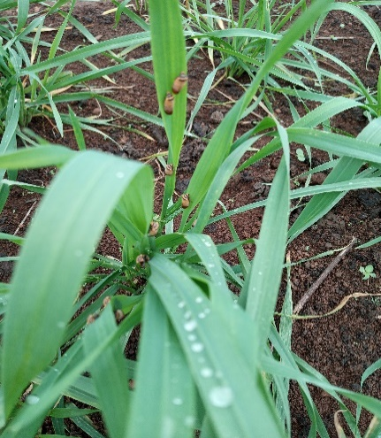 | 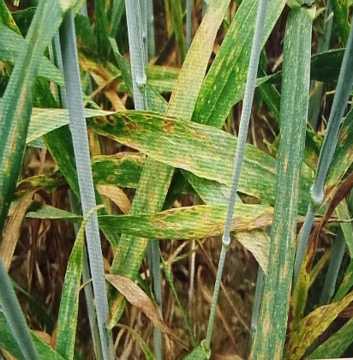
7a : Healthy wheat plant | 7b: Wheat plant affected by yellow rust
Figure 7: Healthy plant (7a) and affected plant by yellow rust (7b) of wheat

Incidence with regard to yellow rust
Concerning IRAD1 variety, the incidence with regard to yellow rust varied from 0.92 ± 1.23% for T2 plants to 16.53 ± 2.56% for T0 plants (table 2). The incidence of T0 plots of IRAD1 variety was 17.06-fold higher than that of T2 plots and 2.20-fold higher than that of T1 plots.
Regarding IRAD2 variety, the highest value of incidence (26.72 ± 3.60%) was found on T0 plot while the smallest value of this epidemiological parameter (2.47 ± 1.80%) was from T2 plots. The incidence of T0 plots of IRAD2 variety was 10.81-fold higher than that of T2 plots and 2.14-fold higher than that of T1 plots.
Table 2: Incidence (%) with regard to yellow rust according to fertilizer
Treatments | Incidence (%) |  | Means
Treatments | IRAD1 | IRAD2 | Means
T0 | 16.53±2.56^{b} | 26.72±3.60^{c} | 21.63±6.24
T1 | 7.50±5.45ª | 12.45±5.04^{b} | 9.98±5.42
T2 | 0.92±1.23ª | 2.47±1.80ª | 1.69±1.21
T3 | 1.42±1.24ª | 5.01±0.44^{ab} | 3.21±2.13
T4 | 17.26±5.49^{b} | 39.37±9.93^{d} | 28.32±14.07
T0: unfertilized plant, T1: chemical fertilizer, T2: compost derived cow dung manure, T3: compost derived poultry litter, T4: mycorrhizal inoculum, V1: IRAD 1 variety, V2: IRAD 2 variety. Values of column affected by the same letter are not significantly different.

It was reported that all the parameters taken into consideration responded positively when the plots were fertilized as compared to the data from the negative control plot (unfertilized plots). Thus, suggesting that, the low nutrient elements available in the growing soil was increased by the different compost as the agronomic parameters considered were improved accordingly.
Previously, several studies (Megueni et al. 2017; Tchuenteu et al. 2018) reported that compost improves crop productivity. The compost contributes to maintaining soil fertility and thus the sustainability of agricultural production. Compost improves soil quality and reduces losses due to phytoparasites (Chabalier et al., 2006). Compost is rich in various mineral elements necessary for plant growth. It improves the physical characteristics of the soil, as well as its biological composition (Vilmar et al., 2012).
The beneficial effect of compost on wheat growth and seed yield would be related to the combined effect of improved soil properties and the availability of nutrients. Also, some works have shown that the organic fertilizer applied to poor tropical and acidic soil can provide the nutrients needed for crop growth (Mulaji 2011).
Besides, Vilmar et al. (2012) studied the growth of amended compost plants and revealed that the compost provides the nitrogen that favors the accumulation of chlorophyll. Indeed, the photosynthetic activity requires chlorophyll, and therefore a higher chlorophyll content suggests the intensification of the photosynthetic activities which results in the improve of plant production. Also, this would justify the positive effects of compost on growth and seed yield of wheat observed in the current study.
Furthermore, Kamdem et al. (2020) revealed that that the combination of compost with mycorrhizae better increases plant growth and production. Thus, suggesting that our future study will be emphases to assess the combination of compost and mycorrhizae on wheat growth and seed yield.
Among the different produced composts, compost derived cow dung manure (T2) gave the highest response in term of plant productivity. By producing, T2 organic fertilizer for growing
wheat, we will contribute to improve the growth and seed yield of this cereal, to valorize the local material (animal wastes) in agroecology, as well as to protect the environment. However, the effects of the various composts used in this word on wheat seeds quality need to be investigated.

Conclusion
The wheat growth and seed yield varied significantly (p<0.05) according to fertilizer and wheat variety. The application of compost derived from cow dung manure (T2) resulted in the highest plant growth response. The wheat seed yield of T2 plants of IRAD1 variety was 2.66-fold and 1.66-fold higher than that of unfertilized plants and chemical fertilizer respectively. T2 organic fertilizer improved the seed yield of IRAD2 variety at 71.17% and 92.29% compared to chemical fertilizer and unfertilized plant respectively. Thus, T2 fertilizer can be employed to replace the chemical fertilizer in an attempt to boost the wheat production while ensure agroecology and reducing the production cost. Our future study will focus on the effects of composts on the wheat seed quality.

Reference

Bajji, M. 1999. Study of the mechanisms of resistance to water stress in durum wheat (Triticum durum Desf.): characterization of cultivars differing in their levels of drought resistance and of somaclonal variants selected in vitro. PhD Thesis, Catholic University of Louvain, Louvain-la-Neuve.

Belabed S., 2015. Effect of inoculation of durum and common wheat (Triticum durum Desf. and T. aestvum L.) with arbuscular mycorrhizal fungi under water stress. Pp 80.
Boukhalfa, 2011. Contribution to the study and optimization of mineral fertilization of durum wheat (Triticum durum Desf), Master's thesis, field of natural and life sciences, biotechnology and plant genomics, Mentouri Brothers University Constantine 1.
Chabalier PF, De Kerchove VV & Macary HS 2006. Guide to organic fertilization in Réunion. Réunion (Réunion Island): CIRAD Edition; 302 pages.
Choueiri. 2003. Value chain analysis: cereal farming [Online]. http://www.agriculture.gov.lb
Chumakov, A. E. & I. I. Zaharova. 1990. Influence and statistics of the development of diseases. In, Disease Damage to Agricultural Crops. Agrorome edition. Moscow.
Dalpé Y., 2003. Subsidiary Body on Scientific, Technical and Technological Advice. Convention on Biological Diversity. Blumwald E. (eds). Macmillan. London. pp. 100–130.

Kamdem, K. F., Tchuenteu, T. L., Maimouna, A., & Megueni, C. 2020. The combination of arbuscular mycorrhizal fungi with rock powder and poultry litter: An appropriate natural fertilizer for improving the productivity of soybean (Glycine max(L.) Merr). Agriculture (Poľnohospodárstvo), 66(3), 108–117.
Lakab R., 2012. Effect of nitrogen fertilization on durum wheat (Triticum durum Desf.) variety “Bousselam” and on the decomposition of organic matter in direct seeding in the semi-arid region of Sétif. Master's thesis in Agronomy. Ferhat Abbas University, Sétif 1.
Lounis K. A. 2017. The effect of splitting a single nitrogen dose on the production of durum wheat (Triticum durum) variety Simeto in the Ouarizane area. Pp: 187
Macauley H., Ramadjita T., ICRISAT, 2015. Cereal crops: rice, maize, millet, sorghum and wheat. Pp1-38
Mandassia F., Singnon I. C., Tchuenteu T. L., & Megueni C. 2025. “Enriched Compost With Vivianite or Basaltic Pyroclastite Powder: Better Fertilizer to Improve Artemisia Growth under High Guinean Savannah Climate of Cameroon”. Journal of Experimental Agriculture International 47 (8):54–65. https://doi.org/10.9734/jeai/2025/v47i83647.

Megueni C., Awono E. T. & Ndouenkeu R., 2011. Simultaneous effect of dilution and combination of rhizobium and mycorrhizae on leaf production and the physicochemical properties of young leaves of Vigna unguiculata (l.) Walp. Journal of Applied Biosciences, 40: 2668-2676.

Megueni, C., Tchuenteu, T. L., Noubissie, E., Maimouna, A., & Bachirou, H. 2017. Field productivity of carrot (Daucus carota L.) in Adamawa, Cameroon, and chemical properties of roots according to chickenmanure pretreatments and vivianite powder. Journal of Agriculture and Veterinary Science (IOSR-JAVS), 10(5), 16–23
Mulaji K. C., 2011. Use of household bio-waste composts for improving the fertility of acidic soils in the province of Kinshasa (Democratic Republic of Congo). Doctoral thesis, Gembloux Agro Bio Tech. 220p.
Nwaga, D. -Engelmann, F. -Hamon S. -Djie- & TO, L.C. 2007. Biotechnologies and control of agricultural inputs in Central Africa. Book of abstracts. 'BIOVEG' Network, AUF/IRD/University of Yaoundé/IRAD, Yaoundé, Cameroon. Available at: http://www.bioveg.auf.org
Sharma V. K., Hobson P. N., 1985. A sporulation medium for strict anaerobes. Applied Microbiology International. Pp: 31-32
Tchuenteu TL, Megueni C, Noubissie E & Wamkoua MM, 2018. Study on physico-chemical properties of composts and the effects on growth, yield and fruit quality of Capsicum annum L. at Dang locality (Ngaoundéré Cameroon). Journal of Agriculture and Veterinary Science (IOSR-JAVS). 11 (11): 26-35.

Tchuenteu, T. L., Megueni, C., & Njintang, Y. N. (2013). A study of the variability for grain and oil yield and yield related trails of castor beans accessions in two savannah agro-ecological zones of Cameroon, 14.
Teffahi Z., Hannachi A., Ferras K., Oulmi A., Boutalbi W., Bouzerzour H. & Benmahammed A., 2017. Analysis of the phenotypic variability of twenty F3 biparental populations of bread wheat (Triticum aestivum L.) Evaluated under semi-arid environment, Journal of Fundamental and Applied Sciences 9(1), 102-118.
Useni S. Y., Kasongo L. M. E., Mwamba M. T., Tshipoya M. P., Mukalay M. J., Mazinga K. M. & Nyembo K. L., 2013. Response of soybean cultivation (Glycine max L. (Merril) to the addition of green biomasses of Tithonia diversifolia (Hemsley) A. Gray as organic manure on a Ferralsol with Lubumbashi, R.D. Congo. Journal of Applied Biosciences 63: 4727 – 4735
Vilmar, A. -Ragagnim, D. -Geraldo D E Sena, J. -Danyllo, S.D. -Weslley, F.B. & Phelipe, D.M N. 2012. Growth and nodulation of soybean plants fertilized with poultry litter. In Ciência e Agrotecnolo-gia, vol. 37, no. 1, pp. 17 -24

