Original Research Article
District-wise distribution and severity of bacterial leaf blight of rice caused by Xanthomonas oryzae pv. oryzae in Northern Karnataka

Abstract
Bacterial leaf blight (BLB), caused by Xanthomonas oryzae pv. oryzae, is one of the most destructive diseases affecting rice production in India, particularly under favourable agro-climatic conditions. A roving field survey was conducted during kharif 2023 and kharif 2024 to assess the severity and spatial distribution of BLB in major rice-growing districts of northern Karnataka, namely Dharwad, Belagavi, and Haveri. Disease severity was recorded using the Standard Evaluation System scale and expressed as per cent disease index (PDI). The survey revealed considerable spatial and temporal variation in BLB severity across districts, taluks, villages, crop growth stages, soil types, and rice genotypes. Higher mean PDI values were consistently observed in Dharwad district, followed by Haveri and Belagavi, indicating differential disease pressure across locations. Genotype-wise analysis based on pooled seasonal data showed marked differences in BLB severity, reflecting variability in host response under field conditions. Disease incidence was influenced by factors such as soil moisture retention, irrigation status, crop stage, and varietal susceptibility. The study highlights the continued importance of BLB as a constraint to rice productivity in northern Karnataka and underscores the need for regular surveillance, deployment of tolerant or resistant varieties, and location-specific disease management strategies. The baseline information generated through this investigation will be useful for resistance breeding programmes, epidemiological studies, and disease forecasting efforts in the region.
Introduction
Rice cultivation forms the foundation of agro-based economies worldwide and is critical for ensuring food security and economic stability, particularly in major rice-producing regions such as southern India (Niño-Liu et al., 2006). In India, rice continues to occupy a dominant position among food crops. During 2024–25, rice was cultivated over approximately 51.4 million hectares, with a production of nearly 150 million tonnes and an average productivity of 4.38 t ha⁻¹, as per provisional statistics (Directorate of Economics and Statistics, Ministry of Agriculture & Farmers Welfare). For 2025–26, rice area and production are projected to increase marginally to about 52 million hectares and 152 million tonnes, respectively, based on advance estimates.
Despite its importance, rice productivity is increasingly constrained by several biotic stresses, including fungal, bacterial, and viral diseases (Jiang et al., 2013). Diseases constitute a major limitation to rice production, with yield losses ranging from 20 to 30 per cent under field conditions. It is estimated that 15–30 per cent of global rice production is lost annually due to diseases occurring during crop growth, resulting in an approximate economic loss of USD 33 billion (Nayak et al., 2021).
Among the diseases affecting rice, bacterial leaf blight (BLB) caused by Xanthomonas oryzae pv. oryzae (Xoo) is regarded as one of the most destructive, leading to severe yield losses worldwide (Jiang et al., 2013). The disease is particularly prevalent in South and Southeast Asia, with major outbreaks reported in countries such as Japan, the Philippines, Indonesia, and India (Khan et al., 2009). Under favourable conditions, BLB can cause crop yield reductions ranging from 50 to 80 per cent in several rice-growing regions of Asia (Yadav et al., 2013).
In severely affected areas, BLB has been reported to cause yield losses ranging from 20 to 50 per cent, and under epidemic situations, losses can reach up to 70 per cent when susceptible varieties are cultivated and may even result in complete crop failure (Walters et al., 2013). In tropical Asia, BLB-associated yield losses have been reported to vary widely from 2 to 74 per cent, depending on factors such as locality, prevailing weather conditions, crop growth stage, and varietal susceptibility (Chaudhary et al., 2012). The disease spreads primarily through infected planting material, contaminated agricultural tools, floodwater, and susceptible seedlings, enabling rapid dissemination under favourable environmental conditions (Sanya et al., 2022).
Owing to the destructive potential and economic importance of bacterial leaf blight, a roving survey was systematically carried out during kharif 2023 and kharif 2024 to assess the severity of the disease in major rice-growing regions of Karnataka. The survey covered representative rice fields in Dharwad district (Dharwad and Kalghatagi taluks), Belagavi district (Belagavi taluk), and Haveri district (Ranebennur and Hanagal taluks). These districts predominantly fall within the Northern Transitional Zone of Karnataka, which is characterized by moderate rainfall, a combination of red and black soils, and agro-climatic conditions favourable for rice cultivation.
Material and Methods
Roving survey and assessment of bacterial leaf blight severity
A roving survey was conducted during kharif 2023 and kharif 2024 to assess the severity of bacterial leaf blight (BLB) of rice caused by Xanthomonas oryzae pv. oryzae in major rice-growing regions of Karnataka. The survey was carried out during the panicle initiation to heading stage of the rice crop, which is favourable for the expression of BLB symptoms. Representative rice fields were surveyed in Dharwad district (Dharwad and Kalghatagi taluks), Belagavi district (Belagavi taluk), and Haveri district (Ranebennur and Hanagal taluks). These districts predominantly fall within the Northern Transitional Zone of Karnataka, characterized by moderate rainfall, red and black soils, and agro-climatic conditions suitable for rice cultivation.

At each survey location, details on the date of survey, predominant rice variety, and crop growth stage were recorded. Disease severity was assessed by recording BLB symptoms using a 0–9 disease rating scale following the Standard Evaluation System (SES) for rice (IRRI 2013). The disease severity scoring was based on the percentage of affected lesion area, where a grade of 1: 1–5 per cent; 3: 6–12 per cent; 5: 13–25 per cent; 7: 26–50 per cent; and 9: 51–100 per cent of the leaf area affected.
In each field, three random spots of 1 × 1 m² area were selected, and within each spot, five plants were randomly chosen for visual assessment of diseased leaf area. Thus, disease severity observations were recorded from a representative sample of plants at each location.
The severity of BLB was expressed as per cent disease index (PDI), which was calculated using the formula described by Wheeler (1969):
$$\text{PDI}=\frac{∑\text{of all disease ratings}}{\text{Total number of observations}×\text{Maximum disease rating}}×100$$
Results and discussion
The roving survey carried out during kharif 2023 and kharif 2024 across the major rice-growing districts of Dharwad, Belagavi, and Haveri revealed that bacterial leaf blight (BLB) continues to be a persistent and economically significant constraint to rice production in northern Karnataka. Marked spatial and temporal variability in disease severity was evident among districts, taluks, villages, rice varieties, and cropping situations, reflecting the combined influence of host genotype, crop growth stage, and prevailing agro-climatic conditions on the development and spread of the disease.
During kharif 2023, BLB severity was comparatively higher, with PDI values ranging from 11.21 to 20.32. The highest disease severity was recorded at Mugad village (Dharwad district) on the variety Kaagisali, where a PDI of 20.32 was observed. Similarly elevated disease levels were recorded in Kittur (Belagavi district) and Kamadod and Hanagal (Haveri district), where susceptible varieties such as Kare Hakkalasali, MTU-1001, and Saali exhibited PDIs close to 19.0. These locations were characterized by favourable environmental conditions such as moderate to high humidity, suitable temperature regimes, and crop stages ranging from panicle initiation to grain filling, which are known to favour rapid multiplication and spread of Xanthomonas oryzae pv. oryzae. In contrast, relatively lower BLB severity was recorded in villages such as Alnavara, Dasanur, and Holeanveri, where PDIs remained close to 11.0, possibly due to varietal tolerance, less conducive microclimatic conditions, or differences in crop management practices.( Table 1)
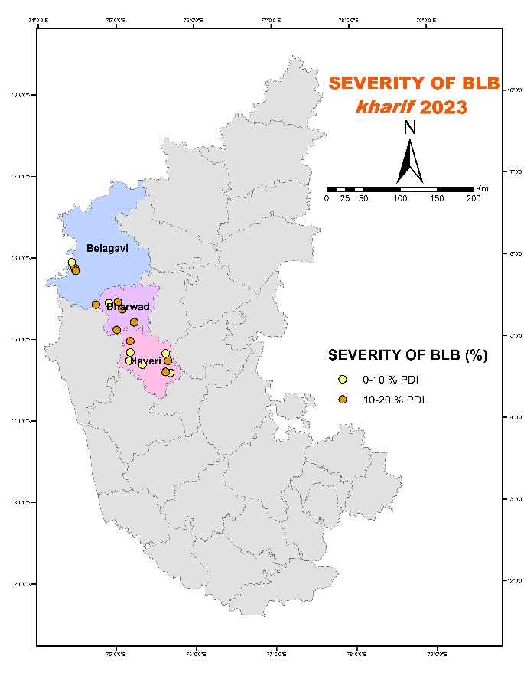
Figure 1. Spatial distribution of bacterial leaf blight (BLB) severity in northern Karnataka during kharif 2023
In kharif 2024, BLB severity was comparatively lower across most surveyed locations, with PDI values ranging from 8.27 to 15.21. The lowest disease severity was observed at Akki-allur (Hanagal taluk) on the variety Intan, where a PDI of 8.27 was recorded, whereas relatively higher PDIs were observed at Tavangeri (Dharwad district) and Shivapur (Haveri district). The overall reduction in disease severity during kharif 2024 may be attributed to variations in rainfall distribution, reduced duration of leaf wetness, and differences in crop growth stage at the time of assessment. This seasonal variation highlights the strong role of environmental factors in determining BLB epidemics under field conditions. (Table 2 )

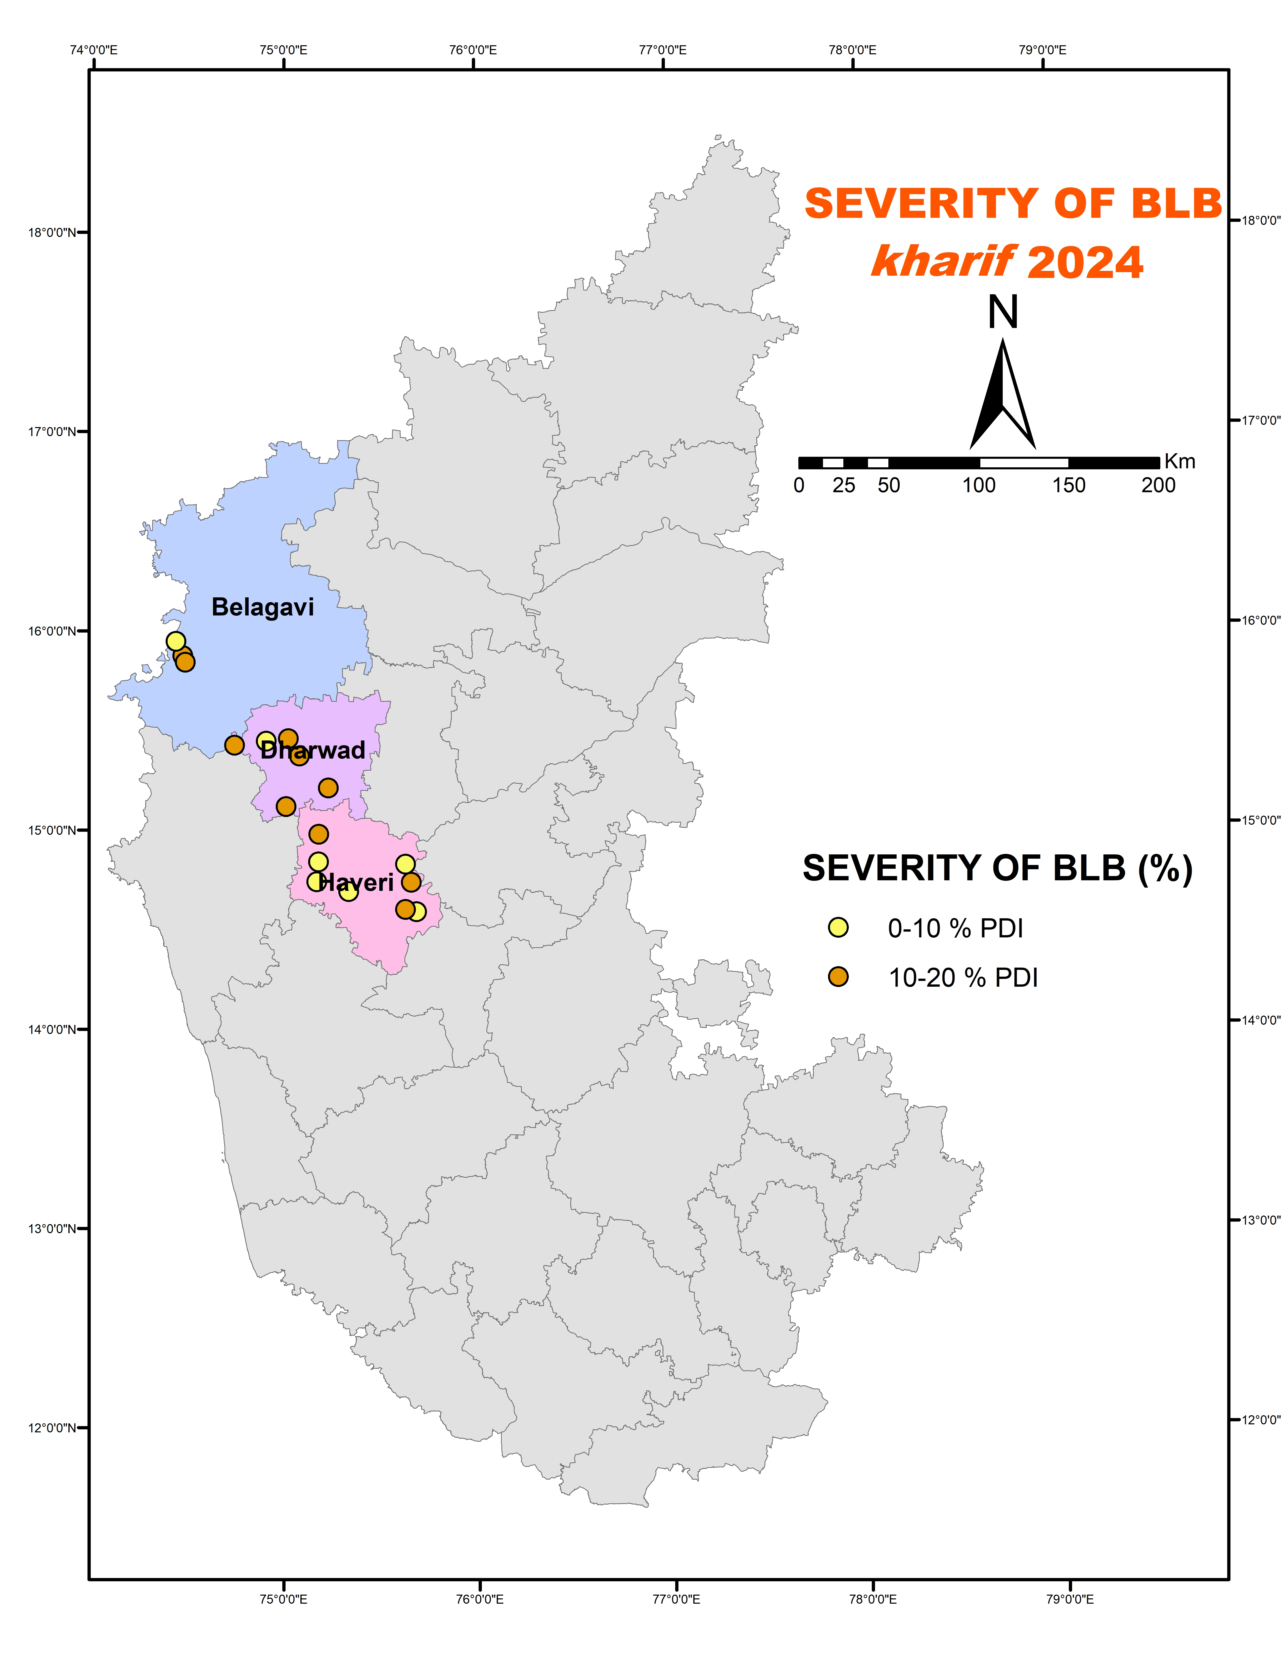
Figure 2. Spatial distribution of bacterial leaf blight (BLB) severity in rice across northern Karnataka during kharif 2024
The taluk-wise and district-wise per cent disease index (PDI) data revealed moderate to high variability in bacterial leaf blight severity across the selected rice-growing areas during kharif 2023 and kharif 2024. Among the taluks studied, Khalgatgi in Dharwad district and Hangal in Haveri district recorded comparatively higher mean PDI values, indicating relatively greater disease pressure, while Belagavi taluk showed lower BLB severity across both seasons.(Table 3 )
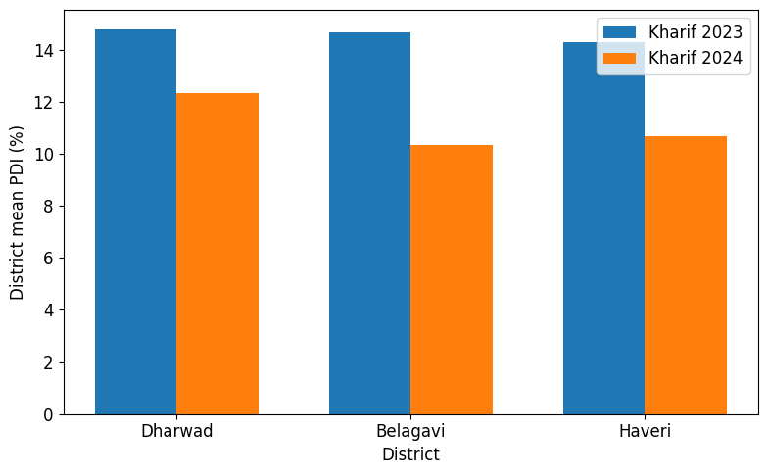
Figure 3. District-wise mean per cent disease index (PDI) of bacterial leaf blight in rice during kharif 2023 and kharif 2024

Figure 4. Genotype-wise mean per cent disease index (PDI) of bacterial leaf blight in rice based on pooled data of kharif 2023 and kharif 2024.
The genotype-wise pooled analysis of per cent disease index (PDI) revealed notable variation in bacterial leaf blight incidence among the evaluated rice varieties. Sonamasuri recorded the highest mean PDI (14.48 %) indicating relatively higher susceptibility under field conditions. In contrast, Kaagisali exhibited the lowest mean PDI (10.27%), suggesting comparatively better tolerance to the disease. Intan (11.65%), Saali (11.82%), MTU-1001 (11.82%), Jaya (11.82%), IR-64 (12.21%), and Abhilash (12.27%) showed moderate levels of disease incidence. The results indicate that while most genotypes fall within a moderate susceptibility range, certain varieties such as Kaagisali demonstrate relatively lower disease severity and may be considered promising under similar agro-ecological conditions. The variation in genotype-wise PDI observed in the present study is in line with the findings of Ashwini et al. (2024), who reported clear differences in disease severity among rice genotypes. Their study showed higher disease severity in susceptible varieties such as BPT-5204 and Dodiga, while comparatively lower severity was observed in genotypes like Abhilash and IR-64, indicating variation in host response to Xanthomonas oryzae pv. oryzae.
The variation in district-wise mean BLB severity can also be partly attributed to differences in soil types prevailing across the study area. Higher disease severity observed in Dharwad and Haveri districts, dominated by medium to deep black and black loamy soils, may be associated with prolonged soil moisture retention that favours pathogen survival and disease development, whereas comparatively lower severity in Belagavi may be linked to relatively better soil drainage conditions.
In addition to BLB, the frequent occurrence of brown spot, neck blast, blast, and false smut in several surveyed locations indicates the presence of multiple biotic stresses in the rice ecosystem. The coexistence of these diseases may compound yield losses and complicate disease management strategies, emphasizing the importance of integrated disease management approaches rather than reliance on single control measures.
Conclusion
The present investigation clearly demonstrates that bacterial leaf blight remains a persistent and economically significant constraint to rice production in northern Karnataka. Marked spatial and seasonal variability in disease severity across districts, cropping situations, and genotypes highlights the strong influence of local agro-climatic conditions and host response on BLB development. These findings emphasize the need for continuous field surveillance, strategic deployment of BLB-tolerant or resistant varieties, and the adoption of location-specific integrated disease management practices. The baseline information generated from this study contributes to a better understanding of BLB epidemiology in the region and provides useful insights for resistance breeding programmes, disease risk assessment, and future forecasting initiatives.
References

- Ashwini, S., Prashanthi, S. K., Vidyashankar, D., Hegde, Y. R., Krishnaraju, P. U., Muttappagol, M., & Krishnanand, I. (2024). Insights into the virulence profiles and molecular diversity of Xanthomonas oryzae pv. oryzae isolates associated with bacterial blight of rice in major districts of Karnataka, India. Physiological and Molecular Plant Pathology, 133, 102338.
- Chaudhary, S. U., Iqbal, J., & Hussain, M. (2012). Effectiveness of different fungicides and antibiotics against bacterial leaf blight in rice. Journal of Agricultural Research, 50(1), 109–117.
- Directorate of Economics and Statistics. (2025). Advance estimates of area, production and yield of major crops in India. Ministry of Agriculture & Farmers Welfare, Government of India.
- IRRI. (2013). Standard evaluation system for rice (5th ed.). International Rice Research Institute.
- Jiang, S. H., Zhou, D. Z., Lin, Y. J., Dong, S. H., Ye, Y., & Zhang, X. M. (2013). Identification and gene mapping of a thermo-sensitive leaf-color mutant at seedling stage in rice. Journal of Rice Science, 27, 359–364.
- Khan, J. A., Arshad, H. M. I., Jamil, F. F., & Hasnain, S. (2009). Evaluation of rice genotypes against bacterial leaf blight disease. Pakistan Journal of Phytopathology, 21, 26–30.
- Nayak, S., Samanta, S., Sengupta, C., & Swain, S. S. (2021). Rice crop loss due to major pathogens and the potential of endophytic microbes for their control and management. Journal of Applied Biology & Biotechnology, 9(5), 166175. https://doi.org/10.7324/JABB.2021.95021
- Niño-Liu, D. O., Ronald, P. C., & Bogdanove, A. J. (2006). Xanthomonas oryzae pathovars: Model pathogens of a model crop. Molecular Plant Pathology, 7(5), 303–324.https://doi.org/10.1111/j.1364-3703.2006.00344.x
- Sanya, D. R. A., et al. (2022). A review of approaches to control bacterial leaf blight in rice. World Journal of Microbiology and Biotechnology, 38, Article 113.https://doi.org/10.1007/s11274-022-03308-4
- Walters, D. R., Ratsep, J., & Havis, N. D. (2013). Controlling crop diseases using induced resistance: Challenges for the future. Journal of Experimental Botany, 64(5), 1263–1280.https://doi.org/10.1093/jxb/ert026
- Wheeler, B. E. J. (1969). An introduction to plant diseases. John Wiley & Sons.
- Yadav, S. A., Singh, N., Goel, R. K., & Singh, A. K. (2013). Identification of Indian rice germplasm lines with bacterial leaf blight resistance genes. Indian Journal of Genetics and Plant Breeding, 73, 310–317.

Sl.  Table 1. Roving survey details and severity of bacterial leaf blight (BLB) in major rice-growing areas of North Karnataka during kharif  2023  No: | District | Taluk | Village | Latitude | Longitude | Soil type | Crop stage | Irrigation | Variety / hybrid | PDI | Other diseases observed
1. | Dharwad | Dharwad | Mugad | 15.26306 | 74.91003 | Black loamy soil | Panicle initiation | Irrigated | Sonamasuri | 20.32 | Brown spot of rice
2. | Dharwad | Dharwad | Mandihala | 15.27212 | 74.89344 | Black loamy soil | Booting | Rainfed | Intan | 13.4 | Brown spot of rice
3. | Dharwad | Dharwad | Alnavara | 15.45289 | 74.89478 | Black loamy soil | Booting | Rainfed | Intan | 11.21 | Brown spot of rice
4. | Dharwad | Khalgatagi | Mukkal | 15.12019 | 75.01343 | Black loamy soil | Tillering | Rainfed | Intan | 14.97 | Grain discoloration
5. | Dharwad | Khalgatagi | Gudihala | 15.81894 | 76.5451 | Red soil | Grain filling | Rainfed | Abhilash | 12.71 | Brown spot of rice
6. | Dharwad | Khalgatagi | Dasanur | 15.65237 | 76.88343 | Loamy soil | Booting | Rainfed | Saali | 11.82 | Blast
7. | Dharwad | Khalgatagi | Belavantara | 15.14977 | 74.9762 | Black soil | Panicle initiation | Rainfed | Sonamasuri | 15.21 | Brown spot of rice
8. | Belagavi | Belagavi | Uchagaon | 15.89064 | 74.42986 | Black loamy soil | Booting | Rainfed | Sonamasuri | 12.21 | Neck blast, Brown spot
9. | Belagavi | Belagavi | Angol | 15.81506 | 74.50597 | Black soil | Booting | Rainfed | Sonamasuri | 11.82 | Brown spot of rice
10. | Belagavi | Belagavi | Kittur | 15.57569 | 74.80731 | Black loamy soil | Grain filling | Rainfed | Sonamasuri | 19.97 | Neck blast, Brown spot
11. | Haveri | Ranebennur | Malanaikanahalli | 14.44131 | 75.62262 | Black loamy soil | Panicle initiation | Irrigated | Sonamasuri | 15.21 | Brown spot of rice
12. | Haveri | Ranebennur | Nitapalli | 14.45964 | 75.64333 | Black soil | Booting | Irrigated | Sonamasuri | 12.21 | Brown spot of rice
13. | Haveri | Ranebennur | Holeanveri | 14.45964 | 75.64333 | Black loamy soil | Booting | Irrigated | Abhilash | 11.82 | Brown spot of rice
14. | Haveri | Ranebennur | Kamadod | 14.58102 | 75.66937 | Black loamy soil | Grain filling | Irrigated | Sonamasuri | 19.97 | Brown spot of rice
15. | Haveri | Ranebennur | Mudenur | 14.49556 | 75.71222 | Black soil | Panicle initiation | Irrigated | Sonamasuri | 15.21 | Brown spot of rice
16. | Haveri | Ranebennur | Nagenahalli | 14.49883 | 75.71671 | Black loamy soil | Booting | Irrigated | Sonamasuri | 12.21 | False smut
17. | Haveri | Ranebennur | Makanur | 14.51677 | 75.72998 | Black soil | Booting | Irrigated | MTU-1001 | 11.82 | Brown spot of rice
18. | Haveri | Hanagal | Hanagal | 14.52392 | 75.74297 | Black soil | Grain filling | Irrigated | Sonamasuri | 19.97 | Brown spot of rice
19. | Haveri | Hanagal | Shivalli | 14.77782 | 75.39082 | Red loamy soil | Grain filling | Irrigated | IR-64 | 15.21 | Brown spot of rice
20. | Haveri | Hanagal | Aladakatti | 14.72806 | 74.89361 | Red soil | Panicle emergence | Irrigated | IR-64 | 12.21 | Brown spot of rice
21. | Haveri | Hanagal | Gourapura | 14.83694 | 75.21333 | Loamy soil | Panicle initiation | Irrigated | Jaya | 11.82 | Brown spot of rice

Table 2. Roving survey details and severity of bacterial leaf blight (BLB) in major rice-growing areas of North Karnataka during kharif
2024

Sl. No: | District | Taluk | Village | Latitude | Longitude | Soil type | Crop stage | Irrigated/Rainfed | Variety / hybrid | PDI | Other diseases observed
1. | Dharwad | Dharwad | Mugad | 15.44778 | 74.90861 | Black loamy | Panicle initiation | Irrigated | Kaagisali | 9.32 | Brown spot of rice
2. | Dharwad | Dharwad | Kyarkoppa | 15.45972 | 75.02361 | Black soil | Panicle initiation | Rainfed | Intan | 10.4 | Brown spot of rice
3. | Dharwad | Dharwad | Kalakeri | 15.4275 | 74.74444 | Loamy soil | Booting | Rainfed | Kaagisali | 11.21 | Brown spot of rice
4 | Dharwad | Khalgatagi | Mukkal | 15.11917 | 75.01194 | Black loamy | Tillering | Rainfed | Sonamasuri | 14.97 | -
5. | Dharwad | Khalgatagi | Yaliwal | 16.67722 | 76.30222 | Red soil | Grain filling | Rainfed | Abhilash | 12.71 | -
6. | Dharwad | Khalgatagi | Devanur | 15.21222 | 75.22972 | Loamy soil | Booting | Rainfed | Saali | 11.82 | Brown spot of rice
7. | Dharwad | Khalgatagi | Tavangeri | 15.37306 | 75.08111 | Black soil | Panicle initiation | Rainfed | Sonamasuri | 15.21 | Blast
8. | Belagavi | Belagavi | Hindalga | 15.87639 | 74.47583 | Black loamy soil | Booting | Rainfed | Sonamasuri | 10.01 | Brown spot of rice
9. | Belagavi | Belagavi | Mandoli | 15.84306 | 74.48889 | Red soil | Tillering | Rainfed | Sona masuri | 12.1 | Neck blast, Brown spot
10. | Belagavi | Belagavi | Mukkal | 15.94722 | 74.44 | Red loamy soil | Grain filling | Rainfed | Sona masuri | 8.9 | Brown spot of rice
11 | Haveri | Ranebennur | Kamadod | 14.59028 | 75.685 | Clay loam soil | Booting | Irrigated | Abhilash | 9.13 | Neck blast, Brown spot
12. | Haveri | Ranebennur | Shivapur | 14.97972 | 75.18083 | Black soil | Panicle initiation | Irrigated | Abhilash | 13.85 | Brown spot of rice
13. | Haveri | Ranebennur | Guttal | 14.82861 | 75.62833 | Deep black soil | Booting | Irrigated | IR-64 | 9.2 | Brown spot of rice
14. | Haveri | Ranebennur | Somalapura | 14.60167 | 75.62778 | Black clay loam | Tillering | Irrigated | Sona masuri | 11.12 | Brown spot of rice
15. | Haveri | Ranebennur | Mallapur | 14.73833 | 75.65778 | Medium black soil | Panicle initiation | Irrigated | Abhilash | 13.21 | Brown spot of rice
16. | Haveri | Hanagal | Kaginelli | 14.69222 | 75.33444 | Black soil | Tillering | Irrigated | Abhilash | 9.43 | Brown spot of rice
17. | Haveri | Hanagal | Akki-allur | 14.74167 | 75.16972 | Black soil | Panicle initiation | Irrigated | Intan | 8.27 | False smut
18. | Haveri | Hanagal | Gundur | 14.84167 | 75.17861 | Black soil | Booting | Irrigated | Sonamasuri | 8.41 | Brown spot of rice

Table 3. Taluk-wise and district-wise per cent disease index (PDI) of bacterial leaf blight in selected districts of North Karnataka (kharif 2023 and kharif 2024)
Sl. No. | District | Taluk | Taluk PDI 2023 (%) | Taluk PDI 2024(%) | Taluk Mean PDI (%) | District PDI 2023 (%) | District PDI 2024 (%) | District Mean PDI (%)
1 | Belagavi | Belagavi | 14.67 | 10.34 | 12.50 | 14.67 | 10.34 | 12.50
2 | Dharwad | Dharwad | 14.98 | 10.31 | 12.65 | 14.33 | 12.00 | 13.17
3 | Dharwad | Khalgatgi | 13.68 | 13.68 | 13.68 | 14.33 | 12.00 | 13.17
4 | Haveri | Hangal | 14.80 | 8.70 | 11.75 | 13.64 | 10.68 | 12.16
5 | Haveri | Ranebennur | 12.48 | 12.66 | 12.57 | 13.64 | 10.68 | 12.16

