Original Research Article
Isolation, screening and characterization of efficient lignocellulose degrading Actinomycetes

ABSTRACT
Ever increasing demand for food made the farming community to adopt intensive agricultural practices leading to a corresponding rise in crop residue production which has to be managed judiciously for by incorporating it in-situ and ex-situ for converting it into compost instead of burning. Faster decomposition of crop residue in the field and production of compost, efficient microbial consortium needs to be developed. To develop efficient decomposing consortium, it requires a variety of lignin, cellulose, hemicelluloses and pectin decomposers. Hence, a study was conducted to isolate decomposers from natural habitat and characterise them to get the efficient ones for developing better consortium for faster decomposition of crop residues. A total of 75 actinomycetes isolates, obtained from 177 various decomposing substrates from natural habit of different parts of Andhra Pradesh. These isolates were primarily screened for in-vitro lignin and cellulose degradation potential. Among these, 52 isolates showed cellulose degradation ability by forming the zone of clearance on carboxy methyl cellulose plates and 29 isolates showed the lignin degradation ability. Among these 75 isolates, 21 have shown both lignin and cellulose degrading ability. Hence, these isolates were quantitatively screened by enzyme assays viz. cellulase, lignin peroxidase, laccase and xylanase activity by using spectrophotometer. Results of secondary screening shows that highest cellulase enzyme activity was shown by LCDA-22 (62.153 U/mL) and LCDA-36 (60.93 U/mL), highest xylanase enzyme activity was recorded by LCDA-1 (39.753 U/mL) and LCDA-22 (39.281 U/mL), highest Laccase enzyme activity was shown by LCDA-22 (579.167 U/mL) and LCDA-1 (509.167 U/mL), then the highest lignin peroxidase enzyme activity was observed in LCDA-22 (5.064 U/mL) and LCDA-1 (5.007 U/mL). These 21 isolates were characterized morphologically and biochemically, found that they bear powdery growth with white to ash coloured mycelia with spiral chains of spores and has shown positive results for utilization of different sugars viz. glucose, arabinose, mannitol, sucrose and starch. Based on these results LCDA-1, 22, 36, 40 and 67 were identified as potential isolates for lignocellulose degradation can be better utilized for developing efficient decomposing consortium.

Keywords: Degradation, Crop residue, Decomposing consortium, Characterization, Isolates
1. Introduction
The increased global population over the years, the demand for food rises accordingly. The escalating demand for food exerts pressure on agricultural systems to produce more with sustainable practices. One of the major challenges in modern agriculture is reducing the environmental impact of food production while making better use of available resources and minimizing reliance on non-renewable inputs (Godfray et al., 2010). Crop residues are the plant biomass or remnants left in the field after harvest, are often seen as mere waste yet they hold significant untapped potential. Rather than being discarded, these agricultural by-products should be recognized and utilized as valuable, renewable resources that can play a vital role in promoting the long-term sustainability of farming (Misselbrook et al., 2012). These majorly including rice straw, wheat straw, cotton, corn stover, and sugarcane bagasse.
According to the Ministry of New and Renewable Energy (MNRE), India generates an average of 500 million tonnes of crop residue annually. While most of this is used for fodder and fuel, 140 million tonnes remain surplus, of which 92 million tonnes burnt each year (https://indiadatainsights.com/crop-residue-in-india/). Burning crop residues emits air pollutants such as carbon-di-oxide (CO₂), nitrous oxide (N₂O), methane (CH₄), carbon monoxide (CO), Ammonia (NH₃), nitrogen oxides (NO₂), sulphur-di-oxide (SO₂), non-methane hydrocarbons, volatile and semi-volatile organic compounds, greenhouse gas emissions and particulate matter leads to public health issues, radiation imbalance, and declining soil organic matter and productivity.
To mitigate the harmful effects of in-situ burning of crop residues and benefit the farmers, an economical and eco-friendly residue management approach should be implemented. Use of agricultural wastes as soil amendments instead of burning which allows cost recovery, prevents soil erosion, improves soil physical, chemical and biological properties, and recycles nutrients (Sharma et al., 2022). Complete removal of crop residue harms soil quality, while leaving excessive amounts can hinder seed-soil contact, increase the carbon-to-nitrogen (C: N) ratio, and keep the soil cool and wet. To reduce these effects, a balanced approach is needed, involving proper mixing of residue into the soil and timely nitrogen application to maintain the C: N ratio (Clay et al., 2019).
Since the major components of crop residues are lignocellulose compounds, their breakdown requires the synergistic action of several enzyme families secreted by lignocellulose-degrading microorganisms (LCDMOs). These enzymes work together, performing complementary oxidative, hydrolytic, and non-hydrolytic activities (Madeira et al., 2017). Microbial inoculation transforms agro-waste into high-quality compost, offering a promising crop residue disposal solution. Inoculating ligno-cellulolytic microorganisms can accelerate the degradation of lignocellulose compounds in agricultural waste (Shukla et al., 2014).
Several microbes, such as bacteria, fungi, actinomycetes, and algae, can decompose lignocellulose, ultimately degrading it into CO₂, methane, and water under anaerobic conditions. They utilize various mechanisms, including supportive enzymes that cause oxidative attacks, reducing the recalcitrance of lignocellulose material and enabling further activity by depolymerizing many enzymes (Harindintwali et al., 2020). A single microorganism cannot secrete all the enzymes required for the optimal biodegradation of lignocellulosic substrates. This necessitates using microbial consortia developed from potent strains of fungi (Rhizopus oryzae, A. oryzae, A. fumigates, A. terreus, P. fusisporous) bacteria (Bacillus sp., and Clostridium) and actinobacteria (Micromonospora, Streptomyces sp., Nocardiodes sp.) which work harmoniously for rapid decomposition (Bhattacharjya et al., 2021).
Lignocellulose degrading microbial consortia are a promising tool for biomass degradation due to their multifunctional mechanisms for decomposing various components and their ability to endure a wide range of stress conditions and environmental factors. Use of efficient microbial consortia results in faster degradation of lignocellulosic waste, with significant reductions in cellulose, hemicellulose, and lignin content (Singh et al., 2002). Hence, it is necessary to develop an efficient microbial decomposing consortium for degradation of agricultural wastes.
2. Material and methods
2.1 Sample collection and isolation of actinomycetes
There were177 samples of decomposing paddy straw, cotton stalks, red gram stalks, wood, cow dung, decomposing coconut shells, compost, and soils collected from different crop fields of Andhra Pradesh. One gram sample was suspended in 9 ml of distilled water and serially diluted up to 10⁻⁶. The suspension was thoroughly mixed using a vortex mixer to ensure the uniformity. Actinomycetes were isolated by pour plate method using Actinomycetes isolation agar with 10⁻⁵ and 10⁻⁶ dilutions. The prominent colonies were purified by streaking onto fresh starch casein agar plates, and the isolates were stored at 4 °C, following the method of Shirling and Gottlieb (1966).
2.2 Primary screening of lignocellulolytic actinomycetes
Pure cultures of actinomycetes isolates were individually transferred onto CMC (Carboxy Methyl Cellulose) agar plates. After incubation for 48 hours, CMC agar plates were flooded with 1 % congo red and allowed to stand for 15 min at room temperature after that remove the stain and reflood the plates with one molar NaCl for 15 to 20 minutes. Clear zones will be appeared around growing bacterial colonies indicating cellulose hydrolysis (Andro et al., 1984). Actinomycetes isolation agar plates were prepared by adding 1% kraft lignin as sole source of carbon and 25 mg/L methylene blue as an indicator dye for identification of lignolytic actinomycetes exhibiting zone of decolourization around the colonies (Bandounas et al., 2011).
2.3 Secondary screening of lignocellulolytic actinomycetes
To determine carboxymethyl cellulase activity (CMCase), 1 mL of supernatant obtained from the carboxymethyl cellulose broth was mixed with 1 mL of 1% carboxymethyl cellulose prepared in 0.1 M sodium acetate buffer (pH 5.5). The reaction mixture was incubated at 45 °C for 5 minutes. The reaction was then terminated by adding 2.5 mL of dinitrosalicylic acid (DNS) reagent, and the optical density (OD) was measured at 540 nm after the mixture had cooled. One unit of cellulase activity was defined as the amount of enzyme required to release 1 μmol of reducing sugar per minute and was expressed as U/mL. The same procedure was used to determine xylanase activity, except that carboxymethyl cellulose was replaced with xylan as the substrate (Bailey et al., 1992).
Lignin peroxidase (LiP) activity was estimated following the method of Tien and Kirk (1984). The assay was carried out at room temperature in a 3 mL reaction mixture containing 2.24 mL of 50 mM sodium tartrate buffer (pH 2.5), 600 μL of 10 mM veratryl alcohol, 100 μL of suitably diluted crude enzyme extract, and 60 μL of 20 mM H₂O₂ as an activator. The reaction was initiated by adding H₂O₂, and the increase in absorbance was recorded at 310 nm. One unit of enzyme activity was defined as the amount of enzyme required to produce 1 μmol of veratraldehyde per minute, calculated using the molar extinction coefficient (ε₃₁₀) of 9,300 M⁻¹ cm⁻¹.
Laccase (Lac) activity was determined using the ABTS oxidation method (Bourbonnais and Paice, 1990). The reaction mixture (3 mL) consisted of 2.7 mL of 50 mM sodium acetate buffer (pH 5.0), 200 μL of 15 mM ABTS, and 100 μL of suitably diluted crude enzyme extract. The oxidation of ABTS was monitored by measuring the change in absorbance at 420 nm using a spectrophotometer at room temperature. One unit of enzyme activity was defined as the amount of enzyme required to oxidize 1 μmol of ABTS per minute, using the molar extinction coefficient (ε₄₂₀) of 36,000 M⁻¹ cm⁻¹.
2.4 Morphological characterization of lignocellulose degrading actinomycetes
The morphological characteristics of the isolated actinomycetes were studied through macroscopic and microscopic observations. For macroscopic analysis, the isolates were cultured on starch casein agar (SCA) plates and incubated at 28°C for 7 days under dark conditions. Colony features such as the colour of substrate mycelium, aerial mycelium, and diffusible pigments were recorded with reference to the ISCC–NBS colour charts (Qi et al., 2019). Microscopic examination was carried out using the cover slip culture technique and Gram staining. The isolates were grown on SCA medium with a sterile cover slip placed at an angle of 45°, incubated at 28°C for four days, and later observed under an oil immersion microscope to study the morphological features (Sapkota et al., 2020). Gram staining was also performed to examine the cellular structure of the isolates (Bartholomew and Mittwer, 1950).
2.5 Biochemical characterization of lignocellulose degrading actinomycetes
Biochemical characterization of the actinomycetes isolates was performed using standard procedures described in Bergey’s Manual of Systematic Bacteriology (Holt et al., 1994). The isolates were subjected to several biochemical tests such as starch hydrolysis, catalase test, casein hydrolysis, lipid hydrolysis, gelatin hydrolysis, and oxidase test to determine their enzymatic activities. In addition, biochemical properties including indole production, methyl red test, Voges–Proskauer test, citrate utilization, and carbohydrate utilization (glucose, adonitol, arabinose, lactose, sorbitol, mannitol, rhamnose, and sucrose) were evaluated using the KB001 HiIMViC biochemical test kit (Borah et al., 2012). These tests helped in understanding the metabolic and enzymatic capabilities of the actinomycete isolates.
2.6 Statistical analysis
Statistical analyses were conducted using SPSS (version 16) and Microsoft Office Excel 2007. All experiments were done following a completely randomised design (CRD), with three replications for in-vitro assays. The data presented represent pooled results from experiments conducted at least twice. ANOVA was used to assess the Treatment effects and comparisons were made using the least significant difference (LSD) test at a 5% probability level (P ≤ 0.05). Corresponding critical difference (CD) and standard error (SE) values were also calculated and tabulated Gomez and Gomez (1984).

3. Results and Discussion
3.1. Collection and isolation of actinomycetes from natural habitats
There were 177 samples collected from decomposing paddy straw, cotton stalks, red gram stalks, wood, cow dung, decomposing coconut shells, compost, and soils from different crop fields of Andhra Pradesh, India (Table 1). Seventy-five actinomycetes isolates were obtained and these were purified and maintained for further studies (Fig. 1). Similar studies were conducted by Kausar et al. (2011), they have isolated 25 actinomycetes from naturally decomposed and from induced composting rice straw. Similarly, Priya et al. (2018) isolated 62 actinomycetes isolates from the soil samples from mango, litchi, banana and guava growing areas.
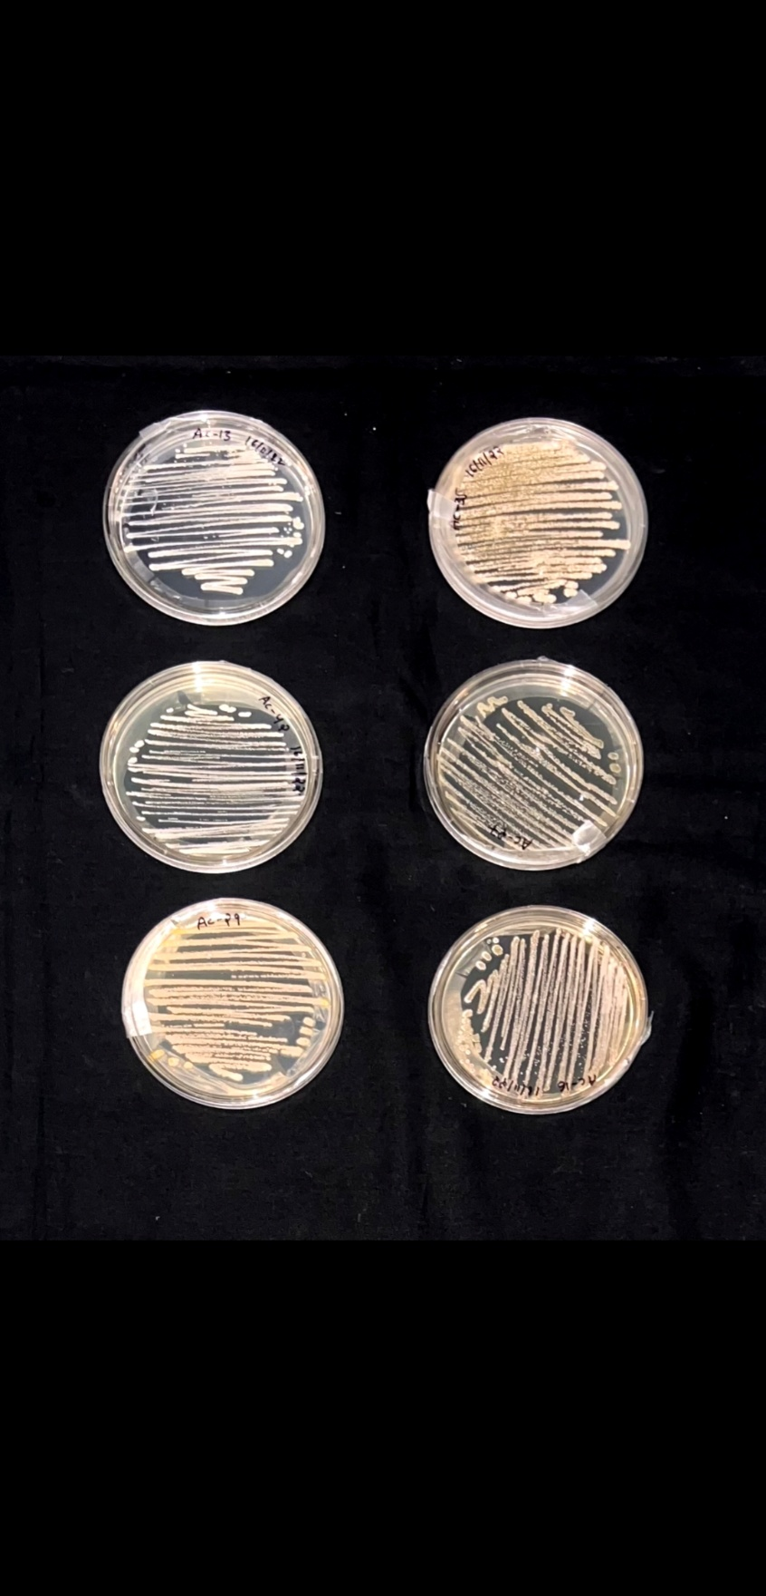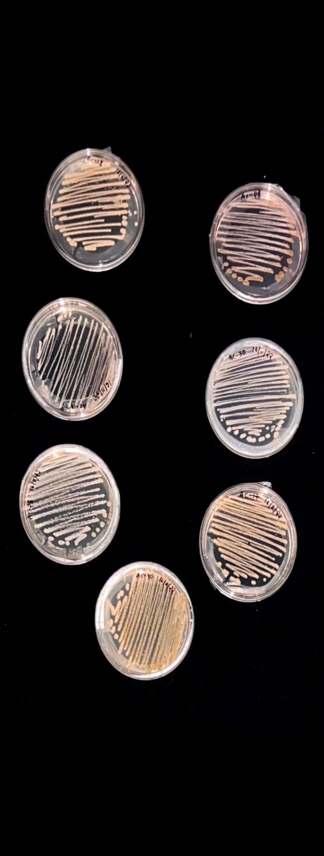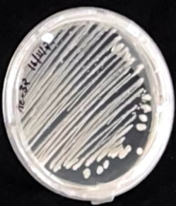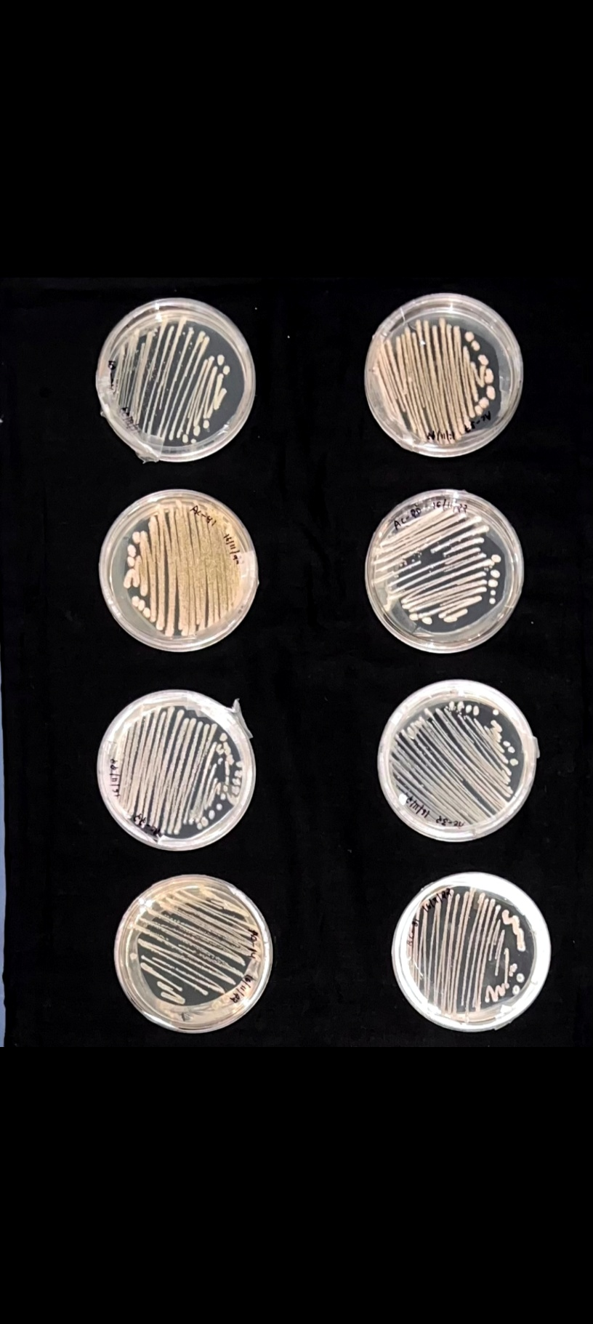
Fig.1. Pure cultures of Actinomycetes isolates

Table 1. Details of agricultural waste samples collected from different regions of Andhra Pradesh, India for isolation of decomposing microorganisms

S. No | Source of waste | No. of Samples Collected | No. of Isolates obtained | Isolate code | Place of Collection | Geographical coordinates
 |  |  |  |  |  | Latitude | Longitude
1. | Cotton stalks | 8 | 5 | LCDA-1 to 5 | Telukutla, Palnadu | 16.36051 N | 79.37252 E
2. | Red gram waste | 6 | 3 | LCDA- 6-8 | Dachepalli, Palnadu | 16.35532 N | 79.38265 E
3. | Cotton Stalks | 8 | 2 | LCDA-9&10 | Gurazala, Palnadu | 16.33006 N | 79.37309 E
4. | Cotton, Red gram and Maize waste | 15 | 2 | LCDA-11-12 | Amaravathi, Palnadu | 16.570831 N | 80.373554 E
5. | Sesamum waste | 5 | 3 | LCDA-13-15 | Tirupathi | 13.641833 N | 79.374186 E
6. | Chilli Waste | 10 | 4 | LCDA-16-19 | Kaza, Guntur | 16.381105 N | 80.548875 E
7. | Groundnut Waste | 11 | 3 | LCDA-20-22 | Yerragudi, Kurnool | 15.514985 N | 77.746304 E
8. | Rice Waste | 9 | 6 | LCDA-23-28 | Cherukupalli, Bapatla | 16.035309 N | 80.694766 E
9. | Rice Straw | 12 | 4 | LCDA-29-32 | Maruteru, Godavari | 16.629831 N | 81.745804 E
10. | Groundnut rhizosphere | 11 | 7 | LCDA-33-39 | Tirupathi | 13.625133 N | 79.374744 E
11. | Rice straw | 8 | 6 | LCDA-40-45 | Uppalapadu, Guntur | 16.302482 N | 80.522509 E
12. | Paddy | 7 | 4 | LCDA-46-49 | Nellore | 79.811135 N | 14.45612 E
13. | Wood decomposing waste | 10 | 5 | LCDA-50-54 | Amaravathi, Palnadu | 16.569775 N | 80.375947 E
14. | Chilli Waste | 6 | 3 | LCDA-55-57 | Krishnagiri, Kurnool | 15.559156 N | 77.790949 E
15. | Chilli Waste | 12 | 5 | LCDA-58-62 | Kurichedu, Prakasam | 15.882521 N | 79.687425 E
16. | Maize waste | 6 | 2 | LCDA-63&64 | Repalle, Bapatla | 16.036742 N | 80.807072 E
17. | Paddy | 7 | 3 | LCDA-65-67 | Nellore | 80.046317 N | 14.34515 E
18. | Rice straw | 10 | 4 | LCDA-68-71 | Maruteru, Godavari | 16.629925 N | 81.745879 E
19. | Compost Waste | 9 | 4 | LCDA-72-75 | Chavapadu, Palnadu | 16.529533 N | 80.383528 E

3.2 Screening of actinomycetes isolates for lignocellulose degrading ability
3.2.1 Primary screening of actinomycetes isolates for lignocellulose degrading ability
Seventy-five actinomycetes were screened for cellulose and lignin degradation ability by growing them on carboxy methyl cellulose agar and in in-vitro assay, 52 actinomycetes have shown positive for cellulose degradation by forming the zone of hydrolysis. Among 52 actinomycetes, 27 isolates have shown strong degradation, 21 isolates have shown moderate degradation and 12 isolates have shown low degradation ability on CMC agar and 29 actinomycetes have shown positive for lignin degradation by forming blue zone of hydrolysis on MSM-L media in the presence of methylene blue as indicator (Fig. 2). Among 29 actinomycetes, 15 (LCDA-1, 2, 4, 16, 22, 23, 33, 36, 39, 40, 42, 65, 67, 69 and 72) isolates have shown strong degradation, 3 isolates (LCDA-12, LCDA-49 and LCDA-63) have shown moderate degradation and 11 isolates have shown low degradation ability on lignin medium. Zone of hydrolysis was measured as strong, moderate, low degradation and no degradation (Table 2).
These studies are in accordance with the results of Bhattacharjya et al. (2021), they identified 10 isolates (four bacterial, two fungal and four actinobacteria) were positive for cellulolytic activity which were isolated from the dump sites of municipal solid waste. These ten isolates have produced the halo zone around the colonies on carboxy methyl cellulose agar (CMC) agar plates in presence of indicator dye. Similarly, Mahmood et al. (2020) screened 42 bacterial isolates for their ability to degrade cellulose by using congo red assay method. Out of 42 isolates only 24 formed a distinct clear zone around colonies on CMC agar plate after congo red staining. Among them, only three bacterial species exhibited the highest cellulose degrading activity, 6 showed high activity, while ten isolates showed moderate cellulolytic activity and other 4 isolates showed lower cellulolytic activity. These findings were coinciding with the results of (Jagadeesh and Muthura, 2022) isolated 78 isolates were screened for lignolytic activity. About 45 isolates which showed better growth and formed zone of clearance in alkali lignin media indicates positive for lignin degradation. Bandounas et al. (2011) proved that bacteria such as Pseudomonas sp. LD002 and Bacillus sp. LD003 isolated from the soil under the rotting logs have produced the zone of hydrolysis on the lignin media In vitro conditions which proves the ability of lignolytic activity of the microbial isolates.

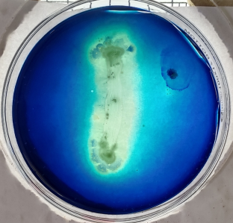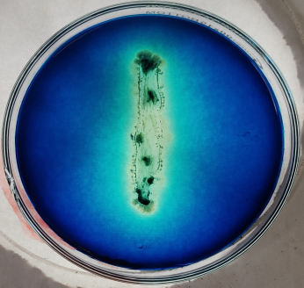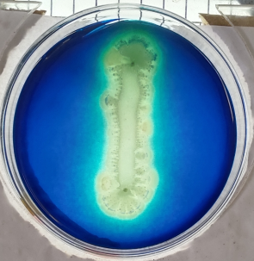
LCDA-1 LCDA-22 LCDA-36

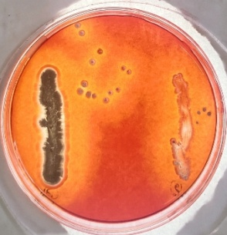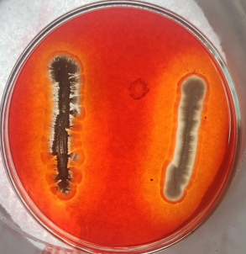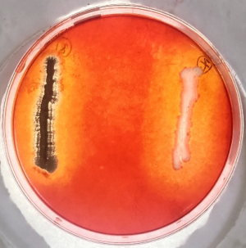
LCDA-1 LCDA-6 LCDA-36 LCDA-69 LCDA-27 LCDA-67 LCDA-36

Fig.2. Qualitative lignocellulolytic screening of actinomycetes lignocellulolytic actinomycetes isolated from natural habitat

Table 2. Qualitative lignocellulose degradation ability of microbial isolates lignocellulolytic actinomycetes isolated from natural habitat
S. No | Isolate | Lignin degradation | Cellulose  degradation | S. No | Isolate | Lignin degradation | Cellulose  degradation
1. | LCDA-1 | +++ | +++ | 39. | LCDA-39 | +++ | +++
2. | LCDA-2 | +++ | +++ | 40. | LCDA-40 | +++ | +++
3. | LCDA-3 | - | ++ | 41. | LCDA-41 | - | ++
4. | LCDA-4 | +++ | +++ | 42. | LCDA-42 | +++ | +++
5. | LCDA-5 | - | +++ | 43. | LCDA-43 | - | ++
6. | LCDA-6 | - | +++ | 44. | LCDA-44 | + | -
7. | LCDA-7 | - | +++ | 45. | LCDA-45 | - | -
8. | LCDA-8 | + | + | 46. | LCDA-46 | + | -
9. | LCDA-9 | - | +++ | 47. | LCDA-47 | - | ++
10. | LCDA-10 | - | - | 48. | LCDA-48 | - | ++
11. | LCDA-11 | - | +++ | 49. | LCDA-49 | ++ | ++
12. | LCDA-12 | ++ | + | 50. | LCDA-50 | - | -
13. | LCDA-13 | - | - | 51. | LCDA-51 | + | ++
14. | LCDA-14 | + | - | 52. | LCDA-52 | - | ++
15. | LCDA-15 | - | ++ | 53. | LCDA-53 | + | ++
16. | LCDA-16 | +++ | +++ | 54. | LCDA-54 | - | ++
17. | LCDA-17 | - | +++ | 55. | LCDA-55 | + | ++
18. | LCDA-18 | + | +++ | 56. | LCDA-56 | - | +
19. | LCDA-19 | - | +++ | 57. | LCDA-57 | - | -
20. | LCDA-20 | - | + | 58. | LCDA-58 | - | +
21. | LCDA-21 | - | +++ | 59. | LCDA-59 | + | ++
22. | LCDA-22 | +++ | +++ | 60. | LCDA-60 | - | +
23. | LCDA-23 | +++ | +++ | 61. | LCDA-61 | - | -
24. | LCDA-24 | - | + | 62. | LCDA-62 | - | -
25. | LCDA-25 | + | ++ | 63. | LCDA-63 | ++ | -
26. | LCDA-26 | - | +++ | 64. | LCDA-64 | - | -
27. | LCDA-27 | - | +++ | 65. | LCDA-65 | +++ | +++
28. | LCDA-28 | - | ++ | 66. | LCDA-66 | - | -
29. | LCDA-29 | - | - | 67. | LCDA-67 | +++ | +++
30. | LCDA-30 | - | ++ | 68. | LCDA-68 | - | +
31. | LCDA-31 | - | ++ | 69. | LCDA-69 | +++ | +++
32. | LCDA-32 | - | + | 70. | LCDA-70 | - | ++
33. | LCDA-33 | +++ | +++ | 71. | LCDA-71 | - | -
34. | LCDA-34 | - | + | 72. | LCDA-72 | +++ | +++
35. | LCDA-35 | - | + | 73. | LCDA-73 | - | +
36. | LCDA-36 | +++ | +++ | 74. | LCDA-74 | - | +
37. | LCDA-37 | - | ++ | 75. | LCDA-75 | + | ++
38. | LCDA-38 | - | +++

3.2.2 Secondary screening of actinomycetes isolates for lignocellulose degrading ability
Secondary screening was done by using the isolates which possessed both lignin and cellulose degrading ability based on the results of qualitative plate assay. A total of four enzyme assays were conducted viz. cellulase, laccase, lignin peroxidase and xylanase enzymes. Then the activity of the enzymes was recorded using spectrophotometer and the results were given in table 3.
Out of 21 Actinomycetes isolates (LCDA-1, 2, 16, 18, 22, 23, 33, 36, 39, 40, 42, 49, 51, 53, 55, 59, 65, 67, 69, 72 and 75), highest cellulase enzyme activity was shown by LCDA-22 (62.153 U/mL), LCDA-36 (60.93 U/mL) and the lowest was recorded by LCDA-53 (41.898 U/mL). In xylanase enzyme assay highest activity was recorded by LCDA-1 (39.753 U/mL), LCDA-22 (39.281 U/mL), and the lowest activity was shown by LCDA-75 (26.337 U/ml). Highest Laccase enzyme activity was shown by LCDA-22 (579.167 U/mL), LCDA-1 (509.167 U/mL) and lowest was recorded in LCDA-59 (260 U/mL). Then highest lignin peroxidase enzyme activity was observed in LCDA-22 (5.064 U/mL), LCDA-1 (5.007 U/mL) and lowest was recorded in LCDA-49 (3.867 U/mL).
Few researchers worked on microbes which are degrading lignocellulosic wastes and the results were in accordance with the present study. Jagadeesh and Muthura (2022) isolated nine actinobacterial isolates and among them, UASAP2 showed relatively higher enzyme production, yielding CMCase (83.24 U/mL), β-glucosidase (6.52 U/mL), xylanase (0.125 U/ml), laccase (0.069 U/mL), and LiP (0.119 U/mL) compared to other isolates. Similar work was conducted by Zhang et al. (2021) and a total of 13 bacteria and 14 fungal isolates were tested for hydrolytic and oxidative enzyme assays. Results of these assays shown that fungal strains (HJ (802.78 U/L) highest laccase activity than bacterial isolates A10 (0.49 U/L). Similarly, CMCase activity is higher in fungal isolate HP (240.53 U/L) than bacterial isolate A10 (210.86 U/mL) whereas lignin peroxidase activity was higher in bacterial isolates S1P2 (23.66) than fungal isolates RP and BP (0.72 U/L).

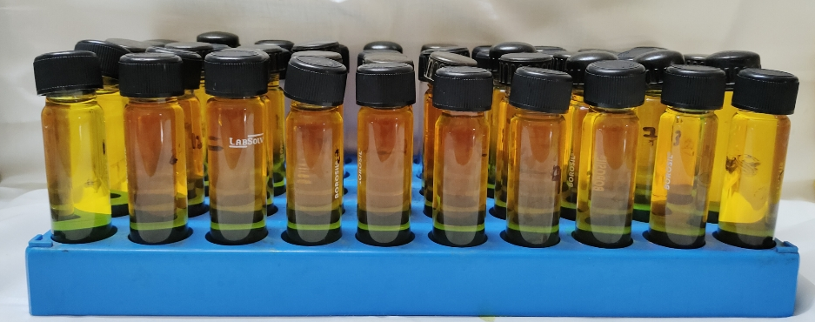
Fig. 3. Quantitative cellulase enzyme assay exhibited by lignocellulolytic actinomycetes

Table 3. Quantitative enzyme assays of lignocellulolytic actinomycetes isolated from natural habitat of decomposing sites.

S.No | Isolate Name | Enzyme activity
S.No | Isolate Name | Hydrolytic enzymes |  | Oxidative enzymes
S.No | Isolate Name | Cellulase  (U/mL) | Xylanase  ( U/mL) | Laccase  ( U/mL) | Lignin peroxidase  ( U/mL)
1. | LCDA-1 | 58.221^{b} | 39.753ª | 509.167^{b} | 5.007^{ab}
2. | LCDA-2 | 45.764^{h} | 33.056^{cd} | 428.333^{i} | 4.242^{jk}
3. | LCDA-16 | 50.126^{fg} | 33.551^{c} | 433.333^{h} | 4.71^{efgh}
4. | LCDA-18 | 53.397^{cde} | 33.798^{c} | 383.333^{l} | 3.912^{l}
5. | LCDA-22 | 62.153ª | 39.281ª | 579.167ª | 5.064ª
6. | LCDA-23 | 54.421^{cd} | 32.876^{cd} | 442.5^{f} | 4.29^{j}
7. | LCDA-33 | 54.52^{cd} | 30.944^{ef} | 337.5^{n} | 4.404^{ij}
8. | LCDA-36 | 60.93ª | 38.539^{ab} | 489.167^{c} | 4.971^{abc}
9. | LCDA-39 | 53.562^{cde} | 28.809^{g} | 395^{k} | 4.752^{defgh}
10. | LCDA-40 | 55.644^{c} | 37.393^{b} | 480.833^{d} | 4.959^{abcd}
11. | LCDA-42 | 49.299^{g} | 26.607^{h} | 429.167^{i} | 4.077^{kl}
12. | LCDA-49 | 51.15^{efg} | 29.551^{fg} | 350.833^{m} | 3.867^{l}
13. | LCDA-51 | 46.656^{h} | 29.371^{fg} | 444.167^{f} | 4.269^{jk}
14. | LCDA-53 | 41.898^{i} | 30.292^{efg} | 276.667^{q} | 4.788^{cdefg}
15. | LCDA-55 | 42.757^{i} | 31.618de | 334.167º | 4.626^{fgh}
16. | LCDA-59 | 45.533^{h} | 26.517^{h} | 260^{r} | 4.821^{bcdef}
17. | LCDA-65 | 45.235^{h} | 32.831^{cd} | 424.167^{j} | 4.554^{hi}
18. | LCDA-67 | 54.884^{c} | 37.034^{b} | 475e | 4.854^{bcde}
19. | LCDA-69 | 44.508^{hi} | 33.933^{c} | 274.167^{q} | 4.593^{ghi}
20. | LCDA-72 | 53.364^{cde} | 33.753^{c} | 280.833^{p} | 4.692^{efgh}
21. | LCDA-75 | 51.943^{def} | 26.337^{h} | 437.5^{g} | 4.245^{jk}
 | CD | 2.357 | 1.475 | 3.223 | 0.188
 | SE(m) | 0.823 | 0.515 | 1.125 | 0.066
 | SE(d) | 1.164 | 0.729 | 1.592 | 0.093
 | C.V. | 2.782 | 2.732 | 0.484 | 2.495

3.3 Morphological and Biochemical characterization of lignocellulolytic actinomycetes
A total of 21 actinomycetes were studied by growing the isolates on their specific media and the results were interpreted in Table 4. The texture of actinomycetes colonies varies from powdery to dry texture with a colour of yellow, grey, ash and white and with aerial mycelium. All the actinomycetes were gram positive and they were cocci shaped having a spiral or chain arrangement. Fungal isolates have different spore colours viz. green, orange, olive green and brown with spherical or oval in shape and having branched hyphal network.
The results of this study are in consistent with the findings of Chukwuma et al. (2023), they characterized the isolates based on visual and microscopic observations and found that 30% of the isolates were Gram-negative with cocci to rod shapes and having chains, pairs and cluster arrangements whereas the other 70% were Gram-positive.

The biochemical characteristics of the 21 actinomycetes isolates (LCDA-1 to LCDA-75) were evaluated using IMViC tests, carbohydrate utilization test, and enzymatic assays. Variations were observed in citrate utilization, lactose, sorbitol, rhamnose utilization, and starch hydrolysis among the isolates. The isolates LCDA-1, LCDA-22, LCDA-36, LCDA-40, and LCDA-67 were considered as the best, as they exhibited of positive reaction for biochemical traits and strong starch hydrolysis activity, whereas the isolates LCDA-39, LCDA-49, and LCDA-55 showed comparatively lower biochemical activity (Table 5).
These findings are in agreement with those of Jain and Jain (2007), who have reported that S. sampsonii strain, GS1322 showed positive reaction for a broad range of biochemical tests, including the utilization of various sugars (glucose, arabinose, xylose, maltose, galactose, lactose, mannitol, raffinose, salicin), as well as starch, gelatin, and casein hydrolysis.

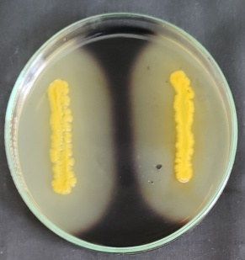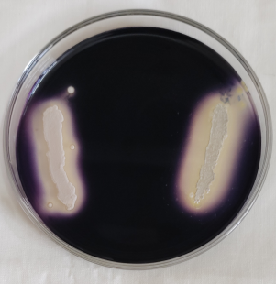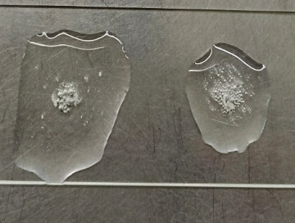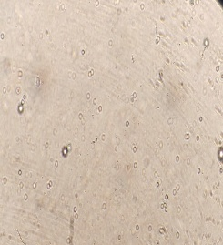
Starch Hydrolysis Catalase test Spores of actinomycetes
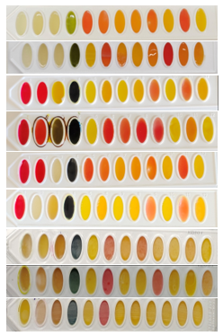
Fig.4. Biochemical characterization of lignocellulolytic actinomycetes isolated from natural habitat

Table 4. Morpho- cultural characteristics of lignocellulolytic actinomycetes isolated from natural habitat
S.No | Isolate | Morphological Characters |  |  | Cultural Characters
S.No | Isolate | Gram Staining Reaction | Cell shape | Cell arrangement | Colour of aerial mycelium | Colour of substrate mycelium | Colony texture
1. | LCDA-1 | Positive | Cocci | Spiral | Ash white | Creamy white | Dry, Powdery
2. | LCDA-2 | Positive | Rod | Chain | White | White | Powdery, Adherent
3. | LCDA-16 | Positive | Rod | Chain | Grey | White | Powdery, Adherent
4. | LCDA-18 | Positive | Cocci | Spiral | White | White | Dry, Powdery
5. | LCDA-22 | Positive | Cocci | Spiral | White | Yellow | Powdery, Adherent
6. | LCDA-23 | Positive | Cocci | Spiral | Yellow | Yellow | Powdery, Adherent
7. | LCDA-33 | Positive | Cocci | Spiral | Grey | White | Powdery, Adherent
8. | LCDA-36 | Positive | Rod | Chain | Ash | Grey | Dry, Powdery
9. | LCDA-39 | Positive | Rod | Chain | White | White | Dry, Powdery
10. | LCDA-40 | Positive | Cocci | Spiral | Ash | Grey | Powdery, Adherent
11. | LCDA-42 | Positive | Rod | Chain | White | Ash | Dry, Powdery
12. | LCDA-49 | Positive | Rod | Chain | Ash | White | Powdery, Adherent
13. | LCDA-51 | Positive | Cocci | Spiral | White | Creamy white | Powdery, Adherent
14. | LCDA-53 | Positive | Rod | Chain | White | Yellow | Dry, Powdery
15. | LCDA-55 | Positive | Cocci | Spiral | Grey | White | Dry, Powdery
16. | LCDA-59 | Positive | Rod | Chain | White | White | Powdery, Adherent
17. | LCDA-65 | Positive | Rod | Chain | Yellow | White | Powdery, Adherent
18. | LCDA-67 | Positive | Cocci | Spiral | White | Ash | Dry, Powdery
19. | LCDA-69 | Positive | Cocci | Spiral | Grey | White | Powdery, Adherent
20. | LCDA-72 | Positive | Rod | Chain | Ash | Grey | Powdery, Adherent
21. | LCDA-75 | Positive | Cocci | Spiral | White | White | Powdery, Adherent

Table 5. Biochemical characterization of lignocellulolytic actinomycetes isolated from natural habitat
S.No | Isolate | Indole | Methyl red | Voges Proskauer's | Citrate  Utilization | Glucose | Adonitol | Arabinose | Lactose | Sorbital | Mannitol | Rhamnose | Sucrose | Catalase | Oxidase | Starch
1. | LCDA-1 | - | - | - | + | + | - | + | + | + | + | + | + | + | + | +++
2. | LCDA-2 | - | - | - | - | + | - | + | + | - | + | + | + | - | + | ++
3. | LCDA-16 | - | - | - | + | + | - | + | - | - | + | + | + | + | + | +
4. | LCDA-18 | - | - | - | - | + | - | + | + | + | + | + | + | + | + | ++
5. | LCDA-22 | - | - | - | - | + | - | + | + | + | + | + | + | + | + | +++
6. | LCDA-23 | - | - | - | - | + | - | + | - | - | + | + | + | - | + | ++
7. | LCDA-33 | - | - | - | + | + | - | + | - | - | + | + | + | + | + | ++
8. | LCDA-36 | - | - | - | - | + | - | + | + | + | + | + | + | + | + | +++
9. | LCDA-39 | - | - | - | - | + | - | + | - | - | + | + | + | - | + | +
10. | LCDA-40 | - | - | - | - | + | - | + | + | + | + | + | + | + | + | +++
11. | LCDA-42 | - | - | - | - | + | - | + | + | + | + | + | + | + | + | ++
12. | LCDA-49 | - | - | - | + | + | - | + | + | - | + | + | + | + | + | +
13. | LCDA-51 | - | - | - | - | + | - | + | - | - | + | + | + | - | + | ++
14. | LCDA-53 | - | - | - | - | + | - | + | + | + | + | + | + | + | + | ++
15. | LCDA-55 | - | - | - | + | + | - | + | - | - | + | + | + | - | + | +
16. | LCDA-59 | - | - | - | - | + | - | + | + | + | + | + | + | + | + | ++
17. | LCDA-65 | - | - | - | - | + | - | + | - | - | + | + | + | + | + | ++
18. | LCDA-67 | - | - | - | - | + | - | + | + | + | + | + | + | + | + | +++
19. | LCDA-69 | - | - | - | - | + | - | + | - | - | + | + | + | - | + | ++
20. | LCDA-72 | - | - | - | + | + | - | + | - | - | + | + | + | + | + | ++
21. | LCDA-75 | - | - | - | - | + | - | + | - | + | + | + | + | - | + | +

4. Conclusion
The present study clearly showed a varied degree of lignin and cellulose degrading ability of isolates obtained. Out of the 75 isolates obtained, 21 showed both lignin and cellulose degrading capacity. Quantitative enzyme analysis confirmed the ability of isolates for production of cellulase, xylanase, laccase, and lignin peroxidase. Further, morphological and biochemical characterization indicated that these isolates were able to utilize a variety of sugars for their growth. The pot and field studies with crop residues are required to confirm their ability of degradation under natural environments. The degradation ability of the isolates can be better utilized for crop residue management. Their application may provide an environmentally friendly approach to reduce crop residue burning and promote sustainable agricultural practices.
Disclaimer (Artificial Intelligence)
Author(s) hereby declares that NO generative AI technologies such as Large Language Models (ChatGPT, COPILOT, etc.) and text-to-image generators have been used during the writing or editing of this manuscript.

References
Andro, T., Chambost, J.P., Kotoujansky, A., Cattaneo, J., Bertheau, Y., Barras, F., Van Gijsegem, F. and Coleno, A. (1984). Mutants of Erwinia chrysanthemi defective in secretion of pectinase and cellulase. Journal of Bacteriology, 160(3), 1199-1203. https://doi.org/10.1128/jb.160.3.1199-1203.1984
Bailey, M. J., Biely, P., Poutanen, K. (1992) Interlaboratory testing of methods for assay of xylanase activity. Journal of Biotechnology, 23(3), 257–270. https:// doi.org/10.1016/0168-1656(92)90074-J
Bandounas, L., Wierckx, N.J., de Winde, J.H. and Ruijssenaars, H.J. (2011). Isolation and characterization of novel bacterial strains exhibiting ligninolytic potential. Bmc Biotechnology, 11(1), 94. https://doi.org/10.1186/1472-6750-11-94
Barthalomew, J.W and Mittewer, T. (1950). A simplified bacterial strain. Stain Technology. 25, 152-153.
Bhattacharjya, S., Sahu, A., Phalke, D.H., Manna, M.C., Thakur, J.K., Mandal, A., Tripathi, A.K., Sheoran, P., Choudhary, M., Bhowmick, A. and Rahman, M.M. (2021). In situ decomposition of crop residues using lignocellulolytic microbial consortia: a viable alternative to residue burning. Environmental Science and Pollution Research. 28(25), 2416-32433. https://doi.org/10.1007/s11356-021-12611-8
Borah, D., Parida, P. and Kumar, T. (2012). Paper currencies, a potential carrier of pathogenic microorganisms. International Journal of Applied Biology and Pharmaceutical Technology, 3(1), 23-25.
Bourbonnais, R. and Paice., M.G. (1990). “Oxidation of non-phenolic substrates: an expanded role for laccase in lignin biodegradation. FEBS letters, 267(1), 99–102. https://doi.org/10.1016/0014-5793(90)80298-W
Chukwuma, O.B., Rafatullah, M., Kapoor, R.T., Tajarudin, H.A., Ismail, N., Siddiqui, M.R. and Alam, M. (2023). Isolation and characterization of lignocellulolytic bacteria from municipal solid waste landfill for identification of potential hydrolytic enzyme. Fermentation, 9(3), 298. https://doi.org/10.3390/fermentation9030298
Clay, D.E., Alverson, R., Johnson, J.M., Karlen, D.L., Clay, S., Wang, M.Q., Bruggeman, S. and Westhoff, S. (2019). Crop residue management challenges: a special issue overview. Agronomy Journal, 111(1), 1-3. https://doi.org/10.2134/agronj2018.10.0657Digital Object Identifier (DOI)
Godfray, H.C.J., Beddington, J.R., Crute, I.R., Haddad, L., Lawrence, D., Muir, J.F., Pretty, J., Robinson, S., Thomas, S.M. and Toulmin, C. (2010). Food security: the challenge of feeding 9 billion people. Science, 327 (5967), 812-818. 10.1126/science.1185383
Gomez, K.A. and Gomez, A.A. 1984. Statistical procedures for agricultural research. John wiley & sons. 1-657.
Harindintwali, J.D., Zhou, J. and Yu, X. (2020). Lignocellulosic crop residue composting by cellulolytic nitrogen-fixing bacteria: a novel tool sustainability. Science of The Total Environment, 715, 136912. https://doi.org/10.1016/j.scitotenv.2020.136912
Holt, J.G, Kreig, N.R., Sneath, P.H.A., Staley, J.T and Williams, S.T. (1994). Bergey‘s manual of determinative bacteriology, 9th ed. Williams and Wilkins, Baltimore, 40-169.
Jagadeesh, U. and Muthura, R. (2022). Isolation and Screening of Potential Lignocellulolytic Microorganisms from Different Ecosystems. Mysore Journal of AgriculturalSciences, 56(4).
Jain, P.K. and Jain, P.C. (2007). Isolation, characterization and antifungal activity of Streptomyces sampsonii GS 1322. Indian Journal of Experimental Biology, 45, 203-206.
Kausar, H., Sariah, M., Mohd Saud, H., Zahangir Alam, M. and Razi Ismail, M. (2011). Isolation and screening of potential actinobacteria for rapid composting of rice straw. Biodegradation, 22(2), 367-375. https://doi.org/10.1007/s10532-010-9407-3
Madeira Jr, J.V., Contesini, F.J., Calzado, F., Rubio, M.V., Zubieta, M.P., Lopes, D.B. and de Melo, R.R. (2017). Agro-industrial residues and microbial enzymes: an overview on the eco-friendly bioconversion into high value-added products. Biotechnology of Microbial Enzymes, 475-511. https://doi.org/10.1016/B978-0-12-803725-6.00018-2
Mahmood, R., Afrin, N., Jolly, S.N. and Shilpi, R.Y. (2020). Isolation and identification of cellulose-degrading bacteria from different types of samples. World Journal of Environmental Biosciences, 9(2), 8-13.
Misselbrook, T.H., Menzi, H. and Cordovil, C. (2012). Preface–recycling of organic residues to agriculture: agronomic and environmental impacts. Agriculture, Ecosystems & Environment, 160: 1-2. https://doi.org/10.1016/j.agee.2012.08.003
Priya, S., Kumar, G., Kumar, S. and Bharti, S.K. (2018). Isolation, characterization and identification of lignocellulose degrading actinomycetes from litchi fruit orchard of Muzaffarpur, Bihar, India. Pharma Innovation Journal, 7(8),463-467.
Qi, D., Zou, L., Zhou, D., Chen, Y., Gao, Z., Feng, R., Zhang, M., Li, K., Xie, J. and Wang, W. (2019). Taxonomy and broad-spectrum antifungal activity of Streptomyces sp. SCA3-4 isolated from rhizosphere soil of Opuntia stricta. Frontiers in Microbiology, 10, 1390. https://doi.org/10.3389/fmicb.2019.01390
Sapkota, A., Thapa, A., Budhathoki, A., Sainju, M., Shrestha, P. and Aryal, S. (2020). Isolation, characterization, and screening of antimicrobial-producing actinomycetes from soil samples. International Journal of Microbiology, 2020: 7. https://doi.org/10.1155/2020/2716584
Sharma, S., Kumawat, K.C. and Kaur, S. (2022). Potential of indigenous ligno-cellulolytic microbial consortium to accelerate degradation of heterogenous crop residues. Environmental Science and Pollution Research, 29 (58), 88331-88346. https://doi.org/10.1007/s11356-022-21809-3
Shirling, E.T. and Gottlieb, D. (1966). Methods for characterization of Streptomyces species. International Journal of Systematic Bacteriology, 16(3), 313-340.
Shukla, L., Senapati, A., Tyagi, S.P. and Saxena, A.K. (2014). Economically viable mass production of lignocellulolytic fungal inoculum for rapid degradation of agrowaste. Current Science, 1701-1704. https://www.jstor.org/stable/24107944
Singh, A. and Sharma, S. (2002). Composting of a crop residue through treatment with microorganisms and subsequent vermicomposting. Bioresource Technology, 85 (2), 107-111. https://doi.org/10.1016/S0960-8524(02)00095-0
Tien, M. and Kirk, T.K. (1984). “Lignin-degrading enzyme from Phanerochaete chrysosporium: purification, characterization, and catalytic properties of a unique requiring oxygen ase,” Proceedings of the National Academy of Sciences of the United States of America, 81 (8), 280–2284. https://doi.org/10.1073/pnas.81.8.2280
Zhang, Z., Shah, A.M., Mohamed, H., Tsiklauri, N. and Song, Y. (2021). Isolation and screening of microorganisms for the effective pretreatment of lignocellulosic agricultural wastes. BioMed Research International, 2021(1), 5514745. https://doi.org/10.1155/2021/5514745

