OUTBREAK OF CONTAGIOUS ECTHYMA IN ASSAM HILL GOATS AND ITS THERAPEUTIC MANAGEMENT AT GOAT RESEARCH STATION, BURNIHAT, ASSAM

Abstract
Contagious ecthyma, also known as orf, is an acute, highly contagious, and economically important zoonotic disease of small ruminants caused by orf virus, belonging to Parapoxvirus genus of the Poxviridae family. An investigation of an outbreak of contagious ecthyma was conducted at Goat Research Station, Burnihat, Assam, from November 2025 to February 2026 to study the epidemiological pattern, clinicopathological changes, and therapeutic management of contagious ecthyma in goats. Out of a total of 170 goats, 28 goats showed clinical manifestations of contagious ecthyma, resulting in an overall outbreak prevalence of 16.47 percent. Among these, kids between 0-3 months of age showed the highest incidence of contagious ecthyma, with female kids being more susceptible to the disease than male kids. Clinically, goats with contagious ecthyma showed pyrexia, anorexia, depression, and proliferative, crusty lesions around the lips, muzzle, and occasionally on the eyelids and limbs. In addition, goats with contagious ecthyma showed leukocytosis with decreased hemoglobin and packed cell volume. Contagious ecthyma was confirmed by PCR assay of scab materials. Antiseptic care, topical antimicrobial agents, systemic antimicrobial agents, and supportive care resulted in complete recovery of goats with contagious ecthyma within 10-20 days, with two mortalities. The findings highlight the seasonal vulnerability of young kids and underline the importance of early diagnosis, isolation and prompt supportive therapy in controlling outbreaks.
Key words: Contagious ecthyma, Orf virus, Assam Hill goat, Parapoxvirus, Zoonosis
- Introduction
Contagious ecthyma, commonly known as Orf, is a viral skin disease of goats and sheep, transmitted by Orf virus, belonging to Parapoxvirus of the Poxviridae family (Bora et al., 2015). It is characterized by proliferative and scabby lesions, mainly involving lips and oral mucosa. The disease is known for its high morbidity rates in naive flocks. Apart from economic losses due to growth retardation, lowered feed intake, and death in young animals, Orf also possesses zoonotic potential, especially in farmers, animal handlers, and even veterinarians (Spyrou and Valiakos, 2015). Transmission of the disease occurs by direct contact with infected animals or fomites. Minor abrasions in the oral mucosa, resulting from rough fodder, provide an entry route for the virus. The persistence of the virus in the environment also plays a role in the spread of the disease. Morbidity can reach as high as 100% during primary outbreaks, whereas mortality rates vary from 5-15%, especially in young kids due to complications like starvation, myiasis, and secondary bacterial infections (Somnath et al., 2025). Assam Hill goats are an indigenous breed of the North Eastern region of India and are of great economic importance. However, there is limited information on the epidemiology of Orf infection and the clinicopathological changes observed in the Assam Hill goats. The present study was undertaken to describe the epidemiological features, clinical manifestations, hematological changes, and therapeutic responses observed during a contagious ecthyma outbreak in Assam Hill goats at the Goat Research Station, Burnihat.
- Materials and Methods-

2.1. Study Area and Duration: The study was conducted at the Goat Research Station, Burnihat, under Assam Veterinary and Fishery University, from November 2025 to February 2026.

2.2. Animals and Clinical Examination: A population of 170 goats, comprising 70 male and 100 female, irrespective of breed, was monitored for the study. Goats showing symptoms such as fever, anorexia, and crusty lesions around the oral commissures were considered suspect cases. Detailed clinical examination was carried out, including rectal temperature, site of lesions, and general condition of the animal.

2.3. Hematological Analysis: About 2 ml of blood was aseptically drawn from the jugular vein into K3 EDTA-coated tubes. Blood analysis was carried out using an automated hematology analyzer. Parameters considered were total leukocyte count (TLC), total erythrocyte count (TEC), hemoglobin (Hb), packed cell volume (PCV), mean corpuscular volume (MCV), mean corpuscular hemoglobin (MCH), and mean corpuscular hemoglobin concentration (MCHC), which were compared with normal reference values (Merck & Co., Inc. 2016).

2.4. Molecular Confirmation: Scab materials (n=15) from active lesions were collected aseptically and transferred immediately in ice box to the laboratory of Department of Veterinary Microbiology, AVFU. The scab materials were processed following standard method and subjected for molecular detection of the orf virus nucleic acid using polymerase chain reaction (PCR) assay targeting full length amplification of ORFV-specific B2L gene. Full-length B2L gene was amplified by conventional PCR from the DNA extracted from processed scab samples using previously published primer sets: OVB2LF, TCCCTGAAGCCCTATTATTTTTGTG and OVB 2LR, GCTTGCGGGCGTT CGGACCTTC (Hosamani et al., 2006). PCR was performed in standard 25 µl reaction containing 3µl extracted DNA, 20 pmol of each primer, 2.5µl of 10X PCR buffer, 25mM of MgCl₂, 10mM dNTPs (deoxynucleotide triphosphates) and 2.5 IU of DyNazyme (Thermo Scientific) in a thermal cycle (Thermo Scientific) with an initial denaturation step of 94ºC for 5 mins followed by 30 cycles of 94ºC for 1 min, 52ºC for 1 min, 72ºC for 1 min and final extension of 72ºC for 7 mins.

2.5. Therapeutic Management: The affected goats were isolated to prevent the spread of the disease. Local treatment for the disease involved debridement and gentle cleaning of the lesions with a diluted potassium permanganate solution, followed by the boric acid-glycerin preparation and the antimicrobial ointment. An immune booster supplement was given orally daily to the affected goats. Treatment for the disease in severe cases involved the administration of antibiotics, such as Ceftiofur @ 2 mg/kg body weight for five days, and Meloxicam @ 0.5 mg/kg body weight for three days, to prevent secondary bacterial infection and inflammation, respectively.
2.6. Statistical analysis: For the analysis of the data, the Chi-square goodness-of-fit test has been employed for the prevalence data, whereas the one-sample t-test has been used for the hematological data by comparing the mean with the midpoint of the reference range. The level of significance has considered at p < 0.05, 0.01. The statistical analysis has been carried out using SPSS version 25 statistical software.

3. Results and Discussion
3.1. Epidemiological Findings:
Out of a total of 170 goats, 28 Assam hill goats were infected, resulting in an outbreak prevalence of 16.47 percent. With regard to age, the results revealed that out of a total of 28 infected goats, 26 goats (92.85%) were within the age group of 0-3 months, whereas only 2 goats (7.14%) were within the age group of 3-6 months (Table.1). The higher occurrence of ORF in kids compared to adult goats could be attributed to their immune status. It has been observed that young animals, especially neonatal animals, do not possess a fully competent immune system. As a result, they are more prone to viral infections. In addition, young animals are more prone to lip and gum abrasions due to their immaturity, which facilitates the entry of parapox virus. Painful proliferative lesions, especially in young animals, may also affect their ability to suckle milk, resulting in poor nutrition and a compromised immune system. Earlier studies also observed that young animals are more prone to ORF due to their immaturity and are more exposed to the disease during their early life stage (Patowary et al., 2025).The higher percentage of infected females (64.28 percent) compared to males (35.71 percent) which was recorded may be attributed to the demographic composition of the herd. Female goats are more in number in a herd, hence more prone to infection. Also, prolonged interaction between female kids and their dams may play a role in transmission of the virus, as these are more intimate interactions, which may lead to transmission of the virus through contaminated lesions. Although all the animals that showed signs of infection in this particular outbreak were recorded during winter, this may also be attributed to a seasonal factor. In winter due to cold temperatures, animals are usually kept indoors in close proximity to each other to shield them from the cold. These conditions create a conducive environment for close contact between animals, thus facilitating the spread of contagious ecthyma virus. Additionally, winter is a major kidding season for goats, thus increasing the population of susceptible young kids in the flock. Environmental stress caused by low temperatures, with the scarcity of pasture and possible nutritional stress, might have also weakened the immune response of the animals, thus increasing susceptibility to the disease. The high prevalence of ORF in young kids, female goats, and winter, as found in the current study, agrees with the earlier reports of the importance of age-related immune immaturity, herd management, and seasonal environmental stress in the epidemiology of contagious ecthyma in goats (Bala et al., 2019; Sunder et al., 2019; Patowary et al., 2025).
Table -1: Sex and age-wise prevalence of contagious ecthyma in goat
Parameter | Category | No. of Positive Cases | Total positive cases | Prevalence (%) | χ² Value | Significance
Age-wise | 0–3 months | 26 | 28 | 92.85 | 44.86ª | p < 0.001
Age-wise | 3–6 months | 2 | 28 | 7.14 | 44.86ª | p < 0.001
Age-wise | >6 months | 0 | 28 | 0.00 | 44.86ª | p < 0.001
Sex-wise | Male | 10 | 28 | 35.71 | 2.29 | NS
Sex-wise | Female | 18 | 28 | 64.28 | 2.29 | NS
ᵃ highly significant (p < 0.001), NS = Non significant (p > 0.05), Chi-square goodness-of-fit test applied

3.2. Clinical Observations: All the infected goats had an increased rectal temperature of 104.5 °F or more, anorexia, and depression. The goats also had the characteristic proliferative lesions accompanied by crust formation at the oral commissures, lips, and muzzles. The lesions sometimes extended to the eyelids, limbs, and thighs (Fig. 1, 2). The advanced lesions had thick brown crusts over the granulating tissue, which bled when the crusts were removed. The kids did not want to suckle, leading to dehydration and weight loss (Constable et al. 2017; Somnath et al., 2025).
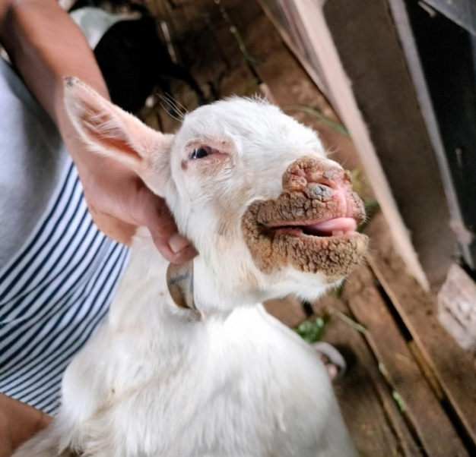 | 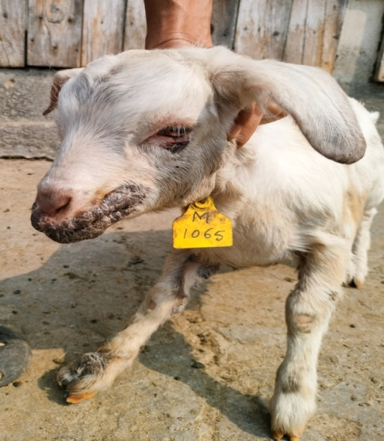
Fig.1: Thick scabby lesions around muzzle, nostrils & in tip of the ears in Assam hill goat kid | Fig.2: Thick scary lesions around muzzle, lower eyelid& in foot in Assam hill goat kid

3.3. Hematological Alterations: The comparative hematological study (Table: 2) showed an increase in TLC (20.15 ± 3.17 m/mm³), which is higher than the normal range (4-14 m/mm³), indicating leukocytosis, which is probably a secondary effect of the inflammatory response and bacterial infection. The hemoglobin level (7.42 ± 0.95 g/dl) and PCV (20.53 ± 2.38 percent) were lower than the reference values, which indicated mild anemia, which could have been caused by reduced feed intake and systemic stress. The MCHC levels were slightly raised, and the MCV levels were decreased. These changes could have been caused by the combined effects of viral disease, inflammation, and nutritional changes during active infection (Ghani et al., 2019; Somnath et al., 2025).

Table 2: Hematological parameters in CE affected goats
Parameter | Infected Goats (Mean ± SD) | 95% CI | Reference Range | Significance
TLC (m/mm³) | 20.15 ± 3.17ᵃ | 15.04–25.26 | 4–13 | p < 0.01
TEC (M/mm³) | 10.14 ± 6.83ᵇ | 7.49–12.79 | 8–18 | p < 0.05
Hemoglobin (g/dl) | 7.42 ± 0.95ᵃ | 7.05–7.79 | 8–12 | p < 0.01
PCV (%) | 20.53 ± 2.38ᵃ | 15.73–25.33 | 22–38 | p < 0.01
MCV (fl) | 14.32 ± 3.60ᵃ | 12.92–15.72 | 16–25 | p < 0.01
MCH (pg) | 7.28 ± 7.51 | 4.37–10.19 | 5.2–8 | NS
MCHC (g/dl) | 42.11 ± 1.58ᵃ | 38.40–45.82 | 28–42 | p < 0.01

ᵃ p < 0.01; ᵇ p < 0.05; NS = Non significant, One sample t test vs. reference midpoint.

3.4. Molecular detection: The PCR amplicons of full length amplification of orf virus B2L gene were analyzed using 1% agarose gel in an UV transilluminator. All the clinical samples yielded an expected specific product of 1206 bp confirming the presence of orf virus in the collected samples (Figure: 3).

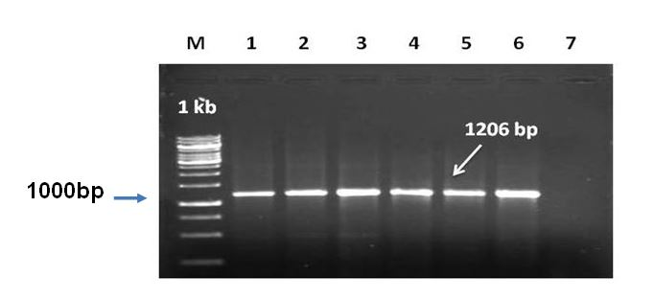

Figure.3: Amplification of full length B2L gene of Orf virus from clinical samples

Lane M: 1Kb DNA Ladder, Lane 1 to 5: Clinical samples, Lane 6: Positive control, Lane 7: NTC

3.5. Therapeutic Response: In most of the animals, there was a gradual resolution of lesions with complete recovery in 10-20 days. It is important to isolate the animals as early as possible and provide consistent wound care. In spite of treatment, two animals died of complications, highlighting the vulnerability of young kids and the importance of early supportive management. Since ORF is a self-limiting disease, complications arising because of secondary bacterial infection can be controlled by antibiotics and anti-inflammatory agents along with regular topical therapy (Maheshwari et al., 2024, Sowmiya et al., 2018).

4. Conclusion

Contagious ecthyma at Goat Research Station, Burnihat, showed moderate prevalence with marked age susceptibility, especially in kids less than three months of age. Seasonal occurrence was also recorded, especially during winter, and higher occurrence in female kids. Clinical and hematological observations indicated that inflammation and secondary infections are important in the progression of the disease. Isolation, local application of antiseptics, and systemic treatment are effective in endemic regions, which are important in controlling economic losses and zoonotic infections.

Disclaimer (Artificial Intelligence)

Author(s) hereby declare that NO generative AI technologies such as Large Language Models (Chat GPT, COPILOT, etc.) and text-to-image generators have been used during the writing or editing of this manuscript.

Competing Interests

Authors have declared that no competing interests exist.

References
Bala, J. A., Balakrishnan, K. N., Abdullah, A. A., Adamu, L., Noorzahari, M. S. B., May, L. K., Mangga, H. K., Ghazali, M. T., Mohamed, R. B., Haron, A. W., Noordin, M. M., & Lila, M. A. M. (2019). An association of Orf virus infection among sheep and goats with herd health programme in Terengganu state, eastern region of the peninsular Malaysia. BMC Veterinary Research, 15(1), 250. https://doi.org/10.1186/s12917-019-1999-1
Bora, M., Bora, D. P., Barman, N. N., Borah, B., Bora, P. L., Talukdar, A., & Tamuly, S. (2015). Isolation and molecular characterization of Orf virus from natural outbreaks in goats of Assam. VirusDisease, 26(1-2), 82–88.
Constable, P. D., Hinchcliff, K. W., Done, S. H., & Grumberg, W. (2017). Veterinary medicine: A textbook of the diseases of cattle, horses, sheep, pigs and goats (11th ed., pp. 1593–1596). Elsevier.
Ghani, M. U., Khan, M. U. R., Aslam, A., Shabbir, Z., Bo, L., & Anwar, N. (2019). Pathological studies on contagious ecthyma in naturally infected small ruminants. H & V, 6(1), 16–22.
Hosamani, M., Bhanuprakash, V., Scagliarini, A., & Singh, R. K. (2006). Comparative sequence analysis of major envelope protein gene (B2L) of Indian orf viruses isolated from sheep and goats. Veterinary Microbiology, 116, 317–324.
Maheshwari, S., Nithiselvi, R., & Thomas, K. S. (2024). A herd outbreak study on contagious ecthyma (ORF) occurrence in Thanjavur Black Goats. International Journal of Livestock Research, 14(7), 33–35.
Merck & Co., Inc. (2016). The MSD veterinary manual (11th ed.). Whitehouse Station, NJ: Merck & Co., Inc.
Patowary, P., Bhuyan, D., Das, A., Sonowal, M., Nath, M., Arif, S. A., & Kalita, M. K. (2025). A study on prevalence of morbidity and mortality due to different diseases in Assam hill goat in Assam Agricultural University: Goat Research Station, Burnihat, Kamrup (M), Assam, India. International Journal of Biological Sciences, 7(1), 41–43.
Somnath, M. N., Moovendan, M., Vivek, S., Rajkumar, K., Gururaj, K., Devadevi, N., Selvi, D., Abiramy Prabavathy, A., & Vijayalakshm, P. (2025). Epidemiology, clinical features, and molecular detection of contagious ecthyma (ORF) virus in naturally infected goats of Puducherry (India) and its adjoining areas of Tamil Nadu. International Journal of Veterinary Sciences and Animal Husbandry, 10(5), 312–316.
Sowmiya, P. V., Ramya, K., Sukmar, K., & Madheswaran, R. (2018). Molecular confirmation of contagious ecthyma among goats in Dharmapuri District of Tamil Nadu, India. International Journal of Current Microbiology and Applied Sciences, 7(6), 60–65.
Spyrou, V., & Valiakos, G. (2015). ORF virus infection in sheep or goats. Veterinary Microbiology, 181, 178–182.
Sunder Jai, Sujatha T., De A.K., Bhattacharya D., Bhowmick S., Perumal P., Kundu A. (2019). First report of contagious ecthyma (orf) outbreak in goats of Andaman and Nicobar Islands. Indian Journal of Animal Research. 54(4): 503-507. doi: 10.18805/ijar.B-3787

