Original Research Article
Effect of digestive enzymes-fortified castor leaves on cocoon and reproductive parameters of erisilkworm (Samiaricini Donovan)

ABSTRACT
Sericulture is an important agro-based industry that provides employment and income to rural communities, particularly in regions like Assam where eri culture is widely practiced. The productivity and quality of silk largely depend on the nutritional quality of host plant leaves and the efficiency of digestion in silkworms. The present study was conducted during 2024–2025 at the Department of Sericulture, Assam Agricultural University, Jorhat, to evaluate the effect of digestive enzymes-fortified castor leaves on the cocoon and reproductive parameters of eri silkworm (Samia ricini Donovan). Lipase and α-amylase enzymes were used as fortification agents at three concentrations (1%, 3%, and 5%), along with a combined treatment (1% lipase + 1% α-amylase) and an untreated control. Castor leaves were fortified using the leaf-dip method and fed to larvae from the first to fifth instar during spring and autumn seasons.The results revealed that enzyme fortification significantly improved most of the economic and developmental parameters compared to the control. Among the treatments, lipase at 5% concentration recorded the best performance, showing the highest cocoon weight (3.00 g in spring and 2.36 g in autumn), shell weight (0.50 g and 0.35 g), pupal weight (2.50 g and 1.88 g), shell ratio (16.88% and 15.66%), moth emergence (92.72% and 91.68%), and adult longevity (8.50 and 9.25 days). The same treatment also resulted in the lowest defective cocoon percentage and reduced pupal duration compared to the control group. The findings indicate that digestive enzyme supplementation, particularly lipase at 5%, can be an effective nutritional management strategy for improving cocoon quality and overall productivity of eri silkworm. This approach may contribute to enhancing the efficiency and sustainability of eri sericulture.
Keywords: Digestive enzymes, catalysts,economic parameters, fortification, nutrient management

INTRODUCTION
Sericulture is an agriculturally based labor intensive environmentally friendly cottage industry that combines the activities of both agricultural (sericulture) and industrial sectors. Sericulture is considered as an important area in uplifting the economic future of rural communities by offering steady employment at different levels like growing food plants, raising silkworms, spinning, twisting, dyeing, and weaving etc., and additional revenue to economically disadvantaged groups (Brahma et al., 2019). On the Indian map of sericulture, the state of Assam because of its favorable climatic and environmental conditions holds a significant place in producing both mulberry and vanya silk but muga and eri significantly contributes to the Assam's total silk production (Mishra et al., 2003).
Metabolism of the ingested and digested food is essential for its growth and development of silkworm as it has direct impact on all genetic traits such as larval, economic and reproductive parameters (Shamsuddin, 2009). During the last larval stage, 80% of the leaves are consumed and it is efficiently used to support the body’s metabolism, producing silk proteins and to conserve energy in non-feeding stages (Junliang and Xiaofeng, 1992). Enzymes are the natural proteins that catalyses the biochemical reaction and provide energy to meet the energy demands of any organism. Functional enzymes are responsible for the metabolic pathways that occur within each cell. Besides biochemical reactions it also reduces the pathogen incidence, free radical damage and provide more support for so many health disorders (Robinson, 2015).
Digestive enzymes play essential role in the body of the insect by breaking down the complex food material into simple micro molecules, simpler forms are essential for energy production, growth, and various functions required for the insect’s survival and development (Wyatt and Kalf, 1957). For the majority of insects as well as for silkworms, carbohydrates are a vital source of energy. They could help to produce amino acids and then be transformed into lipids along with carbohydrates, particularly sugars, have strong feeding stimulant properties (Kerkut and Gilbert 1985; Nation, 2022).Silkworms lack the ability to synthesise sterol in sufficientamounts to fulfil their physiological needs, they must consume it through their feed. As sterol is the building block for the synthesis of the silkworm moulting hormone besides functioning as a component of all cellular membranes (Genc et al., 2002; Nation, 2022). This research is carried out to evaluate the effect of digestive enzymes oncocoon and reproductive parameters of eri silkworm.
MATERIALS AND METHODS
The study was conducted during 2024–2025 at the Department of Sericulture, Assam Agricultural University, Jorhat, to evaluate the effect of digestive enzyme-fortified castor leaves on cocoon and reproductive parameters of eri silkworm (Samia ricini Donovan).
SILKWORM REARING
Disease-free layings were obtained from Government Seed Preparation Centres of the Central Silk Board, Assam. Eggs were surface sterilized with 2% formalin for 5–10 min, rinsed thoroughly, shade dried, and incubated in a BOD incubator under optimum conditions until hatching. Rearing rooms and appliances were disinfected with 0.02% Asthra or 2% bleaching powder with 0.3% slaked lime solution and dried for 2–3 days prior to use.
Larvae were reared on fresh castor (Ricinus communis L.) leaves (native red petiole variety-NBR 1). Standard rearing practices (Chowdhury, 1982) were followed during spring (March–April) and autumn (September–October) seasons of 2024–2025. Upon maturity larval maturity, they were transferred to bamboo mountages for spinning. Cocoons were harvested four days after spinning. Harvested cocoons were used to study the cocoon and reproductive parameters.
ENZYME TREATMENTS
Lipase and α-Amylase (HiMedia) were used as fortification agents. Three concentrations (1%, 3%, and 5%) of each enzyme were prepared fresh daily by dissolving 1 g, 3 g, and 5 g enzyme in 100 ml distilled water, respectively. A combined treatment (1% Lipase + 1% α-Amylase) was also included.Castor leaves were fortified using the leaf-dip method (Devi and Yellamma, 2013) by soaking in enzyme solution for 5 min and air-drying before feeding. Treated leaves were fed from 1st to 5th instar. A control (untreated leaves) was maintained separately.
COCOON AND PUPAL PARAMETERS
Cocoon weight (with pupa) and shell weight (after pupal removal) were recorded in grams.
Shell ratio (%) was calculated as:
$$Shell ratio \left(\%\right)=\frac{Weight of the cocoon shell (g)}{Weight of the cocoon with pupa (g)}×100$$
REPRODUCTIVE PARAMETERS
After adult emergence, moths were allowed to mate. Following ~4 h of coupling, females were separated and tied to a kharika for oviposition.
$$Moth emergence \left(\%\right)=\frac{Total number of moths emerged}{Total number of cocoons harvested}×100$$
Table. 1.Effect of digestive enzymes on cocoon weight (g) of eri silkworm in spring and autumn season
Enzymes | Concentrations | Seasons
 |  | Spring | Autumn
α-Amylase | 1% | 2.69^{c} | 2.02^{cd}
α-Amylase | 3% | 2.94^{ab} | 2.14^{b}
α-Amylase | 5% | 2.51^{d} | 2.00^{cd}
Lipase | 1% | 2.70^{c} | 2.07^{bc}
Lipase | 3% | 2.87^{b} | 2.11^{bc}
Lipase | 5% | 3.00ª | 2.36ª
Combination | α-Amylase 1% + Lipase 1% | 2.48^{d} | 1.92de
Control |  | 2.34e | 1.86e
Overall Mean |  | 2.69 | 2.06
S.Ed(±) |  | 0.037 | 0.049
CD(P=0.05) |  | 0.077 | 0.102

Fig 1. Effect of digestive enzymes on cocoon weight (g) of eri silkworm in spring and autumn season

a

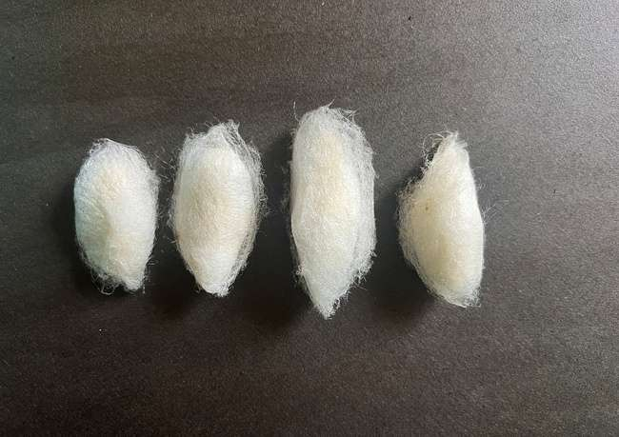
a

b
c
d

Fig 2.Cocoon of a) Lipase 1% b) Lipase 3% c) Lipase 5% d) Control

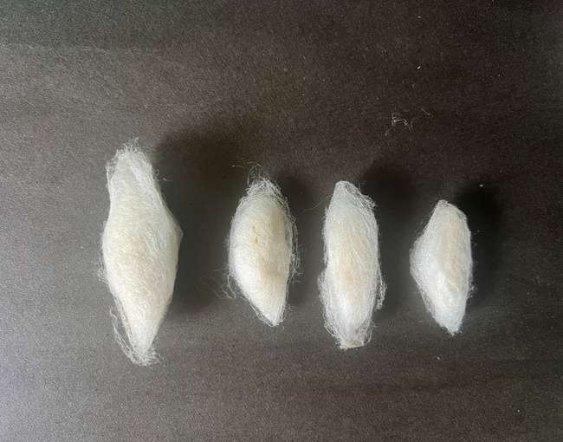
a
b
c
d

Fig 3. Cocoon of a) α-Amylase 1% b) α-Amylase 3% c) α-Amylase 5%d) Control

Table 2.Effect of digestive enzymes on shell weight (g) of eri silkworm in spring and autumn season
Enzymes | Concentrations | Seasons
 |  | Spring | Autumn
α-Amylase | 1% | 0.38e | 0.25e
α-Amylase | 3% | 0.47^{b} | 0.32^{b}
α-Amylase | 5% | 0.32^{f} | 0.24^{f}
Lipase | 1% | 0.41^{d} | 0.29^{d}
Lipase | 3% | 0.43^{c} | 0.31^{c}
Lipase | 5% | 0.50ª | 0.35ª
Combination | α-Amylase 1% + Lipase 1% | 0.31^{g} | 0.22^{g}
Control |  | 0.30^{h} | 0.21^{h}
Overall Mean |  | 0.38 | 0.27
S.Ed(±) |  | 0.004 | 0.003
CD(P=0.05) |  | 0.008 | 0.007

Fig 4.Effect of digestive enzymes on shell weight (g) of eri silkworm in spring and autumn season

Table 3. Effect of digestive enzymes on pupal weight (g) of eri silkworm in spring and autumn season
Enzymes | Concentrations | Seasons
 |  | Spring | Autumn
α-Amylase | 1% | 2.28^{b} | 1.76^{bc}
α-Amylase | 3% | 2.45ª | 1.81^{b}
α-Amylase | 5% | 2.19^{c} | 1.76^{bc}
Lipase | 1% | 2.29^{b} | 1.77^{b}
Lipase | 3% | 2.44ª | 1.79^{b}
Lipase | 5% | 2.50ª | 1.88ª
Combination | α-Amylase 1% + Lipase 1% | 2.18^{c} | 1.69^{cd}
Control |  | 2.06^{d} | 1.64^{d}
Overall Mean |  | 2.29 | 1.76
S.Ed(±) |  | 0.034 | 0.030
CD(P=0.05) |  | 0.071 | 0.061

Fig 5. Effect of digestive enzymes on pupal weight (g) of eri silkworm in spring and autumn season
Table 4. Effect of digestive enzymes on shell ratio (%) of eri silkworm in spring and autumn season
Enzymes | Concentrations | Seasons
 |  | Spring | Autumn
α-Amylase | 1% | 14.35^{d} | 12.67e
α-Amylase | 3% | 16.07^{b} | 15.16^{b}
α-Amylase | 5% | 12.75e | 12.01^{f}
Lipase | 1% | 15.06^{c} | 14.22^{d}
Lipase | 3% | 15.17^{c} | 14.82^{c}
Lipase | 5% | 16.88ª | 15.66ª
Combination | α-Amylase 1% + Lipase 1% | 13.36^{ef} | 11.66^{g}
Control |  | 12.36^{f} | 11.61^{g}
Overall Mean |  | 14.50 | 13.47
S.Ed(±) |  | 0.193 | 0.155
CD(P=0.05) |  | 0.399 | 0.319

Fig 6.Effect of digestive enzymes on shell ratio (%) of eri silkworm in spring and autumn season
Table 5. Effect of digestive enzymes on defective cocoon percentage (%) of eri silkworm in spring and autumn season
Enzymes | Concentrations | Seasons
 |  | Spring | Autumn
α-Amylase | 1% | 4.65e | 5.62^{d}
α-Amylase | 3% | 4.02e | 5.00^{f}
α-Amylase | 5% | 5.14^{c} | 6.56^{c}
Lipase | 1% | 4.35^{d} | 5.34e
Lipase | 3% | 4.34e | 5.03^{f}
Lipase | 5% | 3.75^{f} | 4.94^{f}
Combination | α-Amylase 1% + Lipase 1% | 6.45^{b} | 7.50^{b}
Control |  | 7.65ª | 8.75ª
Overall Mean |  | 5.08 | 6.09
S.Ed(±) |  | 0.062 | 0.095
CD(P=0.05) |  | 0.128 | 0.197

Fig 7.Effect of digestive enzymes on defective cocoon percentage (%) of eri silkworm in spring and autumn season

Table 6. Effect of digestive enzymes on pupal duration (days) of eri silkworm in spring and autumn season
Enzymes | Concentrations | Seasons
 |  | Spring | Autumn
α-Amylase | 1% | 12.50^{b} | 19.50^{bc}
α-Amylase | 3% | 12.50^{b} | 19.00^{c}
α-Amylase | 5% | 12.75^{b} | 19.75^{bc}
Lipase | 1% | 12.50^{b} | 19.50^{bc}
Lipase | 3% | 12.50^{b} | 19.25^{bc}
Lipase | 5% | 12.00^{b} | 19.00^{c}
Combination | α-Amylase 1% + Lipase 1% | 13.00^{b} | 20.00^{b}
Control |  | 14.25ª | 22.00ª
Overall Mean |  | 12.75 | 19.75
S.Ed(±) |  | 0.444 | 0.338
CD(P=0.05) |  | 0.918 | 0.698

Fig 8. Effect of digestive enzymes on pupal duration (days) of eri silkworm in spring and autumn season

Table 7. Effect of digestive enzymes on moth emergence (%) of eri silkworm in spring and autumn season
Enzymes | Concentrations | Seasons
 |  | Spring | Autumn
α-Amylase | 1% | 84.65^{d} | 83.67^{d}
α-Amylase | 3% | 90.45^{b} | 89.02^{b}
α-Amylase | 5% | 83.25de | 83.14^{d}
Lipase | 1% | 87.90^{c} | 83.57^{c}
Lipase | 3% | 89.15^{bc} | 88.31^{bc}
Lipase | 5% | 92.72ª | 91.68ª
Combination | α-Amylase 1% + Lipase 1% | 83.75^{d} | 82.37^{d}
Control |  | 81.75e | 79.34e
Overall Mean |  | 86.70 | 85.51
S.Ed(±) |  | 0.849 | 0.985
CD(P=0.05) |  | 1.753 | 2.034

Fig 9. Effect of digestive enzymes on moth emergence (%) of eri silkworm in spring and autumn season
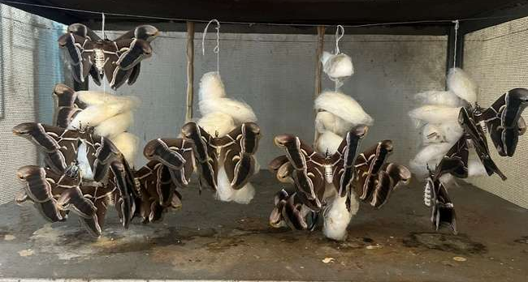

Fig 10: Moth emergence in Lipase 5% treated batch

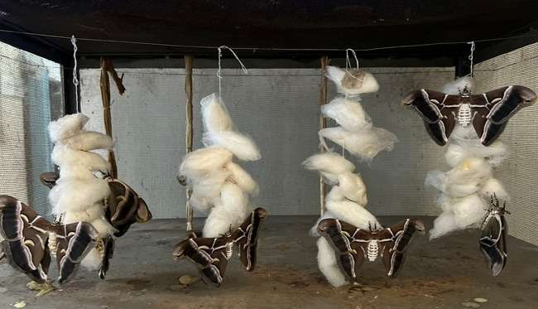
Fig 11: Moth emergence in control batch
Table 8. Effect of digestive enzymes on adult longevity (days) of eri silkworm in spring and autumn season
Enzymes | Concentrations | Seasons
 |  | Spring | Autumn
α-Amylase | 1% | 5.75^{c} | 6.75^{b}
α-Amylase | 3% | 6.00^{c} | 6.75^{b}
α-Amylase | 5% | 5.75^{c} | 6.25^{bc}
Lipase | 1% | 7.25^{b} | 8.25ª
Lipase | 3% | 7.50^{b} | 8.50ª
Lipase | 5% | 8.50ª | 9.25ª
Combination | α-Amylase 1% + Lipase 1% | 5.50^{c} | 5.50^{cd}
Control |  | 5.25^{c} | 4.75^{d}
Overall Mean |  | 6.43 | 7.00
S.Ed(±) |  | 0.408 | 0.549
CD(P=0.05) |  | 0.842 | 1.134
Data are means of four replications
Means followed by different superscript letters are significantly different at p≤0.05
Means followed by same superscript letters are on par with each other p≤0.05

Fig 12. Effect of digestive enzymes on adult longevity (days) of eri silkworm in spring and autumn season
RESULTS AND DISCUSSION
The results of the present investigation indicated that fortification of castor leaves with digestive enzymes had a significant positive influence on the cocoon characteristics, developmental parameters and reproductive performance of eri silkworm compared with the control group.
Among the treatments, Lipase 5% consistently recorded superior performance in most of the economic traits. The cocoon weight of eri silkworm showed a positive response to enzyme-enhanced diets, with Lipase 5% recording the highest cocoon weight (3.00 g in spring and 2.36 g in autumn), followed by α-amylase 3% (2.94 g in spring and 2.14 g in autumn) and Lipase 3% (2.87 g in spring and 2.11 g in autumn), whereas the control group recorded the lowest cocoon weight (2.34 g in spring and 1.86 g in autumn). From the overall mean value of the two seasons, cocoon weight was found to be superior in spring season 2.69 g than autumn season 2.06 g (Table 1 and Fig 1.). Similarly, from the Table 2 and Fig 4 it was clear that shell weight was significantly higher in enzymetreated groups, with Lipase 5% recording the highest shell weight (0.50 g in spring and 0.35 g in autumn), followed by α-amylase 3% (0.47 g and 0.32 g), while the control group recorded the lowest values (0.30 g and 0.21 g). By observing overall mean values a significant increase was seen in spring 0.38 g thereafter observed in autumn 0.27 g. Pupal weight also showed a similar trend, with Lipase 5% recording the highest pupal weight (2.50 g in spring and 1.88 g in autumn), which was on par with α-amylase 3% during spring, whereas the control group recorded comparatively lower pupal weights (2.06 g in spring and 1.64 g in autumn).It is possible to conclude that the spring season (2.29 g) is better than the autumn season (1.76 g) by looking at the overall mean value of both seasons from the Table 3 and Fig 5. The shell ratio ranged from 11.61 to 16.88%, with the highest shell ratio observed in Lipase 5% treatment (16.88% in spring and 15.66% in autumn) followed by α-amylase 3% (16.07% and 15.16%), while the control group recorded the lowest shell ratio (12.36% and 11.61%). Seasonal comparison showed that Spring season shell ratio (14.50%) was found to greater than the autumn season (13.47%) (Table 4 and Fig 6).The improved cocoon and shell parameters in enzyme-treated groups may be attributed to enhanced digestion and nutrient assimilation, which increase the availability of essential nutrients required for larval growth and silk protein synthesis. Similar findings in enhancement of economic traits of mulberry silkworms like cocoon weight, shell weight, pupal weight and shell ratio were reported by the fortification of honey,spirulina (400 ppm), Staphylococcus gallinarum strain SWGB 7, spirulina and thyroxine, spirulina, bee pollen, and bovine milk to mulberry leaves (Thulasi and Sivaprasad 2015; Asaf and Mahavishnu 2018; Saranya et al., 2019; Maqbool et al., 2023; Pande and Sharma 2023and Nivetha et al., 2024 respectively). Cocoon parameters also improved by 0.5% supplementation of the yeast (Saccharomyces cerevisiae) (Soliman, 2021), 1.00% alanine (Muzamil et al., 2023) and 2% Darolac supplementation to eri silkworm (Anitha et al., 2015).
From the Table 5 and Fig 7 it was clear that the percentage of defective cocoons was also reduced in enzymes-treated groups, particularly in Lipase 5%, which recorded the lowest defective cocoon formation (3.75% in spring and 4.94% in autumn), while the control group recorded the highest defective cocoons (7.65% and 8.75%). Percentage of defective cocoon formation was more in autumn season to spring season by calculating the mean values (6.09 % and 5.08). Qadir et al., 2022 found that sericin fortified mulberry leaves increased the percentage of good cocoons, no stained cocoons, negligible flimsy cocoons and also deceases the defective cocoon formation.
Digestive enzyme fortification also influenced developmental parameters, where the shortest pupal duration was observed in Lipase 5% treatment (12.00 days in spring and 19.00 days in autumn), whereas the control group recorded the longest pupal duration (14.25 days in spring and 22.00 days in autumn). From the Table 6 and Fig 8Pupal duration (19.00 days) was found to be shortened in Lipase 5% fortification during spring and autumn season. It is inferred from the mean value that pupal duration was found to be longer in autumn season 19.75 days and shorter in spring season 12.75. Similar results using Fe-plus treated leaves at lesser concentrationsresults about shortened pupal duration (Khan and Saha, 1996)
Adult longevity and moth emergence percentage were also higher in treated groups compared to the control it was in line with the research conducted by Venkatachalapathy and Reddy (2019) and Hazarika and Saikia (2024) they found that zinc, methionine and tryptophan fortification has positive impact on the moth emergence respectively. Similarly, moth emergence was highest in Lipase 5% treatment (92.72% in spring and 91.68% in autumn) followed by α-amylase 3%, while the control group recorded the lowest emergence percentage (81.75% and 79.34%) which was evident from the Table 7 and Fig 9, 10, 11.From the Table 8 and Fig 12it was evident that lipase 5% treatment recorded the highest adult longevity (8.50 days in spring and 9.25 days in autumn), whereas the control group recorded the lowest longevity (5.25 days in spring and 4.75 days in autumn) same results were also obtained byHazarika and Saikia (2024) when methionine and tryptophan improved reproductive parameters of eri silkworm including adult longevity of both male and female moths.
Seasonal influence was also evident, with most economic traits such as cocoon weight, shell weight, pupal weight, shell ratioand moth emergence showing better performance during the spring season compared to the autumn season, adult longevity and pupal duration were found to be lower in spring season. In present investigation, overall economic traits of eri silkworm were found to be superior in spring than the autumn season. Similar findings were also obtained by Borah and Saikia (2020) and Bora et al. (2022).
The improvements observed in enzymes-treated groups may be attributed to enhanced metabolic efficiency, improved nutrient utilization and better physiological development of the larvae, which ultimately contribute to improved cocoon quality and reproductive performance. Similar improvements in cocoon parameters and economic traits due to nutritional supplementation and improved feeding strategies have been reported in silkworms by researchers such as

CONCLUSION
The current study assessed the effects of castor leaf digestive enzyme fortification on eri silkworm cocoon and reproductive parameters. The findings clearly showed that enzyme supplementation significantly improved the majority of the economic characteristics examined. When compared to other treatments and the control group, Lipase 5% enrichment continuously produced better results in terms of cocoon weight, shell weight, shell ratio, pupal weight, decreased pupal duration, lower defective cocoon percentage, increased adult longevity, and higher moth emergence.
The improvement in these parameters may be attributed to enhanced digestion and nutrient assimilation facilitated by digestive enzymes, which promote better larval growth, efficient metabolic activity, and improved silk protein synthesis. Seasonal variation also influenced the performance of eri silkworm, with spring season generally showing better cocoon and silk-related parameters, whereas autumn season exhibited comparatively longer pupal duration and slightly higher adult longevity.
Overall, the study confirms that nutritional enrichment of host plant leaves using digestive enzymes can enhance the biological and economic performance of eri silkworm, thereby contributing to improved productivity in eri sericulture.
REFERENCES
Anitha, J., Sathish, J. and Sujatha, K. (2015). Nutritional efficiency and economic traits in Samiaricini Donovan reared on castor leaves fortified with probiotic agent. International Journal of Innovative Research in Science, Engineering and Technology, 4(5): 2319-8753.
Asaf, C. and Mahavishnu (2018). Morphometric studies of silkworm, Bombyx mori L. fed with spirulina treated MR2 mulberry leaves. Plant Archives, 18(ICAAAS): 316-319.
Borah, S.D. and Saikia, M. (2020). Evaluation of economic characters of two commercial eco-races of eri silkworm (Samia ricini Donovan) reared on castor and borpat leaves during spring and autumn season in Assam. Journal of Entomology and Zoology Studies, 8(3): 1930-1935.
Bora, N., Singha, T.A., Gogoi, D., Kalita, S. and Saikia, H. (2022). Impact of zinc chloride supplementation on larval growth and economic cocoon parameters of eri silkworm. Journal of Entomological Research, 46(Suppl.): 1108-1113.
Brahma, S., Sarma, R. and Nath, R.K. (2019). Livelihood improvement through sericulture in Kokrajhar District of Assam – A key for women empowerment. International Journal of Current Microbiology and Applied Sciences, 8(12): 2762-2766.
Chowdhury, S.N. (1982). Eri Silk Industry. Directorate of Sericulture and Weaving, Assam, pp. 24-25.
Devi, K.L. and Yellamma, K. (2013). The modulatory role of zinc in the silkworm, Bombyx mori L. Bioscience Discovery, 4(1): 58-68.
Genc, H., Phaon, C. and Phyciodes, P. (2002). Life cycle, nutritional ecology and reproduction. Ph.D. Dissertation, University of Florida, Gainesville, FL, USA.
Hazarika, A. and Saikia, M. (2024). Effect of dietary supplementation of methionine and tryptophan on reproductive parameters of eri silkworm. Emergence, 1(86.66): 29-42.
Junliang, X. and Xiaofeng, W. (1992). Research on improvement of efficiency of transferring leaf ingested into silk of the silkworm, Bombyx mori L. International Congress of Entomology, Beijing, China, 169(3): 623.
Kerkut, G.A. and Gilbert, L.I. (1985). Comprehensive Insect Physiology, Biochemistry and Pharmacology. Vol. 2. Pergamon Press, Oxford.
Khan, A.R. and Saha, B.N. (1996). Nutritive effects of Fe-Plus (Ferrous Fumarate + Folic Acid) on the silkworm, Bombyx mori L. Bangladesh Journal of Zoology, 24(2): 195-203.
Maqbool, S., Sahaf, K.A., Tantray, A.K., Ahmad, M., Parray, S.A.M. and Yaqoob, M. (2023). Impact of spirulina and thyroxine fortified mulberry leaves on the rearing performance of silkworm, Bombyx mori L. Heliyon, 9(10): e21053.
Mishra, N., Hazarika, N.C., Narain, K. and Mahanta, J. (2003). Nutritive value of non-mulberry and mulberry silkworm pupae and consumption pattern in Assam, India. Nutrition Research, 23(10): 1303-1311.
Muzamil, A., Tahir, H.M., Ali, A., Bhatti, M.F., Munir, F., Ijaz, F., Adnan, M., Khan, H.A. and Qayyum, K.A. (2023). Effect of amino acid fortified mulberry leaves on economic and biological traits of Bombyx mori L. Heliyon, 9(10): e21053.
Nation, J.L. (2022). Insect physiology and biochemistry. 4th Edition. CRC Press, Boca Raton, pp. 1-19.
Nivetha, S.A., Maheswari, A.S.A., Elakiya, C.A., Gowri, R.A. and Kalaivani, A.A. (2024). Enhancing silk production: Impact of milk fortified mulberry feed on silkworm (Bombyx mori L.) growth and cocoon quality. Uttar Pradesh Journal of Zoology, 45(24): 311-319.
Pande, N. and Sharma, G.D. (2023). Impact of spirulina supplemented mulberry leaves on cocoon parameters of silkworm (Bombyx mori). Journal of Emerging Technologies and Innovative Research, 10(1): 25-27.
Qadir, J., Gupta, R.K., Bali, K., Sharma, M. and Gupta, S.K. (2022). Impact of sericin fortified mulberry leaves on the cocoon traits of silkworm Bombyx mori L. The Pharma Innovation Journal, 11(10): 1519-1522.
Robinson, P.K. (2015). Enzymes: Principles and biotechnological applications. Essays in Biochemistry, 59: 1-41.
Saranya, M., Krishnamoorthy, S. and Murugesh, K. (2019). Fortification of mulberry leaves with indigenous probiotic bacteria on larval growth and economic traits of silkworm (Bombyx mori L.). Journal of Entomology and Zoology Studies, 7(4): 780-784.
Shamsuddin, M. (2009). Silkworm Physiology: A Concise Textbook. Daya Publishing House, New Delhi, pp. 1-212.
Soliman, A.M. (2021). The impact of fortification of mulberry leaves with the yeast Saccharomyces cerevisiae and the blue green algae Spirulina platensis on some quantitative parameters of silkworm Bombyx mori L. Journal of Plant Protection and Pathology, 12(1): 55-59.
Thulasi, N. and Sivaprasad, S. (2015). Larval growth, silk production and economic traits of Bombyx mori L. under the influence of honey-enriched mulberry diet. Journal of Applied and Natural Science, 7(1): 286-289.
Venkatachalapathy, M. and Reddy, G. (2019). Influence of zinc fortification on egg production efficiency in CSR breeds of silkworm, Bombyx mori L. International Journal of Information Research and Review, 6(4): 6257-6260.
Wyatt, G.R. and Kalf, G.F. (1957). The chemistry of insect haemolymph: II. Trehalose and other

