Review Article
Adaptive Responses of Chickpea Cultivars to UV-B Radiation: Implications for Genetic Diversity and Crop Resilience

Abstract
Further people have become aware that the ultraviolet B (UV-B) rays (280–315 nm) impact the development of plants and overall yield, particularly in the context of global warming. Because various varieties of the chickpea (Cicer arietinum L.), a crop extensively valued worldwide for its nutritional and financial benefits, behave differently to UV-B exposure, it is clear that importance genetic diversity is in adaptability to stress. This review compiles recent research on chickpea cultivars' response and adaptations to UV-B radiation. It focuses attention to the genetic, psychological, biological, and structural mechanisms that support stress tolerance. The destruction of the genome and changes caused on by ultraviolet (UV) rays may change gene expression and result in changes in response to stress traits. Plant growth and production are ultimately affected by the physical impacts of ultraviolet (UV) rays on systems like transpiration, irrigation, and nutrient uptake. Normal plants' ability to operate physically is typically affected by higher UV-B radiation level. It can reduce water-use efficiency, stomatal pores formation and metabolic productivity, every one of which slow down biomass production and eventually affect production. Still, genotypes that are more sensitive to UV-B rays have the capacity to handle these challenges. By turning on effective sunscreen mechanisms and altering standards as needed to preserve essential functions, they promote continued development. the context of addition to morphological and biological variations, chickpea plants have significant structural modifications that avoid UV-B damage. These consist of more developed cuticle (the a waxy outer layer), larger leaves, and an altered roots and shoots structure. These major modifications enhance the plant's ability to soak up nutrients, water, and sunlight, all of which assist it handle stress.
Key word :- Chickpea, Mutation, UV-B Rays , Stress Tolerance, Genetic Variability

INTRODUCTION
Chickpea (Cicer arietinum L.) is a popular food grain pulse crop grown mostly in arid and semi-arid climates. It is belongs to the Fabaceae family. Because of the great amount of protein of its seeds. It is known as a significant source of nutrients for humans. The Rabi (winter) season is the time this crop is grown. It is grown commercially in nations like Ethiopia, Australia, Iran, Pakistan, India, and Turkey. The highest production occurs primarily in India. It represents over 70% of global production (FAO, 2023).
Desi and Kabuli are the two primary varieties of chickpeas. Desi chickpeas are smaller, rougher, and brown, whereas Kabuli chickpeas are lighter, smoother, and larger. Because they fix nitrogen, chickpeas are very nutritious and increase soil fertility. The smaller-seeded Desi chickpeas, referred to as "micro sperma," are believed to have given rise to the larger-seeded Kabuli chickpeas, also known as "macro sperma" (Moreno & Cubero, 1978).
Kabuli chickpeas exhibit far less genetic diversity that is, there is less variation within this type -than Desi variants. With over 70% of the world's supply coming from states like MP, Maharashtra, Rajasthan, UP, Andhra Pradesh, Karnataka, and Telangana, India is the biggest producer. (MoAFW, 2024). gram is grown in largely every district in the state, Bundelkhand, Purvanchal, and South-West produce the majority of it. Chickpeas were grown on about 5.5 lakh hectares in Uttar Pradesh in 2024–2025, producing about 6.5 lakh tonnes, according to agricultural statistics. The average output for the state is roughly 1.2 tons per hectare. (MoAFW, 2024; UP Agriculture Dept., 2023)
UV-B rays can have an important impact on the growth and yield of chickpea (Cicer arietinum L.) varieties. Briefly contact with UV-B (1–2 hours each day) can actually increase the quantity and thickness of flowers and pods, but longer exposure (about 3 hours every day) cuts down their development and decreases the plant's capacity for reproduction. Also, UV-B lowers the amount of chlorophyll by 15–25%, which inhibits photosynthetic and the capacity of plants to absorb energy to support growth. On a biological level, it generates the formation of reactive oxygen species (ROS), which may harm cells if the plant's immune systems are ignored. In the end, prolonged UV-B stress impacts not just fertilization but also plant health and development(Kumar et al., 2025).

Mutagenic Feature
Mutagens are various biological, chemical, and physical (radiation) agents that can alter DNA in ways that are irreversible and transmissible (Schrader, 2003). Since mutagens are responsible for causing plant mutations, selecting the right mutagen is important for mutation breeding because different mutagens have various mutagenic qualities (Ukai, 2006). depicts the two primary categories of mutagens: chemical and physical mutagens. (A). Physical: X-rays, Gamma rays, UV radiations, β-particles, Neutrons and Particles from accelerations(B).Chemical: Base analogues, Antibiotics, Alkylating agents, Acridines, Azides, Hydroxylamine and Nitrous acid.
Physical mutagens
Mutagens that are physical are superior to chemical mutagens since they don't create waste and don't need to be cleaned up or treated after use. (Shah Jehan Khan et al., 2000). The first known usage of physical mutagens goes back to the 1920s, when researchers found that radium caused mutagenic effects after using it on fruit-borne insects (Kharkwal et al., 2004). After Muller and Stadler's discovery of the hereditary effects of ionizing radiation (Brunner, 1995), physical mutagens have been used to create more than 70% of the mutant types created to date (Oladosu et al., 2016). Muller demonstrated the effects of X-ray mutation on fruit flies in 1927. Lewis John Stadler wrote three articles about the genetic effects of X-rays on barley and maize in 1928 (Rhoades, 1957). Physical mutagens have gained popularity as a means of mutation breeding since these two findings.
Chemical mutagens
During decades in the past century, numerous scientists experimented with chemically inducing mutations. In 1939, Thomson and Steinberger used nitrous acid to cause mutations in Aspergillus, which was the first convincing outcome of chemical mutagenesis. Auerbach and Robson found that mustard gas clearly possesses mutagenic properties in 1946. It was still unclear if chemical mutagens could cause mutations as frequently as physical mutagens, despite the fact that they are very effective at causing actual gene alterations. Chemical mutagens are just as efficient as physical mutagens, as demonstrated by Auerbach and Robson (1946). Since then, a wide variety of chemical mutagens have been discovered, including as nitroso compounds, base analogues, azides, acridine dyes, and alkylating agents. (Kharkwal, 2012; M M SpencerLopes et al., 2018). However, because physical and biological mutagens do not leave any leftovers, researchers view them as safer alternatives to chemical mutagens, which can leave hazardous residues that may cause cancer.
Effects of Mutation in Chickpea Plants
Ultraviolet radiation (UV-B) that reaches the Earth's surface increases as the ozone layer is depleted (Madronich et al., 1998). Increased UV-B radiation will change how plants grow and metabolize. As a result, UV-B radiation acts as an environmental stress or abiotic factor on plants, slowing down plant growth, damaging photosynthetic pigments, reducing carbon assimilation, and changing the allocation of biomass, all of which lead to a decrease in biomass and productivity (Tevini and Teramura, 1989). Plants respond differently to UV-B radiation; some are able to withstand this stress, while others grow sensitive and lack the ability to do so. To protect themselves from such conditions, these plants will develop a variety of defense mechanisms, such as thicker leaves, enhanced flavonoid production, stimulation of antioxidant formation, activation of reactive species to quench free radicals, etc. DNA damage, photographic damage, membrane alteration, protein destruction, hormone inactivation, signal transduction via phytochrome (which converts sunlight into light in response to UV-B) (Pratt and Butler, 1970), or signal transduction via a UV-B photoreceptor could all be the cause of these alterations (Tevini et al. 1989, 1991b).

UV -Type | Wavelength | Effect on Plants | Reference
UV-A | 315–400 nm | Generally beneficial in small amounts; influences photo morphogenesis, leaf orientation, pigmentation | Caldwell et al. (1998); Jansen et al. (1998); Jenkins (2009); Hideg et al. (2013); Björn (2015); Paul & Gwynn-Jones (2003); WHO (2016); CIE (2006)
UV-B | 280–315 nm | Stressful but adaptive can reduce growth at high levels, but also triggers protective compounds (flavonoids, antioxidants) | Frohnmeyer & Staiger (2003); Jenkins (2009); Caldwell et al. (1998); Jansen et al. (1998); Hideg et al. (2013); Paul & Gwynn-Jones (2003); IARC (2012); WHO (2016
UV-C | 100–280 nm | Highly damaging;  causes DNA damage and cell death; normally blocked by ozone (used only artificially for sterilization) | Kowalski (2009); Bolton &  Cotton (2011); IARC (2012); Hideg et al. (2013); Caldwell et al. (1998); Frohnmeyer & Staiger (2003); WHO (2016); CIE (2006)

Table 1: Different Ultraviolet radiation and their effects on plants

UV-B-induced structural changes
Plant morphology is thought to be a fairly reliable indicator of UV-B damage. Other metrics, including as chlorophyll, carotenoids, phenols, lipid per oxidation, etc., have also shown promise as markers of UV-B sensitivity and tolerance. Although UV-B radiation makes up a very small portion of solar energy, it has a wide range of morphological effects on plants.
And these alterations range from variations in the root-shoot ratio to increases in leaf thickness, color change, and serration (Jansen et al., 2002).The loss of photosynthetic pigments causes a reduction in leaf area, but in order to deal with the situation and boost photosynthesis, the affected plants produce more leaves. This eventually results in more branching in dicots and There is less flowering and fruiting because repair mechanisms consume the majority of the energy. Additionally, plants have developed a defense mechanism to lengthen the UV radiation's path by thickening their leaves.
Physiological changes caused by UV-B
"Photosynthesis" is the process that turns carbon dioxide (CO₂) and water into carbohydrates when sunlight is present. PS-I and PS-II are the two photo systems that make up the photosynthetic apparatus. Despite the fact that UV-B affects most areas of photosynthesis, including damage to the molecular structure of the chloroplast and light harvesting complex, a drop in Rubisco activity, a decline in oxygen evolution and CO₂ fixation, and a decrease in the amount of starch and chlorophyll. Additionally, plant species, cultivars, lab conditions, UV-B dosage, and the proportion of PAR to UV-B light all affect how plants respond photo synthetically to UV-B radiation. Elevated UV-B induces changes in the ultra-structure of leaves, which alters how light is attenuated by the leaf and the overall UV-B radiation, which in turn affects photosynthesis. From pubescent or glucose surfaces, leaves reflect between 3-6% (Gao et al., 1996; Yang et al., 1995) and 10-40% (Robberecht and Caldwell, 1980). If there is no more reflection at the leaf surface, an increase in incident UV-B light would increase the amount transmitted. The morphological reactions of different plant species to UV-B radiation varied, although UV-B frequently caused an increase in leaf thickness (Nagel et al., 1998; Bornman and Vogelman, 1991).

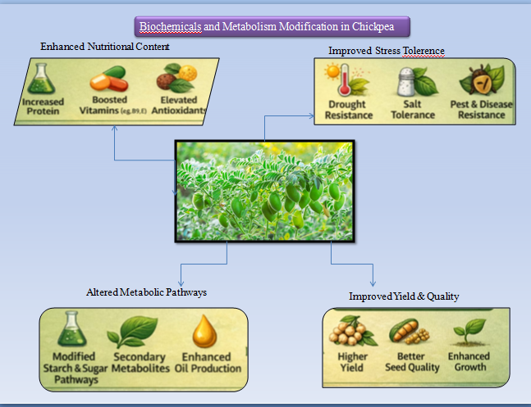

Figure :- 1 Effect of Uv-B radiation on chickpea growth &Physiology
Biochemical and metabolism Modifications

The detrimental effects of UV-B on a number of physiological and biochemical traits of commercially significant plants are widely recognized (Miller et al., 1994; Rao et al., 1996; Ambhast and Agrawal, 2003). Chromophores connected to the photosynthetic machinery absorb UV-B after it passes through leaves. More than 90% of incident UV-B is absorbed by leaves. There is very little UV-B transmission through leaves, and leaf surface reflectance in the wavelength is often less than 10% (Robberecht and Caldwell, 1980; Cen and Bornman, 1993; Gonzalez et al., 1996). Nucleic acids, proteins, lipids, and quinones are among the cell components that directly absorb UV-B (Jordan, 1996)
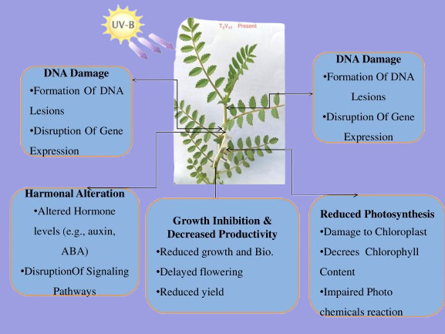

Figure:-2 Define Biochemical Character Changes and Modification Role

Antioxidant Defense Systems
When plants face stress, they produce harmful oxygen molecules. Antioxidants help protect cells by reducing damage caused by free radicals. A strong antioxidant system is important to prevent membrane damage and oxidative stress. Arora, A. et al.,2002 The effectiveness of antioxidant defense varies among different stress conditions and their frequency, and even among plant species and genotypes. Hasanuzzaman, M et al.,2020. Because it postpones programmed cell death, an antioxidant defense mechanism is essential for plants in stressed conditions. When plants lack enough antioxidant enzymes to neutralize excessive ROS, cellular organelles are unable to function effectively, leading to lipid per oxidation, oxidation-induced protein damage, DNA and nucleic acid degradation, and several enzyme inhibitions. Dumanović, J et al.,2021
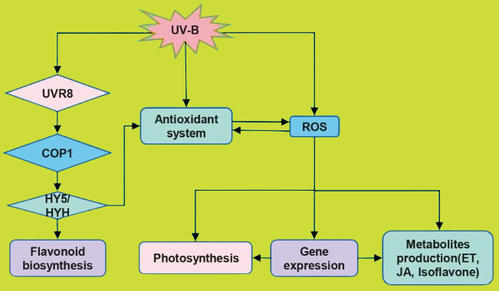

Figure:- 3 Work of Defense system in the Plant Dovelopment

DNA Repair Mechanisms and Photo protective Pathways

Plants withstand UV-B radiation by a mix of exposure avoidance, defensive responses, and DNA repair mechanisms. Reducing exposure to excessive light is one of the best methods of
managing light stress. In order to prevent photo system II (PSII) from being harmed by light, chloroplasts can relocate themselves inside plant cells to restrict the absorption of intense light. (Wada et al. 2003). The proper transmission of genetic information from a parent cell to its daughter cells is essential to an organism's survival. Chromosome placement during cell division and extremely exact DNA replication are necessary for this precise inheritance. Furthermore, cells must be able to withstand environmental and naturally occurring DNA damage while minimizing the amount of inherited mutations(B.-B et al., 2000).

Base excision repair (BER).
The base excision repair (BER) mechanism protects cells from DNA damage induced by normal cellular activities such as reactive oxygen compounds and metabolic by-products. Additionally, it fixes comparable DNA damage caused by alkylating chemicals and ionizing radiation.
Photo reactivation
One of the basic and oldest DNA repair methods is the process of photo reactivation, which requires a single enzyme called photolyase. A number of organisms have this enzyme to repair DNA damage caused by UV light. In particular, photolyase repair DNA lesions such as 6-4 photoproducts (6-4PPs) or CPDs (cyclobutane pyrimidine dimers) using light energy( F. Thoma, et al.,1999)
UVR8 signaling
UVR8 is a UV-B photoreceptor unique to plants that evolved from green algae. (Han et al. 2019 ; Rizzini et al. 2011). UVR8 is an important protein that helps plants respond to UV-B light, controlling their growth and helping them adjust to UV-related stress. (Brown et al. 2005).

Gene Expression Changes: Up regulation of Stress-Responsive Genes
Plants under drought stress undergo a number of physiological and biochemical reactions, including stomatal closure, decreased growth and photosynthesis, and increased respiration. Plants adjust at the cellular and molecular levels by accumulating stress-tolerance proteins and osmolytes, as well as by altering the expression of genes that respond to stress. (Shinozaki et al., 2003; Bartels and Sunkar, et al 2005). Two important cis-acting elements, ABRE and DRE/CRT, are found in the promoter of the stress-inducible gene RD29A (COR78/LTI78), and they control how the gene is expressed in response to cold, salt, and drought stress.

Identifying biotic stress-responsive genes and developing a primer

Various methods were employed for the design of the primer depending on the information available regarding the gene sequence of chickpeas. Heterologous primers were created for the ASR, SuSy, and SPS genes from corresponding Medicago sequences in the first method. Consensus/degenerate primers created at INRA, EPGV, France were used to isolate the ERECTA gene in chickpeas. In the second strategy, sequence-specific primers were created, and chickpea ESTs created under abiotic stress were used to isolate gene homologs.(Varshney et al.,2009)
Under drought stress, endogenous ABA accumulates and controls gene expression.

Additionally, genes encoding heat shock and LEA proteins have been employed to increase transgenic plants' resistance to drought. Galactinol synthase (GolS), a crucial To increase transgenic Arabidopsis's resistance to drought stress, an enzyme involved in the biosynthesis of
Figure:- 4 Describe DNA Repair Mechanism in Plant

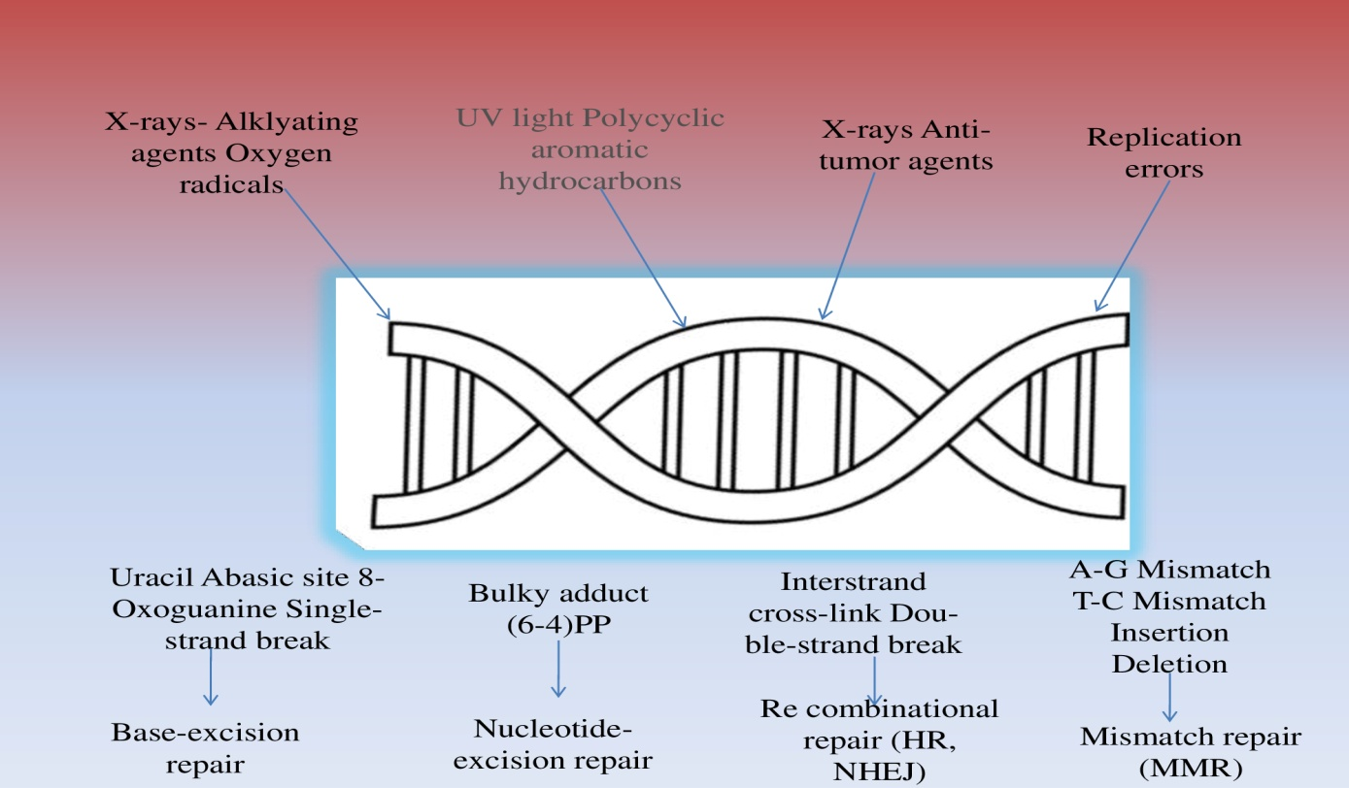
raffinose family oligosaccharides was added (Taji et al., 2002). One important cis-acting element in the expression of ABA-responsive genes is ABRE Two ABRE motifs are significant cis-acting elements that regulate the Arabidopsis RD29B gene's ABA-responsive expression. (Uno et al., 2000).

Table:-2 Chickpea mutation research have identified various types of induced and chemical mutants and their characteristics.
Serial Number | Chickpea Genotype/mutent | Mutagen Used | Results | Reference
1 | CO-4 | Gamma rays + EMS | High frequency of chlorophyll mutants (Viridis dominant) | Umavathi, S., & Mullainathan, L. (2016).
2 | Vishal | Gamma rays, EMS, SA | Morphological variability and chlorophyll mutations | Kamble, M. S., & Patil, G. P. (2018).
3 | GNG-1958 | Gamma rays + EMS | Determination of effective mutagen doses, chlorophyll mutation spectrum | Singh, R., Sharma, S., & Yadav, R. (2024).
4 | BG-212,  JG-11 | Gamma rays + EMS | Reduction in germination and plant height in M₁  Variation in growth habit and yield components. | Khan, S., Wani, M. R.,et al (2020).
5 | Pant Chickpea Genotypes | Gamma rays, EMS | Enhanced genetic variability in M₂ generation | Ahmad, S., & Sadiq, M. (2020).
6 | Pusa-547,  RSG (Kiran), | Induced mutation | High yield and bold seed size, Early maturity and high pod  number, | Malik, S. R., Bakhsh, A., et al., (2019).
7 | Kabuli genotype Ghab-4 | Gamma rays | Increased variability for flowering and yield traits | Siddiqui, S. A.,et al (2018)
8 | Desi mutant line D1M2HT-2,  D1M1HT-2, D1M1HT-3  Kabuli mutant KM3HT-2  KM4HT-1  KM1HT-4 | EMS + Gamma rays | Higher seed yield and pods/plant,  Improved agronomic traits, Enhanced seed yield  Improved yield performance, Moderate yield improvement, Variation in seed traits | Kumar, R., Singh, V. et al  (2024).
9 | Desi chickpea mutants, Glyphosate-tolerant mutants | EMS + Gamma rays | Development of herbicide tolerant lines  High tolerance to glyphosate | Singh, P., et al. (2023)
10 | Glyphosate-tolerant mutants, Tigrina mutants, Albina mutants, Xantha mutants, Chlorina mutants, Viridis mutants | Physical & chemical mutagens | Lethal chlorophyll mutants,  Reduced chlorophyll content,  Light green foliage phenotype, Highest survival among chlorophyll mutants | Umavathi, S., & Mullainathan, L. (2016)

Conclusion
Chickpea genotypes' responses and adjustments to ultraviolet (UV)B rays are explained in this paper, in addition to the importance of those responses for maintaining genetic diversity and increasing crop resilience. UV-B rays is not just an anxious factor for the natural world but also a beneficial mutagen which induces genetic variation. The studies reviewed discovered that UV-B radiation impacts chickpea development, including height of the plant, leaf structure, development of branches, and flowering times, as well as important physical and biochemical modifications, such as reduced sunlight synthesis, altered pigment content, and enhanced antioxidant activity. Plants are able to protect self and survive harsh conditions because to those adaptations. Also, UV-B-triggered mutation are crucial in extending the genetic foundation of the chickpea plant, that is required for producing genotypes that are adaptable and resistant to stress. If everything is examined, holding these responses to adaptation offers essential data for next breeding and mutation-based enhancement behaviors, especially in light of climate change and increasing exposure to UV-B rays.

Future of Research
The growth of plant breeds that are better suitable for changing climates should form the primary objective of future research that examine how plants react to ultraviolet (UV) B radiation. Scientists need to concentrate on discovering and enhancing inherited characteristics that enhance protection from UV-B radiation. Improving the plant's defenses is also crucial, particularly its antioxidant capacity, that minimizes cell harm. A plant's capacity to accept stress from the environment can also be improved through promoting greater levels of antioxidants such flavonoids. Scientists can use genetic material from traditional crop varieties and wild relatives, along with modern gene-editing tools and conventional breeding methods, to produce stronger and more stress-tolerant crops. At the same time, more field experiments are necessary to understand how UV-B radiation works together with other environmental stresses such as drought, high temperatures, and nutrient shortages. By combining advanced genetics with responsible and sustainable farming practices, we can develop crops that remain productive, stable, and resilient despite the challenges of climate change.

References
- Ahmad, S., & Sadiq, M. (2020). Mutagenesis-induced variability through gamma rays and EMS in chickpea genotypes. Journal of Pharmacognosy and Phytochemistry, 9(2), 678–684.
- Ambasht, N.K. and Agrawal, M. (2003). Interactive effects of ozone and ultraviolet-B singly and in combination on physiological and biochemical characteristics of soybean plants. J. Plant Biol., 30:37-45.
- Arora, A., Sairam, R. K., & Srivastava, G. C. (2002). Oxidative stress and antioxidative system in plants. Current Science, 82(10), 1227–1238. http://www.jstor.org/stable/24107045
- B.-B. S. Zhou and S. J. Elledge, The DNA damage response: putting checkpoints in perspective, Nature, 2000, 408, 433–439.
- BA, Cloix C, Jiang GH, Kaiserli E, Herzyk P, Kliebenstein DJ, Jenkins GI (2005) A UV-B-specific signaling component orchestrates plant UV protection. Proc Natl Acad Sci USA 102:18225–18230.biologically active ultraviolet radiation reaching the Earth’s surface. Journal of Agri.
- Bartels D, Sunkars R. (2005). Drought and salt tolerance in plants. Critical Reviews in Plant Science 24, 23–58.
- Björn, L. O. (2015). Photobiology: The science of light and life (3rd ed.). Springer.
- Björn, L. O., Callaghan, T. V., Johnsen, I., Lee, J. A., Manetas, Y., Paul, N. D., Sonesson, M., & Wellburn, A. R. (1999). The effects of UV-B radiation on European heathland species. Plant Ecology, 128, 252–264.
- Bolton, J. R., & Cotton, C. A. (2011). The ultraviolet disinfection handbook. American Water Works Association.
- Britt, A. B. (1996). DNA damage and repair in plants. Annual Review of Plant Physiology and Plant Molecular Biology, 47, 75–100.
- Brunner, H. (1995). Radiation induced mutations for plant selection. Applied Radiation and Isotopes, 46(6–7), pp. 589–594. DOI: https://doi.org/10.1016/0969-8043(95)00096-8.
- Caldwell, M. M., Björn, L. O., Bornman, J. F., Flint, S. D., Kulandaivelu, G., Teramura, A. H., & Tevini, M. (1998). Effects of increased solar ultraviolet radiation on terrestrial ecosystems. Journal of Photochemistry and Photobiology B: Biology, 46(1–3), 40–52.
- Caldwell, M. M., Bornman, J. F., Ballaré, C. L., Flint, S. D., & Kulandaivelu, G. (2007). Terrestrial ecosystems, increased solar ultraviolet radiation, and interactions with other climate change factors. Photochemical & Photobiological Sciences, 6, 252–266.
- Cen, Y.P., Bornman, J.F., (1993). The effect of exposure to enhanced UV-B radiation on the penetration of monochromatic and polychromatic UV-B radiation in leaves of Brassica napus. Physiol. Plant 87:249–255.
- Dumanović, J.; Nepovimova, E.; Natić, M.; Kuča, K.; Jaćević, V. The significance of reactive oxygen species and antioxidant defense system in plants: A concise overview. Front. Plant Sci. 2021, 11, 552969.
- F. Thoma, Light, dark in chromatin repair: repair of UV-induced DNA lesions by photolyase and nucleotide excision repair, EMBO J., 1999, 18, 6585–6598.
- Food and Agriculture Organization of the United Nations. (2023). FAOSTAT statistical database: Crops and livestock products (Chickpea).
- Frohnmeyer, H., & Staiger, D. (2003). Ultraviolet-B radiation-mediated responses in plants. Annual Review of Plant Biology, 54, 189–212.
- Gao, W., Grant, R.H., and Heisler, G.M. (1996). Spectral radiative properties of various tree species in ultraviolet wave lengths and irradiance modeling implications. In: Proceedings of the 22nd Conference on Agricultural and Forest Meteorology with Symposium on Fire and Forest Meteorology, American Meteorological Society, Boston, MA, 417–418.
- Gonzalez, R. (1996). Responses to ultraviolet-B radiation (280–315 nm) of pea (Pisum sativum) lines differing in leaf surface wax, Physiol. Plant. 98:852–860
- Hasanuzzaman, M.; Bhuyan, M.H.M.B.; Zulfiqar, F.; Raza, A.; Mohsin, S.M.; Mahmud, J.A.; Fujita, M.; Fotopoulos, V. Reactive oxygen species and antioxidant defense in plants under abiotic stress: Revisiting the crucial role of a universal defense regulator. Antioxidants 2020, 9, 681.
- Hideg, É., Jansen, M. A. K., & Strid, Å. (2013). UV-B exposure, ROS, and stress: Inseparable companions or loosely linked associates? Trends in Plant Science, 18(2), 107–115.
- Hideg, É., Jansen, M. A. K., & Strid, Å. (2013). UV-B exposure, ROS, and stress: Inseparable companions or loosely linked associates? Trends in Plant Science, 18(2), 107–115.
- Huang X, Ouyang XH, Yang PY, Lau OS, Chen LB, Wei N, Deng XW (2013) Conversion from CUL4-based COP1-SPA E3 apparatus to UVR8-COP1-SPA complexes underlies a distinct biochemical function of COP1 under UV-B. Proc Natl Acad Sci USA 110:16669–16674
- IARC Working Group on the Evaluation of Carcinogenic Risks to Humans. (2012). Radiation: Volume 100D. A review of human carcinogens. International Agency for Research on Cancer.
- International Commission on Illumination. (2006). Erythema reference action spectrum and standard erythema dose. CIE Central Bureau.
- Jansen, M. A. K., Gaba, V., & Greenberg, B. M. (1998). Higher plants and UV-B radiation: Balancing damage, repair and acclimation. Trends in Plant Science, 3(4), 131–135.
- Jansen, M.A.K. (2002). Ultraviolet-B radiation effects on plants: Induction or morphogenic responses. Physiol. Plant. 116: 423-429.
- Jenkins, G. I. (2009). Signal transduction in responses to UV-B radiation. Annual Review of Plant Biology, 60, 407–431.
- Jenkins, G. I. (2009). Signal transduction in responses to UV-B radiation. Annual Review of Plant Biology, 60, 407–431.
- Jordan, B.R. (1996). The effects of ultraviolet-B radiation on plants: a molecular perspective. Adv Bot. Res. 22:98–138
- Kamble, M. S., & Patil, G. P. (2018). Induced mutagenesis and morphological screening in M₂ generation of chickpea varieties Vishal and JAKI-9218. Bioscience Biotechnology Research Communications, 11(2), 356–362.
- Khan, S., Wani, M. R., & Parveen, K. (2020). Mutation-induced alterations in agronomic traits of chickpea. Journal of Pharmacognosy and Phytochemistry, 9(3), 234–239.
- Kharkwal, M. C., Pandey, R. N., & Pawar, S. E. (2004). Mutation Breeding for Crop Improvement. Jain H.K., Kharkwal M.C. (eds), Plant Breeding (pp. 601–645). Springer, Dordrecht. DOI: https://doi.org/10.1007/978-94-007-1040-5_26.
- Kumar, R., Kumar, R., Kumar, G., Tyagi, S., & Goyal, A. K. (2025). Impact of supplemental UV-B radiation on flower and pod formation in chickpea (Cicer arietinum L.). Journal of Plant Development Sciences.
- Kumar, R., Singh, V., & Yadav, S. (2024). Evaluation of EMS and gamma ray induced mutants in chickpea. BMC Plant Biology, 24, 133.
- Madronich, S., McKenzie, R. L., Björn, L. O., & Caldwell, M. M. (1998). Changes in biologically active ultraviolet radiation reaching the Earth's surface. Journal of Photochemistry and Photobiology B: Biology, 46(1–3), 5–19. https://doi.org/10.1016/S1011-1344(98)00182-1
- Malik, S. R., Bakhsh, A., & Aslam, M. (2019). Mutation breeding in chickpea: A review. Advances in Plants & Agriculture Research, 9(2), 214–221.
- Miller, J.E., Booker, F.L., Fiscus, E.L., Heagle, A.S., Pursley, W.A., Vozzo, S.F., Heck, W.W. (1994). Ultraviolet-B radiation and ozone effects on growth, yield, and photosynthesis of soybean.J. Environ. Qual. 23:83–91.
- MoAFW (2024) – Ministry of Agriculture & Farmers Welfare, Government of India. Final estimates of crop production 2024–25, including chickpea output of ~11.11 MT
- Nagel, L.M., Bassman, J.H., Edwards, G.E., Robberecht, R., Franceshi, V.R. (1998). Leaf anatomical changes in Poplus trichocarpa, Quercus rubra, Pseudotsuga menziesii and Pinus ponderosa exposed to enhanced ultraviolet-B radiation. Physiol. Plant 104:385–396
- Oladosu, Y., Rafii, M. Y., Abdullah, N., Hussin, G., Ramli, A., Rahim, H. A., Miah, G. and USMAN, M. (2016). Principle and application of plant mutagenesis in crop improvement: a review. Biotechnology and Biotechnological Equipment, 30(1), pp. 1–16. DOI: https://doi.org/10.10 80/13102818.2015.1087333.
- Paul, N. D., & Gwynn-Jones, D. (2003). Ecological roles of solar UV radiation: Towards an integrated approach. Trends in Ecology & Evolution, 18(1), 48–55.
- Prat, L.H., and Butler, W.L. (1970). Phytochrome conversion by ultraviolet light. Photochem.Photobol. 11:503-509
- Rao, M.V., Paliyath, G., and Ormrod, D.P. (1996) Ultraviolet-B- and ozoneinduced biochemical changes in antioxidant enzymes of Arabidopsis thaliana, Plant Physiol. 110:125–136.
- Rhoades, M. M. (1957). Lewis John Stadler - 1896—1954. National Academy of Sciences.
- Robberecht, R., and Caldwell, M. M., (1980). Leaf ultraviolet optical properties along a latitudinal gradient in the Arctic-alpine life zone. Ecology 61:612–619
- Shah J. K., Hamid U. K., Rahim D. K., Malik M. I. and YUSUF Z. (2000). Development of sugarcane mutants through in vitro mutagenesis. Pakistan Journal of Biological Sciences, 3(7), pp. 1123–1125. DOI: https://doi.org/10.3923/pjbs.2000.1123.1125.
- Shinozaki K, Yamaguchi-Shinozaki K, Seki M. (2003). Regulatory network of gene expression in the drought and cold stress responses. Current Opinion in Plant Biology 6, 410–417.
- Siddiqui, S. A., Singh, A. K., & Kumar, S. (2018). Gamma ray induced variability in kabuli chickpea. Legume Research, 41(4), 515–521.
- Singh, P., et al. (2023). Screening of induced mutants for herbicide tolerance in chickpea. Plant Mutation Reports, 7(1), 21–29.
- Singh, R., Sharma, S., & Yadav, R. (2024). Chlorophyll mutations and comparative effects of physical and chemical mutagens in chickpea cultivar GNG-1958. Journal of Pharmacognosy and Phytochemistry, 13(5), 112–118.
- Smith, H. H. (1958). Radiation in the production of useful mutations. Botanical Review, 24(1), pp. 1–24. http://www.jstor.org/stable/4353579
- Taji T, Ohsumi C, Iuchi S, Seki M, Kasuga M, Kobayashi M, Yamaguchi-Shinozaki K, Shinozaki K. (2002). Important roles of drought- and cold-inducible genes for galactinol synthase
- Tevini, M., And Teramura, A.H. (1989). UV-B effects on terrestrial plants. Photochem.
- Tevini, M., Braun, J., & Fieser, G. (1989). The protective function of the epidermal layer of rye seedlings against ultraviolet-B radiation. Photochemistry and Photobiology, 49, 213–218.
- Tevini, M., Mark, U., Fieser, G., and Saile, M. (1991). Effects of enhanced solar UV-Bradiation on growth and function of selected crop plant seedlings. In photobiology, E.Riklis, ed. (New York : Plenum Press), 635-649.
- Umavathi, S., & Mullainathan, L. (2016). Induced chlorophyll mutations in chickpea (Cicer arietinum. L.). Journal of Agriculture and Agricultural Research, 3(2), 45–50.
- Uno Y, Furihata T, Abe H, Yoshida R, Shinozaki K, Yamaguchi Shinozaki K. (2000). Arabidopsis basic leucine zipper transcrip tional transcription factors involved in an abscisic acid-dependent signal transduction pathway under drought and high-salinity conditions. Proceedings of the National Academy of Sciences, USA 97, 11632–11637.
- Varshney, R. K., Hiremath, P. J., Lekha, P., Kashiwagi, J., Balaji, J., Deokar, A. A.,et al. (2009). A comprehensive resource of drought- and salinity- responsiveESTs for gene discovery and marker development in chickpea (Cicer arietinumL.). BMC Genomics 10:523. doi: 10.1186/1471-2164-10-523
- Wada M, Kagawa T, Sato Y (2003). Chloroplast movement. Annu Rev Plant Biol 54:455–468.
- World Health Organization. (2016). Ultraviolet radiation and the INTERSUN Programme. World Health

