Original Research Article
Species diversity of lepidopterans in SCS College of Agriculture campus and the surrounding area in the Dhubri district of Assam
Diversity of Lepidoptera in SCS College of Agriculture and it surrounding areas, Assam, India

ABSTRACT
A preliminary study was conducted in and around the Sarat Chandra Sinha College of Agriculture, Assam Agricultural University, Rangamati, Chapar, Dhubri campus, Assam, India during 2024-25 to record and study the diversity of lepidopteran insects. The college campus and the surrounding locations harbour a wide variety of butterflies and moths showing the richness of biodiversity of lepidopteran insects. The study revealed an impressive total of 44 butterfly and moth species that belonged to 44 genera and 10 families. It was also noted from the study that with 10 species Nymphalidae emerged as the most dominant family followed by Pieridae and Erebidae (8 species each), Papilionidae (5 species), Geometridae, Crambidae and Hesperidae (3 species each) and Zygaenidae and Notodontidae (1 species each). The highest percentage of 22.72 species was recorded from the family Nymphalidae which was followed by 18.18 per cent in the family Peiridae, and Erebidae followed by Papilionidae with 11.36 per cent, Geometridae, Hesperidae and Crambidae with 6.81 per cent, Sphingidae with 4.54 per cent and the lowest percentage of 2.27 was recorded in the family Zygaenidae and Notodontidae. Given the widespread distribution of such a large number (44) of butterflies and moths species, the college campus and the surrounding area may be considered as an ideal spot for good diversity of lepidopteran insects. Adjacent forests offer an ideal breeding habitat and various wild and cultivated species in and around the campus ensure sufficient food materials round the year to support such a robust population of butterflies and moths which may provides a baseline information on the Lepidopteran diversity in the SCS College campus for future research prospective
____________________________________________________________________________
Keywords: Species-diversity, insect, butterflies, moths, lepidoptera, family

1. INTRODUCTION
Insects occupy an important place in the animal kingdom as they populate more than fifty per cent of animal species in the world. Lepidoptera is the largest and the most diverse order in class Insecta (Benton, 1995). Out of approximately 1,74,250 lepidopteran species, 1,56,300 moths species have been identified so far. The phytophagous larvae of Lepidopteran insects are of great importance. Most of them are considered as serious pests, parasites and defoliators. However, their role as pollinators is essential for boosting agricultural productivity and ecological balance.
Scientific study and documentation of Indian butterflies can be traced to the arrival of a Danish medical doctor Johann Gerhard Koenig in southern India, as early as in 1767. The taxonomic characteristics, distribution pattern, and status of butterflies are investigated in order to evaluate biodiversity. Lepidoptera comprises butterflies and moths which are bio-indicators of the environmental condition. It has been found that the educational campuses and agricultural lands provide a suitable habitat for order Lepidoptera, therefore it can be considered an urban biodiversity hotspot. Additionally, because of the seasonal characteristics and preference for a certain set of habitats (Kunte, 1997), butterflies are useful as biological markers of habitat quality and the overall health of the environmental (Larsen, 1988; Kocher and Williams, 2000; Sawchik et al., 2005). Butterflies can serve as ecological indicators and respond to habitat disturbance and change (Mac Nally and Fleishman, 2004). Due of their strong reliance on plants, they may be negatively impacted by changes in the forest's structure and environmental conditions (Pollard, 1991; Blair, 1999). Threats to the lepidopteran fauna include the use of pesticides, urbanization, intensive forestry, agriculture and exotic species (Bhatt and Nagar, 2017). This study documents the species richness of Lepidoptera within the campus, aiming to enhance baseline knowledge for future biodiversity assessments and conservation strategies.
The present study was conducted In order to list out butterfly and moth and identify the dominant species based on their diversity status in the Sarat Chandra Sinha College of Agriculture campus and its surrounding areas.
The current study focuses on the following objectives and examines the variety of butterflies found in the study area. -
1. To list out different species of butterflies and moths
2. To identify the dominant and rare species of buffer fly and moths in the study area

2. METHODOLOGY
2.1 Study Area
SCS College of Agriculture, Assam Agricultural University Campus, Rangamati, Chapar lies in a semi-urban setting of Dhubri district of Assam. The campus includes landscaped gardens, hedges, old trees, and patches of weedy vegetation.
A survey was conducted during 2024 to 2025 and the sites were selected considering the accessibility in the eco-region of Rangamati, Chapar, Dhubri (26.331075° N, 90.441401°E) which belongs to Lower Brahmaputra Valley Zone of Assam. Diversity of insect showed various patterns due to difference in climatic condition and interaction between different ecosystems. Insects were collected three hours after sunset and collection was made by netting, handpicking, light trap and pheromone traps.

2.2. Collection methods
Insects were caught by aerial insect net along with poison bottle containing chloroform for killing. A net was used to catch insects individually or by sweeping on grasses, bushes or other crops during morning hours (8.00-10.00AM) at weekly interval for every month. Attempts were made to collect the specimens from their host plants and were captured on different dates in different month from various crops. Different parts of crops were examined. Crops covered were rice, maize, cow pea, pumpkin, okra, citrus, grasses etc. Each of the killed specimens was pinned through the middle line of the thorax when both the wings spreading on the insect stretching board. Specimens were preserved in airtight insect boxes having naphthalene ball as fumigant. After being collected, moths were killed right away using ethyl-acetate vapour in an insect-killing bottle to preserve their scales. The moths were then taken out of the bottle.
The insect collections were made in the early hours and evening hours because insects are usually active at early hours of the day and some at found at night. Positively phototaxis insects were collected from near various light sources, Locations of four intensive study sites selected in different areas.
Based on the keys suggested by Richard and Devices (1997), Borror and Delong (1992) and standard manuals, the collected insects were identified. The services of scientists and experts presently working in the Department of Entomology, Assam Agricultural University, Jorhat-13 were utilized for confirmation of the identified materials.

2.3. Preservation for Taxonomic Study

Various procedures, including pinning insects, determining the location for pinning, and the spreading and mounting of insect specimens, were completed prior to conducting the taxonomic analysis. The aim of a taxonomic key is to aid in the identification of a specimen. This objective was accomplished by offering a sequence of relevant diagnostic traits through a series of alternative options characterized by dichotomies (Mayr E, 1976).
3. RESULTS AND DISCUSSION
Based on the recorded data (Table 1) 44 lepidopteran species belonging to ten (10) families were identified from the study area. The family Nymphalidae with ten species viz., Common palm fly butter fly (Elymnias hypermnestra), Glassy tiger butter fly (Parantica aglea), Tiger butter fly (Danaus genutia), Lemon pansy (Junonia lemonius), Saturn butter fly (Zeuxidia amethystus), Dask evening brown (Melanitis phedima), Common crow (Euploea core), Paecock pansy (Junonia almanac), Indian common sailer (Neptis hylas) and Saturn butter fly (Zeuxidia amethystus) was found to be the most prevalent during the present investigations. This was followed by Pieridae with eight species viz., Mottled emigrant (Catopsila pyranthe ), Common grass yellow butter fly (Eurema hecabe), Painted jezbel (Deliash parete), Cabbage butter fly (Peiris rapae), Indian wanderer (Pareronia hippie), three spot grass yellow butter fly (Eurema blenda), Common grass yellow (Eurema hecabe), Lemon emigrant (Eurema hecabe). Likewise Erebidae family with eight (8) species viz., Jewel moth (Cyclosia panthona), tropical tiger moth (Asota caricae), okinawa gypsy moth (Lymantria albescens), clouded tiger moth (Creatonotos transiens), Satin moth (Leucoma salicis), Wasp moth (Amata huebneri), Handmaidan moth (Syntomoides imaon and Hubner’s wasp moth (Amata huebneri). Papilionidae recorded with five (5) species viz., Lemon butterfly (Papilio demoleus), Common mormon (Papilio polytes), Common mime butter fly (Papilio clytia ), Mormon moth (Papilio rumonzovia) and Common jay butter fly (Graphium doson ), Moreover, Geometridae, with three (3) species viz., False tiger moth (Dysphania militaris ), Pingasa moth (Pingasa ruginaria ) and Geometer moth (Agathia iycaenaria ). Crambidae with three (3) species viz., Rice leaf folder (Cnaphalocrocis medinalis ), White stem borer (Scirpophaga innotata ) and Yellow stem borer (Scirpophaga incertulus ). Hesperidae with three species viz., Karana swift (Caltoris canaraica), Southern spotted ace (Thoressa astigmata) and Skipper butterfly (Pelopidas mathias) and Zygaenidae and Notodontidae with one (1) species each viz., Burnet moth (Zygaena philipendulae) and California oak moth (Phryganidia californica). The majority of the insect fauna was gathered from the plant environment.
Given the wide array (44 species) of butterflies and moths observed in the study area, the campus can be considered to have a good diversity of lepidopteron insects. It may be attributed to the wide range of vegetations that provide a suitable food source in different seasons. Further, the nearby forest (Bahalpur range) serves a suitable habitat for breeding of the butterflies. Similar study was conducted by Hazarika et al, (2015) in Jorhat, Assam with the occurrence of 30 species under 28 genera belonging to nine families viz., Saturniidae, Bombycidae, Erebidae, Sphingidae, Crambidae, Geometridae, Pyralidae, Noctuidae and Arctiidae. Almost a century ago, about 962 species and subspecies of butterflies from five taxonomic groups in the Assam region alone were scientifically documented by W.H. Evans (1932).Doubleday (1845), who worked in northern Assam, encompassing the regions of Sadia, Jorhat and Cachar, appears to have been the first individual to study butterflies in the state.
During a similar study, Bhuyan et al (2022) identified a total of 70 species of butterflies from 45 genera in the Regional research Laboratory campus in Jorhat district of Assam. The Nymphalidae family was found to be most dominating of the families contributing ten (10) species. This findings are in the conformity with the present study.. M. J. Gogoi (2011) prepared a preliminary checklist describing 292 species in Jeypore-Dehing forest located in eastern Assam. He also cited two species – Snowy Angle (Darpa pteria) and Wavy Maplet Chersonesia (Rahira rahrioides) from the same area. Bora and Meitei (2014) studied on diversity of butterflies (Order: Lepidoptera) in Assam University campus, Cachar district, Assam and reported a total of 96 species of butterflies belonging to 68 genera and 5 families and they observed that the family Nymphalidae represented by 23 genera and 34 species was the most dominant family. A similar study carried out in Zoo-Cum-Botanical garden, Guwahati (Ali et al., 2000) recorded 72 species belonging to 43 genera with family Nymphalidae 9 being dominant out of the five families.
Likewise Simhachalam et al., (2017) reported 40 species of butterflies belonging to 35 genera of 5 families from Port blavi, South Andamon. Suthar et al. (2019) also reported about 32 butterfly species belonging to 4 families from Pipladevi forest range of Dangs. Singh and Ahmad, (2017) reported 89 Lepidopteran species from palkot wildlife sanctuary, Jharkhand out of which 30 species of butterflies comprises 26 genera and 59 species of moths comprises 42 genera.
From the present investigation it was observed that highest percentage of 22.72 species was recorded from the family Nymphalidae which was followed by 18.18 per cent in the family Peiridae, and Erebidae, followed by Papilionidae with 11.36 per cent, Geometridae, Hesperidae and Crambidae with 6.81 per cent and Sphingidae with 4.54 per cent. The lowest percentage with 2.27 per cent was recorded in the family Zygaenidae and Notodontidae. (Table 2).
The diversity indicates that even moderately urbanized college campuses can serve as microhabitats supporting significant insect biodiversity. The presence of nectar-rich flowers, native trees, and minimal pesticide use on campus likely contribute to this richness (Bonebrake et al., 2010).
4. CONCLUSION
The study highlights the Sarat Chandra Sinha College of Agriculture, Assam Agricultural University, Rangamati, Chapar, Dhubri campus as a biodiversity-rich site supporting both butterfly and moth populations or to adopt any other conservation plans to support the wildlife of the area which can also be used to practically train the students regarding conservation issues and plans. All total 44 species were collected from different plant ecosystem. The diversity study revealed that Nymphalidae (10 species) were the most dominant followed by Pieridae and Erebidae (8 species), Papilionidae (5 species), Geometridae, Crambidae and Hesperidae (3 species) and Zygaenidae and Notodontidae (1 species). The highest percentage of 22.72 species was recorded from the family Nymphalidae which was followed by 18.18 per cent in the family Peiridae, and Erebidae, followed by Papilionidae with 11.36 per cent, Geometridae, Hesperidae and Crambidae with 6.81 per cent, Sphingidae with 4.54 per cent and Zygaenidae and Notodontidae had the lowest percentage of 2.27%. The results presented here would be helpful in developing plans to protect the insect faunal diversity in Rangamati, Chapar, Dhubri, Assam, India. To maintain this diversity of lepidopterans, ongoing documenting and community awareness initiatives are required. The current study offers baseline data on the diversity of Lepidopterans on the campus of the SCS College of Agriculture, Assam Agricultural University, Rangamati, Chapar, Dhubri, Assam, for potential future research, campus planting, and conservation strategy formulation.

REFERENCES
Ali,I., Basistha, S.K., (2000). Butterfly diversity of Assam State Zoo-Cum-Botanical Garden. Zoo’s Print. 15, 264-265.
Bonebrake, T.C., Ponisio, L.C., Boggs, C.L. & Ehrlich, P.R. (2010). More than just indicators: A review of tropical butterfly ecology and conservation. Biological Conservation,
143(8), 1831-1841.
Benton, T.G., (1995). Biodiversity and Biogeography of Henderson Island insects. Biological Journal of Linnaean Society, 56 (1-2), 245-259.
Bora A. & Meitei L.R., (2014). Diversity of butterflies (Order: Lepidoptera) in Assam University campus and its vicinity, Cachar District, Assam, India Journal of Biodiversity and Environmental Sciences, 5(3),328-339.
Bhatt, U.M., & Nagar, P.S. (2017). Diversity of butterflies in an arboretum of Vadodara, Gujarat, India. Check List the journal of biodiversity data, 13(2), 1-15.
Bhuyan, M., Bhattacharya, P.R. & Kanjilal, P.B., (2002). Butterflies of the Regional Research Laboratory Campus, Jorhat, Assam. Zoo’s Print 20, 1910-1911.
Blair R.B., (1999). Birds and Butterflies along an Urban Gradient: Surrogate Taxa for Assessing Biodiversity? Ecological Applications, 9, 164-170.
Doubleday, E., (1845). Description of new or impartially described iurnal Lepidoptera. Ann. Mag. Nat. Hist, 16, 304-308.
Evans, W.H., (1932). The identification of Indian Butterflies. The Bombay Natural History Society, Bombay, India, 455.

Gogoi, M.J., (2011). A preliminary checklist of butterflies recorded from Jeypore-Dehing forest, eastern Assam, India. Journal of Threatened Taxa, 5, 3684-3696.

Kocher, S.D. & Williams E.H., (2000). The diversity and abundance of North American butterflies vary with habitat disturbance and geography. Journal of Biogeography, 27, 785-794.
Kunte, K., (1997). Seasonal patterns in butterfly abundance and species diversity in four tropical habitats in Northern Western Ghats. Journal of Bioscience, 22, 593-603.
Larsen, T.B., (1988). The butterflies of the Nilgiri mountains of the Southern India (Lepidoptera: Rhopalocera). Journal of the Bombay Natural History Society. 84, 26-43.
Mac Nally, R. & Fleishman, E., (2004). A successful predictive model of species richness based on indicator species. Conservation Biology 18, 646-634.
Mayr, E., (1976). Principles of Systematic Zoology. Tata McGraw-Hill Publishing Company Ltd. New Delhi. 428.
Hazarika, M. Borah, N., Rahman, A. & Patgiri, P., (2015). Species diversity of lepidopterans in and around Jorhat district of Assam, India. Current Biotica, 9(3), 293-294
Pollard, E.,(1991). Synchrony of population fluctuations: the dominant influence of widespread factors on local butterfly populations. Oikos. 60, 7-10.

Sawchik, J., Dufrene, M. & Lebrun, P., (2005). Distribution patterns and indicator species of butterfly assemblages of wet meadows in southern Belgium. Belgian Journal of Zoology, 135, 43-52.
Simhachalam, P., Gautam, R. K., Birah, A., Baskaran, V. & Roy, S.D., (2017). Butterfly diversity and distribution in bloomsdale research farm of ICAR-CIARI, Port Blair, South Andaman, Indian Journal of Agriculture Research, 51(1), 32-37.

Singh, N. & Ahmad, J.,(2017). A preliminary list of lipedopteran insects from Palkot Wildlife Sanctuary, Jharkhand, Journal of Entomology and Zoology studies, 5(3), 654-661.

Suthar, A.R., Sankhwal, A.O., Rathod, J.Y. & Gavali, D.J., (2019). Rapid assessment of butterfly diversity and host plants at Pipladevi forest range, Dangs, Gujarat. Bio Bulletin, 5(1), 25-31.

Fig 1: Number of Species distribution under different families
Add percentage for each butterfly family

Table 1: List of Butterflies and Moths recorded in SCS College of Agriculture Campus, Rangamati, Chapar, Dhubri.
Sl No | Family | Common name | Scientific name
1 | Papilionidae | Lemon butterfly | Papilio demoleus
1 | Papilionidae | Common mormon | Papilio polytes
1 | Papilionidae | Common mime butter fly | Papilio clytia
1 | Papilionidae | Mormon moth | Papilio rumonzovia
1 | Papilionidae | Common jay butter fly | Graphium doson
2 | Peiridae | Mottled emigrant | Catopsila pyranthe
2 | Peiridae | Common grass yellow butter fly | Eurema hecabe
2 | Peiridae | Painted jezbel | Deliash parete
2 | Peiridae | Cabbage butter fly | Peiris rapae
2 | Peiridae | Indian wanderer | Pareronia hippie
2 | Peiridae | Three spot grass yellow butter fly | Eurema blenda
2 | Peiridae | Common grass yellow | Eurema hecabe
2 | Peiridae | Lemon emigrant | C. Pomona
3 | Nymphalidae | Common palm fly butter fly | Elymnias hypermnestra
3 | Nymphalidae | Glassy tiger butter fly | Parantica aglea
3 | Nymphalidae | Tiger butter fly | Danaus genutia
3 | Nymphalidae | Lemon pansy | Junonia lemonius
3 | Nymphalidae | Saturn butter fly | Zeuxidia amethystus
3 | Nymphalidae | Dask evening brown | Melanitis phedima
3 | Nymphalidae | Common crow | Euploea core
3 | Nymphalidae | Paecock pansy | Junonia almanac
3 | Nymphalidae | Indian common sailer | Neptis hylas
3 | Nymphalidae | Saturn butter fly | Zeuxidia amethystus
4 | Sphingidae | Humming bird hawk moth | Macroglossum stellatarum
4 | Sphingidae | Green moth | Daphnis nerii
5 | Geometridae | False tiger moth | Dysphania militaris
5 | Geometridae | Pingasa moth | Pingasa ruginaria
5 | Geometridae | Geometer moth | Agathia iycaenaria
6 | Zygaenidae | Burnet moth | Zygaena philipendulae
7 | Erebidae | Jewel moth | Cyclosia panthona
7 | Erebidae | Tropical Tiger moth | Asota caricae
7 | Erebidae | Okinawa gypsy moth | Lymantria albescens
7 | Erebidae | Clouded tiger moth | Creatonotos transiens
7 | Erebidae | Satin moth | Leucoma salicis
7 | Erebidae | Wasp moth | Amata huebneri
7 | Erebidae | Handmaidan moth | Syntomoides imaon
7 | Erebidae | Hubner’s wasp moth | Amata huebneri
8 | Crambidae | Rice leaf folder | Cnaphalocrocis medinalis
8 | Crambidae | White stem borer | Scirpophaga innotata
8 | Crambidae | Yellow stem borer | Scirpophaga incertulus
9 | Notodontidae | California oak moth | Phryganidia californica
10 | Hesperidae | Karana swift | Caltoris canaraica
10 | Hesperidae | Southern spotted ace | Thoressa astigmata
10 | Hesperidae | Skipper butterfly | Pelopidas mathias

Table2. Composition of the ten Families along with their number of lepidopteran Species.
Percentage of ten butterfly families from SCS college, Assam, India
Family | No. of Species | Percentage % | Rank
Papilionidae | 5 | 11.36 | III
Peiridae | 8 | 18.18 | II
Nymphalidae | 10 | 22.72 | I
Sphingidae | 2 | 4.54 | V
Geometridae | 3 | 6.81 | IV
Zygaenidae | 1 | 2.27 | VI
Erebidae. | 8 | 18.18 | II
Crambidae | 3 | 6.81 | IV
Notodontidae | 1 | 2.27 | VI
Hesperidae | 3 | 6.81 | IV
Total | 44

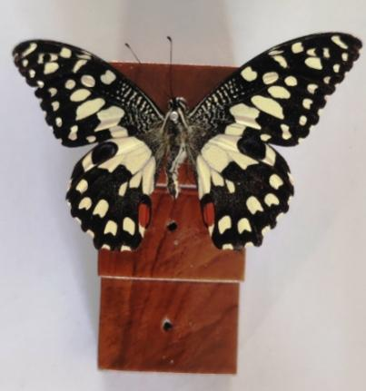 | 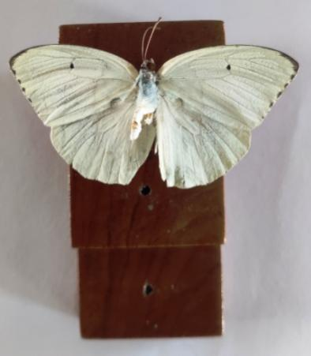 | 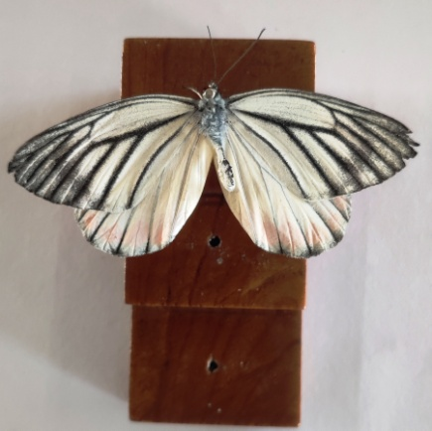
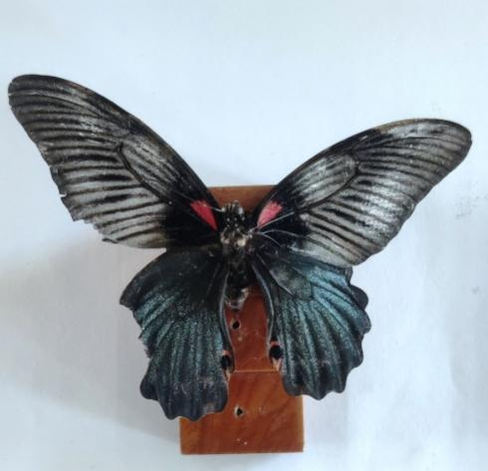 | 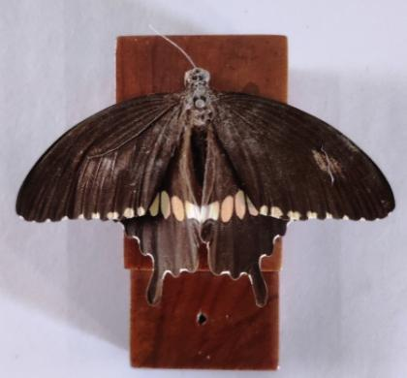 | 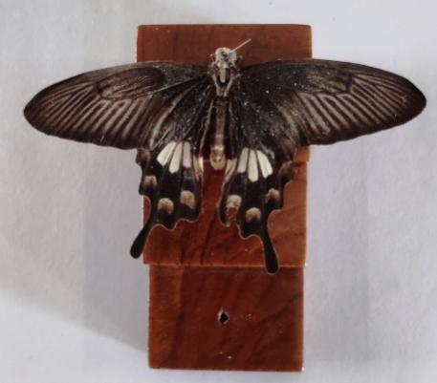
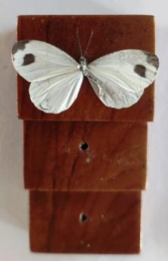 | 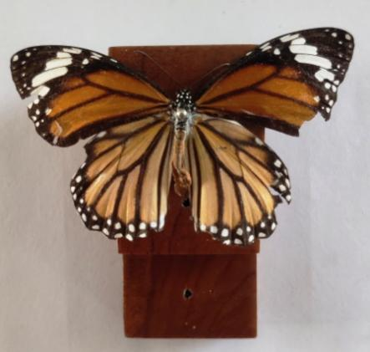 | 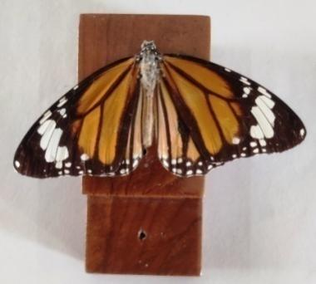
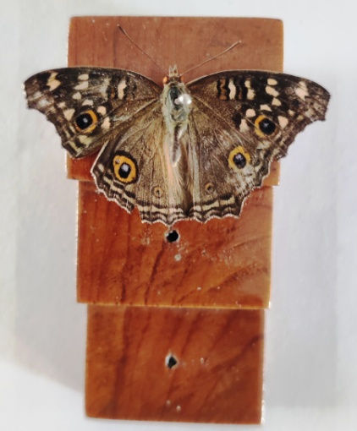 | 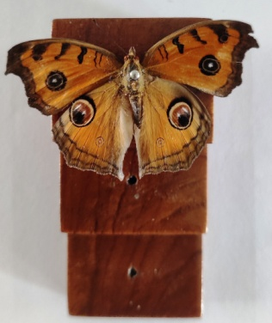 | 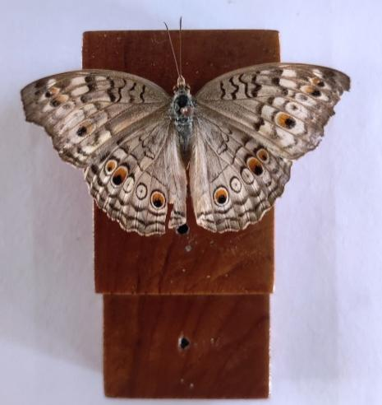
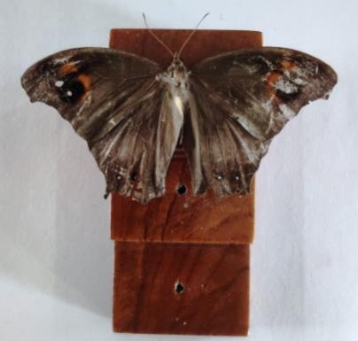 | 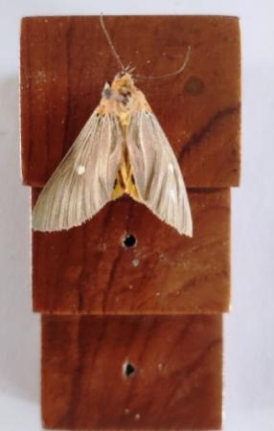 | 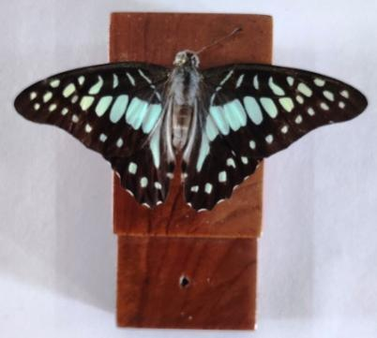
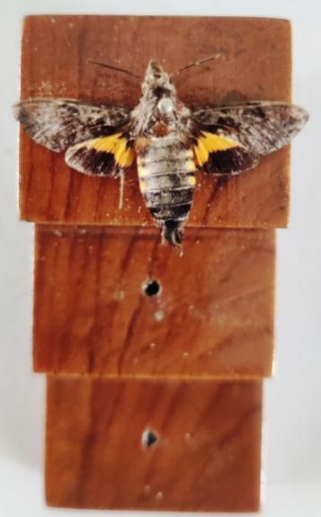 | 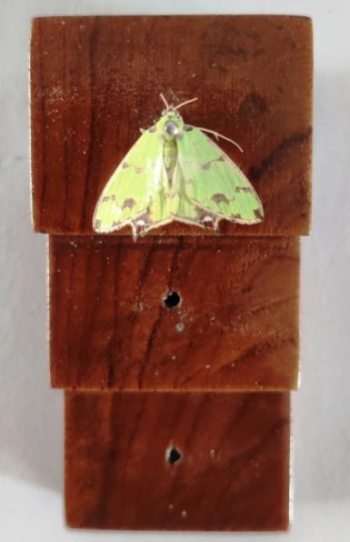 | 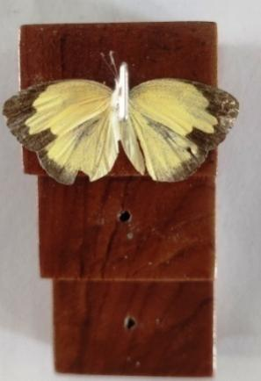
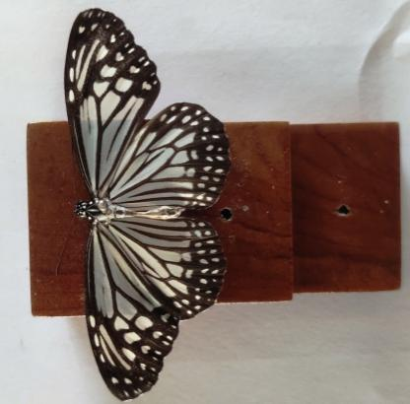 | 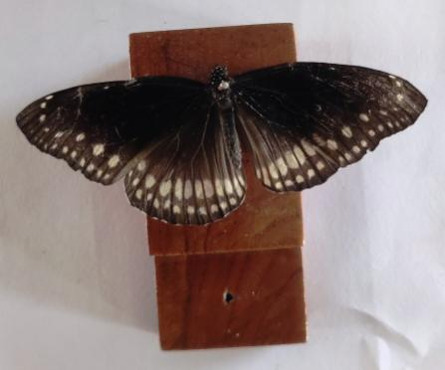 | 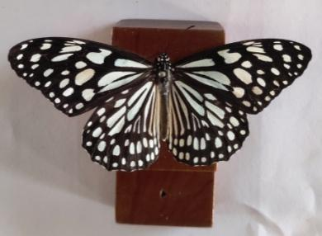
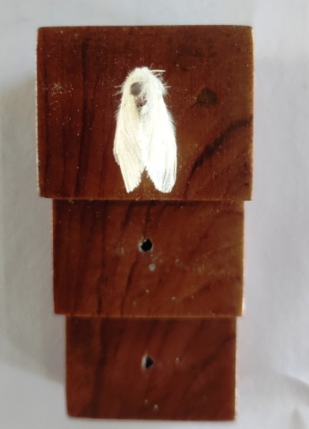 | 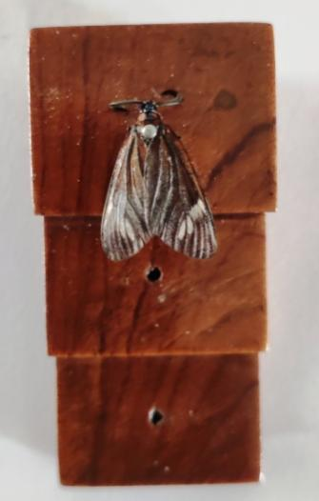 | 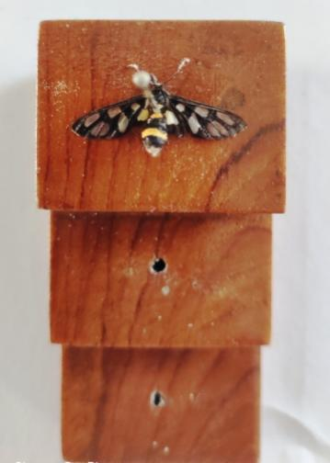
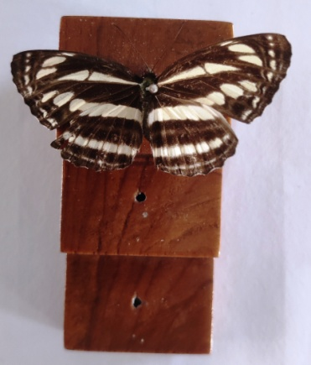 | 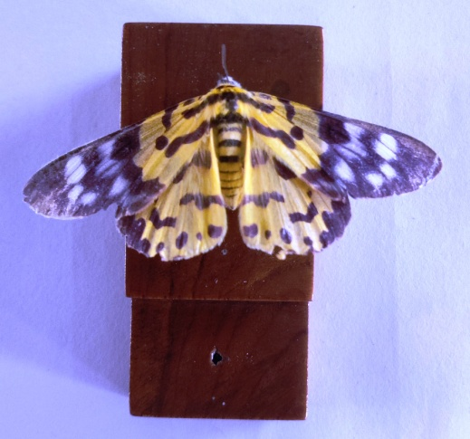 | 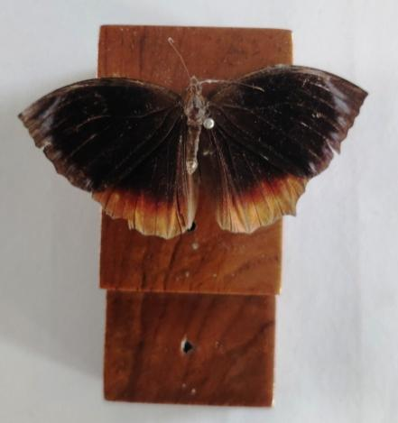
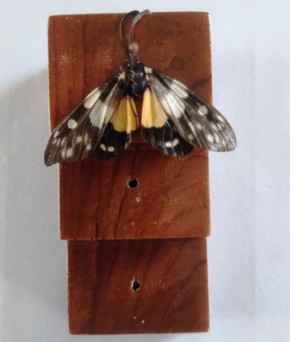 | 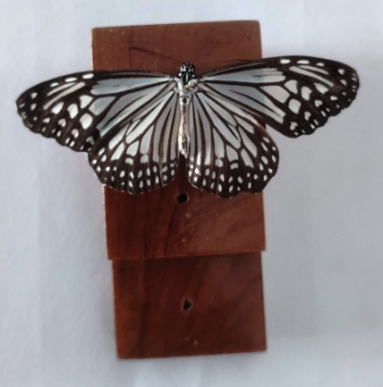 | 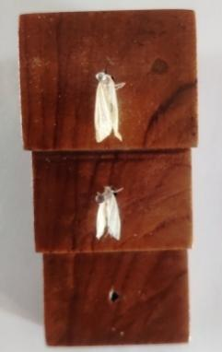
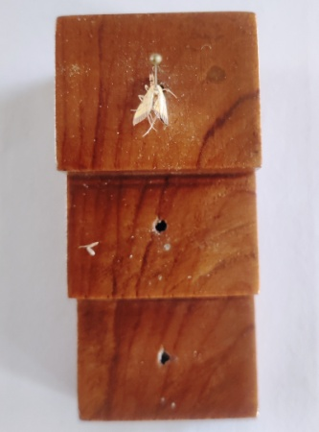 | 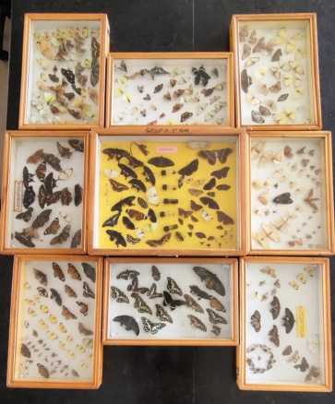
Fig 2: Glimpses of Lepidopteran diversity in SCSCA, AAU campus
State the scientific name of each butterfly and moth species

