Review Article
Postharvest Chemical Treatments for Extending Shelf Life and Preserving Fruit Quality

Abstract
Fruits are highly perishable and often lose quality soon after harvest due to rapid ripening, moisture loss and microbial decay. These postharvest losses reduce both the nutritional value and marketability of fruits, affecting both farmers and consumers. Globally, postharvest losses in fruits are estimated to range between 20% and 50%, with higher percentages reported in tropical and developing regions. To mitigate these challenges, various postharvest management strategies have been developed, among which chemical treatments and edible coatings have gained considerable attention. Chemical treatments, including calcium chloride, calcium lactate, ethylene inhibitors such as 1-methylcyclopropene (1-MCP) and natural plant-based antimicrobials, play a crucial role in delaying senescence and maintaining fruit firmness. Calcium salts help strengthen cell wall structure and reduce enzymatic softening, while ethylene inhibitors suppress ripening processes by blocking ethylene action. Natural plant extracts and organic acids exhibit antimicrobial properties that help control postharvest pathogens and reduce spoilage. Edible coatings represent an eco-friendly and sustainable alternative to synthetic packaging materials. These coatings are composed of biodegradable materials such as polysaccharides (e.g., starch, chitosan, alginate), proteins (e.g., whey protein, gelatin) and lipids (e.g., waxes, fatty acids). When applied to fruit surfaces, edible coatings form a thin, semi-permeable barrier that regulates gas exchange, reduces water loss, delays oxidative reactions and limits microbial contamination. Moreover, edible coatings can serve as carriers for functional additives such as antioxidants, antimicrobials and nutraceutical compounds, further enhancing their protective effect. Together, these technologies play an important role in reducing postharvest losses, improving storage stability and supporting food and nutrition security.
Keywords: Postharvest loss, shelf life, edible coatings, chemical treatment, ripening, chemical treatments
Introduction
Fruits constitute a fundamental component of a balanced human diet. Fruits provide essential micronutrients such as vitamin C, vitamin A, folates, potassium, dietary fibre and a wide range of phytochemicals that are useful for human body. These micronutrients support immune functions and reduce the risk of chronic diseases. Increased consumer awareness regarding nutrition and lifestyle-related disorders has driven a consistent rise in global fruit demand over the past three decades. However, alongside production growth, postharvest loss (PHL) continues to undermine the availability, quality and economic value of fruits.
Postharvest loss refers to the measurable quantitative and qualitative deterioration in fruits occurring between harvest and final consumption (Kader, 2005). These losses may occur during harvesting, handling, transportation, storage, processing and retail marketing. Unlike cereal grains, fruits are highly perishable due to their high moisture content (70–95%), soft texture and active metabolic processes. As a result, fruits are particularly vulnerable to rapid deterioration once detached from the plant. Globally, postharvest losses in fruits are estimated to range between 20% and 50%, with higher percentages reported in tropical and developing regions (FAO, 2019). In developing economies, limited cold chain infrastructure, inadequate packaging, poor road connectivity and traditional marketing systems contribute significantly to these losses (Kitinoja & Kader, 2015).
India presents a paradoxical scenario: it is one of the largest fruit producers in the world, yet it suffers from substantial postharvest inefficiencies. India is the second largest producer of fruits and vegetables after China. According to the Ministry of Food Processing Industries (MoFPI, 2022), postharvest losses in fruits in India range between 15% and 25%, depending on the crop and stage of the supply chain (Fig 1). This reflects a huge economic losses and reduced nutritional security for a growing population. Therefore, a systematic understanding of fruit production patterns and the major causes of postharvest losses is essential for developing effective mitigation strategies.
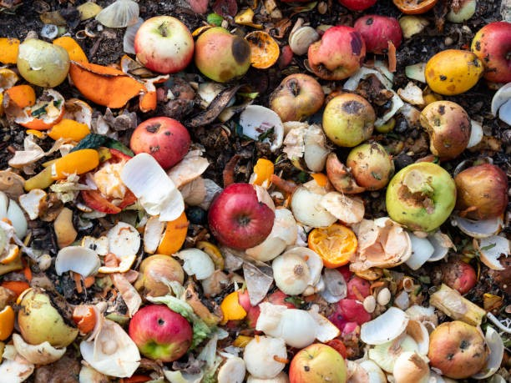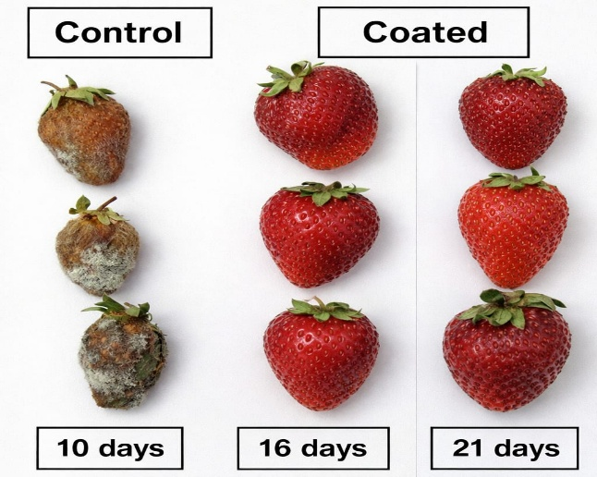
Fig 2. Effect of edible coating on quality of strawberry (Elsabee & Abdou 2013)
Fig 1. Postharvest loss in fruit

Effective postharvest management plays a crucial role in preserving fruit quality from harvest to consumption. Since fruits remain metabolically active even after harvest, they are highly susceptible to rapid ripening, moisture loss, microbial decay and physiological deterioration. In this context, postharvest chemical treatments and edible coatings have emerged as important technological interventions to minimize losses and maintain quality during storage and marketing.
Postharvest chemical treatments such as calcium salts, ethylene inhibitors (e.g., 1-MCP), salicylic acid, fungicides and nitric oxide donors help regulate physiological processes by slowing respiration, delaying ethylene action, strengthening cell walls and suppressing microbial growth. These treatments contribute to maintaining firmness, reducing decay incidence, preserving nutritional quality and extending marketable life. When applied at appropriate concentrations and under recommended conditions, they significantly enhance storage stability and reduce quantitative and qualitative losses.
Edible coatings, on the other hand, provide a biodegradable and eco-friendly approach to postharvest preservation. By forming a thin protective layer on the fruit surface, edible coatings act as semi-permeable barriers that reduce moisture loss, modify internal gas exchange and limit microbial contamination. This controlled internal environment slows ripening and senescence while maintaining texture, appearance and nutritional value (Fig 2). Together, postharvest chemical treatments and edible coatings serve as complementary strategies in modern postharvest management systems. Their integration with proper harvesting, grading, packaging, and cold chain management can substantially reduce postharvest losses, enhance fruit quality, improve economic returns for farmers and strengthen overall food and nutrition security.
Fruit Production Status in India
India has emerged as a global leader in horticultural production. According to the National Horticulture Board (NHB, 2023), India produces approximately 108–110 million tonnes of fruits annually, accounting for nearly 12–13% of global fruit production.
Major Fruit Crops
The principal fruit crops grown in India include: Mango, Banana, Citrus, Papaya, Guava and Pomegranate
Among these:
- Mango contributes nearly 40–45% of global mango production (APEDA, 2023).
- Banana is the leading fruit in terms of production volume.
- Citrus fruits occupy significant area in states such as Maharashtra and Punjab.
Major fruit-producing states include Maharashtra, Andhra Pradesh, Uttar Pradesh, Gujarat, Karnataka, Tamil Nadu, and Madhya Pradesh (NHB, 2023).
Despite this impressive production base, India’s fruit export share remains relatively low compared to its production capacity. One of the primary reasons is postharvest quality deterioration and inadequate infrastructure (APEDA, 2023).
Magnitude of Postharvest Loss in Fruits
Postharvest loss includes:
- Quantitative loss – reduction in weight and volume
- Qualitative loss – deterioration in appearance, texture, nutritional value and safety
A nationwide assessment conducted by NABCONS under the Ministry of Food Processing Industries reported fruit losses ranging from 4.6% to 15.9% at different stages of the supply chain (NABCONS, 2022). Postharvest loss in major fruit crops like guava, apple etc. are listed in Fig 3.
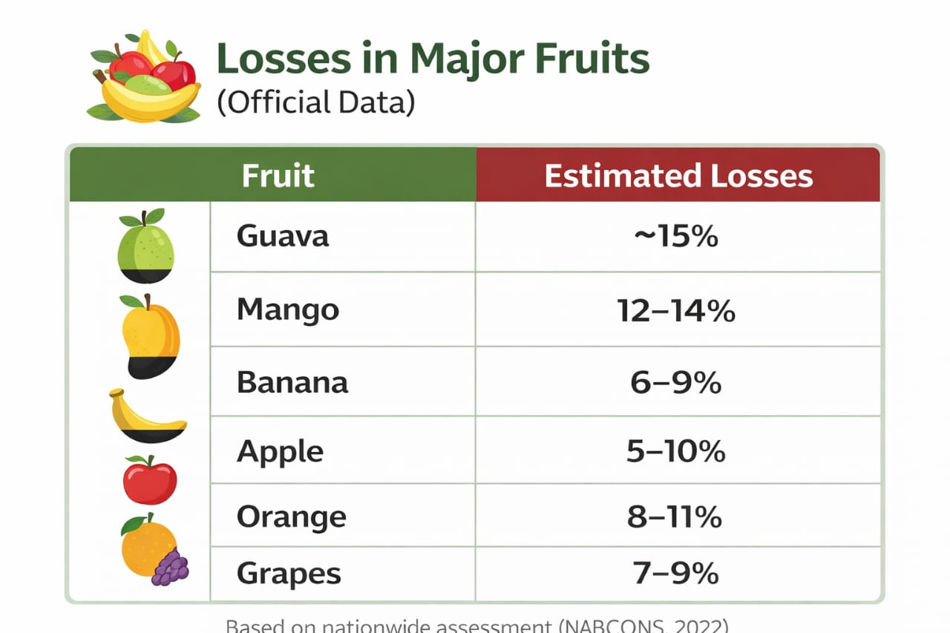
Fig 3. Postharvest loss in major fruit crops as per NABCONS, 2022

Similarly, Jha et al. (2015) estimated that postharvest losses in mango can reach 20% in poorly managed supply chains. These losses are highest at: Farm level (harvesting stage), wholesale markets and retail handling. The absence of precooling facilities and improper packaging aggravates deterioration during transit.
Causes of Postharvest Loss in Fruits
Postharvest losses in fruits result from interconnected biological, physiological, mechanical, environmental and infrastructural factors as shown in Fig 4. 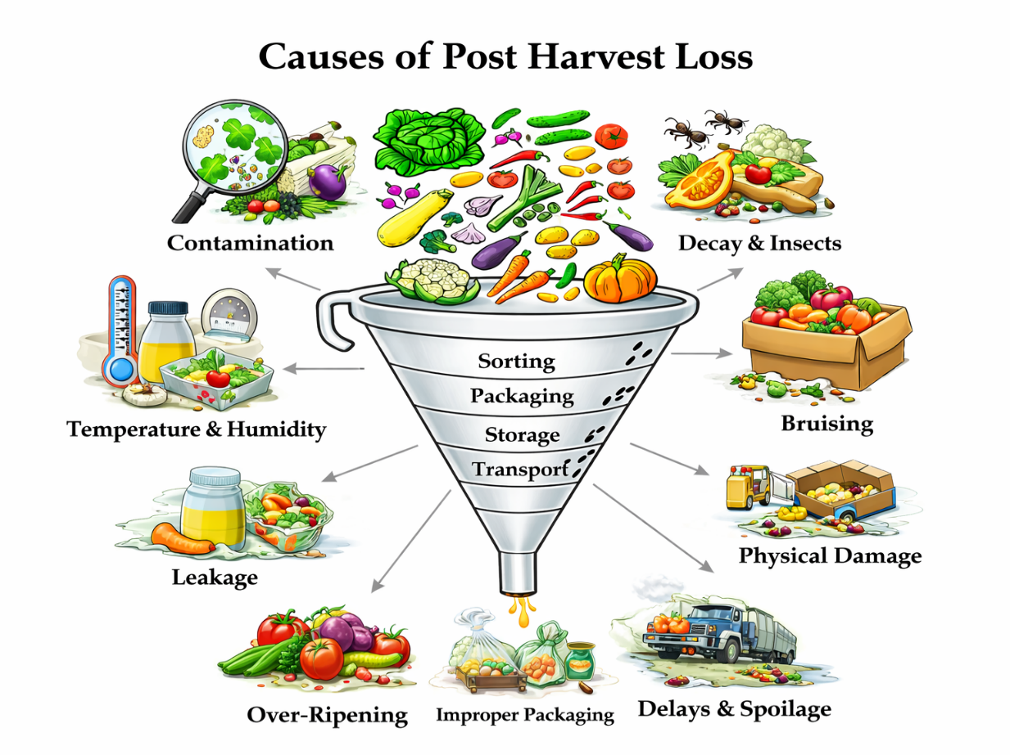
Fig 4. Causes of Postharvest Losses

Physiological Causes
Fruits remain living tissues after harvest and continue metabolic activities such as respiration, transpiration and ripening (Wills et al., 2016).
Respiration
Respiration involves the breakdown of stored carbohydrates to produce energy. High respiration rates accelerate senescence and shorten shelf life. Climacteric fruits like mango and banana exhibit a sharp rise in respiration and ethylene production during ripening (Giovannoni, 2004).
Transpiration
Water loss due to transpiration causes shriveling, loss of firmness and reduction in market weight. High temperature and low relative humidity increase transpiration rates (Kader, 2005).
Ethylene-Induced Ripening
Ethylene plays a crucial role in fruit ripening. Improper storage leading to ethylene accumulation accelerates over-ripening and spoilage (Zhang et al., 2018).
Microbial and Biological Causes
Microorganisms such as fungi and bacteria are major contributors to fruit decay. Common postharvest pathogens include: Colletotrichum gloeosporioides (anthracnose in mango), Penicillium spp. (citrus rot), Botrytis cinerea (grey mold). Microbial infection usually begins at injury sites and spreads rapidly under warm and humid conditions (Sharma et al., 2009). Poor sanitation and delayed marketing further increase infection rates.
Mechanical Damage
Mechanical injuries are common during harvesting, sorting, grading and transportation. Bruising, impact damage and compression injuries disrupt fruit tissues and increase susceptibility to microbial invasion (Jha et al., 2015). Studies by ICAR (2019) demonstrated that improved harvesting tools and cushioning materials significantly reduce mechanical injury in mango and banana supply chains.
Environmental Factors
Temperature is the most critical factor influencing postharvest life. High temperature increases respiration and microbial activity, while extremely low temperatures may cause chilling injury in tropical fruits (Kader, 2005). India faces major challenges due to insufficient cold storage infrastructure. According to the Ministry of Agriculture & Farmers Welfare (2023), the existing cold storage capacity is inadequate for perishable horticultural produce, leading to avoidable losses during peak harvest seasons.
Infrastructural and Supply Chain Constraints
- Postharvest management requires:
- Precooling facilities
- Cold storage units
- Controlled atmosphere storage
- Refrigerated transportation
However, smallholder farmers often lack access to these facilities. Kitinoja & Kader (2015) reported that lack of cold chain integration in developing countries results in 30–40% losses in perishable commodities. Market-level losses are exacerbated by: Poor packaging materials, Overstacking, Prolonged display without refrigeration
India-Specific Challenges
Several structural issues intensify fruit losses in India:
- Fragmented supply chains
- Dominance of intermediaries
- Limited farmer training in postharvest handling
- Inadequate grading and standardization
The Government of India has initiated schemes such as: Mission for Integrated Development of Horticulture (MIDH), Pradhan Mantri Kisan SAMPADA Yojana and Integrated Cold Chain and Value Addition Infrastructure Scheme. These initiatives aim to strengthen postharvest infrastructure and reduce losses (MoFPI, 2022).
Postharvest Chemical Strategies for Shelf Life Extension and Quality Preservation of Fruits
Freshly harvested horticultural products quickly lose their freshness, affecting their market value. Consequently, the horticultural industry has been exploring new methods to control ripening and prolong shelf life. Traditional techniques like cold storage and modified atmosphere storage are employed to extend the shelf life of horticultural products. In recent years, the use of post-harvest chemicals (e.g., calcium salts, salicylic acid, potassium permanganate) and edible coatings (such as starch, chitosan, lipid or nano-emulsions) has emerged as a more effective and sustainable approach. These treatments not only delay ripening and senescence but also maintain fruit firmness, reduce microbial growth and preserve sensory quality. Compared to conventional storage, they are cost-effective, eco-friendly and enhance consumer safety while significantly extending shelf life and reducing wastage.
Postharvest Chemicals for Shelf Life Enhancement of Fruits
To maintain quality after harvest, fruits require careful handling because they continue to respire, ripen, and undergo physiological changes even after being detached from the plant. Postharvest chemical treatments are widely used to slow down these natural processes, reduce microbial decay and extend storage life without significantly affecting nutritional value. Below is a detailed explanation of the major postharvest chemicals commonly used to enhance shelf life of fruits.
1. Ethylene Inhibitors and Modulators
1-Methylcyclopropene (1-MCP)
1-MCP is one of the most effective postharvest chemicals used for climacteric fruits such as mango, banana, apple, papaya and guava. It works by blocking ethylene receptors in fruit tissues, thereby preventing ethylene from triggering ripening processes. It is widely used in commercial storage facilities because even very low concentrations are effective.
Potassium Permanganate (KMnO₄)
Potassium permanganate acts as an ethylene absorbent. It oxidizes ethylene gas present in storage environments, reducing its concentration. This results in slow ripening, reducing premature softening and improving Storage life in packaged fruits. It is commonly used in sachets inside storage containers or packaging.
2. Calcium-Based Treatments
Calcium Chloride (CaCl₂)
Calcium strengthens cell walls by forming calcium pectate, which enhances tissue firmness and reduces enzymatic breakdown. It maintains fruit firmness, reduces physiological disorders, delays softening and improves storage stability. Calcium chloride dips are commonly used in mango, apple, citrus, and pomegranate.
Calcium Lactate
Similar to calcium chloride, calcium lactate helps in maintaining firmness but is often preferred due to lower risk of surface injury in some fruits.
3. Antimicrobial and Antifungal Chemicals
Sodium Hypochlorite
Used as a disinfectant wash to reduce surface microbial load. It reduces fungal and bacterial contamination and prevents decay during storage
Carbendazim and Thiabendazole
These fungicides are used to control postharvest fungal diseases, especially in mango and citrus. Hence enhance the shelf life of fruits.
4. Growth Regulators
Gibberellic Acid (GA₃)
GA₃ delays senescence and reduces physiological disorders in certain fruits. It maintains green color in citrus, delays ripening and reduces rind aging.
Salicylic Acid
Salicylic acid enhances antioxidant activity and reduces ethylene production. It delays ripening, reduces chilling injury and enhances disease resistance.
5. Nitric Oxide Donors
Nitric oxide (NO) treatments are gaining attention for their ability to regulate ripening and reduce oxidative stress.
6. Oxalic Acid
Oxalic acid treatments help in maintaining firmness and reducing decay.
7. Polyamines (Putrescine, Spermidine)
Polyamines regulate cell membrane stability and delay senescence. It maintain firmness, reduce physiological breakdown and extend storage period.
Research Findings :
Watkins (2006) reported that application of 1-MCP at 1 μL L⁻¹ significantly delayed ripening and softened ‘Tommy Atkins’ mangoes during cold storage, maintaining firmness and reducing ethylene production compared with untreated fruits. Ayala-Zavala et al. (2008) observed that 1-MCP treatment prolonged storage life of papaya by up to 14–18 days at 12°C by lowering respiration rate and slowing colour changes. Gao et al. (2020) found that dipping papaya fruits in 2% CaCl₂ solution delayed ripening, reduced ethylene production and maintained firmness compared to control fruits during 21 days of storage. Singh et al. (2018) reported that CaCl₂ application in mango reduced physiological weight loss and maintained pulp firmness during 30 days of storage. Singh & Pareek (2017) reported that KMnO₄ placed in fruit storage chambers reduced ethylene concentration and delayed ripening symptoms in guava, resulting in lower decay and weight loss. Fatima et al. (2023) showed that mangoes stored with KMnO₄ retained firmness and acidity longer than untreated fruits. Upadhyay et al. (2005) found that washing fruits with 100–200 ppm NaOCl reduced surface fungal contamination and delayed spoilage in citrus and mango. Rathore & Parsad (2019) observed that sodium hypochlorite treatments reduced postharvest decay in guava by lowering microbial load. Palou et al. (2008) reported that thiabendazole treatment effectively reduced Penicillium decay in citrus fruits stored at low temperatures. Sivakumar et al. (2010) showed that carbendazim reduced anthracnose incidence in mangoes when applied in combined treatment with calcium. Amanullah et al. (2017) observed that SA treatment in guava fruits reduced physiological weight loss and maintained ascorbic acid content during 12 days of storage. Baswal et al. (2020) reported that SA application in kinnow mandarins improved firmness, reduced decay and maintained better quality during 75 days of cold storage. Zhang et al. (2022) demonstrated that NO donor treatments delayed senescence, reduced ethylene production and improved antioxidant enzyme activity in papaya during storage. Li et al. (2019) showed that exogenous NO reduced chilling injury and maintained firmness in banana stored at low temperature. Tariq et al. (2018) showed that putrescine treatments in mango increased membrane integrity, reduced ethylene evolution and maintained firmness during storage. Singh et al. (2021) reported that spermidine reduced chilling injury and extended shelf life in banana stored at low temperatures.
Edible Coatings: An Emerging Sustainable Approach 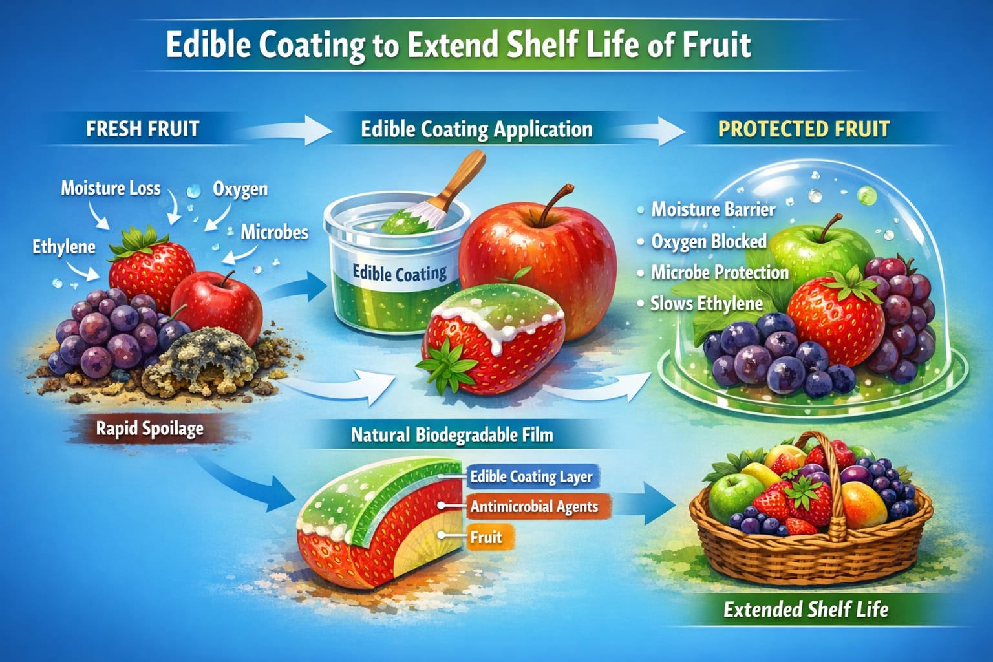
Fig 5. Working mechanism of edible coatings

These coatings are made of biodegradable natural polymers, are applied as thin layers on food surfaces to enhance quality, prolong shelf life and minimize postharvest losses. This coating reduces oxygen entry and carbon dioxide loss, thereby slowing respiration and ethylene production, which delays ripening (Fig 5). It also minimizes moisture loss, reducing shrinkage and weight loss during storage. It also creates a barrier that protects against microbes and decay. Edible coatings can be applied using several practical methods depending on the type of fruit, coating material, and scale of operation. The dipping method is the most common technique, where fruits are immersed in the coating solution for a specific time and then removed and dried, ensuring complete surface coverage. In the spraying method, the solution is sprayed onto the fruit using manual or automated sprayers, which helps form a thin and uniform layer while reducing material wastage. The brushing method involves manually applying the coating with a brush and is mainly suitable for small-scale or laboratory studies. Electrostatic spraying improves adhesion by charging the droplets, allowing better and more uniform deposition on the fruit surface. In the fluidized bed method, small fruits are suspended in an air stream while the coating is sprayed, ensuring even coverage. The foam application method uses a foamed coating solution to reduce liquid usage and enhance uniformity. In the casting method, a film is first prepared separately and then wrapped around the product. The panning method, commonly used in confectionery, coats products by rotating them in a pan while adding the coating gradually. Layer-by-layer deposition involves applying multiple thin layers sequentially to improve barrier properties. Finally, vacuum impregnation allows the coating solution to penetrate surface pores under reduced pressure, providing enhanced internal protection and extending shelf life (Fig 6).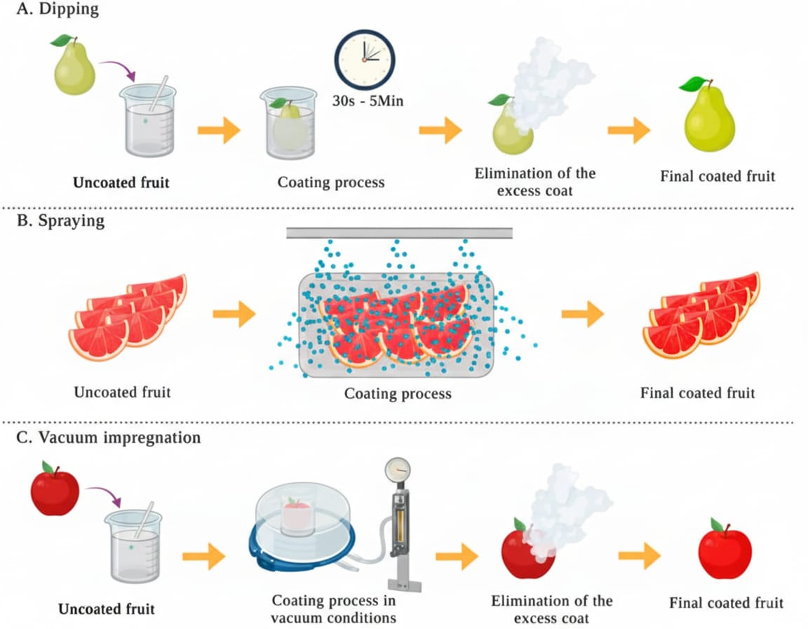
Fig 6. Schematic representation of the processes used for the coating application on fruits and vegetables. (A) dipping; (B) spraying; (C) vacuum impregnation. (Perez-Vazquez et. al 2023)

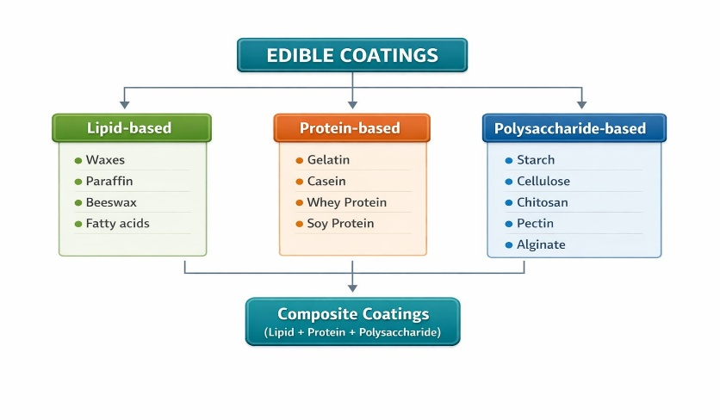
Fig 7. Classification of edible coatings

Types of Edible Coatings : on the basis of materials used, edible coatings are classified into three main categories: polysaccharide-based, protein-based, and lipid-based coatings (Fig 7).
1. Polysaccharide-Based Coatings
Include alginate, chitosan, cellulose, pectin and starch. This type of edible coating is an excellent barrier against oxygen and carbon dioxide, helping to reduce respiration and delay fruit ripening. The antimicrobial effects of polysaccharide-based edible coatings (especially chitosan) are that these coatings disrupt microbial membranes and bind to negatively charged microbial cell walls, inhibiting growth.
2. Protein-Based Coatings
Include casein, whey protein, soy protein, zein and gelatin. This edible coating is a good barrier against O₂ and CO₂ due to its dense protein matrix. Also, this category of edible coating provides structural support and reduces physical damage.
3. Lipid-Based Coatings
Examples: Beeswax, carnauba wax, fatty acids and acetylated monoglycerides. These types of edible coatings are excellent barriers to moisture loss and shriveling in fruits. They also increase the visual appeal of the fruit by creating a gloss on the surface.
4. Composite Coatings
When different edible coatings are combined, the advantages of several edible coatings can be achieved simultaneously. The use of this type of edible coating provides moisture protection and balanced gas exchange. It also improves the performance of the edible coating because it allows for multi-purpose applications (antimicrobial + mechanical strength + antioxidant).
5. Nanoemulsion and Encapsulated Coatings
Nanoemulsified essential oils, lipid nanoparticles and polymer-encapsulated antioxidants are among the compounds that fall into this category. The use of nanoscale particles provides a uniform coating and greater surface contact with the products. Another advantage of these edible coatings is controlled release, so that active agents (e.g., antimicrobials, antioxidants) are released gradually and over time. This feature makes the edible coatings stable and protects sensitive bioactive ingredients from degradation. The different kinds of coating materials available for postharvest management are shown in Fig 8.
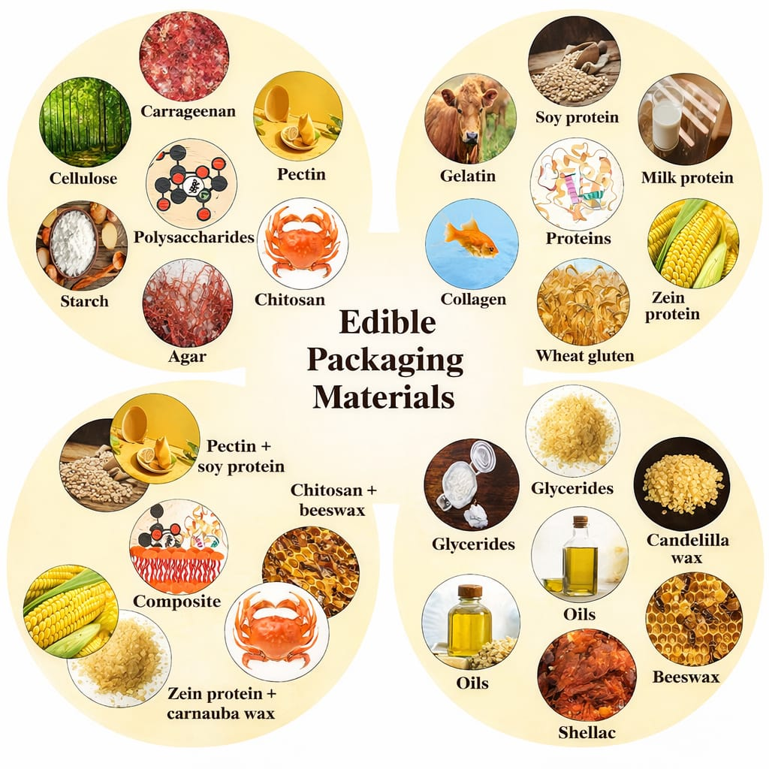
Fig 8. Different edible packaging materials (Kumar et. al 2025)

Research Evidence:
Ali et al. (2011) reported that chitosan + Aloe vera composite coating significantly extended the shelf life of papaya up to 21 days by reducing weight loss, delaying ripening and maintaining firmness during storage. Adetunji et al. (2012) showed that Aloe vera gel coatings effectively reduced physiological weight loss and helped retain ascorbic acid content in pineapple fruits, thereby preserving nutritional quality during storage. Zhang and Quantick (1997) demonstrated that chitosan coating reduced pericarp browning and decay incidence in litchi fruits by forming a semi-permeable barrier that slowed respiration, moisture loss and oxidative changes. Menezes and Athmaselvi (2016) reported that coated sapota fruits exhibited lower weight loss, better firmness retention and delayed ripening compared to uncoated fruits under ambient storage conditions. Dulta et al. (2022) found that alginate–chitosan composite coatings enriched with ZnO nanoparticles significantly reduced decay percentage and respiratory rate in oranges during 20 days of storage, indicating enhanced antimicrobial and barrier properties. Rosman et al. (2024) observed reduced disease incidence and minimized weight loss in ZnO nanoparticle-coated mangoes, highlighting the potential of nano-enhanced edible coatings for improving postharvest quality and extending shelf life.
Conclusion
India is one of the world’s largest fruit producers, yet a major part of production is lost between harvest and final consumption as postharvest losses. This reduce the effective availability of fruits for domestic consumption and export. Losses ranging between 15–25% are common across major fruit crops. The primary causes include physiological deterioration, microbial infection, mechanical injury, environmental stress and infrastructural deficiencies. The available research confirms that both postharvest chemical treatments and edible coatings possess significant potential to minimize quantitative and qualitative losses in fruits. Their proper and regulated application can enhance storage stability, improve marketability, increase farmer profitability and contribute meaningfully to food and nutrition security by ensuring that more high-quality fruits reach consumers. Future research should focus on optimizing concentration levels, consumer safety validation and scaling up nano-coating technologies for commercial adoption.
References
Adetunji, C. O., Fawole, O. B., Arowora, K. A., Nwaubani, S. I., & Oloke, J. K. (2012). Effects of edible coatings from aloe vera gel on quality and postharvest physiology of pineapple fruit during storage. Journal of Food Science and Technology, 49(6), 806–813.
Agricultural and Processed Food Products Export Development Authority (APEDA). (2023). Agricultural and processed food products export data 2022–23. Ministry of Commerce & Industry, Government of India. https://apeda.gov.in
Ali, A., Maqbool, M., Ramachandran, S., & Alderson, P. G. (2011). Gum arabic as a novel edible coating for enhancing shelf-life and improving postharvest quality of tomato fruit. Postharvest Biology and Technology, 58(1), 42–47.
Amanullah, S., Malik, A. U., Khan, A. S., Shahid, M., & Rajwana, I. A. (2017). Salicylic acid reduces physiological weight loss and maintains quality of guava fruit during storage. Journal of Food Processing and Preservation, 41(6), e13251.
Ayala-Zavala, J. F., Wang, S. Y., Wang, C. Y., & González-Aguilar, G. A. (2008). Effect of 1-methylcyclopropene (1-MCP) on the overall quality of fresh-cut papaya. Postharvest Biology and Technology, 47(3), 316–322.
Baswal, A. K., Dhaliwal, H. S., & Mahajan, B. V. C. (2020). Effect of salicylic acid on quality and storage life of kinnow mandarin under cold storage. Scientia Horticulturae, 261, 108950.
Dulta, K., Chauhan, P., & Kumar, R. (2022). Alginate–chitosan composite coatings enriched with ZnO nanoparticles for improving postharvest quality of orange fruits. Food Packaging and Shelf Life, 31, 100781.
Elsabee, M. Z., & Abdou, E. S. (2013). Chitosan based edible films and coatings: A review. Materials Science and Engineering: C, 33(4), 1819–1841.
Fatima, T., Ahmad, S., & Khan, M. A. (2023). Effect of potassium permanganate on storage quality and shelf life of mango fruit. Journal of Food Science and Technology, 60(5), 1632–1640.
Food and Agriculture Organization of the United Nations. (2019). The state of food and agriculture 2019: Moving forward on food loss and waste reduction. FAO. https://www.fao.org
Gao, H., Zhang, Z., Chai, H., Cheng, N., Yang, Y., Wang, D., & Cao, W. (2020). Melatonin treatment delays postharvest senescence and regulates reactive oxygen species metabolism in peach fruit. Postharvest Biology and Technology, 166, 111197.
Giovannoni, J. J. (2004). Genetic regulation of fruit development and ripening. The Plant Cell, 16(Suppl 1), S170–S180.
Indian Council of Agricultural Research (ICAR). (2019). Post-harvest management of horticultural crops: Annual report. ICAR, New Delhi.
Jha, S. N., Vishwakarma, R. K., Ahmad, T., Rai, A., & Dixit, A. K. (2015). Report on assessment of quantitative harvest and post-harvest losses of major crops and commodities in India. ICAR – Central Institute of Post-Harvest Engineering & Technology (CIPHET), Ludhiana.
Kader, A. A. (2005). Increasing food availability by reducing postharvest losses of fresh produce. Acta Horticulturae, 682, 2169–2176.
Kitinoja, L., & Kader, A. A. (2015). Measuring postharvest losses of fresh fruits and vegetables in developing countries. The Postharvest Education Foundation.
Kumar, L., Tyagi, P., Lucia, L., & Pal, L. (2025). Innovations in edible packaging films, coatings, and antimicrobial agents for applications in food industry. Comprehensive Reviews in Food Science and Food Safety, 24(4), e70217.
Li, L., Li, C., & Li, J. (2019). Nitric oxide alleviates postharvest senescence of horticultural crops: A review. Scientia Horticulturae, 246, 825–833.
Menezes, T. P., & Athmaselvi, K. A. (2016). Effect of edible coatings on shelf life and quality of sapota fruit. Journal of Food Science and Technology, 53(1), 482–490.
Ministry of Agriculture & Farmers Welfare, Government of India. (2023). Agricultural statistics at a glance 2022–23. Government of India, New Delhi. https://agricoop.nic.in
Ministry of Food Processing Industries, Government of India. (2022). Annual report 2021–22. Government of India. https://mofpi.gov.in
NABARD Consultancy Services (NABCONS). (2022). Study on assessment of post-harvest losses of fruits and vegetables in India. Ministry of Food Processing Industries, Government of India.
National Horticulture Board. (2023). Horticultural statistics at a glance 2022–23. Ministry of Agriculture & Farmers Welfare, Government of India. https://nhb.gov.in
Palou, L., Smilanick, J. L., Crisosto, C. H., & Mansour, M. F. (2008). Effect of thiabendazole treatment on decay development of citrus fruit during storage. Postharvest Biology and Technology, 47(2), 226–233.
Perez-Vazquez, A., Barciela, P., Carpena, M., & Prieto, M. A. (2023). Edible coatings as a natural packaging system to improve fruit and vegetable shelf life and quality. Foods, 12(19), 3570.
Rathore, A., & Parsad, V. (2019). Effect of sodium hypochlorite on postharvest decay and quality of guava. Journal of Food Science and Technology, 56(4), 1896–1903.
Rosman, N. F., Hassan, Z., & Rahman, R. A. (2024). Zinc oxide nanoparticle-based edible coating reduces postharvest disease and maintains quality of mango fruit. Postharvest Biology and Technology, 205, 112541.
Sharma, R. R., Singh, D., & Singh, R. (2009). Biological control of postharvest diseases of fruits and vegetables by microbial antagonists: A review. Biological Control, 50(3), 205–221.
Singh, R., Kumar, D., & Singh, A. (2021). Spermidine reduces chilling injury and improves postharvest quality of banana during cold storage. Scientia Horticulturae, 283, 110071.
Singh, S. P., & Pareek, S. (2017). Potassium permanganate as an ethylene absorbent to improve storage life of guava fruit. Journal of Food Science and Technology, 54(5), 1213–1221.
Singh, V., Singh, A. K., & Kumar, P. (2018). Effect of calcium chloride treatments on postharvest quality of mango. Indian Journal of Horticulture, 75(3), 456–462.
Sivakumar, D., Jiang, Y., & Yahia, E. M. (2010). Maintaining mango fruit quality during storage by combining calcium and fungicide treatments. Postharvest Biology and Technology, 55(2), 73–79.
Tariq, A., Malik, A. U., & Khan, A. S. (2018). Putrescine application maintains membrane integrity and delays ripening in mango fruit. Journal of Food Processing and Preservation, 42(3), e13543.
Upadhyay, R. K., Ahmad, S., & Singh, R. (2005). Effect of sodium hypochlorite treatments on postharvest quality of mango and citrus fruits. Journal of Food Science and Technology, 42(6), 463–467.
Watkins, C. B. (2006). The use of 1-methylcyclopropene (1-MCP) on fruits and vegetables. Biotechnology Advances, 24(4), 389–409.
Wills, R. B. H., McGlasson, W. B., Graham, D., & Joyce, D. C. (2016). Postharvest: An introduction to the physiology and handling of fruit and vegetables (6th ed.). CABI Publishing.
Zhang, D., & Quantick, P. C. (1997). Effects of chitosan coating on enzymatic browning and decay during postharvest storage of litchi fruit. Postharvest Biology and Technology, 12(2), 195–202.
Zhang, Y., Chen, K., Zhang, S., & Ferguson, I. (2018). The role of salicylic acid in postharvest fruit preservation: A review. Postharvest Biology and Technology, 143, 152–160.
Zhang, Y., Li, S., Chen, K., & Ferguson, I. (2022). Nitric oxide treatment delays senescence and enhances antioxidant defense in papaya fruit. Postharvest Biology and Technology, 188, 111870.

