Original Research Article
Bio-coating made from cashew gum for preserving tomatoes.

ABSTRACT
Cherry tomatoes are a nutritious product commonly used in salads or as a dietary supplement. The rapid deterioration of this fruit is due to moisture loss, microbial contamination, and oxidative degradation, which poses several challenges in terms of post-harvest handling and extending shelf life. This study examines the effectiveness of an edible coating made from cashew gum enriched with lemongrass essential oil in preserving the quality and extending the shelf life of fresh tomatoes stored at room temperature (24 ± 2 °C). To this end, tomatoes were coated with cashew gum gels and then stored at room temperature (24 ± 2 °C and 84 ± 2% RH) for 25 days. According to the results, sampling every 5 days showed that the GC20/HE treatment maintained higher firmness and acidity, with respective values of 15.80 N and 0.42%, during the 25 days of storage. The GC20% treatment slowed down the change in pH (5.77), color change (19.82), and acidity loss (0.42%) compared to uncoated fruit. The GC15% treatment significantly reduced tomato weight loss, with the lowest value (5.8 L). The application of the coating preserved the overall quality of the tomatoes, as measured by various physicochemical attributes. These results indicate that cashew gum-based coatings could be promising post-harvest treatments for extending the shelf life of tomatoes. The GC15% and GC15/HE formulations were selected as the best for preserving the physical and chemical properties of tomatoes and thus extending their shelf life after harvest.
Keywords: Tomatoes, Post-harvest losses, Cashew gum, Edible coatings.

1. INTRODUCTION

Fruit and vegetables are essential for food and nutritional security, and they also contribute significantly to global trade and economic growth (Rosegrant et al., 2024). However, due to their perishable nature, they suffer the highest post-harvest losses, accounting for 28–55% of total production, equating to an annual loss of around US$750 billion (Karoney et al., 2024). These considerable losses affect food security by reducing the availability of nutritious food and compromise the achievement of United Nations Sustainable Development Goal (SDG) No. 2, 'Zero Hunger', by limiting access to fresh produce. Furthermore, climate change is predicted to decrease fruit and vegetable production by 0.3% in developed countries and 5% in developing countries by 2050 (Smith & Glauber, 2020), potentially impacting SDG 2. Various methods have been explored to reduce these losses, including physical methods such as irradiation, ultraviolet light and temperature variations; chemical methods such as natural acids and fungicides; and traditional plastic packaging, which is effective but harmful to the environment and human health (Araújo et al., 2024). Over the past decade, the growing demand for green and sustainable technologies for preserving fruit and vegetables has sparked particular interest in this field.
The application of edible gel coatings on fruits and vegetables is a widespread sustainable and innovative alternative. These coatings are typically made up of natural polymers, such as polysaccharides, proteins or lipids, along with plasticisers, emulsifiers and other bioactive components. They form a protective barrier that slows down gas transmission and moisture loss while maintaining the product's appearance during storage. Polysaccharides, such as guar gum (a galactomannan extracted from the seeds of the guar plant, Cyamopsis tetragonoloba), are widely used to preserve fruit quality thanks to their film-forming ability, non-toxicity, biocompatibility and biodegradability. However, they have certain limitations relating to their low mechanical properties and high hydrophilicity. To improve mechanical strength and water barrier properties, thereby optimising moisture retention, polysaccharides are generally combined with lipids when coating fresh products.
The tomato (Solanum lycopersicum L.) is a staple of the Mediterranean diet, widely consumed around the world and a dietary mainstay in many countries (Alenazi et al., 2020). Despite being rich in nutrients and beneficial compounds, tomatoes have a limited shelf life after harvest. Their climacteric nature makes them susceptible to rapid deterioration due to biochemical and physiological processes such as senescence, ethylene synthesis and transpiration that lead to nutrient loss and economic losses (Huang et al., 2023). Controlling the shelf life of cherry tomatoes after harvest is therefore an important area of research for improving quality and extending storage life. Bioplastic packaging is a promising sustainable alternative for controlling the shelf life of cherry tomatoes, as indicated by several recent studies (Rapisarda et al., 2020), which highlight the effectiveness of PLA compared to PET. Additionally, edible gel-based composite coatings have been demonstrated to effectively preserve the organoleptic qualities of tomatoes during storage (Shakir et al., 2022). Additionally, the use of edible, gel-based composite coatings has been demonstrated to effectively preserve the organoleptic qualities of tomatoes during storage (Shakir et al., 2022).
.
2. material and methods
2.1. Tomato Collection
Green ripe (Sree et al., 2020) tomatoes (Solanum lycopersicum L., variety Cobra 26) (Figure 1 b) were kindly donated by a local producer in Dabou, 45 km from Abidjan (Cote d'Ivoire). After sorting, healthy tomatoes of uniform size and color were washed with chlorinated water (0.05% v/v) for 3 min (Flores-López et al., 2023), rinsed with tap water (Onyegbula et al., 2023), and air dried at room temperature to facilitate the adhesion of the coating solution on the surface (Sree et al., 2020). The tomatoes received were used on the same day of the experiment.
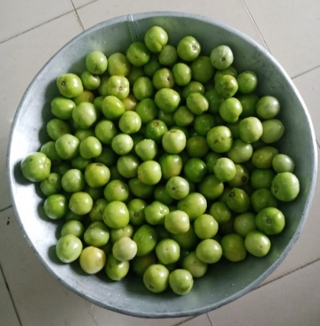 | 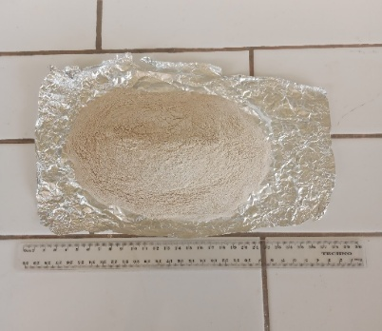  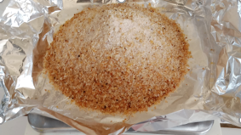
(a) | (b)
Figure 1. Crude gum nodules and flour from Anacardium occidentale L (a), and tomato (var. Cobra 26) (b) used in the study.
2.2. Collection, purification, and characterization of cashew gum (Anacardium occidentale L)
Crude samples of cashew gum were collected from native trees (Figure 1 a) in Karakoro, Korhogo, Côte d'Ivoire and purified as described by Oliveira-Alcântara et al. (2020) with some modifications. The nodules were dried at 50° for 8 h in an oven (Memmert UN160) until they became brittle (Ofori et al., 2010), ground to a fine powder, dissolved in distilled water (1:3, w/v) with stirring for 24 h at room temperature (24 ± 2 °C), filtered through muslin cloth, precipitated with 96% ethanol (1:3, w/w) to recover the cashew gum polysaccharide (CGP). This CGP was washed twice with ethanol (Moreira et al., 2020), dried at 50 °C for 10, ground, sieved through 80 µm, and stored at room temperature in hermetically sealed containers. Moisture was determined by drying 5 g of the gum at 105 °C for 6 h. The pH was determined by immersing the electrode of a standardized pH-meter (pH-mètre C861, consort, bio block, Belgique) in a 1 % (w/v) dispersion prepared by mixing the gum in distilled water for 5 min at room temperature. Ash was determined by igniting 5 g of sample in a furnace at 300°C for 3h and then at 600°C for 1 h.
2.3. Collection of Cymbopogon citratus leaves and essential oil production.
Leaves (5 kg) were collected from the botanical garden of the Peleforo Gon Coulibaly University, dried at room temperature (28 ± 2 °C) for at least seven days, and cut into small pieces of 4 to 8 mm in length. The essential oil (EO) was extracted by steam distillation using a Clevenger-type apparatus for 3 h. After drying on anhydrous magnesium sulfate, the EO was stored at 4 °C, protected from light, until use (Olayemi et al., 2017).
2.4. Preparation of the edible coating solutions
The coating formulation solutions (with and without EO) were prepared according to a modified method of Adjouman et al. (2017). The CGP (10%, 15%, and 20%) (Daisy et al., 2020) coating solutions were prepared by redissolving CGP in distilled water by stirring at 80 °C for 20 min, followed by the addition of 30% glycerol (g/g of gum) as a plasticizer. For the formulations containing Cymbopogon citratus essential oil (Athayde et al., 2016) (EO, final concentration 0.2%, g/g of gum), the glycerol-gum solutions were prepared in distilled water to 80% of the final volume as described above. The EO emulsion was prepared by mixing EO with 5% soya lecithin (mg/g of EO) in water (20% of the final volume) for 5 min at 15000 rpm using an Ultra-Turrax T25 Basic (IKA Werke, Staufen / Germany). The gum solution and EO emulsion were mixed at 750 rpm for 10 min at room temperature to obtain the EO-CGP (10%, 15%, and 20%) coating solutions.
2.5. Application of coatings to tomatoes
The washed and dried healthy tomatoes were divided into 11 groups according to the coating solutions and treated using the dipping method described by Kumar et al. (2021) with some modifications. Each group was immersed in the appropriate treatment solution for 5 min (Peralta-Ruiz et al., 2020), while the control group was immersed in distilled water. The residual coating was allowed to drip off and air-dried for 60 min at ambient temperature (24 ± 2 °C). This process was repeated twice to ensure that the edible coating component was applied to the surface of the tomato. After drying, each of the coated tomato groups was randomly divided into 2 groups of 60 tomatoes and stored at a controlled (13 °C, 89 ± 2% RH) (Mohammed et al., 2021) (Haier WS190GA) and room (24 ± 2 °C, 84 ± 2% RH) temperatures. Room temperature was chosen to simulate conditions commonly found in tomato sales . During the 25 days of storage, the quality attributes of the tomatoes were assessed every 5 days and, in each group of 60 tomatoes, 30 fruits were preserved intact for weight loss, and color, while the other 30 fruits were used for firmness measurement, pH, titrable acidity, and total soluble sugars analysis. For day 0 measurements, fruits were analyzed after dipping in the distilled water.
2.6. Physicochemical quality aspects of control and coated tomatoes
2.6.1. Firmness
Tomato firmness was measured using a hand-held digital penetrometer (PCE-TR 200N, PCE instruments France EURL, France). Tomato fruits were tested with a flat-ended (6 mm in diameter) stainless steel probe that penetrated the sample at three different points for each of the three tomatoes selected per treatment (Kibar and Sabir, 2018). The breaking force required for the tip to penetrate the flesh was measured and values were expressed in Newtons (N).
2.6.2. Weight loss (WL)
The WL of control and coated tomatoes was determined by the gravimetric method using a precision balance (Denver Instrument SI-234, Germany). All tomatoes in each group were individually weighed at the beginning of the study and during storage (Souza et al., 2010). Six tomatoes per treatment were evaluated (Flores-López et al., 2024) and the difference in weight during storage was measured as a percentage of weight loss, as described by Souza et al. (2010). Mass loss was estimated as the average of individual weights per replicate (n = 2 x 3)

% WL = [(Initial weight of tomato - Weight of tomato at storage time) / Initial weight of tomato] x 100 | (2)
2.6.3. Color
The color change of the tomato surface was evaluated using a Minolta CR-10 Plus COLOR READER (Konica Minolta, Japan) handheld colorimeter at ambient temperature (28 ± 2 °C). Average readings were taken at three different points on the surface of each of the 6 tomato fruits (Flores-López et al., 2024). The color scale values of the control and the coated tomato samples were determined in terms of L*, a*, and b* (L* = light/dark; a* = green/red; b* = blue/yellow), and ΔE (color change).
2.6.’. Total soluble solids, Titrable acidity, maturity index, and pH
Three tomatoes from each treatment were cut into small pieces and 50 g were crushed using a 500 W Moulinex faciclic glass blender (LM310E10, China) (Flores-López et al., 2024) and centrifuged at 5000 rpm for 20 min at 4 °C (Thermo Fisher Scientific, Sorvall ST16R, 230/8A) (Onyegbula et al., 2023) to obtain the juice. Total soluble solids (% Brix) were measured on the concentrated juice of each treatment using a combined Brix-acid dual scale digital refractometer model PAL-BX-ACID 91 (ATAGO, France) after adding 1 or 2 drops of the juice on the prism surface. For titratable acidity (% acid), the juice of each treatment was diluted (5 g of juice in 25 mL of distilled water) before the reading was taken (Sree et al., 2020). The pH was determined using a pH meter (pH 340i/SET, Germany) by immersing the electrode in diluted tomato juice. The tomato maturity index (MI) was calculated as reported by Peralta-Ruiz et al. (2020).
3. results and discussion

3.1 Firmness

The firmness of the tomatoes gradually decreased over the 25 days of storage, regardless of treatment or temperature (Fig. 2). From Day 0 to Day 25, a considerably greater reduction was observed in the control groups than in the coated groups. Furthermore, the reduction in firmness occurred more quickly in samples stored at room temperature than in those stored at a cold temperature.
After only five days of storage at RT, the loss of firmness in the control tomatoes was statistically greater (p < 0.05) than that observed in the coated samples. The control tomatoes lost 63.10% of their initial firmness, whereas the reduction was smaller for the coated ones. Of the coated samples, tomatoes with the 20% formulated coating solution experienced the least statistical reduction in firmness (29.09% – 31.31%) compared to those with 10% or 15% formulated coatings (42.1% – 49.68%). The 20% formulated gum solutions experienced the least statistical reduction in firmness by Day 10. However, by Day 15, only the EO-CGP-20% coating gum was found to be the most effective (p < 0.05). By Day 20, a statistical difference could only be observed between the control and the 20% gum solutions. By the end of the storage period (25 days), the control samples stored at room temperature (24 ± 2 °C, 84% ± 2 RH) had reduced in firmness by 73.96%, which was statistically higher (p < 0.05) than that observed with the coated tomatoes. The reduction in firmness of the coated samples ranged from 58.78% to 63.08% for the CGP-coated tomatoes and from 57.10% to 64.50% for the EO-CGP-coated tomatoes. However, no significant difference (p > 0.05) in firmness reduction was observed for all the formulated coating solutions (with or without EO).

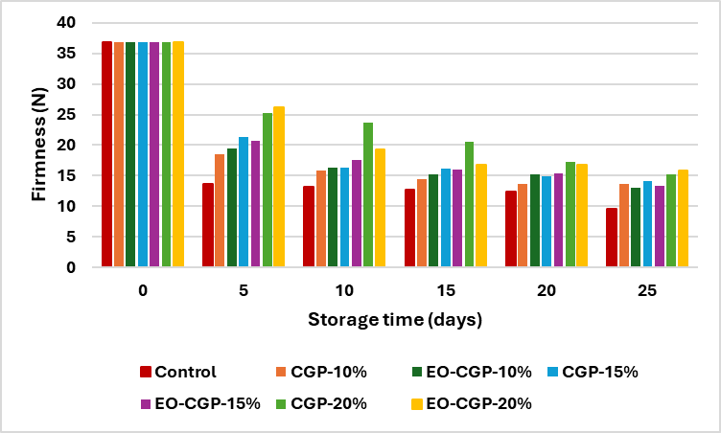
Fig. 2. Effects of treatments and storage times on firmness at 24 ± 2 °C

3.2. Weight loss

In general, the percentage weight loss increases gradually over time for all samples, regardless of the coating formulation or storage conditions (Fig. 3). After five days of storage at room temperature, the water loss (WL) of the tomatoes ranged from 1.73% ± 0.32 to 2.55% ± 1.21. The WL of the control samples was 2.44% ± 0.59. By contrast, the WL of the CGP-coated samples ranged from 1.73% ± 0.32 to 2.25% ± 1.05 and that of the EO-CGP-coated samples from 2.45% ± 0.42 to 2.71% ± 1.02. However, no statistically significant differences (p > 0.05) were observed between the control and coated tomatoes, and this remained the case until the end of the storage period. After the 25 days, WL ranged from 5.80% ± 0.64 to 8.54% ± 0.51 for samples stored at RT. The WL of the control tomato samples was 8.54% ± 0.51. For the CGP-coated samples, WL varied from 5.80% ± 0.64 to 7.34% ± 3.14, and for the EO-CGP-coated samples it ranged from 7.02% ± 0.84 to 8.46% ± 3.52.

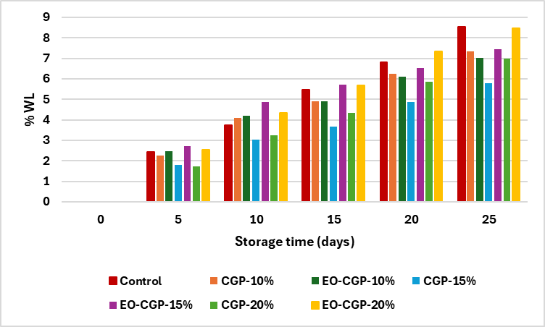
Fig. 3. Effects of treatments and storage times on weight loss at 24 ± 2 °C

3.3. Cumulative Decay percentage
Figure 4 shows the decay percentage of control and coated tomatoes over time. The results revealed that the coating had a significant impact on the percentage of decay in the tomatoes (p < 0.05). Furthermore, tomatoes coated with 10% or 15% of the formulated gum solution showed no signs of decay throughout the experimental period.
At RT. decay was observed on day 10 for the EO-CGP-20% coated tomatoes, affecting 7.14% of the sample. However, the control group did not start to rot until after 15 days of storage. The resulting decay (3.57%) of the control was significantly lower (p < 0.05) than the %decay observed with 20% coted tomatoes, and his remained the case until day 20. In addition, on day 15, the cumulative decay of tomatoes coated with EO-CGP-20% (10.71%) gum was statistically lower than that of CGP-20% (12.00%). However, by day 20 the trend had reversed with a cumulative decay reaching 17.86% for the EO-CGP-20%. By the end of the storage period, the control group showed greater rotting (25%) than the 20% coated groups (17.86%) (p < 0.05).
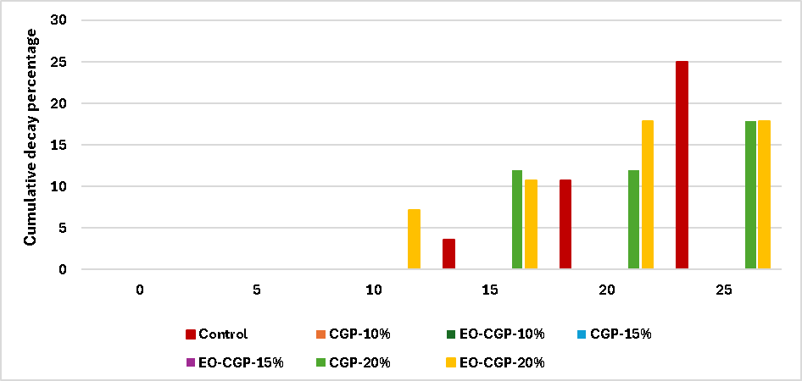

Fig. 4 Effects of treatments and storage times on decays at 24 ± 2 °C

3.4. Maturity index (MI)
The maturity index (TSS/TA) of the control and coated tomatoes is presented in Fig.5.
For the control group stored at RT, the MI varied from 7.32 ± 1.10 on day 0 to 22.61 ± 1.09 on day 25. For the coated tomatoes, however, the MI varied from 11.42 ± 0.14 to 12.84 ± 0.23 for the CGP formulated coating gums, and from 11.20 ± 0.66 to 12.15 ± 1.42 for the EO-CGP by day 25. A statistical difference (p < 0.05) was observed between the control group and the coated groups by day 10, and this remained the case throughout the storage period. However, no significant difference (p > 0.05) in the MI was observed between the coated groups.

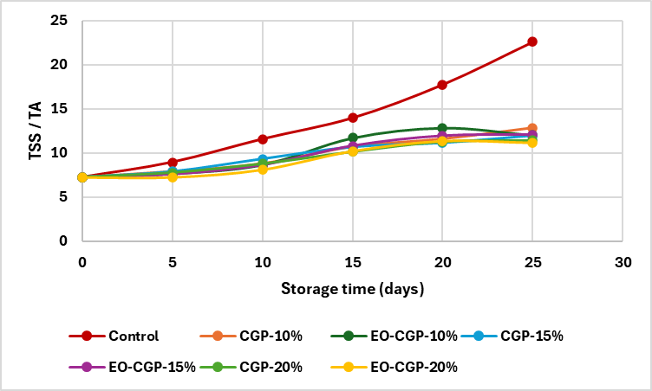

Fig. 5: Effects of treatments and storage times on TSS / TA at 24 ± 2 °C

3.5. Color change (ΔE) during storage
Figure 6 shows the change in color (ΔE) of treated and untreated tomatoes over the 25-day storage period. The color change increased gradually over this period.
The color change in the tomatoes stored at room temperature was statistically greater (p < 0.05) in the control group than in the coated groups, and it varied from 19.80 ± 0.42 on day 5 to 24.97 ± 0.94 on day 25. For the coated tomatoes, however, ΔE value ranged from 20.48 ± 2.33 to 21.12 ± 1.12 for CGP coatings, and from 20.66 ± 1.44 to 21.06 ± 1.16 for EO-CGP coatings by day 25. A significant difference in the efficiency of the coating solutions (p < 0.05) was evident among the coated groups by day 5. The least color change was observed in tomatoes coated with the 20% formulated solutions, while the greatest color change was seen in tomatoes coated with the 10% or 15% solutions enriched with EO. From days 10 to 15, tomatoes coated with CGP-20% exhibited the least color change; however, by day 20, the same was true of tomatoes coated with EO-CGP-20%. By day 25, however, no statistically significant difference (p > 0.05) in color change was observed for any of the coated tomatoes.

Fig. 6. Effects of treatments and storage time on ΔE at 24 ± 2 °C
3.6. pH
The pH of tomatoes during storage shows a general upward trend, both at room temperature (24 ± 2 °C) and at 13 °C. This increase in pH reflects a gradual decrease in the acidity of the fruit, resulting from the degradation of organic acids such as citric and malic acid, often observed during ripening or under the effect of increased microbial activity. At room temperature, the pH of the control sample rose from 5.04 to 6.10 after 25 days, reflecting a more rapid deterioration in physicochemical qualities. In contrast, the coated samples had lower pH values, indicating greater stability.
CG-based treatments limited the rise in pH, demonstrating their barrier effect against gas exchange and tissue metabolic activity. This action is even more pronounced in the EO-CG samples, where the incorporation of essential oils enhances the effectiveness of the coating thanks to their antimicrobial and antioxidant properties. The 15% and 20% formulations are characterized by higher pH stability, reflecting a greater reduction in enzymatic reactions and microbial growth.
In addition, storage at 13°C significantly slows down pH variation compared to storage at room temperature. This low temperature reduces respiratory metabolism and degradation processes, thereby delaying the loss of acidity and aging of the fruit. Overall, the combined effect of 15% or 20% EO-CG coating and cold storage maintained the tomatoes at a pH close to their initial value, demonstrating remarkable effectiveness in extending shelf life and preserving the physicochemical quality of the product.
Table 2. pH of tomato fruits coated with cashew gum during storage at different temperatures.
Days | Control | CGP-10% | CGP-15% | CGP-20% | EO-CGP-10% | EO-CGP-15% | EO-CGP-20%
0 | 5.04 ± 0.07 ^{dA} | 5.04 ± 0.07 ^{dA} | 5.04 ± 0.07 ^{dA} | 5.04 ± 0.07 ^{cA} | 5.04 ± 0.07 ^{dA} | 5.04 ± 0.07 ^{dA} | 5.04 ± 0.07 ^{cA}
5 | 4.93 ± 0.05 ^{eA} | 4.84 ± 0.02 ^{eA} | 4.89 ± 0.01 ^{eA} | 4.88 ± 0.09 ^{dA} | 4.91 ± 0.07 ^{eA} | 4.92 ± 0.04 ^{eA} | 4.86 ± 0.03 ^{dA}
10 | 5.54 ± 0.00 ^{cA} | 5.50 ± 0.00 ^{cA} | 5.34 ± 0.12 ^{cbA} | 5.48 ± 0.12 ^{bA} | 5.49 ± 0.02 ^{cA} | 5.48 ± 0.02 ^{cA} | 5.53 ± 0.01 ^{bA}
15 | 5.93 ± 0.03 ^{bA} | 5.83 ± 0.05 ^{bAB} | 5.76 ± 0.13 ^{bB} | 5.73 ± 0.04 ^{aB} | 5.83 ± 0.04 ^{bAB} | 5.85 ± 0.03 ^{bAB} | 5.77 ± 0.06 ^{aAB}
20 | 5.96 ± 0.00 ^{bA} | 5.91 ± 0.03 ^{aAB} | 5.88 ± 0.03 ^{aAB} | 5.73 ± 0.04 ^{aB} | 5.87 ± 0.01 ^{aAB} | 5.88 ± 0.01 ^{abAB} | 5.77 ± 0.03 ^{aB}
25 | 6.10 ± 0.01 ^{aA} | 5.97 ± 0.02 ^{aB} | 5.91 ± 0.00 ^{aB} | 5.78 ± 0.02 ^{aC} | 5.91 ± 0.02 ^{aB} | 5.93 ± 0.02 ^{aB} | 5.79 ± 0.01 ^{aC}
Results are expressed as mean ± SD. Statistics were performed per storage temperature. Different lowercase letters indicate significant differences (p < 0.05) within the same sample for different storage times. Different capital letters indicate significant differences (p < 0.05) between treatments within the same storage time. CPG-10,15and 20% =10, 15, and 20% concentration of cashew gum polysaccharides; EO-CPG-10, 15, 20% = 10, 15 and 20% cashew gum polysaccharide solutions supplemented with Cymbopogon citratus essential oil (EO).

4. DISCUSSION
The results obtained demonstrate that gum-based coatings significantly improve tomato firmness during storage, confirming their role as semi-permeable barriers capable of reducing water loss and gas exchange (Qubbaj et al., 2023). This observation is consistent with the physiological mechanisms described in the literature, according to which the reduction in O₂/CO₂ diffusion slows down respiration and the enzymatic processes responsible for cell wall degradation. Statistical analysis confirms this trend by highlighting a significant difference between coated fruits and the control (p < 0.05), underscoring the coating's effectiveness in maintaining texture. Polymer concentration appears to be a determining factor in film performance. The most concentrated formulations generated a significant improvement in firmness (p < 0.05), suggesting that the density and integrity of the film directly influence its ability to form an effective barrier, which is consistent with the results reported by Giacondino et al. (2024), who observed that a hydrocolloid matrix richer in structuring agents improves texture preservation. The incorporation of essential oil did not induce a statistically significant difference in the final firmness of the tomatoes (p > 0.05). This result shows that the polymer matrix remains the main factor in mechanical and physiological protection, even though essential oils may, according to Yadav et al. (2022), confer additional antimicrobial or antioxidant properties that can influence other quality parameters. Overall, the results obtained corroborate those of Unchenna et al. (2024), who showed that polysaccharide coatings enriched with bioactive extracts can reduce softening and extend the shelf life of tomatoes. They also confirm the importance of the composition of the polymer matrix in optimizing the effectiveness of coatings for post-harvest preservation. In line with this, analysis of the interaction between formulation and temperature shows that combining the two optimizes firmness preservation
.
As expected for tomatoes stored at room temperature, the results show a significant increase in water loss (WL) between days 5 and 25 for all treatments. This behaviour is consistent with recent observations that tomatoes transpire heavily and have a relatively permeable cuticle, which promotes dehydration during storage (Li et al., 2025). On day 5, no statistically significant differences were observed between the groups (p > 0.05). WL was low at this stage and the values for the different treatments (control, CGP and EO-CGP) overlapped considerably. This is consistent with several recent studies showing that the barrier effect of polysaccharide coatings is limited during the first days of storage because the vapour pressure gradient between the fruit and the environment has not yet reached a critical level (Pan et al., 2024). After 25 days, coated fruits showed a tendency towards lower WL than the control group, particularly for CGP. This is consistent with recent observations that polysaccharide-based coatings reduce water vapour permeability by forming a semi-permeable matrix (Pillai et al., 2024). The addition of essential oils (EO-CGP) does not appear to enhance the barrier effect on WL. This is consistent with reports indicating that incorporating essential oils can modify the microstructure of the film and increase its porosity depending on the concentrations, thus compromising the water barrier (Majewska-Smolarek et al., 2025). Thus, while the studied coatings show a qualitative tendency to limit dehydration in the long term, the variability in the experimental conditions and data does not allow us to conclude that there is a significant effect. As Onwude et al. (2024) pointed out, a lack of statistical significance in post-harvest trials should not be interpreted as an absence of effect, but rather as a methodological limitation often related to fruit variability or sample size. in addition, the natural physiological variability of the fruit reduces the contrast between the treatments in the advanced stages of storage (moradinezhad et al., 2025). thus, the data confirm that the effectiveness of coatings depends on their initial concentration.
Statistical analysis reveals that coating concentration and storage temperature significantly affect tomato degradation dynamics, confirming that these two factors interact decisively in post-harvest preservation. These results are consistent with recent studies showing that the effectiveness of film-forming biopolymers can vary depending on their structure, thickness, and permeability to oxygen and CO₂, parameters that are strongly influenced by coating concentration (Pan et al., 2024). At room temperature, the statistical differences observed between formulations suggest that coatings do not behave uniformly. Some concentrations differ significantly from the control, corroborating Li et al. (2024) observations that suboptimal formulations can either promote water loss or disrupt the respiratory balance of fruit. The fact that contrasts between treatments are more pronounced in this environment also corroborates the findings of Moradinezhad et al. (2025), who demonstrated that high temperatures increase the sensitivity of fresh produce to variations in film permeability. The significant variations observed between treatments, as revealed by the statistical analyses, highlight the need to adapt the formulation of coatings to the storage context. This is in line with FAO recommendations and interdisciplinary work on bioactive materials (Chen et al., 2025). Overall, the statistical analyses confirm the importance of considering both the composition of the coatings and the thermal conditions, a principle that has been widely discussed in recent research on post-harvest preservation technologies. This emphasises the importance of designing coatings that are specifically optimised for their intended environments

Statistical analyses in this study revealed that coatings based on CGP and EO-CGP have a significant impact on the ripening of tomatoes during storage. The significant differences observed between the coated fruits and the control group from the outset confirm that the biofilms rapidly alter the fruit's immediate environment. Similar effects have been reported in recent studies, indicating that polysaccharide-based coatings reduce respiration and slow down ripening, leading to measurable changes in physiological parameters (Alemu et al., 2025). The absence of a statistically significant difference between the two formulations tested suggests that the main effect on the ripeness index depends more on the permeability of the CGP matrix than on the addition of essential oil. This finding aligns with the conclusions of Ali et al. (2025), who argue that the structure and barrier properties of the film are crucial in regulating post-harvest transformations, whereas bioactive compounds primarily impact microbiological activity.
the untreated control group exhibited the most significant colour change at each time interval, with e values steadily increasing. after five days, the colour difference was approximately 20, indicating a rapid and noticeable change in colour. after 25 days, the ΔE value had exceeded 25, representing an extreme colour change. this suggests that the product is undergoing very rapid maturation or degradation due to enzymatic browning reactions or pigment degradation. the cg and eo-cg treatments exhibited significantly lower ΔE values than the control group at every measurement point. the ΔE values of these groups generally remained between 5 and 18 throughout the storage period. this indicates that the treatments significantly slowed down the colour changes in the product.
statistical results indicate a significant increase in the ph of tomatoes during storage, reflecting a gradual loss of acidity due to the degradation of the main organic acids. this phenomenon, commonly observed in climacteric fruits, is associated with increased respiratory metabolism after harvest (wang et al., 2024). at room temperature, uncoated control fruits show a significantly faster increase in ph than coated fruits. this observation suggests that the absence of a protective barrier accelerates the processes of respiration and oxidation of organic acids, leading to earlier deterioration of physicochemical quality, as shown in other studies on tomato storage (singh et al., 2022). cashew gum-based coatings significantly limit ph changes, indicating that biopolymer films are more effective at reducing gas exchange and slowing fruit metabolism. this mode of action is consistent with the work of pan et al. (2024) on the use of polysaccharide matrices to slow down biochemical changes after harvest. composite formulations combining cashew gum with an essential oil (eo-cg) have a statistically superior ph stabilizing effect, particularly at the highest concentrations. the addition of essential oils confers increased antimicrobial and antioxidant activity to the films, which may mitigate the enzymatic degradation of organic acids and reduce microbial loads on the fruit surface, as has been demonstrated for other biopolymer systems enriched with volatile compounds (martins et al., 2024).

5. Conclusion
The overall objective of this study was to develop an edible coating made from cashew gum to preserve tomatoes after harvest. The study examined the effectiveness of the coatings in preserving quality and extending the shelf life of fresh tomatoes after harvest. The results showed that the coatings delayed changes in weight, firmness, pH, titratable acidity, colour change and percentage of rot during storage at room temperature (24 ± 2 °C and 84 ± 2% RH), compared to uncoated control fruits. However, when the coating solutions were enriched with lemongrass oil, a positive effect on the preservation of most tomato properties was observed. In summary, application of the coating preserved the overall quality of the tomatoes as measured by various physicochemical attributes. The GC15% and GC15/HE treatments were the most effective at preserving the physical and chemical properties of the tomatoes, thereby reducing post-harvest losses. Therefore, cashew gum-based coatings could be a promising post-harvest treatment for extending the shelf life of tomatoes.
Disclaimer (Artificial intelligence)
the author(s) hereby declare that generative artificial intelligence (ai) technologies, such as large language models, were used during the preparation and/or editing of this manuscript. complete transparency regarding the usage is provided below, including the name, version, model, source of the ai tool, and input prompts
COMPETING INTERESTS
authors have declared that no competing interests exist

References

Adjouman YA. (2017). Films composites à base d’amidon de manioc: formulations, propriétés et application à la production d’emballages biodégradables. Thèse de Doctorat. Abidjan, Côte d’Ivoire. 235p.
Alemu, T.T., Intipunya, P., & Gebeyo, B.A. A. ((2025).). comprehensive review of edible coatings for postharvest management of fruits and vegetables: enhancing food and nutrition security. Discov Agric 3, 190 https://doi.org/10.1007/s44279-025-00348-8
Ali, M. , Ali, A. , Ali, S. , Chen, H. , Wu, W. , Liu, R. , Chen, H. , Ahmed, Z. F. R. , & Gao, H. (2025). Global insights and advances in edible coatings or films toward quality maintenance and reduced postharvest losses of fruit and vegetables: An updated review. Comprehensive Reviews in Food Science and Food Safety, 24, e70103. https://doi.org/10. 1111/1541-4337.70103
Araújo, A. S., de Lima, G. S., dos Santos Nunes, I., de Oliveira Farias, J. C. R., Navarro, D. M. d. A. F., Melo, N. F. C. B., Magalhães, N. S. S., França, R., Carvalho, R. d. S. F., & Stamford, T. C. M. (2024). Chitosan hydrochloride-gum Arabic-passion fruit seed oil nanoparticle edible coating to control fungal infection and maintain quality parameters of strawberries. Food Control, 161, 110360. https://doi.org/10.1016/j.foodcont.2024.110360
Athayde A. J. A. A., De Oliveira P. D. L., Guerra, I. C. D., Da Conceicao M. L., De Lima, M. A. B., & Arcanjo N. M. O. et de Souza E. L. (2016). A coating composed of chitosan and Cymbopogon citratus (Dc. Ex Nees) essential oil to control Rhizopus soft rot and quality in tomato fruit stored at room temperature. Journal of Horticultural Science and Biotechnology, 91(6), 582–591. https://doi.org/10.1080/14620316.2016.1193428
Chen X., Ding X., Huang Y., Zhao Y., Chen G., Xu X., Xu D., Jiao B., Zhao X., Liu G. (2025). Recent Advances in Polysaccharide-Based Nanocomposite Films for Fruit Preservation: Construction, Applications, and Challenges. Foods, 14(6):1012. https://doi.org/10.3390/foods14061012.
Daisy, L. L., Nduko, J. M., Matofari, W. J., & Mulwa, R.S. (2020). Effect of edible gum Arabic coating on the shelf life and quality of mangoes (Mangifera indica) during storage. Journal Food Sciences Technology, 57(1):79–85. https://doi.org/10.1007/s13197-019-04032-w
Giacondino, C., De Bruno, A., Puntorieri, D., & Pizzimenti, M., Piscopo, A. (2024). Impact of antioxidant-enriched edible gel coatings and bio-based packaging on cherry tomato preservation [article]. Gels, 10(9), article 549. https://doi.org/10.3390/gels10090549
Karoney, E., Molelekoa, T., Bill, M., Siyoum, N., & Korsten, L. (2024). Global research network analysis of fresh produce postharvest technology: Innovative trends for loss reduction. Postharvest Biology and Technology, 208, 112642. https://doi.org/10.1016/j.postharvbio.2023.112642
Kumar, R., Ghoshal, G., & Goyal M. (2021). Biodegradable composite films/coatings of modified corn starch/gelatin for shelf-life improvement of cucumber. International Journal of Food Science and Technology, 58, 1227–1237. https://doi.org/10.1007/s13197-020-04685-y.
Li X, Huang H., Zhang L., & Zhao L. (2025). Effet de la température et de la durée de conservation après récolte sur la qualité des tomates. Foods . ; 14(6) : 1002. https://doi.org/10.3390/foods14061002
Li C., Li F., Wang K., &Xie D. (2024). Environmentally friendly and facile fabrication of chitosan bio-nanocomposite coatings reinforced with multifunctional cellulose nanocrystals and carvacrol for fruit preservation. International journal of biological macromolecules, 265. https://doi.org/10.1016/j.ijbiomac.2024.130651.
Lieu, M.D., Phuong, T.V., Nguyen, T.T.B., Dang, T.K.T., & Nguyen, T.H. (2024). A Review of Preservation Approaches for Extending Avocado Fruit Shelf-Life. Journal Agriculture Food Research, 16 : 101102. https://doi.org/10.1016/j.jafr.2024.101102
Majewska-Smolarek K., & Kowalewska A. (2025). Essential Oils as Green Antibacterial Modifiers of Polymeric Materials. Polymers. 17(21):2924. https://doi.org/10.3390/polym17212924
Mani, A., Prasanna, V. S. S. V.; Halder, S., & Praveena, J. (2018). Efficacy of Edible Coatings Blended with Aloe Vera in Retaining Post-Harvest Quality and Improving Storage Attributes in Ber (Ziziphus Mauritiana Lamk.). International Journal Chemical Study, 6(6), 1727–1733
Martins V.F.R., Pintado M.E., Morais R.M.S.C., & Morais A.M.M.B. (2024). Recent highlights in sustainable bio-based edible films and coatings for fruit and vegetable applications. Foods, 13(2), 318. https://doi.org/10.3390/foods13020318
Mohammed, O. O., Azzazy, M. B., & Badawe A. (2021). Effect of some edible coating materials on quality and postharvest rots of cherry tomato fruits during cold storage. Zagazig Journal of Agricul-tural Research, 48(1), 37–54. https://doi.org/10.21608/zjar.2021.165655.
Moradinezhad F., Adiba A., Ranjbar A., & Dorostkar M. (2025). Edible Coatings to Prolong the Shelf Life and Improve the Quality of Subtropical Fresh/Fresh-Cut Fruits: A Review 2025. Horticulturae. 11(6):577. https://doi.org/10.3390/horticulturae11060577
Moreira, B.R., Pereira-Júnior, M.A, Fernandes, K.F, & Batista, K.A.. (2020). An ecofriendly edible coating using cashew gum polysaccharide and polyvinyl alcohol. Food Bioscience, 37:100722. https://doi.org/10.1016/j.fbio.2020.100722.
Olayemi, R.F., Jawonisi, I.O., & Samuel, J.A. (2018). Characterization and physico-chemical analysis of essential oil of Cymbopogon citratus leaves. Bayero Journal of Pure and Applied Sciences , 11(1):74-81. https://doi.org/10.4314/bajopas.v11i1.14
Oliveira-Alcântara, V., Ana A. S., Abreu, C. G., & Pablo, F.M.A. (2020). Films de cellulose bactérienne/gomme de cajou comme supports probiotiques. LWT - Food Science and Technology, 130 , 109699 . https://doi.org/10.1016/j.lwt.2020.109699
Onyegbula, A. F., Chiamaka, P. N., & Chidi, U. I. (2023). African elemi oil incorporated coating for quality improvement and shelf-life extension of tomato fruit Biological and Pharmaceutical Sciences, 23(01), 046–060 https://doi.org/10.30574/gscbps.2023.23.1.0135.
Pan J., Li C., Liu J., Jiao Z., Zhang Q., Lv Z., Yang W., Chen D., & Liu H (2024). Revêtements et films d'emballage à base de polysaccharides et de composés phénoliques pour la conservation des fruits et légumes : une revue. Foods , 13(23) : 3896. https://doi.org/10.3390/foods13233896
Peralta-Ruiz, Y., Tovar, C. D. G., Sinning-Mangonez, A., Coronell, E. A., Marino, M. F., & Chaves-Lopez C. (2020). Reduction of postharvest quality loss and microbiological decay of tomato “Chonto” (Solanum lycopersicum L.) using chitosan-e essential oilbased edible coatings under low-temperature storage. Polymers, 12(8), 1822. https://doi.org/10.3390/polym12081822.
Pillai ARS, Eapen AS, Zhang W, & Roy S. (2024). Revêtements comestibles à base de biopolymères et de polysaccharides pour la conservation des fruits : une revue. Foods, 13(10) : 1529. https://doi.org/10.3390/foods13101529.
Qubbaj T., & Daraghmah S.T. (2023). Postharvest Guar Gum Coating Modulates Fruit Ripening, Storage Life, and Quality of Tomato Fruits Kept in Ambient or Cold Storage Conditions. Journal of Agricultural Science and Technology, 25(4): 963-974.
Rosegrant, M. W., Sulser, T. B., Dunston, S., Mishra, A., Cenacchi, N., Gebretsadik, Y., Robertson, R., Thomas, T., & Wiebe, K. (2024). Food and nutrition security under changing climate and socioeconomic conditions. Global Food Security, 41, 100755. https://doi.org/10.1016/j.gfs.2024.100755
Singh J., Pareek S., Maurya V. K., Sagar N.A., Kumar Y., Badgujar P. C., & Fawole O. A. (2022). Application of Aloe vera gel coating enriched with cinnamon and rosehip oils to maintain quality and extend shelf life of pomegranate arils. Foods, 11(16), 2497. https://doi.org/ 10.3390/foods11162497.
Souza, B. W.S., , Héctor, A. R., Joana,T. M., Alicia C., &José, A. T.(2010). António A. V. Effect of chitosan-based coatings on the shelf life of salmon (Salmo salar). Journal Agricultural Food Chemistry, 58, 21, 11456–11462. https://doi.org/10.1021/jf102366k
Sree K .P., Sree M.S., & Supriya P. (2020). Samreen. Application of chitosan edible coating for preservation of tomato. International Journal of Chemical Studies ; 8(4): 3281-3285. https://doi.org/ 10.22271/chemi. 2020. v8i4ao.10157
Uchenna EU, Abiodun A O. 2025. Influence of tomato peel fiber and moringa leaf extract bioactive coatings on the quality, shelf life, and sensory properties of fresh tomatoes. Food Chemistry: X, 27, 102396. https://doi.org/10.1016/j.fochx.2025.102396
Yadav A., Kumar N., Upadhyay A., Sethi S., & Singh A. (2022). Edible Coating as Postharvest Management Strategy for Shelf-Life Extension of Fresh Tomato (Solanum lycopersicum L.): An Overview.” Journal of Food Science, 87 (6): 2256–2290. https://doi.org/10.1111/1750-3841.16145
Wang, Y., McClements, D. J., Bai, C., Xu, X., Sun, Q., Jiao, B., & Dai, L. (2024). Application of proteins in edible inks for 3D food printing: A review. Trends in Food Science and Technology, 104691. https://doi.org/10.1016/j.tifs.2024.104691

