Review Article

An overview on botanical and pharmacological aspects of Indigofera tinctoria L.

Abstract
Indigofera tinctoria Linn. (true indigo) is a multipurpose leguminous plant valued for both its natural dye and wide spectrum of medicinal properties. The present review compiles and synthesizes available information on its taxonomy, distribution, traditional significance, phytochemical composition, agronomy, and pharmacological potential. The plant is widely distributed in tropical and subtropical regions and has long been used in Ayurvedic and traditional systems of medicine, particularly for liver disorders and epilepsy. Agronomic studies indicate that proper nutrient management and pre-sowing seed treatments can markedly enhance germination, biomass yield, and dye productivity. Phytochemical investigations reveal the presence of diverse bioactive constituents which collectively contribute to its therapeutic efficacy. Overall, I. tinctoria represents an economically and pharmacologically important species with substantial potential for sustainable dye production and therapeutic applications.
Key words: Agronomic practices, medicinal properties, taxonomy, true indigo

INTRODUCTION
Indigofera tinctoria Linn., commonly known as the true indigo plant, is a medicinally and commercially important dye-yielding plant (Marquiafavel et al., 2009). The natural indigo dye extracted from this plant produces a deep blue colour. Because of its significant trading value, it was known as “Blue gold”. It has a rich history and has been significantly utilized in various systems of medicine. Indigo leaves are popular as hepatoprotective in traditional medicine. Various therapeutic benefits of this plant have been attributed to its leaves and roots. It is a native of Asia distributed in South Asia, South East Asia, Western America, and Africa (Senasri et al., 2022). It grows in Pakistan, China, Thailand, and other countries of the East. It is seen throughout India and is cultivated in Uttarakhand, Andhra Pradesh, Tamil Nadu, and Kerala (Sarada, 2004; Mary et al., 2020).
I. tinctoria, mentioned in various Ayurvedic texts, is a significant medicinal plant known by several Sanskrit names, including Nilini, Neeli, Tooni, Kala, Dola, Neelika, Ranjani, Shriphali, Tuccha, Gramina and Madhuparnika. In other languages it is known by: English- Indian indigo; Chinese- Mu lan; Arabic- Nilaj; French- Indigotier; Spanish- Indigo; German- Faerber, Indigostrauch; Thai- Kram; Indonesia - Tarum or Nila; China- qing dai; Hindi- Nili; Bengali- Nila; Marathi- Nili; Gujarati- Gali; Tamil- Avuri, Neeli, Nilam; Kannada – Karunili; Telugu- Aviri, Nilichettu; Malayalam- Neela amari; Sanskrit-Nilini, Ranjani, Nilika, Neelam, Aklika, Asita, Bhadra (Thomas, 2000; Seidmann, 2005; Aobchey et al., 2007; Handayani and Mualimin, 2013; Ozawa, 2020; Kushwaha, 2022). Among other names, it is commonly referred to as Klitika, Kalkeshi or Neelpuspa in various regions (Datiles and Acevedo, 2014; Kushwaha, 2022).
The genus name Indigofera is a latin word which means “blue colour bearing” (Bailey, 1961). Indigofera belongs to Plantae kingdom, Spermatophyta Phylum, Angiospermae Subphylum, Rosanae super order, Fabales order, Fabaceae Family and Faboideae Subfamily. There are more than 700 species, that grows well in tropical ecosystem (Gupta and Agarwal 1982; Mishra et al., 2020). Some of the important species are I. tinctoria, I. suffruticosa, I. parviflora, I. aspalathoides, I. arrecta, I. spicata, I. cordifolia, I. heterentha, I. oblongifolia, I. emarginella, I. pulchra, I. mysorens etc (Rahman et al., 2018; Gerometta et al., 2020). The natural indigo colour can be produced from different species of Indigofera like I. tinctoria, I. arrecta, I. suffruticosa, and I. longiracemosa (Arista et al., 2024). I. tinctoria is considered as the most important species for sustainable indigo production (Zhang et al., 2019). It is botanically recognized under various synonyms like Anila tinctoria var. normalsi (Kuntze), I. anil var. orthocarpa (DC.), I. bergii (Vatke), I. cinerascens (DC.), I. houer (Forssk.), I. indica (Lam.), I. oligophylla (Baker.), I. orthocarpa (DC.) O. Berg & C. F. (Schmidt.), I. sumatrana (Gaertn.), I. tinctoria (Blanco.) and I. tulearensis (Drake.) respectively. The chromosome number is 2n = 16 (Duke, 1981).
Until the 19th century, the only natural indigo dye available in all nations was "Indigo" dye pigment. In many tropical parts of the world, the plant I. tinctoria is more prevalent than any other plant species used to make natural dyes. Indican, a naturally occurring component of many Indigofera species, is the source of indigo coloring (Simon et al., 1984). Although each species in the genus Indigofera has unique traits and dye-making techniques, all colours share a common chemical composition. The green leaves and stems do not contain the indigo dyestuff; instead, it is created by hydrolysis after harvest (Khan et al., 2008).
Origin and Spread
Exact origins of I. tinctoria are not well-documented. Notably, indigo dye derived from various species of Indigofera, primarily I. tinctoria, has been discovered on artifacts from an Egyptian mummy dating back to 2300 BC, as well as in Inca burial sites (MacLeod, 1997; Armitage, 2008). The earliest references to Nilini are found in the Charaka Samhita, Sushruta Samhita, and Astanga Hridaya. In the Nighantus, it is described in the Kaiyadeva Nighantu, Dhanvantari Nighantu, Bhava Prakash Nighantu, and Raja Nighantu (Kushwaha, 2022). The use of indigo in India traces back to the Indus Valley Civilization, which flourished between 2500 and 1500 BC (Sebastian et al., 2024). Ancient evidence suggests that indigo was among the earliest dyes used for coloring textiles, highlighting its cultural and economic value.
Over time, its significance continued to grow, particularly with the rise of textile trade. I.tinctoria (formerly known as I. sumatrana) was introduced to Bengal, India, in the mid-1700s for large-scale dye production. It is believed to have arrived either from Malabar or directly from Malaya, marking a key development in the commercial cultivation of indigo in colonial India. From Bengal, it was subsequently transported to the West Indies (University of Calcutta, 1902). In Tamil Nadu, it is affectionately known as “Neela Aatha” or the “Blue Goddess” and is predominantly cultivated in the Villupuram region (Sebastian et al., 2024).
Important constituents
Numerous bioactive substances, such as flavonoids, saponins, tannins, steroidal terpenes, phenols, and anthraquinones, are abundant in the leaf extract of I. tinctoria (Renukadevi and Sultana, 2011). These substances support the plant's therapeutic qualities and possible uses in conventional medicine. Numerous investigations have verified the existence of these phytochemicals, underscoring their importance in relation to health advantages.
Constituents | Phytochemical Properties | Reference
Flavonoids | Antioxidant | Cintya and Hutagalung, 2024
Saponins | Antimicrobial and anti-inflammatory | Swaminathan,2018
Tannins | Astringent, wound-healing | Adjeroh, 2020
Steroidal Terpenes | Anti- inflammatory, hepatoprotective | Mishra et al., 2019
Phenols and Anthraquinones | Antioxidant, antimicrobial | Ariyatun et al., 2022; Mishra et al., 2020
Alkaloids | Antimicrobial, Analgesic | Kumar et al., 2017
Glycosides | Antioxidant, therapeutic dye precursor activity | Somrug et al., 2021
List 1- Bioactive substances and their Phytochemical Properties
Plant Botany
Indigo plant is a fast growing highly branched annual, biennial or perennial shrub which grows up to a height of 1-2 m (Dhanasekaran and Sekar, 2020). It is having an erect roundish and solid stem which is green in colour at the young stage and turns to reddish brown on maturity. Leaves are imparipinnate, stipulate and petiolate having pulvinus leaf base. The leaflets are arranged in pairs opposite each other, with an entire margin, an obovate shape that tapers to a rounded tip, and a bluish-green colour. The upper surface of the leaflet is glabrous and lower surface is covered with small hairs (Khan et al., 2008). Plants will bloom 60-90 days after germination. Inflorescence is an axillary raceme with many flowers, pinkish petals and bell shaped calyx. The flowers are complete, exhibiting zygomorphic and irregular characteristics, and they are bisexual with a hypogynous structure. They are pedicellate, featuring five gamosepalous sepals. The fruit is a cylindrical dehiscent pod that is slightly curved at the tip and contains very small square to oblong shaped seeds (about 3-15 seeds per pod) with a hard outer coating. As the pod matures, its color transitions from green to light yellow and eventually to brown (Khan et al., 2008; Chikmawati et al., 2018). Since it is a pulse crop, it has the ability to form root nodules which enables a symbiotic relationship with nitrogen-fixing bacteria. Rhizobium indigoferae is a nitrogen fixing bacteria that forms root nodules in indigo plant (Sedimann, 2005).
Climate and Soil
The Indian indigo thrives in both hilly and plain regions and needs enough of sunlight. In areas with an average annual temperature of 23⁰C and 500–1500 mm of rainfall, indigo grows at elevations between 0 and 1000 -1250 meters. It can wither under extreme heat and hot winds, and it cannot withstand prolonged rain, significant flooding and waterlogging, strong winds, or hailstorms (Duke, 1981; Seidemann, 2005). As per the study conducted by Duke (1981), I. tinctoria can withstand an annual temperature of 23.1⁰C, 15.2 dm of rainfall, and a soil pH of 6.5. As long as sufficient soil moisture is maintained, it can tolerate temperatures of up to 40°C (Thomas et al., 2000). Macfadyen (1837) reported that indigo dye from plants grown in a damp environment was less as well as inferior in quality, and harvests were negatively impacted by shade, making it clear that it requires little or no shade to thrive.
The best soils are sandy loams. Seaside sandy soils also provide a favourable environment for its growth. It is inappropriate to use clayey soil where water logging is likely to occur (Thomas et al., 2000).
Propagation
I. tinctoria is cultivated by seed propagation, which frequently entails pre - soaking the seeds. Usually, seed germination takes four days or less. Commercial cultivation is constrained by several seed-related limitations, including seed dormancy, poor seed quality and germination, uneven germination, weak seedling establishment, and susceptibility to pests and diseases. In indigo, the hard seed coat acts as a physical barrier to germination, and the thickness of the integument further influences seedling emergence and early growth (Somrug et al., 2021). The integration of microbial pre-treatments with physical or chemical methods used to overcome dormancy can markedly improve seed and seedling performance (Taylor and Harman, 1990).
A study conducted by Neema et al. (2018) demonstrates that physical dormancy in I. tinctoria seeds can be effectively overcome by chemical scarification, with a quick dip in concentrated sulfuric acid producing the highest germination (76%), making it the most efficient pre-sowing treatment. Mechanical scarificaion using sand and hot water dip for one second was also found to be effective in overcoming seed dormancy.
Manuring
Sindhu et al. (2016) conducted a study at the AICRP on Medicinal and Aromatic Plants, Kerala Agricultural University, and reported that the combined application of FYM @ 10 Mg ha⁻¹ + Azospirillum @ 2 kg ha⁻¹ produced the highest pooled herbage yield (5691 kg ha⁻¹) and maximum benefit–cost ratio (3.51), which was statistically on par with coirpith compost @ 4 Mg ha⁻¹ (5542 kg ha⁻¹) and vermicompost @ 3 Mg ha⁻¹ + Azospirillum (5304 kg ha⁻¹). Field experiments showed that applying NPK fertilizer significantly increased the fresh weight of I. tinctoria at 11 weeks after planting. There was also a strong positive relationship between fresh and dry weight (0.91) and a moderate correlation with specific leaf weight (0.60), indicating that proper fertilization improves plant growth and supports sustainable natural dye production (Arista et al., 2024).
Harvesting
The optimal harvesting stage is at full flowering, usually 90–120 days after sowing, when the leaves contain the highest concentration of indigo (John and Angelini, 2009). Stevense (2023) reported that manual harvesting is the predominant practice in Indigofera cultivation because it facilitates selective removal of mature leaves and reduces potential injury to the plants. The study conducted in Sakon Nakhon province, Thailand, demonstrated that harvesting Indigofera plants at the brown pod stage (18–20 weeks) during early morning (6:00 a.m.) significantly maximized natural indigo dye yield, with plants grown under 100% sunlight producing higher dye content than those under 60% sunlight exposure (Thosaikham and Sakong, 2024).
Pharmacological properties of I. tinctoria

I. tinctoria proved to possess antioxidant activity, hepatoprotective activity, anticancerous activity, antiseizure activity, antidyslipidemic activity and antibacterial activity.

Renukadevi and Sultana (2011) reported that the leaf extract of I. tinctoria exhibited significant antioxidant activity, with an IC₅₀ value of 51.66 μg/mL. The antioxidant potential of I. tinctoria has been widely investigated using different solvent extracts. According to Singh et al. (2015) and Mishra (2020), hydroethanolic extracts of I. tinctoria exhibited comparatively stronger antioxidant activity than ethanol extracts, as evidenced by lower IC₅₀ values in multiple radical scavenging assays. Anasuya and Manian (2013) reported that the ethyl acetate extract of I. tinctoria leaves showed strong antioxidant activity, including high DPPH and nitric oxide scavenging ability and lipid peroxidation inhibition (87–96%). Ethyl acetate, methanol, and aqueous extracts were reported to possess higher phenolic and tannin contents, along with notable antihemolytic and metal-chelating activities . Similarly, Srinivasan et al. (2016) reported that the aqueous extract of I. tinctoria contained high levels of total phenolics (267.2 ± 2.42 mg/g), flavonoids (75.43 ± 3.36 mg/g), and total antioxidants (349.11 ± 8.04 mg/g). At 250 μg/mL, significant free radical scavenging activity was observed against DPPH (52.08%), nitric oxide (23.12%), and superoxide anion radicals (26.79%) (p < 0.05 versus ascorbic acid). HPTLC fingerprinting confirmed the presence of phenols, flavonoids, saponins, and terpenoids, supporting the extract’s antioxidant potential.
Leaves of I. tinctoria have traditionally been used in the management of liver disorders, and this therapeutic claim has been experimentally validated. Muthulingam et al. (2010) done an in vivo study and reported that paracetamol administration induced significant hepatic injury in experimental rats, characterized by altered biochemical parameters and histopathological damage. Treatment with aqueous extract of I. tinctoria at doses of 250 and 500 mg/kg significantly restored serum biochemical markers and improved liver histoarchitecture. These findings indicate a protective role of the extract against chemically induced hepatotoxicity. According to Benny et al. (2021), the hepatoprotective effect is primarily attributed to the bioactive compound indigtone.
In an in vitro study, purified indirubin (30 mM) from Indigofera tinctoria inhibited the growth of MCF-7 breast cancer cells by approximately 42% within 24 hours, demonstrating its significant anticancer potential (Aobchey et al., 2007). The cytotoxic activity of the I. tinctoria leaf extract was assessed in vitro against the NCI-H69 lung cancer cell line, and cell viability decreased progressively with increasing extract concentration (Renukadevi and Sultana, 2011).
In an in vivo study, the methanolic extract of I. tinctoria showed safe and significant anti-seizure activity in experimental models by delaying seizures, reducing their severity, and completely preventing death in treated animals (Kumar et al., 2009). Garbhapu et al. (2011) reported that the ethanolic extract of I. tinctoria was effective in controlling and treating various types of seizures. I. tinctoria is traditionally used by indigenous communities in India for the treatment of epilepsy, with the whole plant and unspecified plant parts reported for this purpose (Jain and Verma, 2016).
The lipid-lowering potential of I. tinctoria has been reported in high-fat diet–induced dyslipidemic models. Puri et al. (2007) demonstrated that administration of the chloroform fraction (250 mg/kg body weight) significantly reduced plasma triglycerides by 52% (P < 0.001), total cholesterol by 29% (P < 0.05), glycerol by 24%, and free fatty acids by 14% in hamsters. Additionally, high-density lipoprotein (HDL) levels increased by 9%, and the HDL-C/TC ratio improved by 52%, indicating enhanced cardioprotective potential. These results support the traditional use of I. tinctoria in cardiovascular health management.
The antibacterial efficacy of I. tinctoria leaf extracts has been evaluated in vitro against a range of clinically relevant pathogens. Renukadevi and Sultana (2011) reported that the ethanol leaf extract exhibited significant activity against Gram-positive bacteria, including B. pumilus, Staphylococcus aureus, and Streptococcus pyogenes, producing inhibition zones of 16–17 mm. Furthermore, Vijayan et al. (2012) reported that the methanolic leaf extract displayed potent antibacterial activity with low minimum inhibitory concentration (MIC) values against methicillin-sensitive Staphylococcus aureus (0.125 μg/mL), methicillin-resistant S. aureus (0.25 μg/mL), Enterococcus spp. (0.125–0.5 μg/mL), Streptococcus spp. (0.125–0.25 μg/mL), and anaerobic bacteria (1–2 μg/mL).
Conclusion
I. tinctoria is a historically significant dye-yielding plant that also possesses considerable medicinal potential. The presence of diverse phytochemicals underpins its broad spectrum of biological activities, including antioxidant, hepatoprotective, anticancer, antidyslipidemic, and antibacterial effects. Experimental evidence strongly supports many of its traditional uses, particularly in liver protection and seizure management. From an agronomic perspective, appropriate seed treatments, nutrient management, and optimal harvesting stages are critical for maximizing germination, biomass, and indigo yield. With integrated research and sustainable cultivation practices, I. tinctoria holds strong promise as both a natural dye resource and a valuable medicinal plant for future pharmaceutical and industrial applications.
Future prospects
Despite encouraging pharmacological findings, most studies remain at the in vitro and animal levels, highlighting the need for advanced toxicological studies, molecular investigations, and well-designed clinical trials. Agronomic improvements, including advanced seed priming, integrated nutrient management, and development of high-indican genotypes, can enhance yield and dye quality. With coordinated multidisciplinary research, I. tinctoria can emerge as an important sustainable industrial and medicinal crop.

Reference
Adjeroh, L. A. (2020). Phytochemical screening and medicinal properties of tannin-rich plants. Journal of Medicinal Plants Research, 14(6), 289–296. https://doi.org/10.5897/JMPR2020.6892
Anusuya, N., & Manian, S. (2013). Antioxidant and free radical scavenging potential of different solvent extracts of Indigofera tinctoria L. leaves. International Journal of Pharmacy and Pharmaceutical Sciences, 5(1), 142–147.
Arista, N. I. D., Aziz, S. A., & Kurniawati, A. (2024). Natural dye of Indigofera tinctoria for textile industry. Journal of Environmental Science and Sustainable Development, 7(1), 578–598.
Ariyatun, A., Rahmawati, D., & Sari, M. P. (2022). Antioxidant and antimicrobial activity of phenolic and anthraquinone compounds from medicinal plants. International Journal of Pharmaceutical Sciences and Research, 13(4), 1765–1772. https://doi.org/10.13040/IJPSR.0975-8232.13(4).1765-72
Armitage, A. M. (2008). Herbaceous perennial plants: A treatise on their identification, culture, and garden attributes. Stipes Publishing.
Bailey, L. H. (1961). Manual of cultivated plants (pp. 547–562). Macmillan.
Benny, N. R., Sonia, N. S., & Sreekala, G. S. (2021). Hepatoprotective medicinal plants: Traditional knowledge to scientific evidences—A review. Journal of Pharmacognosy and Phytochemistry, 10, 285–288.
Chikmawati, T., Ariyanti, N. S., & Ramli, M. (2018). Morphological characterization of dye-producing tom java (Indigofera tinctoria L.) in three islands of Indonesia. Malaysian Applied Biology, 47(3).
Cintya, H., & Hutagalung, C. M. (2024). Phytochemical investigation and antioxidant activity of ethanolic extract, n-hexane and ethyl acetate fraction of salaon leaves (Indigofera tinctoria Linn.). IOP Conference Series: Earth and Environmental Science, 1302(1), 012082.
Datiles, M. J., & Acevedo-Rodríguez, P. (2014). Indigofera tinctoria (true indigo). CABI Compendium. https://doi.org/10.1079/cabicompendium.28613
Dhanasekaran, D., & Sekar, K. (2020). Integrated nutrient management studies on biomass, dye yield and quality of indigo (Indigofera tinctoria L.). Plant Archives, 20(2), 3899–3901.
Duke, J. A. (1981). Handbook of legumes of world economic importance. Plenum Press.
Garbhapu, A., Yalavarthi, P., & Koganti, P. (2011). Effect of ethanolic extract of Indigofera tinctoria on chemically induced seizures and brain GABA levels in albino rats. Iranian Journal of Basic Medical Sciences, 14(4), 318.
Gerometta, E., Grondin, I., Smadja, J., Frederich, M., & Gauvin-Bialecki, A. (2020). A review of traditional uses, phytochemistry and pharmacology of the genus Indigofera. Journal of Ethnopharmacology, 253, 112608.
Gupta, P. K., & Agarwal, K. (1982). Cytological studies in the genus Indigofera L. Cytologia, 47, 665–681. https://doi.org/10.1508/CYTOLOGIA.47.665
Handayani, P. A., & Mualimin, A. A. (2013). Pewarna alami batik dari tanaman nila (Indigofera) dengan katalis asam. Jurnal Bahan Alam Terbaharukan, 2(1), 1–6. https://doi.org/10.15294/jbat.v2i1.2909
Jain, V., & Verma, S. K. (2016). Folkloric use of plants for treatment of epilepsy in India. Journal of Traditional and Folk Practices, 2(1), 120–134.
John, P., & Angelini, L. G. (2009). Indigo—Agricultural aspects. In Handbook of natural colorants (p. 75).
Khan, A. B. M. M. M., Prodhan, A. K. M. A., Howlader, M. H. K., & Fakir, M. S. A. (2008). Morphological variation in three Indigofera spp. Journal of Agroforestry and Environment, 2, 7–12.
Kumar, S., Sharma, A., & Verma, R. (2017). Alkaloids from medicinal plants: Pharmacological properties and therapeutic applications. Asian Journal of Pharmaceutical and Clinical Research, 10(3), 45–52.
Kumar, S. A., Mohan, M. E., Gandhimathi, R., & Amuda, P. (2009). Study on the anti-seizure activity of methanolic extracts of Indigofera tinctoria (L). Pharmacologyonline, 1, 1341–1351.
Kushwaha, A. K. (2022). A review on Nilini: An important Ayurvedic medicinal plant. Journal of Advanced Applied Scientific Research, 4(4), 84–87.
MacFadyen, J. (1837). The flora of Jamaica. Longman.
MacLeod, M. J. (1997). Dyes. In H. Selin (Ed.), Encyclopaedia of the history of science, technology, and medicine in non-western cultures (pp. 251–252). Kluwer Academic.
Marquiafável, F. S., Ferreira, M. D. S., & de Pádua Teixeira, S. (2009). Novel reports of glands in Neotropical species of Indigofera L. Flora, 204, 189–197. https://doi.org/10.1016/j.flora.2008.01.012
Mary, J. F., Senthil Kumar, M., Dinesh Kumar, T., Divya, R., Nandakumar, M., & Pooja, B. (2020). Ethnobotanical and pharmacological review on Indigofera tinctoria. International Research Journal of Pharmaceutical and Applied Sciences, 10(1), 1–6.
Mishra, P., Dash, D., & Sahoo, S. (2019). Terpenoids and steroids from medicinal plants and their biological activities. Pharmacognosy Reviews, 13(25), 12–20. https://doi.org/10.4103/phrev.phrev_38_18
Mishra, R., Pandey, A., & Singh, R. (2020). Anthraquinones as bioactive compounds: A review of their pharmacological potential. Journal of Pharmacognosy and Phytochemistry, 9(5), 2105–2112.
Muthulingam, M., Mohandoss, P., Indra, N., & Sethupathy, S. (2010). Antihepatotoxic efficacy of Indigofera tinctoria (Linn.) on paracetamol induced liver damage in rats. International Journal of Pharma and Biomedical Research, 1(1), 13–18.
Neema, M., Aparna, V., Krishna Prakash, K. P., & Reghunath, B. R. (2018). Pre-sowing seed treatments for Indian indigo (Indigofera tinctoria). International Journal of Innovative Horticulture, 7(1), 54–55.
Ozawa, K., Mori, D., Hatanaka, A., Sawano, T., Nakatani, J., Ikeya, Y., Nishizawa, M., & Tanaka, H. (2020). Comparison of the anti-colitis activities of qing dai/indigo naturalis constituents in mice. Journal of Pharmacological Sciences, 142(4), 148–156.
Puri, A., Khaliq, T., Rajendran, S. M., Bhatia, G., Chandra, R., & Narender, T. (2007). Antidyslipidemic activity of Indigofera tinctoria. Journal of Herbal Pharmacotherapy, 7(1), 57–64.
Renukadevi, K. P., & Sulthana, S. S. (2011). Determination of antibacterial, antioxidant and cytotoxicity effect of Indigofera tinctoria on lung cancer cell line NCI-H69. International Journal of Pharmacology, 7(3), 356–362.
Sarada, S. (2004). Evaluation of neelayamari (Indigofera tinctoria L.) for yield and glycoside content under open and shade conditions (MSc thesis). Kerala Agricultural University.
Sebastian, S., et al. (2024). Exploring and documenting the environmentally safe traditional indigo (Indigofera tinctoria L.) cultivation heritage in India. Fresenius Environmental Bulletin, 1449.
Sindhu, P. V., Kanakamany, M. T., & Beena, C. (2016). Effect of organic manures and biofertilizers on herbage yield, quality and soil nutrient balance in Indigofera tinctoria cultivation. Journal of Tropical Agriculture, 54(1), 16–16.
Singh, R., Sharma, S., & Sharma, V. (2015). Comparative and quantitative analysis of antioxidant and scavenging potential of Indigofera tinctoria Linn. extracts. Journal of Integrative Medicine, 13(4), 269–278.
Somrug, S., Charoenwongpaiboon, T., & Inta, A. (2021). Glycosides and natural dye compounds in Indigofera species: Phytochemical and functional significance. Plants, 10(9), 1896. https://doi.org/10.3390/plants10091896
Srinivasan, S., Wankhar, W., Rathinasamy, S., & Rajan, R. (2016). Free radical scavenging potential and HPTLC analysis of Indigofera tinctoria Linn (Fabaceae). Journal of Pharmaceutical Analysis, 6(2), 125–131.
Swaminathan, R. (2018). Saponins and their role in plant defense and human health. International Journal of Green Pharmacy, 12(2), 85–92.
Taylor, A. G., & Harman, G. E. (1990). Concepts and technologies of selected seed treatments. Annual Review, 28, 321–339.
Thomas, J. (2000). Agronomic practices for aromatic and medicinal plants.
Thosaikham, W., & Sakong, P. (2024). Effects of cultivation factors on indigo dye yield in Indigofera plants. Trends in Sciences, 21(8), 7854.
Vijayan, M., Jacob, K., & Govindaraj, Y. (2012). Antibacterial activity and mutagenicity of leaves of Indigofera tinctoria Linn. Journal of Experimental and Integrative Medicine, 2(3), 263–269.
Zhang, L., Wang, L., Cunningham, A. B., Shi, Y., & Wang, Y. (2019). Island blues: Indigenous knowledge of indigo-yielding plant species used by Hainan Miao and Li dyers on Hainan Island, China. Journal of Ethnobiology and Ethnomedicine, 15(1). https://doi.org/10.1186/s13002-019-0314-3
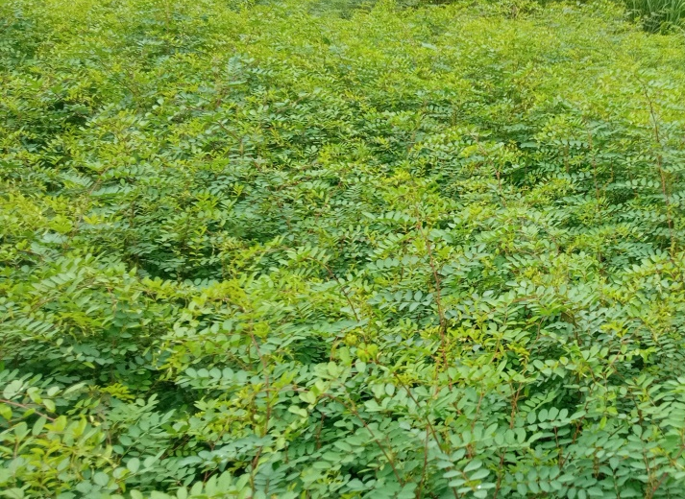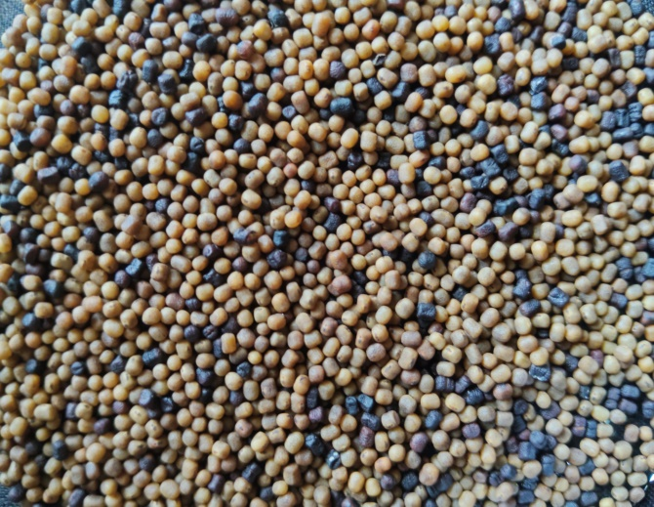
Plate No.1. I. tinctoria plants Plate No.2. Seeds of I. tinctoria
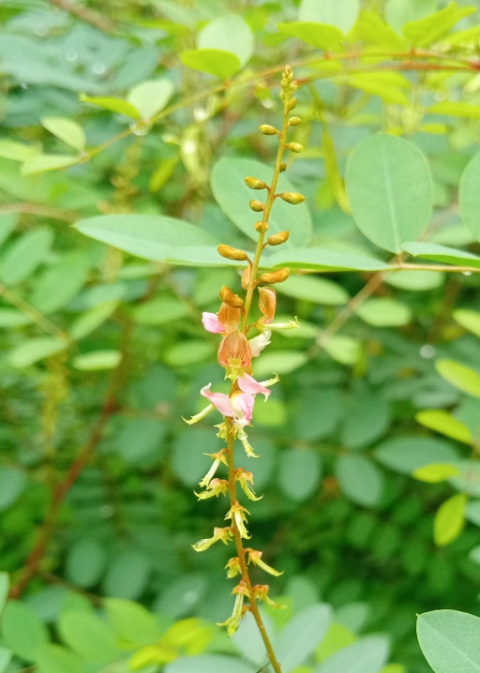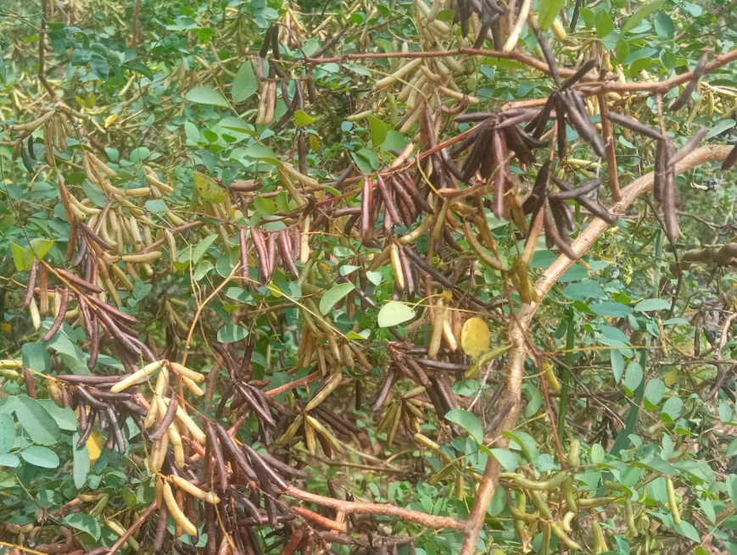
Plate No.3. Inflorescence of I. tinctoria Plate No.4. Pods of I. tinctoria
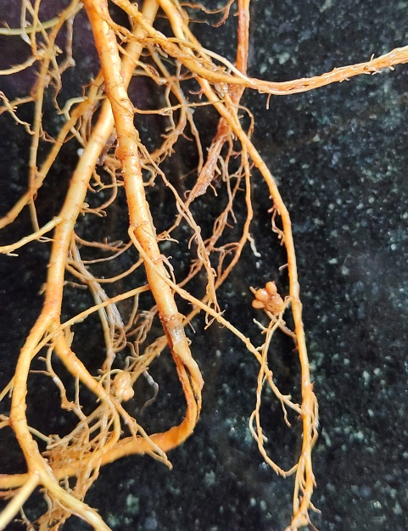
Plate No.5. Root nodules of I. tinctoria

