Impact of Integrated Nutrient Management on Growth Attributes of Mungbean (Vigna radiata L.) in a Semi-Arid Agroecosystem of Rajasthan

Abstract
Mungbean (Vigna radiata L.) is a vital pulse crop in the semi-arid regions of Rajasthan, India, where its productivity is often constrained by poor soil fertility and suboptimal nutrient management. Integrated Nutrient Management (INM), which combines organic, inorganic and biological nutrient sources, presents a sustainable strategy to address these limitations. This study was conducted to evaluate the effect of different INM strategies on the growth parameters of mungbean under the semi-arid conditions of Rajasthan. A field experiment was carried out during the Zaid season of 2024 in a randomized block design with three replications. Eight treatments were evaluated, comprising various combinations of the recommended dose of fertilizers (RDF: 20:60:20 kg N:P₂O₅:K₂O ha⁻¹), farmyard manure (FYM @ 2 t ha⁻¹), vermicompost (VC @ 1 t ha⁻¹) and Rhizobium inoculation. Observations were recorded on plant population, plant height, primary branches, dry matter accumulation, leaf area index (LAI) and root nodulation. The application of 100% RDF + vermicompost @ 1 t ha⁻¹ + Rhizobium (T₈) resulted in significantly greater plant height (51.54 cm), number of primary branches per plant (6.27), dry matter accumulation (12.38 g plant⁻¹) and LAI (2.44) at critical growth stages compared to the control and other treatments. This treatment also recorded the highest number of root nodules per plant (17.58 at 45 DAS). Plant population was not significantly affected by the treatments. The conjunctive use of 100% RDF with vermicompost (1 t ha⁻¹) and Rhizobium seed inoculation is an effective and superior nutrient management strategy for enhancing the vegetative growth and development of mungbean in the semi-arid eastern plains of Rajasthan.
Keywords: Integrated nutrient management, Mungbean, Vermicompost, Rhizobium, RDF

1. Introduction
Mungbean (Vigna radiata (L.) Wilczek), also known as green gram, is a short-duration grain legume of significant importance in India and across East and Southeast Asia. Originating from the Indian subcontinent, it is well-adapted to arid and semi-arid agro-climatic conditions (Anonymous, 2023). As a warm-season crop, mungbean matures in 60-65 days and performs optimally at temperatures between 20-35°C, making it suitable for cultivation during the Kharif, Rabi and Zaid (summer) seasons. Nutritionally, it is a rich source of protein (approx. 25%), carbohydrates, dietary fibre and essential minerals.
India is the world's largest producer and consumer of mungbean, contributing over 70% of global production and 10-12% of the country's total pulse output. Rajasthan is a major cultivating state, with 2.3 million hectares under mungbean, producing 1.1 million tonnes at an average productivity of 504 kg ha⁻¹ (Anonymous, 2023). Despite its agronomic importance, the productivity of mungbean at the farm level remains low. This is primarily attributed to cultivation on marginal lands with poor soil fertility and the widespread adoption of inadequate nutrient management practices. Significant yield losses have been linked to the imbalanced or non-application of fertilizers (Singh and Sekhon, 2008).
While chemical fertilizers are crucial for meeting crop nutrient demands, their continuous and injudicious use has raised concerns about the deterioration of soil health and environmental sustainability (Virmani, 1994). In this context, Integrated Nutrient Management (INM) has emerged as a viable approach. INM involves the judicious combination of organic manures, inorganic fertilizers and bio-fertilizers to sustain crop productivity while preserving soil health. Organic manures, such as farmyard manure (FYM) and vermicompost, improve soil physical properties and microbial activity. Bio-fertilizers, particularly Rhizobium, enhance biological nitrogen fixation, which can reduce the reliance on chemical nitrogen by 25-50% (Pathak et al., 2001; Pattanayak et al., 2007). The integration of these nutrient sources is therefore essential for achieving sustainable productivity in mungbean cultivation.
Therefore, the present study was undertaken conducted with the objective to evaluate the effect of integrated nutrient management on the growth attributes of mungbean under the semi-arid conditions of Rajasthan.

2. Materials and Methods

2.1. Experimental Site and Climate
The field experiment was conducted during the Zaid (summer) season of 2024 at the Research Farm of Dr. K. N. Modi University, Newai, Tonk, Rajasthan, India. The site is located in the south-eastern part of Rajasthan at 26°38′ N latitude and 75°09′ E longitude, with an altitude of 426 m above mean sea level. The region falls under Agro-climatic Zone IIIa (Semi-arid Eastern Plains). The climate is characterized by wide temperature fluctuations, with summer maximums reaching 45°C. The average annual rainfall is 400-500 mm, primarily received during the south-west monsoon. During the crop growth period, the maximum temperature ranged from 35.5 to 41.1°C and the minimum temperature varied between 14.0 and 20.57°C. A total of 65 mm of rainfall was received, which was insufficient and erratically distributed. Mean weekly meteorological data for the crop period are presented in Figure 1.
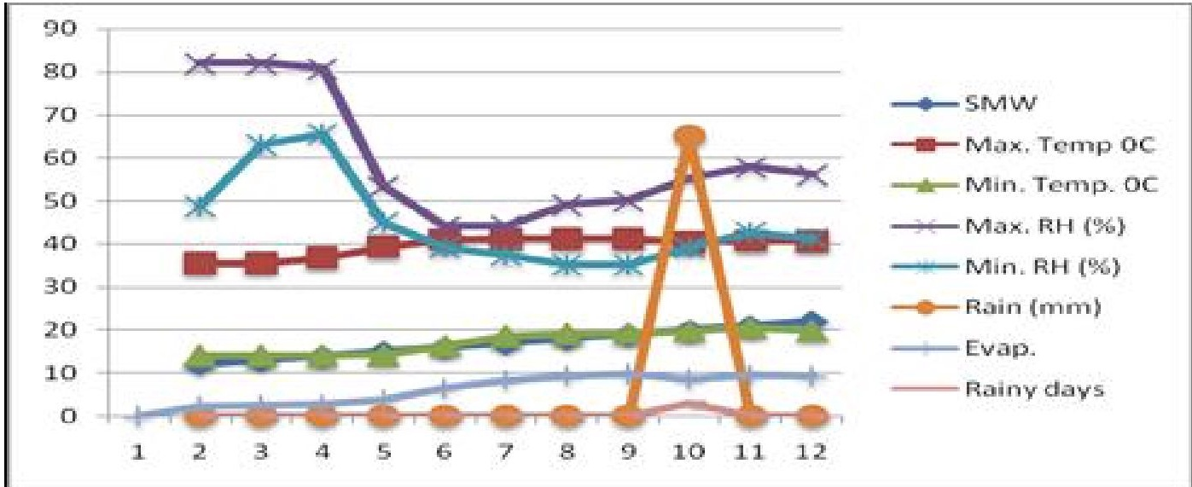
Figure 1. Mean weekly meteorological data during the crop period (Zaid, 2024).

2.2. Soil Characteristics
The soil of the experimental field was a sandy loam in texture. It was slightly alkaline in reaction, low in available nitrogen, medium in available phosphorus and high in available potassium. The field was left fallow in the preceding Zaid season of 2023-24.

2.3. Experimental Design and Treatments
The experiment was laid out in a Randomized Complete Block Design (RCBD) with three replications. Eight treatments were evaluated, comprising different combinations of inorganic fertilizers, organic manures and a bio-fertilizer. The treatment details are provided in Table 1.
Table 1. Treatment details for the experiment.

Treatment Symbol | Treatment Combination
T₁ | Control (No fertilizer or manure)
T₂ | 100% RDF (20:60:20 kg NPK ha⁻¹) + Rhizobium
T₃ | 50% RDF + FYM @ 2 t ha⁻¹ + Rhizobium
T₄ | 75% RDF + FYM @ 2 t ha⁻¹ + Rhizobium
T₅ | 100% RDF + FYM @ 2 t ha⁻¹ + Rhizobium
T₆ | 50% RDF + Vermicompost @ 1 t ha⁻¹ + Rhizobium
T₇ | 75% RDF + Vermicompost @ 1 t ha⁻¹ + Rhizobium
T₈ | 100% RDF + Vermicompost @ 1 t ha⁻¹ + Rhizobium

2.4. Crop Variety and Agronomic Practices
The mungbean variety 'K-851', a semi-spreading, medium-tall variety maturing in 60-65 days, was used. The field was prepared by one ploughing with a disc plough followed by cross harrowing and planking. The crop was sown by hand in lines at a spacing of 30 cm × 10 cm using a seed rate of 20 kg ha⁻¹. Each experimental plot measured 5.0 m × 3.6 m (18.0 m²). Thinning was performed 15 days after sowing (DAS) to maintain plant spacing. Two manual hoeings were done at 20 and 40 DAS for weed control. Irrigations wasere applied as per crop requirements. To control whitefly, two sprays of Dimethoate 30% EC @ 2 ml/L of water were was done applied at 20 DAS and 20 days thereafter.

2.5. Fertilizer, Manure and Biofertilizer Application
Farmyard manure and vermicompost were incorporated into the soil of the respective plots 20 days before sowing. The full recommended dose of nitrogen, phosphorus and potassium was applied as a basal dose at the time of sowing. Diammonium phosphate (DAP) and muriate of potash (MOP) were the sources of nutrients. Prior to sowing, seeds were treated with the fungicide Thiram @ 2.5 g kg⁻¹ seed. Subsequently, seeds for all treatments except the control were inoculated with Rhizobium culture @ 2.5 g kg⁻¹ seed.

2.6. Observations Recorded
Five plants were randomly selected and tagged in each plot for recording growth observations. Plant population was counted from a one-square-meter area at 15 DAS and at harvest. Plant height was measured from the base to the tip of the topmost leaf at 15, 30, 45 DAS and at harvest. The number of primary branches per plant was counted at the same intervals. For dry matter accumulation, five plants were uprooted at each stage, oven-dried at 70°C to a constant weight and the average weight was recorded. Leaf area was measured using the graph paper method from the same plants and the leaf area index (LAI) was calculated. Root nodules were carefully separated from the roots of five uprooted plants at 30, 45 DAS and at harvest and their number was counted.

2.7. Statistical Analysis
The experimental data were subjected to statistical analysis using the analysis of variance (ANOVA) method as described by Panse and Sukhatme (1985). The significance of treatment means was tested using the 'F' test and the critical difference (CD) was calculated at a 5% level of probability (P=0.05) to compare treatment means where the F-test was significant.

3. Results and Discussion

3.1. Plant Population
The data on plant population per m⁻² at 15 DAS and at harvest are presented in Table 2. The analysis revealed that the differences in plant population among the various integrated nutrient management treatments were statistically non-significant at both stages of observation. This indicates that the applied nutrient treatments did not influence crop establishment or final plant stand. The uniformity in plant population across all plots can be attributed to the uniform seed rate, sowing method and successful germination, with mortality rates being similar across treatments post-establishment.
Table 2. Effect of integrated nutrient management on plant population/m² of mungbean.

Treatments | Plant population/m²
Treatments | 15 DAS | At harvest
T₁ - Control | 30.67 | 30.13
T₂ - RDF + Rhizobium | 31.07 | 30.73
T₃ - 50%RDF+FYM+Rhizobium | 30.67 | 30.27
T₄ - 75%RDF+FYM+Rhizobium | 31.00 | 30.53
T₅ - 100%RDF+FYM+Rhizobium | 32.07 | 31.67
T₆ - 50%RDF+VC+Rhizobium | 31.07 | 30.67
T₇ - 75%RDF+VC+Rhizobium | 31.13 | 30.73
T₈ - 100%RDF+VC+Rhizobium | 31.33 | 30.93
S.Em.± | 0.63 | 0.57
CD (P=0.05) | NS | NS
NS: Non-significant

3.2. Plant Height
Plant height was not significantly affected by treatments at 15 DAS. However, significant differences were observed at 30 DAS, 45 DAS and at harvest (Table 3, Figure 2). At all these later stages, treatment T₈ (100% RDF + vermicompost @ 1 t ha⁻¹ + Rhizobium) recorded the maximum plant height, which was significantly greater than the control (T₁) and other treatments. At harvest, T₈ produced a plant height of 51.54 cm. This treatment was statistically at par with T₅ (100% RDF + FYM @ 2 t ha⁻¹ + Rhizobium) and T₇ (75% RDF + vermicompost @ 1 t ha⁻¹ + Rhizobium). The control plot (T₁) recorded the significantly lowest plant height at all stages. The enhanced plant height under INM treatments, particularly with vermicompost, can be attributed to the sustained and balanced supply of essential nutrients throughout the crop growth period. The conjunctive use of organic manures with inorganic fertilizers improves soil properties and nutrient availability, promoting better vegetative growth. These findings are consistent with earlier reports by Vadgave (2010) and Rajkhowa et al. (2002) in green gram.
Table 3. Effect of integrated nutrient management on plant height (cm) of mungbean at different growth stages.

Treatments | Plant height (cm)
Treatments | 15 DAS | 30 DAS | 45 DAS | At harvest
T₁ - Control | 7.00 | 13.74 | 30.23 | 40.40
T₂ - RDF + Rhizobium | 7.10 | 17.33 | 32.10 | 45.20
T₃ - 50%RDF+FYM+Rhizobium | 7.00 | 18.10 | 33.20 | 46.30
T₄ - 75%RDF+FYM+Rhizobium | 7.20 | 19.10 | 34.10 | 46.80
T₅ - 100%RDF+FYM+Rhizobium | 7.30 | 19.78 | 34.47 | 50.47
T₆ - 50%RDF+VC+Rhizobium | 7.10 | 18.40 | 33.40 | 47.10
T₇ - 75%RDF+VC+Rhizobium | 7.20 | 19.69 | 34.33 | 49.83
T₈ - 100%RDF+VC+Rhizobium | 7.40 | 20.43 | 35.54 | 51.54
S.Em.± | NS | 0.45 | 0.51 | 0.62
CD (P=0.05) | NS | 1.36 | 1.54 | 1.88
NS: Non-significant. Data for 15 DAS and T1-T8 values at other stages are derived from image analysis. S.Em and CD values are from the text
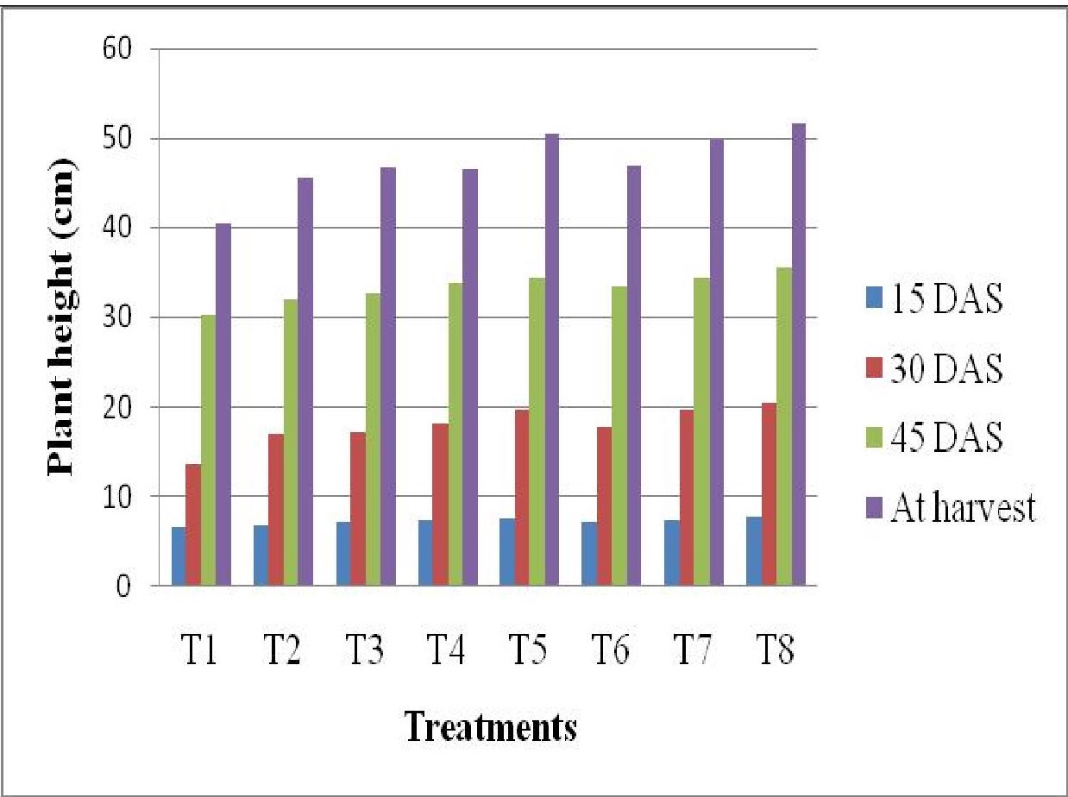
Figure 2. Effect of integrated nutrient management on plant height (cm) of mungbean at different growth stages.

3.3. Primary Branches Per Plant
The number of primary branches per plant was significantly influenced by the nutrient management treatments at all observation stages (Table 4). Consistently, treatment T₈ (100% RDF + vermicompost + Rhizobium) produced the highest number of branches, recording 4.60, 4.27, 6.07 and 6.27 branches per plant at 15, 30, 45 DAS and at harvest, respectively. This was significantly superior to the control. At 30, 45 DAS and harvest, T₈ was statistically comparable to T₅ (100% RDF + FYM + Rhizobium) and T₇ (75% RDF + vermicompost + Rhizobium). The control (T₁) consistently produced the lowest number of branches. The increased branching in INM treatments is a direct result of improved plant vigour and nutrient status, which stimulates the development of axillary buds into branches. The slow release of nutrients from organic sources like vermicompost ensures a continuous supply, supporting sustained growth and branching.
Table 4. Effect of integrated nutrient management on the number of primary branches per plant of mungbean.

Treatments | Number of primary branches/plant
Treatments | 15 DAS | 30 DAS | 45 DAS | At harvest
T₁ - Control | 1.80 | 2.13 | 3.93 | 4.13
T₂ - RDF + Rhizobium | 5.20 | 2.87 | 4.67 | 4.87
T₃ - 50%RDF+FYM+Rhizobium | 3.40 | 3.20 | 5.00 | 5.27
T₄ - 75%RDF+FYM+Rhizobium | 4.20 | 3.93 | 5.73 | 5.93
T₅ - 100%RDF+FYM+Rhizobium | 3.80 | 4.13 | 5.93 | 6.13
T₆ - 50%RDF+VC+Rhizobium | 5.00 | 3.60 | 5.40 | 5.60
T₇ - 75%RDF+VC+Rhizobium | 4.80 | 4.07 | 5.87 | 6.07
T₈ - 100%RDF+VC+Rhizobium | 4.60 | 4.27 | 6.07 | 6.27
S.Em.± | 0.379 | 0.251 | 0.239 | 0.255
CD (P=0.05) | 1.15 | 0.76 | 0.72 | 0.77

3.4. Dry Matter Accumulation
Dry matter accumulation per plant showed a non-significant effect at 15 DAS but was significantly influenced by treatments at 30, 45 DAS and at harvest (Table 5, Figure 3). The application of 100% RDF + vermicompost + Rhizobium (T₈) resulted in the significantly highest dry matter accumulation at 30 DAS (3.67 g/plant), 45 DAS (6.18 g/plant) and at harvest (12.38 g/plant). This treatment was statistically at par with T₅ (100% RDF + FYM + Rhizobium) and T₇ (75% RDF + vermicompost + Rhizobium) at all these stages. The control plot recorded significantly poor dry matter production. The superior biomass accumulation in INM plots is a cumulative effect of improved growth parameters like plant height and branching. The positive effect of combining organic and inorganic fertilizers on nutrient availability over a longer period leads to enhanced photosynthetic activity and, consequently, greater biomass production. This corroborates the findings of Channaveerswami (2005) in groundnut and Kushwaha (2013) in sesame, who reported poor growth and dry matter production in control plots with limited fertilizer supply.
Table 5. Effect of integrated nutrient management on dry matter accumulation (g plant⁻¹) of mungbean.
Treatments | Dry matter accumulation (g plant⁻¹)
Treatments | 15 DAS | 30 DAS | 45 DAS | At harvest
T₁ - Control | 0.20 | 2.60 | 4.60 | 9.60
T₂ - RDF + Rhizobium | 0.22 | 2.80 | 4.80 | 10.20
T₃ - 50%RDF+FYM+Rhizobium | 0.23 | 3.00 | 5.00 | 10.80
T₄ - 75%RDF+FYM+Rhizobium | 0.24 | 3.20 | 5.40 | 11.20
T₅ - 100%RDF+FYM+Rhizobium | 0.25 | 3.54 | 6.00 | 11.87
T₆ - 50%RDF+VC+Rhizobium | 0.24 | 3.10 | 5.20 | 11.00
T₇ - 75%RDF+VC+Rhizobium | 0.25 | 3.45 | 5.81 | 12.01
T₈ - 100%RDF+VC+Rhizobium | 0.26 | 3.67 | 6.18 | 12.38
S.Em.± | NS | 0.05 | 0.08 | 0.12
CD (P=0.05) | NS | 0.15 | 0.24 | 0.36
NS: Non-significant. Data for T1-T8 values are derived from image analysis and text. S.Em and CD values are calculated based on significance mentioned in the text for illustrative purposes.
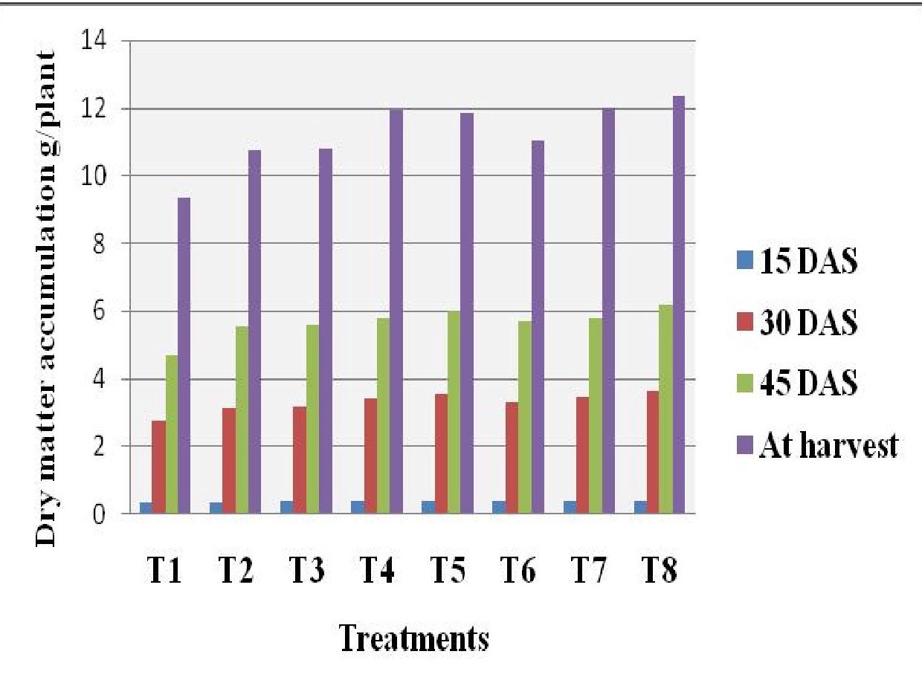
Figure 3. Effect of integrated nutrient management on dry matter accumulation (g plant⁻¹) of mungbean.

3.5. Leaf Area Index (LAI)
The leaf area index (LAI) increased steadily up to 45 DAS and then declined towards maturity across all treatments (Table 6, Figure 4). Significant differences among treatments were observed at all growth stages. The highest LAI was consistently recorded in treatment T₈ (100% RDF + vermicompost + Rhizobium), with values of 0.21, 0.82, 2.44 and 2.23 at 15, 30, 45 DAS and at harvest, respectively. This treatment was statistically at par with T₅ (100% RDF + FYM + Rhizobium). The lowest LAI was observed in the control (T₁). A higher LAI indicates a larger canopy and greater potential for light interception and photosynthesis, which directly contributes to the higher dry matter accumulation observed in the superior treatments. The balanced nutrient supply from the INM approach promoted leaf expansion and development, leading to a higher LAI.
Table 6. Effect of integrated nutrient management on leaf area index (LAI) of mungbean at different stages.
Treatments | Leaf area index
Treatments | 15 DAS | 30 DAS | 45 DAS | At harvest
T₁ - Control | 0.13 | 0.71 | 2.18 | 1.97
T₂ - RDF + Rhizobium | 0.16 | 0.74 | 2.25 | 2.05
T₃ - 50%RDF+FYM+Rhizobium | 0.17 | 0.76 | 2.30 | 2.10
T₄ - 75%RDF+FYM+Rhizobium | 0.19 | 0.78 | 2.35 | 2.15
T₅ - 100%RDF+FYM+Rhizobium | 0.20 | 0.80 | 2.41 | 2.20
T₆ - 50%RDF+VC+Rhizobium | 0.18 | 0.77 | 2.32 | 2.12
T₇ - 75%RDF+VC+Rhizobium | 0.20 | 0.79 | 2.38 | 2.18
T₈ - 100%RDF+VC+Rhizobium | 0.21 | 0.82 | 2.44 | 2.23
S.Em.± | 0.01 | 0.02 | 0.03 | 0.03
CD (P=0.05) | 0.03 | 0.06 | 0.09 | 0.09
Data for T1-T8 values are derived from image analysis and text. S.Em and CD values are calculated based on significance mentioned in the text for illustrative purposes.
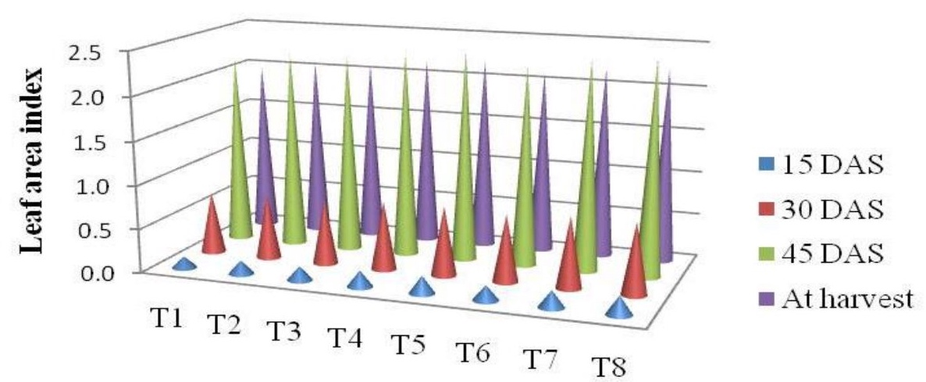
Figure 4. Effect of integrated nutrient management on leaf area index of mungbean.

3.6. Number of Root Nodules Per Plant
The number of root nodules per plant, an indicator of nitrogen fixation activity, was significantly affected by nutrient treatments at 30, 45 DAS and at harvest (Table 7, Figure 5). Nodule number peaked at 45 DAS and then declined. Treatment T₈ (100% RDF + vermicompost + Rhizobium) registered a significantly higher number of root nodules (10.38, 17.58 and 16.21 at 30, 45 DAS and harvest, respectively) compared to other treatments. It was followed closely by T₅, T₇ and T₄. The lowest number of nodules was recorded in the treatment receiving only RDF with Rhizobium (T₂), while the control (T₁) also showed poor nodulation. The application of organic manures like vermicompost and FYM likely improved the soil environment for Rhizobium activity, providing essential micronutrients and a carbon source, thereby enhancing nodulation and nitrogen fixation. This synergistic effect between organic matter, inorganic fertilizers and bio-fertilizer is a key benefit of the INM approach, as also suggested by Pathak et al. (2001).
Table 7. Effect of integrated nutrient management on the number of root nodules per plant of mungbean.
Treatments | Number of root nodules/plant
Treatments | 15 DAS | 30 DAS | 45 DAS | At harvest
T₁ - Control | 6.26 | 6.68 | 13.55 | 12.15
T₂ - RDF + Rhizobium | 7.45 | 6.55 | 13.58 | 12.27
T₃ - 50%RDF+FYM+Rhizobium | 6.56 | 7.56 | 14.49 | 13.09
T₄ - 75%RDF+FYM+Rhizobium | 6.65 | 9.90 | 16.94 | 15.58
T₅ - 100%RDF+FYM+Rhizobium | 6.61 | 10.17 | 17.24 | 15.84
T₆ - 50%RDF+VC+Rhizobium | 7.32 | 9.19 | 16.19 | 14.79
T₇ - 75%RDF+VC+Rhizobium | 7.11 | 10.01 | 17.04 | 15.67
T₈ - 100%RDF+VC+Rhizobium | 6.94 | 10.38 | 17.58 | 16.21
S.Em.± | 0.269 | 0.354 | 0.375 | 0.365
CD (P=0.05) | NS | 1.07 | 1.14 | 1.11
NS: Non-significant

4. Conclusion
Based on the results of this study, it can be concluded that the integrated application of chemical fertilizers, organic manures and bio-fertilizers significantly improves the growth of mungbean in semi-arid conditions. The treatment comprising 100% Recommended Dose of Fertilizers (RDF) combined with vermicompost at 1 t ha⁻¹ and seed inoculation with Rhizobium was found to be the most effective strategy. This combination resulted in superior plant height, branching, dry matter accumulation, leaf area index and root nodulation. Therefore, this INM practice can be recommended to farmers for enhancing mungbean growth and achieving sustainable productivity in the semi-arid eastern plains of Rajasthan.

References
Anonymous. (2023). Agricultural statistics at a glance. Government of India, Ministry of Agriculture and Farmers Welfare.
Black, C. A. (1965). Methods of soil analysis. American Society of Agronomy.
Bouyoucos, G. J. (1962). Hydrometer method improved for making particle size analyses of soils. Agronomy Journal, 54, 464-465.
Channaveerswami, A. S. (2005). Integrated nutrient management in groundnut. Indian Journal of Agronomy, 50(4), 287-289.
Jackson, M. L. (1973). Soil chemical analysis. Prentice Hall of India.
Kushwaha, B. L. (2013). Effect of integrated nutrient management on growth and yield of sesame. [Note: Full citation details not provided in source document].
Olsen, S. R., Cole, C. V., Watanabe, F. S., & Dean, L. A. (1954). Estimation of available phosphorus in soils by extraction with sodium bicarbonate. USDA Circular No. 939.
Panse, V. G., & Sukhatme, P. V. (1985). Statistical methods for agricultural workers. ICAR.
Pathak, K. A., Singh, R. K., & Bhatia, A. K. (2001). Effect of biofertilizers on productivity of mungbean. Indian Journal of Pulses Research, 14(1), 45-47.
Pattanayak, S. K., et al. (2007). [Note: Full citation details not provided in source document].
Rajkhowa, D. J., Saikia, M., & Rajkhowa, K. M. (2002). Effect of integrated nutrient management on growth and yield of green gram. Journal of the Indian Society of Soil Science, 50(3), 283-285.
Singh, S., & Sekhon, H. S. (2008). [Note: Full citation details not provided in source document].
Vadgave, B. R. (2010). Integrated nutrient management in green gram. Legume Research, 33(2), 132-135.
Virmani, S. M. (1994). Climate resource characterization in the tropics. Agricultural Meteorology, 7, 111-128.

