Epidemiological Study of Canine Distemper in Dogs at Jabalpur, India

ABSTRACT
Canine distemper is a highly contagious viral disease of dogs caused by Canine Distemper Virus (CDV), affecting multiple organ systems and associated with high morbidity and mortality. The present study was conducted to determine the prevalence and clinico-epidemiological patterns of canine distemper. A total of 2875 dogs were screened, of which 239 dogs showing clinical signs suggestive of distemper were examined. Diagnosis was performed using rapid antigen test kits and confirmed by RT-PCR. The overall prevalence was 1.19% by rapid test and 0.86% by RT-PCR. Age-wise analysis revealed significantly higher prevalence in dogs below 12 months (68%). Non-descript (mongrel) dogs showed the highest breed-wise prevalence (52%), and males were more commonly affected (72%). A strong association was observed between lack of vaccination and disease occurrence, with 92% of positive dogs being unvaccinated. Clinically, gastrointestinal (28%) and respiratory (32%) forms were most common, followed by cutaneous (16%), nervous (16%), and ocular (8%) manifestations. The findings highlight the importance of early diagnosis, routine vaccination, and improved management practices to reduce the burden of canine distemper.

1. INTRODUCTION
Canine distemper is a highly contagious viral disease of domestic and wild carnivores, historically known as hardpad disease, Carre’s disease, old dog encephalitis, and enamel hypoplasia. The etiological agent, Canine Distemper Virus (CDV), is an enveloped, single-stranded RNA virus belonging to the genus Morbillivirus within the family Paramyxoviridae. CDV exhibits a wide host range, primarily affecting members of the families Canidae and Felidae, and has been reported in several terrestrial and aquatic carnivore species. (Deem et al., 2000). Puppies aged 0–6 months are particularly susceptible. Canine distemper is transmitted mainly through oro-nasal secretions of infected animals, with infection commonly acquired through inhalation of virus-laden aerosol droplets. Indirect transmission through contaminated feed, water, and fomites also contributes to disease spread. The incubation period ranges from 1–4 weeks. Following entry, CDV initially replicates in lymphocytes and macrophages and subsequently spreads to the tonsils and regional lymph nodes. Systemic dissemination occurs via monocytes to the spleen, thymus, mucosa-associated lymphoid tissues, and Kupffer cells. By approximately day 10 post infection, the virus reaches epithelial tissues, the dermis, and the central nervous system (CNS) (Vandevelde and Zurbriggen, 2005). Early disease is characterized by a biphasic fever: the first peak corresponds to viral replication in lymphoid tissues, while the second is associated with viremia. Initial signs include tonsillitis and serous to mucopurulent nasal and ocular discharge (Winters et al., 1984). CDV manifests in five principal forms—respiratory, gastrointestinal, ocular, cutaneous, and neurological Epithelial involvement results in gastrointestinal manifestations such as vomiting and foul-smelling diarrhoea; respiratory signs including pneumonia, dry cough, and dyspnoea; and ocular abnormalities such as conjunctivitis, keratoconjunctivitis sicca, anterior uveitis, corneal opacity, optic neuritis, choroiditis, and retinal detachment (Greene and Appel, 1990). Dermatological lesions include abdominal pustules and hyperkeratosis of the footpads and nasal planum. Neurological signs generally appear 2–3 weeks after infection and include chorea, circling, compulsive movements, nystagmus, paresis, ataxia, seizures, and dementia (Vandevelde and Zurbriggen, 2005). In some cases, systemic and neurological signs occur simultaneously (Tipold et al., 1992). Mortality is high, with death often occurring within 2–4 weeks. Survivors may develop chronic neurological deficits due to post-infection encephalitis. Diagnostic approaches include virus neutralization tests, immunofluorescence assays, immunochromatographic tests, and reverse transcriptase polymerase chain reaction (RT-PCR), the latter being the most sensitive and widely used for confirmation. Treatment is largely supportive because no antiviral therapy provides a definitive cure once neurological involvement occurs. Therapeutic protocols include broad-spectrum antibiotics such as cephalosporins to prevent secondary infections, fluid therapy, and corticosteroids. Supportive care also includes antacids, anti-emetics, sedatives or muscle relaxants, antiepileptics, neuropathic analgesics, antioxidants, haematinics, immune modulators, and vitamin-mineral supplements.

2. MATERIALS AND METHODS
The study was conducted in the Department of Veterinary Medicine, Veterinary Clinical Complex (VCC), College of Veterinary Science and Animal Husbandry, Nanaji Deshmukh Veterinary Science University, Jabalpur (M.P.). a total 2875 dogs were screened out of which 239 dogs were examined for the clinical sign related to canine distemper with the clinical history indicative of canine distemper including neurological signs (paresis, chorea etc), cutaneous lesions (pustules, hyperkeratosis of foot pad), ocular discharge (greenish yellow), biphasic fever, gastro-intestinal signs (vomiting/diarrhea) and respiratory signs (nasal discharge etc.) was screened. For statistical analysis, chi-square test of significance was applied for the qualitative data.

3. RESULTS AND DISCUSSION
3.1 Overall prevalence of canine distemper in dogs at VCC, Jabalpur
The overall prevalence of canine distemper in dogs among the total dog population was recorded as 1.19 percent in rapid kit test and 0.86 per cent in RT-PCR. Results are depicted in table 01 and 02.
Table 01: Overall prevalence of canine distemper in dogs in rapid kit test
No. of screened | Positive in rapid kit test | Prevalence (%)
2875 | 34 | 1.19

Table 02: Overall prevalence of canine distemper in dogs in RT-PCR
No. of screened | Positive in RT-PCR | Prevalence (%)
2875 | 25 | 0.86

The results of the present prevalence study are in close proximity with the findings of Yama et al. (2020) who recorded the incidence rate of canine distemper as 1.11% (10/900) and Sharma et al. (2017) who recorded 2.34 per cent incidence rate. Although much higher incidence rate was reported in Wenzhou, China by Luo et al. (2017) which was 28.5% and Shurbe et al. (2019) which was (22.85%).
These variations in the prevalence could be due to several extrinsic factors like geographical, environmental and managemental practices or differences in sample size. The diagnostic method used, breed variations as well as welfare conditions for pet dogs in those regions might have led to the differences in prevalence.
3.2 Age wise prevalence of canine distemper infected dogs
The age wise prevalence was studied in 25 RT-PCR positive animals. and the prevalence percentage under the age of 12 months was 68% (17/25), 20% (5/25) between 12 to 24 months and in dogs above 24 months prevalence rate was 12% (3/25).
Table 03: Age wise distribution of canine distemper in dogs
Age (months) | No. of dogs positive for RT-PCR (n=25) | Per cent (%)
0-12 | 17 | 68
12 to 24 | 5 | 20
>24 | 3 | 12

A highly significant association between age group and prevalence was recorded and younger dogs (0–12 months) are significantly more affected. The present finding was corresponding with the work of Headley and Graca (2000), who reported highest prevalence in young puppies below 1.5 yrs and Luo et al. (2017), reported high prevalence in dogs between 2-12 months (61.9%).
The higher prevalence in the young population of dogs may be due to lack of specific immunity and insufficient development of immune system and as the dog grow older the chance of getting infection and severity of disease decrease.
3.3 Breed wise prevalence of canine distemper infected dogs:
In the presented study among 25 canine distemper infected dogs the prevalence of canine distemper was more in Mongrel 52% (13/25), followed by labrador retriever 16% (4/25) followed by golden retriever and pug which is 8% (2/25). The least prevalence was among Pomeranian, Indian spitz and Chow Chow 4% (1/25). The breed wise prevalence is given in table 04.
Table 04: Breed wise distribution of canine distemper in dogs
Breed | No. of dogs positive for RT-PCR (n=25) | Per cent (%)
Non-descript (Mongrel) | 13 | 52
Labrador | 4 | 16
German Shepherd | 2 | 8
Pomeranian | 1 | 4
Golden retriever | 2 | 8
Pug | 2 | 8
Chow chow | 1 | 4

Highly significant association between breed and prevalence of canine distemper in Nondescript (mongrel) dogs was reported in this study. The present finding were in concurrence with the findings of Saaed and Al-Obaidi (2021) who reported highest prevalence in non-descript dogs 24.6% than in pet dogs and Shurbe et al. (2019) reported 87.5% in local breeds and 12.5% in exotic breeds.
Similar results were also reported by Ogbu et al. (2017) who concluded that canine distemper was higher in local breeds than exotic breed. In contrary to the present study Luo et al. (2017) reported higher prevalence in pure breed (37.3%) followed by mongrel (23.9%). The high prevalence of CDV in non-descript breeds may be attributed to the fact that these dogs are not reared in good hygiene condition and receive less attention and irregularities in vaccination.
3.4 Gender wise prevalence of canine distemper infected dogs:
In the present study gender wise distribution of canine distemper was observed more in male (72%) followed by female (28%). The gender wise prevalence is given in table 05.
Table 05: Gender wise distribution of canine distemper in dogs
Gender | No. of dogs positive for RT-PCR(n=25) | Per cent (%)
Male | 18 | 72
Female | 7 | 28

In the present study male dogs have significantly higher prevalence than female dogs which was similar to that observed by Kumar R. et al. (2011) who reported that male were more prone to infection 74% than female 26% and Islam et al. (2019) in his study reported highest prevalence in male dogs 53%. Contrary to this Shabbir et al. (2010) reported equal prevalence irrespective of gender. The prevalence of the male dog being infected more might be due to their natural habit of territory marking which bring them more contact to infection
3.5 Vaccination status of canine distemper infected dogs:
In the presented study out of 25 positive cases only 2 dogs (8%) were vaccinated and rest are unvaccinated (92%). Vaccination status is depicted in table 06.
Table 06: Immune status of canine distemper infected dogs
Particulars | Positive in RT-PCR(n=25) | Per cent (%)
Vaccinated | 2 | 8
Unvaccinated | 23 | 92

Vaccination status is extremely significantly associated with disease positivity. Unvaccinated dogs have dramatically higher prevalence among positive cases. Accordingly, M. Akhila (2022) conducted a study and found that unvaccinated dogs contributed 93.1% and by vaccinated dogs contributed 6.82%. Similar results were also observed by Abirami et al. (2020).
Irregular vaccination or unvaccinated dogs might lose their immunity and stress, immunosuppression, or contact with diseased individuals predispose to infection. Improper immunization, or failure of vaccination due poor storage of vaccines also contribute to the disease. Interactions between canine distemper virus and canine adenovirus type 1 or canine adenovirus type 2 are responsible for the polyvalent vaccine induced suppression of lymphocyte responsiveness. The individual vaccine components from the polyvalent vaccines when inoculated alone did not significantly suppress the lymphocyte response to mitogen. Hence the use of polyvalent vaccination in the present study could also be a reason for vaccine failure (Phillips et al.,1989).
3.6 Clinical signs associated with canine distemper infected dogs
The clinical signs observed in canine distemper–affected dogs are presented in (Table 07). Pyrexia was recorded in 28 per cent (7/25) of the affected dogs. Congestion of mucous membranes was observed in 64 per cent (16/25) cases, whereas pallor of mucous membranes was noticed in 36 per cent (9/25) dogs. Enlargement of lymph nodes was evident in 44 per cent (11/25) of the affected dogs. Dehydration was observed in 24 per cent (6/25) cases. With respect to cardiorespiratory abnormalities, dyspnoea was recorded in 8 per cent (2/25) of dogs affected with canine distemper. Bradycardia was observed in 16 per cent (4/25) cases, while tachycardia was noticed in 4 per cent (1/25) of the affected dogs. The results of the clinical sign are depicted in the table07.

Table 07: Clinical signs in canine distemper infected dogs
Parameters | No. of dogs (n=25) | Per cent (%)
Pyrexia | 07 | 28
Congested mucus membrane | 16 | 64
Pale mucus membrane | 09 | 36
Enlarged lymph node | 11 | 44
Dehydration | 06 | 24
Dyspnoea | 02 | 08
Bradycardia | 04 | 16
Tachycardia | 01 | 04

In the present study pyrexia was recorded in 28.0% of the affected dogs, which corroborates the findings of Behera et al. (2014), who reported pyrexia in 50.0% of infected dogs. Biphasic fever reported in canine distemper has been attributed to initial viral replication in lymphoid tissues followed by secondary bacterial infections arising from virus-induced immunosuppression (Buragohain et al., 2018). The increased heart and respiratory rates observed in the present study may be secondary to elevated body temperature, dehydration, and anaemia, resulting in increased cardiac output and oxygen demand.
Congested mucous membranes were observed in 64.0% of dogs, while lymphadenopathy was recorded in 44.0% of cases, indicating active viremia and systemic inflammatory response. Similar findings of lymph node enlargement and mucous membrane congestion in canine distemper have been documented by Behera et al. (2014) and Greene and Appel (2006).
Pale mucous membranes, of the dogs, reflected anaemia and reduced haemoglobin concentration, possibly due to suppression of erythropoiesis. Erythroid hypoplasia in canine distemper resulting from viral inhibition of bone marrow activity.
Dehydration was evident in 24.0% of the affected dogs, which may be attributed to adipsia, reduced intake, vomiting, diarrhoea, and increased insensible fluid losses. Dyspnoea was observed in 8.0% of dogs, while bradycardia and tachycardia were recorded in 16.0% and 4.0% of cases, respectively. These cardiopulmonary alterations are consistent with the reports of Behera et al. (2014) and Amude et al. (2006), who attributed such changes to fever, dehydration, anaemia, and respiratory compromise. Additionally, hypersalivation observed in a proportion of infected dogs in the present study was suggestive of neurological involvement, which is characteristic of the neurological phase of canine distemper (Greene and Appel, 2006)
3.7 Systemic manifestations associated with canine distemper infected dogs
Dogs investigated for the canine distemper showed different forms of the disease showed in table 08. Out of 25 dogs 7 dogs with gastrointestinal form (28%) in which 2 dogs presented with vomiting contributing to 28.50 per cent (2/7), diarrhoea observed in 3 dogs that is 42.80 per cent (3/7), and both vomition and diarrhoea was presented in 2 dogs which was 14.28 per cent (2/7). Respiratory form was presented 8 (32%) out of 25 dogs nasal discharge was observed in 5 dogs which was 62.50 per cent and coughing in 3 dogs which was 37.50 per cent. Ocular form was recorded in 2 (8%) dogs in which conjunctivitis and ocular discharge was observed in 50 per cent among all cases showing ocular form. Cutaneous signs were observed in 4(16%) cases including pustules + digital hyperkeratosis in 50 per cent (2/4), papules in 25 per cent (1/4) and digital hyperkeratosis + nasal hyperkeratosis in 25 per cent (1/4). Nervous manifestations were recorded in 4 cases i.e. (16%) out of 25 including twitching of limbs and chorea in 25 per cent cases (1/4), champing of jaws in 50 per cent (2/4) and fits/seizure in 25 per cent (1/4) cases. The results of systemic manifestations are depicted in table08.
Table 08: Systemic manifestation in canine distemper infected dogs
System | Symptoms | No. of infected dogs  (n=25) | Percent (%)
Gastric (7) | Vomition | 2 | 28.50
Gastric (7) | Diarrhoea | 3 | 42.80
Gastric (7) | Vomition + Diarrhoea | 2 | 14.28
Respiratory (8) | Nasal Discharge | 5 | 62.50
Respiratory (8) | Coughing | 3 | 37.50
Ocular (2) | Ocular Discharge | 1 | 50.00
Ocular (2) | Conjunctivitis | 1 | 50.00
Cutaneous (4) | Pustules + Digital Hyperkeratosis | 2 | 50.00
Cutaneous (4) | Papules | 1 | 25.00
Cutaneous (4) | Digital Hyperkeratosis + Nasal Hyperkeratosis | 1 | 25.00
Nervous (4) | Twitching of Limbs and chorea | 1 | 25.00
Nervous (4) | Champing of jaws | 2 | 50.00
Nervous (4) | Fits/Seizure | 1 | 25.00

In the present study, gastrointestinal involvement was observed in seven dogs, of which diarrhoea was the most frequent manifestation (42.80%), followed by vomiting (28.50%) and concurrent vomiting with diarrhoea (14.28%). Similar gastrointestinal manifestations in canine distemper–affected dogs have been documented by Buragohain et al. (2018), Budaszewski et al. (2014), and Saaed and Al-Obaidi (2021), who reported diarrhoea and vomiting as common findings attributed to virus-induced immunosuppression and secondary bacterial infections of the gastrointestinal tract.
Respiratory signs were recorded in eight dogs, with nasal discharge being the predominant finding. These observations are in agreement with earlier reports by Jozwik and Frymus (2002), Battersby and Harvey (2006), and Budaszewski et al. (2014), who described serous to mucopurulent nasal discharge and cough as frequent respiratory manifestations of canine distemper due to epithelial involvement and secondary respiratory infections.
Ocular involvement was observed in two dogs, equally represented by ocular discharge (50.00%) and conjunctivitis (50.00%). Similar ocular signs have been widely reported in canine distemper–infected dogs by Latha et al. (2007), Behera et al. (2014), and Shabbir et al. (2010), who described conjunctivitis and ocular discharge as common early indicators of CDV infection.
Cutaneous manifestations were recorded in four dogs, with pustules accompanied by digital hyperkeratosis being the most common presentation. These findings corroborate the observations of Koutinas et al. (2002), Buragohain et al. (2018), and Behera et al. (2014), who reported erythematous lesions, pustules, and hyperkeratosis of the nose and footpads as characteristic cutaneous signs of chronic canine distemper.
Neurological signs were noted in four dogs, with champing of jaws (chewing gum fits) being the predominant manifestation followed by twitching of limbs with chorea and fits or seizures. These findings are consistent with the classical neurological manifestations of canine distemper described by Greene and Appel (2006), Martella et al. (2007), and Budaszewski et al. (2014). Chewing gum fits and myoclonus are considered as pathognomonic neurological signs associated with CDV-induced polioencephalomyelitis and demyelination.

4. CONCLUSION
The present study establishes canine distemper as an important infectious disease among dogs presented to the Veterinary Clinical Complex, Jabalpur, with an overall prevalence of 1.19% by rapid antigen testing and 0.86% by RT-PCR. Higher susceptibility was observed in young dogs (<12 months), non-descript breeds, males, and unvaccinated animals, indicating strong associations of age, breed, sex, and immunization status with disease occurrence. Gastrointestinal and respiratory forms were the most frequently observed systemic manifestations, while neurological involvement, though less common, was associated with severe clinical outcomes. The marked predominance of cases in unvaccinated dogs underscores the critical role of effective and timely vaccination in disease prevention. Variations in prevalence may reflect differences in management practices, hygiene, and vaccine compliance. The findings highlight the need for improved vaccination coverage, early diagnosis using sensitive molecular techniques, and enhanced awareness to reduce the burden of canine distemper and its associated morbidity and mortality.

DISCLAIMER(ARTIFICIALINTELLIGENCE)
Author(s) hereby declares that no AI technologies such as Large Language Models (ChatGPT, COPILOT, etc.) and text-to-image generators have been used during the writing or editing of this manuscript.

COMPETING INTERESTS
Authors have declared that no competing interests exist.

REFERENCES
Abirami, M., Srinivas, M. V., Vasu, J., Antony, P. X., Thanislass, J., Muthaiah, M. and Mukhopadhyay, H. K. (2020). Genotyping of canine distemper virus lineage in clinically infected dogs in Puducherry, Southern India. Microbiology Research Journal International 30(7): 17-30.
Amude, A. M., Alfieri, A. A. and Alfieri, A. F. (2006). Antemortem diagnosis of CDV infection by RT-PCR in distemper dogs with neurological deficits without the typical clinical presentation. Veterinary Research Communications, 30(6): 679-687.
Banyard, A.C., Mansfield, K.L., Wu, G., Selden, D., Thorne, L., Birch, C. and Fooks, A. R. (2019). Re-evaluating the effect of Favipiravir treatment on rabies virus infection. Vaccine, 37(33): 4686-4693.
Battersby, I. and Harvey, A. (2006). Differential diagnosis and treatment of acute diarrhoea in the dog and cat. In Practice, 28(8): 480-488
Behera, S. K., Bordoloi, G. and Behera, P. (2014). Clinico-hemato-biochemical and therapeutic study of canine distemper: a report from north-eastern part of India. Indian Journal of Field Veterinarians, 9(3):18-20
Budaszewski, R. Pinto, L. D., Weber, M. N., Caldart, E. T., Alves, C. D. B. T., Martella, V., Ikuta, N., Lunge, V. R. and Canal, C. W. (2014). Genotyping of canine distemper virus strains circulating in Brazil from 2008 to 2012. Virus Research, 180(1): 76-83.
Buragohain, M., Goswami, S., Boro, S. K., Boruah, K., and Saikia, K. (2018). Occurrence of canine distemper virus infection in Guwahati (Assam). Journal of Entomology Zoology Studies, 6(1): 1008-1011.
Carvalho, O.V., Botelho, C.V., Ferreira, C.G.T., Scherer, P.O., Martins, J.A.P.S., Almeida, M.R. and Junior, A.S. (2012). Immunopathogenic and neurological mechanisms of canine distemper virus. Advances in Virology, 2012(1):1-10.
Deem, S. L., Spelman, L. H., Yates, R. A. and Montali, R. J. (2000). Canine distemper in terrestrial carnivores: a review. Journal of Zoo and Wildlife Medicine, 31(4): 441-451.
Greene G. E. and Appel M.J. (1990). Infectious Diseases of the Dog and Cat, 3rd Edn., Saunders, Philadelphia, pp. 226-244.
Greene G. E. and Appel M.J. (2006). Infectious Diseases of the Dog and Cat, 3rd Edn., Saunders, Philadelphia, pp. 25-41
Headley, S. A. and Graca, D. L. (2000). Canine distemper: epidemiological findings of 250 cases. Brazilian Journal of Veterinary Research and Animal Science, 37(1): 136-140.
IBM Corp. (2023). IBM SPSS Statistics for Windows, Version 30.0. IBM Corp., Armonk, New York, USA, online https://www.ibm.com/products/spss-statistics.
Islam, O., Khatun, S., Azad, S. A. K., Famous, M. and Uddin, M. M. (2019). Prevalence of different diseases of dogs recorded at central veterinary hospital, Dhaka, Bangladesh. Research Journal for Veterinary Practitioners, 7(9): 53-57.
Jesus, I. S., Cruz, A. V., Santos, C. M. P., Barra, E. C. M., Costa, J. C., Monteiro, T. R. M., Santos C.C., Valente K.F., Silva B.W.L., Rodrigues E.D.L., Almeida J.C.F., Silva Filho E., Figueiredo, M.J.F.M., Sousa, S.K.S.A., Silva, S.P., Casseb, L.M.N.,
Negrao, A.M.G. and Casseb, A. R. (2021). Molecular diagnosis and clinicopathological characteristics of canine distemper neurologic disease. Genetics and Molecular Research, 20(3): 18884. doi: 10.4238/gmr18884.
Jozwik, A. and Frymus, T. (2002). Natural distemper in vaccinated and unvaccinated dogs in Warsaw. Journal of Veterinary Medicine, 49(9): 413-414.
Koutinas, A. F., Polizopoulou, Z. S., Baumgaertner, W., Lekkas, S. and Kontos, V. (2002). Relation of clinical signs to pathological changes in 19 cases of canine distemper encephalomyelitis. Journal Of Comparative Pathology, 126(1): 47-56.
Kumar R. (2011). Demylenating neuropathy with special reference to canine distemper in dogs. PhD. Thesis, (Department of Veterinary Medicine), Indian Veterinary Research Institute, Izatnagar, U P.
Latha, D., Srinivasan, S. R., Thirunavukkarasu, P. S., Gunaselan, L., Ramadass, P. and Narayanan, R. B. (2007). Assessment of canine distemper virus infection in vaccinated and unvaccinated dogs. Indian Journal of Biotechnology, 6(1): 35-40.
Luo, H., Li, K. and Zhang, H. (2017). Epidemiology of Canine distemper and Canine parvovirus in pet dogs in Wenzhou, China. Indian Journal of Animal Research 51(1): 159-161
Martella, V., Elia, G., Lucente, M. S., Decaro, N., Lorusso, E., Banyai, K., Merete BM., Thi, L.N., Ryoji, Y. and Buonavoglia, C. (2007). Genotyping canine distemper virus (CDV) by a hemi-nested multiplex PCR provides a rapid approach for investigation of CDV outbreaks. Veterinary Microbiology, 122(2): 32-42.
Ogbu, K. I., Ochai, S. O., Olaolu, O. S., Woma, T. Y., Anyika, K. C., Obiagha, T. and Okoro, J. I. (2017). Prevalence of canine distemper virus in dogs in Northern Plateau State, Nigeria. Saudi Journal of Medicine, 2(5):121-125.
Phillips, T. R., Jensen, J. L., Rubino, M. J., Yang, W. C. and Schultz, R. D. (1989). Effects of vaccines on the canine immune system. Canadian Journal of Veterinary Research, 53(2): 154-170.
Saaed, M. M. and Al-Obaidi, Q. T. (2021). Clinical, haematological and some biochemical changes in dogs infected with canine distemper. Journal of Agriculture and Veterinary Science, 14(5): 26-33.
Shabbir, M. Z., Rabbani, M., Ahmad, A., Ahmed, A., Muhammad, K., and Anwar, I. (2010). Comparative evaluation of clinical samples from naturally infected dogs for early detection of canine distemper virus. Turkish Journal of Veterinary and Animal Sciences, 34(6): 547-552.
Sharma, M. (2017). Clinico-therapeutic studies on canine distemper. M. V. Sc. & A.H. thesis (Department of veterinary medicine), CSKHPKV, Palampur.
Shurbe, M., Gizaw, D. and Hassen, A. (2019). Isolation and characterization of canine distemper virus from clinical domestic dogs in Addis Ababa pet clinics, Ethiopia. Journal of Clinical and Medical Case Study, 7(3): 11-21
Tipold, A., Vandevelde, M. and Jaggy, A., (1992). Neurological manifestations of canine distemper virus infection. Journal of Small Animal Practice, 33(10): 466–470.
Vandevelde, M. and Zurbriggen, A. (2005). Demyelination in canine distemper virus infection: a review. Acta Neuropathologica, 109(1): 56-68.
Winters, K.A., Mathes, L.E., Krakowka, S. and Olsen, R.G., (1984). Immunoglobulin class response to canine distemper virus in gnotobiotic dogs. Vet Immunol Immunopathol, 5(2): 209–215.
Yama, T., Rajesh, J.B., Prasad, H., Rajkhowa, T.K., Sarma, K., Roychoudhury, P. and Behera, S.K. (2020). Scholarly view of canine distemper cases in Mizoram. International Journal of Current Microbiology and Applied Sciences, 9(9): 3260-3266

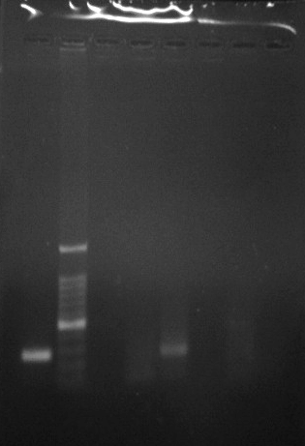

Plate 01 : Molecular detection of NP Gene
LANE 1 : Positive control
LANE M : 1000 bp ladder
Lane 2 : Positive canine distemper sample for NP gene
Lane 3 : Negative

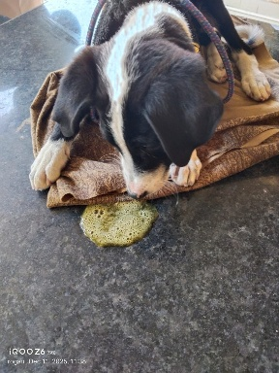


- (b)
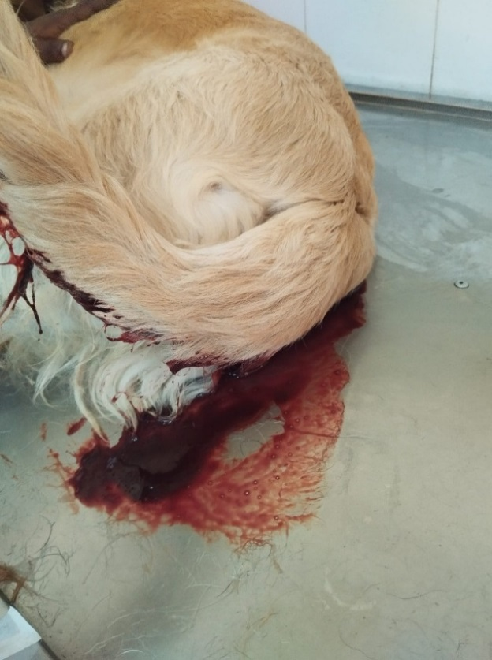

(c)
Plate 02 : Gastric form of canine distemper in dogs showing (a) vomition (b) haematemesis (c) malena
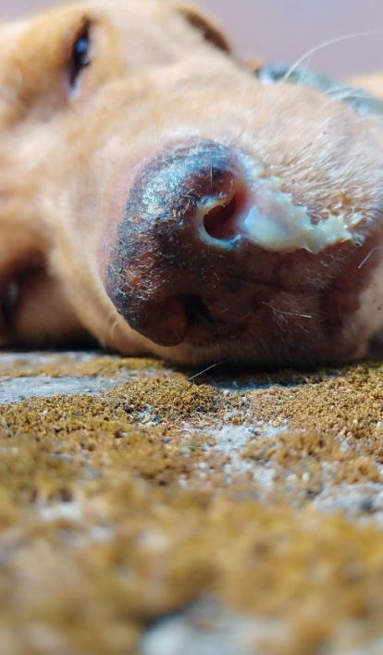
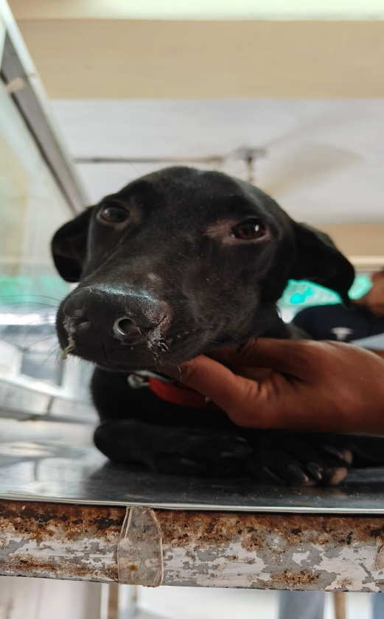
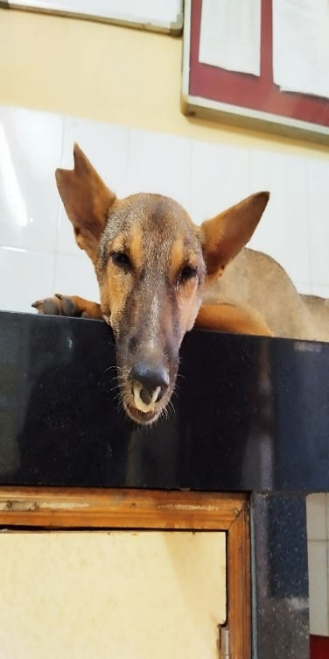
Plate 03: Respiratory form of canine distemper in dogs showing (a) and (b) muco-purulent nasal discharge (c) mucoid nasal discharge (d) and (e) serous nasal-discharge

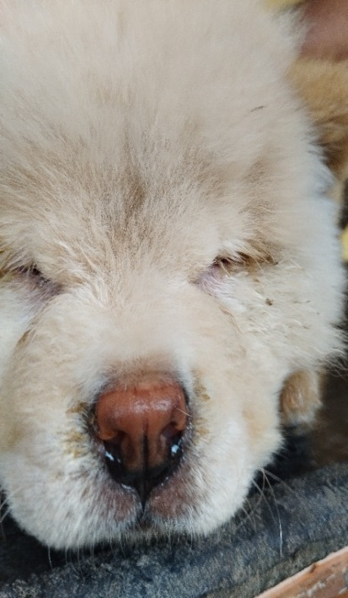
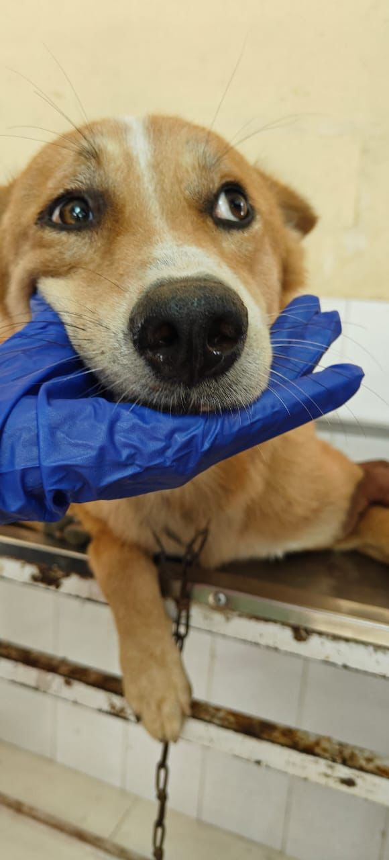
- (b) (c)

(d) (e)

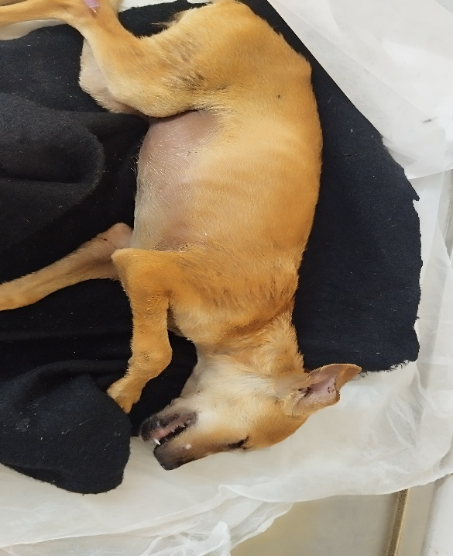
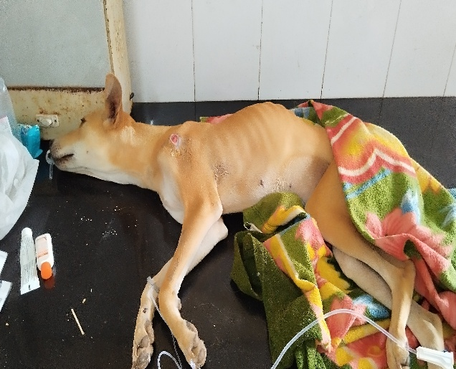

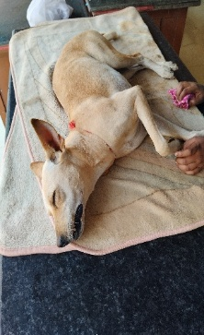
- (b)

(c)
Plate 04: Nervous form canine distemper in dogs showing (a) twitching of limbs (b) paresis (c) champing of jaw

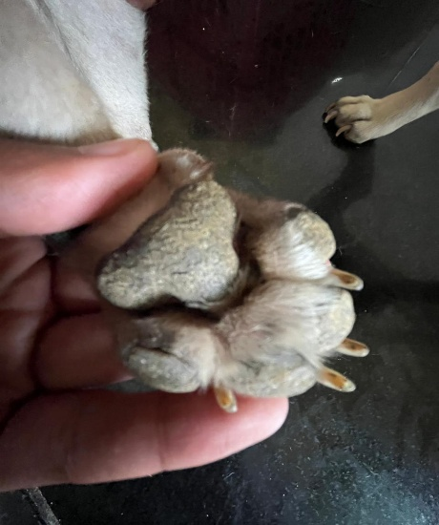
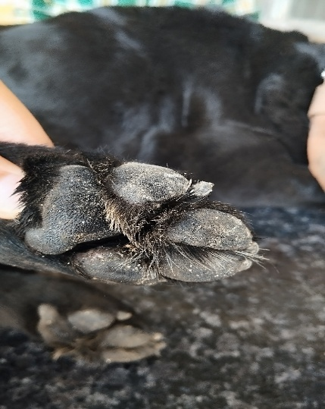

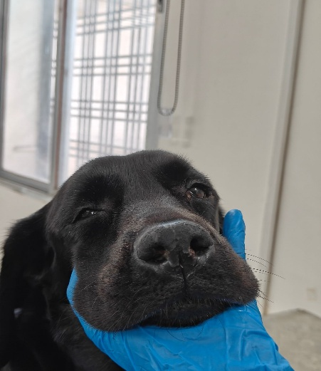
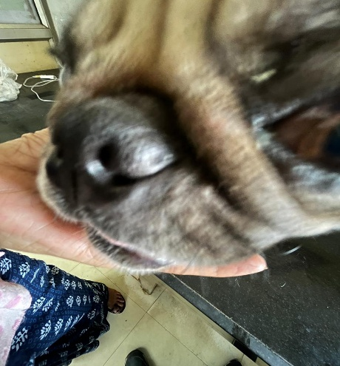
- (b)

(c) (d)
Plate 05: Cutaneous form of canine distemper in dogs showing (a) and (b) hyper-keratenized foot pad and (c) and (d) hypr-keratinized nose

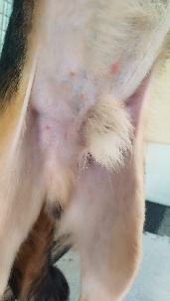
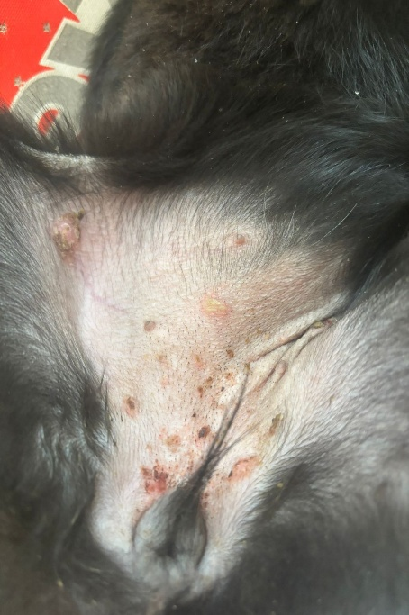

- (b)
Plate 06: Cutaneous form in canine distemper infected dog showing (a) and (b) papules and pustules
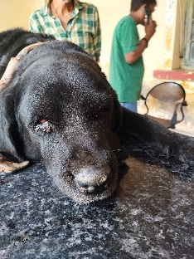
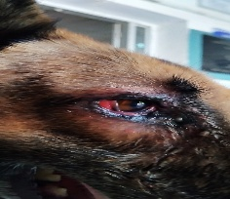

- (b)
Plate 07: Ocular form of canine distemper in dogs showing(a) conjunctivitis (b) ocular discharge

