Molecular Diversity Analysis of Mid-Late Maturing Sugarcane Clones Derived from Bi-parental and General Crosses Using SSR Markers

Abstract
The present study was conducted during 2022–23 to characterize the molecular diversity among twenty mid-late maturing sugarcane genotypes derived from bi-parental and general crosses using Simple Sequence Repeat (SSR) markers. All the genotypes along with one check were planted at the research farm of Dr. Rajendra Prasad Central Agricultural University (RPCAU), Pusa, in a Randomized Block Design with two replications. Genomic DNA was isolated from young leaf tissues of all twenty genotypes and quantified using agarose gel electrophoresis. Eleven polymorphic SSR primer pairs were used for amplification, generating a total of 53 alleles, including 37 shared and 16 unique alleles. The number of alleles per locus ranged from three to seven. The Polymorphism Information Content (PIC) values ranged from 0.39 (SOSSR 48) to 0.78 (SOSSR 31), with an average of 0.61, indicating a high level of marker in formativeness. Genetic similarity coefficients among the genotypes ranged from 0.800 to 0.892. UPGMA-based cluster analysis grouped the genotypes into four major clusters, largely corresponding to their parental lineage. Clones with common parentage were predominantly grouped together, whereas genotypes derived from the same cross but placed in separate clusters revealed substantial intra-cross genetic variability. The results demonstrate that SSR markers are highly efficient in detecting molecular diversity an

Keywords: Sugarcane, SSR markers, molecular diversity, PIC, cluster analysis, genetic similarity

Introduction
Sugarcane (Saccharum spp. complex) is one of the most important commercial crops cultivated globally for sugar, ethanol, bio-energy, and several value-added by-products. India is one of the leading producers of sugarcane, and varietal improvement remains a continuous priority to enhance cane yield, sugar recovery, and adaptability under diverse agro-climatic conditions. However, genetic improvement in sugarcane is particularly challenging due to its highly polyploid, aneuploid, and heterozygous genome, large genome size, and complex interspecific origin involving Saccharum officinarum, S. spontaneum, and related species.
The mid-late maturing sugarcane clones play a crucial role in sustaining sugar industries by extending the crushing season, stabilizing sugar recovery, and ensuring consistent cane supply to mills. Therefore, precise characterization of genetic diversity among mid-late maturing genotypes derived from bi-parental and general crosses is essential for effective parent selection and development of superior varieties.
Traditionally, genetic diversity has been assessed based on morphological and agronomic traits. However, these traits are greatly influenced by environmental conditions and genotype × environment interactions, often leading to unreliable estimates of true genetic relationships. In contrast, molecular marker systems enable direct assessment of genetic variation at the DNA level, independent of environmental influences, thus providing a more accurate and stable measure of genetic diversity.
Over the past few decades, several molecular marker systems have been employed in sugarcane, including Restriction Fragment Length Polymorphism (RFLP), Random Amplified Polymorphic DNA (RAPD), Amplified Fragment Length Polymorphism (AFLP), Inter Simple Sequence Repeats (ISSR), and Sequence Characterized Amplified Regions (SCAR). More recently, Simple Sequence Repeats (SSRs or microsatellites), Single Nucleotide Polymorphisms (SNPs), Diversity Arrays Technology (DArT), genotyping-by-sequencing (GBS), and next-generation sequencing (NGS)-based approaches have significantly advanced molecular breeding in sugarcane.
Among these, SSR markers are particularly suitable for diversity analysis in polyploid crops like sugarcane due to their co-dominant inheritance, high polymorphism, multi-allelic nature, reproducibility, and wide genome distribution. SSRs are highly informative for assessing genetic similarity, population structure, and clustering patterns. Furthermore, the development of EST-SSRs and gene-targeted markers has enhanced their utility in functional diversity studies.
In recent years, high-throughput genotyping platforms such as SNP arrays, GBS, and whole-genome resequencing have facilitated genome-wide diversity assessment and association mapping in sugarcane. Additionally, emerging tools such as genomic selection (GS), marker-assisted selection (MAS), quantitative trait locus (QTL) mapping, and CRISPR-based genome editing are accelerating sugarcane improvement programs. Nevertheless, SSR markers remain cost-effective, reliable, and highly informative for routine diversity analysis, especially in breeding programs with limited resources.
Therefore, the present investigation was undertaken to assess the molecular diversity among mid-late maturing sugarcane clones derived from bi-parental and general crosses using SSR markers. The study aims to evaluate genetic similarity, clustering patterns, and intra-cross variability to facilitate effective parent selection and enhance genetic gain in sugarcane breeding programmes.

Materials and Methods

Plant Material: The experimental material comprised twenty mid-late maturing sugarcane genotypes, including one standard check, CoP 2061. All genotypes, along with the check, were planted during the 2022–23 planting season at the research farm of Dr. Rajendra Prasad Central Agricultural University (RPCAU), Pusa. The experiment was laid out in a Randomized Block Design (RBD) with two replications.
Fresh, young and healthy leaf samples from each genotype were collected for molecular analysis. Immediately after collection, the samples were placed in an insulated isothermal container containing ice gel pads to maintain sample integrity and prevent DNA degradation. The samples were then transported to the Molecular Laboratory of the Department of Genetics and Plant Breeding (GPB), Faculty of Agriculture, RPCAU, Pusa, for further analysis. The details of the genotypes, including their parentage derived from bi-parental crosses (BC) and general crosses (GC) are presented in Table 1.
Table: 1 List of experimental materials 19 clones and CoP 2061 with parentage.
Sr. No. | Clones | Parentage
1. | CoX 20322 | BO 102 × Co 775
2. | CoX 20418 | Co 09022 × BO154
3. | CoX 20412 | Co 09022 × BO154
4. | CoX 20118 | Co 09022 × BO154
5. | CoX 20053 | CoPb 9181 GC
6. | CoX 20400 | CoH 160 × Co 62198
7. | CoX 20047 | CoPb 9181 GC
8. | CoX 20159 | CoP 06436 GC
9. | CoX 20123 | CoN 05103 GC
10. | X 20035 | BO 154 GC
11. | X 20039 | BO 154 GC
12. | CoX 20111 | Co 09022 × BO 154
13. | CoX 20022 | BO 154 GC
14. | CoX 20165 | Co 1158 × BO 130
15. | X 20015 | BO 154 GC
16. | CoX 20041 | Co 0238 GC
17. | CoX 20065 | CoPb 9181 GC
18. | CoX 20130 | CoN 05103 GC
19. | CoX 20068 | CoPb 9181 GC
20. | CoP 2061 | CoLk 8102 × HR 83/65
(Symbol CoX: Co indicate Coimbatore and X indicate Pusa )

Genomic DNA Isolation and Quantification

DNA Isolation
Genomic DNA was isolated from fresh, young, and healthy sugarcane leaf tissues following the modified CTAB (Cetyl Trimethyl Ammonium Bromide) method described by Srivastava and Gupta (2008). The CTAB method is widely used for plant DNA extraction, particularly in crops like sugarcane that contain high levels of polysaccharides and polyphenols. CTAB, a cationic detergent, facilitates cell lysis and forms complexes with nucleic acids, thereby aiding in the separation of DNA from proteins and other cellular components.

Preparation of CTAB Extraction Buffer: The CTAB extraction buffer consisted of the following components viz, 100 mM Tris-HCl (pH 8.0), 20 mM EDTA (pH 8.0),1.4 M NaCl and 1.5% (w/v) CTAB. All components were dissolved in distilled water, mixed thoroughly, and the pH was adjusted to 8.0 using HCl or NaOH. The solution was autoclaved prior to use. Additionally, 2% β-mercaptoethanol was added freshly (1 µl per ml of extraction buffer) at the time of sample processing to prevent oxidation of phenolic compounds. Other reagents used included chloroform:isoamyl alcohol (24:1), chilled isopropanol, 70% ethanol (prepared by mixing 70 ml absolute ethanol with 30 ml distilled water), 1× TE buffer, and RNase A (20 mg/ml prepared in nuclease-free water and stored at −20°C).

DNA Extraction Procedure
Approximately 1 g of young, healthy green leaf tissue collected from water shoots was used for DNA isolation. Mortar and pestle were sterilized with ethanol prior to use. The leaf tissue was finely chopped using sterilized scissors and homogenized in 1 ml of pre-heated CTAB extraction buffer containing β-mercaptoethanol.
The homogenized sample was transferred to labeled 2 ml centrifuge tubes and incubated in a water bath at 65°C for 1 hour to ensure complete cell lysis. After incubation, an equal volume of chloroform:isoamyl alcohol (24:1) was added, and the mixture was gently inverted to mix thoroughly. The samples were then centrifuged at 12,000 rpm for 12 minutes to separate the phases.
Following centrifugation, the upper aqueous phase containing DNA was carefully transferred to a fresh 1.5 ml centrifuge tube. To precipitate the DNA, 600 µl of chilled isopropanol was added, and the tubes were incubated at −20°C overnight. The samples were subsequently centrifuged at 12,000 rpm for 12 minutes to pellet the DNA, and the supernatant was discarded.
The DNA pellet was washed with 500 µl of 70% ethanol and centrifuged at 6,000 rpm for 6 minutes. The ethanol was discarded, and the pellet was air-dried to remove residual ethanol. The dried DNA pellet was dissolved in 70 µl of nuclease-free molecular-grade water, and 5 µl of RNase A was added to remove RNA contamination. The mixture was incubated at 37°C for 15 minutes for RNase activation. Finally, the purified genomic DNA was stored at −20°C until further use.

DNA Quantification
The quality and quantity of genomic DNA were assessed using 1% agarose gel electrophoresis in 1X Tris-Borate-EDTA (TBE) buffer. DNA samples were mixed with 6X bromophenol blue loading dye and loaded into wells formed in the gel matrix. Upon application of an electric field (70 V for 45 minutes), negatively charged DNA fragments migrated toward the positive electrode, separating according to size.
The gel was stained with ethidium bromide, a fluorescent intercalating dye that enables visualization of DNA bands under ultraviolet (UV) light. The integrity and purity of DNA were evaluated based on the presence of sharp, distinct, high-molecular-weight bands without smearing. Agarose gel electrophoresis is a sensitive and reliable technique capable of detecting DNA in the range of 1–10 ng and is routinely used to assess DNA quality prior to PCR amplification.
Only high-quality DNA samples showing intact bands were selected for subsequent SSR-based PCR analysis.

SSR Primers and PCR Amplification
Eleven sugarcane-specific SSR primer pairs (Table 2) were selected for molecular analysis. PCR amplification was carried out in a standard reaction mixture. The amplified products were resolved on 3% agarose gel and visualized under UV light. Only clear and reproducible bands were scored.
Table 2. List of eleven microsatellite primer pairs used in the present experiment
No | Primer | Forward sequence | Reverse sequence | Annealing temp.
1 | SOSSR 1 (NKS 1) | TGGCATGTGTCATAGCCAAT | CCCCAACTGGGACTTTTACA | 55 °C
2 | SOSSR 3(NKS 3) | CGTGTTCCTCTTCAACAACG | TGCTTCGCTATATATGGGTTCA | 55 °C
3 | SOSSR 8 (NKS 8) | GTGACAGCGGCTTGTTCAG | TTAAACACGCAGCCATTCAG | 55 °C
4 | SOSSR 9 (NKS 9) | CTTTCAGTGGCCATCTCCAT | GAATGCGCAGGGATAGGATA | 55 °C
5 | SOSSR 31 (NKS 31) | AACCACCACTCATCGTCCTC | CACCGAGTTCCCATTGTTCT | 55 °C
6 | SOSSR 34 (NKS 34) | CGTCTTGTGGATTGGATTGG | TGGATTGCTCAGGTGTTCA | 55 °C
7 | SOSSR 38 (NKS 38) | TGAACTCGGCAACAGTTTTT | CCCACCAAGTCGTTCTGAAT | 58 °C
8 | SOSSR 48 (NKS 48) | ACAATAACCCCGCAGACATC | TAATGCGTCATTTGGAGCAG | 55 °C
9 | SOSSR 49 (NKS 49) | CTCACGTCCTGTTGGTGCTA | TACATGGGACACATGCTTGC | 55 °C
10 | SOSSR 57 (NKS 57) | CGAGCCTCCCTCCATAGATT | ACCACCACCAACCTCATCTC | 55 °C
11 | SOSSR 61 (NKS 61) | TTGGACATGGCAAGTCTTTG | AGGAACCTCCCAAGAACACA | 55 °C

Data Scoring and Statistical Analysis
SSR amplification profiles were scored in a binary format as present (1) or absent (0) for each genotype. The total number of alleles, shared alleles, unique alleles, and percentage of polymorphism were calculated using the formula:
Polymorphism (%) = (Number of unique alleles / Total number of alleles) × 100.
Polymorphic Information Content (PIC) values were computed to assess the informativeness of each primer using the standard formula based on allele frequency.
Genetic similarity among genotypes was estimated using Jaccard’s similarity coefficient based on pairwise comparison of shared and non-shared bands. Cluster analysis was performed using the Unweighted Pair Group Method with Arithmetic Mean (UPGMA), and a dendrogram was constructed to illustrate genetic relationships.
A total of 11 SSR primer pairs were used for molecular characterization. SSR markers, known for their high polymorphism, co-dominant inheritance, and environmental stability, proved effective in assessing genetic diversity and relatedness among mid-late maturing sugarcane genotypes.

Results and Discussion

Genetic Similarity Analysis
Genetic similarity coefficients among the twenty genotypes ranged from 0.800 to 0.892. The highest similarity (0.892) was observed between X 20039 and CoX 20022, both derived from BO 154 female cross, indicating close genetic relatedness. The lowest similarity (0.800) was recorded among genotype combinations such as CoX 20123 & CoX 20165 and X 20039 & CoX 20130, suggesting substantial genetic divergence. The observed range of similarity coefficients indicates the presence of adequate variability for effective selection of diverse parents.

SSR Polymorphism and Allelic Variation
The eleven SSR primer pairs generated clear and polymorphic amplification patterns across all twenty sugarcane genotypes. A total of 53 alleles were detected, with the number of alleles per locus ranging from three (SOSSR 48 and SOSSR 61) to seven (SOSSR 57), averaging 4.8 alleles per marker (Table 3). Among these, 37 alleles were shared and 16 were unique, indicating considerable genetic variation among the studied genotypes.
The presence of unique alleles reflects genotype-specific polymorphism, which is valuable for varietal identification and germplasm conservation. Similar levels of allelic diversity using SSR markers in sugarcane have been reported by Pan (2006), Singh et al. (2008), and Simullah et al. (2013).

Polymorphism Information Content (PIC)
PIC values varied from 0.39 (SOSSR 48) to 0.78 (SOSSR 31), with an average value of 0.61 (Table 3). Higher PIC values observed for primers SOSSR 31, SOSSR 34, and SOSSR 49 indicate their superior discriminatory ability. According to Cordeiro et al. (2003), markers with PIC values greater than 0.50 are considered highly informative, confirming the suitability of the SSR markers used in this study. Comparable PIC ranges have been reported in earlier sugarcane diversity studies (Arora et al., 2018; Alarmelu et al., 2020).
Table 3 Primer pairs analysis for the genomic DNA extracted from twenty genotypes of Sugarcane
Primers | Size of alleles | Number of alleles | No. of unique alleles | % of unique alleles | No. of shared alleles | PIC
SOSSR 1 (NKS 1) | 237-323 | 5 | 2 | 40.00 | 3 | 0.54
SOSSR 3 (NKS 3) | 175-247 | 5 | 1 | 20.00 | 4 | 0.71
SOSSR 8 (NKS 8) | 178-225 | 4 | 1 | 25.00 | 3 | 0.65
SOSSR 9 (NKS 9) | 150-430 | 6 | 1 | 16.67 | 5 | 0.54
SOSSR 31 (NKS 31) | 235-290 | 5 | 1 | 20.00 | 4 | 0.78
SOSSR 34(NKS 34) | 136-230 | 6 | 2 | 33.33 | 4 | 0.75
SOSSR 38(NKS 38) | 215-300 | 5 | 1 | 20.00 | 4 | 0.71
SOSSR 48 (NKS 48) | 125-223 | 3 | 1 | 33.33 | 2 | 0.39
SOSSR 49(NKS 49) | 136-182 | 4 | 2 | 50.00 | 2 | 0.75
SOSSR 57(NKS 57) | 83-341 | 7 | 3 | 42.86 | 4 | 0.42
SOSSR 61(NKS 61) | 210-245 | 3 | 1 | 33.33 | 2 | 0.46

Genomic DNA Amplification Using SSR Primers
Genomic DNA of twenty mid-late maturing sugarcane genotypes was amplified using eleven SSR primer pairs (SOSSR 1, 3, 8, 9, 31, 34, 38, 48, 49, 57, and 61). Successful amplification was obtained for almost all primer–genotype combinations, producing clear and scorable bands in fig 1 and 2. The amplified fragment sizes varied depending on the primer used. For instance, SOSSR 1 generated products ranging from 237–323 bp, while SOSSR 3 produced fragments between 175–247 bp. Similarly, SOSSR 8 amplified products of 178–225 bp, and SOSSR 9 produced fragments ranging widely from 150–430 bp. Primer SOSSR 31 generated bands between 235–290 bp, SOSSR 34 between 136–230 bp, SOSSR 38 between 215–300 bp, SOSSR 48 between 125–223 bp, SOSSR 49 between 136–182 bp, SOSSR 57 between 83–341 bp, and SOSSR 61 between 210–245 bp.

Table 4. Dice similarity coefficient matrix for the twenty mid-late maturing clones of sugarcane
 | G2 | G3 | G4 | G5 | G6 | G7 | G8 | G9 | G10 | G11 | G12 | G13 | G14 | G15 | G16 | G17 | G18 | G19 | G20
G1 | 0.846 | 0.854 | 0.854 | 0.823 | 0.856 | 0.839 | 0.846 | 0.846 | 0.823 | 0.815 | 0.815 | 0.838 | 0.815 | 0.823 | 0.859 | 0.831 | 0.846 | 0.831 | 0.839
G2 |  | 0.869 | 0.869 | 0.839 | 0.839 | 0.839 | 0.831 | 0.846 | 0.823 | 0.815 | 0.815 | 0.823 | 0.815 | 0.823 | 0.839 | 0.831 | 0.861 | 0.831 | 0.854
G3 |  |  | 0.861 | 0.846 | 0.846 | 0.831 | 0.839 | 0.839 | 0.815 | 0.808 | 0.808 | 0.815 | 0.808 | 0.815 | 0.831 | 0.823 | 0.839 | 0.823 | 0.831
G4 |  |  |  | 0.831 | 0.861 | 0.815 | 0.839 | 0.839 | 0.815 | 0.823 | 0.839 | 0.846 | 0.839 | 0.815 | 0.831 | 0.839 | 0.823 | 0.808 | 0.831
G5 |  |  |  |  | 0.846 | 0.861 | 0.854 | 0.854 | 0.831 | 0.839 | 0.839 | 0.846 | 0.823 | 0.831 | 0.862 | 0.823 | 0.854 | 0.808 | 0.831
G6 |  |  |  |  |  | 0.846 | 0.869 | 0.838 | 0.861 | 0.839 | 0.839 | 0.846 | 0.839 | 0.831 | 0.831 | 0.854 | 0.839 | 0.823 | 0.846
G7 |  |  |  |  |  |  | 0.869 | 0.839 | 0.831 | 0.808 | 0.839 | 0.831 | 0.823 | 0.831 | 0.877 | 0.839 | 0.885 | 0.839 | 0.831
G8 |  |  |  |  |  |  |  | 0.861 | 0.808 | 0.831 | 0.869 | 0.831 | 0.823 | 0.839 | 0.846 | 0.846 | 0.815 | 0.839 | 0.839
G9 |  |  |  |  |  |  |  |  | 0.839 | 0.846 | 0.831 | 0.839 | 0.831 | 0.839 | 0.854 | 0.831 | 0.861 | 0.831 | 0.839
G10 |  |  |  |  |  |  |  |  |  | 0.823 | 0.853 | 0.815 | 0.823 | 0.800 | 0.831 | 0.808 | 0.823 | 0.808 | 0.815
G11 |  |  |  |  |  |  |  |  |  |  | 0.846 | 0.885 | 0.831 | 0.839 | 0.823 | 0.815 | 0.831 | 0.815 | 0.823
G12 |  |  |  |  |  |  |  |  |  |  |  | 0.839 | 0.892 | 0.823 | 0.854 | 0.861 | 0.831 | 0.800 | 0.839
G13 |  |  |  |  |  |  |  |  |  |  |  |  | 0.870 | 0.861 | 0.831 | 0.839 | 0.823 | 0.808 | 0.846
G14 |  |  |  |  |  |  |  |  |  |  |  |  |  | 0.854 | 0.853 | 0.846 | 0.815 | 0.800 | 0.853
G15 |  |  |  |  |  |  |  |  |  |  |  |  |  |  | 0.861 | 0.839 | 0.839 | 0.823 | 0.831
G16 |  |  |  |  |  |  |  |  |  |  |  |  |  |  |  | 0.823 | 0.859 | 0.823 | 0.846
G17 |  |  |  |  |  |  |  |  |  |  |  |  |  |  |  |  | 0.831 | 0.831 | 0.839
G18 |  |  |  |  |  |  |  |  |  |  |  |  |  |  |  |  |  | 0.846 | 0.838
G19 |  |  |  |  |  |  |  |  |  |  |  |  |  |  |  |  |  |  | 0.838

G1.CoP 2061 | G 2.CoX 20322 | G 3.CoX 20418 | G 4.CoX 20412 | G 5.CoX 20118
G 6.CoX 20053 | G 7.CoX 20400 | G 8.CoX 20047 | G 9.CoX 20159 | G 10.CoX 20123
G 11.X 20035 | G 12.X 20039 | G 13.CoX 20111 | G 14.CoX 20022 | G 15.CoX 20165
G 16.X 20015 | G 17.CoX 20041 | G 18.CoX 20065 | G 19.CoX 20130 | G 20.CoX 20068

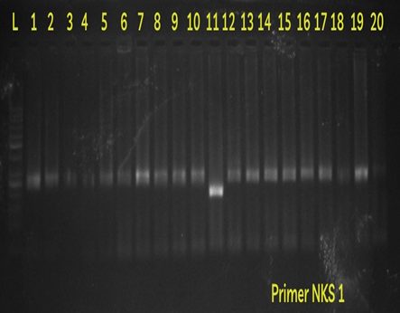 |  |  | 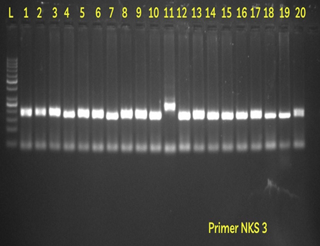
PLATE 1  PRIMER SOSSR 1 (NKS 1) |  |  | PLATE 2  PRIMER SOSSR 3 (NKS 3)
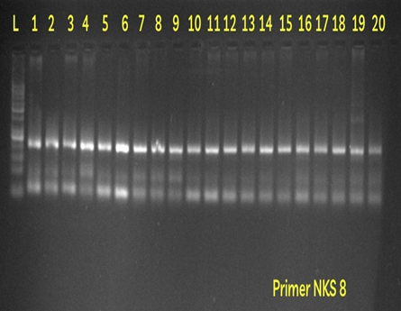 |  |  | 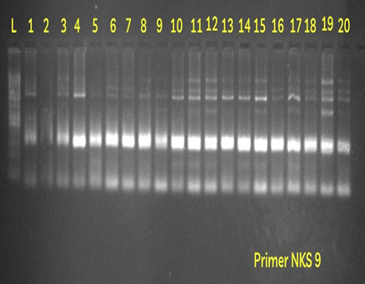
PLATE 3  PRIMER SOSSR 8 (NKS 8) |  |  | PLATE 4  PRIMER SOSSR 9 (NKS 9)
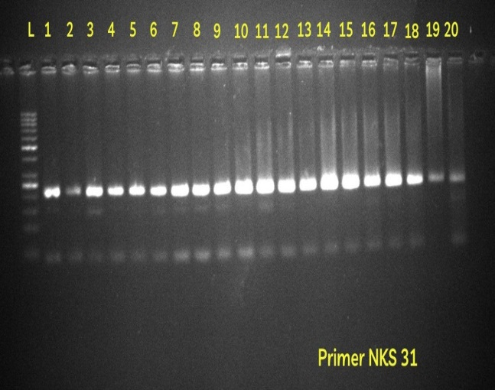 |  | 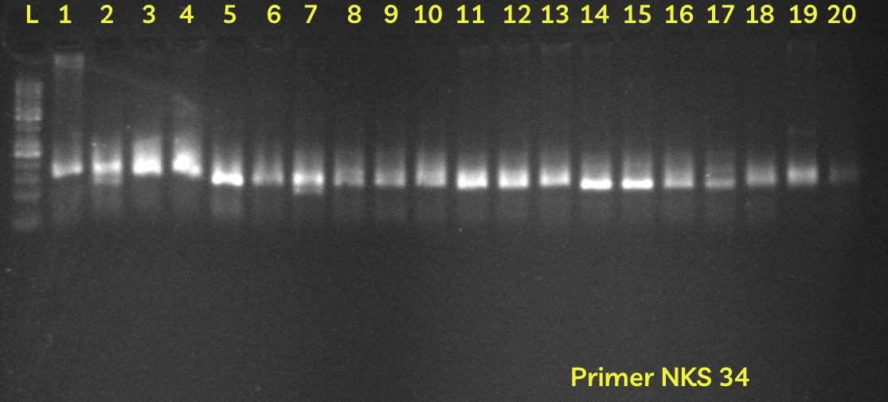
PLATE 5  PRIMER SOSSR 31 (NKS 31) |  | PLATE 6  PRIMER SOSSR 34 (NKS 34)
Fig. 1: Amplification of the genomic DNA extracted from the leaves of the sugarcane by the SSR primer pairs SOSSR 1, SOSSR 3,SOSSR 8, SOSSR 9, SOSSR 31 & SOSSR 34

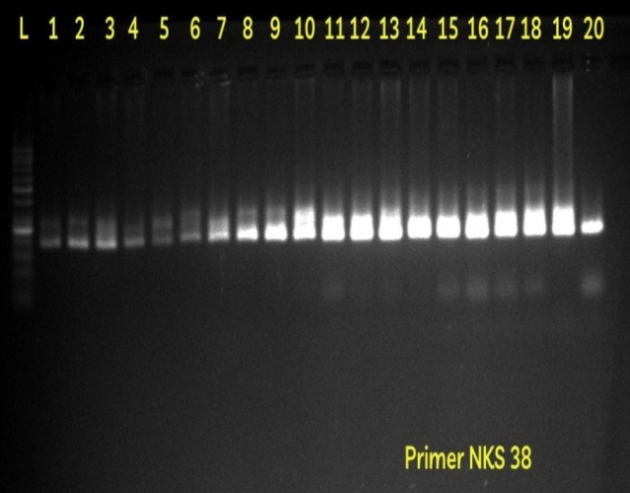 |  | 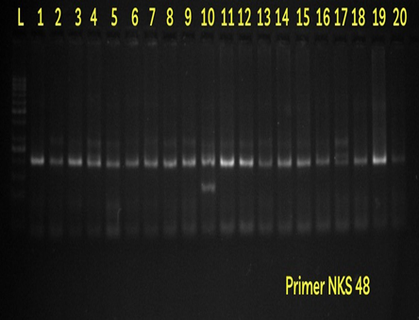
PLATE 7  PRIMER SOSSR 38 (NKS 38) |  | PLATE 8  PRIMER SOSSR 48 (NKS 48)
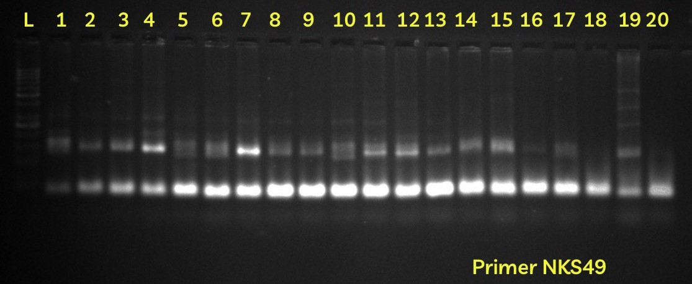 | 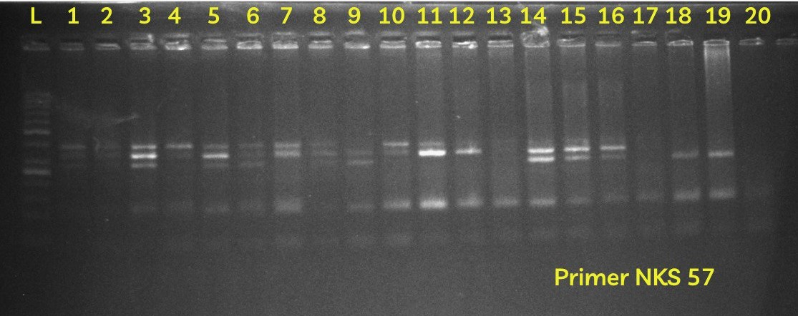
PLATE 9  PRIMER SOSSR 49 (NKS 49) | PLATE 10  PRIMER SOSSR 57 (NKS 57)
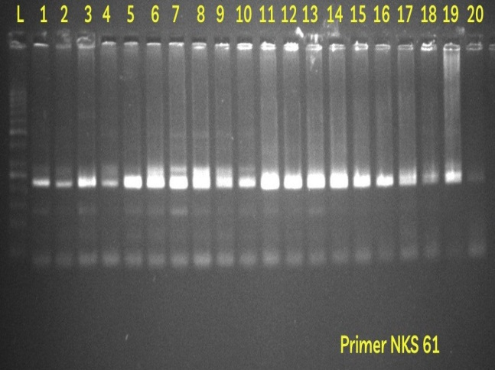
PLATE 11
PRIMER SOSSR 61 (NKS 61)
Fig. 2: Amplification of the genomic DNA extracted from the leaves of the sugarcane by the SSR primer pairs SOSSR 38, SOSSR 48,SOSSR 49, SOSSR 57 & SOSSR 61

Genetic Similarity Evaluation
Genetic similarity among the twenty sugarcane genotypes was estimated based on the presence or absence of amplified products generated by eleven SSR primer pairs. Similarity coefficients were calculated for all pairwise combinations of genotypes (Table 4.). The similarity values, reflecting genetic relatedness based on amplified DNA fragments, ranged from 0.800 to 0.892. The highest genetic similarity (0.892) was observed between genotypes X 20039 and X 20022, indicating a close genetic relationship between them. Other genotype pairs showing relatively high similarity included X 20035 and CoX 20111 (0.885), CoX 20400 and X 20015 (0.877), and CoX 20111 and CoX 20022 (0.870). In contrast, the lowest similarity coefficient (0.800) was recorded among several genotype pairs, including CoX 20123 and CoX 20165, CoX 20111 and X 20039, and CoX 20022 and CoX 20130. Several other combinations exhibited similarity values of 0.808, indicating moderate genetic divergence. The observed range of similarity coefficients suggests the presence of appreciable molecular diversity among the twenty mid-late maturing sugarcane genotypes, which can be effectively utilized for parent selection and genetic improvement in breeding programmes.

Genotype Clustering Based on SSR Markers
Genotype clustering was performed using SSR marker data to assess genetic relationships among the twenty sugarcane genotypes. Genetic similarity coefficients were calculated from binary data representing the presence (1) or absence (0) of amplified bands. Based on these similarity values, a dendrogram was constructed using the UPGMA method to illustrate the pattern of genetic relatedness and divergence among the genotypes. Genotypes with higher similarity coefficients clustered together, indicating closer genetic relationships. The dendrogram revealed four major clusters. Cluster I comprised eleven genotypes, Cluster II included seven genotypes, while Clusters III and IV each contained a single genotype, indicating their distinct genetic makeup. Cluster I was further subdivided into two sub-clusters (IA and IB). Sub-cluster IA included closely related genotypes such as CoX 20322 and CoX 20418, which were clearly separated from CoP 2061 and CoX 20412. Sub-cluster IB consisted of closely associated genotypes CoX 20400 and CoX 20065, along with CoX 20053 and CoX 20047, while genotypes such as CoX 20118, X 20015, and CoX 20159 showed moderate divergence. Overall, the clustering pattern confirmed substantial genetic variability among the studied sugarcane genotypes.

Cluster Analysis
UPGMA-based cluster analysis grouped the twenty genotypes into four major clusters (Fig. 3; Table 5). Cluster I contained eleven genotypes, cluster II contained seven genotypes, while clusters III and IV were monogenotypic.

Table 5 Clustering of the total twenty sugarcane genotypes based on dendrogram data
Clusters | Sub-clusters | Genotypes included
I | IA | CoX 20322 , CoX 20418,CoP 2061 and CoX 20412
I | IB | CoX 20400,CoX 20065,CoX 20118, X 20015 and CoX 20159
I | IB | CoX 20053 and CoX 20047
II | IIA | X 20035, CoX 20111 and CoX 20165
II | IIB | X 20039, CoX 20022, CoX 20041 and CoX 20068
III |  | CoX 20123
IV |  | CoX 20130

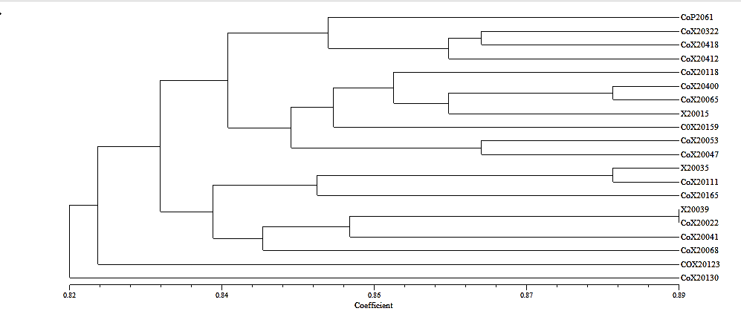
Fig. 3: The classification of the twenty mid-late maturing sugarcane clones using the eleven pairs of SSR primers by depicting in dendrogram
Most genotypes sharing common parentage were grouped within the same clusters. Clones CoX 20418, CoX 20412, and CoX 20118, all derived from Co 09022 × BO 154, were grouped together in cluster I. Similarly, clones X 20035, X 20039, and CoX 20022 derived from BO 154 female cross were grouped in cluster II. Clones derived from CoPb 9181 general cross were also predominantly grouped in cluster I.
Interestingly, clones CoX 20123 and CoX 20130, despite sharing the same parentage (CoN 05103 GC), were placed in separate clusters (III and IV), indicating high intra-cross genetic variability. Such divergence may result from extensive recombination and chromosomal rearrangements during gamete formation in sugarcane, as reported by earlier workers.
The cluster II is also further sub-divided into two sub-clusters i.e., A & B. The sub-cluster IIA consists of the three genotypes, where the genotypes X 20035 and CoX 20111 were highly similar and they were distinguishable from the third genotype i.e., CoX 20165. The sub-cluster IIB consists of four genotypes, where X 20039 and CoX 20022 were closely related and they were less closely related with the rest two genotypes namely CoX 20041, CoX 20068.
By comprehensive study of the table 6 and 2, it has been found that some of the clones having the same parentage are included in the same cluster, indicating the level of similarity between them. The clones such as CoX 20418, CoX 20412 and CoX 20118 having the common parentage Co 09022 × BO 154 are present in the cluster I. The clones such as X 20035, X 20039 and CoX 20022 having the common parentage BO 154 FC are found to be present in the same cluster i.e., cluster II. Also, the clones such as CoX 20053, CoX 20047, CoX 20065 and CoX 20118 having the common parentage i.e., CoPb 9181 GC are found to be present in the cluster I. It was also observed that the two genotypes namely, CoX 20123 & CoX 20130 (cluster III & IV) having common parentage viz., CoN 05103, were found to be diversely related with each other and also with the rest of the genotypes under study .

Molecular Characterization
SSR-based molecular characterization proved to be an effective tool for assessing genetic diversity among the twenty mid-late maturing sugarcane genotypes. Compared to conventional morphological evaluation, SSR markers provide precise, reliable, and environment-independent information about genetic variability. The use of molecular markers and genetic similarity analysis enhances breeding efficiency by enabling accurate identification of diverse parents and superior genotypes for hybridization programmes.
A total of 53 alleles were detected across the twenty genotypes using eleven SSR primer pairs. Among these, 37 were shared alleles and 16 were unique alleles, indicating substantial genetic variation within the experimental material. The number of shared alleles varied among primers, with the lowest observed in SOSSR 47 and SOSSR 61, while the highest was recorded for SOSSR 9. Similarly, unique alleles ranged from one (SOSSR 61) to three (SOSSR 57), with SOSSR 49 exhibiting a comparatively higher percentage of unique alleles. These findings are consistent with earlier reports highlighting the effectiveness of SSR markers in detecting polymorphism in sugarcane germplasm.
Allelic diversity was further evaluated using Polymorphism Information Content (PIC). PIC values ranged from 0.39 (SOSSR 48) to 0.78 (SOSSR 31), with an average value of 0.61, indicating moderate to high marker informativeness. High PIC values reflect greater discriminatory power of markers in distinguishing genotypes. Similar ranges of PIC values have been reported in previous sugarcane diversity studies, confirming the robustness of SSR markers for molecular characterization.
Genetic similarity coefficients among genotypes ranged from 0.800 to 0.892, suggesting appreciable molecular diversity within the population. Moderate similarity values indicate sufficient genetic variability, which is advantageous for parent selection and recombination breeding.
Cluster analysis based on SSR data grouped the genotypes into four major clusters. Cluster I and II comprised eleven and seven genotypes, respectively, while Clusters III and IV each contained a single genotype, indicating distinct genetic backgrounds. Genotypes sharing common parentage were predominantly grouped within the same cluster, demonstrating the reliability of SSR markers in reflecting pedigree relationships. However, some genotypes derived from the same cross were placed in different clusters, indicating intra-cross variability, likely due to chromosomal recombination and genetic segregation during gamete formation. Such variability forms the basis for effective selection and genetic improvement in sugarcane breeding programmes.
Overall, SSR marker analysis successfully revealed significant molecular diversity, confirmed pedigree relationships, and demonstrated its utility in genotype differentiation. The results highlight the importance of molecular characterization in strengthening sugarcane breeding strategies through informed parent selection and conservation of genetic resources.

Conclusion
The SSR-based molecular analysis revealed moderate genetic diversity among the twenty sugarcane clones. A total of 53 alleles were detected, including 37 shared and 16 unique alleles, indicating the presence of genetic variability within the studied material. The Polymorphism Information Content (PIC) values ranged from 0.39 (SOSSR 48) to 0.78 (SOSSR 31), with an average of 0.61, demonstrating moderate to high marker informativeness. Genetic similarity coefficients varied from 0.800 to 0.892. The highest similarity (0.892) was observed between clones X 20039 and CoX 20022, while the lowest similarity (0.800) was recorded among combinations such as CoX 20123 & CoX 20165, X 20039 & CoX 20130, and CoX 20022 & CoX 20130. The relatively narrow similarity range suggests limited molecular variation among the clones, indicating a comparatively close genetic relationship. Cluster analysis grouped the twenty clones into four major clusters (I–IV), comprising 11, 7, 1, and 1 clones, respectively. Most clones sharing common parentage were grouped within the same cluster, confirming the reliability of SSR markers in reflecting genetic relationships. For instance, clones derived from Co 09022 × BO 154 were placed in Cluster I, while clones from BO 154 FC were grouped in Cluster II. However, a few genotypes with the same parentage were distributed across different clusters, likely due to chromosomal recombination and genetic variation during gamete formation. Overall, the study confirms the effectiveness of SSR markers in assessing genetic diversity and clustering sugarcane genotypes, providing valuable information for parent selection and breeding programmes.

References
Alarmelu, S., Karpagam, E., Nagarajan, R. and Shanthi, R. M. (2020). Molecular identification and genetic diversity analysis of sugarcane clones by SSR markers.
Arora, n., kashyap, l., gill, r. S. and thind, k. S. (2018).Assessment of genetic divergence among sugarcane genotypes (Saccharum officinarumL.)Based on molecular markers. Assessment, 13(1): 41-45.
Cordeiro, G.M., Pan, Y.B. and Henry, R.J. (2003). Sugarcane microsatellites for the assessment of genetic diversity in sugarcane germplasm. Journal of PlantScience, 165: 181-189.
Devarumath, R. M., Kalwade, S. B., Kawar, P. G. and Sushir, K. V. (2012).Assessment of genetic diversity in sugarcane germplasm using ISSR and SSR markers. Sugar Tech, 14, 334-344.
Govindaraj, P., Gowri, R., Mohanraj, K., & Amalraj, V. A. (2021). SSR marker based molecular genetic diversity analysis among Saccharum spontaneum L.collected from North Western region of India. Sugar Tech, 23; 730-740.
Kumari, P., Kumar, B., Kamat, D. N., Singh, R., Singh, D.& Suman, S. K. (2023).Molecular Characterization of Mid-late Maturing Sugarcane Clones by Using Microsatellite Markers. International Journal of Environment and Climate Change, 13(9): 1644-1654.
Liu, P., Que, Y. and Pan, Y. B. (2011).Highly polymorphic microsatellite DNA markers for sugarcane germplasm evaluation and variety identity testing. Sugar Tech, 13(2): 129-136.
Pan, Y. B. (2006). Highly polymorphic microsatellite DNA markers for sugarcane germplasm evaluation and variety identity testing. Sugar Tech, 8, 246-256.
Singh, R. K., Srivastava, S., Singh, S. P., Sharma, M. L., Mohopatra, T., Singh, N. K. and Singh, S. B. (2008). Identification of new microsatellite DNA markers for sugar and related traits in sugarcane. Sugar Tech, 10, 327-333.
Smiullah, S., Khan, F.A., Afzal, A., Abdullah, I., A. and Ijaz, U. (2013).Diversityanalysis of sugarcane genotypes by microsatellite (SSR) markers.InternationalJournal of Biotechnology and Molecular Biology, 4 (7): 105-110.
Sharma, M. D., Dobhal, U., Singh, P., Kumar, S., Gaur, A. K., Singh, S. P., ... and Kumar, S. (2014). Assessment of genetic diversity among sugarcane cultivars using novel microsatellite markers. African Journal of Biotechnology, 13(13): 1144-1151
***

