Genetic variability and character association for fruit yield and its attributing traits in Bottle gourd (Lagenaria siceraria (Mol.) Standl.)

Abstract
The present investigation was carried out during the summer season of the year 2024-25 in the experiment field of department of Vegetable Science at Pt. KLS College of Horticulture and Research Station, Rajnandgaon (C.G.), under Mahatma Gandhi University of Horticulture & Forestry, Durg (C.G.). The experiment was laid under Randomized Block Design (RBD) with three replications and the experimental material consisting of eighteen genotypes of Bottle gourd. eighteen bottle gourd genotypes were growth, flowering and yield traits. Analysis of variance revealed that mean sum of squares due to genotypes was highly significant for all characters. Among eighteen genotypes, the genotype BOGVAR-10 was noted for 1st germination (5.16 days). The genotype BOGVAR-3 was noted for earliness in 50% germination (8.37 days). The maximum plant height (1.88 m) in 60 DAS was recorded in BOGVAR-8 and maximum plant height (6.03 m) in 90 DAS in the same genotype. The genotype BOGVAR-14 was also noted for early days taken to first male flower (27.14) first female flower (30.00) DAT. The genotype BOGVAR-3 was also recorded the earliest node for first male flower (3.46) and first female flower (8.23). Maximum number of fruits per plant (14.42) was recorded in BOGVAR-3. The genotype BOGVAR-3 was noted for days taken to 1st fruit harvest i.e. 41.43 DAT. Maximum fruit length (57.42 cm) was recorded in BOGVAR-18. Maximum fruit diameter (13.24 cm) and average fruit weight (1784.26 g) was recorded in BOGVAR-4. Maximum fruit yield per plant (12.76 kg) and fruit yield per hectare (383.90 q/ha) was recorded in BOGVAR-8.
Keywords: Bottle gourd, genotype, earliness, fruit yield
Introduction
Bottle gourd (Lagenaria siceraria (Mol.) Standl.) belongs to the family Cucurbitaceae, having chromosome number 2n=22. Bottle gourd is believed to have originated in Southern Africa and subsequently spread to Asia and other tropical regions. It goes by several names, including ghia, lauki, calabash, and white-flowered gourd. The Latin terms "lagena" (bottle) and "sicera" (drinking utensil) are the source of the names "lagenaria" and "siceraria" (Suman et al., 2023). The fruit is used for a variety of purposes, tender fruits are used as vegetables and for preparing sweet dishes, raita and pickles. It is one of the most important cucurbitaceous vegetables cultivated in India. It is a monoecious, diploid, climbing or prostrate plant, solitary flowers and strictly cross pollinated due to its monoecious nature (Kumar et al., 2019). Lagenaria siceraria is commonly grown in both rainy and summer seasons and tropical regions in the world, its fruits are available in the market throughout the year. The fruits are variable in shape and size, Pear shaped, Globular, Cylindrical, Lengthened Cylindrical and Elongate depending upon the variety. Numerous health benefits are reported in bottle gourd including its anti-cancerous, cardio protective, diuretic, aphrodisiac etc. Its medicinal value extends to its use in treating pain, ulcers, fever, bronchial disorders, and reducing cholesterol, triglyceride, and low-density lipoproteins. (Suman et al., 2023). Therefore, the present study was undertaken to evaluate the genetic variability among bottle gourd genotypes for yield and yield-related traits under ……… conditions.
Materials and Methods
The investigation was conducted during the summer season of the year 2024-25 at the field of Vegetable Science at Pt. KLS College of Horticulture and Research Station, Rajnandgaon (C.G.), under Mahatma Gandhi University of Horticulture & Forestry Durg, (C.G.). The experiment comprised of eighteen genotypes of bottle gourd viz., BOGVAR-1, BOGVAR-2, BOGVAR-3, BOGVAR-4, BOGVAR-5, BOGVAR-6, BOGVAR-7, BOGVAR-8, BOGVAR-9, BOGVAR-10, BOGVAR-11, BOGVAR-12, BOGVAR-13, BOGVAR-14, BOGVAR-15, BOGVAR-16, BOGVAR-17 and BOGVAR-18. The experiment was laid under Randomized Block Design (RBD) with three replications at 2×1.5 m row to row and plant to plant spacing. All the recommended cultural practices were adopted to raise a healthy crop. Data were recorded on three randomly selected plants with respect to character viz., Days taken to 1st germination, days taken to 50% germination, plant height (m), days taken to 1st male flower appears, days taken to 1st female flower appears, node at which 1st male flower appears, node at which 1st female flower appears, number of fruits per plant, days taken to 1st fruit harvest, fruit length (cm), fruit diameter (cm), average fruit weight (g), fruit yield /plant (kg) and fruit yield /hac. (q). Analysis of variance (ANOVA) was performed following the procedure described by …… for Randomized Block Design.
Result and discussions
The mean values of different growth and yield parameters with respect to genotypes are presented in table 1. The analysis of variance revealed that mean sum of squares due to genotypes were highly significant for all characters. Significant mean sum of squares due to fruit yield and attributing characters revealed existence of considerable variability in material studied for improvement for various traits. These findings are in general agreement with the findings of Kumar et al. (2012) and Bhardwaj et al. (2013).
The 1st seed germination varied from 5.16 days to 11.19 days with an overall mean of 8.26 days. The 1st seed germination was recorded in BOGVAR-10 (5.16 days) and delayed 1st seed germination was recorded in BOGVAR-6 (11.19 days). The earliest days to 50% seed germination were recorded in 8.37 days to 17.69 days with an overall mean of 12.20 days. The Earliest 50% seed germination was recorded in BOGVAR-3 (8.37 days) and delayed 50% seed germination was recorded in BOGVAR-6 (17.69 days). The 60 DAS plant height range between 1.15 m to 1.88 m with an overall mean 1.52 m. The highest plant height was recorded at 60 DAS in BOGVAR-8 (1.88 m) and the lowest plant height was recorded in BOGVAR-1 (1.15 m). The 90 DAS plant height range between 3.44 m to 6.03 m with an overall mean of 4.49 m, the highest plant height was recorded at 90 DAS in BOGVAR-8 (6.03 m) and the lowest plant height was recorded in BOGVAR-6 (3.44 m). Days taken to the 1st male flower appears ranged between 27.14 DAT to 44.41 DAT the significantly earliest days for the appearance of the 1st male flower was recorded in BOGVAR-14 (27.14 DAT) and maximum days to 1st male flower appears was recorded in the genotype BOGVAR-7 (44.41 DAT). Days taken to the 1st female flower appears ranged between 30.00 DAT to 49.83 DAT. the significantly earliest days for the appearance of the 1st female flower was recorded in BOGVAR-14 (30.00 DAT) and maximum days to 1st female flower appears was recorded in the genotype BOGVAR-7 (49.83 DAT). Node at which the 1st male flower appears ranged between 3.46 to 4.86. the earliest node for the appearance of the 1st male flower was recorded in BOGVAR-3 (3.46) and the maximum node at which the 1st male flower appears was recorded in the genotype BOGVAR-2 (4.86). Node at which the 1st female flower appears ranged between 8.23 to 11.55, the earliest node for the appearance of the 1st female flower was recorded in BOGVAR-3 (8.23) and the maximum node at which the 1st female flower appears was recorded in the genotype BOGVAR-13 (11.55). The maximum number of fruits per plant ranged between 6.53 to 14.42, with an overall mean of 9.55 fruits per plant. The maximum number of fruits per plant was recorded in the genotype BOGVAR-3 (14.42) and genotype BOGVAR-7 (6.53) was noted for the minimum number of fruits per plant. Days taken to 1st fruit harvest has been ranged between 41.43 DAT to 67.69 DAT, with an overall mean of 52.17 DAT. Early harvesting was recorded in the genotype BOGVAR-3 (41.43 DAT), whereas the maximum days to first fruit harvest was recorded in the genotype BOGVAR-7 (67.69 DAT). The length of fruits was ranging from 15.31 cm to 57.42 cm, with an overall mean of 33.85 cm. The maximum fruit length was recorded in the genotype BOGVAR-18 (57.42 cm) and the lowest fruit length was recorded in genotype BOGVAR-3 (15.31 cm). The diameter of fruits has been ranging from 5.36 cm to 13.24 cm, with an overall mean of 7.38 cm. The maximum fruit diameter was recorded in the genotype BOGVAR-4 (13.24 cm) and the lowest fruit diameter was recorded in genotype BOGVAR-18 (5.36 cm). The average fruit weight ranged from 896.11 g to 1784.26 g, with an overall mean of 1097.90 g. the maximum average fruit weight was recorded in the genotype BOGVAR-7 (1784.26 g) and the lowest average fruit weight was BOGVAR-6 (896.11 g). The fruit yield per plant ranged between 6.56 kg to 12.76 kg, with an overall mean of 9.23 kg and the maximum fruit yield per plant was recorded in the genotype BOGVAR-8 (12.76 kg and Genotype BOGVAR-6 (6.56 kg) yielded minimum fruit yield per plant. The fruit yield per hectare has been ranged between 196.80 q to 383.90 q, with an overall mean of 277.80 q. The maximum fruit yield per hectare was recorded in the genotype BOGVAR-8 (383.90 q) and genotype BOGVAR-6 (196.80 q) yielded minimum fruit yield per hectare.

Fig-1 Morphology of all genotypes under experiment
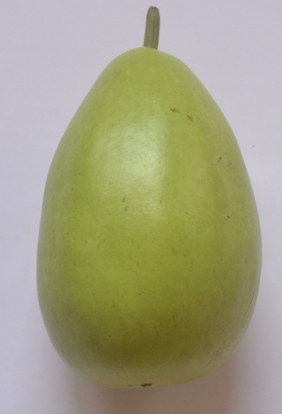
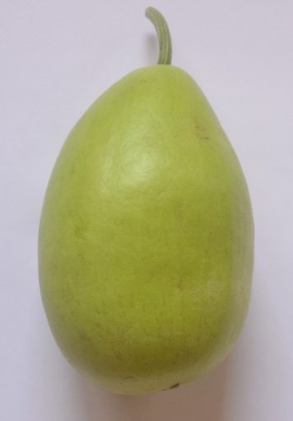

BOGVAR - 2

BOGVAR - 1

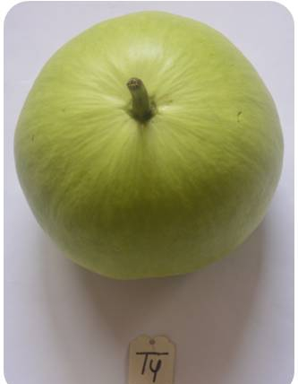
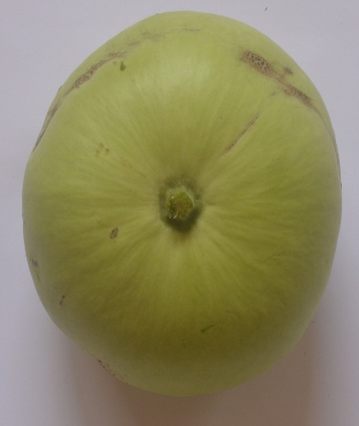

BOGVAR - 4

BOGVAR - 3

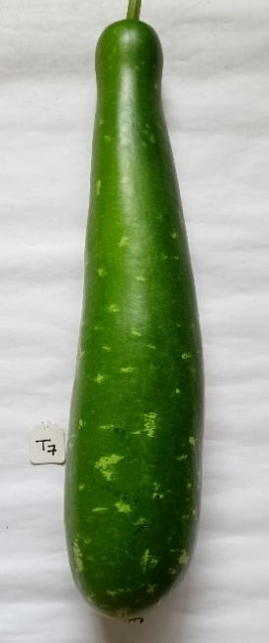
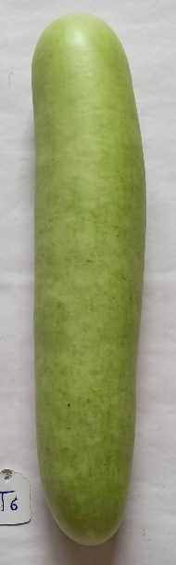
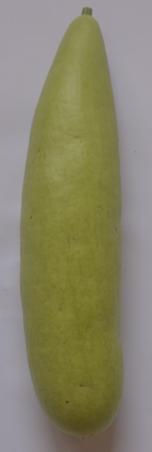

BOGVAR - 5

BOGVAR - 7

BOGVAR - 6

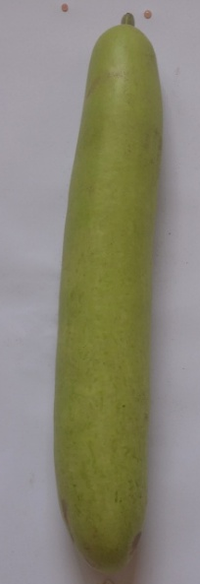
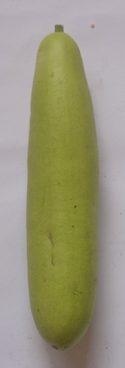

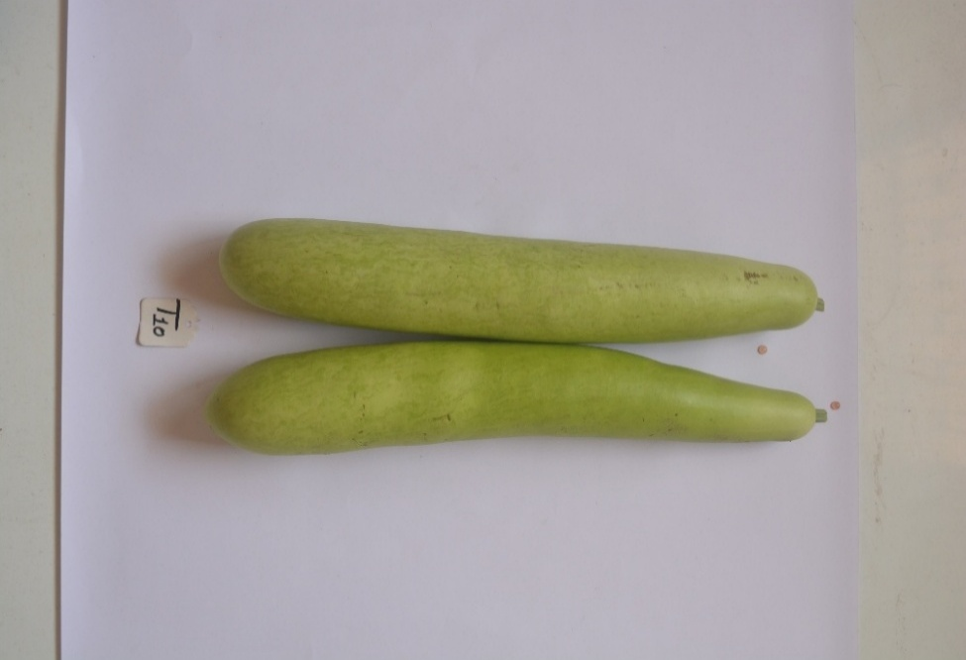

BOGVAR - 10

BOGVAR - 9

BOGVAR - 8

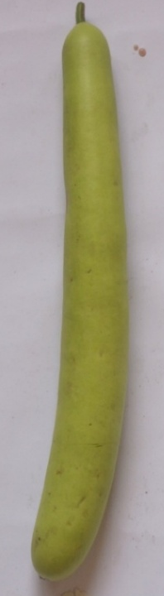
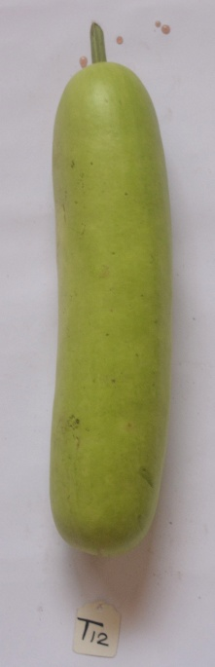
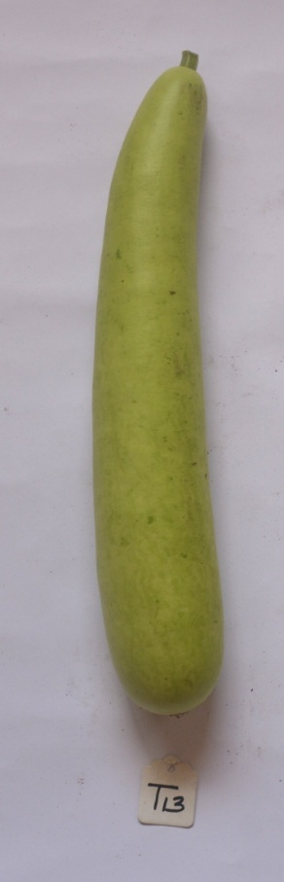
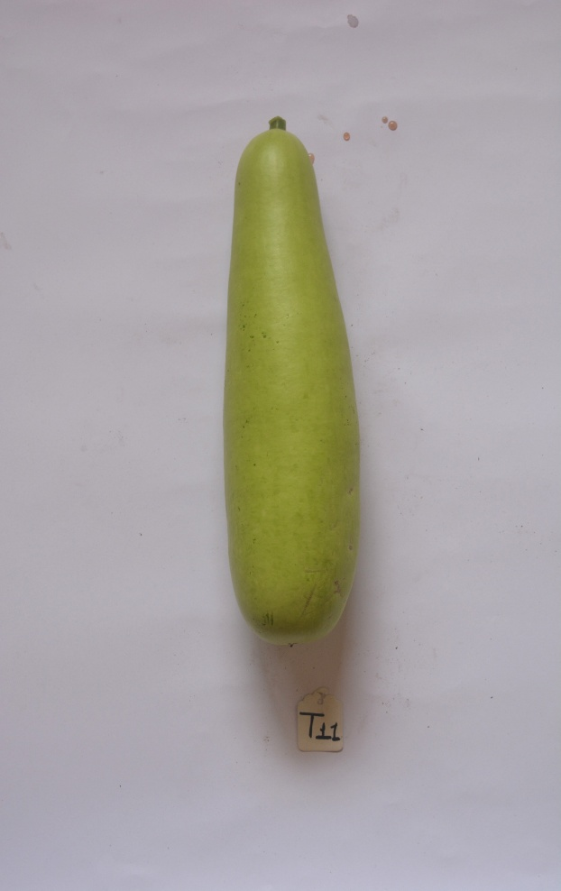

BOGVAR - 14

BOGVAR - 12

BOGVAR - 13

BOGVAR - 11

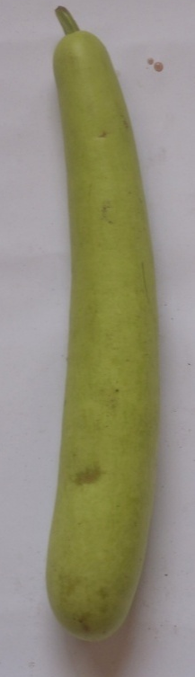
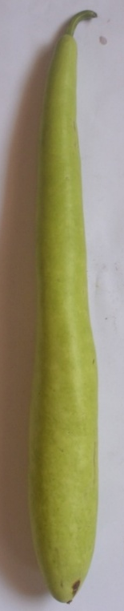
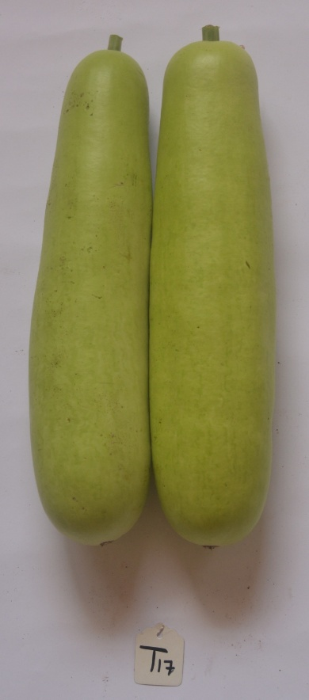
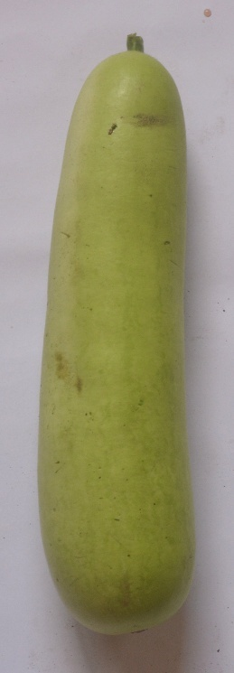

BOGVAR - 18

BOGVAR - 17
BOGVAR - 16

BOGVAR - 15

Table -1 Mean performance for fruit yield and its components in bottle gourd
Treatment | Days taken to 1st Germi-nation | Days taken to 50% Germi-nation | Plant height (m) |  | Days taken to 1st Male flower appears | Days taken to 1st Female flower appears | Node at which 1st Male flower appears | Node at which 1st Female flower appears | Number of fruits per plant | Days taken to 1st fruit harvest | Fruit length (cm) | Fruit diameter (cm) | Average fruit weight (g) | Fruit  yield/  plant  (kg) | Fruit yield /hac. (q)
Treatment | Days taken to 1st Germi-nation | Days taken to 50% Germi-nation | 60 DAS | 90 DAS
BOGVAR - 1 | 7.79 | 12.03 | 1.15 | 4.23 | 32.67 | 36.67 | 4.27 | 9.06 | 9.09 | 53.23 | 21.80 | 10.83 | 1138.72 | 8.97 | 269.00
BOGVAR - 2 | 8.81 | 13.85 | 1.47 | 4.17 | 33.05 | 37.67 | 4.86 | 9.54 | 8.17 | 52.27 | 22.83 | 11.14 | 1163.01 | 8.36 | 250.70
BOGVAR - 3 | 5.18 | 8.37 | 1.73 | 5.96 | 27.29 | 30.11 | 3.46 | 8.23 | 14.42 | 41.43 | 15.31 | 12.12 | 897.00 | 10.80 | 324.00
BOGVAR - 4 | 8.58 | 12.10 | 1.27 | 4.05 | 38.29 | 41.33 | 4.27 | 8.92 | 8.09 | 54.21 | 19.23 | 13.24 | 1071.63 | 7.87 | 236.10
BOGVAR - 5 | 7.60 | 10.78 | 1.35 | 3.89 | 34.21 | 42.23 | 4.42 | 9.75 | 7.60 | 57.93 | 31.20 | 6.99 | 927.73 | 7.52 | 225.50
BOGVAR - 6 | 11.19 | 17.69 | 1.38 | 3.44 | 39.24 | 43.82 | 4.85 | 10.11 | 8.04 | 62.03 | 31.48 | 5.96 | 896.11 | 6.56 | 196.80
BOGVAR - 7 | 9.60 | 12.09 | 1.32 | 4.31 | 44.41 | 49.83 | 4.72 | 10.88 | 6.53 | 67.69 | 47.05 | 6.29 | 1784.26 | 9.53 | 286.00
BOGVAR - 8 | 6.74 | 10.15 | 1.88 | 6.03 | 29.50 | 32.56 | 4.22 | 9.77 | 13.24 | 49.48 | 37.85 | 5.93 | 1038.53 | 12.76 | 383.90
BOGVAR - 9 | 8.66 | 11.47 | 1.66 | 4.58 | 31.89 | 35.45 | 4.62 | 9.22 | 10.59 | 52.81 | 36.72 | 6.03 | 914.40 | 10.10 | 303.10
BOGVAR - 10 | 5.16 | 8.55 | 1.63 | 5.45 | 27.62 | 30.67 | 4.14 | 9.12 | 11.01 | 47.15 | 35.28 | 5.89 | 1083.40 | 10.85 | 328.17
BOGVAR - 11 | 7.44 | 9.92 | 1.54 | 4.16 | 30.34 | 33.00 | 4.83 | 10.65 | 9.84 | 53.57 | 33.50 | 6.76 | 992.49 | 8.23 | 247.00
BOGVAR - 12 | 7.38 | 13.33 | 1.81 | 4.91 | 29.23 | 32.55 | 4.53 | 9.66 | 11.12 | 50.40 | 34.08 | 6.39 | 1043.41 | 10.70 | 321.00
BOGVAR - 13 | 7.45 | 13.21 | 1.66 | 4.29 | 29.33 | 31.78 | 4.32 | 11.55 | 10.40 | 48.24 | 38.53 | 5.76 | 1039.96 | 9.10 | 276.57
BOGVAR - 14 | 7.55 | 13.56 | 1.43 | 5.08 | 27.14 | 30.00 | 3.77 | 8.70 | 9.89 | 43.72 | 42.28 | 5.65 | 1242.67 | 10.77 | 326.10
BOGVAR - 15 | 10.01 | 13.43 | 1.25 | 4.38 | 33.17 | 37.78 | 4.30 | 10.77 | 8.89 | 49.82 | 39.51 | 5.72 | 1151.20 | 9.85 | 299.67
BOGVAR - 16 | 11.08 | 15.45 | 1.64 | 3.64 | 27.95 | 30.67 | 3.78 | 9.54 | 8.08 | 49.62 | 31.19 | 6.32 | 1081.24 | 7.45 | 227.17
BOGVAR - 17 | 11.12 | 13.20 | 1.68 | 3.99 | 34.17 | 39.33 | 3.63 | 8.60 | 9.33 | 51.26 | 34.12 | 6.45 | 958.56 | 7.67 | 230.20
BOGVAR - 18 | 7.33 | 10.43 | 1.57 | 4.26 | 30.13 | 36.22 | 4.24 | 9.02 | 7.48 | 54.23 | 57.42 | 5.36 | 1337.88 | 8.98 | 269.50
GM | 8.26 | 12.20 | 1.52 | 4.49 | 32.20 | 36.20 | 4.29 | 9.62 | 9.55 | 52.17 | 33.85 | 7.38 | 1097.90 | 9.23 | 277.80
CD (p=0.05) | 0.99 | 1.48 | 0.20 | 0.69 | 3.57 | 4.12 | 0.57 | 1.22 | 1.33 | 5.54 | 3.62 | 1.44 | 131.88 | 1.67 | 49.41
SEm± | 0.35 | 0.52 | 0.07 | 0.24 | 1.24 | 1.43 | 0.20 | 0.42 | 0.46 | 1.93 | 1.26 | 0.50 | 45.89 | 0.58 | 17.19
SEd | 0.49 | 0.73 | 0.10 | 0.34 | 1.76 | 2.03 | 0.28 | 0.60 | 0.65 | 2.73 | 1.78 | 0.71 | 64.89 | 0.82 | 24.31
C.V. (%) | 7.24 | 7.32 | 7.92 | 9.20 | 6.68 | 6.85 | 7.96 | 7.64 | 8.39 | 6.40 | 6.45 | 11.72 | 7.24 | 10.93 | 10.72

Conclusion
The results from the present investigation concluded that Bottle gourd Genotype BOGVAR-8 was recorded maximum fruit yield/plant (12.76 kg) and fruit yield/hectare (383.90 q), was superior among all the genotypes.

References
Bhardwaj, D. R., Singh, A. and Singh, U. 2013. Genetic variability of bottle gourd (Lagenaria siceraria (Mol.) Standl.) by multivariate analysis. Published in Proc. of National Symposium on Abiotic and Biotic Stress management in Vegetable Crops. Ind. Soc. Veg. Sci. pp., 370.
Bhatt, R., Raghav, M., Singh, J.P., Verma, S.K., Srivastava, R.M. and Maurya, S.K. 2022. Studies of genetic variability in bottle gourd (Lagenaria siceraria (Mol.) Standl). The Pharma Innovation, 11(9): 778-783.
Bhavanasi, S., Bahadur, V., Kerketta, A. and Prasad. V.M. 2022. Performance of Bottle Gourd (Lagenaria siceraria L.) Genotypes for Growth, yield and quality. International Journal of Plant and Soil Science, 34(23): 239-244.
Garande, V.K., Palghadmal, U.B., Padgaonkar, D.R., Sonawane, P.N., Dhumal, S.S. and Pawar R.D. 2017. Performance of Bottle Gourd Selections under Sub-Montane Zone of Maharashtra, India. International Journal of Current Microbiology and Applied Sciences, 6(11): 3011-3017.
Harika, M., Gasti, V.D., Shantapra, T., Mulge, R., Shirol, A.M., Mastiholi, A.B. and Kulkarni, M.S. 2012. Evaluation of bottle gourd genotypes (Lagenaria siceraria (Mol.) Standl.) for various horticultural characters. Karnataka J. Agric. Sci., 25(2): 241-244.
Kumar, A., Singh, B., Kumar, V., Singh, M. K. and Singh, K. V. 2012. Correlation and path coefficient analysis for certain metric traits in bottle gourd (Lagenaria siceraria (Mol.) Standl.) using line × tester analysis. Annals Horti., 5(1): 90-94.
Kumar, L., Trivedi, J., Sharma, D. and Dixit, A. 2019. Performance of bottle gourd genotypes for earliness and yield under Chhattisgarh conditions. International Journal of Chemical Studies, 7(4): 2326-2328.
Singh, R., Singh, B., Prakash, S., Kumar, M., Kumar, V., Chand, P. and Vaishali. 2021. Genetic variability, heritability and genetic advance in bottle gourd (Lagenaria Siceraria (Mol.) Standl.). Annals of Horticulture, 14 (1): 72-78.
Suman, A., Jha, A., Shivam., Mishra, A., Kumawat, A. 2023. Analysis of genetic variability, heritability and genetic advance for yield and yield-associated traits for bottle gourd (Lagenaria siceraria (Mol.) Standl.). International Journal of Research in Agronomy, 7(8): 35-38.
Thakur, P., Sharma, D., Vishan,V. K., Dash, S.P. 2015. Evaluation of bottle gourd (Lagenaria siceraia (Mol.) Standl.) genotypes. Plant Archives, 15(2):1037-1040.
Venkatraman, M., Anbarasi, D. And Haripriya, K. 2024. Evaluation of genetic variability, heritability and genetic advance in thirty-five bottle gourd (Lagenaria siceraria) varieties for yield and yield related traits. Plant Archives 24(1):1203-1210.
Visen, V.K., Sharma, D., Thakur, P. 2015. Performance of bottle gourd genotypes for earliness and yield under Chhattisgarh plains. Trends in Biosciences., 8(18) :4823-4826.

