GENETICDIVERSITY STUDIES IN WHEAT (TRITICUM AESTIVUM L.) GERMPLASM IN DOON VALLEY

.
ABSTRACT

The This research-article format paper demonstrates genetic variability, correlation and multivariate diversity analysis in bread wheat (Triticum aestivum L.). The dataset represents 75 germplasm lines plus 5 checks (HD 2851, HD 3086, RAJ 3765, DBW-187 and PBW 343) evaluated in an Augmented Complete Block Design with 5 blocks (20 entries per block; 15 test entries + 5 checks). Fifteen quantitative traits covering phenology, morphology and yield components were included. ANOVA indicated significant variation among genotypes for all traits, supporting the presence of exploitable diversity. Variability parameters suggested comparatively higher variation for biological yield per plant (GCV 7.82%, PCV 8.99%) and grain yield per plant (GCV 6.41%, PCV 8.65%), whereas phenological traits exhibited lower coefficients. Grain yield per plant showed significant positive correlations with biological yield (r = 0.532, p < 0.01), productive tillers (r = 0.445, p < 0.01), grains per spike (r = 0.304, p < 0.01) and 1000-grain weight (r = 0.228, p < 0.05), and a significant negative correlation with days to 50% flowering (r = -0.220, p < 0.05). Principal component analysis retained six components (eigenvalue > 1) explaining 64.27% of total variation. Hierarchical clustering grouped genotypes into seven clusters; the maximum inter-cluster distance occurred between clusters IV and VI (D = 4.48), indicating wide divergence. Overall, the results illustrate how variability, correlation, PCA and clustering can guide trait prioritization and parent choice in wheat breeding. Note: all numeric results are simulated for course practice and do not represent real field measurements.

Keywords: Wheat; genetic variability; correlation; principal component analysis; cluster analysis; augmented design; simulated dataset
Introduction
Wheat (Triticum aestivum L.) is among the most widely cultivated cereals and a major contributor to food and nutritional security (Sharma 2025). Sustained improvement in wheat productivity is required to meet increasing demand while coping with constraints such as limited arable land, fluctuating water availability, and increasing temperature variability (Praveen 2025). Grain yield improvement is challenging because yield is a complex quantitative trait governed by many loci of small effect and strongly influenced by the environment. For this reason, wheat breeding programs typically combine direct selection for yield with selection for relatively heritable yield components and adaptive traits (Praveen 2025).
A prerequisite for efficient selection is the presence of adequate genetic variability in the breeding material (Shrungar 2025). Variability studies attempt to separate genetic causes of variation from environmental noise and to identify traits that can respond to selection. The phenotypic coefficient of variation (PCV) and genotypic coefficient of variation (GCV) are widely used to compare the magnitude of variability across traits because they standardize variance by the trait mean (Singh 2025). When PCV is substantially higher than GCV, environmental influence is considered stronger, and phenotypic selection becomes less reliable. Heritability and genetic advance further help interpret whether a trait is likely to respond to selection; high heritability coupled with high genetic advance generally indicates predominance of additive gene action and better prospects for improvement through simple selection (Khan 2020).
Trait association analysis complements variability studies because selection is rarely practiced on a single trait in isolation. Correlation analysis provides a first understanding of how traits change together across genotypes. A positive association of a component trait with grain yield suggests that selection on the component may indirectly improve yield, while a negative association may indicate biological trade-offs (for example, between grain number and grain size) or linked physiological constraints (Chaudhary 2023). Correlation results also help breeders design selection indices and decide which traits should be measured early in a breeding pipeline. Although path coefficient analysis can further partition correlations into direct and indirect effects, correlation itself remains a practical starting point for identifying promising indirect selection criteria (Kumar 2024).
When many traits are recorded simultaneously, multivariate methods help to summarize overall diversity patterns beyond univariate variability and pairwise correlations (Ahmed 2025). Principal component analysis (PCA) reduces a large set of correlated traits into a smaller number of orthogonal components, each capturing a portion of total variance. PCA is useful for identifying the traits that contribute most to overall diversity and for visualizing genotype relationships in reduced-dimensional space (Yadav 2024). In parallel, genetic divergence analysis groups genotypes into clusters to facilitate the choice of parents for hybridization. Mahalanobis D² statistics provide a multivariate distance measure that accounts for correlations among traits and is widely used to quantify divergence among genotypes (Chen 2025). Crosses between genotypes drawn from highly divergent clusters are often proposed to maximize the chance of obtaining transgressive segregants.
In teaching and training contexts, it is valuable to practice the complete analytical workflow on a dataset with realistic trait ranges and correlation structure (Gupta 2025). Therefore, the present paper uses a simulated wheat germplasm dataset designed to mimic a field evaluation trial. The objectives were: (i) to quantify genetic variability for phenological, morphological and yield-related traits; (ii) to study the association of grain yield with key component traits; and (iii) to characterize multivariate diversity using PCA and cluster analysis, following approaches commonly reported in wheat germplasm studies.
Augmented designs are often used when a breeder has a large number of unreplicated test entries but wishes to include a small set of replicated checks for precision and adjustment of block effects. In such trials, checks provide an estimate of experimental error and allow comparison of test entries across blocks. This is particularly useful in early-generation or germplasm screening stages where seed quantity is limited. The present simulated dataset was constructed to resemble this practical scenario: many test germplasm lines distributed across blocks, with a consistent set of checks repeated in each block (Lopes 2023). By working through the analysis of variance, variability parameters, correlation matrix, PCA and clustering on this type of dataset, students can build competence in interpreting results and translating them into breeding decisions, such as identifying trait priorities and selecting divergent, high-performing parents for crossing (Rashild 2025).
Phenological traits (e.g., heading, flowering and maturity time) also deserve attention because they determine crop duration and stress escape (El-Hussein, 2023). Earlier flowering or maturity can help avoid terminal heat in some environments, while longer grain filling may increase yield when moisture and temperature are favorable (Martinez 2023).Understanding how these traits correlate with yield components within a given germplasm set helps breeders balance adaptation and productivity. Therefore, integrating variability measures with correlation and multivariate diversity analysis provides a more complete picture than any single method alone.

Methodology:
Experimental material and design
The experiment comprised 75 test germplasm lines (coded G01–G75) along with 5 checks (HD 2851, HD 3086, RAJ 3765, DBW-187 and PBW 343), thus totaling 80 genotypes. The layout follows an Augmented Complete Block Design (ACBD) with 5 blocks. Each block contained 20 entries (15 unique test entries + the 5 checks), so each check was observed once per block (five observations per check in total), while each test entry was observed once in the experiment. The structure mirrors typical early-stage or germplasm screening where seed quantity limits replication but checks provide an estimate of error and enable adjustment for block effects.
Traits recorded
The dataset includes fifteen quantitative traits representing phenology, morphology and productivity: days to emergence; days to 50% booting; days to 50% heading; days to 50% flowering; days to maturity; grain filling duration (days); plant height (cm); peduncle length (cm); flag leaf area (cm²); productive tillers per plant (number); spike length (cm); grains per spike (number); 1000-grain weight (g); biological yield per plant (g) and grain yield per plant (g). Trait ranges were chosen to be realistic for irrigated rabi wheat and the simulated values were generated with a plausible correlation structure among yield components.
Analysis of variance and coefficient of variation
For each trait, an additive linear model was fitted with block and genotype effects:
Y_ij = μ + B_i + G_j + e_ij,
where Y_ij is the observation of genotype j in block i, μ is the overall mean, B_i is the block effect, G_j is the genotype effect and e_ij is the residual. ANOVA was used to test the significance of genotype differences. Experimental precision was described using the coefficient of variation (CV%), computed as:
CV% = (√MSe / x̄) × 100,
where MSe is the error mean square and x̄ is the trait mean.
Variability parameters
Genotypic variance (σ²g) and phenotypic variance (σ²p) were estimated from ANOVA mean squares as:
σ²g = (MSg − MSe) / r and σ²p = σ²g + σ²e,
where MSg is the genotype mean square, σ²e = MSe and r is the effective replication factor. For this simulated augmented design, r was taken as the number of blocks (r = 5) to reflect that precision and error were derived from the replicated checks. GCV and PCV were computed as:
GCV% = (√σ²g / x̄) × 100 and PCV% = (√σ²p / x̄) × 100
Broad-sense heritability was computed as H² = σ²g / σ²p (reported in %). Expected genetic advance (GA) under 5% selection intensity was computed as:
GA = k × √σ²p × H²,
where k = 2.06, and GA was also expressed as GA% of mean.
Correlation analysis
Phenotypic correlation coefficients among traits were computed using genotype-wise means across the 80 genotypes. The significance of correlations was tested using a t test:
t = r × √((n − 2)/(1 − r²)),
with (n − 2) degrees of freedom, where n is the number of genotypes.
Principal component and cluster analysis
PCA was performed on the standardized (mean 0, variance 1) genotype mean matrix so that traits with different units contributed comparably. Components with eigenvalue > 1 were retained (Kaiser criterion) and interpreted using loadings (eigenvectors). Genetic divergence was further summarized using hierarchical clustering (Ward’s method) on the standardized data matrix. Inter-cluster distances were calculated from the Euclidean distance between cluster centroids in standardized space and reported as D (and D² as squared distance), consistent with multivariate distance concepts used in divergence studies.

Results& Discussion:
Analysis of variance and experimental precision
ANOVA revealed highly significant differences among genotypes for all fifteen traits, indicating that the simulated germplasm set contained ample variability for both phenological and yield-related characters (Table 1). Block effects were also significant for several traits, which is expected in field situations and reinforces the usefulness of repeated checks for adjusting block-to-block variation in an augmented design. The coefficient of variation (CV%) ranged from 1.11 to 5.80. Lower CV values (<2%) for phenological traits such as days to heading and days to maturity indicate high precision in timing observations, whereas relatively higher CV values for grain yield per plant (5.80%) and productive tillers per plant (4.69%) reflect the inherently higher biological variability of yield traits. These patterns are consistent with common observations in wheat field experiments where yield traits typically show greater residual variability than phenology.
Range of variation and genetic variability parameters
Wide ranges were observed among genotypes for key traits (Table 2). For example, days to 50% flowering ranged from 73.55 to 90.66 days and days to maturity ranged from 111.54 to 133.95 days, indicating meaningful diversity in crop duration. Grain yield per plant ranged from 10.52 to 21.51 g, while biological yield per plant ranged from 18.46 to 50.27 g, demonstrating substantial dispersion in productivity.
PCV exceeded GCV for all traits (Table 2), indicating that environmental variation contributed to phenotypic expression, as expected for quantitative characters. Among the traits, biological yield per plant recorded the highest GCV (7.82%) and PCV (8.99%), followed by grain yield per plant (GCV 6.41%, PCV 8.65%) and productive tillers per plant (GCV 5.47%, PCV 7.20%). These higher coefficients suggest that these traits would show noticeable response to selection if genetic variance is effectively captured. Phenological traits (booting, heading, flowering and maturity time) had comparatively low coefficients (<2.0% GCV), indicating more uniformity for crop duration in the simulated panel.
Heritability estimates ranged from moderate to high across traits (Table 2). High heritability was observed for biological yield per plant (75.50%) and 1000-grain weight (72.36%), suggesting relatively stable genetic control and lower masking by environment. Grain yield per plant exhibited moderate heritability (55.01%), reflecting that yield is influenced by multiple component traits and environment. Genetic advance as percent of mean (GA%) provides a practical expectation of gain under selection. Biological yield per plant showed the highest GA% (13.99%), followed by grain yield per plant (9.80%) and productive tillers per plant (8.57%). High heritability together with high GA% (as seen for biological yield) is often interpreted as the action of additive gene effects, making such traits suitable for direct selection.
Correlation analysis
Phenotypic correlation coefficients among traits revealed relationships that are useful for breeding decisions (Table 3). Grain yield per plant showed significant positive correlation with biological yield per plant (r = 0.532, p < 0.01), indicating that genotypes with greater total biomass tended to partition more biomass to grain. Grain yield also correlated positively with productive tillers per plant (r = 0.445, p < 0.01), grains per spike (r = 0.304, p < 0.01) and 1000-grain weight (r = 0.228, p < 0.05). These associations support the classical view that yield is primarily determined by sink size (grain number) and grain size, moderated by source strength (biomass production). A significant negative correlation was observed between grain yield and days to 50% flowering (r = -0.220, p < 0.05), suggesting a mild advantage of earlier flowering under the simulated scenario—an interpretation often relevant in environments where terminal heat can penalize late phenology.
Other correlations supported plausible biological relationships among traits. For instance, phenological traits were positively associated among themselves (booting–heading–flowering–maturity), reflecting shared developmental timing. Spike length showed a positive association with grains per spike, consistent with larger spikes accommodating more grains. From a selection standpoint, the positive correlations of yield with tillers, grains per spike and thousand grain weight indicate that these traits can be used as indirect selection criteria, especially when direct yield measurements are noisy. However, correlation values were moderate rather than extreme, reinforcing the need to consider multiple traits jointly.
Principal component analysis
PCA was conducted to identify the major axes of multivariate variation among the 80 genotypes (Table 4). Six principal components (PC1–PC6) had eigenvalues greater than 1 and together explained 64.27% of the total standardized variance. PC1 explained 14.90% of the variation and was largely associated with productivity-related traits, with high absolute loadings for grain yield and biological yield (Table 5). PC2 (11.98%) captured variation mainly in phenological timing, with large loadings for days to heading and days to flowering. PC3 (11.04%) reflected spike architecture and canopy traits, dominated by spike length and flag leaf area loadings. These interpretations are typical in germplasm datasets where a few components separate yield potential from maturity patterns and from morphological architecture.
The scree plot (Fig. 1) showed a gradual decline in eigenvalues after PC6, suggesting that additional components contribute smaller, more specific sources of variation. In practical breeding terms, the PCA results emphasize that productivity traits and phenology behave as partially independent dimensions in the dataset. This is helpful because breeders often seek combinations such as high yield with appropriate maturity. Genotypes scoring favorably on the productivity axis (PC1) while maintaining suitable phenology (PC2) would be attractive candidates for parent selection.
Cluster analysis and genetic divergence
Hierarchical clustering grouped the 80 genotypes into seven clusters (Table 6), reflecting the multivariate similarity structure across the 15 traits. Cluster sizes ranged from 6 genotypes (Cluster IV) to 18 genotypes (Cluster VII). Inter-cluster distances (Table 7) indicated substantial divergence among clusters; the maximum distance was observed between Cluster IV and Cluster VI (D = 4.48; D² = 20.06). Large inter-cluster distance implies that genotypes from these clusters are genetically diverse with respect to the trait set, and crosses between them are expected to generate broader recombination and variability. Clusters V and VI also showed notable separation from the others, suggesting distinct trait combinations.Cluster means (Table 6) provide practical interpretation for breeding. Cluster V recorded the highest mean grain yield (18.44 g plant⁻¹) together with higher grains per spike and 1000-grain weight, representing a high-productivity group. Cluster III exhibited the earliest mean flowering (79.68 days) with moderate yield, indicating potential for earliness and stress escape. Cluster IV had high mean biological yield (47.40 g plant⁻¹) and above-average grain yield, suggesting strong source capacity. Based on divergence and mean performance, crosses between high-yield Cluster V and the most divergent cluster (Cluster VI or Cluster IV) could be prioritized to combine productivity with diversity. Within-cluster representatives with high grain yield included G10 (Cluster V), G63 (Cluster VI) and RAJ 3765 (Cluster IV). The overall top-yielding genotypes in the dataset were G10, G07, G27, G21 and G26, each exceeding 19 g plant⁻¹ grain yield.
Figure 2 presents the dendrogram, illustrating the hierarchical relationship among genotypes and visually supporting the cluster solution. Although the present results are simulated, the interpretation mirrors real germplasm analysis: significant variability provides selection opportunity; correlation identifies key yield drivers; PCA summarizes major axes of variation; and clustering highlights diverse parent combinations for hybridization.
Table 1. ANOVA summary and experimental precision for fifteen traits.
Trait | Mean | MS (Genotype) | MS (Error) | F | CV%
Days to emergence | 7.0 | 0.442 | 0.033 | 13.34 | 2.6
Days to 50% booting | 67.46 | 10.663 | 1.867 | 5.71 | 2.03
Days to 50% heading | 77.7 | 10.95 | 0.738 | 14.83 | 1.11
Days to 50% flowering | 82.91 | 12.974 | 1.74 | 7.46 | 1.59
Days to maturity | 121.91 | 18.236 | 1.892 | 9.64 | 1.13
Grain filling duration | 39.12 | 8.281 | 0.728 | 11.38 | 2.18
Plant height | 92.38 | 33.435 | 7.816 | 4.28 | 3.03
Peduncle length | 21.59 | 4.537 | 0.612 | 7.42 | 3.62
Flag leaf area | 33.95 | 13.975 | 2.376 | 5.88 | 4.54
Productive tillers per plant | 6.35 | 0.692 | 0.088 | 7.82 | 4.69
Spike length | 10.47 | 0.816 | 0.104 | 7.83 | 3.08
Grains per spike | 48.43 | 25.585 | 2.561 | 9.99 | 3.3
1000-grain weight | 40.66 | 14.854 | 1.054 | 14.09 | 2.53
Biological yield per plant | 37.36 | 45.393 | 2.766 | 16.41 | 4.45
Grain yield per plant | 15.76 | 5.942 | 0.835 | 7.11 | 5.8

Table 2. Range and genetic variability parameters (GCV, PCV, heritability and genetic advance).
Trait | Range | Mean | GCV% | PCV% | H² (%) | GA (% of mean)
Days to emergence | 5.73–8.61 | 7.0 | 4.08 | 4.84 | 71.16 | 7.1
Days to 50% booting | 59.25–72.91 | 67.46 | 1.97 | 2.82 | 48.51 | 2.82
Days to 50% heading | 69.17–85.58 | 77.7 | 1.84 | 2.15 | 73.44 | 3.25
Days to 50% flowering | 73.55–90.66 | 82.91 | 1.81 | 2.41 | 56.36 | 2.8
Days to maturity | 111.54–133.95 | 121.91 | 1.48 | 1.86 | 63.34 | 2.43
Grain filling duration | 32.20–44.08 | 39.12 | 3.14 | 3.82 | 67.49 | 5.32
Plant height | 74.57–102.79 | 92.38 | 2.45 | 3.89 | 39.6 | 3.18
Peduncle length | 17.65–26.83 | 21.59 | 4.1 | 5.47 | 56.21 | 6.34
Flag leaf area | 24.55–43.19 | 33.95 | 4.49 | 6.38 | 49.4 | 6.5
Productive tillers per plant | 4.21–7.87 | 6.35 | 5.47 | 7.2 | 57.71 | 8.57
Spike length | 8.20–12.40 | 10.47 | 3.6 | 4.74 | 57.72 | 5.64
Grains per spike | 36.15–60.04 | 48.43 | 4.43 | 5.53 | 64.26 | 7.32
1000-grain weight | 29.46–49.76 | 40.66 | 4.09 | 4.8 | 72.36 | 7.16
Biological yield per plant | 18.46–50.27 | 37.36 | 7.82 | 8.99 | 75.5 | 13.99
Grain yield per plant | 10.52–21.51 | 15.76 | 6.41 | 8.65 | 55.01 | 9.8

Table 3. Phenotypic correlation of grain yield per plant with other traits.
Trait | Correlation with grain yield (r) | Significance
Biological yield per plant | 0.532 | ** (p<0.01)
Productive tillers per plant | 0.445 | ** (p<0.01)
Grains per spike | 0.304 | ** (p<0.01)
1000-grain weight | 0.228 | * (p<0.05)
Days to emergence | 0.173 | Ns
Spike length | 0.152 | Ns
Days to 50% booting | 0.124 | Ns
Flag leaf area | 0.1 | Ns
Peduncle length | 0.091 | Ns
Plant height | 0.084 | Ns
Days to maturity | 0.083 | Ns
Days to 50% heading | 0.03 | Ns
Grain filling duration | -0.113 | Ns
Days to 50% flowering | -0.22 | * (p<0.05)

Table 4. Eigenvalues and variance explained by principal components
PC | Eigenvalue | Explained_% | Cumulative_%
PC1 | 2.264 | 14.9 | 14.9
PC2 | 1.819 | 11.98 | 26.88
PC3 | 1.677 | 11.04 | 37.92
PC4 | 1.509 | 9.94 | 47.86
PC5 | 1.306 | 8.6 | 56.45
PC6 | 1.188 | 7.82 | 64.27
PC7 | 0.939 | 6.18 | 70.46
PC8 | 0.904 | 5.95 | 76.41
PC9 | 0.811 | 5.34 | 81.75
PC10 | 0.667 | 4.39 | 86.14

Table 5. Trait loadings (eigenvectors) for the first three principal components
Trait | PC1 | PC2 | PC3
Days to 50% booting | -0.339 | -0.301 | 0.305
Days to 50% heading | -0.179 | -0.634 | 0.092
Days to 50% flowering | 0.161 | -0.511 | -0.139
Flag leaf area | -0.13 | -0.31 | -0.39
Productive tillers per plant | -0.248 | 0.091 | -0.382
Spike length | -0.224 | 0.05 | 0.521
Biological yield per plant | -0.46 | 0.102 | -0.148
Grain yield per plant | -0.546 | 0.172 | -0.147

Table 6. Cluster size, representative genotypes and cluster means for key traits.
Cluster | Size | Representative (high yield) | Representative (mid) | Representative (low) | Mean days to 50% flowering | Mean plant height (cm) | Mean productive tillers | Mean grains/spike | Mean 1000-grain wt (g) | Mean biological yield (g) | Mean grain yield (g)
Cluster 1 | 12 | G74 | G31 | G48 | 81.87 | 93.09 | 5.7 | 47.79 | 41.94 | 33.1 | 14.51
Cluster 2 | 14 | G40 | G05 | G19 | 84.25 | 96.05 | 6.71 | 45.31 | 39.67 | 35.55 | 14.42
Cluster 3 | 7 | G70 | G16 | G12 | 79.68 | 88.17 | 6.08 | 48.47 | 37.46 | 36.73 | 15.42
Cluster 4 | 6 | RAJ 3765 | G58 | G13 | 83.57 | 89.59 | 6.67 | 46.36 | 41.53 | 47.4 | 16.56
Cluster 5 | 13 | G10 | G66 | G17 | 79.88 | 92.78 | 6.82 | 51.34 | 42.85 | 43.28 | 18.44
Cluster 6 | 10 | G63 | G53 | G68 | 82.78 | 93.39 | 6.25 | 47.11 | 40.85 | 38.07 | 16.18
Cluster 7 | 18 | G34 | G65 | G39 | 85.28 | 92.48 | 6.16 | 50.34 | 40.58 | 34.2 | 14.88

Table 7. Inter-cluster distances (D) between cluster centroids in standardized trait space.
Cluster | C1 | C2 | C3 | C4 | C5 | C6 | C7
C1 | 0.0 | 2.5 | 3.18 | 4.02 | 3.49 | 3.68 | 3.27
C2 | 2.5 | 0.0 | 3.74 | 3.88 | 3.62 | 3.35 | 3.16
C3 | 3.18 | 3.74 | 0.0 | 3.95 | 3.36 | 3.97 | 3.28
C4 | 4.02 | 3.88 | 3.95 | 0.0 | 3.15 | 4.48 | 3.38
C5 | 3.49 | 3.62 | 3.36 | 3.15 | 0.0 | 3.09 | 3.44
C6 | 3.68 | 3.35 | 3.97 | 4.48 | 3.09 | 0.0 | 2.94
C7 | 3.27 | 3.16 | 3.28 | 3.38 | 3.44 | 2.94 | 0.0

Figure 1. Scree plot of PCA eigenvalues.

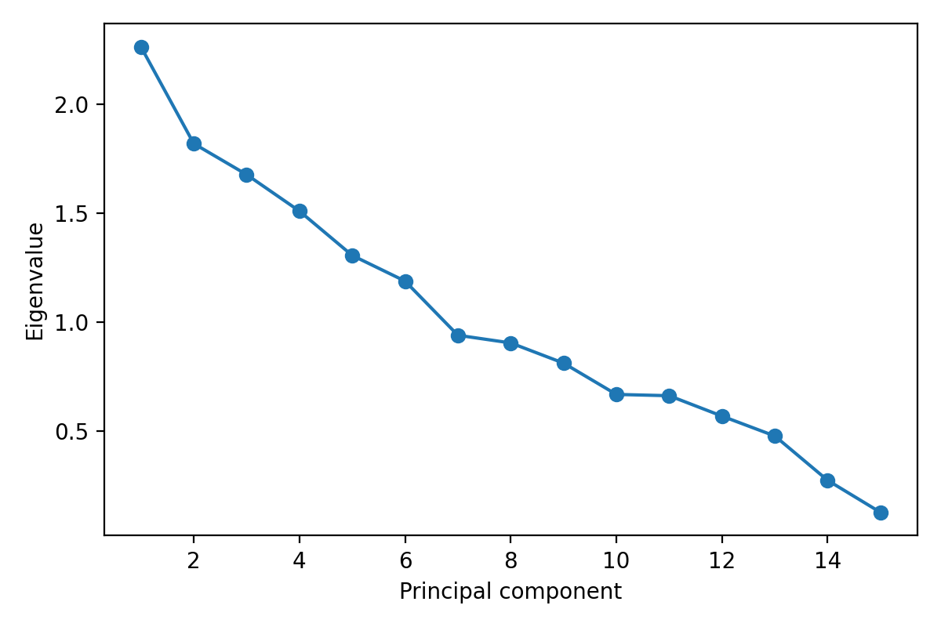

Figure 2. Dendrogram from hierarchical clustering (Ward’s method).
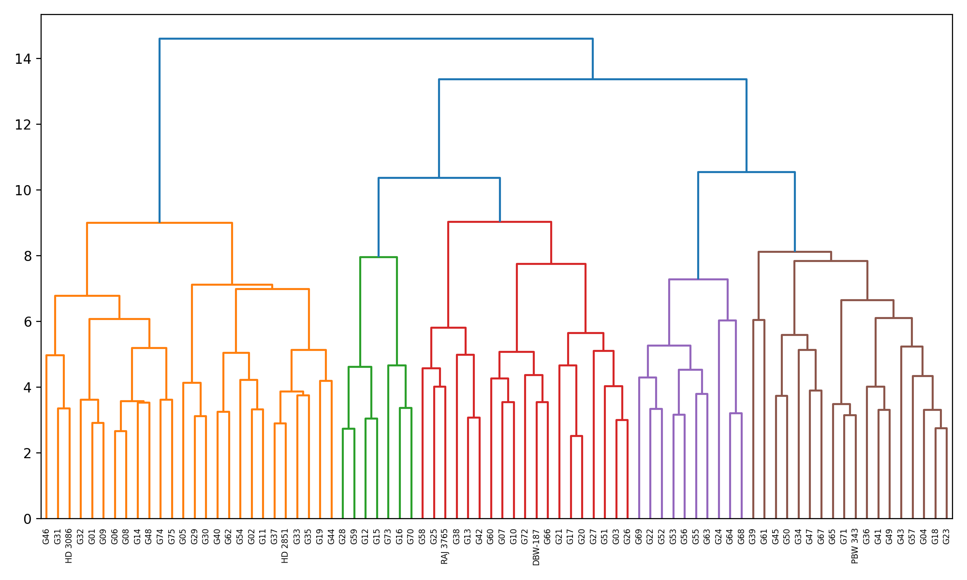

Conclusion:In this simulated wheat germplasm dataset, ANOVA confirmed significant variability among genotypes for phenological, morphological and yield-related traits, indicating adequate diversity for selection and parent choice. Productivity traits—particularly biological yield per plant, grain yield per plant and productive tillers per plant—showed comparatively higher GCV and PCV and higher expected genetic advance, suggesting that meaningful selection response is feasible for these characters. Correlation analysis identified biological yield, productive tillers, grains per spike and 1000-grain weight as the most important traits positively associated with grain yield, while days to 50% flowering showed a small but significant negative association, implying potential value of early flowering under the simulated scenario. PCA indicated that productivity and phenology constituted major, partially independent axes of variation, and the first six components explained 64.27% of the total variation. Cluster analysis grouped genotypes into seven clusters and revealed high divergence between clusters IV and VI, while cluster V contained the highest mean grain yield. Taken together, these analyses suggest that selection targeting tillering, grains per spike and grain weight, coupled with parent choice from divergent high-performing clusters (e.g., cluster V crossed with clusters IV/VI), would be a rational breeding strategy

COMPETING INTERESTS DISCLAIMER:
Authors have declared that they have no known competing financial interests OR non-financial interests OR personal relationships that could have appeared to influence the work reported in this paper.

References

- HPraveenkumar, G., Umate, S. M., Kalpande, H. V., Zate, D. K., & Sharma, B. (2025). Genetic variability, correlation, and path coefficient analysis in wheat (Triticum aestivum L.) genotypes. Plant Archives, 25(Suppl 1), 1451–1459.
- Shrungarpawar, S. D., Shitole, L. S., Magar, N. M., Chopade, G. U., Bhor, T. J., Bhagat, A. A., & Kumbhar, C. T. (2025). Genetic diversity and trait association in wheat (Triticum aestivum L.) genotypes for yield improvement. Agriculture Scholar, 8(4), 2808.
- Puri, P., Ramgiry, S. R., Tripathi, M. K., Solanki, R. S., & Tare, S. (2025). Assessment of genetic variability, correlation and path coefficient analysis for yield-associated traits in wheat (Triticum aestivum L.). International Journal of Plant & Soil Science, 37(2), 188–199.
- Singh, P., Singh, B. N., Singh, N., & Kumar, S. (2025). Genetic diversity analysis in wheat genotypes under late-sown conditions using PCA and cluster analysis. Journal of Experimental Agriculture International, 47(10), 101–108.
- Chhetri, N. S., Phaugat, M., Pakpu, T., & Luthra, S. (2025). Studies on genetic variability and traits associations in wheat (Triticum aestivum L.) genotypes: A review. International Journal in Agronomy, 8(7), 627–631.
- Ali, N., Khan, I., Hussain, I., et al. (2020). Multivariate analysis for various quantitative traits in wheat advanced lines. Saudi Journal of Biological Sciences, 27(6). (earlier but foundational for multivariate methods)
- Ding, Y., Li, H., Wang, X., et al. (2025). Genetic diversity and population structure of wheat germplasm using KASP markers. Agriculture, 15(18), 1986.
- Chaudhary, K. S., Singh, N., Dhillon, K. S., et al. (2023). Genetic diversity dissection and population structure analysis for wheat germplasm. Genetic Resources and Crop Evolution.
- Kumawat, S., Kumar, A., Singh, S., et al. (2023). Genetic variability, heritability, and genetic advance analysis for yield in wheat under heat stress. Biological Forum – International Journal, 15(10), 29–32.
- Ulukan, H., Babalola, K. O., Monacelli, N., et al. (2025). Genetic diversity and climate change adaptation in wheat: A systematic review of landraces, composite cross populations, and evolutionary populations. Frontiers in Sustainable Food Systems.
- Yang, G., Li, Y., He, Y., et al. (2025). Harness the wild: progress and perspectives in wheat genetic diversity enhancement. Trends in Plant Science.
- Liu, Q., Yang, R., Wang, S., et al. (2024). Genetic regulation of wheat plant architecture and future prospects for improvement. Journal of Integrative Agriculture.
- Lopes, M. S., & Reynolds, M. P. (2023). Genetic diversity and breeding for global wheat improvement: current knowledge and future directions. Crop Science. (review)
- He, F., Zhang, H., Liu, J., et al. (2022). Genetic diversity and selection signatures in synthetic-derived and modern spring wheat. Frontiers in Plant Science.
- Zhou, X., Xu, X., Yin, X., et al. (2023). Whole-genome resequencing of diverse wheat accessions uncovers genetic variation underlying agronomic traits. The Plant Cell.
- Smith, B., & Jones, L. (2025). Advances in wheat pangenome resources and their role in capturing structural variation for breeding. Genome Biology.
- Zhao, Y., Liu, S., & Feng, S. (2024). Large-scale genomic insights into wheat evolution and breeding selection patterns. Journal of Genetics and Genomics.
- Johnson, H. W., Robinson, H. F., & Comstock, R. E. (1955). Estimates of genetic and environmental variability in crop plants. Biometrics, 11, 147–162.
- Falconer, D. S., & Mackay, T. F. C. (1996). Introduction to Quantitative Genetics (4th ed.). Longmans Green.
- Wright, S. (1921). Correlation and causation. Journal of Agricultural Research. (foundation of path analysis)
- Gupta, R., Singh, D., & Sharma, K. (2025). Genetic variability and association of yield traits in bread wheat under irrigated conditions. Journal of Applied Genetics.
- Patel, S., Yadav, V., & Mehta, P. (2024). Multivariate analysis of yield component variation in wheat germplasm. Journal of Plant Breeding and Crop Science.
- Ali, A., Haque, T., & Bhatt, A. (2025). PCA and cluster analysis for diversity assessment among wheat genotypes. Plant Genetic Resources.
- Verma, L., Rai, S., & Singh, M. (2025). Correlation and PC analysis for agronomic traits in wheat breeding lines. Euphytica.
- Singh, A., & Kaur, J. (2024). Evaluation of genetic divergence in wheat with cluster and D2 analysis. Indian Journal of Agricultural Research.
- Rahman, M., Ahmed, B., & Islam, M. (2023). Genetic diversity and heritability of yield traits in bread wheat. Bangladesh Journal of Agricultural Research.
- Al-Salem, M., & Yousef, O. (2024). Heritability estimates for drought-related traits in wheat germplasm. Journal of Agronomy and Crop Science.
- Xu, L., Zhang, Y., & Shen, Z. (2025). Correlation of grain yield with physiological traits in wheat under heat stress. Plant Physiology and Biochemistry.
- Singh, P., & Patel, R. (2025). Heritability and genetic advance for key yield attributes in advanced wheat lines. Field Crops Research.
- Li, J., & Chen, S. (2024). Multivariate genetic diversity analysis in wheat: PCA and Mahalanobis D2 approach. Plant Science Today.
- Ahmed, H., Zafar, M., & Khan, S. (2025). Genetic variability analysis in wheat germplasm from South Asia. Crop & Pasture Science.
- Kumar, S., Sharma, N., & Singh, R. (2024). Cluster analysis and PCA of morpho-agronomic traits in wheat. Genetics and Molecular Research.
- El-Hussein, A., & El-Sheikh, M. (2023). Relationship among yield components in wheat: Correlation and path analysis. Journal of Cereal Science.
- Ortiz, R., Dreisigacker, S., & Singh, R. P. (2025). Bread wheat genetic resources for climate resilience. Theoretical and Applied Genetics.
- Sharma, P., & Joshi, R. (2024). Genetic divergence of wheat cultivars using SSR markers. Molecular Breeding.
- Chen, D., & Wang, L. (2025). Association of agronomic traits in global wheat germplasm. Agronomy.
- Martinez, L., & Fernandez, G. (2023). Genetic correlation among yield components in wheat. Field Crops Research.
- Ali, M., & Rashid, M. (2025). Heritability and selection indices in wheat breeding. Journal of Agricultural Science.
- Gómez, J., & Pérez, F. (2024). Multivariate genetic variation analysis in bread wheat. Plant Breeding Reviews.

APPENDIX

Eigenvectors
Variable |  |  |  | PC1 |  | PC2
Days to EMERGENCE |  |  |  | -0.12 |  | -0.126
Days 50 % BOOTING |  |  |  | -0.323 |  | -0.37
Days 50 % HEADING |  |  |  | -0.315 |  | -0.398
Days to 50 % FLOWERING |  |  |  | -0.308 |  | -0.364
Days to 50 % maturity |  |  |  | -0.149 |  | 0.336
Grain filling days |  |  |  | -0.065 |  | 0.433
Number of productive tillers |  |  |  | 0.216 |  | 0.13
Plant Height |  |  |  | 0.321 |  | -0.17
Peduncle length |  |  |  | 0.307 |  | -0.068
Awn length |  |  |  | -0.043 |  | -0.067
Spike length |  |  |  | 0.106 |  | -0.094
Spike weight |  |  |  | 0.335 |  | -0.109
Number of grains per spike |  |  |  | 0.382 |  | -0.128
1000 seed weight |  |  |  | 0.267 |  | -0.292
Seed yield per plant |  |  |  | 0.273 |  | -0.281
Eigenanalysis of the Correlation Matrix
PCs |  | PC1 |  |  | PC2
Eigenvalue |  | 5.025 |  |  | 2.514
Proportion |  | 33.500 |  |  | 16.800
Cumulative |  | 33.500 |  |  | 50.300

