Original Research Article

Agroforestry shading mitigates light stress in cocoa (Theobroma cacao L.) by improving photosystem II efficiency assessed via chlorophyll fluorescence (Fv/Fm)

.
ABSTRACT
Aims: Cocoa is a shade-tolerant species. Excessive light can induce photo-oxidative stress and photosystem II (PSII) photoinhibition in cocoa. In agroforestry, the tree canopy plays a key role in modulating the light microclimate and could therefore contribute to cocoa photoprotection. This study evaluates the effect of different agroforestry shading levels on PSII efficiency, estimated from the maximum photochemical yield (Fv/Fm) measured after dark adaptation.
Study Design: Field experiment comparing three light environments on mature cocoa trees (O0: full sun; O1: moderate shade; O2: dense shade).
Place and Duration of Study: Experimental cocoa agroforestry sites in Côte d’Ivoire (Azaguie, Soubré, and Blé/Divo); duration not specified in the original manuscript.
Methodology: Three light environments were implemented on mature cocoa trees: full direct light (O0), partial shade (approximately 30%, O1), and dense shade (30–60%, O2). The effect of shade on Fv/Fm was assessed using a Kruskal–Wallis test complemented by post hoc analyses (α = 5%).
Results: Shade had a significant effect on PSII efficiency (p-value = 0.009). Cocoa trees under full sunlight showed a reduced Fv/Fm ratio (0.752 ± 0.015), indicating strong photoinhibition, whereas trees under moderate shade (0.796 ± 0.003) and dense shade (0.785 ± 0.005) exhibited markedly higher values. O1 and O2 did not differ significantly, suggesting that a moderate shade level is sufficient to provide effective protection against light stress.
Conclusion: These results indicate that agroforestry shade reduces light stress in cocoa while increasing PSII performance. They highlight the value of moderate shade as a management approach to prevent photoinhibition.
Keywords: Theobroma cacao; agroforestry; shading; photoinhibition; chlorophyll fluorescence (Fv/Fm).
1. INTRODUCTION
Cocoa (Theobroma cacao L.) is a tropical species originating from the forest understory of the Amazon, where it naturally develops beneath tree cover. This ecological origin explains its shade tolerance and its sensitivity to excess solar radiation (Acheampong et al., 2015; Arévalo-Gardini et al., 2021). Several studies have shown that the photosynthetic light-saturation threshold of cocoa generally ranges between 400 and 700 µmol m⁻² s⁻¹, whereas irradiance under tropical conditions may exceed 1500 µmol m⁻² s⁻¹ at midday (Baker, 2008; Daymond et al., 2011; Suárez Salazar et al., 2018). This imbalance leads to excess light energy absorbed by the light-harvesting antennae of photosystem II (Hieke et al., 2003; Keren et al., 1997).
When absorbed energy exceeds the capacity for photochemical use, it promotes the formation of reactive oxygen species (ROS), which can damage PSII components, notably the D1 protein in the reaction center (Foyer & Hanke, 2022). This phenomenon, known as photoinhibition, results in a reduction in the maximum photochemical efficiency of PSII (Keren et al., 1997). This efficiency is commonly assessed using the chlorophyll fluorescence ratio Fv/Fm (Maxwell & Johnson, 2000), determined after a dark period that allows full reopening of reaction centers (Murchie & Lawson, 2013; Osorio Zambrano et al., 2021). In cocoa, several studies have documented reductions in Fv/Fm under high irradiance, with values potentially dropping to 0.70–0.75 under full-sun conditions (Acheampong et al., 2013; Jaimez et al., 2018).
Shade trees are commonly used to partially shade cocoa, thereby reducing light stress through microclimate regulation (Agele et al., 2016; Kohl et al., 2024; Niether et al., 2018). This buffering of environmental constraints may reduce PSII photoinhibition, improve cocoa photochemical efficiency, and consequently support photosynthetic activity. The present study therefore evaluates the effect of different shading levels on the maximum quantum yield Fv/Fm in cocoa, in order to identify the optimal shade level that limits light stress while maintaining efficient photosynthetic function.
2. MATERIAL AND METHODS
2.1 Study sites
The study was conducted in 1,000 m² experimental cocoa plots established within traditional agroforestry sites across three locations in Côte d’Ivoire: Azaguie (5°37′ N, 4°05′ W) in a forest–savanna transition zone in the south; Divo (5°50′ N, 5°21′ W) in an intermediate subequatorial zone; and Soubré (5°46′ N, 6°36′ W) in a humid forest zone in the southwest. These sites, among the country’s main cocoa-producing regions, present contrasting agroecological conditions. Azaguie has a tropical savanna climate with approximately 1,466 mm of annual rainfall and a mean temperature of 26.7 °C. Divo has a subequatorial climate (approximately 1,200 mm annual rainfall; 26.5 °C mean temperature). In contrast, Soubré experiences a humid tropical climate (approximately 1,069 mm annual rainfall; 26.1 °C mean temperature). These climatic differences create diverse environmental conditions, enabling a comprehensive assessment of the relationship between shade and cocoa performance (Figure 1).
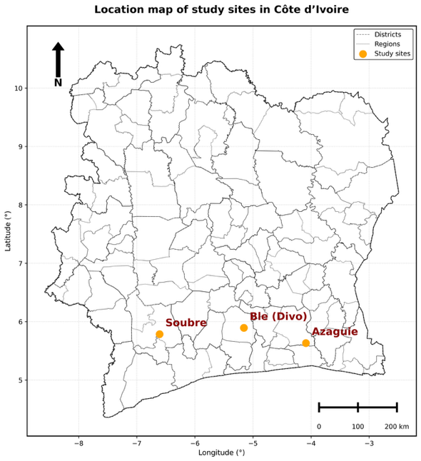
Fig. 1. Location map of study sites in Côte d’Ivoire.
2.2 Shade mapping and quantification
Upper-canopy shade was measured using a LI-191R quantum sensor (LI-COR) on a regular grid of 25 points spaced 8 m apart, covering each 1,000 m² plot (Figure 2). Photosynthetically active radiation (PAR) measurements were taken inside the plot just below the shade-tree canopy (PARi) and outside the plot in full sun (PARe) between 12:00 and 14:00 under clear-sky conditions to minimize variation due to solar angle or cloud cover. The shade percentage (TO) at each grid point was calculated as follows (Monteith & Unsworth, 2013):
TO = 1 - (PARi / PARe)
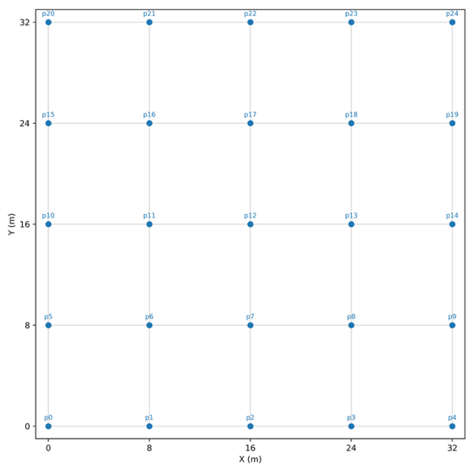
Fig. 2. Regular 25-point sampling grid (8 m spacing) used for shade measurements in 1,000 m² plots.
This value represents the fraction of incident light intercepted by the shade-tree canopy. The TO values were then used to characterize shade conditions within the study plots using the ordinary kriging continuous interpolation method (Goovaerts, 1997; Gratton, 2002; Webster & Oliver, 2007). Using a variogram model, the exponential function provided the best descriptive fit of the spatial dependence of shade (TO) data. The resulting map provides a local estimate of TO (with kriging variance) at any location within the plot. All geospatial analyses were performed in Python 3.10 using the PyKrige library. A key processing step relied on the Python Geopandas library to automate extraction of shade values at each measurement point. The shade level received by cocoa trees was subsequently extracted based on their GPS positions.
2.3 Chlorophyll fluorescence measurements (Fv/Fm)
Chlorophyll fluorescence measurements were conducted using a CIRAS-4 photosynthetic gas analyzer equipped with the CFM-4 fluorimetry module (Pulse-Amplitude Modulated, PAM) integrated into a compatible leaf chamber (Schreiber, 2004). The CFM-4 is a pulse-modulated fluorometer that generates the fluorescence signal. The maximum PSII quantum yield (Fv/Fm) was measured on leaves that had been dark-adapted for 20 minutes (He et al., 2024; Kalaji et al., 2017). For each leaf, the minimum (Fo) and maximum (Fm) fluorescence signals were obtained under modulated measuring light (Fo) and following a saturating pulse (Fm), respectively. Variable fluorescence was calculated as Fv = Fm − Fo, and maximum PSII yield as:
Fv/Fm = (Fm − Fo) / Fm
These equations correspond to the calculations implemented in the CIRAS-4 for fluorescence parameters.
2.4 Statistical analysis
Processed Fv/Fm data were analyzed using non-parametric statistical methods. First, a global Kruskal–Wallis test was applied to assess the effect of shading treatment on the median Fv/Fm. When a significant difference was detected (p < 0.05), pairwise comparisons were performed using the Least Significant Difference (LSD) test to determine which treatments differed significantly. All analyses were performed in Python 3.1.3.
3. RESULTS AND DISCUSSION
3.1 Results
Effect of shading on Fv/Fm: depending on shade regime, dawn Fv/Fm values varied markedly (Figure 3). The Kruskal–Wallis analysis indicated a highly significant effect of shade (H = 9.32; p = 0.009) on maximum PSII performance (Fv/Fm). Under full sunlight (O0), cocoa leaves displayed the lowest mean Fv/Fm (0.752 ± 0.015). In contrast, leaves under moderate shade (O1) showed the highest mean Fv/Fm (0.796 ± 0.003), while those under dense shade (O2) had a mean Fv/Fm of 0.785 ± 0.005. Thus, both shaded treatments produced Fv/Fm values approximately 4–5 percentage points higher than the full-sun condition.
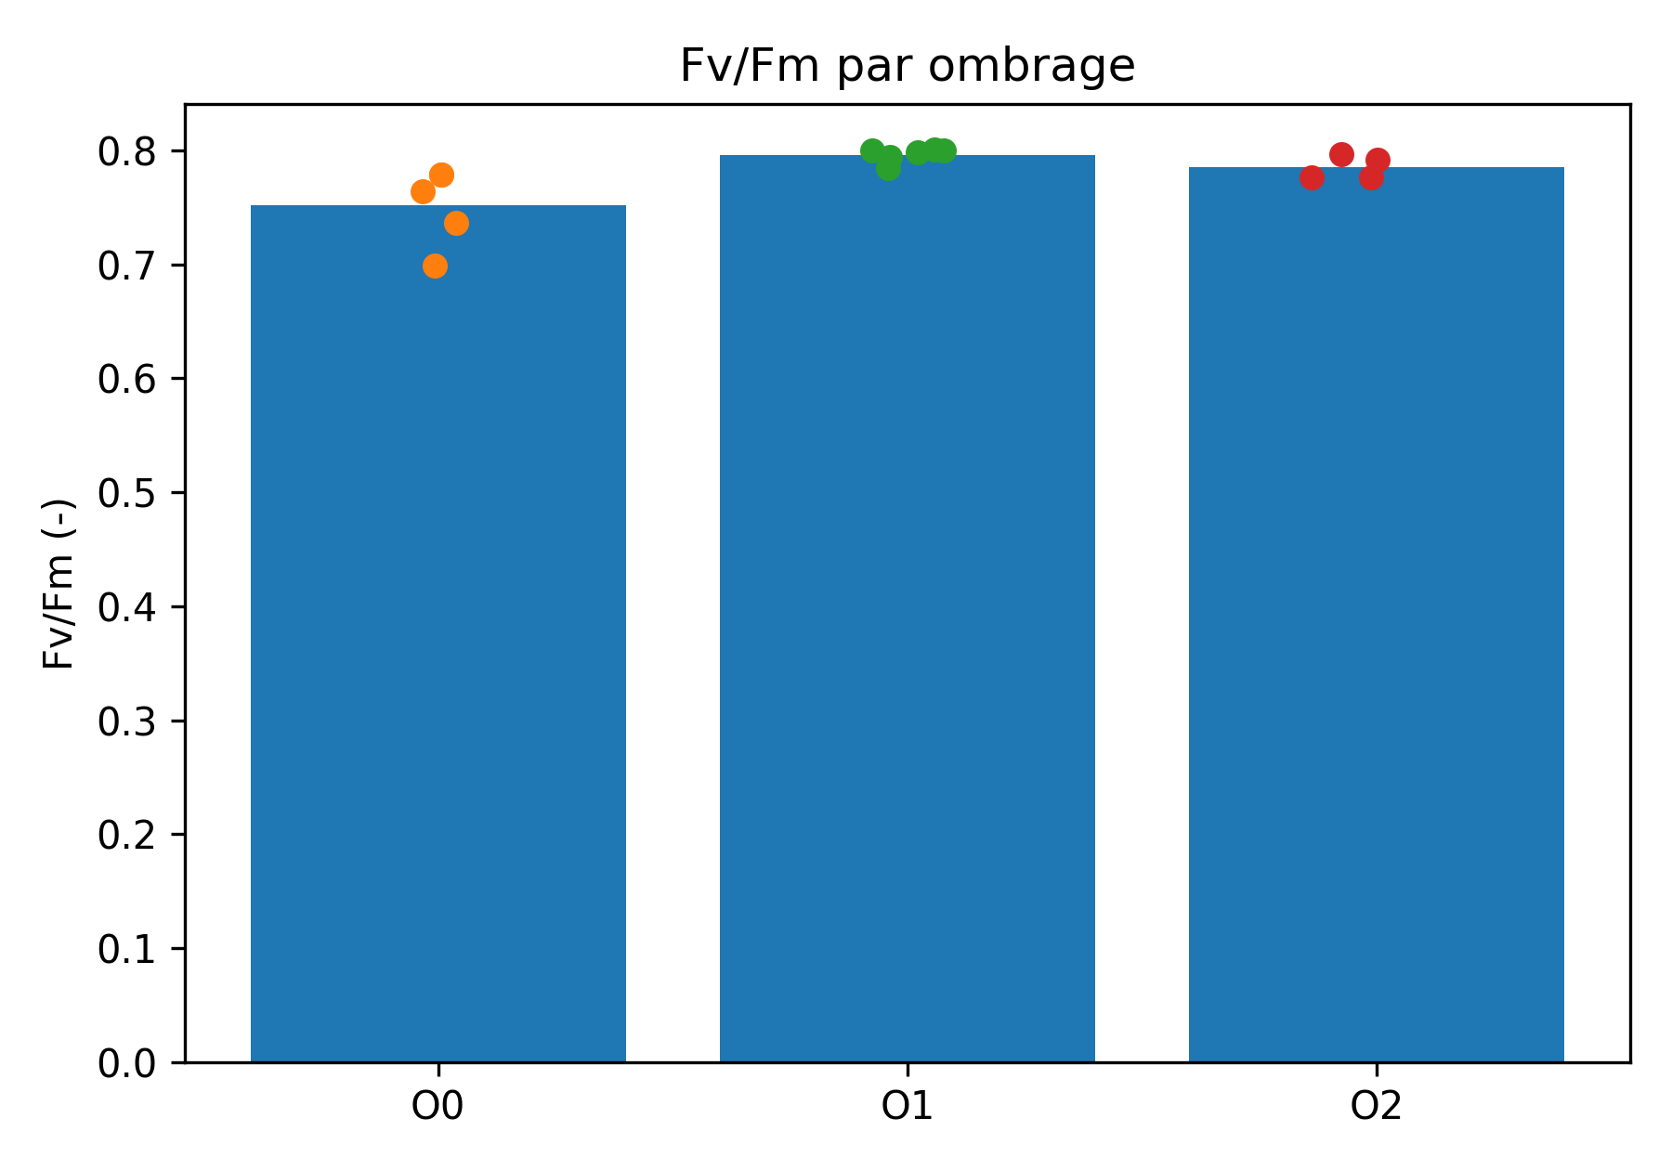
Fig. 3. Effect of shade regimes (O0: full sun, O1: shade < 30%, O2: shade 30–60%) on maximum PSII yield (Fv/Fm) measured in cocoa.
Post hoc analyses confirmed that shading significantly increased Fv/Fm compared with full sun. A statistically significant difference was observed between O0 and both shaded treatments (p < 0.05): on average, Fv/Fm increased by approximately +0.04 under shade (moderate or dense). Conversely, the difference in Fv/Fm between moderate (O1) and dense shade (O2) was small (+0.011) and not significant (LSD, p > 0.05). In other words, O1 and O2 provided a comparable benefit in PSII protection, both outperforming the full-sun condition.
3.2 Discussion
The data indicate that direct exposure to sunlight causes marked photosystem II (PSII) photoinhibition in cocoa, as evidenced by a reduction in maximum quantum yield Fv/Fm to around 0.75. According to ecophysiological criteria, an ideal Fv/Fm value for non-stressed leaves ranges from 0.80 to 0.83, whereas values below 0.80 reflect residual photochemical stress (Maxwell & Johnson, 2000; Baker, 2008).
These observations are consistent with previous research on cocoa. Cocoa genotypes exposed to high irradiance show a marked decline in Fv/Fm at midday, followed by partial recovery during periods of lower light (Jaimez et al., 2018). Similarly, strong daytime photoinhibition has been reported under full sun, while shade-grown leaves maintained values closer to the optimum (Baker, 2008). These findings support the idea that cocoa, as a forest species, has a limited capacity to tolerate high irradiance levels (Daymond & Hadley, 2008).
The decline in Fv/Fm under high light results from an imbalance between photo-oxidative damage and PSII repair processes. Excess light enhances ROS production, leading to degradation of the D1 protein in the reaction center (Baker, 2008). When the rate of degradation exceeds the rate of repair, photochemical efficiency decreases (Takeuchi et al., 2025). The temperature increase commonly associated with full-sun exposure further intensifies this process by limiting D1 resynthesis and exacerbating oxidative damage (Murchie & Niyogi, 2011).
Cocoa trees under moderate (O1) and dense shade (O2) exhibited Fv/Fm values around 0.79–0.80, indicating an almost complete absence of persistent photoinhibition. This is consistent with Maxwell & Johnson (2000), who associate values close to 0.83 with fully functional PSII. In this context, shade acts as a microclimate regulator by reducing incident radiation and leaf temperature, two key drivers of photochemical stress (Blaser et al., 2018; Niether et al., 2018). By intercepting a substantial fraction of photosynthetically active radiation, the shade canopy modulates light flux to match the intrinsic photosynthetic capacity of cocoa, thereby preventing PSII saturation.
A notable result of this study is the absence of a significant difference between moderate shade (≈30%) and dense shade (30–60%) for Fv/Fm. This suggests a threshold beyond which additional shade provides no further benefit for PSII protection. Likewise, Daymond et al. (2008) reported that excessive shade can reduce overall photosynthetic capacity without necessarily improving photoprotection further.
From an agronomic perspective, these results are particularly relevant in the context of climate change. Agroforestry systems are recognized for their potential to reduce climatic extremes, stabilize microclimates, and enhance crop resilience over the long term (Schroth et al., 2016; Tscharntke et al., 2011). By maintaining functional PSII and minimizing recurrent photo-oxidative damage, moderate shade may support more stable photosynthesis throughout the day while reducing the physiological costs associated with PSII repair (Murchie & Niyogi, 2011). This could ultimately contribute to longer leaf lifespan, an increase in active photosynthetic area, and more stable production.
Overall, the evidence supports the idea that moderate shade represents an optimal balance: insufficient shade exposes cocoa trees to chronic photoinhibition, whereas excessive shade does not necessarily provide further gains in PSII efficiency and could constrain productivity.
4. CONCLUSION
This study shows that agroforestry shade significantly reduces light stress in cocoa by limiting PSII photoinhibition. Based on Fv/Fm, maximum PSII quantum efficiency was clearly higher under shaded conditions than under direct sunlight, indicating a more favorable photochemical status of leaves in shade. A moderate shade level (approximately 30%) was sufficient to raise Fv/Fm to values close to the optimum (~0.80), nearly eliminating the persistent photoinhibition observed without shade. Denser shade did not further increase Fv/Fm, suggesting an optimal shade threshold beyond which benefits plateau. Practically, these findings support agroforestry management as a means of improving cocoa resilience to extreme light and temperature conditions in open systems. Maintaining adequate tree cover in tropical cocoa farms helps preserve photosynthetic efficiency. In summary, moderate shade is a key agronomic factor for combining physiological performance with sustainable cocoa production in tropical regions.

CONSENT
Not applicable.
ETHICAL APPROVAL
Not applicable.
COMPETING INTERESTS DISCLAIMER:
Authors have declared that they have no known competing financial interests OR non-financial interests OR personal relationships that could have appeared to influence the work reported in this paper.

REFERENCES
Acheampong, K., Hadley, P., Daymond, A. J., & Adu-Yeboah, P. (2015). The Influence of Shade and Organic Fertilizer Treatments on the Physiology and Establishment of Theobroma cacao Clones. American Journal of Experimental Agriculture, 6(6), Article 6.
Agele, S., Famuwagun, B., & Ogunleye, A. (2016). Effects of Shade on Microclimate, Canopy Characteristics and Light Integrals in Dry Season Field-Grown Cocoa (Theobroma cacao L.) Seedlings. Journal of Horticultural Sciences, 11(1), 47–56. https://doi.org/10.24154/jhs.v11i1.105
Arévalo-Gardini, E., Farfán, A., Barraza, F., Arévalo-Hernández, C. O., Zúñiga-Cernades, L. B., Alegre, J., & Baligar, V. C. (2021). Growth, Physiological, Nutrient-Uptake-Efficiency and Shade-Tolerance Responses of Cacao Genotypes under Different Shades. Agronomy, 11(8), Article 8. https://doi.org/10.3390/agronomy11081536
Baker, N. R. (2008). Chlorophyll fluorescence: A probe of photosynthesis in vivo. Annual Review of Plant Biology, 59, 89–113. https://doi.org/10.1146/annurev.arplant.59.032607.092759
Blaser, W. J., Oppong, J., Hart, S. P., Landolt, J., Yeboah, E., & Six, J. (2018). Climate-smart sustainable agriculture in low-to-intermediate shade agroforests. Nature Sustainability, 1(5), 234–239. https://doi.org/10.1038/s41893-018-0062-8
Daymond, A. J., Tricker, P. J., & Hadley, P. (2011). Genotypic variation in photosynthesis in cacao is correlated with stomatal conductance and leaf nitrogen. Biologia Plantarum, 55(1), Article 1.
Foyer, C. H., & Hanke, G. (2022). ROS production and signalling in chloroplasts: Cornerstones and evolving concepts. The Plant Journal, 111(3), 642–661. https://doi.org/10.1111/tpj.15856
Goovaerts, P. (1997). Geostatistics for Natural Resources Evaluation. Oxford University Press.
Gratton, Y. (2002). LE KRIGEAGE : LA MÉTHODE OPTIMALE D’INTERPOLATION SPATIALE.
He, H., Liu, C., Wu, Z., Chen, M., Qu, K., Zhao, J., Wang, Y., Hu, Z., & Li, Q. (2024). Responses of Rice Photosynthesis and Yield to Elevated CO2 Concentrations: A Quantitative Analysis via Chlorophyll Fluorescence Technology. Journal of Soil Science and Plant Nutrition, 24(3), 5043–5054. https://doi.org/10.1007/s42729-024-01890-y
Hieke, S., Menzel, C., & Lüdders, P. (2003). Effects of light availability on leaf gas exchange and expansion in lychee (Litchi chinensis). Tree Physiology, 22, 1249–1256. https://doi.org/10.1093/treephys/22.17.1249
Jaimez, R. E., Puyutaxi, F. A., Vasco, A., Loor, R. G., Tarqui, O., Quijano, G., Jimenez, J. C., & Tezara, W. (2018). Photosynthetic response to low and high light of cacao growing without shade in an area of low evaporative demand. Acta Biológica Colombiana, 23(1), Article 1. https://doi.org/10.15446/abc.v23n1.64962
Kalaji, H. M., Schansker, G., Brestic, M., Bussotti, F., Calatayud, A., Ferroni, L., Goltsev, V., Guidi, L., Jajoo, A., Li, P., Losciale, P., Mishra, V. K., Misra, A. N., Nebauer, S. G., Pancaldi, S., Penella, C., Pollastrini, M., Suresh, K., Tambussi, E., … Bąba, W. (2017). Frequently asked questions about chlorophyll fluorescence, the sequel. Photosynthesis Research, 132(1), 13–66. https://doi.org/10.1007/s11120-016-0318-y
Keren, N., Berg, A., van Kan, P. J. M., Levanon, H., & Ohad, I. (1997). Mechanism of photosystem II photoinactivation and D1 protein degradation at low light: The role of back electron flow. Proceedings of the National Academy of Sciences, 94(4), 1579–1584. https://doi.org/10.1073/pnas.94.4.1579
Kohl, T., Niether, W., & Abdulai, I. (2024). Impact of common shade tree species on microclimate and cocoa growth in agroforestry systems in Ghana. Agroforestry Systems, 98(6), 1579–1590. https://doi.org/10.1007/s10457-024-01029-z
Maxwell, K., & Johnson, G. N. (2000). Chlorophyll fluorescence—A practical guide. Journal of Experimental Botany, 51(345), 659–668. https://doi.org/10.1093/jxb/51.345.659
Monteith, J., & Unsworth, M. (2013). Principles of Environmental Physics: Plants, Animals, and the Atmosphere. Academic Press.
Murchie, E. H., & Lawson, T. (2013). Chlorophyll fluorescence analysis: A guide to good practice and understanding some new applications. Journal of Experimental Botany, 64(13), 3983–3998. https://doi.org/10.1093/jxb/ert208
Murchie, E. H., & Niyogi, K. K. (2011). Manipulation of Photoprotection to Improve Plant Photosynthesis. Plant Physiology, 155(1), 86–92. https://doi.org/10.1104/pp.110.168831
Niether, W., Armengot, L., Andres, C., Schneider, M., & Gerold, G. (2018). Shade trees and tree pruning alter throughfall and microclimate in cocoa (Theobroma cacao L.) production systems. Annals of Forest Science, 75(2), 38. https://doi.org/10.1007/s13595-018-0723-9
Osorio Zambrano, M. A., Castillo, D. A., Rodríguez Pérez, L., & Terán, W. (2021). Cacao (Theobroma cacao L.) Response to Water Stress: Physiological Characterization and Antioxidant Gene Expression Profiling in Commercial Clones. Frontiers in Plant Science, 12, 700855. https://doi.org/10.3389/fpls.2021.700855
Schreiber, U. (2004). Pulse-Amplitude-Modulation (PAM) Fluorometry and Saturation Pulse Method: An Overview. In G. C. Papageorgiou & Govindjee (Eds.), Chlorophyll a Fluorescence: A Signature of Photosynthesis (pp. 279–319). Springer Netherlands. https://doi.org/10.1007/978-1-4020-3218-9_11
Schroth, G., Läderach, P., Martinez-Valle, A. I., Bunn, C., & Jassogne, L. (2016). Vulnerability to climate change of cocoa in West Africa: Patterns, opportunities and limits to adaptation. Science of The Total Environment, 556, 231–241. https://doi.org/10.1016/j.scitotenv.2016.03.024
Suárez Salazar, J. C., Melgarejo, L. M., Casanoves, F., Di Rienzo, J. A., DaMatta, F. M., & Armas, C. (2018). Photosynthesis limitations in cacao leaves under different agroforestry systems in the Colombian Amazon. PLOS ONE, 13(11), Article 11. https://doi.org/10.1371/journal.pone.0206149
Takeuchi, K., Harimoto, S., Maekawa, S., Miyake, C., & Ifuku, K. (2025). PSII photoinhibition as a protective strategy against PSI photoinhibition: Maintaining PSI in an oxidized state by suppressing PSII activity under environmental stress (p. 2025.05.06.652500). bioRxiv. https://doi.org/10.1101/2025.05.06.652500
Tscharntke, T., Clough, Y., Bhagwat, S. A., Buchori, D., Faust, H., Hertel, D., Hölscher, D., Juhrbandt, J., Kessler, M., Perfecto, I., Scherber, C., Schroth, G., Veldkamp, E., & Wanger, T. C. (2011). Multifunctional shade-tree management in tropical agroforestry landscapes – a review. Journal of Applied Ecology, 48(3), 619–629. https://doi.org/10.1111/j.1365-2664.2010.01939.x
Webster, R., & Oliver, M. A. (2007). Geostatistics for Environmental Scientists. John Wiley & Sons.

