Original Research Article

Outcomes of Carbon Markets on Pastoralist Livelihoods and Household Resilience in Ngaremara, Isiolo County, Kenya

Abstract
Carbon market initiatives are increasingly recognized as mechanisms for enhancing climate adaptation while simultaneously improving livelihoods in vulnerable regions. This study examines the outcomes of carbon market initiatives on pastoralist livelihoods and household resilience in Ngaremara, Isiolo County, Kenya. Using a survey-based approach, the research assesses how participation in carbon markets has influenced economic opportunities, income stability, and household adaptation to climate variability (Using a cross-sectional survey of 367 households, the study evaluates how participation in carbon market initiatives influences economic opportunities, income stability, and household adaptation to climate variability). The findings reveal that while carbon markets have generated some economic benefits such as increased income and employment opportunities, challenges remain in ensuring equitable benefit distribution and effective household adaptation. Although 51.2% of respondents reported improved incomes, 48.2% experienced no financial change, highlighting disparities in economic gains (Approximately 51.2% of respondents reported increased income, while 48.2% reported no significant financial change, indicating uneven distribution of benefits). Additionally, household resilience to climate variability showed moderate improvement, with 55% of respondents reporting enhanced adaptive capacity. Governance challenges, limited financial access, and socio-cultural barriers constrained the full realization of benefits. The study concludes that while carbon markets offer livelihood and resilience potential, targeted policy interventions are necessary to enhance financial inclusion, training, and governance frameworks for sustainable and equitable impact in pastoralist communities. These findings contribute to the broader discourse on climate finance and sustainable development in dryland regions.
Keywords: climate finance; dryland communities; adaptive capacity; sustainable land management; socio-economic impacts; pastoral economies
- Statistical results could be presented more clearly.
- Mention sample size (n=367).

Introduction
Climate change poses significant threats to dryland ecosystems and the communities that depend on them, with pastoralist groups being among the most vulnerable due to their reliance on natural resources for sustenance and economic stability (IPCC, 2021; Bryan et al., 2018). In these regions, increasing temperature extremes, erratic rainfall patterns, and prolonged droughts undermine traditional livelihood systems, exacerbating poverty and food insecurity.
Carbon markets have emerged as innovative mechanisms that align climate mitigation with sustainable development objectives. By offering financial incentives for carbon sequestration activities — such as afforestation, reforestation, and improved rangeland management — they aim to link environmental conservation with socio-economic benefits (Asquith et al., 2002; Atela et al., 2015). In developing countries, these initiatives have been associated with improved livelihoods, stronger resource governance, and enhanced environmental stewardship (Bond et al., 2020; Bryan et al., 2018). However, their effectiveness in ensuring long-term and equitable livelihood improvements remains debated, particularly among marginalized communities (Mathur et al., 2014; Bernard & Adkins, 2014).
Pastoralist communities in northern Kenya face distinctive barriers to participating in carbon markets. Limited land tenure security, inequitable benefit distribution, and governance challenges often restrict access to these initiatives (Herr et al., 2019; Little, 2011). While some research highlights increased income, employment opportunities, and adaptive capacity among participants, others reveal persistent constraints such as low financial inclusion, limited awareness, and socio-cultural barriers (McCarthy & Di Gregorio, 2007; Munene, 2019). Elite capture and weak governance mechanisms can further undermine community trust and participation.
Resilience in pastoralist systems hinges on adaptive strategies such as diversifying income sources, improving water management, and adopting sustainable grazing practices (IPCC, 2021; Mburu, 2015). Carbon market projects have the potential to fund and incentivize these strategies, yet their real impact on household stability is contested (Mukami, 2016; Wako, 2022). Achieving meaningful resilience outcomes often requires participatory governance structures, accessible financing, and integration with indigenous knowledge systems (Bryan et al., 2018).
Ngaremara in Isiolo County, Kenya, offers a relevant case study for exploring these dynamics. This semi-arid area is characterized by recurrent droughts, resource-based conflicts, and shrinking grazing lands (Mburu, 2015). Carbon market initiatives in the region — focusing on planned grazing, tree planting, and improved water management — seek to diversify livelihoods and strengthen climate adaptation. However, few empirical studies have examined their household-level impacts in Kenyan pastoralist contexts, and even fewer assess the dual outcomes for both livelihoods and resilience.
This study addresses this gap by assessing the outcomes of carbon market participation on livelihoods and household resilience in Ngaremara. Specifically, it evaluates the extent to which participation has influenced income stability, employment generation, and climate adaptation capacity. By grounding the analysis in localized evidence and drawing from broader literature on carbon markets in pastoralist contexts, the study contributes to designing more inclusive, equitable, and sustainable carbon finance models for dryland communities.
- Add Global Context
- Improve research gap clarity
- Add Research Objectives clearly

Methodology

Study Area
This study was conducted in Ngaremara, a semi-arid region in Isiolo County, Kenya, where pastoralist communities predominantly rely on livestock for their livelihoods. The region is characterized by recurrent droughts, resource conflicts, and increasing climate variability, making it a suitable case for assessing the outcomes of carbon market initiatives on livelihoods and household resilience (Mburu, 2015). Carbon market initiatives in the area focus on sustainable land use, planned grazing, and reforestation as mechanisms to promote carbon sequestration and community adaptation. The figure below shows the map of the study area:
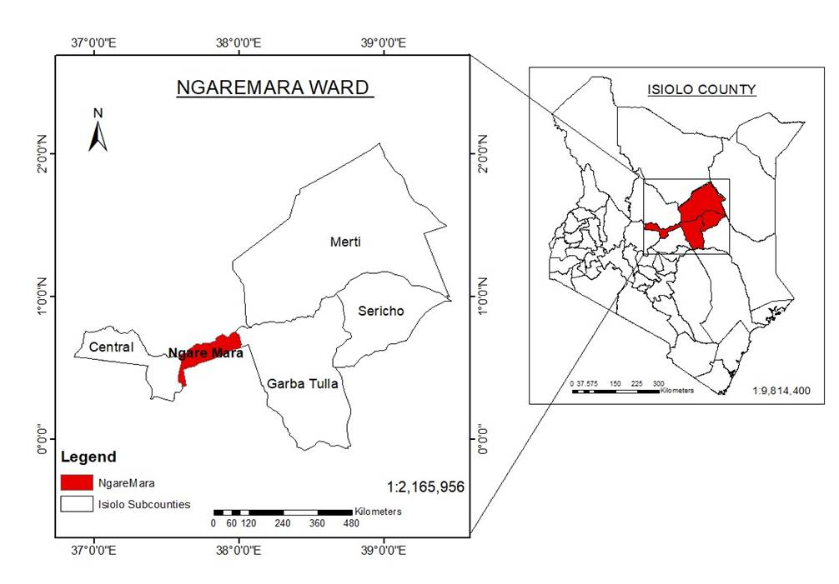
Figure 1: GIS map of Isiolo North Constituency, Kenya

Research Design
A cross-sectional survey design was employed to capture both quantitative and qualitative data on the livelihood and resilience outcomes of carbon market initiatives. This design was selected for its suitability in analyzing relationships between carbon market participation and household-level socio-economic indicators at a single point in time, while also incorporating contextual narratives from participants.

Sampling and Data Collection
A stratified random sampling technique was used to ensure adequate representation of households with varying levels of participation in carbon markets. The sample size of 367 households was determined using statistical sample size calculation formulas to achieve a 95% confidence level and acceptable margin of error, considering the total population of Ngaremara.
Data Collection Methods
Primary data were collected using structured household questionnaires that captured demographic details, income changes, livelihood diversification, employment opportunities, and indicators of household resilience. In-depth interviews were conducted using a semi-structured guide to explore personal experiences and perceptions of the benefits and challenges of carbon market initiatives. Direct observation was employed to document social and cultural practices relevant to carbon market participation and livelihood adaptation. In addition, secondary data were reviewed from academic literature, government reports, and project documents to provide contextual background for the study. Data entry and management during fieldwork were facilitated using ODK (Open Data Kit) software.

Data Analysis
Quantitative data were analyzed using descriptive statistics, correlation, and regression analysis to examine relationships between carbon market participation and outcomes such as income, livelihood diversification, and resilience. Qualitative responses were thematically analyzed to identify recurring patterns related to benefits, challenges, and community perceptions.

Ethical Considerations
The study received approval from Kenyatta University’s Graduate School and a research permit from the National Commission for Science, Technology, and Innovation (NACOSTI). Informed consent was obtained from all participants, with assurances of confidentiality and voluntary participation. Cultural sensitivity was observed throughout the research process to ensure respectful engagement with community members.

Results

Participation in Carbon Market Initiatives
Out of the 367 households surveyed, 70.8% reported participation in carbon market projects, while 29.2% indicated no involvement. The main activities undertaken by participants included planned grazing (34.9%), tree planting (32.6%), and improved water management (29.2%). The figure below shows the various types of participation in carbon market initiatives:
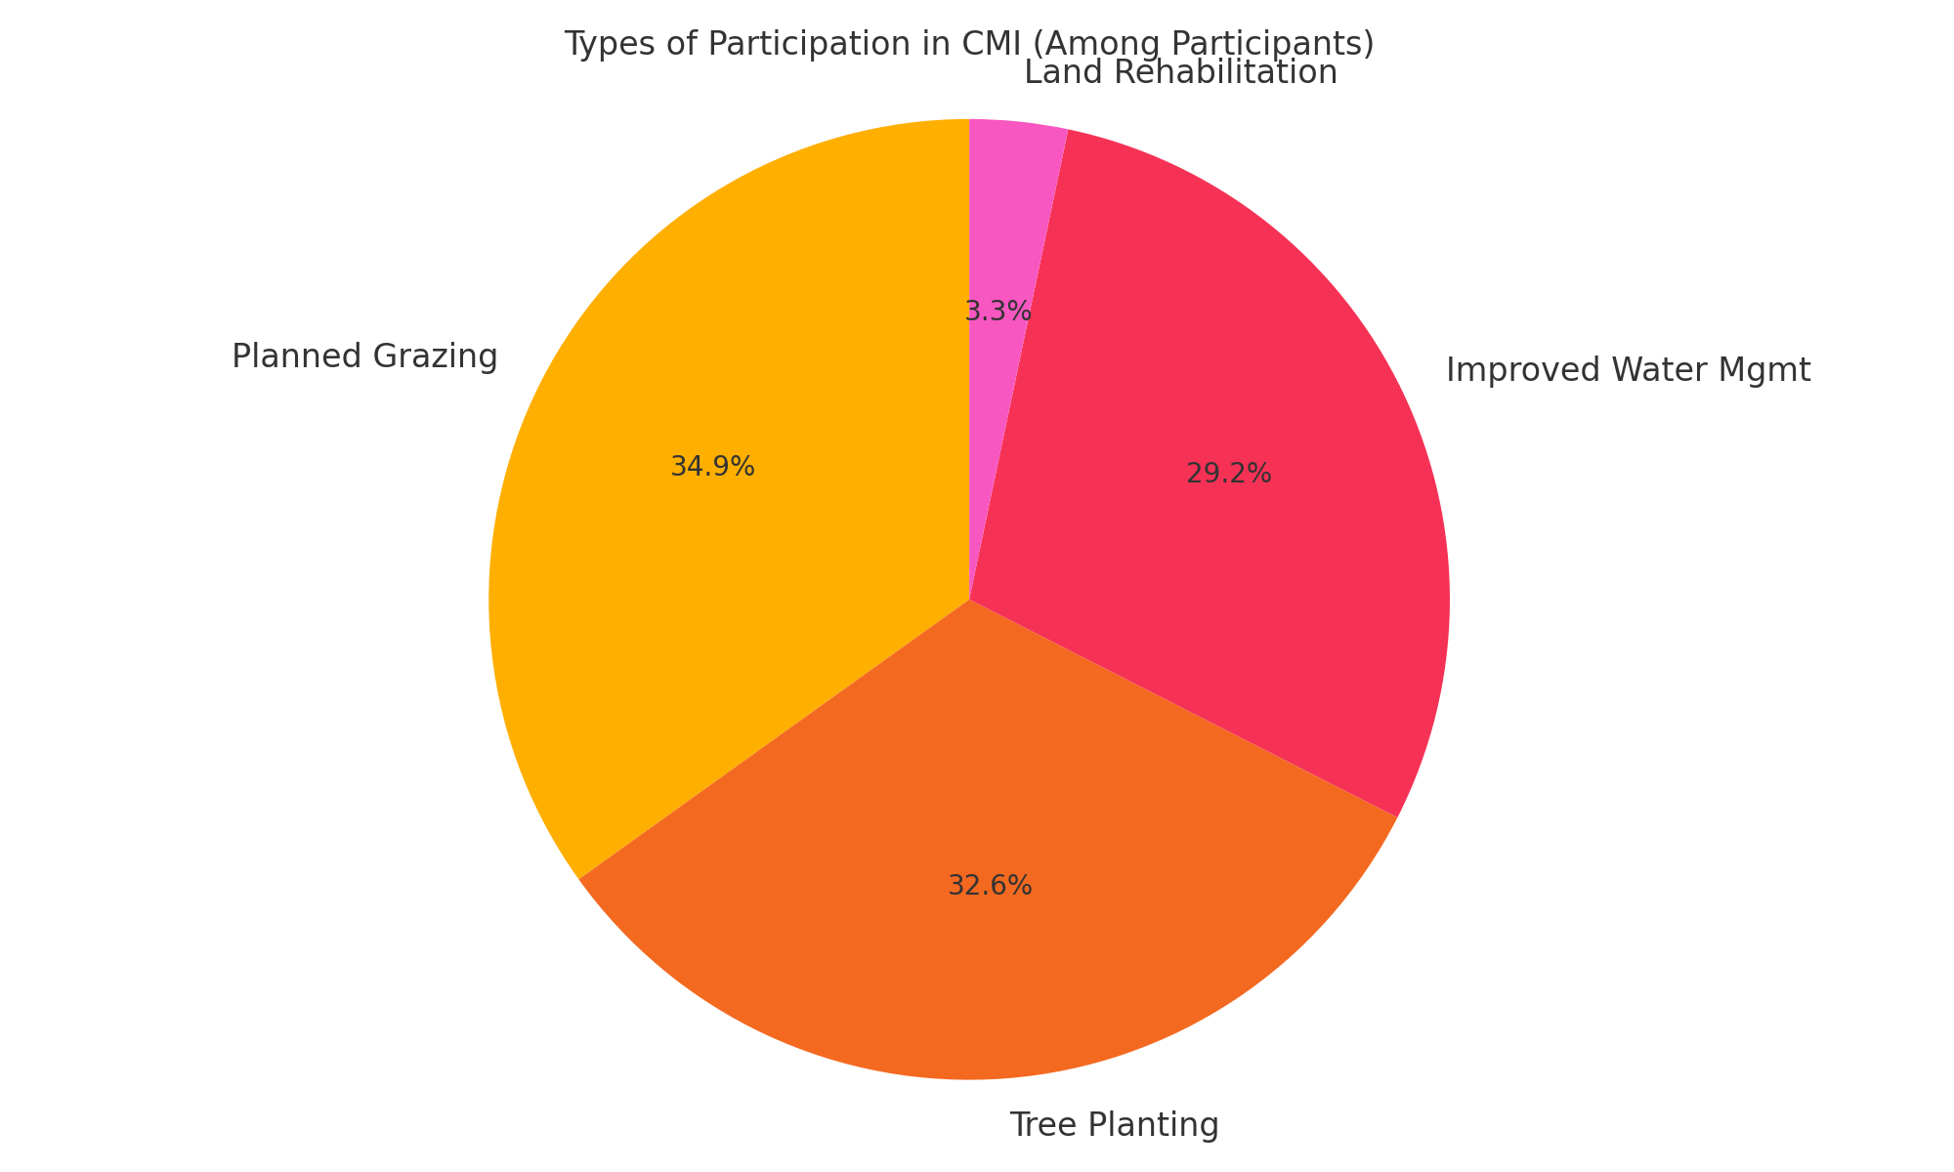
Figure 2: Types of Participation in CMI

Economic Outcomes of Carbon Market Participation
Among participants, 51.2% reported increased income, 48.2% indicated no financial change, and 0.5% experienced decreased income. Employment opportunities through carbon market initiatives were reported by 24.6% of respondents. Only 18.8% of households engaged in new income-generating activities beyond their primary livelihood. The reported economic outcomes are shown in the figure below:
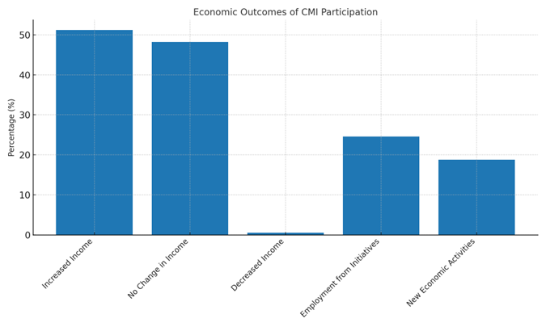
Figure 3: Economic Outcomes of CMI Participation

Household Resilience and Climate Adaptation
A total of 55% of respondents reported improved adaptive capacity to climate variability. No change in resilience was reported by 26.4% of respondents, and 0.6% reported a decline in resilience. Common adaptation measures included improved water management, small-scale farming, and participation in savings initiatives. The figure below shows the reported resilience outcomes:
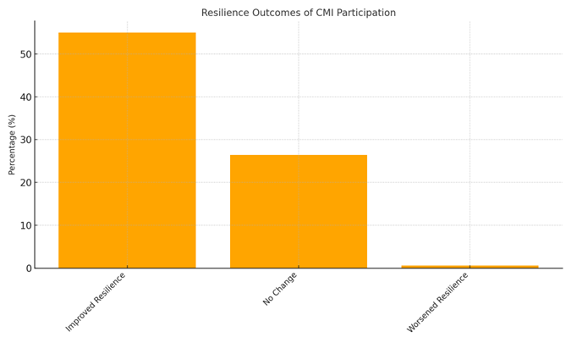
Figure 4: Resilience Outcomes of CMI Participation

Statistical Analysis – Livelihood Outcomes
Regression analysis indicated a significant positive association between carbon market participation and several livelihood indicators. Participation was positively associated with livelihood score (β = 1.045, p < 0.001, R² = 0.445), income change (β = 1.319, p < 0.001, R² = 0.386), and quality of life (β = 0.826, p < 0.001, R² = 0.405). These results are summarized in Table 1 below:
Table 1: Regression Results - CMI Impact on Livelihood Outcomes
Outcome Variable | β | SE | t | p-value | Sig. | R²
Livelihood Score | 1.045 | 0.068 | 15.339 | 0.00 | *** | 0.445
Income Change | 1.319 | 0.095 | 13.866 | 0.00 | *** | 0.386
Income Stability | 0.455 | 0.291 | 1.564 | 0.12 |  | 0.023
Quality of Life | 0.826 | 0.064 | 12.998 | 0.00 | *** | 0.405
Note: *p < 0.05, **p < 0.01, ***p < 0.001. Controlled for family size and education level.
Statistical Analysis – Resilience Outcomes
Participation in carbon market initiatives was significantly associated with higher resilience scores (β = 0.349, p < 0.001, R² = 0.118) and adaptation ability (β = 0.729, p < 0.001, R² = 0.339). Climate confidence was not significantly influenced (β = -0.030, p = 0.748). These results are summarized in Table 2 below:
Table 2: Linear Regression Results - CMI Impact on Resilience Outcomes
Outcome Variable | β | SE | t | p-value | Sig. | R²
Resilience Score | 0.349 | 0.068 | 5.165 | 0.000 | *** | 0.118
Climate Confidence | -0.030 | 0.095 | -0.322 | 0.748 |  | 0.014
Adaptation Ability | 0.729 | 0.066 | 11.017 | 0.000 | *** | 0.339
Social and Environmental Co-Benefits
Additional reported benefits included strengthened community cohesion (28.1%), enhanced environmental conservation (22.1%), and empowerment of women and youth (18.8%). Furthermore, 85.8% of respondents reported improved access to essential services such as education, water, and healthcare. Some of the social and environmental benefits of carbon market initiatives are indicated in the figure below:
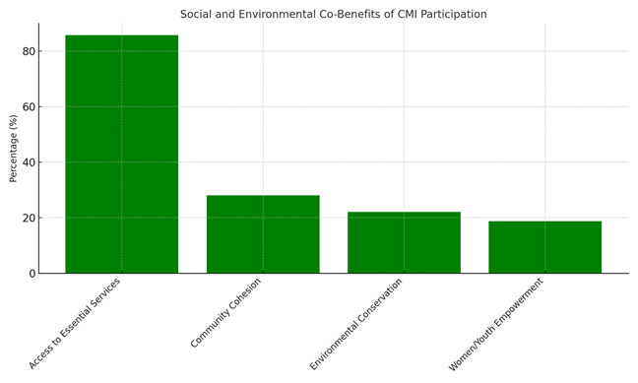
Figure 5: Social and Environmental Co-Benefits of CMI Participation

Discussion
Participation in Carbon Market Initiatives
A participation rate of 70.8% reflects substantial community engagement, yet the 29.2% non-participation underscores barriers such as limited awareness, access constraints, or socio-cultural reservations. Similar patterns have been documented in other dryland regions, where awareness campaigns and localized engagement strategies have been shown to increase participation rates (Atela et al., 2015; Mathur et al., 2014).
Economic Outcomes
The finding that slightly over half of respondents (51.2%) experienced income increases aligns with literature indicating that CMIs can generate alternative income streams and employment opportunities (Bryan et al., 2018; Bond et al., 2020). However, the high proportion of households reporting no change in income (48.2%) and the low rate of new income-generating activities (18.8%) suggest that the economic benefits remain limited in scale. This could be due to irregular or small carbon payments, unequal benefit-sharing, or inadequate linkages to broader market opportunities — challenges noted in previous research on carbon finance in pastoralist settings (McCarthy & Di Gregorio, 2007).
Household Resilience
An improvement in adaptive capacity among 55% of households indicates a positive influence of CMIs on resilience, particularly through water management, small-scale farming, and savings groups. This mirrors evidence from other semi-arid regions where targeted adaptation measures have strengthened household coping strategies (IPCC, 2021; Mukami, 2016). Nonetheless, the persistence of households reporting no change (26.4%) or worsened resilience (0.6%) points to gaps in technical training, access to climate adaptation resources, and the integration of traditional pastoralist knowledge into project design.
Statistical Insights
Regression results confirm that CMI participation is significantly associated with improvements in livelihood scores, income change, quality of life, resilience, and adaptation ability. However, the lack of statistical significance for climate confidence suggests that economic gains are not yet consistent over time, and that perceptions of preparedness for climate shocks may be shaped by broader socio-economic factors beyond CMI participation.
Social and Environmental Co-Benefits
The reported increases in community cohesion, environmental conservation, and women and youth empowerment underscore the multi-dimensional benefits of CMIs. These findings support the argument that climate finance interventions can contribute to both ecological restoration and social development when effectively designed (Herr et al., 2019).
Limitations and Implications
Despite these gains, the uneven distribution of benefits highlights governance and equity challenges. Similar to experiences elsewhere in sub-Saharan Africa, elite capture, limited financial inclusion, and exclusion of marginalized groups can undermine project impact (Mathur et al., 2014). Addressing these issues will require stronger community-led governance structures, transparent benefit-sharing frameworks, and targeted capacity-building programs.
Conclusion and Recommendations
Conclusion
This study assessed the outcomes of carbon market initiatives (CMIs) on pastoralist livelihoods and household resilience in Ngaremara Ward, Isiolo County, Kenya. The findings demonstrate that CMIs have contributed to moderate improvements in income, adaptive capacity, and access to essential services, while also delivering social and environmental co-benefits such as community cohesion and environmental conservation. However, benefits remain unevenly distributed, with significant portions of the population experiencing no economic gains or resilience improvements. Statistical analysis confirmed positive associations between participation in CMIs and key livelihood and resilience indicators, although climate confidence showed no significant change.
Overall, while carbon markets show promise as a mechanism for linking climate adaptation with livelihood enhancement in dryland pastoralist settings, persistent challenges related to benefit-sharing, governance, and technical capacity must be addressed for these initiatives to achieve their full potential and long-term sustainability.

Recommendations
- Expand financial inclusion and income-generating opportunities: Strengthening microfinance access, reinvesting carbon payments into community businesses, and developing alternative livelihoods can help more households experience long-term economic benefits.
- Enhance climate adaptation training and resilience-building: Providing structured training on financial management, climate-smart agriculture, and sustainable resource management can empower households to maximize the benefits of carbon markets and reduce dependency on pastoralism alone.
- Improve community participation and governance: Establishing more transparent decision-making frameworks and ensuring inclusive benefit-sharing mechanisms will enhance trust and encourage wider participation in carbon initiatives.
- Strengthen policy integration and project sustainability: Carbon market projects should be better integrated into national and local climate policies, with increased investment in infrastructure and technical support to ensure that adaptation benefits are long-lasting.

References
Asquith, N. M., Vargas Ríos, M. T., & Smith, J. (2002). Can forest-protection carbon projects improve rural livelihoods? Analysis of the Noel Kempff Mercado climate action project, Bolivia. Mitigation and Adaptation Strategies for Global Change, 7(4), 323–337. Retrieved from https://www.cifor-icraf.org/knowledge/publication/1273/
Atela, J. O., Minang, P. A., Quinn, C. H., & Duguma, L. A. (2015). Implementing REDD+ at the local level: Assessing the key enablers for credible mitigation and sustainable livelihood outcomes. Journal of Environmental Management, 157, 238–249. https://doi.org/10.1016/j.jenvman.2015.04.015
Bernard, F., & Adkins, B. (2014). Community-based conservation and carbon markets: A critical analysis. Global Environmental Change, 24, 53-64. https://doi.org/10.1016/j.gloenvcha.2013.11.007
Bond, I., Millar, I., & Ramos, C. (2020). Governance challenges in carbon market implementation: Lessons from sub-Saharan Africa. Environmental Policy and Governance, 30(2), 129-144. https://doi.org/10.1002/eet.1885
Bryan, E., Ringler, C., Okoba, B., Roncoli, C., Silvestri, S., & Herrero, M. (2018). Adaptive capacity and climate resilience of Kenyan smallholder farmers. Climate Risk Management, 4, 43–54. https://doi.org/10.1016/j.crm.2014.10.004
Herr, D., Blum, M., Himes-Cornell, A., & Sutton-Grier, A. (2019). The role of blue carbon in climate adaptation and sustainable development. Frontiers in Marine Science, 6, 237. https://doi.org/10.3389/fmars.2019.00237
IPCC. (2021). Climate Change 2021: The Physical Science Basis. Contribution of Working Group I to the Sixth Assessment Report of the Intergovernmental Panel on Climate Change. Cambridge University Press. Retrieved from https://www.ipcc.ch/report/ar6/wg1/
Little, P. D. (2011). Pastoralism, biodiversity, and the shaping of savanna landscapes in East Africa. Africa, 66(1), 37–51. https://doi.org/10.2307/1161510
Mathur, V. N., Afionis, S., Paavola, J., Dougill, A. J., & Stringer, L. C. (2014). Experiences of host communities with carbon market projects: Towards multi-level climate justice. Climate Policy, 14(1), 42–62. https://doi.org/10.1080/14693062.2013.861728
Mburu, C. W. (2015). Factors influencing implementation of selected donor-funded projects in Kenya: The case of World Vision Isiolo County, Kenya (Master's thesis). University of Nairobi. Retrieved from http://erepository.uonbi.ac.ke/handle/11295/90505
McCarthy, J., & Di Gregorio, M. (2007). Climate change adaptation, rural institutions, and development. World Development, 35(3), 341–363. https://doi.org/10.1016/j.worlddev.2006.10.008
Mukami, D. M. (2016). Carbon markets and livelihood sustainability in dryland regions: Evidence from Kenya (Doctoral dissertation). Kenyatta University. Retrieved from https://ir-library.ku.ac.ke/
Munene, M. W. (2019). Factors influencing management of rangelands by pastoral communities in Gotu, Ngaremara ward, Isiolo County, Kenya (Master's thesis). University of Nairobi. Retrieved from http://erepository.uonbi.ac.ke/handle/11295/106751
Wako, A. G. (2022). Socio-economic impacts of carbon projects in Northern Kenya: An assessment of governance structures and equity in benefit-sharing (Master’s thesis). University of Nairobi. Retrieved from http://erepository.uonbi.ac.ke/

