Original Research Article
Spatiotemporal Variability and Trends of Rainfall in Zambia and Their Links to Oceanic Teleconnections

Abstract
Rainfall variability strongly influences agriculture, water resources, and socio-economic stability in Zambia, where livelihoods largely depend on seasonal precipitation. Understanding the spatial and temporal dynamics of rainfall is therefore essential for effective climate risk management. This study investigates the spatiotemporal variability of rainfall across Zambia during 1993–2024 and examines its relationship with large-scale ocean–atmosphere interactions. Monthly precipitation data from the ERA5 reanalysis and sea surface temperature (SST) fields from NOAA were analyzed using standardized rainfall anomalies, the Mann–Kendall trend test, Sen’s slope estimator, Empirical Orthogonal Function (EOF) analysis, and correlation analysis. Results indicate that Zambia exhibits a unimodal rainfall regime, with most precipitation occurring during the NDJFMA rainy season (November–April). Trend analysis reveals spatially heterogeneous rainfall changes, with statistically significant increases in northern and northeastern Zambia, reaching approximately 8 mm yr⁻¹, while central and southern regions display weak or non-significant trends. Temporal analysis highlights strong interannual variability, with rainfall fluctuations largely controlled by variations during the main rainy season. EOF analysis shows that the leading mode (EOF1) explains 53% of total rainfall variance, representing a coherent countrywide rainfall pattern, while the second mode (EOF2) accounts for 15.3% of the variance and reflects a north–south rainfall dipole. Correlation analysis further demonstrates that Zambia’s rainfall variability is significantly linked to SST anomalies in the tropical Pacific and Indian Oceans. In particular, El Niño conditions are generally associated with below-normal rainfall, whereas La Niña conditions favor wetter-than-normal seasons. Overall, the findings highlight the dominant influence of large-scale ocean–atmosphere interactions on Zambia’s rainfall variability and provide useful insights for improving seasonal climate prediction, water resource management, and agricultural planning under a changing climate.
Keywords: Rainfall variability, Empirical Orthogonal Function, Zambia and ERA5 reanalysis

Introduction
Rainfall variability is an important characteristic of the climate system in tropical and subtropical regions, where seasonal precipitation supports ecosystems, water availability, and socio-economic stability. In sub-Saharan Africa, where agriculture is largely rain-fed, fluctuations in rainfall have direct consequences for food security and livelihoods (Adjei, 2021; IPCC, 2021; Muleta & Negera, 2023). In many parts of the world, rainfall directly controls water availability for agriculture, hydropower production, and household use, making it one of the most important climate factors influencing both human activities and natural environments. Over recent decades, observational records have revealed noticeable changes in rainfall timing, intensity, and spatial distribution across southern Africa, together with an apparent increase in the occurrence of droughts and heavy rainfall events (IPCC, 2021). Understanding how rainfall patterns are evolving both in space and over time has therefore become increasingly important for climate risk management and long-term development planning.
Zambia is particularly sensitive to rainfall variability because of its strong reliance on climate-dependent sectors. Agriculture plays a central role in employment and national food security, and most farming systems depend directly on seasonal rains (Government of the Republic of Zambia, 2022; Ngoma et al., 2021; Siamachoka, 2022). The country experiences a unimodal rainfall regime that extends from November to March during the austral summer, delivering the bulk of annual precipitation. This seasonal cycle is closely linked to the migration of the Inter-Tropical Convergence Zone (ITCZ) and the transport of moisture from the tropical Indian and Atlantic Oceans (Cook et al., 2004). Observe 10 years recency of the literature.
Rainfall variability in Zambia is shaped by a combination of ocean-atmosphere processes operating across multiple timescales. The El Niño–Southern Oscillation (ENSO) is a major source of interannual variability, with El Niño events commonly linked to suppressed summer rainfall and La Niña events often associated with wetter conditions (Hachigonta & Reason, 2006; Libanda et al., 2015). Variability in the tropical Indian Ocean, including the Indian Ocean Dipole (IOD), further modulates regional convection and moisture transport (Zhang & Mochizuki, 2023). While these large-scale drivers are well documented at the southern African scale, their influence on spatially heterogeneous rainfall trends within Zambia has not been comprehensively assessed.
In recent decades, Zambia has experienced severe droughts, delayed rainfall onset, prolonged intra-seasonal dry spells, and occasional flooding events, all of which have affected crop production, hydropower generation, and water supply (Matchaya et al., 2022; Mulimba, 2025; Spahia & others, 2025). Despite recognition of increasing climate variability across southern Africa (Engelbrecht et al., 2015; Shongwe et al., 2009), the magnitude and spatial consistency of long-term rainfall trends within Zambia remain insufficiently understood. It is also unclear whether recent changes reflect sustained climate change signals or natural decadal variability.
Most previous studies have examined rainfall variability at the broader regional level, often treating Zambia as part of a larger climatic zone (Chisanga et al., 2023; Libanda et al., 2020; Mulungu et al., 2019). Although this approach provides valuable context, it may overlook localized dynamics and contrasting sub-regional trends. Given projected changes in atmospheric circulation and thermodynamic processes under continued global warming (IPCC, 2021), there is a growing need for detailed, spatially explicit analyses that combine robust statistical trend detection with evaluation of underlying climatic drivers.
This study addresses these gaps by providing a comprehensive assessment of rainfall variability and trends across Zambia over the period (1993 - 2024). The objectives are to quantify spatially resolved seasonal and annual rainfall trends; examine interannual and decadal variability; and evaluate the relationship between rainfall patterns and major large-scale climate drivers, particularly ENSO and Indian Ocean variability. By integrating spatial trend analysis with climate mode diagnostics, this research seeks to clarify the mechanisms shaping rainfall variability and to distinguish externally forced changes from internal climate fluctuations. The findings will enhance understanding of Zambia’s hydroclimatic dynamics and provide an evidence base for adaptation planning in agriculture, water resource management, and disaster risk reduction. More broadly, the study contributes to improving our understanding of how rainfall systems across southern Africa are responding to ongoing climate variability and change. No theories that support about this study?

2. Data and methods

2.1 Area of study
Zambia is a landlocked country located in the central part of southern Africa, between approximately 8°–18°S and 22°–34°E. It shares borders with Angola, Democratic Republic of the Congo, Tanzania, Malawi, Mozambique, Zimbabwe, Botswana, and Namibia. Covering approximately 752,600 km², the country lies predominantly on a high plateau with elevations generally ranging from 1,000 to 1,500 m above sea level (Pennell et al., 2001).
Zambia’s climate system is characterized by a distinct alternation between wet and dry seasons. The year is typically divided into three main seasons, a cool dry season from May to August, a hot dry season from September to October, and a warm wet season from November to March. This seasonal rainfall regime is closely linked to the southward migration of the Inter-Tropical Convergence Zone (ITCZ), which brings moist tropical air masses into the region during boreal winter and austral summer (Kanyanga et al., 2012). Northern parts of the country, are strongly influenced by tropical convection and proximity to the Congo Basin, typically receives more than 1,000 mm of rainfall annually. In contrast, southern regions receive below 800 mm per year, and are more vulnerable to drought conditions (Musonda et al., 2020; Ngoma et al., 2021). This pronounced north-south rainfall gradient is a defining feature of Zambia’s hydroclimate and contributes to regional differences in agricultural productivity and water availability. The combination of strong rainfall seasonality, marked spatial gradients, elevated topography, and exposure to large-scale climate drivers such as ENSO makes Zambia particularly suitable for investigating the spatiotemporal variability of rainfall trends and their underlying mechanisms.
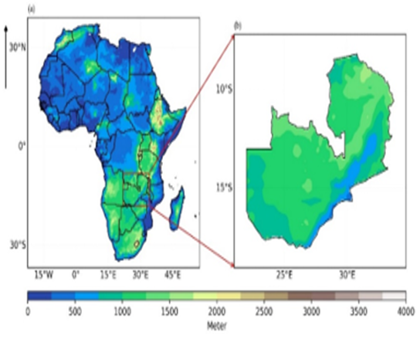
Fig.1 Geographical location (a) Africa (b) Zambia

2.2 Data

2.2.1 Rainfall dataset
This study utilized monthly precipitation data from the European Centre for Medium-Range Weather Forecasts ERA5 reanalysis, which were used to compute seasonal rainfall fields, and the obtain from https://cds.climate.copernicus.eu/datasets/derived-era5-single-levels-daily-statistics

2.2.2 Sea Surface Temperature dataset
In addition, monthly Sea Surface Temperature (SST) data obtained from the National Oceanic and Atmospheric Administration (NOAA) were incorporated into the analysis, the data was accessed from this website https://www.ncei.noaa.gov/data/sea-surface-temperature-extended-reconstructed/v6/access/. The SST dataset, with a spatial resolution of 1° × 1°, covered the same study period (1993–2024) and was used to examine ocean–atmosphere interactions and their influence on rainfall variability over Zambia.

2.3 Methods
Various statistical and graphical methods were taken into consideration to examine Zambia’s rainfall variability. Standardized rainfall anomaly, Empirical Orthogonal Functions (EOF), correlation analysis, root mean square error (RMSE), Bias, the Mann-Kendall trend test, and the Sen Slope estimator were used in this research.

2.3.1 Standardized rainfall anomalies
Standardized anomaly Rainfall time-series data was standardized in the range of -1 and 1 to assess the rainfall anomaly, where +1 indicates wet years while less than 1 depicts an anomalously dry year, using the equation below:
$Z= \frac{x-\overline{x}}{S_{x}}$ (1)
Where: Z is standardized anomaly, X is the observed rainfall, and x and S_{x} are the mean and standard deviation of rainfall.

2.3.2 Mann-Kendall trend test
Mann-Kendal (MK) test was used in climatological and hydrological trend analysis. This test can handle the sudden discontinuities due to inhomogeneous time succession and thus considered highly robust. It also does not need other presumptions related to data distribution and hence widely employed for rainfall trend analysis (Vivekanandan, 2024). The standardized Mann Kendall (MK) test statistics (S) can be expressed as;
$S=\sum_{i=1}^{n-1}{\sum_{j=i+1}^{n}{sgn(x_{j}-x_{i})}}$ (2)
Where the time-series observations in the year are given and denoted by i and j (j >i), n is the period of the analysis and sgn ($x_{j}$, $x_{i}$) is calculated as;
$sgn(x_{j}-x_{i})=\left\{\begin{aligned}1x_{j}>x_{i} \\ 0x_{j}=x_{i} \\ -1x_{j}<x_{i}\end{aligned}\right.$ (3)
If the dataset has a mean of zero, then the variance of S is obtained as;
$S_{v}=\frac{n\left(n-1\right)\left(2n+5\right)-\sum_{p-1}^{q}{t_{p}(t_{p}-1)(2t_{p}+5)}}{18}$ (4)
Where n represents the data size, q represents the tied groups, and $t_{p}$ represent the amount of data in the tied group, p. The trend significance is estimated using Z statistics,
$Z=\left\{\begin{aligned}\frac{S-1}{\sqrt{Var(S)}} if S>0 \\ 0 if S=0 \\ \frac{S-1}{\sqrt{Var(S)}} if S<0\end{aligned}\right.$ (5)
In this study, the MK was conducted at a significant level 0.05. The Sequential MK test was developed to determine the change points, the beginning of a significant trend, and abrupt alterations in the series. An unexpected shift at a point is noted if the inter section occurs outside the tabulated α-value (1.96). A 95% confidence level or α =0.05, which corresponds to ±1.96-tabulated valves, was used in this research to assess the significant trend.

2.3.3 Sen’s slope estimator
The estimator of Sen’s slope was used to estimate the magnitude of trends in the time series; this nonparametric method is generally used:
$T_{i}=\frac{X_{j}-X_{k}}{j-k}$ (6)
Where, $X_{j}$ and $X_{k}$ data value at times j and k, respectively. The Sen’s slope ($Q_{i}$) is estimated as;
$Q_{i}=\left\{\begin{aligned}T_{\frac{n+1}{2} }N is odd \\ 1/2\left(T_{\frac{N}{2}}+T_{\frac{N+2}{2}}\right) N is even\end{aligned}\right.$ (7)

2.3.4 Empirical Orthogonal Function analysis
Empirical Orthogonal Functions (EOF) method was used to identify the most dominant mode of variability associated with a set of variables. The principal components (PC) mode one time series is correlated with SST to identify the significant regions over the Indian Ocean that influence Zambia. The EOF is used in many climates’ diagnostic studies over various regions around the globe (Ariska et al., 2024; Lian & Chen, 2012). Expressed as follows:
$Z\left(x, y, t\right)= \sum_{K=1}^{N}{PC(t)*EOF(x,y)}$ (8)
Where Z (x, y, t) denotes the function at space (x, y), and at the time (t), the spatial structure concerning the temporal variance of Z is therefore represented by EOF (X, Y). The key component that explains how each EOF’s amplitude varies with time is PC (t)

2.3.5 Correlation analysis
Correlation analysis is a statistical approach used to examine the connection between two variables. The most widely applied method for measuring the strength and direction of a linear relationship such as between rainfall and Sea Surface Temperatures (SSTs) is the Pearson correlation coefficient, given below:
$r_{xy}= \frac{\frac{1}{n}\sum_{t=1}^{n}{(x_{t}-\overline{x})(y_{t}-\overline{y})}}{\sqrt{\frac{1}{n}\sum_{t=1}^{n}{{x_{t}-\overline{x}}^{2}{(y_{t}-\overline{y})}^{2}}}}$ (9)
Where the x t and y t are the anomaly associated with x and y, and n is the number of observations. The correlation coefficient value $r_{xy}$ lie between -1 < $r_{xy}$ < +1 used
In this study, Pearson correlation was used to assess the relationship between SST-based climate indices and seasonal rainfall in order to determine their association at the seasonal time scale. To evaluate whether the observed correlations are statistically meaningful, the student’s t-test was applied.
$t=r\frac{\sqrt{N-2}}{\sqrt{1-r^{2}}}$ (10)
In the t-test equation, t represents the calculated t-value, n is the sample size, and r is the correlation coefficient being tested. If the calculated t-value exceeds the critical (tabulated) t-value at (n − 2) degrees of freedom, the correlation is considered statistically significant.
Root Mean Square Error (RMSE) is a statistical measure used to assess the difference between satellite-based rainfall estimates and ground station observations. It represents the average magnitude of errors, where lower RMSE values indicate better agreement. Bias measures the systematic tendency of the satellite data to overestimate or underestimate rainfall relative to observations. Positive bias indicates overestimation, while negative bias indicates underestimation.
The following equations are used to calculate RMSE and Bias:
$RMSE= \frac{\sqrt{\sum_{i=1}^{n}{{({Obs}_{k}-{Est}_{k})}^{2}}}}{n}$ (11)
$Bias=\frac{\sum_{i=1}^{n}{({Obs}_{i}-{Est}_{i})}}{n}$ (12)

3. Results and discussion

3.1 Spatial distribution of rainfall across Zambia
The spatial distribution of mean annual rainfall and rainfall during the main wet season (November–April; NDJFMA) over Zambia is presented in Fig. 2. Both maps exhibit very similar spatial patterns, indicating that the majority of annual rainfall occurs during the NDJFMA season. Annual rainfall over Zambia showed a pronounced spatial gradient. The northern and northeastern regions receive the highest precipitation amounts, generally exceeding 1000 mm yr⁻¹, while the southern and southwestern parts of the country receive substantially lower totals, typically below 800 mm yr⁻¹. This north–south rainfall gradient reflects the influence of large-scale atmospheric circulation, moisture transport from adjacent ocean basins, and regional topographic features. The spatial pattern during the NDJFMA season closely mirrors the annual distribution but with slightly lower totals, confirming that most of Zambia’s rainfall occurs during this period. High rainfall amounts remain concentrated in the northern and eastern regions, while relatively dry conditions persist across the southern and southwestern areas. The similarity between the annual and seasonal maps highlights the dominant contribution of the NDJFMA rainy season to Zambia’s annual precipitation climatology. Overall, these spatial patterns emphasize the strong seasonal control on rainfall distribution across Zambia and reinforce the existence of persistent hydroclimatic gradients across the country.

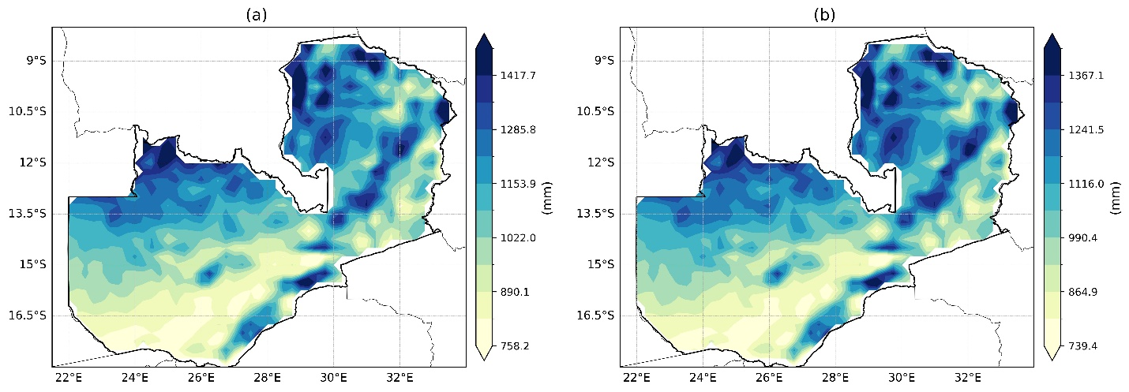
Fig.2 Spatial distribution of rainfall across Zambia: (a) mean annual total rainfall and (b) total rainfall during (NDJFMAM).
The climatological mean monthly precipitation over Zambia is shown in Fig. 3, which illustrates a clear and well-defined seasonal cycle. Rainfall begins to increase in October, marking the onset of the rainy season, and reaches its peak between December and March, with January and February representing the wettest months. During these peak months, precipitation totals can locally exceed 300–400 mm month⁻¹, particularly in the northern and eastern regions of the country. A strong spatial gradient persists throughout the rainy season, with northern Zambia consistently receiving greater rainfall than southern regions. This pattern reflects enhanced convective activity and moisture transport associated with the southward migration of the Intertropical Convergence Zone (ITCZ) during the austral summer. Rainfall decreases rapidly from April to May, signaling the transition from the wet season to the dry season. The dry season extends from June to September, during which precipitation is extremely limited or nearly absent across most of Zambia. Spatial differences during this period become minimal due to the dominance of dry atmospheric conditions and suppressed convective activity. Rainfall begins to reappear in October, initially over the northern regions before gradually expanding southward in November, marking the re-establishment of widespread convective activity associated with the seasonal migration of rain-bearing systems. Overall, the climatological cycle confirms that Zambia experiences a unimodal rainfall regime, characterized by a short but intense wet season and a prolonged dry season.
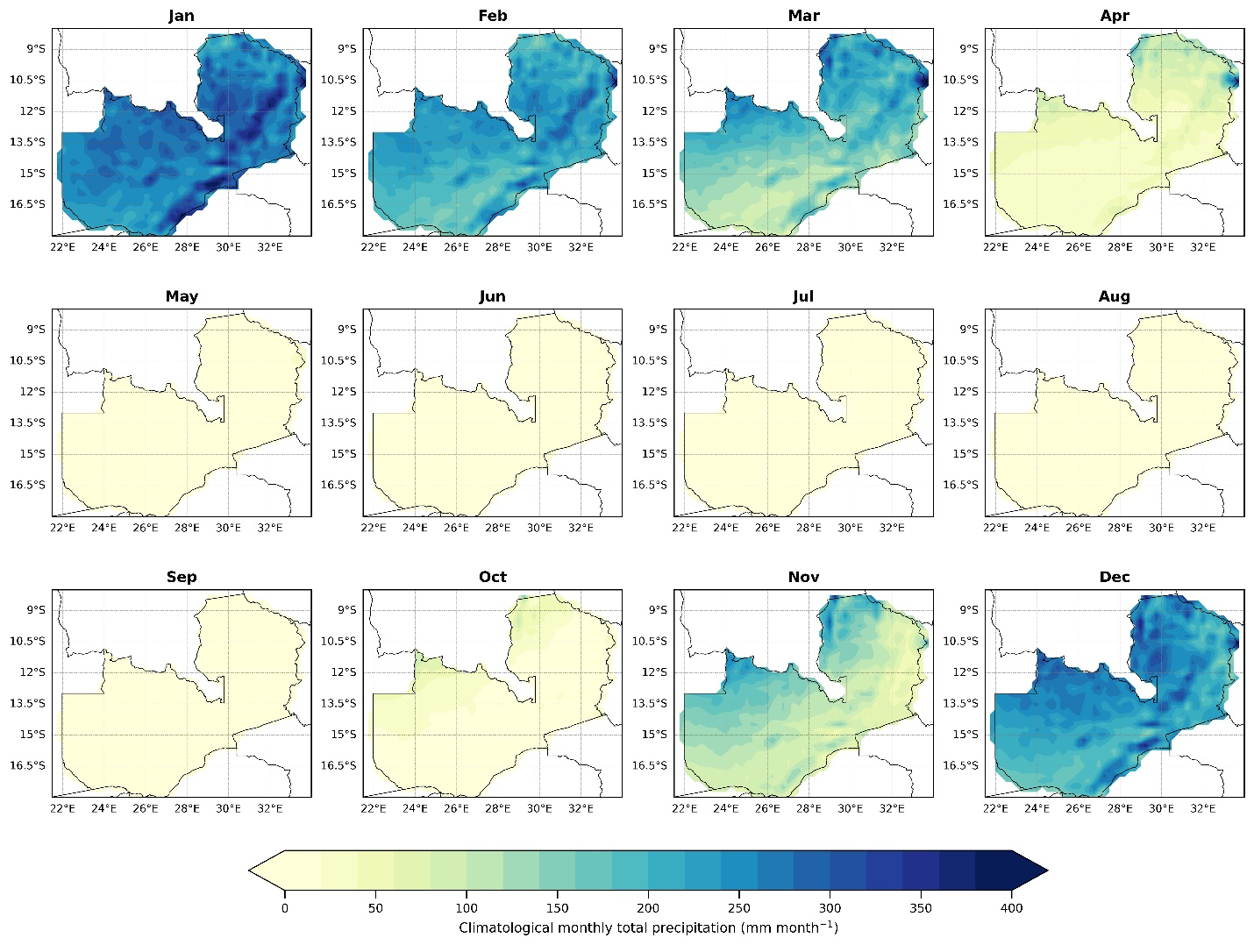
Fig.3 Climatological mean monthly total precipitation (mm month⁻¹) over Zambia.

3.2 Mann-Kendall and Sen’s slope spatial patterns
The spatial distribution of rainfall trends across Zambia derived from the Mann–Kendall (MK) trend test and Sen’s slope estimator is presented in Fig. 4 for both annual rainfall and the main rainy season (NDJFMA: November–April). Sen’s slope quantifies the magnitude of change (mm yr⁻¹), while the Mann–Kendall test evaluates the statistical significance of the trends. The results reveal a clear spatial structure in rainfall trends across the country. Northern and northeastern Zambia exhibit a pronounced increase in rainfall, with Sen’s slope values reaching approximately 8 mm yr⁻¹, many of which are statistically significant at the 95% confidence level. This pattern indicates a persistent wetting signal in the northern regions during the study period. In contrast, central, southern, and southwestern Zambia show weak and spatially heterogeneous trends, with slope values generally close to zero. Although localized negative trends appear in parts of southern Zambia, these are mostly not statistically significant, suggesting relatively stable rainfall conditions in these regions. The spatial pattern of NDJFMA rainfall trends closely mirrors the annual distribution, indicating that long-term changes in Zambia’s annual precipitation are largely driven by variability during the main rainy season. The concentration of significant positive trends in northern Zambia suggests a potential intensification of wet-season rainfall, reinforcing the existing north–south rainfall gradient. Further insight is provided by the monthly trend analysis shown in Fig. 5, which illustrates the spatial distribution of rainfall trends throughout the year. Red shades represent increasing rainfall trends, while blue shades indicate decreasing trends, with black dots marking areas where trends are statistically significant at the 95% confidence level.
A clear seasonal structure emerges from the monthly analysis. During the core rainy-season months (November–March), parts of northern and northeastern Zambia display positive Sen’s slope values, several of which are statistically significant. This suggests that rainfall intensification during peak rainy months is occurring in localized northern areas. In contrast, the dry and transitional months (May–September and, in some regions, October) are dominated by negative trends across much of the country, particularly in western and southern Zambia, where some drying signals are statistically significant. The persistence of these patterns suggests a gradual weakening of rainfall outside the main wet season. The transitional months of April and October show mixed spatial signals, though drying trends are more spatially extensive in western Zambia. These patterns may indicate changes in the timing of rainy-season onset and cessation. Overall, the Mann–Kendall and Sen’s slope analyses indicate that rainfall changes across Zambia are spatially and seasonally heterogeneous, with significant wetting in northern regions during peak rainfall months and localized drying in western and southern regions during dry and transitional seasons. These results suggest increasing seasonal contrasts in rainfall distribution, with important implications for agriculture, water resources, and climate adaptation planning.
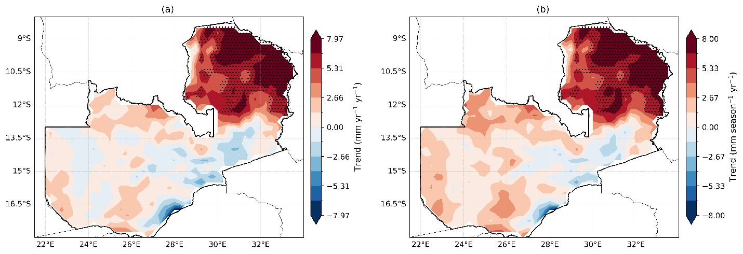
Fig.4 Spatial distribution of trends in (a) annual and (b)(NDJFMA) rainfall over Zambia during 1993-2024. The dots represent regions with a significant trend at a 95% confidence level
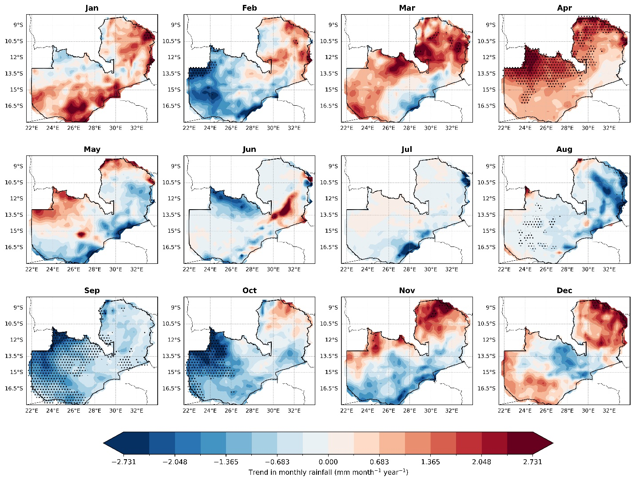
Fig.5 Spatial distribution of trend in average monthly rainfall over Zambia. The places hatched with black dots define significance change at a 95% confidence level.

3.3 Temporal variations in rainfall
Fig. 6 illustrates the interannual variability of standardized rainfall anomalies over Zambia for both annual rainfall and the main rainy season (NDJFMA). Positive anomaly values indicate wetter-than-normal conditions, while negative values represent drier-than-normal years. The dashed lines at ±1 standard deviation highlight moderately extreme wet and dry events. Both time series exhibited pronounced interannual variability, characterized by frequent shifts between wet and dry conditions throughout the study period. During the mid-1990s, rainfall anomalies were predominantly negative, indicating a period of below-normal rainfall. This was followed by a relatively wetter phase in the late 1990s and early 2000s, although variability remained high. One of the most notable drought signals occurs around 2005, when anomalies fall well below −1 standard deviation in both the annual and NDJFMA series, indicating a severe dry year.
Between 2007 and 2012, rainfall anomalies fluctuated around near-normal conditions, suggesting a relatively stable but still variable period. The mid-2010s onward again display alternating wet and dry years, reflecting the inherent variability of Zambia’s rainfall system. Several pronounced wet events occur after 2017, with anomalies exceeding +1 standard deviation and approaching +2 around 2021–2022, indicating unusually wet seasons. In contrast, the most recent year in the record (2023) shows a sharp negative anomaly below −2 standard deviations, suggesting an exceptionally dry year that could have significant implications for agriculture, water resources, and hydropower generation. The strong similarity between the annual and NDJFMA anomaly patterns indicates that Zambia’s interannual rainfall variability is largely controlled by fluctuations during the main rainy season, when the majority of annual precipitation occurs. This highlights the dominant role of wet-season rainfall in shaping the country’s overall hydroclimatic variability.
Further detail is provided by the monthly standardized rainfall anomalies shown in Fig. 7, which reveal substantial variability across individual months. The most pronounced wet and dry extremes occur during the core rainy-season months (November–March), when rainfall anomalies frequently exceed ±1 standard deviation. In contrast, anomalies during the dry-season months (May–September) are generally weaker and less persistent, reflecting the limited contribution of rainfall during this period. Overall, the temporal analysis indicates that Zambia’s rainfall is characterized by strong interannual variability and episodic extreme events, with the most significant fluctuations occurring during the main rainy season. These patterns highlight the sensitivity of Zambia’s hydroclimate to year-to-year climate variability and emphasize the importance of understanding the drivers of seasonal rainfall fluctuations. To better understand the dominant modes of rainfall variability and their spatial structure, the temporal fluctuations described above are further examined using Empirical Orthogonal Function (EOF) analysis.
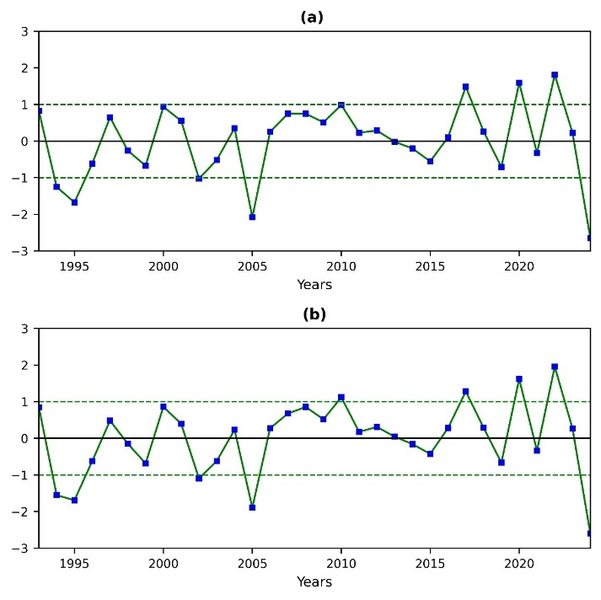
Fig.6 The inter-annual variability of rainfall at (a)annual, and (b)seasonal (NDJFMA) scale over Zambia for the period 1993–2024.
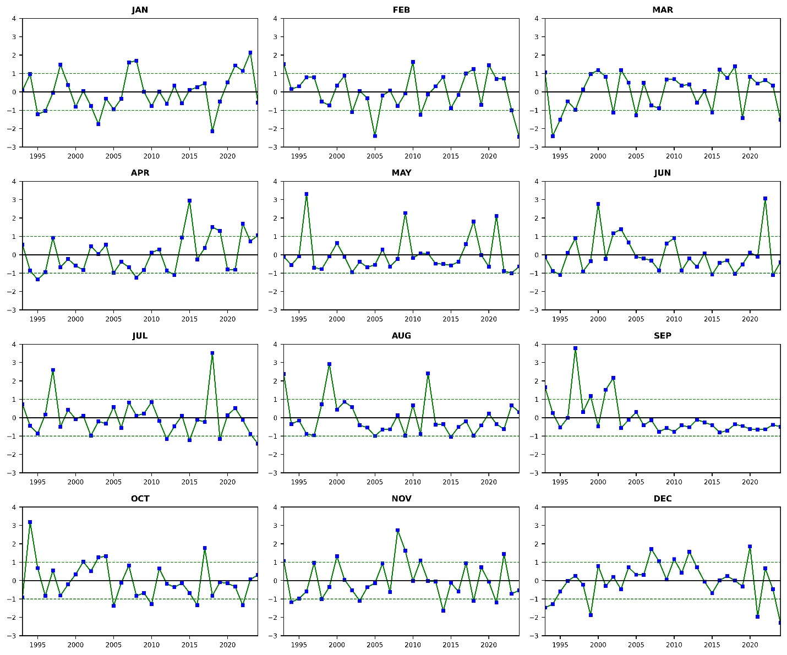
Fig. 7. The monthly standardized anomaly of rainfall over Zambia from 1993 to 2024

3.4 Empirical orthogonal function (EOF) analysis
Fig. 8 presents the EOF analysis of NDJFMA rainfall over the study period. The first two EOF modes explained a substantial portion of the total rainfall variability during the main rainy season. EOF1 accounted for 53.0% of the total variance, while EOF2 explained 15.3%, indicating that together they capture approximately 68% of the dominant rainfall variability across the country. The spatial pattern of EOF1 exhibited largely uniform loadings across most of Zambia, with relatively stronger amplitudes over the central, southern, and western regions. The consistent sign of the loadings indicates a coherent countrywide rainfall mode, suggesting that much of Zambia tends to experience wetter-than-normal or drier-than-normal conditions simultaneously during the rainy season. The associated principal component (PC1) time series showed pronounced interannual variability, with positive values corresponding to widespread wet conditions and negative values indicating broadly dry seasons. Periods of positive PC1 values, such as during the mid-1990s, early 2000s, and around 2018–2024, reflect wetter phases, while negative values during 2009–2011 and 2019–2022 correspond to relatively dry conditions. Overall, EOF1 represents the dominant large-scale rainfall variability mode, likely reflecting the influence of major climate drivers affecting southern African rainfall.
The second mode, EOF2, explained a smaller but still significant portion of variability (15.3%) and displayed a clear north–south dipole structure. Positive loadings dominate the northern and northeastern regions, whereas negative loadings appear over southern and southwestern Zambia. This dipole pattern indicates a spatial redistribution of rainfall, where wetter conditions in the north are often associated with drier conditions in the south, and vice versa. The PC2 time series exhibits alternating phases, with notable positive peaks around 2001 and 2019–2023, suggesting periods when northern Zambia experienced relatively wetter conditions compared to the south. Conversely, strong negative values around 2005 indicate the opposite configuration. Overall, the EOF analysis demonstrates that NDJFMA rainfall variability in Zambia is primarily governed by a coherent countrywide mode, which accounts for more than half of the total variance, alongside a secondary mode representing regional north–south contrasts in rainfall distribution. These two modes highlight the combined influence of large-scale atmospheric forcing and regional spatial variability, which together shape drought and flood patterns across Zambia during the main rainy season.
The dominant rainfall variability modes identified by the EOF analysis suggest that large-scale ocean–atmosphere interactions may influence Zambia’s rainfall patterns. To further explore these relationships, the link between rainfall anomalies and global sea surface temperature (SST) variability is examined in the following section.
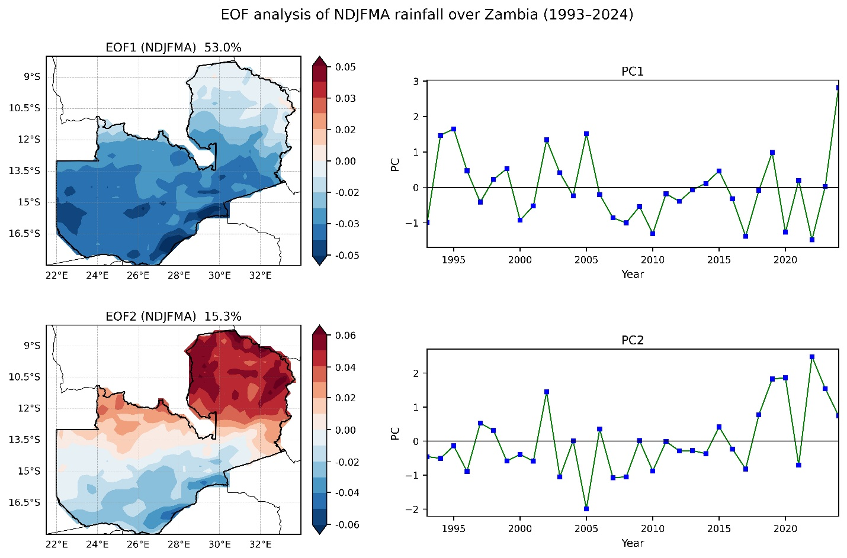
Fig.8 The spatial variability of EOF1 and EOF2 and the time series of PCs during NDJFMA for the period 1993 -2024.

3.5 Relationship between SSTs and rainfall at annual and NDJFMA seasons
The relationship between Zambia’s rainfall variability and global sea surface temperature (SST) anomalies is shown in Fig. 9, which presents spatial correlations between rainfall anomalies and SST fields. Panel (a) illustrates correlations using annual rainfall and annual SST anomalies, while panel (b) focuses on the main rainy season (NDJFMA). In the maps, blue shading indicates negative correlations, meaning that warmer SSTs are associated with reduced rainfall over Zambia, while red shading represents positive correlations, indicating that warmer SSTs correspond to increased rainfall. At the annual scale, the relationship between rainfall and global SST anomalies appears relatively weak and spatially scattered. Some negative correlations are observed over the central and eastern equatorial Pacific Ocean, suggesting that warmer SSTs associated with El Niño–Southern Oscillation (ENSO) events tend to coincide with reduced rainfall over Zambia. However, these correlations are generally weak and lack strong spatial coherence. Weak positive correlations are also present in parts of the western Pacific and southern oceans, but the overall annual pattern remains diffuse. This likely reflects the inclusion of both wet and dry months in the annual averages, which tends to obscure the stronger seasonal climate signals associated with the rainy season.
In contrast, the NDJFMA analysis reveals more coherent and physically meaningful correlation patterns. Stronger negative correlations appear across portions of the central tropical Pacific, indicating that warmer SSTs in this region characteristic of El Niño conditions are associated with below-normal rainfall in Zambia. Conversely, cooler SST anomalies associated with La Niña events tend to correspond with wetter-than-normal conditions. Additional correlations are also observed in parts of the Indian Ocean, suggesting that SST variability in this basin may contribute to modulating seasonal rainfall through its influence on regional atmospheric circulation and moisture transport. The contrast between the annual and NDJFMA analyses highlights the importance of the seasonal rainfall cycle in shaping Zambia’s climate variability. While annual averages tend to weaken the SST–rainfall relationship, the rainy-season analysis clearly demonstrates the influence of large-scale ocean–atmosphere interactions, particularly ENSO-related variability in the tropical Pacific. These results indicate that Zambia’s rainfall variability is strongly linked to large-scale SST anomalies, especially during the main rainy season when the majority of annual precipitation occurs.

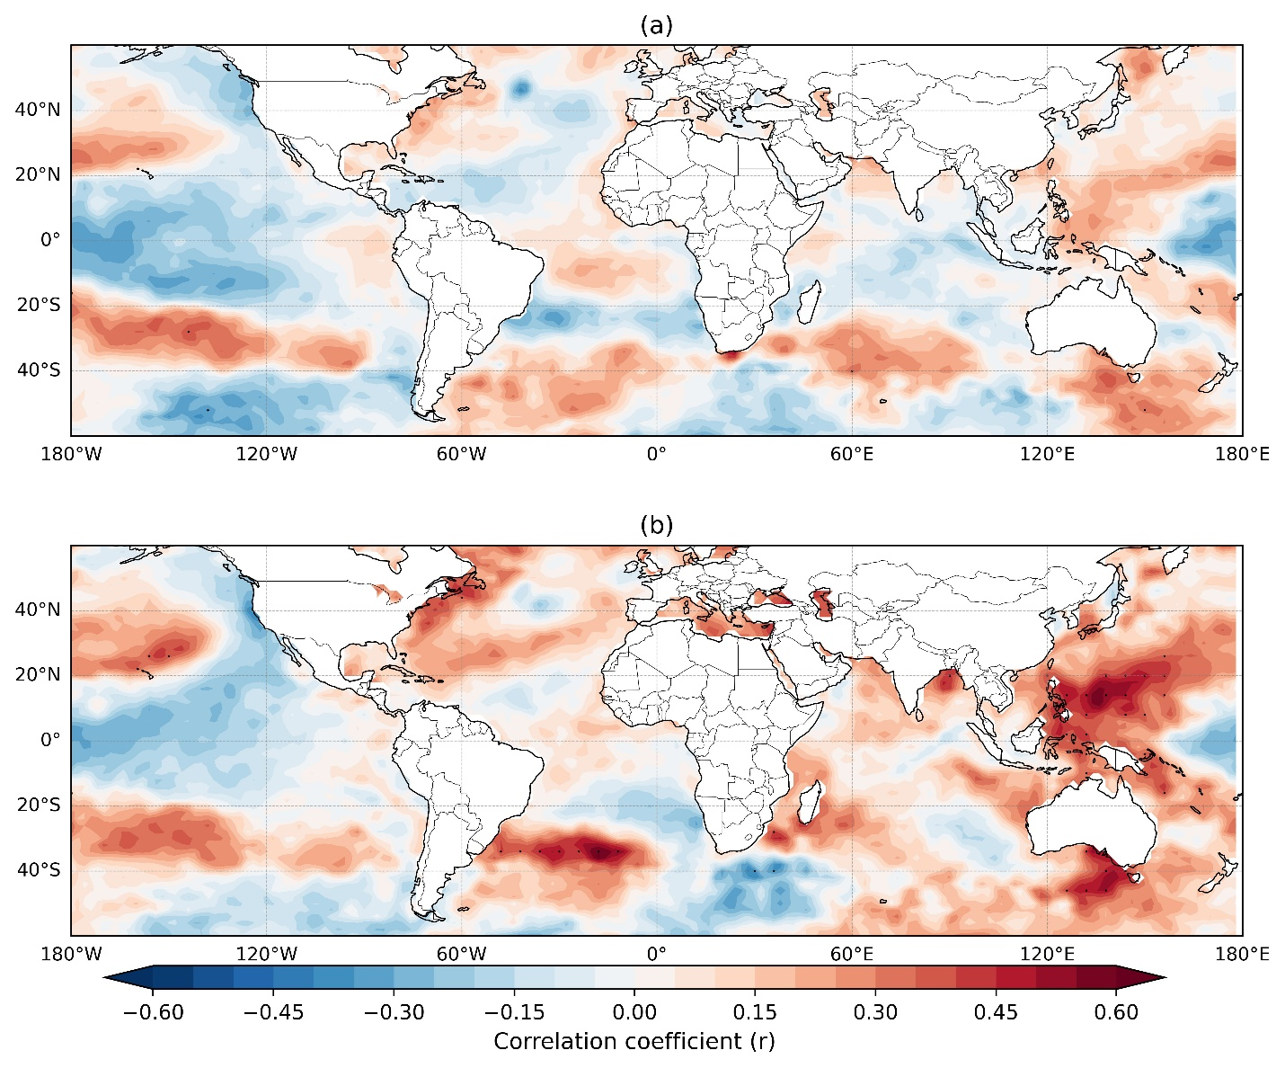
Fig.9 Spatial correlation of (a)annual and (b)NDJFMA rainfall anomaly with global SST anomaly over ENSO and IOD for 1994–2024.

Conclusion
This study examined the spatiotemporal variability of rainfall across Zambia during 1993–2024 and investigated its relationship with large-scale ocean–atmosphere interactions. The results confirm that Zambia exhibits a unimodal rainfall regime, with the majority of annual precipitation occurring during the NDJFMA rainy season, which largely controls both annual rainfall totals and interannual variability. Spatial climatology and trend analyses reveal clear regional contrasts in rainfall distribution and long-term changes. Northern and northeastern Zambia receive the highest rainfall totals and display statistically significant increasing rainfall trends, with Sen’s slope values reaching approximately 8 mm yr⁻¹ in some areas. In contrast, central, southern, and southwestern regions exhibit relatively weak or non-significant trends, with localized drying signals. These findings indicate that rainfall changes across Zambia are spatially heterogeneous and are primarily driven by variability during the main rainy season.
Temporal analysis highlights strong interannual variability, with alternating wet and dry phases throughout the study period. Several pronounced wet and dry events occur, emphasizing the sensitivity of Zambia’s hydroclimate to year-to-year climate fluctuations. The close correspondence between annual and NDJFMA rainfall anomalies further demonstrates that annual rainfall variability is largely controlled by wet-season dynamics. The EOF analysis showed that rainfall variability during NDJFMA is dominated by a coherent countrywide mode, explaining 53% of the total variance, together with a secondary north–south dipole mode accounting for 15.3% of the variance. These modes indicate that rainfall variability across Zambia is influenced by both large-scale atmospheric forcing and regional spatial contrasts, which together shape drought and flood patterns across the country.
Correlation analysis between rainfall anomalies and global sea surface temperature (SST) patterns reveals a clear connection between Zambia’s rainfall variability and large-scale ocean–atmosphere interactions. In particular, warmer SST anomalies in the central tropical Pacific associated with El Niño events correspond to reduced rainfall over Zambia, whereas cooler SST anomalies during La Niña conditions tend to promote wetter conditions. Additional correlations with SST variability in the Indian Ocean suggest that multiple ocean basins contribute to modulating rainfall variability across southern Africa. Inclusive, the results demonstrate that Zambia’s rainfall variability is strongly influenced by both regional climatic processes and large-scale oceanic teleconnections. Understanding these relationships is important for improving seasonal forecasting, water resource management, and agricultural planning in the region. However, this study relies primarily on reanalysis rainfall data and statistical analyses, which may not fully capture localized rainfall variability or the complex physical mechanisms governing regional climate dynamics. Future research incorporating high-resolution observational datasets, regional climate models, and additional climate drivers would help further clarify the mechanisms controlling rainfall variability and improve climate risk assessments and adaptation strategies in Zambia under a changing climate.

References
Adjei, V. (2021). Climate Change : Threat to Agricultural System and Food Security in Africa. 1(4), 1–5. https://doi.org/10.53902/GSRES.2021.01.000518
Ariska, M., Suhadi, S., Supari, S., Irfan, M., & Iskandar, I. (2024). Annual and Interannual Rainfall Variability in Indonesia Using Empirical Orthogonal Function ( EOF ) Analysis and Its Response to Ocean- Atmosphere Dynamics. Jurnal Ilmu Fisika, 16(2), 151–165. https://doi.org/https://doi.org/10.25077/jif.16.2.151-165.2024
Chisanga, C., Chipeta, G., Ngoma, H., & Mwanamambo, M. (2023). Observed and projected climate trends in Zambia: Implications for agriculture and water resources. Climate Services, 32, 100373. https://doi.org/10.1016/j.cliser.2023.100373
Cook, C., Reason, C. J. C., & Hewitson, B. (2004). Wet and dry spells within particularly wet and dry summers in the South African summer rainfall region. Climate Research, 26(1), 17–31. https://doi.org/https://doi.org/10.3354/cr026017
Engelbrecht, F. A., Adegoke, J., Bopape, M. J., Naidoo, M., Garland, R., Thatcher, M., McGregor, J., Katzfey, J., Werner, M., Ichoku, C., & Gatebe, C. (2015). Projections of rapidly rising surface temperatures over Africa under low mitigation. Environmental Research Letters, 10(8), 85004. https://doi.org/10.1088/1748-9326/10/8/085004
Government of the Republic of Zambia. (2022). Seventh National Development Plan: Climate Resilience and Sustainable Development. Ministry of National Development Planning.
Hachigonta, S. P., & Reason, C. J. C. (2006). Interannual variability in dry and wet spell characteristics over Zambia. Climate Research, 32(1), 49–62. https://doi.org/10.3354/cr032049
IPCC. (2021). Climate Change 2021: The Physical Science Basis. Contribution of Working Group I to the Sixth Assessment Report. Cambridge University Press. https://doi.org/10.1017/9781009157896
Kanyanga, J., Hachigonta, S., & Sibanda, L. M. (2012). Southern African Agriculture and Climate Change: A Comprehensive Analysis - Zambia. International Food Policy Research Institute (IFPRI), 255–287. https://doi.org/10.2499/9780896292086
Lian, T., & Chen, D. (2012). An Evaluation of Rotated EOF Analysis and Its Application to Tropical Pacific SST Variability. Journal of Climate, 25(3), 5361–5373. https://doi.org/10.1175/JCLI-D-11-00663.1
Libanda, B., Bwalya, K., Nkolola, N. B., & Chilekana, N. (2020). Quantifying long-term variability of precipitation and temperature over Zambia. Journal of Atmospheric and Solar-Terrestrial Physics, 198, 105201. https://doi.org/https://doi.org/10.1016/j.jastp.2020.105201
Libanda, B., Mulenga, B., & Phiri, D. (2015). Assessing rainfall variability and its impact on crop production in Zambia. African Journal of Agricultural Research, 10(45), 4255–4263. https://doi.org/10.5897/AJAR2015.10216
Matchaya, G., Tadesse, G., & Kuteya, A. (2022). Rainfall shocks and crop productivity in Zambia: Implication for agricultural water risk management. Agricultural Water Management, 269, 107648. https://doi.org/10.1016/j.agwat.2022.107648
Muleta, B. W., & Negera, T. T. (2023). Climate Change and Food Security in Sub-Saharan Africa. 3(2), 91–97.
Mulimba, D. (2025). Climate change in Zambia: A Review of impacts and adaptation strategies. International Journal of Big Data Mining for Global Warming, 7(2), S2630534825300039. https://doi.org/10.1142/S2630534825300039
Mulungu, K., Tembo, G., Bett, H., & Ngoma, H. (2019). Climate Change and Crop Yields in Zambia: Correlative Historical Impacts and Future Projections. 15357.31209. https://doi.org/DOI:10.13140/RG.2.2.15357.31209
Musonda, B., Jing, Y., Iyakaremye, V., & Ojara, M. (2020). Analysis of Long-Term Variations of Drought Characteristics Using Standardized Precipitation Index over Zambia. In Atmosphere (Vol. 11, Issue 12, p. 1268). https://doi.org/10.3390/atmos11121268
Ngoma, H., Lupiya, P., Kabisa, M., & Hartley, F. (2021). Impacts of climate change on agriculture and household welfare in Zambia: an economy-wide analysis. Climatic Change, 167(3–4), 55. https://doi.org/10.1007/s10584-021-03168-z
Pennell, K. D., Martin, C. A., Ramsburg, C. A., & Taylor, T. P. (2001). Groundwater Quality. Water Environment Research, 72(1), 144–213. https://doi.org/10.2175/106143000x144213
Shongwe, M. E., Van Oldenborgh, G. J., Van Den Hurk, B. J. J. M., De Boer, B., Coelho, C. A. S., & Van Aalst, M. K. (2009). Projected changes in mean and extreme precipitation in Africa under global warming. Part I: Southern Africa. Journal of Climate, 22(13), 3819–3837. https://doi.org/10.1175/2009JCLI2317.1
Siamachoka, R. (2022). No TitleDeterminants of Smallholder Farmers’ Crop Productivity amidst Rainfall Variability Concerns in Chongwe District, Zambia. Journal of Natural and Applied Science, 6(2), 1–13. https://doi.org/https://doi.org/10.53974/unza.jonas.6.2.929
Spahia, L., & others. (2025). Rainfall shocks and crop productivity in Zambia: Implication for agricultural water risk management.
Vivekanandan, N. (2024). Trend analysis of rainfall data using Mann-Kendall test and sen’s slope estimator. I-Manager’s Journal on Civil Engineering, 14(2), 18. https://doi.org/10.26634/jce.14.2.21074
Zhang, X., & Mochizuki, T. (2023). Decadal modulation of ENSO and IOD impacts on the Indian Ocean upwelling. Frontiers in Earth Science, 11(1), 1212421. https://doi.org/10.3389/feart.2023.1212421

