Original Research Article

Comparative study of morphometric and USDA SCS - CN methods for assessing runoff potential in Hazaribagh Plateau, India

Abstract
The assessment and management of surface runoff is important for watershed planning and water resource utilization, especially in areas where agriculture is mostly dependent on rainfall. This study aims to evaluate and compare the runoff potential of 98 delineated watersheds within the Hazaribagh Plateau region using two distinct approaches namely morphometric analysis and the Soil Conservation Service-Curve Number (SCS-CN) methods using Geographic Information System (GIS) and Remote Sensing (RS) techniques. Morphometric parameters under linear, areal and relief aspects, derived from Digital Elevation Model (DEM), were used to calculate a Compound Factor (CF) that reflects the structural runoff potential of each watershed. Simultaneously, the SCS-CN method based on land use/land cover, hydrologic soil groups, and antecedent moisture conditions was used to estimate actual runoff. Watersheds were ranked into 5 classes based on runoff potential. Results from both methods were compared and it was found that 46 watersheds had matching ranks, while 35 showed lower SCS-CN ranks and 17 showed higher, suggesting the influence of slope and land surface characteristics in the SCS-CN approach. The results emphasize that while morphometric analysis provides a valuable preliminary understanding of hydrologic response, it can be best complemented with hydrological models like SCS-CN approach for efficient planning of watershed.
Key words: Surface runoff potential, Morphometric analysis, SCS-CN method, Remote Sensing and Geographic Information System.
- Introduction
Water is an essential requirement for life, beside food and shelter. In many parts of the world, sustainable development revolves around water resources that are dispersed in space and time, and their accessibility varies widely from one location to another. Rapid increase in population, water resource contamination and climate change are resulting in a significant reduction in freshwater supply in several countries. The need to assess the available water resources in order to manage them ecologically and environmentally arose from an unexpected shift and disparities in the hydrological cycle (Somasekar et al., 2011). Every piece of land on Earth's surface is a component of a river basin or a watershed. A watershed is the entire area of land that drains runoff to a common outlet. Size, form, drainage, vegetation, geology, soil, geomorphology, climate, and land use are all distinct features of watershed.
Runoff is an important element of hydrologic cycle. The majority of uses for water resources depend on the amount of runoff. After all surface and subsurface losses have been satisfied, excess rainfall flows down the slope as runoff. Runoff's amount and occurrence are influenced by the duration, intensity and distribution of rainfall events (Tailor et al., 2016). In addition to rainfall characteristics, various catchment-specific factors significantly influence both the generation and volume of surface runoff. Effective water resource management requires a comprehensive systems-based approach that considers all hydrological components and their interconnections, interactions, consequences, and implications (Al-Ghobari et al., 2020). Surface runoff refers to the portion of precipitation that reaches streams and rivers following a rainfall event. Elements such as land use, slope, channel inclination, topographic features, and soil properties play crucial roles in determining runoff rates and volumes. Assessing surface runoff is essential for understanding the potential of water availability, designing soil and water conservation measures, minimizing sedimentation, and mitigating flood risks downstream (Mulu et al., 2025). The behavior of a watershed is influenced by two main factors: 1. permanent features like the drainage pattern and drainage density, and 2. temporary or changing factors such as precipitation levels and land use types (Manjare et al., 2018).
Morphometric analysis is a quantitative assessment of the form characteristics of the earth’s surface and plays a vital role in understanding the hydrological behavior and surface water potential of drainage basins, which significantly influence the surface runoff characteristics of a watershed. Topography acts as a primary control on the hydrological response of a region to rainfall. A detailed evaluation of morphometric characteristics such as slope, drainage patterns, and channel networks provides insights into runoff generation, infiltration and flood peaks (Horton, 1932, 1945; Strahler, 1957). Morphometric analysis provides essential physiographic information including watershed slope, channel configuration, drainage divide location, and geomorphologic indices like drainage density, stream frequency, bifurcation ratio, form factor, and relief which help in identifying watershed behavior and hydrological performance (Arulbalaji and Padmalal, 2020). The integration of the morphometric indices helps in assessing the runoff potential and hydrological behavior of watersheds, which is essential for effective water resource planning and management. This integration can be done with compound factor method of averaging by allotting weightages to each parameter (Al-Neama et al., 2022).
Among the various methods available to estimate runoff from rainfall, the Soil Conservation Service-Curve Number (SCS-CN) method is one of the most widely used due to its simplicity, reliability, and empirical basis. Developed by the Natural Resources Conservation Service (NRCS) of the United States Department of Agriculture (USDA) in 1969, the SCS-CN method provides a conceptual and predictable approach for estimating direct runoff. The method revolves around determining a precise runoff Curve Number (CN), which reflects the runoff potential of a watershed based on land use/land cover (LULC), soil type (hydrologic soil group, HSG), and Antecedent Moisture Condition (AMC) (Gitika and Ranjan, 2014). Additionally, inputs such as precipitation (P), Potential Maximum Retention (S), Weighted Curve Number (CN_{weighted}), and hydrologic soil characteristics are essential for accurate runoff estimation. This combination of physiographic and hydrologic variables allows the SCS-CN method to effectively quantify runoff, making it a powerful tool for hydrological analysis and watershed management (Karunanidhi et al., 2021; Kumar et al., 2021; Patil et al., 2024; Rajbanshi, 2016).
Traditional methods for extracting morphometric parameters are often time-consuming and resource-intensive. However, Remote Sensing (RS) and Geographic Information Systems (GIS) has revolutionized this process by offering faster, cost-effective, and accurate tools for morphometric analysis (Eniyew et al., 2024). Digital Elevation Models (DEMs) can be used within GIS environments to extract detailed information on watershed characteristics such as slope, drainage pattern, and channel network with high precision. GIS is an effective tool due to its capability in visualizing, processing, and quantifying topographic attributes. In regions lacking observed hydrological data, numerical morphometric analysis using GIS serves as a reliable alternative for deriving essential insights into the hydrological, topographical, and geological behavior of drainage basins (Kabite et al., 2018). Integrating the SCS-CN method with RS and GIS offer powerful tools for estimating surface runoff, especially in regions lacking direct runoff observations, allowing for the generation of accurate curve number (CN) and runoff maps. Satellite imagery provides a synoptic view and large-scale coverage, making it ideal for analysing extensive river basins. GIS facilitates the integration of diverse thematic layers such as land use/land cover (LULC), hydrologic soil group (HSG), slope, and rainfall, enabling efficient spatial analysis and decision-making. Traditional methods for runoff estimation in ungauged basins are often time-intensive and laborious, whereas the use of geospatial datasets significantly enhance precision and efficiency (Al-Ghobari et al., 2020; Nageswara Rao, 2020; Ramakrishnan et al., 2009).
The present study was done in the Hazaribagh Plateau which holds considerable potential for hydrological and morphometric studies due to its diverse terrain, seasonal rainfall patterns, and increasing anthropogenic pressures such as expanding agriculture and land-use changes. Geomorphologically, the plateau encompasses numerous small to large-sized watersheds that vary in shape, size, and drainage characteristics, making them ideal units for detailed morphometric analysis. Understanding the surface runoff potential of these watersheds is crucial for effective water resource planning, particularly in the context of watershed management and sustainable agriculture. The land use in the region is characterized by a mosaic of agricultural lands, forest patches, and built-up areas, with agriculture being the dominant activity. The irregular topography and limited irrigation facilities have led to a reliance on rainfed farming, underscoring the need for efficient utilization of the rainwater. The estimation of surface runoff becomes especially significant given the undulating terrain, temporal variability in rainfall, and the region’s vulnerability to soil erosion and water scarcity. Therefore, runoff estimation emerges as a key for promoting sustainable land and water management in the Hazaribagh Plateau. Morphometric analysis and the SCS-CN method offer complementary insights into surface runoff potential. While morphometric parameters reflect the physical characteristics and runoff behavior of a watershed based on its terrain and drainage geometry, the SCS-CN method provides a quantitative estimate of runoff using land use, soil type, and rainfall data. When used together, morphometric analysis helps identify watersheds with inherent runoff sensitivity, while the SCS-CN method validates and quantifies runoff under actual hydrological conditions.
- Materials and methods
2.1 Study area
The Hazaribagh Plateau lies between 23°00′00″N to 25°30′00″N latitude and 85°00′00″E to 88°00′00″E longitude, forming a significant part of the north eastern section of the Chota Nagpur Plateau of India (Fig. 1). The Hazaribagh region is known for its abundant mineral resources, including coal, mica, copper, limestone, and iron ore. It extends about 64 km east to west and 24 km north to south, with an average elevation of around 610 meters. Geomorphologically, it is bounded by the Ranchi Plateau and Manbhum Singbhum plateau to the south and the Palamu plateau to the west (Ghosh et al., 2023). The total area of the Hazaribagh Plateau region is approximately 40,600 km². The part of this area is drained by several tributaries of the Damodar River, such as the Barakar, Konar, and Bokaro rivers, flowing through narrow valleys carved into the plateau surface. The plateau is underlain by hard Precambrian rocks, predominantly granite-gneiss, schist, and quartzite, which are part of the ancient Chotanagpur Gneissic Complex (CGC). The climate of the Hazaribagh Plateau is subtropical with a monsoonal influence, marked by hot summers, moderately cool winters, and a well-defined rainy season from June to September. The mean summer temperature reaches up to 38–40°C, while winter temperatures drop to around 10–12°C. The average annual rainfall ranges from 1200 to 1400 mm, most of which occurs during the monsoon period. Relative humidity varies between 35% in dry months to over 90% during peak monsoon.
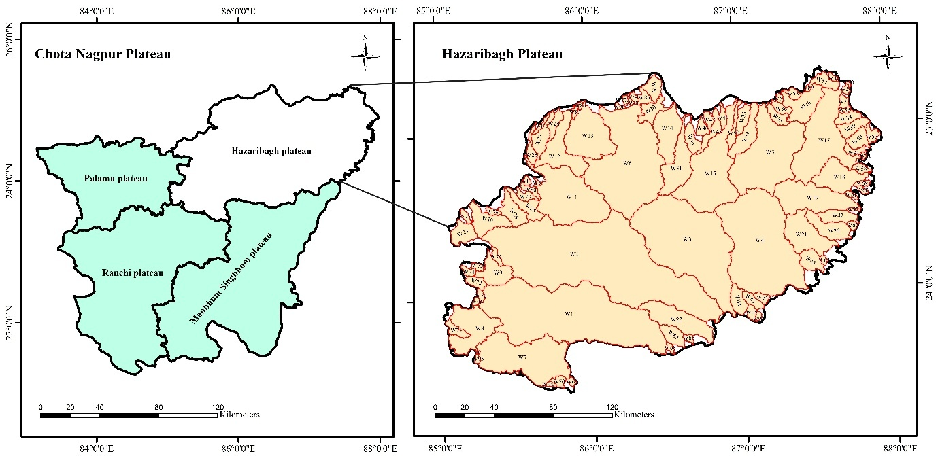
Fig.1 Location of Hazaribagh plateau
The delineation of watersheds and stream networks forms the foundation for any morphometric or hydrological analysis. In the present study, stream networks were first extracted for the entire Hazaribagh Plateau using the Hydrology toolset under the Spatial Analyst Tools in ArcGIS 10.3 software, based on CARTOSAT-1 Digital Elevation Model (DEM) data (Table 1). Stream orders were assigned using the “Stream Order” and “Stream to Feature” tools, following Strahler’s method. The extracted streamlines were then manually refined to correct segmentation issues and ensure continuity, particularly for higher-order streams. Watershed delineation was then carried out through ‘‘watershed” function, with two specific criteria: i. a flow accumulation threshold set at 0.1% of the maximum flow accumulation value, and ii. selection of pour points positioned specifically on streams of third order or higher that flow out of the study area boundary. This approach ensured the identification of hydrologically meaningful watershed outlets and minimized internal fragmentations. As a result, a total of 98 discrete watersheds were delineated across the Hazaribagh Plateau (Fig.1).
Table 1 Data used in present study
S.No. | Dataset | Description | Resolution / Scale | Source / Agency
1 | Digital Elevation Model (DEM) | Cartosat-1 DEM used for watershed delineation | 30 m | ISRO – Bhoonidhi Portal (https://bhoonidhi.nrsc.gov.in)
2 | Land Use/Land Cover (LULC) | Sentinel-2 based land cover classification | 10 m | ESRI Land Cover (Sentinel-2) (https://livingatlas.arcgis.com)
3 | Hydrologic Soil Group (HSG) | Global Hydrologic Soil Groups (HYSOGs250m) | ~250 m | ORNL DAAC – https://daac.ornl.gov/SOILS/guides/HYSOGs250m.html
4 | Rainfall Data | Daily gridded rainfall data (1994–2023) | 0.25° × 0.25° (~25 km) | India Meteorological Department (IMD)

2.2 Analysis of morphometric parameters
From the watershed and stream network maps, key morphometric information was extracted using ArcGIS 10.3 software. These include watershed area, perimeter, and length (The straight-line distance from the outlet to the farthest point on the watershed boundary), stream order, stream number (The count of streams of different orders within each watershed), stream length (Total length of streams by order), and relief (The elevation difference between the highest and lowest points within a watershed). These parameters served as the foundational data for calculating the twelve morphometric indices (Table 2) that are considered to influence surface runoff generation.
Two key linear morphometric parameters namely stream order (U) and mean bifurcation ratio (Rb_{m}) were considered significant in evaluating the runoff potential of the watersheds. Stream order shows the level or position of a stream in the drainage network. Streams of higher order usually collect more water from larger areas and can generate more runoff. Bifurcation ratio (Rb) is the ratio of the number of streams in one order to the number of streams in the next higher order, which shows that the drainage system is branching. A low Rb indicates direct flow and higher runoff, while a high Rb implies more branching, slowing flow and reducing runoff. The mean bifurcation ratio is the average of these ratios for all stream orders in a watershed and is used in this study to assess how efficiently water flows through the drainage system.
Table 2 Methods and formulae adopted for computing morphometric parameters
Aspect | Parameter | Method / Formula | Reference
Linear aspect | Stream Order (U) | Hierarchical method of ranking | Strahler (1957)
Linear aspect | Mean Bifurcation Ratio (Rb_{m}) | Bifurcation Ratio, $Rb={N_{U}}/{N_{U+1}}$  Where: N_{U} = number of streams of a certain order U, N_{U+1} = number of streams of the next high one  Rb_{m} is the average of the bifurcation ratios of all orders | Schumm (1956)
Areal aspect | Elongation Ratio (Re) | $$Re= {(2√{(A}/{π))}}/L$$  Where: A = Area of the watershed (km²), L = Length of the watershed (km) | Schumm (1956)
Areal aspect | Circularity Ratio (Rc) | $$Rc= {4πA}/{P^{2}}$$  Where: A = Area of the watershed (km²), P = Perimeter of the watershed (km) | Miller (1953)
Areal aspect | Form Factor (Ff) | $$Ff= A/{L^{2}}$$  Where: A = Area of the watershed (km²), L = Length of the watershed (km) | Horton (1932)
Areal aspect | Drainage Density (Dd) | $$Dd= {L_{U}}/A$$  Where: L_{U} = Total stream length of all orders (km), A = Area of the watershed (km²) | Horton (1932)
Areal aspect | Stream Frequency (Fs) | $$Fs={∑N_{U}}/A$$  Where: $∑N_{U}$= Total no. of streams of all orders, A = Area of the watershed (km²) | Horton (1932)
Areal aspect | Infiltration Number (If) | $$If=Dd*Fs$$  Where: Dd = Drainage density, Fs = Stream frequency | Faniran (1968)
Areal aspect | Compactness Coefficient (Cc) | $$Cc=0.2821×P/{√A}$$  Where: P = Perimeter of the watershed (km), A = Area of the watershed (km²) | Horton (1945)
Relief aspect | Relief (H) | Vertical distance between the highest and lowest points of the watershed | Schumm (1956)
Relief aspect | Relief Ratio (Rr) | $$Rr= H/L$$  Where: H = Relief, L = Length of the watershed | Schumm (1956)
Relief aspect | Ruggedness Number (Rn) | $$Rn=Dd×H$$  Where: Dd = Drainage density, H = Relief | Strahler (1957)

Areal morphometric parameter like elongation ratio, circularity ratio, form factor, drainage density, stream frequency, infiltration number, and compactness coefficient were analysed to assess their impact on surface runoff potential. The elongation ratio (Re) is defined as the ratio between the diameter of a circle with the same area as the basin and the maximum length of the basin. The form factor (Ff) is the ratio of the basin area to the square of its length. Watersheds with high Re and Ff tend to be more circular, allowing quicker water concentration at the outlet and thus higher runoff. The circularity ratio (Rc) compares the area of the basin to the area of a circle having the same perimeter. Values close to 1 suggest high runoff potential due to compactness and efficient drainage. Drainage density (Dd) is calculated by dividing the total length of all streams in the basin by the basin area. Higher Dd implies more streams per unit area, which enhances runoff as water has less distance to travel before reaching a stream. Stream frequency (Fs) indicates the number of streams per unit area; higher (Fs) generally leads to greater runoff due to reduced infiltration and quicker surface flow. Infiltration number (If) indicates the runoff-infiltration relationship. A higher If generally corresponds to less infiltration and more runoff. compactness coefficient (Cc) is the ratio of the perimeter of the basin to the circumference of a circle with the same area. Lower Cc suggest more circular basins that tend to generate higher runoff, while higher values indicate elongated shapes with reduced runoff potential.
Three key relief parameters namely relief, relief ratio, and ruggedness number were considered for their influence on runoff potential. A greater relief (H) generally indicates steeper slopes, which enhances the velocity of surface water flow and contributes to higher runoff. Relief ratio (Rr) is the ratio of the total relief to the length of the watershed. It reflects the overall steepness of the basin and is directly related to the potential energy available for runoff. Higher Rr imply steeper slopes, faster flow, and greater runoff generation. The ruggedness number (Rn) is a product of basin relief and drainage density, and it represents the combined effect of terrain steepness and the extent of drainage development. A higher Rn indicates a more dissected and steep terrain, which typically results in rapid runoff and reduced infiltration. Together, these parameters help assess the geomorphic control on runoff behavior across the watersheds.
2.3 Surface run-off potential ranking based on morphometric parameters
In first part of the study, runoff potential of the delineated watersheds was evaluated based on an analysis of morphometric parameters. To achieve this, the derived parameters pertaining to linear, areal, and relief aspects that directly influence runoff, were assigned compound score on a scale from 1 to 98, corresponding to the total number of watersheds under investigation. Subsequently, a compound factor (CF) was calculated for each watershed as the average of the assigned compound scores across all selected parameters. This CF value was then used to assess and rank the runoff potential of each watershed. A high CF value indicates that a watershed possesses favourable morphometric characteristics conducive to high runoff generation, whereas a low CF value suggests limited runoff potential (Al-Neama et al., 2022). The morphometric parameters considered to be directly proportional to surface runoff included: stream order, elongation ratio, form factor, circularity ratio, drainage density, stream frequency, infiltration number, relief ratio, total relief, and ruggedness number. For these parameters, higher values signify greater runoff potential; therefore, the highest parameter value was assigned a compound score of 98, the second highest 97, and so forth, down to the lowest value which was assigned a compound score of 1. On the other hand, parameters such as the mean bifurcation ratio and compactness coefficient are inversely related to runoff potential. In this case, lower values indicate higher runoff potential, and thus the lowest value received a compound score of 98, the second lowest 97, continuing down to the highest value, which received a score of 1.
$CF= \frac{C_{U}+C_{{Rb}_{m}}+C_{Re}+C_{Rc}+C_{Ff}+C_{Dd}+C_{Fs}+C_{If}+C_{Cc}+C_{H}+C_{Rr}+C_{Rn} }{n}$ (1)
Where, $CF$ = Compound Factor, n = Total number of parameters, $C_{U}$ = Compound score of stream order, $C_{Fs}$ = Compound score of stream frequency, $C_{{Rb}_{m}}$= Compound score of mean bifurcation ratio, $C_{If}$= Compound score of infiltration number, $C_{Re}$= Compound score of elongation ratio, $C_{Cc}$= Compound score of relief, $C_{Rc}$= Compound score of circularity ratio, $C_{H}$= Compound score of relief, $C_{Ff}$= Compound score of form factor, $C_{Rr}$= Compound score of relief ratio, $C_{Dd}$= Compound score of drainage density, $C_{Rn}$= Compound score of ruggedness number.
2.4 Runoff estimation by SCS-CN method
In the second part of the study, surface runoff from 98 watersheds of Hazaribagh plateau region was estimated using SCS-CN method, using ArcGIS 10.3. List of data used in present study is given in Table 1. The Land-use/Landcover is one of the significant variables for runoff estimation (Dinka and Klik, 2019). Land use map for the study area was extracted using delineated watershed boundary from Sentinel-2 based land cover classification data in ArcGIS software. The LU/LC classes identified in the study area were water bodies, agricultural land, bare land, built-up area, rangeland and forest cover. Hydrological Soil Group (HSG) map of the study area was extracted from Global Hydrologic Soil Groups map using Arc GIS software. Initially, all raster-based maps were reprojected to a common coordinate system and resampled to a uniform spatial resolution to maintain consistency across datasets. They were converted to vector format to facilitate overlay operations and spatial analysis. Subsequently, the land use/land cover (LULC), hydrologic soil group (HSG), and watershed boundary maps were overlaid. Using the 'Summary Statistics' tool in Arc Toolbox, the area of each LULC–HSG combination within each watershed was extracted. These values were then processed in Excel to compute the weighted average Curve Number (CN_{weighted}) for each watershed. The formula for Weighted Average Curve Number for a watershed is:
${CN}_{weighted}​=\frac{∑(Ai​×CNi​)}{∑Ai​}​​$ (2)
Where, Ai​ = Area of land use–soil group combination i within the watershed (km²), CNi​ = Curve Number corresponding to combination i, ∑Ai​ = Total area of the watershed (km²)
Curve Numbers (CNi) corresponding to each unique combination of land use/land cover (LULC) and hydrologic soil group (HSG) were derived from the standard tables (USDA NRCS, 2004), which are widely used for surface runoff estimation in the SCS-CN method. The values of CNi for each combination of LULC and HSG used in present study is listed in Table 3.
Table 3 CNi values for different LULC – HSG combinations
Land Use/ Land Cover | Hydrologic Soil Groups
Land Use/ Land Cover | C | D
Water Bodies | 100 | 100
Agricultural Land | 85 | 89
Bare Land | 91 | 94
Built-up Area | 90 | 92
Rangeland | 79 | 84
Forest Cover | 70 | 77

The weighted Curve Number (CN_{weighted}) used in this study corresponds to CN II, which represents the Antecedent Moisture Condition II (AMC II). AMC describes the soil moisture conditions prior to a rainfall event, which directly affects runoff estimation. There are three standard Antecedent Moisture Conditions: AMC I (Dry soils with low moisture), AMC II (Normal or average soil moisture, used as the standard condition), and AMC III (Wet soils saturated from recent rainfall, resulting in high runoff potential). The classification of AMC is determined based on the total rainfall over the previous 5 days preceding a rainfall event. The USDA-SCS criteria for classifying AMC using 5-day antecedent rainfall is given in Table 4.
Table 4 AMC Classification based on 5-day antecedent rainfall
Soil Type | AMC I (mm) | AMC II (mm) | AMC III (mm)
Dormant Season (Nov - Apr) | <13 | 13-28 | >28
Growing Season (May - Oct) | <36 | 36-53 | >53

CN II (AMC II) values were used as the base, and Curve Numbers corresponding to AMC I (dry) and AMC III (wet) were derived using the standard USDA-SCS adjustment formulas (1) and (2). These adjusted CN values provide a more realistic representation of varying field conditions and are essential for accurate surface runoff estimation under different soil moisture scenarios.
For AMC I, ${CN}_{I}=\frac{{CN}_{II}}{2.281-0.01281×{CN}_{II}}$ (3)
For AMC III, ${CN}_{III}=\frac{{CN}_{II}}{0.427+0.00573×{CN}_{II}}$ (4)
Daily rainfall data for a 30-year period (1994–2023) were obtained from IMD gridded datasets (NetCDF format) and extracted for each of the 98 watersheds using Python-based processing. From this, the normal year daily rainfall for each watershed was identified using a custom Python script. Given the spatial heterogeneity in rainfall across the Hazaribagh Plateau, normal year rainfall was computed separately for each watershed based on deviation from the 30-year annual mean. The normal year rainfall values were used to determine the Antecedent Moisture Condition (AMC), which enabled the classification of each day into AMC I, AMC II, or AMC III based on standard criteria for the dormant and growing seasons. Corresponding to these AMC classes, Curve Number (CN) values; CN I, CN II, and CN III were assigned. The maximum potential retention (S), which represents the maximum amount of water the soil can retain before runoff begins, was then calculated using the standard formula:
$S= \frac{25400}{CN}-254$ (5)
Using the calculated S values and normal daily rainfall data, the Soil Conservation Service-Curve Number (SCS-CN) method was applied to estimate daily surface runoff. The SCS-CN equation is given as:
$$Q=\frac{{\left(P-0.2S\right)}^{2}}{P+0.8S}, for P>0.2S$$
$Q=0, for P≤0.2S$ (6)
Where: $Q$ = runoff depth (mm), $P$ = daily rainfall (mm), $S$ = maximum potential retention (mm).
Subsequently, the annual runoff depth was determined by summing daily runoff values, and the runoff coefficient was computed using the formula:
$Runoff Coefficient \left(C\right)= \frac{Annual runoff depth (mm)}{Annual rainfall depth (mm)}$ (7)
These runoff coefficients reflect the proportion of rainfall converted into surface runoff and serve as an indicator of the watershed’s response to rainfall. This procedure provided an effective assessment of the runoff potential of the watersheds under varying soil moisture conditions. This procedure was carried for all 98 watersheds and runoff coefficient was determined.
- Results and discussion
Results are presented in two parts with the first part pertaining to the morphometric analysis of the watersheds to assess their runoff potential based on key linear, areal, and relief parameters, while the second part focussing on the evaluation of surface runoff potential using the SCS-CN method, followed by a comparative analysis of the runoff potential rankings derived from both approaches.
3.1 Extraction of basic morphometric parameters
The watershed boundary and stream network map were derived from the DEM. Figure 2 presents the stream network overlaid on the delineated watershed map, covering a total area of approximately 38,743.37 km² across the plateau region. Parameters such as area, perimeter, watershed length, and relief were extracted from the watershed boundary layer. Based on the FAO watershed size classification, the watersheds were categorized into three groups (Singh 1997); 5 watersheds (W1–W4, W6) fall under the large watershed category, covering area more than 2500 km², 19 watersheds (W5, W7-W22, W31, W34) are classified as medium-sized, with areas ranging between 250–2500 km² and the remaining 74 watersheds are considered small, each covering area less than 250 km². The watershed length was determined using the Measure tool in Arc Toolbox. Among all, W2 is the largest watershed, with an area of 5736.89 km², a perimeter of 549.43 km, a relief of 1321 m, and a watershed length of 168.46 km. Similar parameters were obtained for the other watersheds as well.
From the stream network, drainage characteristics such as stream order, total number of streams, and total stream length were calculated. The 6th stream order, the highest observed in the study area, is present in six watersheds (W1–W6). W2 has largest number of streams (2004 streams). This is followed by the 5th order, found in 16 watersheds (W7–W22), and the 4th order, observed in 21 watersheds (W23–W25, W27–W32, W34, W36–W40, W42–W44, W67, W71, W85). The remaining 55 watersheds had a maximum of 3rd order streams. Since runoff potential generally increases with stream order, stream order has been incorporated into the Compound Factor (CF) calculation. With these basic morphometric parameters obtained using GIS tools, the parameters selected for CF determination were computed using methods/ formulas listed in Table 2.
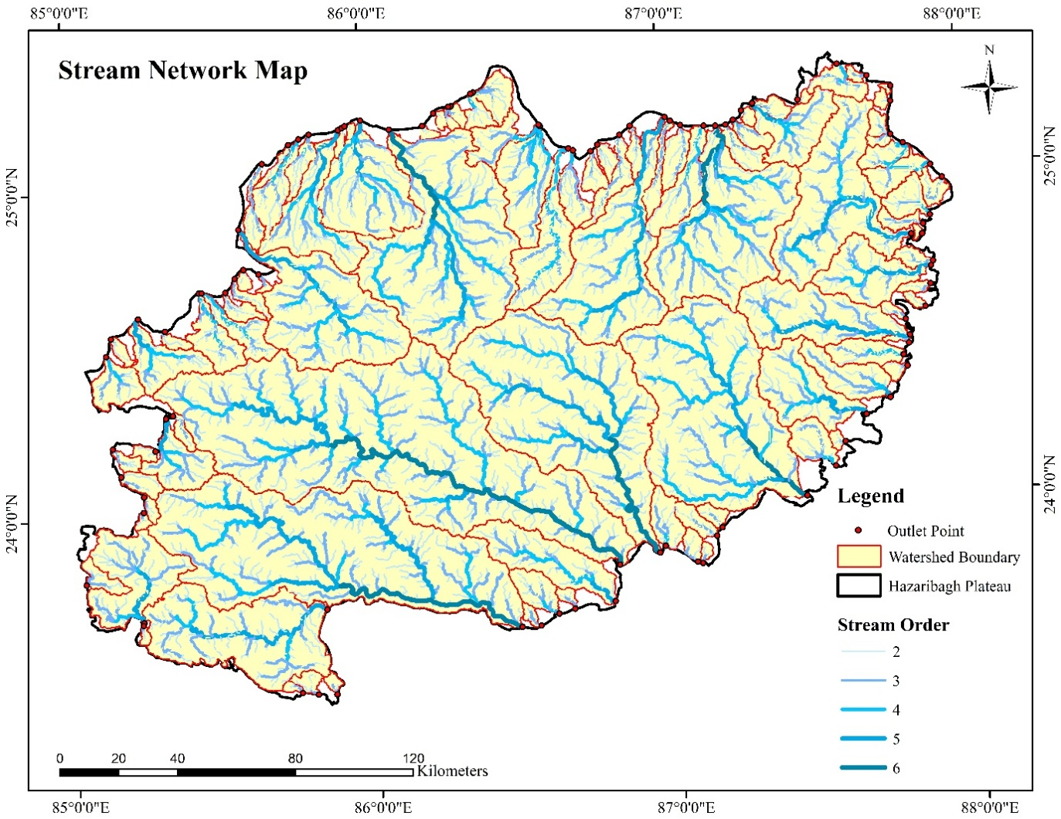
Fig.2 Stream Network Map with the delineated watershed boundaries and outlets
3.2 Assessment of surface runoff potential using morphometric parameters
To evaluate the runoff potential, 12 morphometric parameters namely linear aspects (stream order [U], mean bifurcation ratio [Rb_{m}]), areal aspects (elongation ratio [Re], circularity ratio [Rc], form factor [Ff], drainage density [Dd], stream frequency [Fs], infiltration number [If], compactness coefficient [Cc]), and relief aspects (relief [H], relief ratio [Rr], and ruggedness number [Rn]) were considered. These parameters were calculated for 98 delineated watersheds, and compound scores were assigned based on their hydrological relationship with runoff potential. Subsequently, a compound factor (CF) was derived for each watershed using the equation (1), and this CF value was utilized to rank the runoff potential of each watershed. For example, Watershed W1 has the following parameter values: U = 6, Rb_{m} = 4.12, Re = 0.54, Rc = 0.27, Ff = 0.23, Dd = 0.73 km/km², Fs = 0.35 streams/km², If = 0.26, Cc = 1.93, H = 1242 m, Rr = 9.42, and Rn = 0.15. W1 got compound scores with C_{U} = 95.5, C_{Rbm} = 29, C_{Re} = 18, C_{Rc} = 18, C_{Ff} = 18.5, C_{Dd} = 35.5, C_{Fs} = 38, C_{If} = 31.5, C_{Cc} = 17, C_{H} = 97, C_{Rr} = 36 and C_{Rn} = 34. The CF for W1 is calculated as:
$CF= \frac{95.5+29+18+18+18.5+35.5+38+31.5+17+97+36+34 }{12}=39.0$
Watersheds with higher compound factor values were interpreted as having morphometric characteristics more conducive to surface runoff generation during storm events, whereas those with lower values were considered less efficient in generating runoff. Based on the range of compound factors, the watersheds were classified into five equal-interval categories: very high runoff potential (CF = 69–82), high runoff potential (CF = 56–69), moderate runoff potential (CF = 43–56), low runoff potential (CF = 30–43), and very low runoff potential (CF = 17–30). The spatial distribution of these classifications is illustrated in Figure 3, and potential ranks corresponding to each watershed are presented in Table 5.
The results of the rank evaluation of the watersheds’ potential to generate surface runoff revealed that 8 watersheds (W29, W54, W63, W81, W87, W89, W94, and W98) had a very high potential, as indicated by their high compound factor (CF) values of 78.7, 71.1, 72.8, 81.8, 77.8, 74.0, 71.8, and 77.5, respectively. Twenty watersheds (W13, W16, W23, W36, W37, W38, W51, W55, W56, W69, W71, W84, W85, W86, W88, W90, W91, W95, W96, and W97) fall under the high potential category, with CF values of 67.2, 62.4, 67.0, 59.0, 60.4, 58.3, 60.8, 64.1, 62.9, 68.3, 58.4, 68.5, 62.8, 59.7, 65.4, 61.8, 61.3, 67.1, 61.9, and 64.8, respectively, indicating that these watersheds possess morphometric characteristics that are more favourable for surface runoff generation. Nearly, 38 watersheds (W3, W4, W5, W6, W7, W8, W9, W10, W14, W17, W18, W20, W21, W24, W25, W32, W40, W43, W46, W52, W53, W58, W60, W61, W62, W64, W65, W66, W67, W68, W70, W72, W74, W75, W77, W79, W83, and W93) have CF values of 43.2, 55.8, 55.5, 53.9, 44.5, 50.8, 53.3, 52.8, 52.1, 52.5, 47.9, 43.0, 45.3, 50.0, 45.5, 43.0, 53.2, 52.7, 50.1, 46.9, 54.5, 47.3, 52.5, 54.8, 43.7, 47.4, 43.4, 47.8, 47.1, 48.8, 47.6, 52.5, 54.1, 55.5, 49.0, 43.9, 44.8, and 44.7, respectively, and are categorized under the moderate runoff potential rank.
24 watersheds (W1, W2, W11, W12, W15, W19, W22, W27, W28, W30, W31, W35, W39, W41, W42, W44, W47, W57, W59, W73, W76, W78, W80, and W92) had low CF values of 39.0, 35.5, 41.8, 40.8, 39.5, 40.2, 38.0, 31.2, 41.8, 36.1, 31.0, 31.7, 41.4, 38.5, 36.6, 42.8, 41.7, 36.3, 37.5, 39.5, 40.9, 40.6, 37.5, and 40.4, respectively, indicating that these watersheds possess morphometric characteristics less favourable for surface runoff generation. Finally, 8 watersheds (W26, W33, W34, W45, W48, W49, W50, and W82) with very low CF values of 17.2, 27.0, 23.5, 29.4, 21.4, 28.2, 18.6, and 27.0, respectively, reflect poor morphometric traits and hence had the least potential to generate runoff. Overall, the findings demonstrate that a significant portion of the study area possesses moderate to low runoff potential.
Table 5 Watershed classification by Compound factor (CF) range from morphometric parameters and their surface runoff potential rank
S.No. | CF Value | Watersheds | Potential Rank
1 | 69–82 | W29, W54, W63, W81, W87, W89, W94, W98 | Very High
2 | 56–69 | W13, W16, W23, W36, W37, W38, W51, W55, W56, W69, W71, W84, W85, W86, W88, W90, W91, W95, W96, W97 | High
3 | 43–56 | W3, W4, W5, W6, W7, W8, W9, W10, W14, W17, W18, W20, W21, W24, W25, W32, W40, W43, W46, W52, W53, W58, W60, W61, W62, W64, W65, W66, W67, W68, W70, W72, W74, W75, W77, W79, W83, W93 | Moderate
4 | 30–43 | W1, W2, W11, W12, W15, W19, W22, W27, W28, W30, W31, W35, W39, W41, W42, W44, W47, W57, W59, W73, W76, W78, W80, W92 | Low
5 | 17–30 | W26, W33, W34, W45, W48, W49, W50, W82 | Very Low

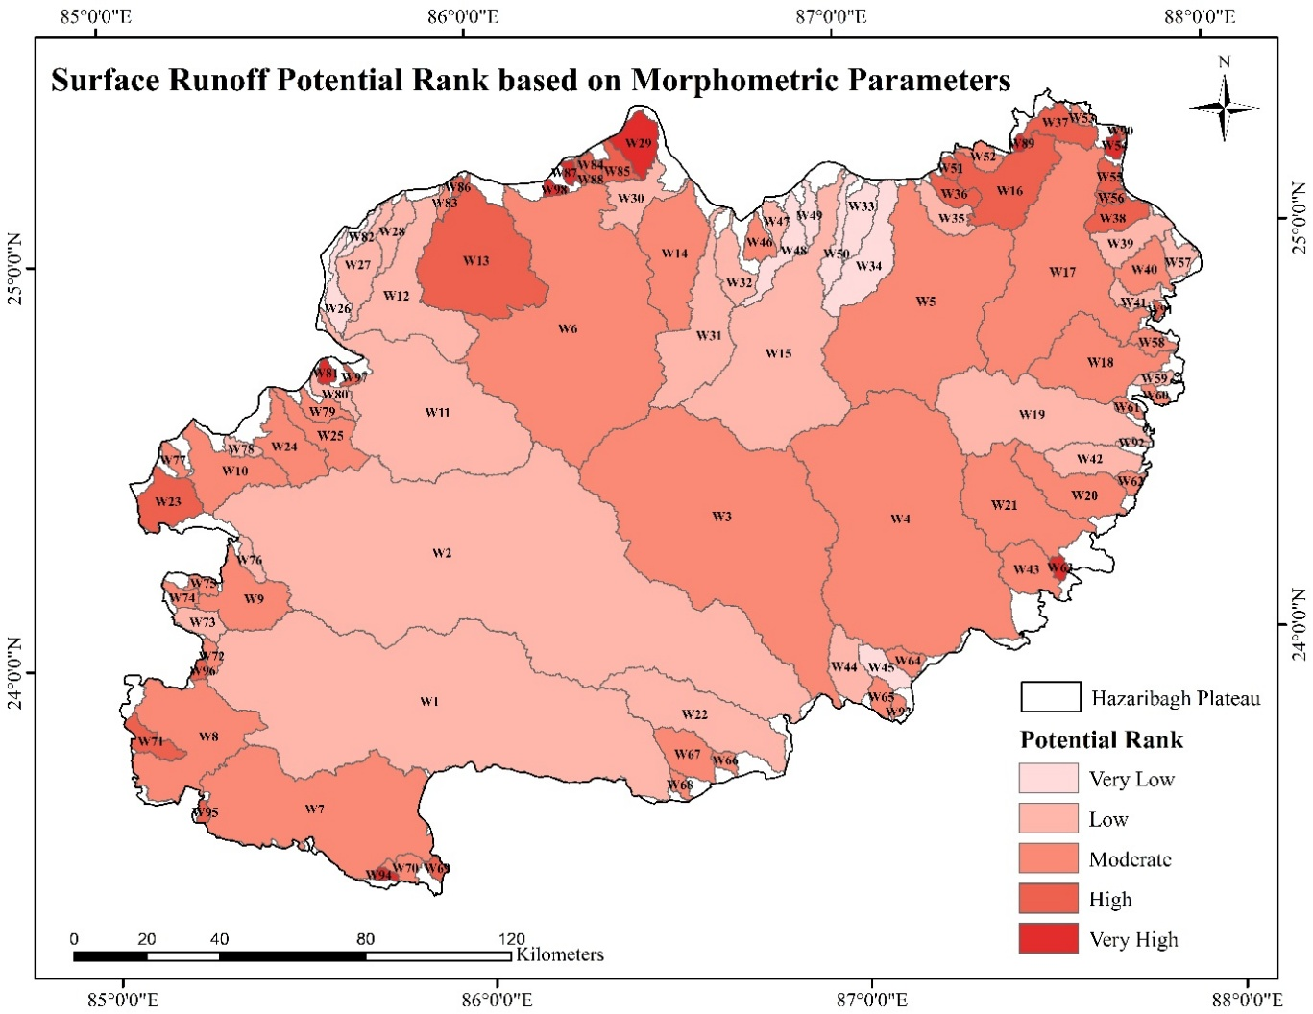
Fig.3 Surface runoff potential rank of watersheds based on morphometric parameters
3.3 Assessment of surface runoff potential by SCS-CN method
3.3.1 Land use/ land cover (LULC)
Figure 4 shows the land use/land cover (LULC) distribution of the study area. Analysis showed that approximately 1.12% of the total area (432.75 km²) is covered by water bodies, while agricultural land constitutes the major part by 44.69% (17,313.85 km²). rangeland accounts for 26.83% (10,394.60 km²), followed by forest cover at 18.16% (7,035.80 km²), built-up areas at 9.07% (3,514.24 km²), and bare land at 0.14% (53.03 km²).
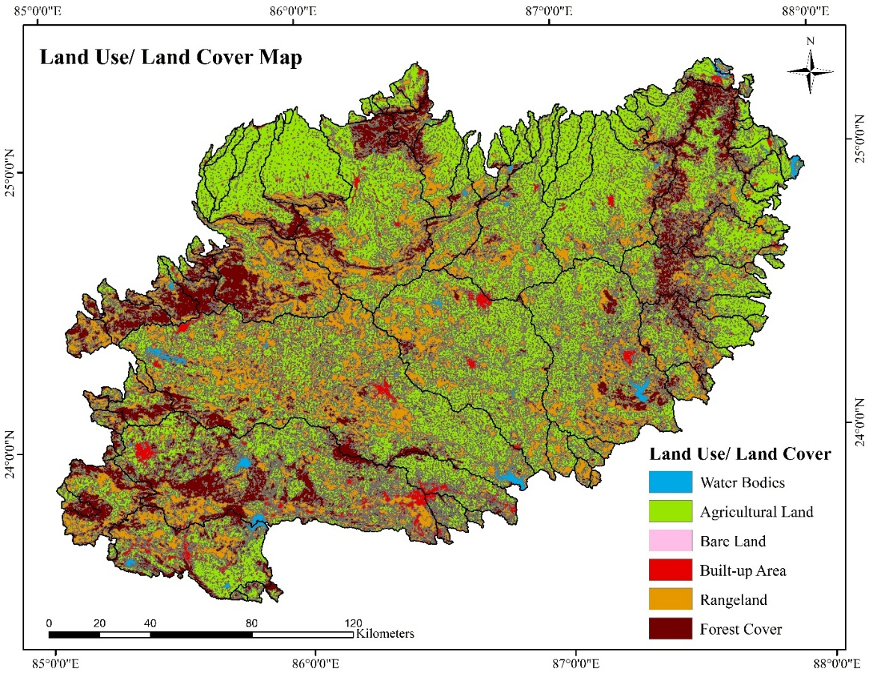
Fig.4 LULC map of watersheds in Hazaribagh Plateau
3.3.2 Hydrological soil groups (HSG)
Figure 5 presents the spatial distribution of Hydrologic Soil Groups (HSG) within the study area. It is observed that only HSG C and HSG D are present. These soil groups are characterized by low to very low infiltration rates, resulting in moderate to higher surface runoff potential. Specifically, HSG C typically includes fine-textured soils like clay loam, while HSG D comprises poorly drained soils with a high clay content or shallow water table. The study area is predominantly characterized by HSG C, which covers approximately 69.64% of the total area, amounting to 26,983.10 km². This is followed by HSG D, which accounts for the remaining 30.36%, covering an area of about 11,760.67 km².
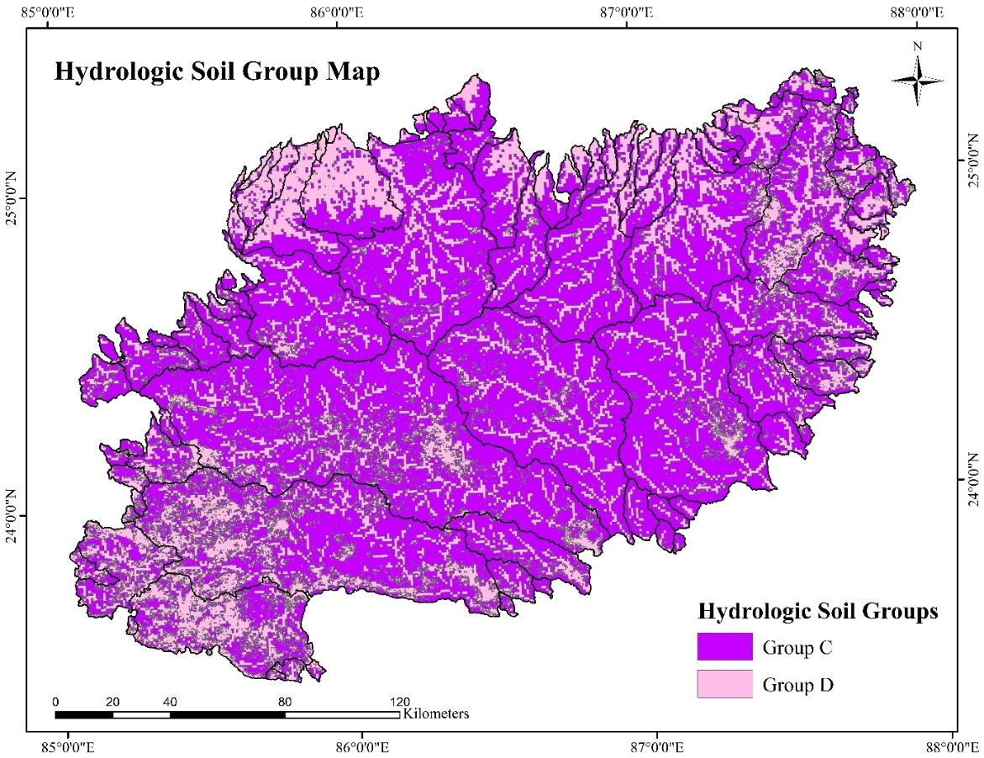
Fig.5 HSG map of watersheds in Hazaribagh Plateau
3.3.3 Slope (%)
Figure 6 shows the slope map of the watersheds in the study area. It can be seen that higher slopes are present predominantly in north eastern portion of the study and some part of the western area. Most of the central and southern watersheds are having flat to gentle slope.
3.3.4 Estimation of curve number (CN) and runoff coefficient (C)
The weighted Curve Number (CN), also referred to as CN II, was determined individually for all 98 watersheds using equation (2) and Table 3, which contains CN values for different land use/land cover (LULC) and Hydrologic Soil Group (HSG) combinations. Figure 7 illustrates the CN II map of the study area encompassing all 98 watersheds. Based on the derived CN II values, the corresponding CN I and CN III values were calculated using Equation (3) and Equation (4), respectively. Watersheds with higher CN values have comparatively higher runoff.
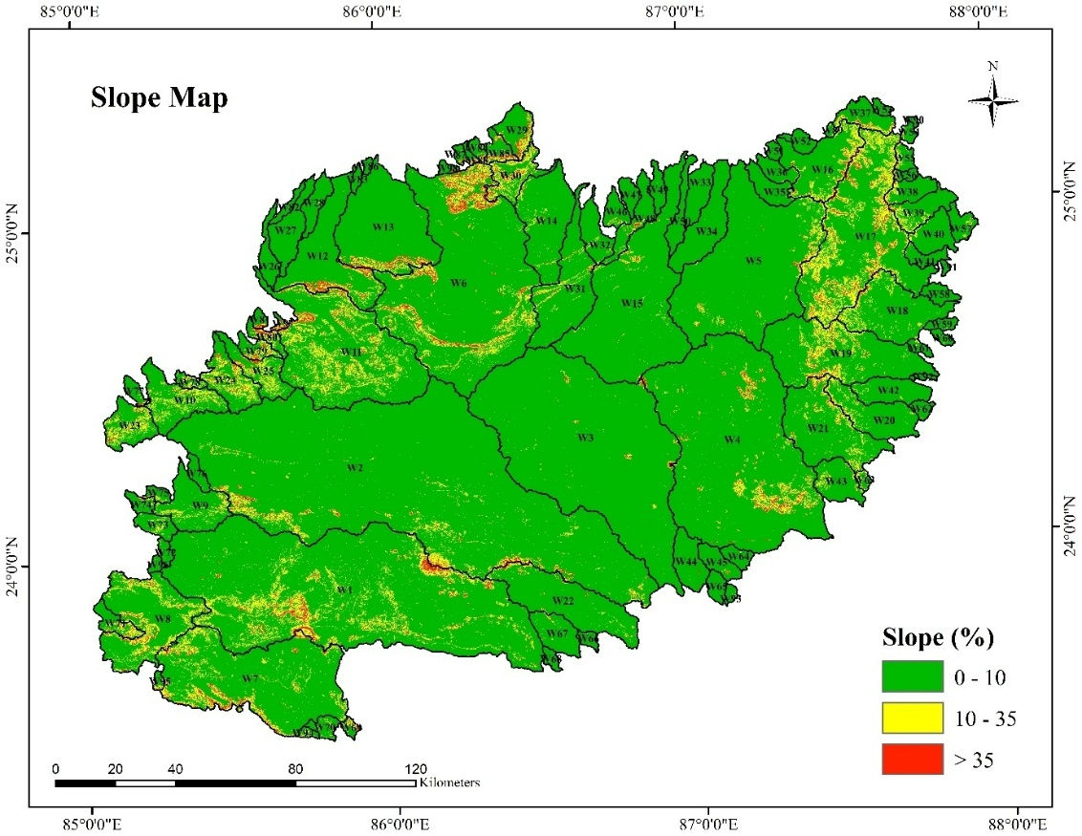
Fig.6 Slope map of watersheds in Hazaribagh Plateau
The daily rainfall data of the normal year for each of the 98 watersheds was extracted from IMD gridded rainfall datasets (1994–2023) using a custom Python script. Based on this, appropriate AMC classes were assigned, and the respective CN values were applied. The SCS-CN method was then employed using Equation (5) for potential maximum retention (S) and Equation (6) for runoff estimation. This procedure yielded the daily runoff depth for each watershed. From this, the annual rainfall depth and annual runoff depth were computed, which was used to calculate the runoff coefficient for all 98 watersheds.
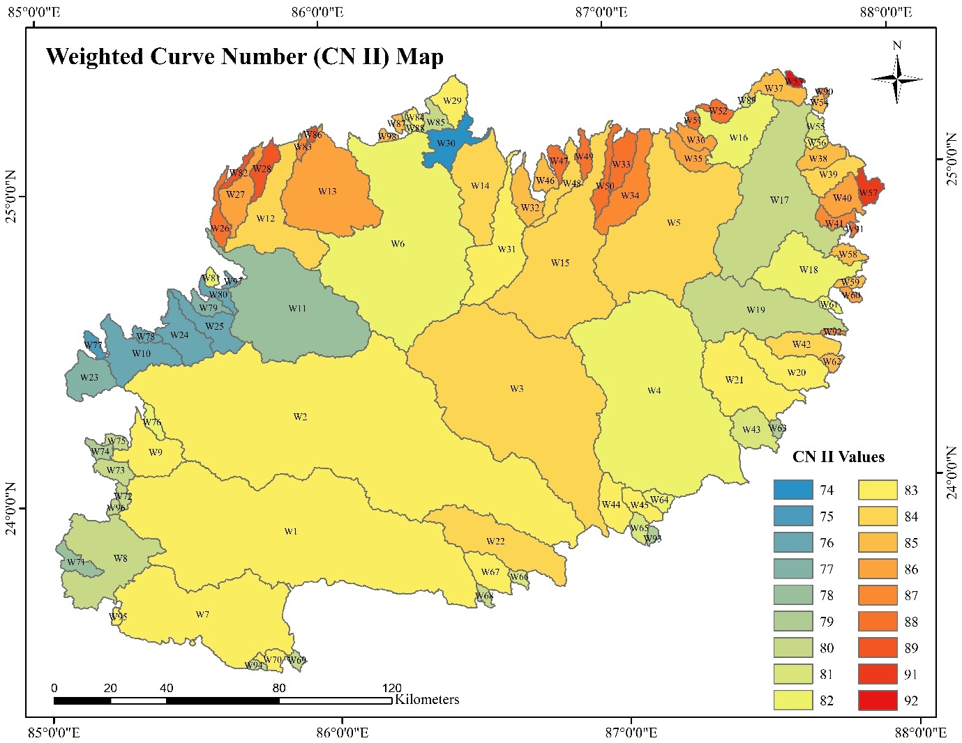
Fig.7 Weighted Curve number (CN_{weighted} / CN II) of watersheds in Hazaribagh Plateau
3.4 Ranking surface runoff potential of the watersheds based on runoff coefficient (C)
Figure 8 presents the spatial distribution of watersheds based on runoff coefficient ranks. The 98 delineated watersheds were categorized into five runoff potential ranks using equal intervals determined from the maximum and minimum runoff coefficient values. Watersheds with runoff coefficients ranging from 0.09 to 0.18 were classified as having very low runoff potential, 0.18 to 0.26 as low, 0.26 to 0.35 as moderate, 0.35 to 0.47 as high, and those ranging from 0.47 to 0.56 were identified as having very high runoff potential (Table 6).
Only 2 watersheds W53 and W57 had very high runoff potential with C values of 0.56 and 0.55, respectively. LULC map indicated presence of large water bodies and agricultural areas in these watersheds. Water bodies increase immediate surface storage, contributing to high runoff coefficient if the surrounding land has low infiltration. The combination of saturated soils, impervious areas and low-infiltration would have resulted in very high runoff. 24 watersheds ( W16, W28, W29, W33, W36, W37, W38, W39, W40, W41, W49, W51, W54, W55, W56, W82, W84, W86, W87, W88, W89, W90, W91, W98) showed high runoff potential with C values of 0.35, 0.37, 0.40, 0.45, 0.41, 0.38, 0.42, 0.38, 0.39, 0.35, 0.45, 0.44, 0.43, 0.35, 0.39, 0.37, 0.40, 0.38, 0.42, 0.38, 0.43, 0.47, 0.36, 0.42; respectively. Figure 6 shows that these two classes of watersheds are clustered in the northeastern corner of the plateau where there are predominant steep slopes. High slopes along with the HSG C and D increase overland flow velocity, reducing infiltration. From the LULC map, these areas have bare land with some built-up area and water bodies. High runoff is due to steep terrain, limited infiltration, and presence of impervious or low absorption land covers.
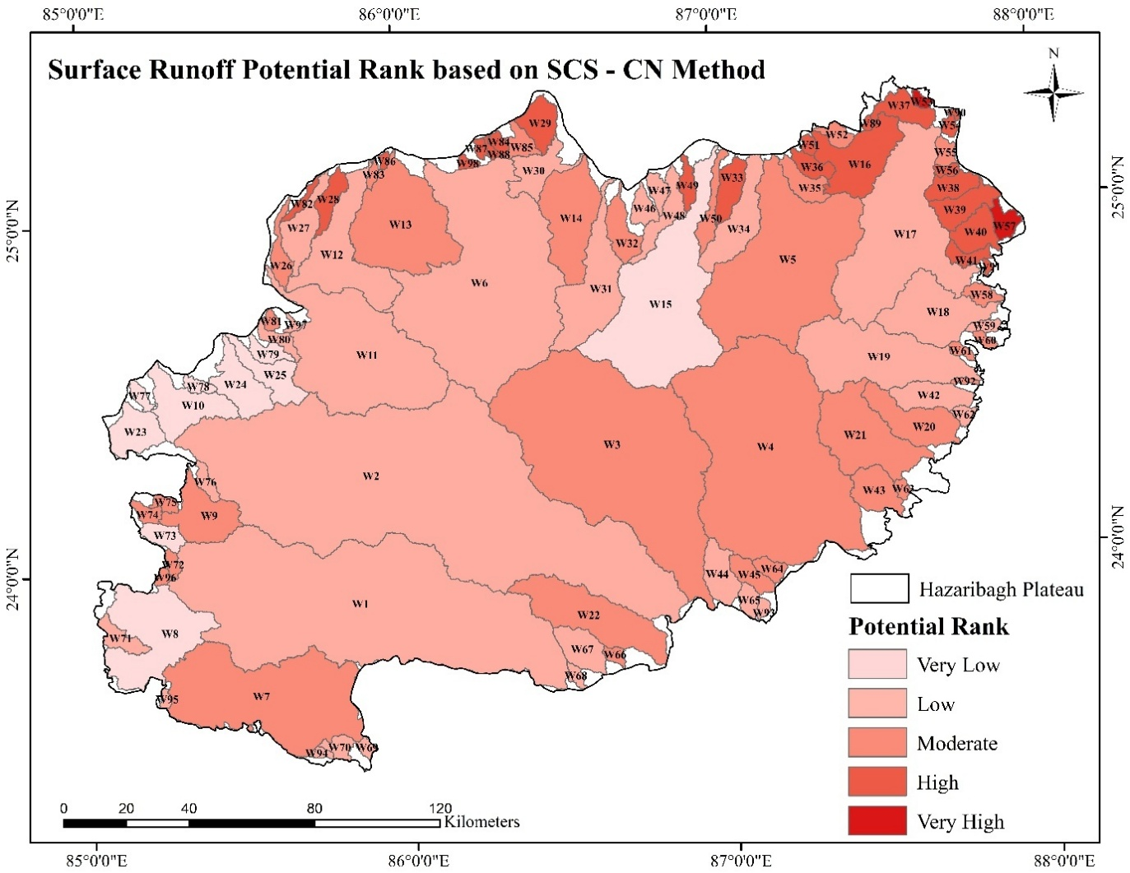
Fig.8 Surface runoff potential ranking of watershed based on SCS-CN method
10 watersheds (W8, W10, W15, W23, W24, W25, W73, W77, W78, W79) showed very low potential with runoff coefficient (C) values of 0.17, 0.09, 0.16, 0.15, 0.18, 0.13, 0.12, 0.16, 0.09, 0.15; respectively. These lie in the western parts of the plateau region. Despite having steep slopes and HSG C and D, these watersheds are heavily forested, which is evident in LULC map. Forests have high interception and deep root systems that enhance infiltration and slow down overland flow. 31 watersheds (W1, W2, W6, W11, W12, W17, W18, W19, W27, W30, W31, W34, W42, W44, W46, W47, W48, W59, W62, W65, W67, W68, W69, W70, W71, W76, W80, W93, W94, W 95, W 97) showed low potential with C values of 0.20, 0.26, 0.19, 0.19, 0.25, 0.24, 0.20, 0.20, 0.25, 0.26, 0.24, 0.25, 0.25, 0.24, 0.18, 0.22, 0.22, 0.25, 0.23, 0.22, 0.20, 0.21, 0.20, 0.22, 0.22, 0.23, 0.22, 0.20, 0.19, 0.20, 0.21; respectively. Slope map shows flat to gentle slopes. LULC map revealed predominantly agricultural lands and some forest. these conditions promote infiltration and water retention, reducing runoff. 31 watersheds (W3, W4, W5, W7, W9, W13, W14, W20, W21, W22, W26, W32, W35, W43, W45, W50, W52, W58, W60, W61, W63, W64, W66, W72, W74, W75, W81, W83, W85, W92, W96) have moderate runoff potential with C values of 0.32,0.27,0.28,0.26, 0.26, 0.26, 0.30, 0.28, 0.28, 0.29, 0.33, 0.30, 0.34, 0.26, 0.31, 0.33, 0.34, 0.29, 0.32, 0.26, 0.30, 0.29, 0.27, 0.26, 0.32, 0.32, 0.33, 0.34, 0.32, 0.32, 0.26; respectively. Slope map indicated gentle slopes. LULC map showed mixed land use with agriculture, forest, and scattered built-up areas. Mixed land use offers variable hydrological response. Moderate runoff is attributed by the balance of slope and heterogeneous land use.
Despite the dominance of Hydrologic Soil Group, HSG C and D in all watersheds, the majority still exhibited low to moderate runoff potential. This can be explained by factors such as vegetation cover, slope gradients, land use practices and hence its infiltration capacity that act to moderate runoff even in lower permeable soils. HSG C and D usually indicate poor infiltration, but land use and slope override hydrologic soil group influence. Runoff from HSG C and D can be significantly influenced by land cover and terrain features that alter flow paths and infiltration opportunities. Additionally, it was observed that the larger watersheds tend to fall under the low or moderate runoff categories, likely because of the greater spatial heterogeneity within them and higher retention due to longer flow paths and more vegetative or storage zones.
Table 6 Watershed classification by Runoff coefficient (C) from SCS-CN method and their surface runoff potential rank
S.No. | Runoff Coefficient (C) | Watersheds | Potential Rank
1 | 0.47-0.56 | W53, W57 | Very High
2 | 0.35-0.47 | W16, W28, W29, W33, W36, W37, W38, W39, W40, W41, W49, W51, W54, W55, W56, W82, W84, W86, W87, W88, W89, W90, W91, W98 | High
3 | 0.26-0.35 | W3, W4, W5, W7, W9, W13, W14, W20, W21, W22, W26, W32, W35, W43, W45, W50, W52, W58, W60, W61, W63, W64, W66, W72, W74, W75, W81, W83, W85, W92, W96 | Moderate
4 | 0.18-0.26 | W1, W2, W6, W11, W12, W17, W18, W19, W27, W30, W31, W34, W42, W44, W46, W47, W48, W59, W62, W65, W67, W68, W69, W70, W71, W76, W80, W93, W94, W 95, W 97 | Low
5 | 0.09-0.18 | W8, W10, W15, W23, W24, W25, W73, W77, W78, W79 | Very Low

3.5 Comparison of surface runoff potential ranks from both approaches
The runoff potential ranks derived from morphometric analysis using the Compound Factor (CF) method and those obtained through the SCS-CN method were compared across 98 watersheds in the Hazaribagh Plateau (Table 7). The results revealed that 46 watersheds exhibited identical runoff ranks in both methods, indicating a strong agreement between geomorphometric parameters and actual hydrological response modelled by the SCS-CN method. It reinforces the validity of morphometric analysis as a reliable preliminary tool for assessing surface runoff potential. These watersheds cover most part of the study area as they are generally large to medium sized watersheds, prominently located in the central and southern regions and reflect consistent topographic and land surface characteristics, suggesting reliable morphometric estimation (Fig. 9). However, 35 watersheds had lower runoff ranks in the SCS-CN method compared to their morphometric potential ranks. This discrepancy is likely due to the presence of forest cover and agricultural land that promotes infiltration which are the factors not captured by morphometric parameters. Such watersheds highlight the limitations of relying solely on structural attributes for runoff prediction.
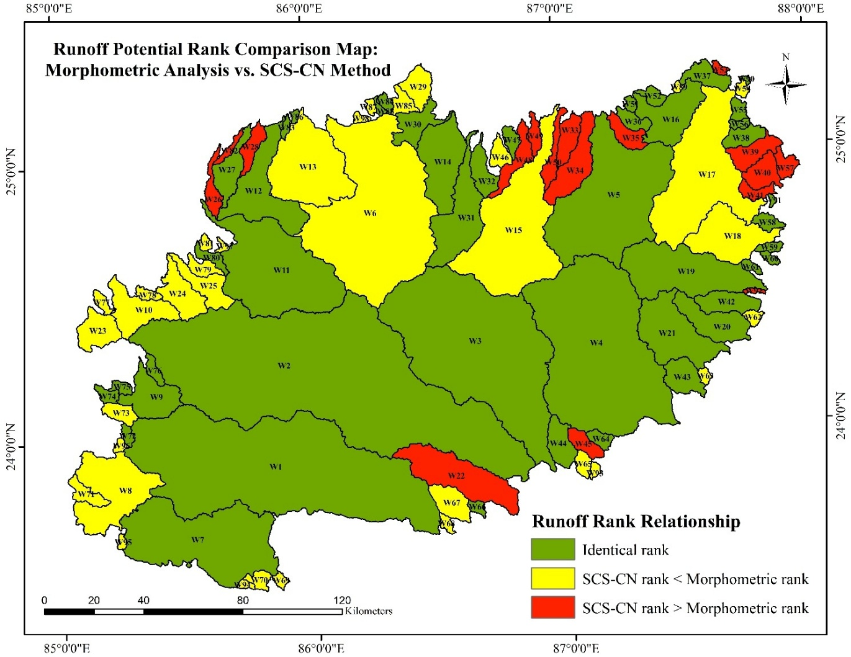
Fig.9 Comparison of surface runoff potential ranks obtained from morphometric analysis and SCS-CN method
Conversely, 17 watersheds, predominantly smaller in size and located mostly in the northeastern parts of the study area, showed higher runoff potential in the SCS-CN method than what morphometric analysis suggested. Steep slopes combined with impervious land cover (e.g., built-up areas) and land cover like bare lands and waterbodies attributed to enhanced surface runoff regardless of the watersheds’ form. These findings underline the importance of integrating both morphometric and land-based hydrological models. While morphometric analysis provides a preliminary, structure-driven estimation of runoff potential, the SCS-CN method reflects actual hydrological behavior by incorporating dynamic variables such as land use/land cover, soil group, and antecedent moisture condition. Therefore, a combined approach is essential for effective water resource management.
Table 7 Comparison of surface runoff potential ranks obtained from morphometric analysis and SCS-CN method
Category | Watersheds
Watersheds having equal rank in both methods | W1, W2, W3, W4, W5, W7, W9, W11, W12, W14, W16, W19, W20, W21, W27, W30, W31, W32, W36, W37, W38, W42, W43, W44, W47, W51, W52, W55, W56, W58, W59, W60, W61, W64, W66, W72, W74, W75, W76, W80, W83, W84, W86, W88, W90, W91
Watersheds having SCS-CN rank lower than their morphometric parameter rank | W6, W8, W10, W13, W15, W17, W18, W23, W24, W25, W29, W46, W54, W62, W63, W65, W67, W68, W69, W70, W71, W73, W77, W78, W79, W81, W85, W87, W89, W93, W94, W95, W96, W97, W98
Watersheds having SCS-CN rank higher than their morphometric parameter rank | W22, W26, W28, W33, W34, W35, W39, W40, W41, W45, W48, W49, W50, W53, W57, W82, W92

- Conclusion
Effective assessment of surface runoff is essential for efficient management of rainwater, especially in regions with limited ground-based data. This study evaluated the surface runoff potential of 98 delineated watersheds in the Hazaribagh Plateau region using an integrated approach combining Geographic Information System (GIS) and Remote Sensing (RS) technologies. Two distinct methodologies: (i) morphometric parameter analysis using a compound factor approach, and (ii) the Soil Conservation Service-Curve Number (SCS-CN) method based on land use, soil, and rainfall data; were adopted and results were compared. Using Cartosat-1 DEM, watershed boundaries and stream networks were extracted. Key morphometric parameters related to linear, areal, and relief aspects were computed, and watersheds were ranked based on compound factor obtained into five runoff potential classes. The morphometric analysis classified the watersheds as 8 with very high runoff potential, 20 with high potential, 38 with moderate potential, 24 with low potential, and 8 with very low potential. The SCS-CN method which uses LULC, Hydrologic Soil Groups (HSG), and Antecedent Moisture Conditions (AMC), was used for runoff estimation. Weighted curve numbers were calculated based on LULC-HSG combinations within each watershed. Thirty years (1994–2023) of IMD gridded rainfall data were analysed to identify a normal rainfall year for each watershed, and annual runoff depth was estimated using the SCS-CN method. The runoff coefficient, derived from annual runoff and rainfall depths, was used to classify runoff potential similarly into five categories: 2 watersheds with very high potential, 24 with high potential, 31 with moderate potential, 31 with low potential, and 10 with very low runoff potential.
Comparison between the two methods revealed that 46 watersheds had identical runoff ranks, indicating a strong agreement between morphometric structure and hydrologic response. However, 35 watersheds had lower ranks in the SCS-CN method than in morphometric analysis, while 17 small watersheds showed higher SCS-CN ranks, likely due to the influence of dynamic land surface conditions. This supports the limitations of relying solely on terrain-based morphometric analysis. This study reinforces the significance of combining morphometric and hydrologic modeling approaches using SCS-CN method, GIS and RS for a holistic and reliable assessment of surface runoff potential. Such integrated assessments can play important role in prioritizing watersheds for conservation planning, designing water harvesting structures, and implementing soil erosion control strategies in the Hazaribagh Plateau and similar physiographic regions.
Declarations

Competing interest- The authors declare no competing interest.

Reference
Al-Ghobari, H., Dewidar, A., & Alataway, A. (2020). Estimation of surface water runoff for a semi-arid area using RS and GIS-based SCS-CN method. Water, 12(7), 1924.
Al-neama, S. N., Yang, S., & Yahya, B. M. (2022). Evaluation of surface run-off potential of basins in Nineveh governorate, Iraq based on morphometric analysis, using RS and GIS. Materials Today: Proceedings, 60, 1753-1768.
Arulbalaji, P., & Padmalal, D. (2020). Sub-watershed prioritization based on drainage morphometric analysis: a case study of Cauvery River Basin in South India. Journal of the Geological Society of India, 95(1), 25-35.
Dinka, M. O., & Klik, A. (2019). Effect of land use–land cover change on the regimes of surface runoff—the case of Lake Basaka catchment (Ethiopia). Environmental monitoring and assessment, 191(5), 278.
Eniyew, S., Meshesha, D. T., Zeleke, G. A., & Wassie, S. B. (2024). Combining geospatial information and SCS-CN for surface runoff estimation in Rib watershed, upper Blue Nile Basin, Ethiopia. Geomatics, Natural Hazards and Risk, 15(1), 2338533.
Faniran, A. (1968). The index of drainage intensity: a provisional new drainage factor. Aust J Sci, 31(9), 326-330.
Ghosh, A., & Bera, B. (2023). Landform classification and geomorphological mapping of the Chota Nagpur Plateau, India. Quaternary Science Advances, 10, 100082.
Gitika, T., & Ranjan, S. (2014). Estimation of surface runoff using NRCS curve number procedure in Buriganga Watershed, Assam, India-a geospatial approach. International Research Journal of Earth Sciences, 2(5), 1-7.
Horton, R. E. (1932). Drainage-basin characteristics. Transactions, American geophysical union, 13(1), 350-361.
Horton, R. E. (1945). Erosional development of streams and their drainage basins; hydrophysical approach to quantitative morphology. Geological society of America bulletin, 56(3), 275-370.
Kabite, G., & Gessesse, B. (2018). Hydro-geomorphological characterization of Dhidhessa River basin, Ethiopia. International Soil and Water Conservation Research, 6(2), 175-183.
Karunanidhi, D., Anand, B., Subramani, T., & Srinivasamoorthy, K. (2020). Rainfall-surface runoff estimation for the Lower Bhavani basin in south India using SCS-CN model and geospatial techniques. Environmental Earth Sciences, 79(13), 335.
Kumar, A., Kanga, S., Taloor, A. K., Singh, S. K., & Đurin, B. (2021). Surface runoff estimation of Sind River basin using integrated SCS-CN and GIS techniques. HydroResearch, 4, 61-74.
Manjare, B. S., Khan, S., Jawadand, S. A., & Padhye, M. A. (2018). Watershed prioritization of Wardha river basin, Maharashtra, India using morphometric parameters: A remote sensing and GIS-based approach. In Hydrologic Modeling: Select Proceedings of ICWEES-2016 (pp. 353-366). Springer Singapore.
Miller, V. C. (1953). A quantitative geomorphic study of drainage basin characteristics in the Clinch Mountain area, Virginia and Tennessee (Technical Report 3). Columbia University, Department of Geology, ONR Geography Branch.
Mulu, A., Kassa, S. B., Wossene, M. L., Meshesha, T. M., Fenta, A. A., & Hailu, Y. B. (2025). Runoff estimation using the SCS-CN method and GIS: a case study in the Wuseta watershed, upper blue Nile Basin, Ethiopia. Discover Water, 5(1), 32.
Patil, N. D., Ayare, B. L., Bhange, H. N., Ingle, P. M., Tharkar, M. H., & Gavit, S. B. (2024). Runoff Estimation in Kajurli Watershed Using SCS-CN and GIS Techniques. International Journal of Environment and Climate Change, 14(10), 547-556.
Rajbanshi, J. (2016). Estimation of runoff depth and volume using NRCS-CN method in Konar Catchment (Jharkhand, India). Journal of Civil & Environmental Engineering, 6(4), 236.
Ramakrishnan, D., Bandyopadhyay, A., & Kusuma, K. N. (2009). SCS-CN and GIS-based approach for identifying potential water harvesting sites in the Kali Watershed, Mahi River Basin, India. Journal of earth system science, 118, 355-368.
Rao, K. N. (2020). Analysis of surface runoff potential in ungauged basin using basin parameters and SCS-CN method. Applied Water Science, 10 (1).
Schumm, S. A. (1956). Evolution of drainage systems and slopes in badlands at Perth Amboy, New Jersey. Geological society of America bulletin, 67(5), 597-646.
Singh, V. P. (1997). Kinematic wave modeling in water resources: Environmental hydrology. John Wiley & Sons.
Somashekar, R. K., Ravikumar, P., Sowmya, S. V., Dar, M. A., & Ravikumar, A. S. (2011). Runoff estimation and morphometric analysis for Hesaraghatta watershed using IRS–1D LISS III FCC satellite data. Journal of the Indian Society of Remote Sensing, 39, 95-106.
Strahler, A. N. (1957). Quantitative analysis of watershed geomorphology. Eos, Transactions American Geophysical Union, 38(6), 913-920.
Tailor, D., & Shrimali, N. J. (2016). Surface runoff estimation by SCS curve number method using GIS for Rupen-Khan watershed, Mehsana district, Gujarat. J. Indian Water Resour. Soc, 36(4), 1-5.
USDA NRCS. (2004). Part 630 Hydrology, National Engineering Handbook – Chapter 9: Hydrologic Soil-Cover Complexes. U.S. Department of Agriculture, Natural Resources Conservation Service, Washington, D.C.

