Original Research Article

Assessing Experiences, Public Awareness, and Participation (EAP) in Addressing Environmental Pollution

.
ABSTRACT

The current study examines the public involvement with environmental pollution based on the Experience -Awareness-Participation (EAP), thus to evaluate on the ecological problems by the way of how the people in terms of perceive, understand and respond. A cross-sectional quantitative survey design was adopted where 120 participants were sampled from diverse age, occupational and residential strata. An organized 15-item questionnaire was used that encompassed a 3-factor scale: experience with pollution, the level of environmental policies and campaigns awareness and participation in environmental actions, with a 5-point Likert scale. Mean rank test revealed that majority of the respondents recognised water quality degradation was mainly due to pollution. While majority of the respondents supported awareness initiatives and regulatory actions, their knowledge of government policies and water conservation programs remained comparatively low.
Responses ranged widely. Many people were willing to volunteer. However, performing simple daily sustainable actions like waste segregation and water saving were less common. While some modest positive associations were found between awareness and participation, the absence of any correlation between experience and participation suggests that experience may be unrelated to awareness. Age, residence, and work were found to substantially and differentially influence awareness and participation, but had little effect on pollution-related experiences. There were only beginner levels of internal consistency on the crossing items in the questionnaire (alpha = 0.602). In summary, the results showed a substantial gap between personal action and lived civility which implies the value of deeper education and communication on policy to facilitate participation in protecting the environment.

Keywords: Environmental Pollution, Experience-Based Perception, Public Awareness, Environmental Participation, Community Engagement

1. INTRODUCTION

The "Assessing Experiences, Public Awareness, and Participation (EAP)" framework is an innovative step towards obtaining the AWE public framework focusing on public engagement to combat environmental pollution (Sinclair & Diduck 2017). It highlights the recognition and value of environmental governance attributable to the public and the community (Benham 2017). The EAP was inspired by mid-20th century grassroots activism and public-sponsored movements chronicled in the works of Bhattacharya (2025). EAP illustrates the paradigm shift in the citizens’ participation narrative and active role of society in the collective responsibility of environmental protection, influencing policy and public behavior to the extent of activism.

The EAP illustrates pluralism in the design of the study by integrating cross-sectional, factorial survey and community participatory approaches in order to appreciate the people-centered motivations and experiences of community sustaining participants (Moser & Bader 2023). These approaches gauge public attitudes and quantify planned involvement for community engagement. Van Zomeren (Van Zomeren et al., 2010) and Fritsche (Fritsche et al., 2018) provide important frameworks for the integration of sentiment and participation, and social identity for an intended systematic analysis of social identity and participatory efficacy described in (Marczak 2024). The Citizen Science Toolbox and the Effective Engagement Toolkit constitute frameworks for the environmental monitoring initiatives. The Citizen Science Toolbox guides the monitoring of environmental initiatives, while the Effective Engagement Toolkit guides the participating participants in monitoring. (Dickinson et al., 2012).

Hnatyuk et al. (2024) emphasize the importance of accountability in the governance of the environment and fostering civic environmental engagement. Public engagement aids in the elevation of environmental literacy and fosters the adoption of sustainable practices. As the saying goes, “knowledge is power.” Educating people about the impacts of pollution and the possible solutions may bring about the needed transformation. (Rich et al., 1995). Educated and informed citizens can advocate for tighter regulations and facilitate the tracking of regulations and innovative practices to curb pollution and adapt to climate change (Tietenberg & Wheeler 2001).

Regardless of its merits, EAP still encounters issues such as the perception of tokenistic participation, as well as institutional pushback (Abbas & Singh 2014) However, the framework still manages to galvanize collective action, as evidenced by grassroots mobilization. The 8th Environmental Action Programme of the European Union is an example since it focuses on community activism, more stringent pollution control regulations, and the conditions needed to adopt sustainable practices (Pindaru et al., 2023).

This study aimed to understand how the public engages with pollution on the three overlapping elements of Experience, Awareness, and Participation (EAP) Framework. Specifically, this encompassed how people living with and influenced by pollution see it, how aware they are of the policies, rules, and initiatives of the government bordering on the environment, and how much they undertake actions/protective measures on the issue of the environment. This study sought to understand the linkage of the three in relation to the socio-demographic variables to assist in the development of focused and effective environmental educations; the communication of policies and the engagement of the people.

2. material and methods

2.1 Study Design and Objectives

The current study was conducted in the 8 areas of the Bilaspur district in the state of Chhattisgarh in India (Figure1). This study employed a quantitative, cross-sectional survey design aimed at assessing the public’s Experience, Awareness, and Participation (EAP) in relation to environmental pollution. The primary objective was to evaluate the extent to which individuals recognize and are impacted by environmental pollution, how aware they are of relevant policies and issues, and the degree to which they actively participate in environmental protection efforts. A secondary objective was to analyze how demographic variables influence these three dimensions.

2.2 Sample and Sampling Procedure

Using purposive sampling, 120 participants were chosen from various demographic backgrounds—including different ages, genders, professions, and living environments (urban, suburban, and rural)—as this profile was deemed appropriate for capturing the perspectives of working individuals who may encounter and address environmental issues in their daily life and work activities.

2.3 Instrumentation

Data collection utilized a structured Experience, Awareness, and Participation (EAP) questionnaire which consisted of 15 items, with three items allocated to each of the domains. The Experience-Based Section (5 items) examined responses pertaining to individual experiences with environmental challenges, including the impact of air and water contamination, soil erosion, and associated health consequences. Awareness-Based Section (5 items) measured awareness of government policies, public campaigns, and perceptions of regulatory efforts. Participation-Based Section (5 items) assessed behavioral involvement in environmental conservation practices and initiatives.

Each item was measured using a 5-point Likert scale, ranging from "Strongly Disagree = 1" to "Strongly Agree = 5."

2.4 Data Collection Procedure

The questionnaire was administered in-person ensuring voluntary participation and informed consent. Respondents were assured of the confidentiality of their responses and the academic purpose of the study.

2.5 Data Analysis

Collected data were analyzed using IBM SPSS Statistics version 26. Descriptive Statistics was used to summarize demographic variables and individual item responses. Normality Tests (Kolmogorov-Smirnov and Shapiro-Wilk) was used to assess the distribution of EAP scores. Reliability test was evaluated using Cronbach’s alpha. Mean Rank Analysis was performed to identify the relative importance or prominence of individual questionnaire items and Spearman’s Correlation was used to explore the relationships within and between the EAP domains.Finally, the Chi-Square Tests was performed to examine associations between demographic variables and questionnaire responses. All statistical tests were conducted at a 95% confidence level, and results were interpreted with attention to both statistical significance (p < 0.05) and practical relevance.

3. results

3.1 Normality test

The normality tests indicated that the data from the surveys was not normally distributed. The Kolmogorov-Smirnov test (p = 0.000) and the Shapiro-Wilk test (p = 0.000) both indicated non-normality. This was further illustrated descriptively, where a mean of 59.575, and a standard deviation of 4.411, and a weak positive skewness of 0.567, were reported. The kurtosis of -0.545 indicates that there was a distribution with fewer extreme higher values. This clearly indicated no normal distribution of the data, and non-parametric statistical procedures were thereafter used (see Table 1). The data normality graphs, in particular the Q-Q plot and bar plot, are provided in Figure 2.

Figure 1. Map of Study area

Table 1. Normality test of the survey data

(A) | Tests of Normality
 | Kolmogorov-Smirnovª |  |  | Shapiro-Wilk
 | Statistic | df | Sig. | Statistic | df | Sig.
TOTAL | 0.160 | 120 | 0.000 | 0.943 | 120 | 0.000
a. Lilliefors Significance Correction

(B) | Descriptives
 |  |  | Statistic | Std. Error
TOTAL | Mean |  | 59.575 | 0.403
TOTAL | 95% Confidence Interval for Mean | Lower Bound | 58.778
TOTAL |  | Upper Bound | 60.372
TOTAL | 5% Trimmed Mean |  | 59.454
TOTAL | Median |  | 58.500
TOTAL | Variance |  | 19.457
TOTAL | Std. Deviation |  | 4.411
TOTAL | Minimum |  | 51.000
TOTAL | Maximum |  | 69.000
TOTAL | Range |  | 18.000
TOTAL | Interquartile Range |  | 6.000
TOTAL | Skewness |  | 0.567 | 0.221
TOTAL | Kurtosis |  | -0.545 | 0.438

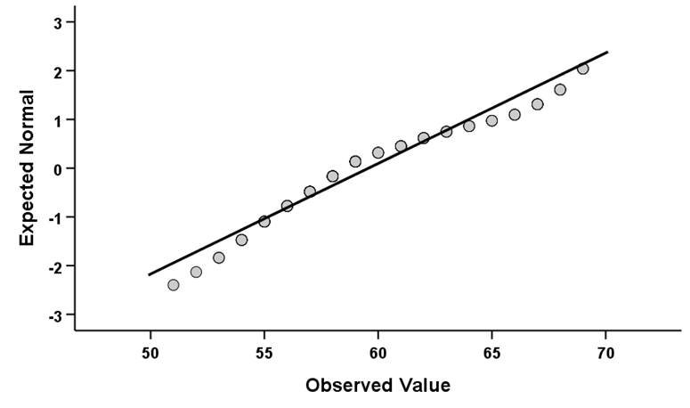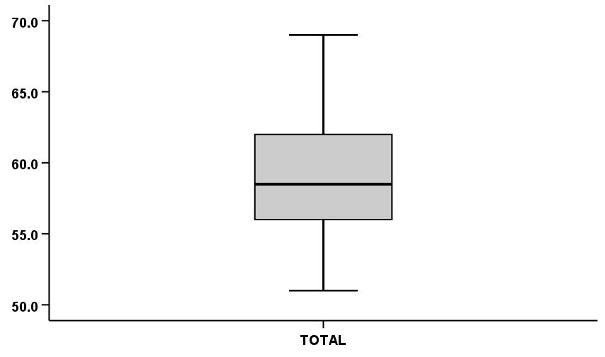

Figure 2. Q-Q plot and bar plot of the normality test

3.2 Descriptive analysis of the demographic data

The descriptive analysis of the survey data, as presented in Table 2, provides an overview of the demographic characteristics of the 120 respondents who participated in the study. The age distribution revealed that the largest proportion of participants fell within the 25–34 age group, comprising 32.5% of the total sample. This was followed by those aged 35–44 years (25%), 18–24 years (18.3%), and 45–54 years (16.7%). Participants aged 55–64 years accounted for 6.7%, while only a single respondent (0.8%) was aged 65 or older. This distribution suggests that the sample predominantly consisted of young to middle-aged adults.

In terms of gender, the sample was skewed towards male respondents, who made up 73.3% of the population, while females represented 26.7%. Regarding location, the majority of respondents resided in urban areas (54.2%), followed by suburban areas (41.7%), and a small minority from rural regions (4.2%), indicating a predominantly urban-suburban representation in the sample.

The occupational breakdown showed that government employees were the most represented group, accounting for 60% of the participants. Students comprised the second-largest group at 25.8%, followed by self-employed individuals (13.3%), and a very small number of retired individuals (0.8%). Overall, the descriptive profile of the respondents reflects a sample dominated by young, urban, male government employees, which may influence perspectives on environmental issues due to their specific social and occupational contexts.

Table 2. Mean values of the climatic variables for the study period

 | Minimum | Maximum | Mean | Std. Error | Std. Deviation
Temp (°C) | 18.25 | 23.75 | 21.38 | 0.31 | 1.73
Rain (mm) | 0.00 | 1.05 | 0.17 | 0.04 | 0.24
Cloud (%) | 0.00 | 79.75 | 38.05 | 5.30 | 29.95
Pressure (mb) | 1005.25 | 1015.00 | 1009.96 | 0.47 | 2.67
Wind (km/h) | 5.13 | 9.88 | 7.15 | 0.19 | 1.10
Gust (km/h) | 10.00 | 17.63 | 14.20 | 0.36 | 2.05

3.3 Species Composition and Abundance

Table 3 captures these fluctuations month-wise and species-wise, indicating that April supported the highest species richness (7 species) and with 338 individuals. In contrast, March had only 3 species, and May had 5, signifying a transitional composition bracketed by cooler and warmer extremes. The grand total number of individuals collected in the study period was 526 individuals. Figure 3 shows the figures of seven different species found during the current study.

Table 3. Descriptive analysis of the survey data

Characteristics |  | Frequency | Percent | Valid Percent | Cumulative Percent
Age | 18-24 | 22.00 | 18.30 | 18.30 | 18.30
Age | 25-34 | 39.00 | 32.50 | 32.50 | 50.80
Age | 35-44 | 30.00 | 25.00 | 25.00 | 75.80
Age | 45-54 | 20.00 | 16.70 | 16.70 | 92.50
Age | 55-64 | 8.00 | 6.70 | 6.70 | 99.20
Age | 65 or older | 1.00 | 0.80 | 0.80 | 100.00
Age | Total | 120 | 100 | 100
Gender | Male | 88.00 | 73.30 | 73.30 | 73.30
Gender | Female | 32.00 | 26.70 | 26.70 | 100.00
Gender | Total | 120 | 100 | 100
Location | Urban | 65.00 | 54.20 | 54.20 | 54.20
Location | Sub urban | 50.00 | 41.70 | 41.70 | 95.80
Location | Rural | 5.00 | 4.20 | 4.20 | 100.00
Location | Total | 120 | 100 | 100
Occupation | Student | 31.00 | 25.80 | 25.80 | 25.80
Occupation | Govt Employed | 72.00 | 60.00 | 60.00 | 85.80
Occupation | Self-employed | 16.00 | 13.30 | 13.30 | 99.20
Occupation | Retired | 1.00 | 0.80 | 0.80 | 100.00
Occupation | Total | 120 | 100 | 100

3.4 Reliability test

The reliability analysis of the Experience, Awareness, and Participation (EAP) questionnaire, as presented in Table 4, was conducted to assess the internal consistency of the instrument used in the study. The results yielded a Cronbach’s alpha coefficient of 0.602 for the overall scale, indicating a moderate level of reliability. When standardized items were considered, the alpha value slightly decreased to 0.475, suggesting some variability in item performance across the different domains of the questionnaire.

The scale comprised 15 items, yielding a mean score of 51.275, variance of 14.756, and standard deviation of 3.841, which suggests a fairly compact interval of responses was recorded. The mean values of the items spanned from 1.183 to 4.908, and the maximum to minimum was 4.148. Item variances of 0.084 and 1.025 further suggested that there was some diversity in how survey participants answered specific questions. Moreover, the inter-item covariances from -0.072 to 0.552 expose a lack of complete coherence on some items which may help to explain the scale’s moderate alpha.

Table 4. Reliability test of the EAP questionnaire variables

Reliability Statistics | Cronbach's Alpha |  |  | Cronbach's Alpha Based on Standardized Items |  |  | N of Items
Reliability Statistics | 0.602 |  |  | 0.475 |  |  | 15
Scale Statistics | Mean |  | Variance |  | Std. Deviation |  | N of Items
Scale Statistics | 51.275 |  | 14.756 |  | 3.841 |  | 15
Summary Item Statistics | Variable | Mean | Minimum | Maximum | Range | Maximum / Minimum | Variance | N of Items
Summary Item Statistics | Item Means | 3.418 | 1.183 | 4.908 | 3.725 | 4.148 | 2.419 | 15
Summary Item Statistics | Item Variances | 0.431 | 0.084 | 1.025 | 0.941 | 12.209 | 0.099 | 15
Summary Item Statistics | Inter-Item Covariances | 0.039 | -0.072 | 0.552 | 0.624 | -7.611 | 0.011 | 15
3.5 Mean rank test

Table 5 provides an overview of the mean rank assessment of the EAP (Experience, Awareness, and Participation) questionnaire, focusing on the degree of agreement respondents expressed on the different items, and the differences across the three domains.
In the experience-related item (Table 5A), E4 ("I think water quality in my area has deteriorated due to pollution") has the most considerable mean rank, suggesting an almost unanimous agreement with the statement of significance of water-related pollution. This was closely followed by E5, which regarded the belief of soil pollution and the impact of food and water. E1, regarding the perception of environmental pollution and major issue, ranked third. For items E2 and E3, which looked at the experience of having visible air pollution and the associated health effects of the pollution, were ranked lower. This suggests that in the case of pollution and its consequences, there is a recognition of its presence more so than the health impacts, visible air pollution, and the direct experience may not be prevalent or highly perceived.

In the awareness section (Table 5B), A3 ("I think more public awareness campaigns on pollution should be conducted") got the most responses which implies people are likely to think there needs to be more education on the issues surrounding pollution. Closely following was A4, "There should be stronger laws on industrial pollution". A1 and A5, which are mentions of particular government activities, had lower awareness levels and A2 ("I believe the government’s efforts to control air pollution are sufficient") had the lowest score. This indicates there is a more generalized sense of dissatisfaction which leads to a lack awareness of existing programs and probable active policies.

Regarding the participation domain (Table 5C), P5 ("I actively support or volunteer for environmental protection initiatives") received the highest rating which means that a lot of respondents see themselves as engaged in organized efforts of volunteerism to protect the environment. P1 ("I discuss environmental issues with family and friends") and P4 ("I participate in tree-planting drives or similar environmental activities") also received high ratings, which suggests moderate levels of informal and community engagement. In comparison, the more pragmatic actions of conserving water (P2) and composting or waste segregation (P3) were rated as the least practiced, which suggests an inconsistency in adopting individual, less complex behavioral initiatives, which in other respects might signal environmental support.

In summary, the mean rank analysis shows that respondents are highly aware of and concerned about environmental issues, particularly in relation to water and soil pollution. They express strong support for increased awareness and regulation, yet there remains a disparity between supportive attitudes and consistent personal action in day-to-day environmental practices.

Table 5. Mean rank test (A) Experience-based questionnaire, (B) Awareness-based questionnaire, and (C) Participation-based questionnaire

(A)
Code | Experience based questionnaire | N | Mean | Std. Deviation | Rank
E1 | I believe environmental pollution is a major issue in my area. | 120 | 4.77 | 0.53 | 3
E2 | I often notice visible air pollution (e.g., smog, haze) in my surroundings. | 120 | 4.68 | 0.60 | 4
E3 | I have experienced health issues (e.g., respiratory problems, skin irritation) that I suspect are related to pollution. | 120 | 4.63 | 0.67 | 5
E4 | I think water quality in my area has deteriorated due to pollution. | 120 | 4.88 | 0.33 | 1
E5 | I believe soil pollution affects the quality of food and water in my locality. | 120 | 4.78 | 0.54 | 2
(B)
Code | Awareness based questionnaire | N | Mean | Std. Deviation | Rank
A1 | I am aware of Indian government policies addressing environmental pollution. | 120 | 1.61 | 0.99 | 4
A2 | I believe the government’s efforts to control air pollution are sufficient. | 120 | 1.18 | 0.47 | 5
A3 | I think more public awareness campaigns on pollution should be conducted. | 120 | 4.91 | 0.29 | 1
A4 | I believe stricter laws should be enforced to reduce industrial pollution. | 120 | 4.72 | 0.58 | 2
A5 | I am aware of water conservation initiatives promoted by the government. | 120 | 1.95 | 0.93 | 3
(C)
Code | Participation based questionnaire | N | Mean | Std. Deviation | Rank
P1 | I discuss environmental issues with family and friends. | 120 | 2.99 | 0.49 | 2
P2 | I take measures to conserve water at home (e.g., fixing leaks, using water-efficient methods). | 120 | 1.76 | 1.01 | 4
P3 | I compost organic waste or segregate waste at home. | 120 | 1.45 | 0.83 | 5
P4 | I participate in tree-planting drives or similar environmental activities. | 120 | 2.10 | 0.65 | 3
P5 | I actively support or volunteer for environmental protection initiatives. | 120 | 4.89 | 0.31 | 1

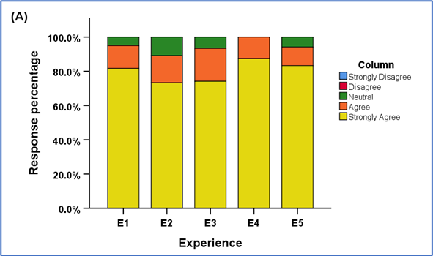

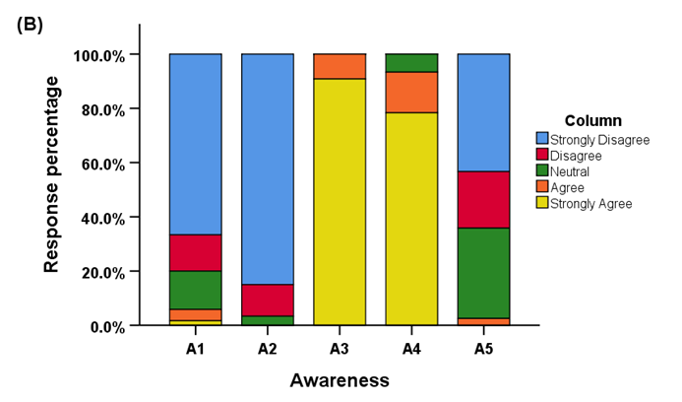

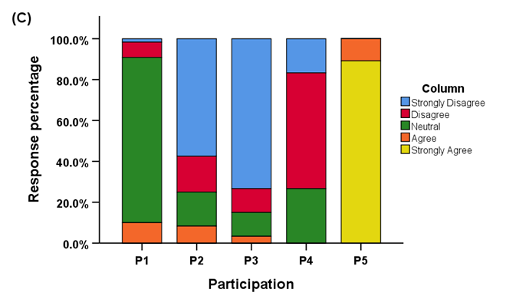

Figure 3. Response percentage of (A) Experience-based questionnaire, (B) Awareness-based questionnaire, and (C) Participation-based questionnaire

3.6 Response percentage of EAP

Figure 3 displays results concerning response proportions to the Experience-based, Awareness-based, and Participation-based questionnaires and reveals different tendencies in the respondents’ perception, cognition, and action regarding environmental issues.

3.6.1 Experience-Based Questionnaire

Responses indicate a strong perception of environmental degradation among participants. For instance, a large majority of respondents "Strongly Agree" with statements about environmental pollution being a major issue (E1: 81.7%) and the deterioration of water quality due to pollution (E4: 87.5%). Similarly, 83.3% "Strongly Agree" that soil pollution affects food and water quality (E5). While responses to air pollution (E2) and health impacts (E3) are slightly more varied, the dominant response remains "Strongly Agree" at 73.3% and 74.2%, respectively (Figure 3A). These results suggest that the respondents have a high level of experiential awareness of various environmental issues, especially concerning water and soil quality.

3.6.2 Awareness-Based Questionnaire

Awareness levels showed a greater degree of polarization. Most respondents “Strongly Agree” on the need for more public awareness campaigns (A3: 90.8%) and more stringent laws on pollution (A4: 78.3%). Yet, a comparatively lower number of people are aware of (A1) and (A5) the policies concerning water conservation, where 66.7% and 43.3% respectively “Strongly Disagree”. Moreover, 85% “Strongly Disagree” on the sufficiency of government measures aimed at air pollution control (A2), showing lack of recognition of official measures (Figure 3B) and indicating widespread dissatisfaction. Such patterns broadly state the support for awareness and legal measures, but at the same time, a lack of knowledge on the initiatives of government.

3.6.3 Participation-Based Questionnaire

Various levels of participation were documented. In P5, engagement peaks, with 89.2% of respondents asserting that they actively "Strongly Agree" with supporting or volunteering for environmental initiatives. However, for other participation options, the responses were rather lukewarm. Notably, 80.8% were simply "Neutral," without engagement, and 26.7% were "Neutral" about activities that are participatory, such as tree-planting (P4). In mitigative actions, however, a large number reported limited participation. For example, 73.3% "Strongly Disagree" with the practice of composting and waste segregation at home (P3), and 57.5% "Strongly Disagree" with the practice of water conservation (P2), which is illustrated in Figure 3C. These results suggest that support is directed at high-visibility actions, but the much routine sustainable actions are less prevalent, which is surprising.

3.7 Correlation within the EAP questionnaire

Table 6 provides results from a Spearman correlation analysis on the relationships between the individual items concerning the Experience, Awareness, and Participation components of the EAP questionnaire. The analysis results indicate how perceptions and behaviors across the components are interrelated.

3.7.1 Experience-Based Questionnaire

Within the experience-based section (Table 6A), a statistically significant negative correlation was observed between E1 ("Environmental pollution is a major issue in my area") and E2 ("I often notice visible air pollution") (r = –0.229, p < 0.05). This suggests that individuals who strongly perceive pollution as a major issue may not necessarily observe visible manifestations of air pollution, or vice versa, potentially reflecting differences in geographic or contextual exposure. Other item pairs in this section, such as E3 (health impacts), E4 (water quality deterioration), and E5 (soil pollution), did not exhibit significant correlations, indicating that respondents’ experiences of pollution may be specific and not necessarily interconnected across environmental dimensions.

Table 6. Spearman correlation within (A) Experience-based questionnaire, (B) Awareness-based questionnaire, and (C) Participation-based questionnaire

(A)
 | E1 | E2 | E3 | E4 | E5
E1 | 1
E2 | -.229* | 1
E3 | -0.044 | 0.006 | 1
E4 | -0.117 | 0.156 | -0.115 | 1
E5 | 0.013 | 0.082 | -0.164 | 0.022 | 1
* Correlation is significant at the 0.05 level (2-tailed).

(B)
 | A1 | A2 | A3 | A4 | A5
A1 | 1
A2 | -0.014 | 1
A3 | -0.032 | 0.133 | 1
A4 | 0.084 | 0.147 | -0.036 | 1
A5 | .420** | 0.05 | -0.071 | 0.157 | 1
** Correlation is significant at the 0.01 level (2-tailed).

(C)
 | P1 | P2 | P3 | P4 | P5
P1 | 1
P2 | 0 | 1
P3 | 0.175 | .382** | 1
P4 | 0.136 | .628** | .421** | 1
P5 | -0.056 | 0.083 | 0.018 | 0.019 | 1
** Correlation is significant at the 0.01 level (2-tailed).

3.7.2 Awareness-Based Questionnaire

In the awareness domain (Table 6B), the only statistically significant correlation was found between A1 ("Awareness of government policies addressing environmental pollution") and A5 ("Awareness of water conservation initiatives") (r = 0.420, p < 0.01). This strong positive association indicates that individuals informed about broader environmental policies are also likely to be aware of specific conservation programs, reflecting a coherent pattern of policy-related knowledge. Other awareness items such as A2 (perceived sufficiency of government efforts), A3 (need for awareness campaigns), and A4 (support for stricter industrial laws) did not correlate significantly with each other, suggesting that awareness is fragmented across different thematic areas.

3.7.3 Participation-Based Questionnaire

The items pertaining to participation showed the strongest and most widespread correlations (Table 6C). P2 ("Water conservation at home") and P3 ("Composting or waste segregation") (r = 0.382, p < 0.01), as well as P3 and P4 ("Participation in tree planting drives") (r = 0.421, p < 0.01), suggest the existence of an interconnected set of behaviors concerning eco-friendly practices at home and in the wider community. P4 also stands out in that it had strong correlational ties with P2 (r = 0.628, p < 0.01), demonstrating that participation in one type of environmental activity fosters involvement in others. P5 ("Volunteering for environmental protection initiatives"), however, did not show a significant correlational link with any of the other participation items, which suggests that the aspect of formal volunteering may be viewed or carried out separately from more habitual, everyday environmental practices.

In summary, the correlation analysis reveals that while awareness and experience tend to be domain-specific with limited internal consistency, participation behaviors are more strongly interrelated, suggesting that promoting one form of environmental action may encourage others.

3.8 Correlation between the EAP

The Spearman correlation analysis between the three core constructs of the EAP framework—Experience, Awareness, and Participation—is presented in Table 7 and provides insight into the interrelationships among these dimensions of environmental engagement.

The correlation between Experience and Awareness was found to be negligible (r = –0.009), indicating virtually no association between respondents’ personal experiences with environmental pollution and their level of awareness regarding environmental policies, campaigns, or governmental efforts. This suggests that firsthand exposure to environmental issues does not necessarily translate into greater awareness of formal structures or information related to environmental protection.

Conversely, the relationship between Experience and Participation showed a small positive value (r = 0.095). The relationship, however, is weak and inconsequential. Individuals with higher levels of experiential exposure to the degradation of the environment might tend to marginally engage in participatory actions, but overall, within this particular sample, the degree of connection is too weak to help find a resolution.

The only statistically significant connection was between the variables Awareness and Participation, as r = 0.195 (p < 0.05) suggests. This result demonstrates the moderate meaningful relationship these variables possess, which implies individuals with greater knowledge of the concepts and policies of the environment tend to take some actions towards the environment as they participate in greater activism.

Overall, these findings highlight that awareness appears to be a more reliable predictor of participation than direct experience. However, the generally low correlation values across all dimensions indicate that the constructs of experience, awareness, and participation function relatively independently within this sample, underscoring the complexity of environmental engagement behaviors.

Table 7. Spearman correlation between Experience, Awareness, and Participation (EAP)

 | Experience | Awareness | Participation
Experience | 1
Awareness | -0.009 | 1
Participation | 0.095 | .195* | 1
* Correlation is significant at the 0.05 level (2-tailed).

3.9 Chi square test of the data

The chi-square analysis summarized in Table 8 explores the associations between key demographic variables—age, gender, location, and occupation—and the three domains of the EAP (Experience, Awareness, Participation) questionnaire. The results provide valuable insights into how demographic characteristics may influence environmental perceptions, knowledge, and behaviors among respondents.

Table 8. Chi square analysis (A) Demographic variables vs Experience-based questionnaire, (B) Demographic variables vs Awareness-based questionnaire, and (C) Demographic variables vs Participation-based questionnaire
(A)
Experience |  | Age | Gender | Location | Occupation
E1 | Chi-square | 14.949 | 0.688 | 3.307 | 10.399
E1 | df | 10 | 2 | 4 | 6
E1 | Sig. | .134a,b | .709a | .508a,b | .109a,b
E2 | Chi-square | 6.299 | 2.755 | 9.58 | 13.197
E2 | df | 10 | 2 | 4 | 6
E2 | Sig. | .790a,b | .252a | .048a,b,* | .040a,b,*
E3 | Chi-square | 15.062 | 0.209 | 3.443 | 2.227
E3 | df | 10 | 2 | 4 | 6
E3 | Sig. | .130a,b | .901a | .487a,b | .898a,b
E4 | Chi-square | 10.326 | 0.39 | 1.452 | 3.724
E4 | df | 5 | 1 | 2 | 3
E4 | Sig. | .067a,b | .533a | .484a,b | .293a,b
E5 | Chi-square | 11.794 | 2.901 | 8.647 | 6.601
E5 | df | 10 | 2 | 4 | 6
E5 | Sig. | .299a,b | .234a | .071a,b | .359a,b
Results are based on nonempty rows and columns in each innermost subtable.
* The Chi-square statistic is significant at the .05 level.
a More than 20% of cells in this subtable have expected cell counts less than 5. Chi-square results may be invalid.
b The minimum expected cell count in this subtable is less than one. Chi-square results may be invalid.

(B)
Awareness |  | Age | Gender | Location | Occupation
A1 | Chi-square | 35.495 | 5.665 | 28.878 | 22.453
 | df | 20 | 4 | 8 | 12
 | Sig. | .018*,b,c | .226b,c | .000*,b,c | .033*,b,c
A2 | Chi-square | 5.859 | 0.034 | 2.968 | 4.937
 | df | 10 | 2 | 4 | 6
 | Sig. | .827b,c | .983b | .563b,c | .552b,c
A3 | Chi-square | 5.727 | 4.813 | 9.563 | 3.206
 | df | 5 | 1 | 2 | 3
 | Sig. | .334b,c | .028*,b | .008*,b,c | .361b,c
A4 | Chi-square | 13.142 | 1.135 | 10.87 | 12.338
 | df | 10 | 2 | 4 | 6
 | Sig. | .216b,c | .567b | .028*,b,c | .055b,c
A5 | Chi-square | 26.495 | 7.154 | 21.95 | 33.338
 | df | 15 | 3 | 6 | 9
 | Sig. | .033*,b,c | .067b,c | .001*,b,c | .000*,b,c
Results are based on nonempty rows and columns in each innermost subtable.
* The Chi-square statistic is significant at the .05 level.
b More than 20% of cells in this subtable have expected cell counts less than 5. Chi-square results may be invalid.
c The minimum expected cell count in this subtable is less than one. Chi-square results may be invalid.

(C)
Participation |  | Age | Gender | Location | Occupation
P1 | Chi-square | 20.807 | 0.96 | 6.416 | 14.947
 | df | 15 | 3 | 6 | 9
 | Sig. | .143a,b | .811a,b | .378a,b | .092a,b
P2 | Chi-square | 42.416 | 4.332 | 36.805 | 24.784
 | df | 15 | 3 | 6 | 9
 | Sig. | .000a,b,* | .228a | .000a,b,* | .003a,b,*
P3 | Chi-square | 19.747 | 2.544 | 17.933 | 7.433
 | df | 15 | 3 | 6 | 9
 | Sig. | .182a,b | .467a | .006a,b,* | .592a,b
P4 | Chi-square | 26.745 | 1.448 | 29.376 | 16.809
 | df | 10 | 2 | 4 | 6
 | Sig. | .003a,b,* | .485a | .000a,b,* | .010a,b,*
P5 | Chi-square | 1.531 | 1.037 | 0.678 | 0.719
 | df | 5 | 1 | 2 | 3
 | Sig. | .910a,b | .308a | .712a,b | .869a,b
Results are based on nonempty rows and columns in each innermost subtable.
* The Chi-square statistic is significant at the .05 level.
a More than 20% of cells in this subtable have expected cell counts less than 5. Chi-square results may be invalid.
b The minimum expected cell count in this subtable is less than one. Chi-square results may be invalid.

3.9.1 Demographic Variables vs Experience-Based Questionnaire

The analysis revealed that, overall, there were no statistically significant associations between demographic factors and the experience-based items, with one exception (Table 8A). A significant relationship was observed between location and E2 ("I often notice visible air pollution") (p = 0.048), and between occupation and E2 (p = 0.040), suggesting that individuals’ observation of air pollution may vary depending on where they live and their employment context. However, all other items, including E1 (perception of pollution as a major issue), E3 (health impacts), E4 (water quality), and E5 (soil pollution), showed no significant correlations with any demographic variables, indicating that experiences related to environmental pollution were largely uniform across different groups.

3.9.2 Demographic Variables vs Awareness-Based Questionnaire

Stronger patterns emerged in the awareness domain. Significant associations were found between age and A1 (awareness of government policies) (p = 0.018), location and A1 (p < 0.001), and occupation and A1 (p = 0.033), suggesting that awareness of governmental environmental policies varies with these demographic factors (Table 8B). Similarly, gender was significantly associated with A3 (support for more public awareness campaigns) (p = 0.028), and location was again linked to A3 (p = 0.008), highlighting geographic and gender-based differences in environmental communication preferences. Additionally, A4 (support for stricter industrial laws) showed a significant association with location (p = 0.028), and A5 (awareness of water conservation initiatives) demonstrated strong associations with age (p = 0.033), location (p = 0.001), and occupation (p < 0.001). These results indicate that awareness is not evenly distributed and is significantly influenced by where individuals live, their age, and their occupational roles.

3.9.3 Demographic Variables vs Participation-Based Questionnaire

Within the participation domain, several significant associations were observed (Table 8C). Age was significantly related to P2 (water conservation behavior) (p < 0.001) and P4 (participation in tree planting) (p = 0.003), suggesting generational differences in environmental actions. Location was significantly associated with P2 (p < 0.001), P3 (waste management, p = 0.006), and P4 (p < 0.001), indicating that geographical setting plays a key role in shaping participation patterns. Furthermore, occupation was significantly linked to P2 (p = 0.003) and P4 (p = 0.010), reinforcing the notion that work context may influence engagement in certain environmental practices. However, no significant associations were found for P5 (volunteering), indicating that formal participation in environmental initiatives may be driven by factors beyond basic demographics.

In summary, the chi-square analysis demonstrates that while personal experiences with environmental issues are relatively consistent across demographic groups, awareness and participation levels are significantly shaped by age, location, and occupation. These findings underscore the importance of targeted communication and engagement strategies to effectively reach and mobilize different segments of the population in environmental efforts (Maibach et al., 2011).

4. DISCUSSION

This study sought to explore how individuals perceive and engage with environmental pollution through the interconnected dimensions of personal experience, awareness, and participation, while also examining how demographic variables influence these domains. The results present a nuanced understanding of environmental engagement among the surveyed population.

4.1 Experience with Environmental Pollution

The findings indicate that a large majority of respondents report direct experiences with environmental degradation, particularly regarding water and soil pollution. Items such as E4 (deterioration of water quality) and E5 (impacts of soil pollution) received the highest agreement levels, suggesting that these forms of pollution are the most visible or impactful to individuals in their local contexts. However, the relatively lower agreement with items concerning air pollution and health effects suggests variability in how environmental issues are experienced or perceived, possibly due to differences in regional exposure or environmental literacy (Ramírez et al., 2019). The absence of significant correlations between experience variables and most demographic factors further indicates that environmental pollution is a broadly shared concern across different social groups (Liu et al., 2014).

4.2 Awareness of Environmental Issues and Policies

While there was considerable backing for initiatives aimed at the encouragement of the public and more rigorous environmental policies, understanding of the government policies and programs seemed shallow. A considerable portion of the respondents appeared to strongly disagree with the statements indicating satifaction with government initiatives (A2) and with the policies awareness (A1, A5) which was perplexing. This suggests an awareness deficit which could undermine meaningful engagement. The notable relationships of demographic variables and the awareness items, especially with respect to geography, occupation, and age, imply unequal access to and uptake of environmental communication. This points to the need for strategies that consider geography and occupation as key parameters (Oliveira et al., 2012).

4.3 Participation in Environmental Action

While the majority of respondents expressed support for volunteering in environmental initiatives (P5), lower participation was reported in everyday sustainable behaviors such as composting (P3) and water conservation (P2). This discrepancy highlights a common phenomenon in environmental psychology: while pro-environmental attitudes are high, translating these into consistent action remains a challenge. The strong correlations among household- and community-level participation behaviors (e.g., between P2, P3, and P4) suggest that once individuals adopt one type of action, they may be more inclined to adopt others. Importantly, demographic factors such as age, location, and occupation showed significant associations with several participation items, emphasizing the role of structural or contextual factors in shaping environmental behaviour as reported in earlier studies (Larson et al., 2011; Burton 2014).

4.4 Interrelationship Among EAP Components

The correlation analysis between the EAP components reveals that awareness has a modest but statistically significant relationship with participation, whereas experience shows little to no meaningful correlation with either awareness or participation. This suggests that simply experiencing pollution does not guarantee awareness or action, reinforcing the need for intentional educational and policy interventions to bridge these gaps (Kollmuss & Agyeman 2002). The finding that awareness is more strongly linked to action supports existing literature emphasizing the role of environmental knowledge in shaping pro-environmental behaviour (Finger 1994; Bickerstaff & Walker 2001; Okumah et al., 2018; Riley et al., 2021).

5. Conclusion

To sum up, there is a great gap between the recognition of environmental pollution, the support for environmental action, and behavioral participation especially for routine, low, and inconspicuous activities. Age, place, and profession do differentiate awareness and participation, but the experiences about environmental pollution seemed to be widespread across the sample.

Such findings raise important issues regarding environmental policies and advocacy. For example, pathways for policy and action advocacy must be opened, especially for remote, marginalized, and underserved regions. From symbolic participation, the expectation to support the promotion of environmental activism must be shifted toward the adoption of sustainable practices in everyday life. Finally, demographic-sensitive design, like working with youth, through workplaces, and in specific local areas, would meaningfully broaden the coverage and effectiveness of activism.

Finally, addressing environmental pollution requires not only structural reforms but also a deeper understanding of how individuals perceive, learn about, and act on environmental issues. Bridging the gap between knowledge and behavior through inclusive, tailored, and action-oriented strategies will be essential for fostering meaningful public participation in environmental protection.

Consent - NA

Ethical approval – NA

COMPETING INTERESTS DISCLAIMER:
Authors have declared that they have no known competing financial interests OR non-financial interests OR personal relationships that could have appeared to influence the work reported in this paper.

References

Abbas, M. Y., & Singh, R. (2014). A survey of environmental awareness, attitude, and participation amongst university students: A case study. International Journal of Science and Research, 3(5), 1755-1760.
Benham, C. F. (2017). Aligning public participation with local environmental knowledge in complex marine social-ecological systems. Marine Policy, 82, 16-24. https://doi.org/10.1016/j.marpol.2017.04.003
Bhattacharya, R. (2025). Political Social Work Principles. Educohack Press.
Bickerstaff, K., & Walker, G. (2001). Public understandings of air pollution: the ‘localisation’of environmental risk. Global environmental change, 11(2), 133-145. https://doi.org/10.1016/S0959-3780(00)00063-7
Burton, R. J. (2014). The influence of farmer demographic characteristics on environmental behaviour: A review. Journal of environmental management, 135, 19-26. https://doi.org/10.1016/j.jenvman.2013.12.005
Dickinson, J. L., Shirk, J., Bonter, D., Bonney, R., Crain, R. L., Martin, J., ... & Purcell, K. (2012). The current state of citizen science as a tool for ecological research and public engagement. Frontiers in Ecology and the Environment, 10(6), 291-297. https://doi.org/10.1890/110236
Finger, M. (1994). From knowledge to action? Exploring the relationships between environmental experiences, learning, and behavior. Journal of social issues, 50(3), 141-160. https://doi.org/10.1111/j.1540-4560.1994.tb02424.x
Fritsche, I., Barth, M., Jugert, P., Masson, T., & Reese, G. (2018). A social identity model of pro-environmental action (SIMPEA). Psychological review, 125(2), 245. https://psycnet.apa.org/doi/10.1037/rev0000090
Hnatyuk, V., Pshenychna, N., Kara, S., Kolodii, V., & Yaroshchuk, L. (2024). Education's role in fostering environmental awareness and advancing sustainable development within a holistic framework. Multidisciplinary Reviews, 7. https://doi.org/10.31893/multirev.2024spe012
Kollmuss, A., & Agyeman, J. (2002). Mind the gap: why do people act environmentally and what are the barriers to pro-environmental behavior?. Environmental education research, 8(3), 239-260. https://doi.org/10.1080/13504620220145401
Larson, L. R., Whiting, J. W., & Green, G. T. (2011). Exploring the influence of outdoor recreation participation on pro-environmental behaviour in a demographically diverse population. Local Environment, 16(1), 67-86. https://doi.org/10.1080/13549839.2010.548373
Liu, X., Vedlitz, A., & Shi, L. (2014). Examining the determinants of public environmental concern: Evidence from national public surveys. Environmental Science & Policy, 39, 77-94. https://doi.org/10.1016/j.envsci.2014.02.006
Maibach, E. W., Leiserowitz, A., Roser-Renouf, C., & Mertz, C. K. (2011). Identifying like-minded audiences for global warming public engagement campaigns: An audience segmentation analysis and tool development. PloS one, 6(3), e17571. https://doi.org/10.1371/journal.pone.0017571
Marczak, M. K. (2024). Emotional Responses to Climate Change (Doctoral dissertation, Norwegian University of Science).
Moser, S., & Bader, C. (2023). Why do people participate in grassroots sustainability initiatives? Different motives for different levels of involvement. Frontiers in Sustainability, 3, 994881. https://doi.org/10.3389/frsus.2022.994881
Okumah, M., Martin-Ortega, J., & Novo, P. (2018). Effects of awareness on farmers’ compliance with diffuse pollution mitigation measures: A conditional process modelling. Land Use Policy, 76, 36-45. https://doi.org/10.1016/j.landusepol.2018.04.051
Oliveira, A. P. B., Heller, L., Nascimento, N., & Lobina, E. (2012). Integrated urban water governance in Belo Horizonte, Brazil: changes and inertias. International Journal of Water, 6(3-4), 232-249. https://doi.org/10.1504/IJW.2012.049498
Pindaru, L. C., Nita, A., Niculae, I. M., Manolache, S., & Rozylowicz, L. (2023). More streamlined and targeted. A comparative analysis of the 7th and 8th Environment Action Programmes guiding European environmental policy. Heliyon, 9(9). https://doi.org/10.1016/j.heliyon.2023.e19212
Ramírez, A. S., Ramondt, S., Van Bogart, K., & Perez-Zuniga, R. (2019). Public awareness of air pollution and health threats: challenges and opportunities for communication strategies to improve environmental health literacy. Journal of Health Communication, 24(1), 75-83. https://doi.org/10.1080/10810730.2019.1574320
Rich, R. C., Edelstein, M., Hallman, W. K., & Wandersman, A. H. (1995). Citizen participation and emprowerment: The case of local environmental hazards. American journal of community psychology, 23, 657-676. https://doi.org/10.1007/BF02506986
Riley, R., de Preux, L., Capella, P., Mejia, C., Kajikawa, Y., & de Nazelle, A. (2021). How do we effectively communicate air pollution to change public attitudes and behaviours? A review. Sustainability Science, 1-21. https://doi.org/10.1007/s11625-021-01038-2
Sinclair, A. J., & Diduck, A. P. (2017). Reconceptualizing public participation in environmental assessment as EA civics. Environmental Impact Assessment Review, 62, 174-182. https://doi.org/10.1016/j.eiar.2016.03.009
Tietenberg, T., & Wheeler, D. (2001). Empowering the community: Information strategies for pollution control. Frontiers of environmental economics, 85-120. https://doi.org/10.4337/9781843767091
Van Zomeren, M., Spears, R., & Leach, C. W. (2010). Experimental evidence for a dual pathway model analysis of coping with the climate crisis. Journal of Environmental Psychology, 30(4), 339-346. https://doi.org/10.1016/j.jenvp.2010.02.006

