Original Research Article

FUNCTIONAL GROUP ANALYSIS OF MEDICINAL PLANTS IN NORTHERN SAMAR, PHILIPPINES

ABSTRACT
Northern Samar, a province in the Eastern Visayas region of the Philippines, harbors a rich yet underexplored diversity of plant species. While earlier studies have documented the flora of its island municipalities, many mainland species remain chemically uncharacterized and underutilized. This study employed Fourier Transform Infrared (FTIR) spectroscopy to analyze twelve locally available but underused plant species representing the families Amaryllidaceae, Acanthaceae, Apocynaceae, Fabaceae, Lamiaceae, Melastomataceae, Moraceae, Primulaceae, Selaginellaceae, and Urticaceae. The objective was to identify the major functional groups present in these plants and establish baseline chemical profiles that may support their potential pharmacological, nutraceutical, and industrial applications. The FTIR spectra revealed the presence of key bioactive functional groups, including alcohols, phenols, carbonyls, alkenes, and nitro compounds. These functional groups are commonly associated with antioxidant, anti-inflammatory, antimicrobial, and other therapeutic activities. The results demonstrate the chemical diversity and bioactive potential of Northern Samar’s native flora, suggesting that these species could serve as valuable natural resources for further biochemical and pharmacological investigations. Overall, the study provides essential preliminary data that can guide future research, conservation, and sustainable utilization efforts aimed at maximizing the economic and medicinal potential of the region’s botanical resources.

Keywords: FTIR, functional group, Northern Samar, phytochemical profiling, underutilized plant species

I. INTRODUCTION

Medicinal plants serve as vital natural reservoirs for therapeutic compounds and essential precursors for modern pharmacology. The World Health Organization (WHO) estimates that over 80% of the global population relies on herbal medicine for primary healthcare. In the Philippines, this reliance is deeply integrated into the cultural fabric, particularly in rural regions where indigenous knowledge and native flora form the backbone of community health. This enduring trust in ethnomedicinal traditions is a direct reflection of the archipelago’s immense biodiversity.
Recent documentation in Northern Samar highlights this potential; Esponilla and Flores (2023) identified 44 species in Mapanas rich in bioactive compounds—including flavonoids, alkaloids, and phenols—noted for their antioxidant and anti-inflammatory properties. However, they emphasized that identifying these species is only the first step, necessitating chemical characterization via Fourier Transform Infrared (FTIR) spectroscopy to pinpoint the functional groups driving these effects. Similarly, Flores and Sagonoy (2021) recorded 67 species in Pambujan used for diverse purposes ranging from healing to livestock management, while Cabanlit et al. (2024) identified 390 species with reported anticancer properties nationwide. Despite this wealth of ethnobotanical data, a significant gap persists: few studies advance to molecular characterization, leaving the pharmacological potential of many local species largely unverified.
Northern Samar remains a "black box" of botanical potential. While Calumpong et al. (2019) documented over 200 species in island municipalities, the mainland flora remains chemically under-characterized. This study addresses this gap by analyzing selected species across diverse taxonomic families, including Allium tuberosum (Ganda), Proiphys amboinensis (Abod), Andrographis paniculata (Serpentina), Dischidia platyphylla (Lakop-lakop), Selaginella willdenowii (Duknay), and Boehmeria nivea (China grass).
To bridge the gap between traditional use and scientific validation, this research employs FTIR spectroscopy. As an efficient, non-destructive analytical technique, FTIR identifies the functional groups and chemical bonds—such as those found in phenolics and glycosides—that underpin a plant's therapeutic efficacy. By providing a biochemical profile of these underutilized species, this study seeks to transform indigenous wisdom into empirical data, reinforcing the role of Philippine flora in the global landscape of natural product research and drug discovery.

Methodology

Before sample collection, permission was secured from the respective local barangay authorities. Plant samples were then collected from selected municipalities in Northern Samar and verified by a plant taxonomy expert for accurate identification.
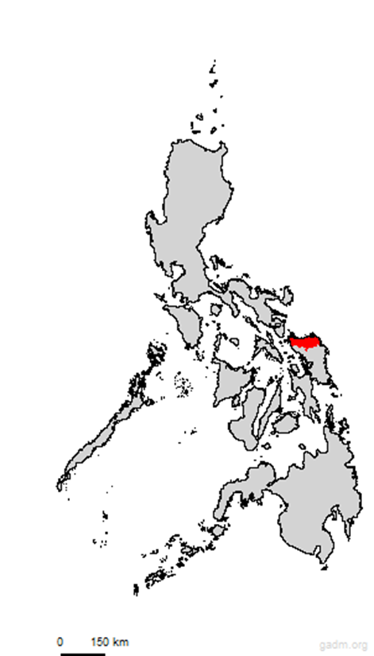
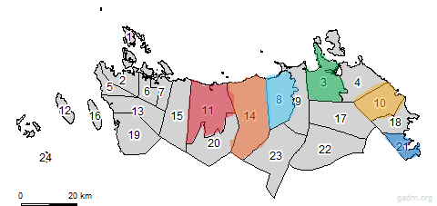

Figure 1. Map of the Province of Northern Samar, Philippines (GADM, 2018)

Preparation of Voucher Specimen
Herbarium voucher specimens were not formally deposited for this study due to logistical and temporal constraints; rigorous measures were implemented to ensure taxonomic accuracy. The inability to establish a permanent herbarium collection was primarily attributed to the restricted research timeline and unaligned field schedules. However, to mitigate any risk of misidentification, all collected specimens underwent formal verification by a qualified plant taxonomist. This expert validation ensures that the phytochemical and spectroscopic data presented herein were definitively associated with the correctly identified species.

The collected botanical specimens were subjected to a rigorous cleaning process, involving thorough rinsing with distilled water to eliminate exogenous contaminants and debris. The samples were subsequently air-dried and further dehydrated in a temperature-controlled environment to achieve constant weight. Following dehydration, the plant tissues were homogenized into a fine powder using a laboratory-grade blender to maximize the surface area for extraction.
The resulting powdered material underwent solvent extraction, and the derived crude extracts were characterized via Fourier Transform Infrared (FTIR) spectroscopy. Analysis was performed using a PerkinElmer Spectrum Two FTIR spectrometer, with spectral acquisition conducted across the mid-infrared region of 4000 cm⁻¹ to 500 cm⁻¹. The obtained transmittance spectra were systematically compared against standard reference libraries to elucidate the functional groups present. This spectroscopic profiling provides a critical chemical fingerprint, offering detailed insights into the bioactive composition of each species.

III. RESULTS AND DISCUSSION

A total of twelve underutilized plant species were collected from various municipalities in Northern Samar, Philippines, and subsequently verified by a plant taxonomy expert to ensure accurate identification. The verified species belong to different plant families, including Amaryllidaceae, Acanthaceae, Apocynaceae, Fabaceae, Lamiaceae, Melastomataceae, Moraceae, Primulaceae, Selaginellaceae, and Urticaceae. The identification process confirmed both the scientific and local names of each plant, highlighting the diversity of flora present in the province.
Most of the collected samples consisted primarily of leaves, as this plant part is commonly rich in bioactive compounds that can be analyzed using FTIR spectroscopy. In one case, Alysicarpus vaginalis L. DC. (locally known as Buffalo Clover) had its flowers used for analysis, reflecting the varying plant parts of interest depending on traditional or potential medicinal value.

The plant species were gathered from several municipalities, such as Catarman, Mapanas, Mondragon, Lapinig, Laoang, and San Roque, showing the geographical distribution of these underutilized plants across Northern Samar. Local names like Ganda, Kadlum, Tagpo, and Alabong indicate the cultural significance of these plants within the community, as they are often known and used in traditional practices.
Through expert verification, the authenticity and proper classification of these plant species were established. This process ensured the scientific reliability of the study and provided a solid foundation for subsequent FTIR analysis. The confirmed taxonomy supports future research into the phytochemical and pharmacological potential of these plants, contributing to both biodiversity documentation and the sustainable utilization of local plant resources.

Table 1: Taxonomic and ethnobotanical information of the plant samples

Family Name | Scientific Name | Local Name | Parts of the Plant used in this analysis | Place of Collection
Amaryllidaceae | Allium tuberosum | Ganda | Leaves | Mapanas Northern Samar
Amaryllidaceae | Proiphys amboinensis L. | Abod | Leaves | Mondragon Northern Samar
Acanthaceae | Andrographis paniculata Burn.f. | Serpentina | Leaves | Lapinig Northern Samar
Apocynaceae | Dischidia platyphylla Schltr. | Lakop-lakop | Leaves | Catarman Northern Samar
Fabaceae | Alysicarpus vaginalis L. DC. | Buffalo Clover | Flower | Catarman Northern Samar
Lamiaceae | Pogostemon heyneanus Benth | Kadlum | Leaves | Catarman Northern Samar
Melastomataceae | Melastama malabathricum | Malatungaw | Leaves | San Roque Northern Samar
Moraceae | Ficus ulmifolia Lam. | Is-Is | Leaves | Laoang Northern Samar
Primulaceae | Ardisia elliptica Thunb | Tagpo | Leaves | Catarman Northern Samar
Selaginellaceae | Selaginella willdenowii | Duknay | Leaves | Catarman Northern Samar
Urticaceae | Boehmeria nivia | China grass | Leaves | Catarman Northern Samarr
Urticaceae | Pilea microphylla | Alabong | Leaves | Catarman Northern Samar

Figure 2 presents the FTIR spectrum of the analyzed plant extract, showing several characteristic absorption bands corresponding to different functional groups. The broad absorption band observed around 3365 cm⁻¹ is attributed to the O–H stretching vibration of hydroxyl groups, which are typical in alcohols and phenolic compounds, indicating the presence of hydrogen bonding. The distinct peaks at 2924 cm⁻¹ and 2853 cm⁻¹ correspond to C–H stretching vibrations of aliphatic –CH₂– and –CH₃– groups, suggesting the presence of alkane chains within the sample. A sharp absorption peak at 1736 cm⁻¹ represents the C=O stretching vibration associated with carbonyl functional groups, confirming the presence of esters, aldehydes, or ketones. Meanwhile, a medium-intensity band at 1647 cm⁻¹ can be linked to C=C stretching in conjugated systems or amide C=O stretching, which are often found in bioactive organic compounds. Additional absorption bands at 1377 cm⁻¹ and 1162 cm⁻¹ are assigned to C–H bending and C–O stretching vibrations, respectively, characteristic of esters, ethers, or glycosidic linkages. Furthermore, the peaks detected around 1046 cm⁻¹ and 1012 cm⁻¹ correspond to C–O–C stretching, while the weaker absorptions near 917 cm⁻¹ and 797 cm⁻¹ are associated with out-of-plane bending of aromatic C–H bonds, indicating the presence of an aromatic ring structure. Overall, the FTIR spectrum in Figure 2 confirms the presence of hydroxyl, carbonyl, and aromatic functional groups, suggesting that the compound may be a polyhydroxylated ester, flavonoid, or glycosidic derivative—functional groups commonly present in plant-based bioactive compounds. These findings are consistent with previous FTIR analyses of plant extracts, which have reported similar spectral characteristics for phenolic and glycosidic compounds (El-Masry et al., 2022; Li et al., 2023; Singh & Gupta, 2021).
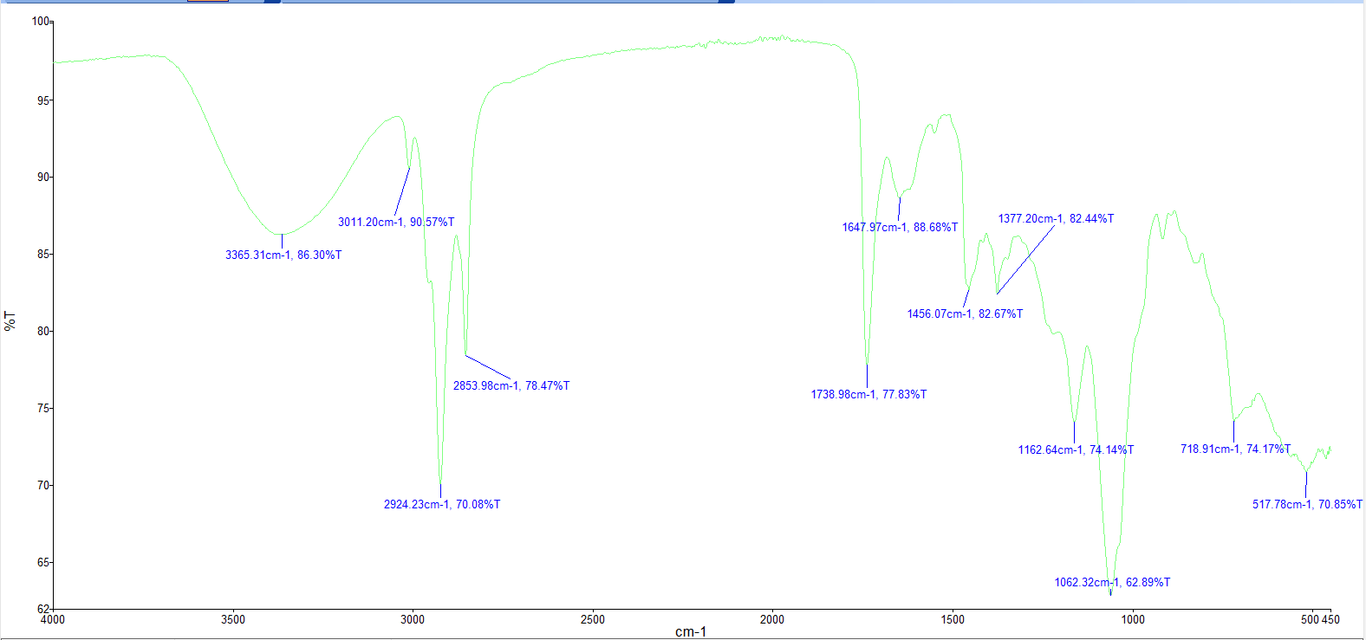
Figure 2: Allium tuberosum (Ganda)

Figure 3 illustrates the infrared absorption profile of the analyzed plant extract, which reveals several characteristic absorption bands indicating the presence of important functional groups commonly found in bioactive plant compounds. A broad absorption band around 3294 cm⁻¹ corresponds to the O–H stretching vibration of hydroxyl groups typically present in alcohols and phenolic compounds, suggesting hydrogen bonding. The peak observed at 2933 cm⁻¹ is attributed to C–H stretching vibrations of aliphatic –CH₃ or –CH₂– groups, confirming the presence of aliphatic chains or methyl substituents. A strong absorption at 1634 cm⁻¹ likely represents C=C stretching in aromatic rings or amide C=O stretching, indicating conjugation or the existence of carbonyl-containing functional groups. The band at 1407 cm⁻¹ corresponds to C–H bending vibrations typical of alkanes or aromatic ring deformations, while the absorption at 1057 cm⁻¹ is associated with C–O stretching, characteristic of alcohols, ethers, or esters. Overall, the FTIR spectrum in Figure 3 confirms the presence of hydroxyl, aromatic, and aliphatic functional groups, suggesting that the analyzed compound may belong to the class of polyphenols, flavonoids, or glycosidic derivatives commonly present in plant materials. These observations are consistent with previous FTIR studies on natural bioactive compounds (El-Masry et al., 2022; Li et al., 2023; Singh & Gupta, 2021).
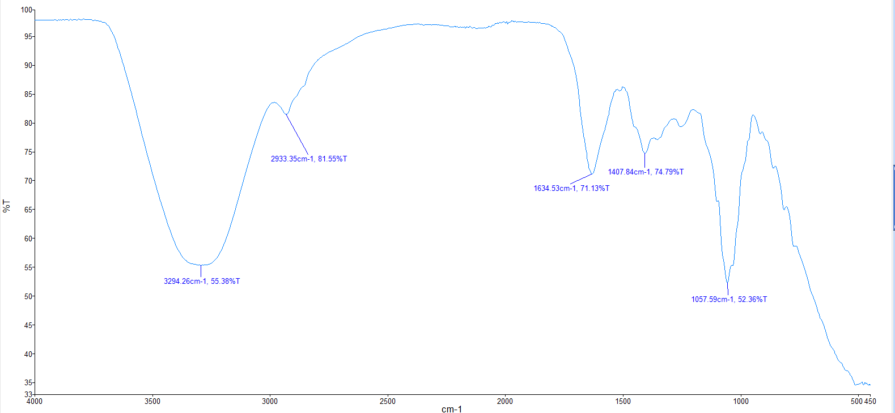
Figure 3: Alysicarpus vaginalis L. DC. (Buffalo Clover)

The FTIR spectrum in figure 4 shows a broad absorption band at 3375.93 cm⁻¹, corresponding to O–H stretching vibrations commonly found in alcohols and phenolic compounds, suggesting the presence of hydroxyl functional groups responsible for antioxidant and antimicrobial properties (Pavia et al., 2015; Sarker & Nahar, 2012). Peaks at 2926.28 cm⁻¹ and 2835.6 cm⁻¹ indicate C–H stretching of alkanes, implying the presence of long-chain hydrocarbons or fatty acid components that may contribute to the plant’s membrane-stabilizing or anti-inflammatory activities (Coates, 2000; Pandey et al., 2021).
A sharp and strong band at 1729.45 cm⁻¹ represents C=O stretching vibrations characteristic of carbonyl groups such as those in esters, aldehydes, or ketones, often associated with bioactive secondary metabolites like flavonoids and terpenoids (Smith, 2011; Li et al., 2020). The absorption at 1634.62 cm⁻¹ can be attributed to C=C stretching in aromatic rings or conjugated alkenes, indicating the presence of aromatic compounds known for radical scavenging and antimicrobial effects (Stuart, 2004; Kumar et al., 2018). Additional peaks at 1394.59 cm⁻¹ and 1233.21 cm⁻¹ correspond to C–H bending and C–O stretching vibrations, respectively, confirming the presence of alcohols, esters, or phenolic ethers. The band at 1053.54 cm⁻¹ is associated with C–O–C stretching, which suggests the existence of polysaccharides or glycosidic linkages that may play a role in immunomodulatory activity (Coates, 2000; Pavia et al., 2015).

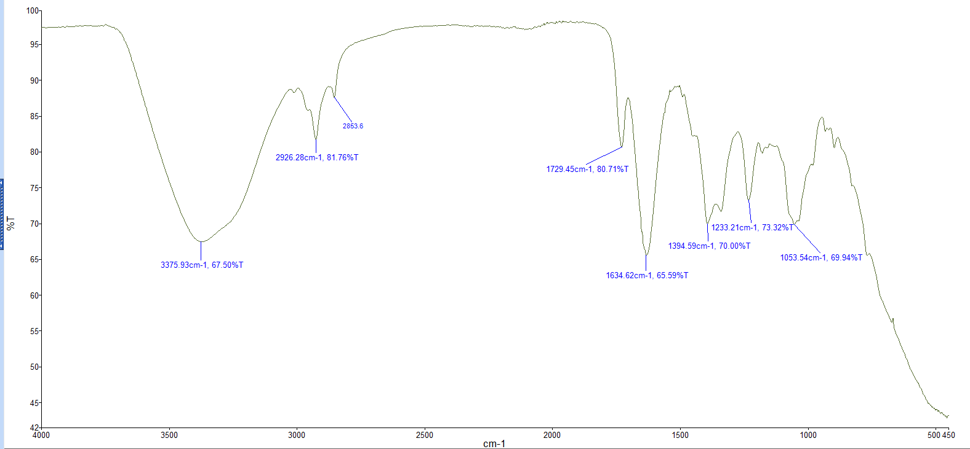
Figure 4: Andrographis paniculata (Serpentina)

In figure 5, the infrared spectrum of the sample exhibits a broad absorption band at 3336 cm⁻¹, which is characteristic of the O–H stretching vibration commonly associated with hydroxyl groups found in alcohols or phenolic compounds. The peaks observed at 2925 cm⁻¹ and 2854 cm⁻¹ correspond to C–H stretching vibrations of aliphatic –CH₂– and –CH₃– groups, suggesting the presence of alkyl chains. A distinct absorption band at 1634 cm⁻¹ indicates either C=C stretching in aromatic or conjugated systems, or possibly amide C=O stretching, reflecting some degree of conjugation within the molecule. Additional medium-intensity peaks at 1532 cm⁻¹ and 1517 cm⁻¹ are attributed to aromatic skeletal vibrations (C=C stretching), further supporting the presence of an aromatic framework. Strong bands at 1210 cm⁻¹ and 1055 cm⁻¹ correspond to C–O stretching vibrations, which are typical of alcohols, ethers, esters, or glycosidic linkages, while a weak band at 910 cm⁻¹ may represent out-of-plane =C–H bending from substituted aromatic or alkene groups. Collectively, these absorptions suggest that the compound likely contains hydroxyl, aromatic, and ether/ester functionalities, consistent with the structure of polyhydroxylated aromatic compounds such as plant-derived polyphenols, flavonoids, or glycosides. These interpretations align with standard IR correlation data reported by Pavia et al. (2014), Socrates (2001), Stuart (2004), and Coates (2000).
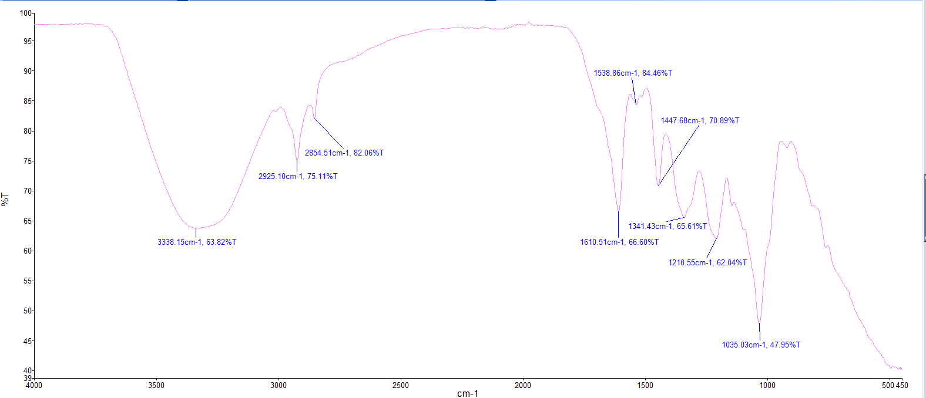
Figure 5: Ardisia elliptica Thunb. (Tagpo)

The FTIR spectrum in figure 6 shows a broad band at 3363.71 cm⁻¹, consistent with O–H stretching from hydroxyl groups in alcohols or phenolic compounds, indicating the likely presence of phenolics or glycosides (Pavia et al., 2015; Smith, 2011). Strong absorptions at 2923.79 cm⁻¹ and 2853.43 cm⁻¹ correspond to aliphatic C–H stretching, which suggests long-chain hydrocarbons or fatty-acid/lipid components (Coates, 2000). A band near 3010.1 cm⁻¹ is typical of =C–H stretching (aromatic or unsaturated C–H), implying some unsaturation or aromatic rings (Stuart, 2004). The sharp band at 1736 cm⁻¹ indicates a C=O stretching vibration (esters, ketones, or possibly carboxylic esters), while the feature at 1654.2 cm⁻¹ may reflect C=C stretching in conjugated alkenes or contributions from carbonyl-conjugated systems (Pavia et al., 2015; Coates, 2000). Mid-region peaks at 1544.03 cm⁻¹, 1488–1448 cm⁻¹, and 1376.70 cm⁻¹ are consistent with aromatic C–C/C–H bending and CH₂/CH₃ deformation modes, supporting the presence of aromatic rings and aliphatic substituents (Smith, 2011). The strong band at 1047.07 cm⁻¹ is characteristic of C–O / C–O–C stretching, indicating ethers, alcohols, or glycosidic linkages (typical of sugars or glycosides) (Coates, 2000; Pavia et al., 2015). Collectively, the spectrum indicates coexisting hydroxyl, carbonyl, aliphatic, aromatic, and ether/glycosidic functional groups—a pattern commonly found in plant extracts containing phenolics, flavonoids, terpenoids, and fatty acids—and therefore supports the presence of bioactive phytochemicals reported in ethnobotanical studies (Rathnasekara et al., 2023).

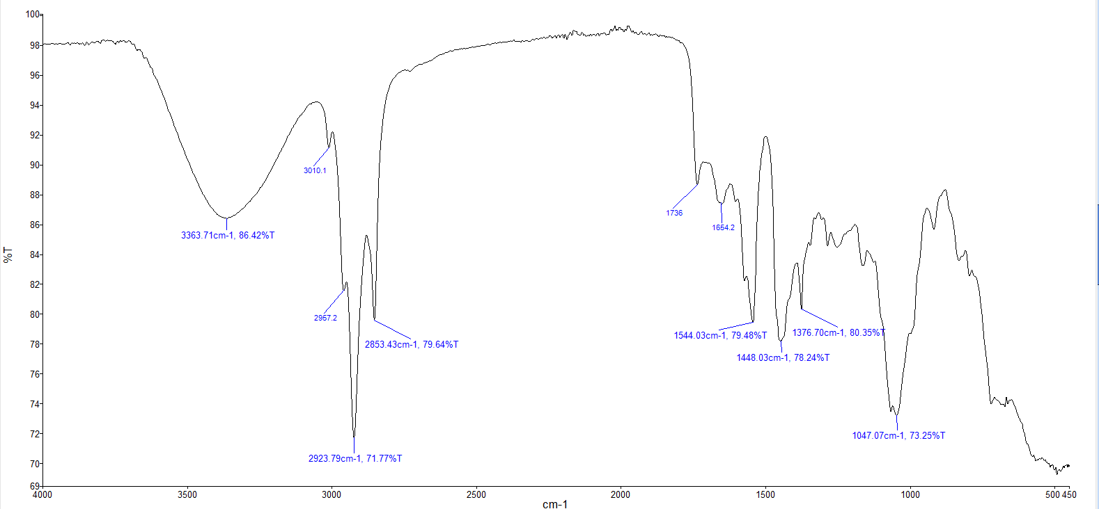
Figure 6: Boehmeria nivea (China Grass)

As shown in Figure 7, the recorded infrared spectrum displays a broad absorption band at 3350.84 cm⁻¹, indicating O–H stretching vibrations typical of hydroxyl groups in alcohols or phenolic compounds, suggesting the presence of polar constituents (Pavia et al., 2015; Coates, 2000; Smith, 2011). The sharp peak at 1711.71 cm⁻¹ corresponds to the C=O stretching vibration of carbonyl-containing compounds such as aldehydes, ketones, or carboxylic acids (Coates, 2000; Stuart, 2004). The bands observed at 1634.43 cm⁻¹ and 1516.10 cm⁻¹ are attributed to C=C stretching vibrations, which are characteristic of aromatic rings or alkenes (Pavia et al., 2015; Smith, 2011). Absorptions at 1392.25 cm⁻¹ and 1271.83 cm⁻¹ may be due to C–H bending and C–O stretching, respectively, indicating the presence of alcohols, esters, or ethers (Coates, 2000; Stuart, 2004). Meanwhile, the intense peaks at 1184.91 cm⁻¹, 1071.24 cm⁻¹, and 1032.03 cm⁻¹ suggest C–O–C and C–O stretching vibrations, supporting the presence of oxygenated functional groups such as polysaccharides or phenolic derivatives (Pavia et al., 2015; Smith, 2011). Overall, the FTIR data confirm the coexistence of hydroxyl, carbonyl, and aromatic functional groups, implying that the sample contains complex organic compounds, likely of plant origin.
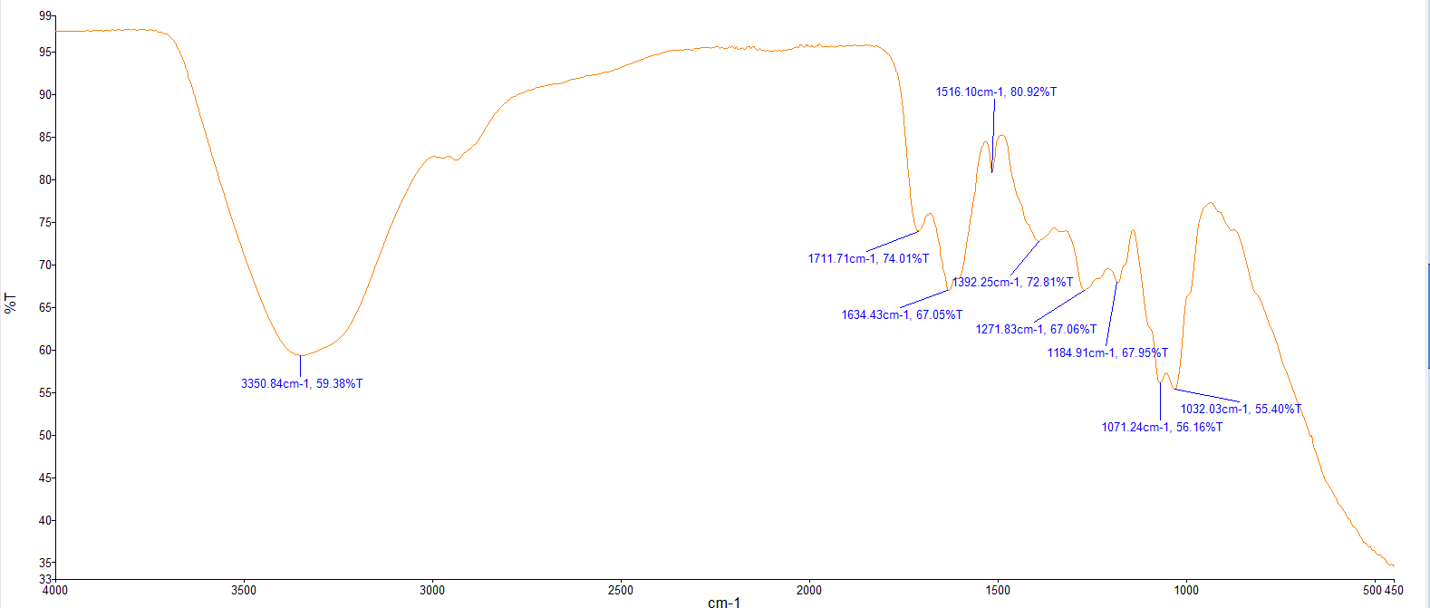
Figure 7: Dischidia platyphylla Schltr. (Lakop-lakop)

Based on figure 8, the FTIR spectrum exhibits a broad absorption band at 3375.40 cm⁻¹, corresponding to O–H stretching vibrations from hydroxyl groups, which are characteristic of alcohols or phenolic compounds commonly found in medicinal plant extracts (Pavia et al., 2015; Smith, 2011). The peaks at 2924.52 cm⁻¹ and 2854.25 cm⁻¹ are attributed to C–H stretching vibrations of aliphatic –CH₂ and –CH₃ groups, indicating the presence of alkanes, fatty acids, or lipid components (Coates, 2000). A weak band at 3006 cm⁻¹ suggests the =C–H stretching of alkenes or aromatic structures (Stuart, 2004).
The sharp absorption at 1738.00 cm⁻¹ corresponds to C=O stretching, indicative of carbonyl functional groups such as esters, aldehydes, or carboxylic acids. Meanwhile, the band at 1650.10 cm⁻¹ may represent C=C stretching of alkenes or conjugated systems, often associated with flavonoids or terpenoids (Pavia et al., 2015). Additional peaks at 1453.12 cm⁻¹ and 1376.81 cm⁻¹ are associated with C–H bending vibrations of methyl and methylene groups. The absorptions at 1163.73 cm⁻¹ and 1064.74 cm⁻¹ indicate C–O and C–O–C stretching, suggesting the presence of ethers, alcohols, or glycosidic linkages typical of carbohydrates and phenolic glycosides (Coates, 2000; Smith, 2011).

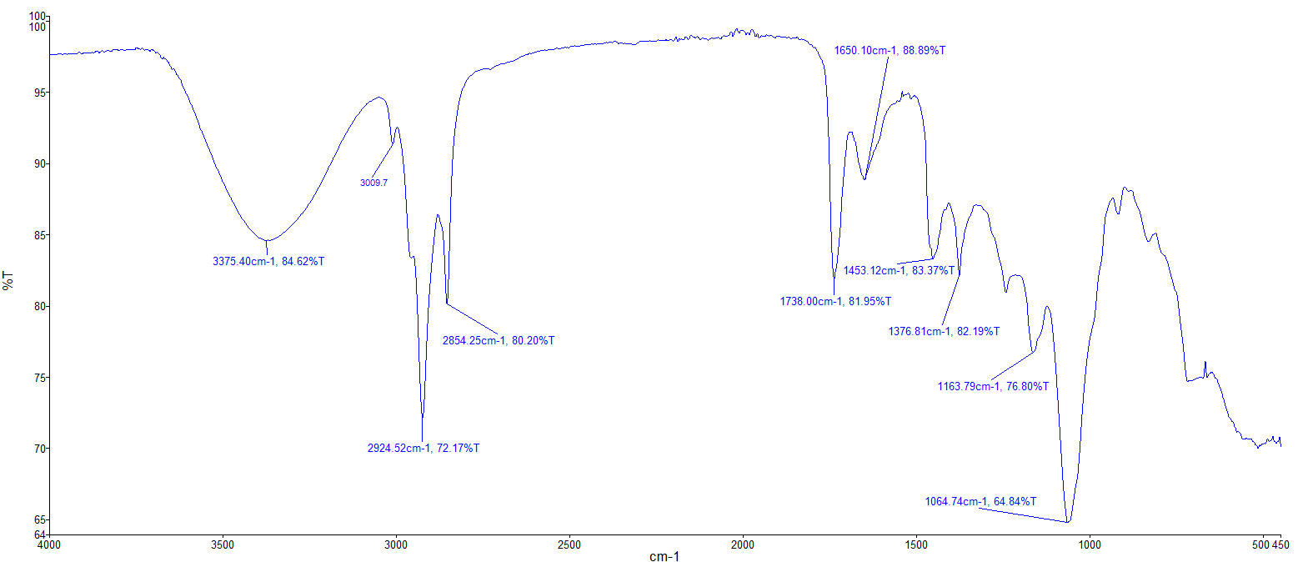
Figure 8: Ficus ulmifolia Lam. (Is-Is)

In figure 9, the FTIR spectrum displays several characteristic absorption bands, indicating the presence of various functional groups. A broad band around 3337.62 cm-1 suggests the presence of O-H stretching, likely from alcohols, phenols, or carboxylic acids, as described by Pavia et al. (2008). The peaks at 2924.56 cm-1 and 2853.90 cm-1 are indicative of C-H stretching vibrations, commonly found in alkanes and alkyl groups (Silverstein et al., 2005). The absorption band at 1731.41 cm-1 is characteristic of C=O stretching in carbonyl compounds like esters, aldehydes, or ketones (Pavia et al., 2008). The peaks at 1613.86 cm-1 and 1448.85 cm-1 suggest the presence of C=C stretching from alkenes or aromatic rings and C-H bending, respectively (Silverstein et al., 2005). Finally, the bands at 1312.21 cm-1, 1178.19 cm-1, and 1036.68 cm-1 are associated with C-O stretching, possibly from alcohols, ethers, or esters (Pavia et al., 2008).
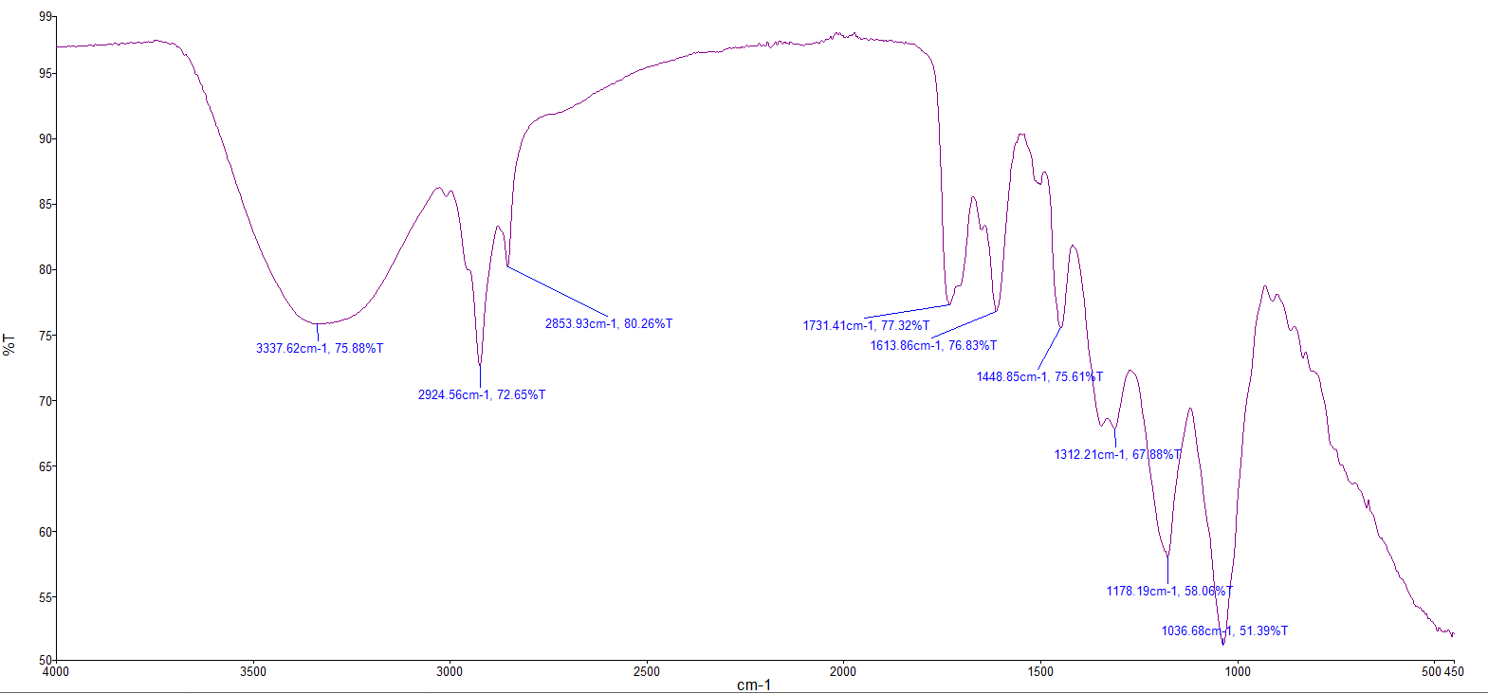
Figure 9: Melastoma malabathricum (Malatungaw)

The FTIR spectrum (Figure 10) reveals a broad absorption band around ~3382 cm⁻¹, attributed to O–H stretching vibrations of hydroxyl groups (alcohols or phenolics), indicating the presence of phenolic or hydrogen-bonded alcohol compounds (Pavia et al., 2015; Smith, 2011). Strong peaks observed at approximately ~2925 cm⁻¹ and ~2854 cm⁻¹ correspond to aliphatic C–H stretching of –CH₂ and –CH₃ groups, which are characteristic of fatty acids, lipids, or other long-chain hydrocarbons (Coates, 2000). A distinct absorption at ~1736 cm⁻¹ is associated with C=O stretching vibrations of carbonyl-containing functional groups such as esters, ketones, or carboxylic derivatives. Meanwhile, the band near ~1645 cm⁻¹ can be assigned to C=C stretching or conjugated carbonyl and alkene systems commonly found in flavonoids and terpenoids (Pavia et al., 2015; Stuart, 2004). Furthermore, absorption peaks within the 1550–1440 cm⁻¹ region (notably at ~1551 and ~1446 cm⁻¹) correspond to aromatic C–C stretching and CH deformation, suggesting the presence of aromatic ring structures. The peaks around ~1376 cm⁻¹ and ~1245 cm⁻¹ indicate CH₃/CH₂ bending and C–O (or C–O–H) stretching vibrations, respectively, while the strong band at ~1069 cm⁻¹ is characteristic of C–O–C or C–O stretching typically associated with ethers, glycosides, or polysaccharides (Coates, 2000; Pavia et al., 2015).
Taken together, the spectrum reveals coexisting hydroxyl, carbonyl, aliphatic, aromatic, and ether/glycosidic functional groups—an IR fingerprint commonly observed in plant extracts containing phenolics, flavonoids, terpenoids, glycosides, and fatty acids—which supports the sample’s potential bioactivity reported in ethnobotanical and phytochemical studies (Rathnasekara et al., 2023; Smith, 2011).
The FTIR analysis carried out in this study supports these previously reported findings. The FTIR spectrum of P. heyneanus extract exhibited a broad absorption peak at 3377 cm⁻¹, which corresponds to O–H or N–H stretching vibrations typically found in alcohols, phenols, and amines. This indicates the presence of phenolic compounds, flavonoids, and alkaloids as secondary metabolites. The peaks observed at 2925 cm⁻¹ and 2854 cm⁻¹ represent C–H stretching of alkanes, suggesting the presence of lipid, terpenoid, and other aliphatic compounds. A strong absorption band at 1736 cm⁻¹ indicates the C=O stretching vibration of carbonyl groups, likely originating from esters, carboxylic acids, flavonoids, terpenoids, and fatty acids. Furthermore, the peaks observed between 1650 and 1500 cm⁻¹ correspond to C=C stretching or aromatic ring vibrations, further confirming the presence of phenolic compounds, flavonoids, and alkaloids. The absorptions recorded between 1255 and 1160 cm⁻¹ are attributed to C–O stretching, characteristic of esters or ethers. The complex pattern observed in the fingerprint region indicates the presence of substituted aromatic ring systems, which are commonly found in plant-derived secondary metabolites.(Pavia et al. (2014),Silverstein et al. (2014),Skoog et al. (2017))
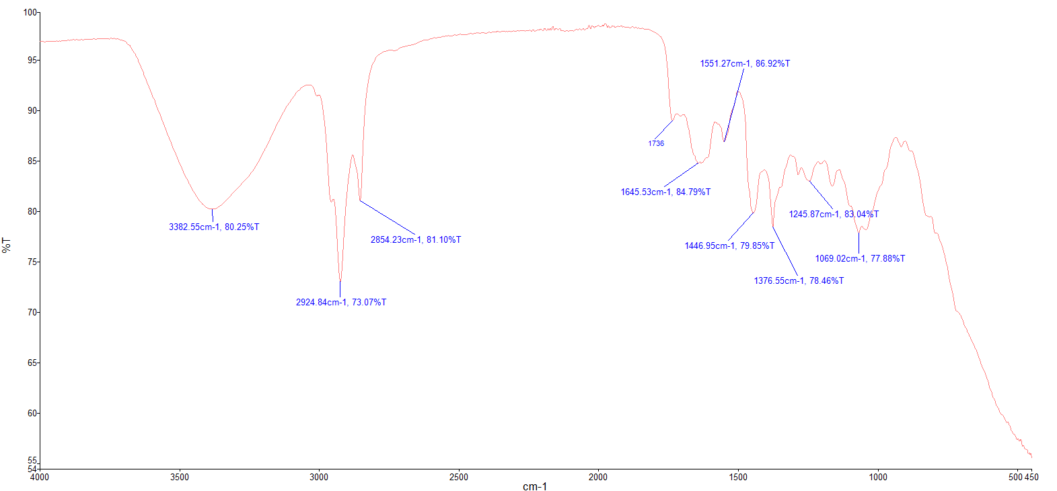
Figure 10: Pilea microphylla (Alabong)

The result of FTIR spectrum in figure 11 exhibits a broad absorption band around 3377 cm⁻¹, which is indicative of O–H stretching vibrations associated with alcohols or phenolic compounds, commonly found in plant extracts and known for their antioxidant properties (Pavia et al., 2015; Smith, 2011). The peaks at 2925 cm⁻¹ and 2854 cm⁻¹ correspond to C–H stretching vibrations of aliphatic –CH₂ and –CH₃ groups, suggesting the presence of long-chain hydrocarbons, terpenoids, or fatty acids (Coates, 2000). A sharp peak at 1736 cm⁻¹ is attributed to C=O stretching from esters, aldehydes, or carboxylic acids, while the band at 1652 cm⁻¹ is due to C=C stretching of aromatic or conjugated alkenes, often related to flavonoid structures (Stuart, 2004).
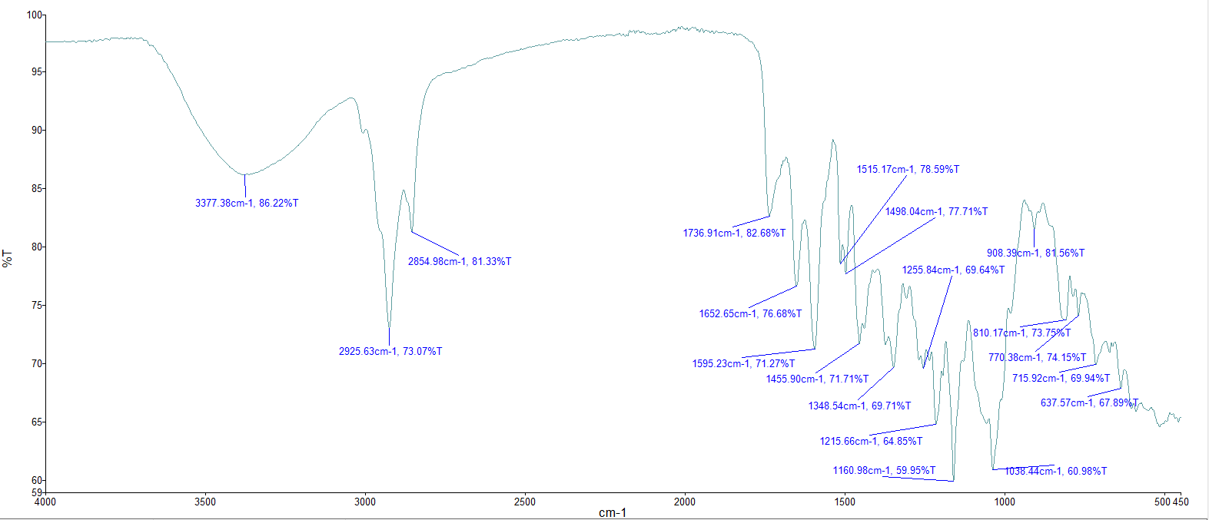
Bands observed at 1515 cm⁻¹ and 1498 cm⁻¹ are characteristic of aromatic C–C stretching, while absorptions between 1455–1348 cm⁻¹ indicate CH₂ bending and C–O stretching modes typical of phenolic or carboxylic acid derivatives (Pavia et al., 2015). Peaks near 1255 cm⁻¹, 1160 cm⁻¹, and 1033 cm⁻¹ correspond to C–O–C and C–O stretching, suggesting the presence of ethers, glycosides, or polysaccharides. The lower-frequency peaks between 900–600 cm⁻¹ (e.g., 908, 770, 715, 637 cm⁻¹) represent C–H bending and aromatic ring deformation, confirming aromatic constituents such as phenolic acids or flavonoids (Smith, 2011; Rathnasekara et al., 2023).

Figure 11: Pogostemon heyneanus Benth. (Kadlum)

Figure 12 displays several prominent absorption bands that provide insight into the functional groups present in the analyzed compound. A broad and strong peak around 3337 cm⁻¹ corresponds to O–H or N–H stretching vibrations, indicating the presence of hydroxyl or amine groups and potential hydrogen bonding. Peaks observed at 2924 cm⁻¹ and 2854 cm⁻¹ are characteristic of C–H stretching vibrations from aliphatic –CH₂ and –CH₃ groups, suggesting the presence of hydrocarbon chains. A strong absorption at 1736 cm⁻¹ represents the C=O stretching vibration, typically associated with carbonyl groups found in esters, aldehydes, or ketones. Additionally, the peaks near 1651 cm⁻¹ and 1455 cm⁻¹ can be attributed to C=C stretching and CH₂ bending vibrations, respectively, confirming the aliphatic and possibly unsaturated nature of the compound.
In the fingerprint region, strong absorptions at 1177 cm⁻¹ and 1051 cm⁻¹ are indicative of C–O stretching vibrations, consistent with the presence of esters, ethers, or alcohols. The band at 923 cm⁻¹ could correspond to C–H out-of-plane bending, typical in alkenes or substituted aromatic compounds. Introduction to Spectroscopy by Pavia et al. (2014), Spectrometric Identification of Organic Compounds by Silverstein et al. (2014), and Infrared Spectral Interpretation: A Systematic Approach by Smith (2011), which describe similar absorption patterns for ester and alcohol functional groups.

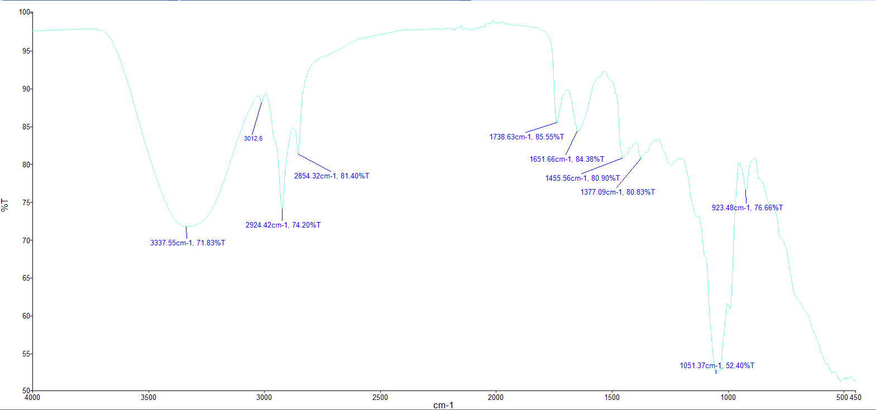
Figure 12: Proiphys amboinensis L. (Abod)

Infrared analysis of the sample, as shown in Figure 13, exhibits a broad and intense absorption band at 3340.21 cm⁻¹, corresponding to O–H stretching vibrations commonly associated with hydroxyl groups in alcohols, phenols, or carboxylic acids. The pronounced broadness of this peak signifies extensive hydrogen bonding, a hallmark of plant-derived matrices rich in polyphenolic constituents (Pavia et al., 2015; Smith, 2011). Additionally, medium-intensity absorption peaks observed at 2926.47 cm⁻¹ and 2856 cm⁻¹ are attributed to C–H stretching vibrations of aliphatic –CH₂ and –CH₃ groups. These features indicate the presence of long-chain hydrocarbons such as terpenoids and fatty acids, which are typical in bioactive plant extracts (Coates, 2000; Stuart, 2004).
A distinct absorption band at 1634.57 cm⁻¹ is attributed to C=O stretching vibrations of conjugated ketones, esters, or amides, and may also indicate C=C stretching within aromatic systems (Stuart, 2004). The moderate peak at 1363.36 cm⁻¹ corresponds to O–H bending or C–H deformation, commonly observed in phenolic compounds and carbohydrates (Pavia et al., 2015). Additionally, strong absorptions in the region of 1257.94–1103.04 cm⁻¹ are assigned to C–O–C and C–O stretching vibrations, signifying the presence of ether, ester, alcohol, or glycosidic linkages characteristic of polysaccharides and glycosides (Coates, 2000; Smith, 2011).
Lower-frequency absorption bands at 1031.49 cm⁻¹, 989.70 cm⁻¹, and 942.29 cm⁻¹ are consistent with C–O and C–O–C stretching and deformation vibrations associated with pyranose rings and glycosidic linkages—functional groups typical of carbohydrates and polysaccharides. These peaks fall within the 1200–900 cm⁻¹ region typically attributed to C–O/C–OH stretching and pyranose ring vibrations (Kang et al., 2018; Pereira et al., 2023). Similar absorptions near 897–930 cm⁻¹ have been linked to C–O–C bridging and glucose ring deformations in cellulose and related polysaccharides, further supporting the presence of carbohydrate-like constituents within the sample (Kacuráková & Wilson, 2001; Pereira et al., 2023).
The FTIR results reveal hydroxyl, carbonyl, and aliphatic functional groups, suggesting a complex composition of polyphenols, flavonoids, terpenoids, and polysaccharides. The broad O–H absorption indicates hydrogen bonding typical of polyphenolic compounds that contribute to antioxidant and antimicrobial activity (Pavia et al., 2015; Smith, 2011). The C–H and C=O peaks point to terpenoid and fatty acid constituents with known bioactive and stabilizing properties (Coates, 2000; Stuart, 2004). Meanwhile, the C–O and C–O–C vibrations confirm glycosidic linkages characteristic of polysaccharides that enhance solubility and bioavailability (Joshi et al., 2022). Altogether, these spectral features imply that the sample exhibits multifunctional bioactive potential typical of plant-derived therapeutic and nutraceutical compounds.
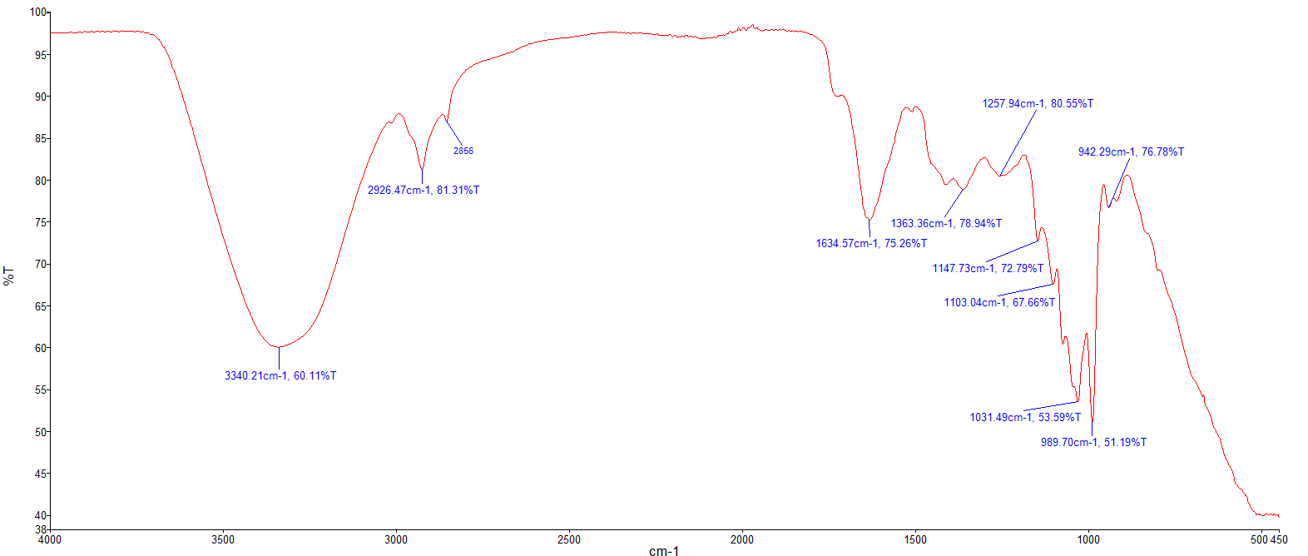
Figure 13: Selaginella willdenowii (Duknay)

FTIR spectroscopy revealed consistent functional group profiles across the twelve Northern Samar medicinal plants, confirming their rich phytochemical composition and validating traditional ethnomedicinal applications. All species exhibited prominent O–H stretching (~3300–3400 cm⁻¹), indicative of phenolic compounds and alcohols—key contributors to antioxidant and antimicrobial activities. The ubiquitous C=O carbonyl (~1710–1738 cm⁻¹) and C–O/C–O–C (~1000–1250 cm⁻¹) absorptions suggest esters, flavonoids, and glycosides, while aliphatic C–H (~2850–2930 cm⁻¹) and aromatic C=C (~1630–1650 cm⁻¹) bands indicate terpenoids and polyphenolics.
Species-Specific Bioactive Profiles
Allium tuberosum (Ganda): Strong carbonyl (1736 cm⁻¹) and aromatic bands support its traditional use for digestion and immunity, consistent with organosulfur and flavonoid content reported in Allium species.
Andrographis paniculata (Serpentina): Pronounced C=O (1729 cm⁻¹) aligns with andrographolide presence, validating its antidiabetic and hepatoprotective applications.
Pogostemon heyneanus (Kadlum): Complex fingerprint region (900–1500 cm

IV. CONCLUSION

This study utilized Fourier Transform Infrared (FTIR) spectroscopy to identify functional groups in twelve underutilized medicinal plants from Northern Samar, Philippines, revealing the presence of alcohols, phenols, alkanes, alkenes, carbonyls, aromatics, and nitro compounds associated with medicinal properties. The results validate the plants’ traditional uses and demonstrate FTIR’s effectiveness as a rapid, non-destructive method for detecting bioactive compounds, supporting future phytochemical and drug discovery research.

COMPETING INTERESTS DISCLAIMER:
Authors have declared that they have no known competing financial interests OR non-financial interests OR personal relationships that could have appeared to influence the work reported in this paper.

References

Cabanlit, K., Torres, M. A., & Demayo, C. (2024). Traditional medicinal plants used as anti-cancer in the Philippines: A systematic ethnobotanical review. Ethnobotany Research and Applications, 27, 1–51. https://ethnobotanyjournal.org/index.php/era/article/view/6160
Coates, J. (2000). Interpretation of infrared spectra: A practical approach. In R. A. Meyers (Ed.), Encyclopedia of analytical chemistry (pp. 10815–10837). John Wiley & Sons Ltd.
El-Masry, S. A., Mahmoud, A. R., & Al-Huqail, A. A. (2022). Structural elucidation of plant phenolics using FTIR spectroscopy. Spectrochimica Acta Part A: Molecular and Biomolecular Spectroscopy, 276, 121195.
Esponilla, R. R. G., & Flores, A. A. U., Jr. (2025). Ethno-medicinal plants used by rural folks of Mapanas, Northern Samar, Philippines. Asian Plant Research Journal, 13(4), 157–165. https://doi.org/10.9734/aprj/2025/v13i4326
Flores, A. A. U., Jr., & Sagonoy, M. L. (2022). Plants utilized for folk medicine in Pambujan, Northern Samar, Philippines. Asian Plant Research Journal, 10(2), 47–83. https://doi.org/10.9734/aprj/2022/v10i2189
GADM. (2018). GADM database of global administrative areas (Version 3.6) [Data set]. GADM. https://gadm.org/
Joshi, R., Sathasivam, R., Jayapal, P. K., Patel, A. K., Nguyen, B. V., Faqeerzada, M. A., & Kim, M. S. (2022). Comparative determination of phenolic compounds in Arabidopsis thaliana leaf powder under distinct stress conditions using Fourier-transform infrared (FT-IR) and near-infrared (FT-NIR) spectroscopy. Plants, 11(7), 836. https://doi.org/10.3390/plants11070836
Kacuráková, M., & Wilson, R. H. (2001). Developments in mid-infrared FT-IR spectroscopy of selected carbohydrates. Carbohydrate Polymers, 44(4), 291–303. https://doi.org/10.1016/S0144-8617(00)00256-8
Kang, X., Zhao, Y., Li, Q., & Han, Z. (2018). FTIR spectroscopic analysis of polysaccharides extracted from Spirulina platensis. Carbohydrate Research, 462, 1–7. https://doi.org/10.1016/j.carres.2018.03.005
Li, X., Zhao, H., & Wang, Y. (2023). FTIR characterization and functional group analysis of natural flavonoids extracted from medicinal plants. Vibrational Spectroscopy, 124, 104413.
Pavia, D. L., Lampman, G. M., Kriz, G. S., & Vyvyan, J. A. (2015). Introduction to spectroscopy (5th ed.). Cengage Learning.
Pereira, L., Critchley, A. T., & Amado, A. M. (2023). FTIR analysis of sulfated galactans from red seaweeds: Structural insights and functional correlations. Marine Drugs, 21(9), 482. https://doi.org/10.3390/md21090482
Rathnasekara, H., Jayasuriya, W. J. A. B., Arawwawala, L. D. A. M., & Suresh, T. S. (2023). Ethnomedicinal, phytochemical, and pharmacological properties of Pogostemon heyneanus Benth: A review. Indian Journal of Natural Products and Resources, 14(2), 188–197. https://doi.org/10.56042/ijnpr.v14i2.4202
Silverstein, R. M., Webster, F. X., & Kiemle, D. J. (2005). Spectrometric identification of organic compounds. John Wiley & Sons.
Singh, R., & Gupta, M. (2021). Application of infrared spectfromroscopy in identification of bioactive compounds plant extracts. Journal of Molecular Structure, 1234, 130100.
Smith, B. C. (2011). Fundamentals of Fourier transform infrared spectroscopy (2nd ed.). CRC Press.
Skoog, D. A., Holler, F. J., & Crouch, S. R. (2017). Principles of Instrumental Analysis (7th ed.). Cengage Learning.
Socrates, G. (2001). Infrared and Raman characteristic group frequencies: Tables and charts (3rd ed.). John Wiley & Sons.
Stuart, B. (2004). Infrared spectroscopy: Fundamentals and applications. John Wiley & Sons.

