Original Research Article
Strengthening the food system through value-added potato products in North and Central Gujarat

ABSTRACT
Gujarat has emerged as a major potato producing and processing hub in India, ranking fourth in national potato production, with North and Central Gujarat contributing significantly to the state’s output. The region is also a leading producer and exporter of processed potato products, particularly French fries, supported by favorable agro-climatic conditions, processing grade varieties, cold storage infrastructure, and entrepreneurial investment. This study examines the role of value-added potato processing in strengthening the regional food system. Primary data were collected from 15 operational potato processing units in North and Central Gujarat using a descriptive research design, supported by secondary sources. The findings indicate that value addition through products such as frozen fries, wafers, flakes, and powders improves shelf life, reduces post-harvest losses, stabilizes prices, and strengthens production–market linkages. Availability of working capital, demand estimation, and quality control systems were identified as key growth drivers, while financial constraints and high production costs emerged as major challenges. The study concludes that value-added potato processing enhances food system efficiency, farmer income stability, employment generation, and supply chain resilience, highlighting the need for targeted policy support.
Keywords: Potato, Value Addition, Potato Processing, Food Systems, Agribusiness

1. INTRODUCTION
Potato is a major commercial crop in India, providing employment and nutritional security (FAO, 2023). Gujarat ranks fourth nationally, with North and Central Gujarat serving as key hubs for processing-grade varieties. The crop’s perishability and concentrated production necessitate effective post-harvest management and value addition. Processing potatoes into chips, fries, flakes, and starch extends shelf life, reduces losses, stabilizes prices, and strengthens farm-to-market linkages, offering higher and more stable returns to farmers (Government of Gujarat, 2024).
Despite their growing importance, limited empirical evidence exists on the structure, functioning, and performance of regional potato processing industries from a food systems perspective. This study examines operational processing units in North and Central Gujarat to assess their role in procurement, processing, storage, and distribution, evaluating contributions to value addition, loss reduction, supply continuity, and market integration. By situating processing industries within the broader food system, the study highlights their potential to enhance regional food system efficiency and sustainable agri-food development.
2. OBJECTIVES
- Examine the current status and structure of potato processing industries in North and Central Gujarat.
- Analyse the contribution of potato processing industries to food system efficiency through value addition and post-harvest functions.
- Identify key constraints and policy initiatives influencing the growth of potato processing industries and their role in strengthening the food system.
3. LITERATURE REVIEW
Singh et al. (2025) analysed contract farming among potato growers in Punjab, finding positive implications for profitability and supply consistency in processing value chains. Bandana, Kumar, and Singh (2024) discussed key aspects of post-harvest management in India, noting the importance of improved storage and handling to reduce losses in potato supply chains. Gupta et al. (2024) provided an overview of potato processing in India, highlighting the growing role of processing-oriented cultivation and the industry’s future prospects. Sahu et al. (2024) identified factors influencing post-harvest losses and constraints in the potato value chain in Uttar Pradesh, suggesting enhanced storage and market intelligence can strengthen efficiency. Yadav and Singh (2021) quantified potato losses during transportation and storage, emphasizing the need for optimized handling and environmental controls.
Materials and Methods
The study collected primary data from 15 operational potato processing units in North and Central Gujarat, the core production and processing regions. Field verification showed that, although more units were registered, only these 15 were actively engaged in value-added processing, making the sample nearly a census of functional firms.
A descriptive research design was used, with purposive sampling limited to active processing units. Data were gathered through structured surveys covering firm characteristics, raw material sourcing, processing capacity, storage, product diversification, market linkages, and operational constraints. Secondary data from company reports, websites, and government publications complemented the analysis.
Using a firm-level food systems approach, the study examined key post-harvest functions like procurement, processing, storage, and distribution to assess how processing units contribute to value addition, loss reduction, supply continuity, and market integration, supporting regional food system efficiency and resilience.
5. RESULTS AND DISCUSSION
5.1 Potato Production and Processing Potential in North and Central Gujarat
Gujarat ranks fourth nationally in potato production, with 48.59 lakh tonnes in 2024–25, contributing about 8.1% of India’s output (Desh Gujarat, 2025; Gujarat Information, 2025). North and Central Gujarat, particularly Banaskantha, Sabarkantha, and Aravalli account for nearly 80% of the state’s production, much of it grown for processing. The region’s agro-climatic suitability, modern farming practices, and cold storage infrastructure support year-round supply of processing-grade potatoes. Over 25% of production is suitable for products like wafers (60%) and French fries (40%) (IANS, 2025), while expansion into flakes and powder can further stabilize prices and enhance farmer incomes.
Table 1: State-wise production trends of potato in India (Area in ‘000Ha, Production in 000MT)
S.No. | State | 2022-23 |  | 2023-24 |  | 2024-25
 |  | Area | Production | Area | Production | Area | Production
1 | Uttar Pradesh | 694.10 | 20,126 | 696.03 | 19,173 | 698.00 | 20,242
2 | West Bengal | 489.00 | 14,508 | 492.91 | 13,000 | 515.00 | 13,763
3 | Bihar | 331.76 | 9,075 | 329.46 | 8,200 | 312.40 | 7,386
4 | Gujarat | 131.43 | 4,026 | 134.86 | 4,000 | 156.21 | 5,080
5 | Madhya Pradesh | 172.21 | 3,955 | 155.56 | 3,949 | 169.72 | 3,898
6 | Punjab | 114.07 | 3,156 | 117.07 | 3,237 | 120.00 | 3,312
Source: APEDA, 2025
Gujarat is preferred by processors and exporters for producing industrially suitable potato varieties. Wafers require tubers >45 mm with high total solids and low reducing sugars, while French fries need lengths of 75 mm with high solids and low sugar content. Northern districts cultivate varieties such as Lady Rosetta, Kufri Chipsona, and Santana, ideal for chips and fries (DeshGujarat, 2025; Indian Potato, 2025). Improved seed quality and technical support have enabled yields up to 34 tonnes/ha in Sabarkantha and Aravalli, strengthening Gujarat’s position in the value-added potato supply chain. Production is concentrated in North and Central Gujarat, with northern districts leading output and central districts contributing moderately.
Table 2: District-wise share of production (2024-25)
Sr. No. | District | % of state production
1 | Banaskantha | 38.5
2 | Sabarkantha | 26.7
3 | Aravalli | 14.4
4 | Anand | 4.1
5 | Gandhinagar | 3.2
6 | Kheda | 3.0
 | Top Six District | 89.9
 | Rest of District | 10.1
 | Total State Production | 100.0
Source: DeshGujarat, 2025
These production characteristics provide a strong foundation for a resilient regional food system by ensuring reliable raw material supply for processing and year-round availability.
5.2 Cold Storage Infrastructure and Supply Chain Stability
Cold storage is vital for stabilizing potato supply and reducing seasonal gluts. Gujarat has around 539 cold storages, with 213 primarily for potatoes, concentrated in major producing districts like Banaskantha and Sabarkantha (Gujarat Cold Storage Association, 2025). While some use modern technologies such as controlled atmosphere storage, most are conventional, highlighting the need for upgrades. Cold storage ensures uninterrupted raw material supply, supports off-season processing, and helps stabilize prices across the value chain.
Table 3: Area wise number of cold storage (2024)
Sr. No. | District | No. of cold storage
1 | Banaskantha | 45
2 | Aravalli and Sabarkantha | 39
3 | Ahmedabad | 25
4 | Gandhinagar | 16
5 | Kheda,Anand and Vadodara | 9
6 | Others | 79
 | Total | 213
Source: The Gujarat cold storage association, 2025
Some of the existing cold storages in Gujarat are equipped with modern facilities such as controlled atmosphere and chemical treatments, but most are traditional in design. This highlights a need to invest in cold storages with latest technology. Cold storage infrastructure thus functions as a key food-system stabilizer by reducing post-harvest losses, smoothing seasonal price fluctuations and enabling continuous processing.
5.3 Structure and Characteristics of Potato Processing Units
Primary survey results revealed that 15 processing units were actively operational in the study area. Most firms were structured as private limited companies, while a smaller number operated as limited liability partnerships, reflecting the dominance of private corporate entities in the sector. The majority of processing units owned their land, with larger firms occupying more than 7.9 hectares, indicating capital-intensive operations.
Investment patterns showed that companies with modern technologies reported relatively higher investment levels and profit ranges, indicating better scale and market positioning., with no loss-making units observed during the study period. This highlights the economic viability of value-added potato processing when supported by adequate technology and infrastructure.
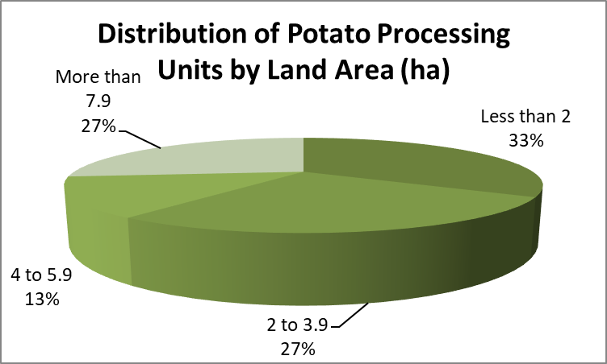
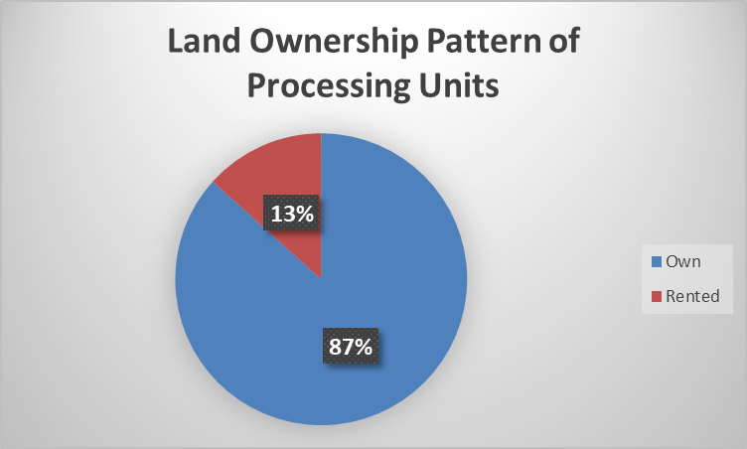
n=15
n=15
Fig 1: Distribution of Potato Processing Units by Land Area and Ownership Pattern
Source: Primary data
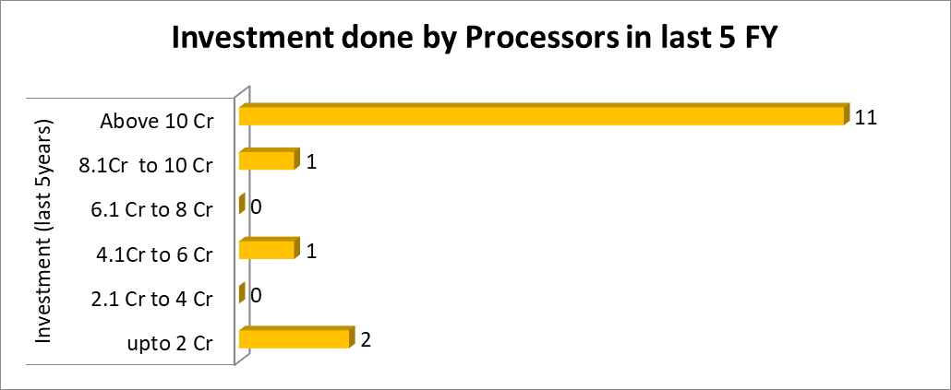
n=15
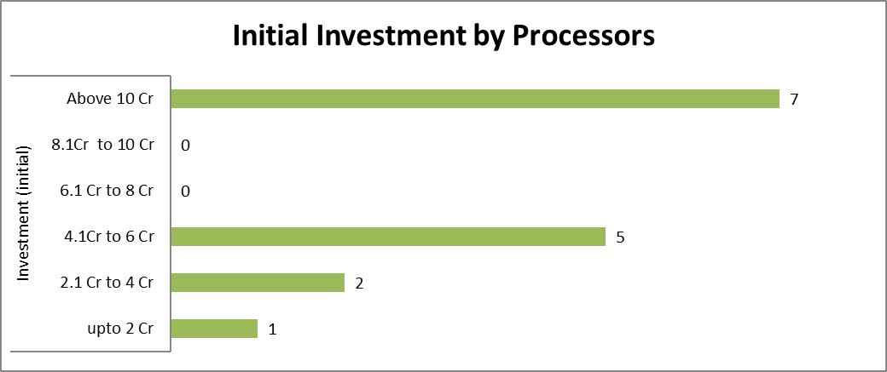
n=15

Fig 2: Initial Investment and Investment in Last 5FY by Processors
Source: Primary data
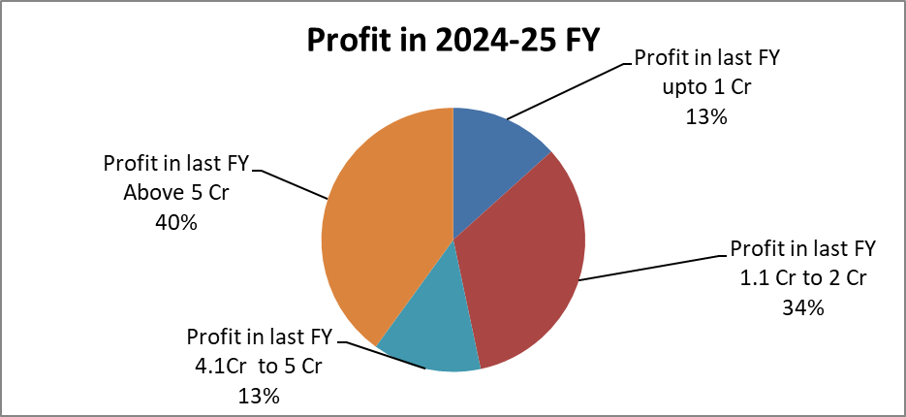
n=15
Fig 3: Distribution of Potato Processing Units by Land Area and Ownership Pattern
Source: Primary data collected through schedule
It was observed that most of the companies with latest technology were having higher investment in last 5 FY. Also, it can be observed from the above figure that the companies were all showing profits and there were no loss making units. The presence of financially viable and technologically equipped processing units enhances the midstream segment of the food system, strengthening value addition and market connectivity.
5.4 Contract Farming, Raw Material Sourcing and Storage Practices
Contract farming connects farmers with processing firms, ensuring quality, traceability, and consistency. Major processors such as McCain Foods, HyFun Foods, and Iscon Balaji Foods use contract farming to control seed selection, crop management, and harvesting, improving processing efficiency. Some firms also source potatoes through traders and mandis, especially in the off-season, and use flakes or powder to maintain year-round production. About 54% of surveyed units have storage facilities, owned or rented, enhancing supply chain resilience and integrating farmers securely into the food system.
Table 4: Companies sourcing potatoes from Gujarat through contract farming
Sr. No. | Company | Use
1 | McCain | French Fries
2 | Balaji | Wafers
3 | Pepsi | Wafers
4 | ITC | Wafers
5 | Himalaya | French Fries
6 | HyFun Foods | French Fries
7 | Farmton Foods | French Fries
8 | Greenfay | Potato Flakes
9 | Iscon Balaji | French Fries
10 | Others | Wafers
Source: Company Website
Table 4 presents major companies engaged in potato contract farming with farmers in Gujarat. Several of these firms operate processing units outside the study region; however, they source raw potatoes from Gujarat, highlighting the state’s importance as a raw material base for processing-oriented contract farming.
5.5 Constraints, Growth Factors and Institutional Support
Working capital availability, demand estimation, and quality control were identified as the most critical factors for firm growth, while financial constraints, quality issues, and high production costs were the main challenges. Scarcity of raw material and limited target markets were less significant concerns.

Table 5: Factors affecting growth of the Companies
n=15
Factors | Responses |  |  |  |  | WAM
 | 1 | 2 | 3 | 4 | 5 | WAM
Financial estimation | 10 | 2 | 3 | 0 | 0 | 1.53
Demand estimation | 8 | 6 | 1 | 0 | 0 | 1.53
Quality Control System | 9 | 4 | 2 | 0 | 0 | 1.53
Capacity Utilization | 5 | 2 | 7 | 1 | 0 | 2.27
Inventory Management System | 1 | 6 | 6 | 2 | 0 | 2.6
Maintance Procedure | 2 | 8 | 2 | 3 | 0 | 2.4
Waste Minimization | 1 | 7 | 3 | 4 | 0 | 2.67
Availability of Working Capital | 10 | 4 | 1 | 0 | 0 | 1.4
Control Mechanism Applied | 2 | 8 | 4 | 1 | 0 | 2.27
Waste Utilization | 3 | 5 | 6 | 0 | 1 | 2.4
(Note: 1 is highly required, 2 is required, 3 is not necessarily required, 4 is not required and 5 is highly not required)
Source: Primary data collected through schedule from where ??
With the help of the above table we can say that working capital availability is the most important factor to decide the growth of the company followed by financial estimation, demand estimation and Quality control system. Waste minimization and Inventory
Table 6: Problems faced by the Industry
Rank the problems that your business faces in industry
Financial Issues | Issues related to quality | High production cost | Competition | Inefficient supply chain management | Technological Issues | Personnem issues | Scarcity of raw material | Lack of infrastructure | Government policies and taxes | Scarce target customers
80.72727 | 80.09091 | 80 | 79.54545 | 78 | 71.45455 | 63.90 | 61.54 | 59.45455 | 57.63636 | 50.63
1 | 2 | 3 | 4 | 5 | 6 | 7 | 8 | 9 | 10 | 11
Source: Primary data collected through schedule from where ?
Through Garrett ranking it is observed that financial issues are the most prominent followed by quality issues, production cost, competition and inefficient supply chain whereas, scarcity of target customers was perceived as a relatively less severe constraint compared to financial and quality-related issues
Government initiatives under Gujarat’s Comprehensive Agro Business Policy provide financial and infrastructural support to lower investment barriers and encourage modernization. Capital and interest subsidies aid the setup and expansion of processing units and cold storage, freight assistance reduces logistical constraints, and support for quality certification ensures compliance with national and international standards. Additional instruments, including the India Agri Business Fund II and renewable energy schemes, enhance processing capacity and sustainability. These measures help firms overcome financial and structural constraints, improve supply chain efficiency, and expand value-added activities. However, awareness and utilization of these programs vary across firms, highlighting the need for better outreach and facilitation.
6. CONCLUSION
Potato is a vital staple and commercial crop in India, providing essential nutrients while supporting farmer incomes and rural livelihoods North and Central Gujarat, favorable agro-climatic conditions and processing-compatible varieties, such as Lady Rosetta, Kufri Chipsona, and Santana, ensure year-round availability of high-quality raw material
Value-added processing strengthens the regional food system by linking production, storage, processing, and markets. Contract farming, cold storage, and processing into wafers, French fries, flakes, and powders reduce post-harvest losses, stabilize prices, and ensure continuous supply for domestic and export markets Surveyed processing units highlighted working capital, financial planning, demand estimation, and quality control as key growth factors, while financial constraints and the need for technological upgrades remain challenges.
Government initiatives, including capital investment and interest subsidies, freight support, quality certification programs, and renewable energy schemes, support sector growth, though delays and lack of working capital schemes limit effectiveness
In summary, value-added potato processing not only enhances food availability and farmer incomes but also strengthens the resilience, efficiency, and sustainability of the regional food system. Continued investment in technology, supportive policies, and institutional arrangements is essential to maximize the contribution of potatoes to regional food security and agri-food development.

To strengthen the regional food system, entrepreneurs should focus on value-added potato products, ensuring consistent supply through measures like contract farming and strategic storage to reduce post-harvest losses. Farmers are encouraged to grow processing-compatible varieties to support year-round availability of high-quality raw material, linking production more effectively to markets.
Government and policy makers can enhance food system efficiency by improving transparency and timeliness in financial support, providing targeted aid for working capital, and facilitating infrastructure development, including cold storage and processing facilities. These measures will help stabilize supply, reduce seasonal fluctuations, and support sustainable growth of the potato-based food system in North and Central Gujarat.
Acknowlegements
Competing interset
Authers contributions
9. REFERENCES
Bandana, Kumar, D., & Singh, B. (2024). Post-harvest management of potatoes. Indian Farming, 74(5), 31–34.
DeshGujarat. (2025). Gujarat emerges as largest producer of processed potatoes; Banaskantha tops state with 18.70 lakh tonnes cultivation. Available at<https://deshgujarat.com/2025/07/14/gujarat-emerges-as-largest-producer-of-processed-potatoes-banaskantha-tops-state-with-18-70-lakh-tonnes-cultivation>
Food and Agriculture Organization of the United Nations. (2023). FAOSTAT statistical database.
Government of Gujarat. (2024). Horticulture statistics of Gujarat. Department of Agriculture & Cooperation.
Government of Gujarat. (2016). Comprehensive Agro Business Policy 2016: Policy & incentives for agro and food processing units [Policy document]. Ministry of Agriculture & Farmers Welfare, Government of Gujarat. Details available through Food Processing India: State Policy & Fiscal Incentives.
Gupta, V. K., Sood, S., Mangal, V., Luthra, S. K., & Chaudhary, B. (2024). Potato processing scenario and future prospects in India. Indian Farming, 74(5), 35–38.
Gujarat Cold Storage Association. (2025). Cold storage details. Gujarat Cold Storage Association. https://www.gcsa.in/coldstorage.php
Gujarat Information. (2025). Gujarat leads in processed potato production for French fries and wafers [Press release]. Government of Gujarat. Available at<https://gujaratinformation.gujarat.gov.in/PressReleaseDetailsL/?DepId=38&DistrictId=35&LanguageId=1&id=15114>
IANS. (2025). Gujarat emerges as leader in production of processed potatoes. Available at <https://ianslive.in/gujarat-emerges-as-leader-in-production-of-processed-potatoes--20250714195703>
Indian Potato. (2025). Gujarat’s potato production and processed potato dynamics in 2024–25. Available at <https://indianpotato.com/gujarat-potato-production-and-processed-potato/>
Sahu, S., Sharma, J. P., Roy Burman, R., Gills, R., & Datta, A. (2024). An inquest into predictors of losses and constraints in Uttar Pradesh’s potato (Solanum tuberosum) value chain. Indian Journal of Agricultural Sciences.
Singh, S., Patil, C., G. B., Sharafat, M., & V. P. H. D. (2025). Analysis of contract farming and its implication on profitability: Evidence from potato farmers in Punjab, India. Potato Journal, 52(1).
Yadav, A., & Singh, U. (2021). Post-harvest losses for potato during transportation and storage. International Journal of Agricultural Invention, 6(1), 75–79.

