Original Research Article
Influence of ripening stage on the phytochemical composition of local cherry tomato (Solanum lycopersicum L.) cultivated in Côte d'Ivoire

Abstract
Aims: The aim of this study was to analyze the impact of ripening stage (green, yellow, orange, and red) on the phytochemical composition of local cherry tomato (Solanum lycopersicum L.) cultivated in Côte d'Ivoire.
Methods: Local cherry tomatoes were harvested at distinct ripening stages: green, yellow, orange, and red. A portion of the tomatoes was processed while fresh by crushing, while another portion was subjected to drying and subsequently ground into a powder. The samples obtained were analyzed to determine their phytochemical composition. The resulting data were analysed using ANOVA and principal component analysis (PCA).
Results: The results indicate that the ripening process significantly influences the phytochemical composition of local cherry tomatoes. Notable increases in the concentrations of various phytochemicals were observed during the transition from the green to the red stage of ripening. The total polyphenol content was quantified to range from 32.8 ± 9.14 to 55.2 ± 17.52 mg of Equivalent Acid Quality (EAQ) per gram of fresh matter (FM). The lycopene content varied between 27.2 ± 3.61 and 108.4 ± 6.55 mg per 100 grams of FM. Additionally, the β-carotene content ranged from 578 ± 89.19 to 2542 ± 254.07 µg per 100 grams of FM, while the vitamin C content was measured to range from 41.66 ± 16.53 to 56.25 ± 15.56 mg per 100 grams of FM.

Conclusion: The study demonstrated that the ripening process significantly influences the phytochemical parameters of local cherry tomatoes cultivated in Côte d’Ivoire. Notably, the red stage of ripening was associated with the highest concentrations of phytochemicals.
Keywords: local cherry tomato, ripening stage, phytochemical composition, Côte d'Ivoire.

1. Introduction
The tomato (Solanum lycopersicum) is a species of herbaceous plant in the Solanaceae family, native to South America, widely cultivated for its fruit. It is one of the most popular and nutrient-rich vegetables (Kumar et al., 2020). It is one of the most processed and consumed vegetables in the world (Figueroa-Cares et al., 2018). Tomatoes are rich in vitamins (A, C, E), minerals, fiber, and antioxidants such as lycopene and β-carotene. Several studies have linked the consumption of tomatoes and tomato products to a reduced risk of cancer and cardiovascular disease (Ali et al., 2021; Przybylska & Tokarczyk, 2022). Consuming around 100 g of tomatoes per day could improve the immune system, reduce cholesterol, and lower blood pressure (Zeng et al., 2020). Tomatoes are therefore a functional food (Li et al., 2021; Nam et al., 2025) whose consumption (raw tomatoes and tomato-based products) is encouraged as part of a healthy lifestyle and good eating habits.
In addition, there are several thousand varieties of tomato, which differ in taste and appearance. The cherry tomato is one such variety, characterized by its small fruit (Tsouvaltzis et al., 2023). They range in size from 1 to 5 cm in diameter and come in various colours and shapes (Sanmathi, 2023). The local variety grown in Côte d'Ivoire is known to the population as the 'traditional tomato', 'African tomato' or 'Baoulé tomato'. It is generally consumed in sauces and rarely eaten raw.
Furthermore, ripening is a complex process involving changes to the fruit's physical, biochemical, phytochemical and nutritional properties (Pinheiro et al., 2019). It therefore affects the texture, colour, flavour and aroma of the fruit flesh (Zuo et al., 2019). The color of tomatoes depends on their ripening stage (green, yellow, orange, or red), with red indicating full maturity. Several studies have focused on tomatoes grown in Côte d'Ivoire (Dembélé et al., 2019; Akpo, 2022). However, none of these studies have examined the evolution of phytochemical compounds of this tomato during ripening.
This study therefore aims to assess the influence of ripening stage (green, yellow, orange, and red) on the phytochemical composition of local cherry tomatoes grown in Côte d'Ivoire.

2. Materials and methods
2.1. Plant material
The material consists of local cherry tomatoes (Solanum lycopersicum L.) that were harvested at different ripening stage (green, yellow, orange, and red) at the same time. The fruits were picked in N'Gattakro, near Yamoussoukro in central Côte d'Ivoire, between 2024 and 2025. These traditional small tomatoes vary in diameter from 1 to 4 cm (Fig.1).

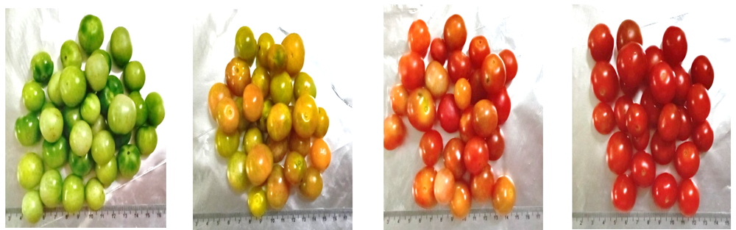
A
D
C
B
Fig.1: Photographs of local cherry tomatoes harvested at different ripening stage (green (A), yellow (B), orange (C), and red (D))

2.2 Methods
2.2.1. Preparation of samples of local cherry tomatoes at different ripening stage
Tomatoes were sorted according to their ripening stage. Each sample was washed with water to remove impurities and most of the microorganisms present on the surface. They were then weighed separately on a precision scale. Some tomatoes at each ripening stage were crushed fresh in a porcelain mortar, while others were cut, dried and ground into powder using a blender (Sept 7 Star, Germany). The obtained samples were used for various analyses.

2.2.2. Preparation of hydro-ethanolic extracts from local cherry tomato samples at different ripening stage
The hydro-ethanolic extracts were prepared using maceration. Ten grams of powder from local cherry tomato samples at various ripening stage were mixed with 100 ml of hydroethanolic solution (80 ml ethanol and 20 ml distilled water). The mixture was left to macerate for 15 minutes. To macerate was then filtered using a funnel and Whatman No. 4 filter paper. The resulting extract was used for the various tests.

2.2.3. Determination of phytochemical compounds in local cherry tomatoes at different ripening stage
Spectrophotometric determination of total flavonoids
Marinova et al.'s (2005) method was used to determine total flavonoids. In a 25 mL flask, 0.75 mL of 5% sodium nitrite (NaNO₂) was added to 2.5 mL of extract from samples of local cherry tomatoes at various ripening stage. This was then mixed with 0.75 mL of 10% (m/v) aluminum chloride (AlCl₃) and incubated in the dark for 6 minutes. After incubation, 5 mL of sodium hydroxide (NaOH, 1 N) were added, and the volume was made up to 25 mL. The mixture was stirred vigorously before being measured using a UV-visible spectrophotometer. The reading was taken at 510 nm. The tests were carried out in triplicate. The flavonoid content was expressed in grams per liter of quercetin-equivalent extract.

Spectrophotometric determination of total polyphenols
The method described by Wood et al. (2002) was employed to quantify total polyphenol content. 2.5 mL of diluted (1/10) Folin-Ciocalteu reagent was added to 30 µL of extract from local cherry tomato samples at different ripening stage. The mixture was left in the dark at room temperature for 2 minutes, after which 2 mL of a 75 g/L sodium carbonate solution was added. The mixture was then placed in a water bath at 50 °C for 15 minutes, after which it was cooled rapidly. Absorbance was measured at 760 nm, with distilled water used as the blank. A calibration curve was produced using gallic acid at various concentrations. The analyses were performed in triplicate, with the polyphenol concentration expressed as gallic acid equivalent extract (g/L, GA Eq).
Determination of lycopene content
Lycopene content was measured using the method described by Benakmoum et al. (2008). To do this, 0.1 g of powdered local cherry tomato samples at different ripening stage were dissolved in a solvent mixture (hexane/acetone/ethanol, 50:50:1, v/v/v) and shaken for 10 minutes. The mixture was then centrifuged at 5000 rpm for 15 minutes. Next, 1 ml of the organic phase was recovered and diluted in 10 ml of hexane. The absorbance of this solution was measured at 472 nm, using hexane as the blank. The lycopene content was determined using the following formula:
$$Lycopene content (mg/100g)= \frac{({Abs}_{472}×DF×{10}^{5}×V)}{ 3450×100×m}$$

DF: Dilution factor
V: Volume of extraction solvent
3450: Extinction coefficient of hexane
m: Mass of test sample

Determination of β-carotene and vitamin A content
The β-carotene content of local cherry tomato samples at different ripening stage was measured using the method described by Aké et al. (2001). Five millilitres of hexane were added to a mixture consisting of one gram of sample, 2.5 millilitres of 96% ethanol and 0.1 millilitres of 20% alcoholic hydroquinone solution. The mixture was homogenised by vigorous vortexing, transferred to cups and centrifuged at 3000 rpm for 20 minutes. The supernatant was collected in test tubes and protected from light with aluminium foil. Four millilitres of the supernatant were transferred to a cuvette to measure the optical density at 450 nm using a T80UV/VIS spectrophotometer against a blank. In parallel, a β-carotene standard range was prepared from a stock solution of 10 μg/mL. For each test, the amount of β-carotene was calculated from a calibration curve using the following regression equation: DO₄₅₀ = 0.0163 Q, with R² = 0.9988. The vitamin A content of local cherry tomato samples at various ripening stage was determined by dividing the β-carotene content by six (Borel et al., 2005).

Determination of vitamin C content
The method used to measure the vitamin C content of local cherry tomatoes at various ripening stage was based on the procedure described by Pongracz et al. (1971). This method is based on the reduction of 2,6-dichlorophenolindophenol (DCPIP) by vitamin C.
A 10 g sample was crushed and solubilised in 40 mL of a metaphosphoric acid and acetic acid solution (2% w/v). The resulting mixture was then centrifuged at 3000 rpm for 20 minutes. The supernatant was transferred to a 50 mL volumetric flask and adjusted with distilled water that had been boiled and cooled in the absence of air. A 10 mL test sample was placed in an Erlenmeyer flask and titrated with 2,6-DCPIP at 0.5 g/L until a persistent pink colour was obtained. The vitamin C content of the sample was determined using the following formula:
$$Vitamin C \left(mg/100g\right)= \frac{\left(C_{DCPIP}×V_{eq}\right)×5 ×100}{ m_{e}}$$

Veq: volume (mL) of 2.6 DCPIP added to equivalence.
me: mass (g) of the sample.
C_{DCPIP}: DCPIP concentration (g/L): 0.5

2.2.4. Statistical analysis
The various analyses were performed in triplicate and the numerical values obtained are expressed as the arithmetic mean with the corresponding statistical standard deviation. One-factor analysis of variance (ANOVA) was performed using RStudio statistical software, version 4.2.2, with a significance level of p ≤ 0.05. Additionally, principal component analysis (PCA) was performed to further interpret the results.

3. Results
3.1. Phytochemical composition of local cherry tomatoes at different ripening stage
3.1.1. Total flavonoid content
Fig.2 shows how total flavonoid content changes during the ripening of local cherry tomatoes. The content varies from 22 ± 6.63 to 40.95 ± 11.08 mg EAQ/g of fresh weight (FW), with significantly higher levels observed at the red stage (p < 0.001).
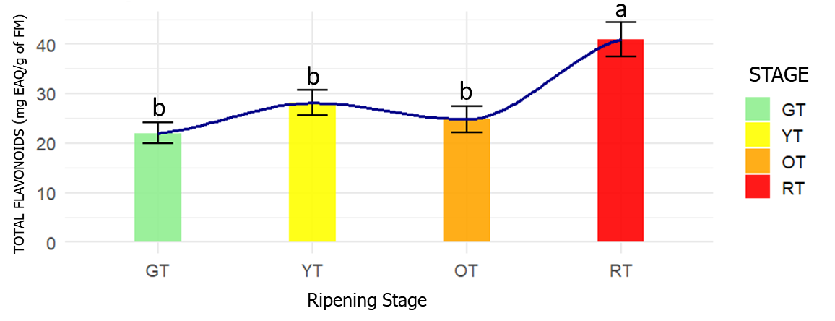
Fig.2: Total flavonoid content of local cherry tomatoes at various ripening stage
The assigned means of the different lowercase letters were significantly different (at the 5% threshold). GT: Green tomato; YT: Yellow tomato; OT: Orange tomato; RT: Red tomato.

3.1.2. Total polyphenol content
The total polyphenol content of local cherry tomatoes at four ripening stage ranges from 32.8 ± 9.14 to 55.2 ± 17.52 mg EAQ/g of fresh weight (Fig. 3). Analysis indicates that, at the red stage, fruits have significantly higher total polyphenol content (p < 0.001).
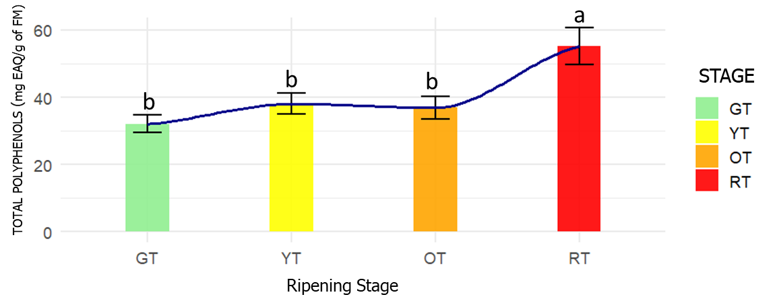
Fig.3: Total polyphenol content of local cherry tomatoes at different ripening stage
The assigned means of the different lowercase letters were significantly different (at the 5% threshold). GT: Green tomato; YT: Yellow tomato; OT: Orange tomato; RT: Red tomato.

3.1.3. Lycopene content
The lycopene content of local cherry tomatoes ranges from 27.2 ± 3.61 to 108.4 ± 6.55 mg/100 g of fresh matter (FM), depending on the ripening stage (see Fig. 4). Analysis reveals a significant increase in lycopene as ripening progresses (p < 0.001).
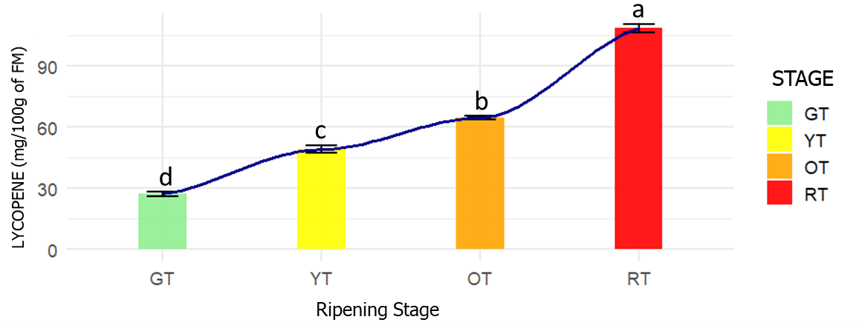
Fig.4: Lycopene content of local cherry tomatoes at different ripening stage
The assigned means of the different lowercase letters were significantly different (at the 5% threshold). GT: Green tomato; YT: Yellow tomato; OT: Orange tomato; RT: Red tomato.

3.1.4. β-Carotene content
Fig. 5 shows the β-carotene content of local cherry tomatoes, which ranges from 578 ± 89.19 to 2582 ± 254.07 μg/100 g of fresh weight (FW). Significantly higher concentrations of β-carotene were observed in the orange and red stages (p<0.001), indicating an increase as ripening progresses.
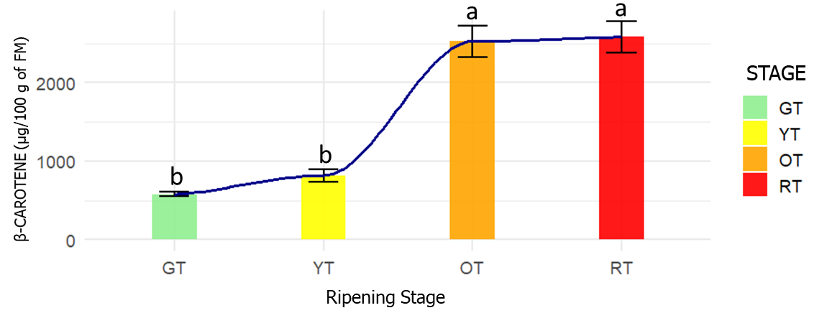
Fig.5: β-carotene content of local cherry tomatoes at different ripening stage
The assigned means of the different lowercase letters were significantly different (at the 5% threshold). GT: Green tomato; YT: Yellow tomato; OT: Orange tomato; RT: Red tomato.

3.1.5. Vitamin A content
The vitamin A content of local cherry tomatoes ranges from 96.33 ± 4.9 to 423.66 ± 5.01 μg/100 g of fresh matter (FM). This vitamin is significantly more concentrated (p < 0.001) at the orange and red ripening stages than at earlier stages (Fig. 6).
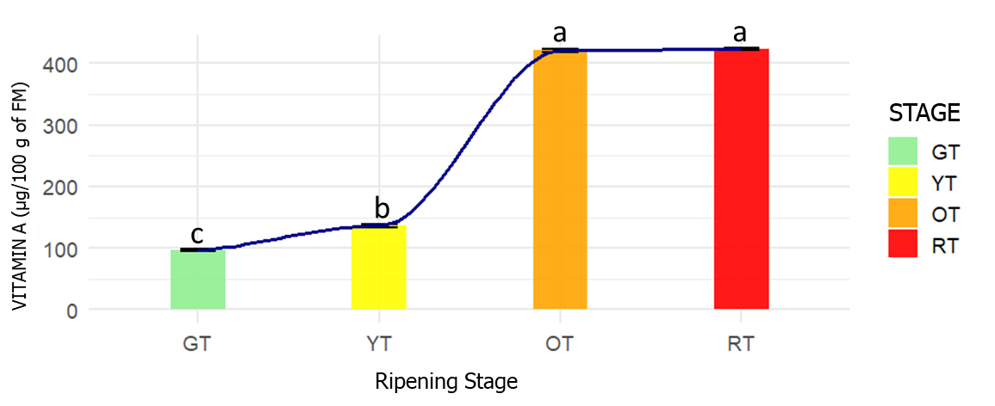
Fig.6: The vitamin A content of local cherry tomatoes at different ripening stage
The assigned means of the different lowercase letters were significantly different (at the 5% threshold). GT: Green tomato; YT: Yellow tomato; OT: Orange tomato; RT: Red tomato.

3.1.6. Vitamin C content
The vitamin C content of local cherry tomatoes ranges from 41.66 ± 16.53 to 56.25 ± 15.56 mg/100 g of fresh matter (FM) (Fig. 7). Vitamin C levels increase significantly (p < 0.05) during the different stages of ripening.
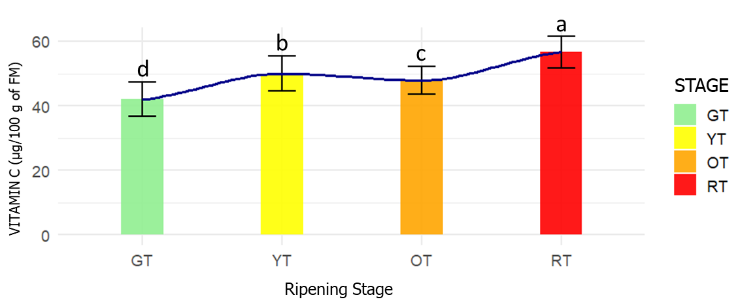
Fig.7: Vitamin C content of local cherry tomatoes at different ripening stage
The assigned means of the different lowercase letters were significantly different (at the 5% threshold). GT: Green tomato; YT: Yellow tomato; OT: Orange tomato; RT: Red tomato.

3.2. Principal Component Analysis (PCA) of phytochemical compounds in local cherry tomatoes at different ripening stage
PCA analysis allowed us to examine the variation in phytochemical compounds in samples of local cherry tomatoes across four ripening stages. The first two axes explain 98.2% of the variance, providing an accurate representation of the data. Axis 1 is primarily linked to total flavonoids, total polyphenols, β-carotene, lycopene and vitamins A and C, reflecting an overall gradient of phytochemical richness. Axis 2 enables a secondary distinction to be made between vitamin C and flavonoids, and β-carotene, lycopene and vitamin A. The high correlations between the variables demonstrate that they evolve together during ripening. The red stage (TR) contains the highest levels of phytochemicals, followed by the orange stage (TO) for carotenoids and vitamin A, while the yellow (TJ) and green (TV) stages contain the lowest levels (Fig. 8).
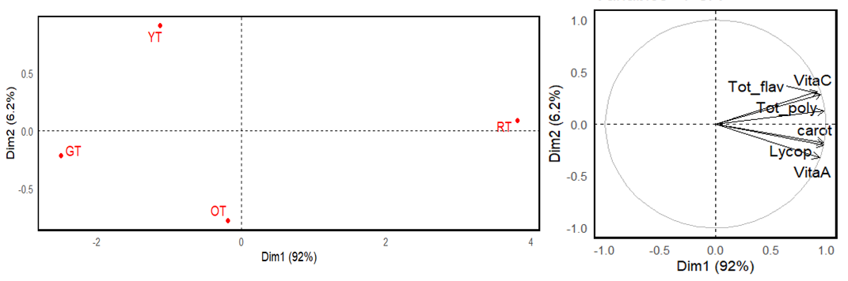
Fig.8: Projection of phytochemical compounds in samples of local cherry tomatoes at different ripening stage in the plane formed by axes F1 and F2
4. Discussion
Tomatoes are an excellent source of bioactive chemicals that benefit health (Szabo et al., 2025). The presence and concentration of these chemicals in tomato fruits depends on several factors, including the ripening stage. Our research has shown that the ripening process influences the phytochemical parameters of local cherry tomatoes. In fact, there is a significant increase in total flavonoids from the green stage to the red stage. This increase can be attributed to the biosynthesis of flavonoids during ripening. This process originates from the phenylpropanoid pathway and produces precursors such as p-coumaroyl-CoA. Chalcone isomerase and chalcone synthase then led to naringin, a precursor of various flavonoids (Saltzman, 2023). Flavonoids are secondary metabolites with powerful anti-inflammatory, anti-cancer and antioxidant properties (Ba et al., 2023).
Furthermore, the total polyphenol content of local cherry tomatoes increases during ripening. This result is consistent with those of Dūma et al. (2018) and Staveckiene et al. (2023), who studied the influence of variety and ripening stage on the bioactive compound content of tomato fruits and Solanum species, respectively. According to these authors, the total flavonoid and total phenol contents increased during ripening. Phenolic compounds contribute to approximately 60-70% of the antioxidant activity of tomato extracts (Oboulbiga et al., 2017).
Tomatoes contain various types of carotenoids and are particularly high in lycopene and β-carotene. According to our results, the levels of lycopene and β-carotene increase significantly from the green stage to the red stage during ripening. This observation has also been made by Ramesh et al. (2017) and Cruz-Chamorro et al. (2024). This could be explained by the fact that, during ripening, carotenoid biosynthesis is strongly activated while chlorophyll degrades under the influence of ethylene. Carotenoid biosynthesis in tomatoes is indeed a biochemical pathway that enables the transition of chloroplasts into chromoplasts, resulting in the characteristic red and orange hues of ripe fruit (Llorente et al., 2016; ElShamey et al., 2025). This process is governed by a precise genetic and enzymatic system resulting in the formation of the red pigment lycopene (Zhou et al., 2022; Vardanian et al., 2025). The main characteristic of ripe tomatoes is their accumulation of lycopene, which can be converted into β-carotene (Heymann et al., 2015). Lycopene has powerful antioxidant properties, neutralising free radicals and reducing oxidative stress, which is associated with chronic diseases. It plays a role in protecting the cardiovascular system and reducing the risk of prostate, breast, lung and stomach cancers (Imran et al., 2020). β-Carotene, a precursor of vitamin A, is essential for vision, the immune system and skin health (Tufail et al., 2024).
The content of vitamin A increases significantly during ripening. Consuming tomatoes rich in carotenoids has been shown to protect against disorders related to vitamin A deficiency and other chronic diseases, including eye damage, cataract development and age-related macular degeneration (Imran et al., 2020). Similarly, vitamin C content increases during the ripening of local cherry tomatoes. This trend was also observed in the studies of Fenech et al. (2019) and Mellidou and Kanellis (2023). Indeed, vitamin C accumulates gradually during tomato ripening (Fenech et al., 2019). The biosynthesis of vitamin C in tomatoes is a complex and finely regulated process, primarily occurring via the L-galactose pathway (Castro et al., 2023). Tomatoes are a significant source of vitamin C, which is an essential, water-soluble antioxidant (Muzolf-Panek et al., 2017). It boosts immunity and stimulates white blood cell production. It also improves iron absorption and reduces the risk of anemia by optimizing the absorption of non-haem iron.
Finally, a principal component analysis of the phytochemical compounds found in locally grown cherry tomatoes shows that most of these compounds are most abundant at the red ripening stage.

5. Conclusion
This study examined the phytochemical compounds present in locally grown cherry tomatoes (Solanum lycopersicum L.) during the ripening process. Significant increases in total flavonoids, total polyphenols, lycopene, β-carotene and vitamins A and C were observed from the green to the red stage of ripening. These compounds have antioxidant properties that contribute to human health. The consumption of locally grown cherry tomatoes in Côte d'Ivoire can therefore be recommended due to their high nutrient content.

References
Aké, M., Poby, A., Malan, K., Tebi, A., & Monnet, D. (2001). Effect of vitamin A supplementation on nutritional markers in the management of childhood malnutrition. Annual Biological Clinical, 59: 417-421.

Akpo, A. F. (2022). Development of a method for preserving tomatoes (Solanum lycopersicum) using cold and plant extracts with anti-ripening and antifungal effects. Earth Sciences. University of Avignon; Nangui Abrogoua University (Abidjan).

Ali, M. Y., Sina, A. A. I., Khandker, S. S., Neesa, L., Tanvir, E. M., Kabir, A., Khalil, M. I., & Gan, S. H. (2021). Nutritional Composition and Bioactive Compounds in Tomatoes and Their Impact on Human Health and Disease: A Review. Foods 10, 45.
Ba, W., Xu, W., Deng, Z., Zhang, B., Zheng, L., & Li, H. (2023). The antioxidant and anti-inflammatory effects of the main carotenoids from tomatoes via Nrf2 and NF kB signaling pathways. Nutrients 15, 4652. doi: 10.3390/nu15214652
Benakmoum, A., Abbeddou, S., & Ammouche, A. (2008). Valorization of low-quality edible oil with tomato peel waste. Food Chemistry. 110:684-690.
Bhandari, S. R., & Lee, J. G. (2016). Ripening-dependent changes in antioxidants, color attributes, and antioxidant activity of seven tomato (Solanum lycopersicum L.) cultivars. J Anal Methods. doi:10.1155/2016/5498618
Borel, P., Drai, J., Faure, H., Fayol, V., Galabert, C., Laromiguière, M., & Le Moël, G. (2005). Recent Data on the Absorption and Catabolism of Carotenoids. Annales de Biologie Clinique, 63(2), 165–177.
Castro, J. C., Castro, C. G., and Cobo, S. M. (2023). Genetic and biochemical strategies for regulation of L-ascorbic acid biosynthesis in plants through the L-galactose pathway. Front. Plant Sci. 14, 1099829. doi: 10.3389/fpls.2023.1099829
Cruz-Chamorro, I., Santos-Sánchez, G., Martín, F., Fernández-Pachón, M.-S., Hornero-Méndez, D., & Cerrillo I. (2024). Evaluation of the Impact of Ripening Stage on the Composition and Antioxidant Properties of Fruits from Organically Grown Tomato (Solanum lycopersicum L.) Spanish Varieties. Preprints.org. P 1-14.
Dembélé, S., Koffi, E. N., Cissé, I., Adima, A. A., Yao, K., & Anin A. A. L. (2019). Nutritional Composition and Antioxidant Capacity of Four Tomato Varieties (Lycopersicon esculentum Mill) Cultivated in Cote d'Ivoire. Current Journal of Applied Science and Technology 36(5): 1-11.
Duma, M., Alsin, A. I., Dubova, L., & Erdberga, I. (2018). Bioactive compounds in tomatoes at different stages of maturity. Proc. Latv. Acad. Sci. Section. B.Nat. Exact Appl. Sci. 72, 85–90.
ElShamey, E., Zeng, Y., Ding, Y., & Yang, J. (2025). Functional phytochemicals in tomatoes: biosynthesis, gene regulation, and human health implications. Forehead. Plant Sci. 16:1662388. doi: 10.3389/fpls.2025.1662388
Ezquerro, M. (2022). Unraveling new roles of geranylgeranyl diphosphate synthases and phytoene synthases in tomato.
Fenech, M., Amaya, I., Valpuesta, V., & Botella, M. A. (2019). Vitamin C content in fruits: Biosynthesis and regulation. Forehead. Plant Sci. 9, 2006. doi: 10.3389/ fpls.2018.02006
Figueroa-Cares, I. E., Cruz-Álvarez, O., Martínez-Damián, M. T., Rodríguez-Pérez, J. E., Colinas-León, M. T., & Valle-Guadarrama, S. (2018). Nutrient quality and antioxidant capacity in native tomato varieties and genotypes (Solanum lycopersicum L.). Rev. Fac. Agron. 35, 63–84.
Heymann, T., Heinz, P., and Glomb, M. A. (2015). Lycopene inhibits the isomerization of b-carotene during quenching of singlet oxygen and free radicals. J. Agric. Food Chem. 63, 3279–3287. doi: 10.1021/acs.jafc.5b00377
Imran, M., Ghorat, F., Ul-Haq, I., Ur-Rehman, H., Aslam, F., Heydari, M., et al. (2020). Lycopene as a natural antioxidant used to prevent human health disorders. Antioxidants 9, 706. doi: 10.3390/antiox9080706
Kumar, A., Kumar, V., Gull, A., & Nayik, G., A. (2020). “Tomato (Solanum lycopersicon),” in Antioxidants in vegetables and nuts-Properties and health benefits, 191–207.
Li, N., Wu, Tomato and lycopene and multiple health outcomes: Umbrella review, Food Chem., 343, 128396.
Llorente, B., D’andrea, L., Ruiz-Sola, M.A., Botterweg, E., Pulido, P., Andilla, J., et al. (2016). Tomato fruit carotenoid biosynthesis is adjusted to actual ripening progression by a light-dependent mechanism. Plant J. 85, 107–119. doi: 10.1111/tpj.13094
Marinova, D., Ribarova, F., & Atanassova, M. (2005). Total phenolics in Bulgarian Fruits and vegetables. Journal of the University of Chemical Technology and Metallurgy. 40(3):255-260.
Mellidou, I. & Kanellis, A. K. (2023). Deep inside the genetic regulation of ascorbic acid during fruit ripening and postharvest storage. Postharvest Biol. Technol. 204, 112436. doi: 10.1016/j.postharvbio.2023.112436
Muzolf-Panek, M., Kleiber, T., and Kaczmarek, A. (2017). Effect of increasing manganese concentration in nutrient solution on the antioxidant activity, vitamin C, lycopene and polyphenol contents of tomato fruit. Food Additives Contaminants: Part A 34, 379–389. doi: 10.1080/19440049.2016.1277037
Nam, Y. E., Hwang, I. G., & Jang, H. H. (2025). Role of lycopene from tomato on cardiovascular risk: an umbrella review of systematic reviews and meta-analyses of intervention studies. Food & Function.
Oboulbiga, E. B., Parkouda, C., Sawadogo-Lingani, H., Compaoré, E. W. R., Sakira, A. K., & Traoré, A. S. (2017). Nutritional Composition, Physical Characteristics and Sanitary Quality of the Tomato Variety Mongol F1 from Burkina Faso. Food Nutr. Sci. 8, 444–455.
Pinheiro, J., Alegria, C., Abreu, M., Gonçalves, E. M., & Silva, C. L. M. (2019). Changes in the physicochemical parameters, antioxidant activity and vitamin C of fresh-cut tomato (Solanum lycopersicum) during storage. Journal of Food Processing and Preservation, 43(1), e13831.
Pongracz G., Weiser H. & Matzinger D. (1971). Tocopherols-antioxidant. Fat and science and technology, 97: 90-401.
Przybylska, S. & Tokarczyk, G. (2022). Lycopene in the Prevention of Cardiovascular Diseases, Int. J. Mol. Sci., 23, 1957.
Ramesh, K. S., Ahmad, J. Z., & Young-Soo, K. (2017). Ripening improves the content of carotenoid, a-tocopherol, and polyunsaturated fatty acids in tomato (Solanum lycopersicum L.) fruits. 3 Biotech 7:43.
Saltzman, B. C. (2023). In Vitro Characterization of the Role of Chalcone Isomerase Like (CHIL) in Flavanone Biosynthesis (McGill University (Canada).
Sanmathi, N. A. T. S. (2023). Cherry tomatoes: A Bountiful Source of Natural Nutraceuticals. Department of Vegetable Science, College of Horticulture, Bengaluru, Karnataka.
Staveckiene, J., Kulaitiene, J., Levickiene, D., Vaitkeviˇciene, N., & Vaštakaite-Kairiene, V. (2023). The Effect of Ripening Stages on the Accumulation of Polyphenols and Antioxidant Activity of the Fruit Extracts of Solanum Species. Plants 12, 2672. https://doi.org/10.3390/ plants12142672
Szabo, K., Varvara, R.-A., Ciont, C., Macri, A. M., & Vodnar, D. C. (2025). An updated overview on the revalorization of bioactive compounds derived from tomato production and processing by-products. J. Cleaner Production, 145151. doi: 10.1016/ j.jclepro.2025.145151
Tsouvaltzis, P., Gkountina, S., Siomos, A. S. Quality Traits and Nutritional Components of Cherry Tomato in Relation to the Harvesting Period, Storage Duration and Fruit Position in the Truss. Plants 2023, 12, 315.
Tufail, T., Bader Ul Ain, H., Noreen, S., Ikram, A., Arshad, M. T., and Abdullahi, M. A. (2024). Nutritional benefits of lycopene and beta-carotene: A comprehensive overview. Food Sci. Nutr. 12, 8715–8741. doi: 10.1002/fsn3.4502
Vardanian, I., Sargsyan, G., Martirosayn, G., Pahlevanyan, A., Tsereteli, I., Martorosyan, H., et al. (2025). Lycopene in tomatoes: genetic regulation, agronomic practices, and environmental influence. Funct. Food Science-Online ISSN: 2767-3146 5, 127–145. doi: 10.31989/ffs.v5i4.1617
Wang, C. Li, M., Duan, X., Abu-Izneid, T., Rauf, A., Khan, Z. et al. (2023b). Phytochemical and nutritional profiling of tomatoes; impact of processing on bioavailability-a comprehensive review. Food Rev. Int. 39, 5986–6010. doi: 10.1080/87559129.2022.2097692
Wood, J., E., Senthilmohan, S., T., & Peskin, A., V. (2002). Antioxidant activity of procyanidin-containing plant extracts at different pHs. Food Chemistry. 77: 155-161
Zeng, Y., Maxwell, S., Runting, R. K., Venter, O., Watson, J. E., & Carrasco, L. R. (2020). Environmental destruction not avoided with the Sustainable Development Goals. Nat. Sustain. 3, 795–798.
Zhou, X., Rao, S., Wrightstone, E., Sun, T., Lui, A. C. W., Welsch, R. et al. (2022). Phytoene synthase: the key rate-limiting enzyme of carotenoid biosynthesis in plants. Front. Plant Sci. 13, 884720. doi: 10.3389/fpls.2022.884720

Zuo, J., Wang, Y., Zhu, B., Luo, Y., Wang, Q., Gao, L. (2019). Network analysis of noncoding RNAs in pepper provides insights into fruit ripening control. Scientific Reports 9, 8734. https://doi.org/10.1038/s41598-019-45427-1

