Original Research Article

Efficacy of Methyl Jasmonate and Calliette in Black spot disease management in Pineapple (Ananas comosus) caused by Fusarium moniliforme var. subglutinans

ABSTRACT
Pineapples play an important role in the lives of people. However, they are threatened by black spot disease caused by Fusarium moniliforme var. subglutinans, which significantly reduces fruit quality. Unfortunately, chemical control methods against this disease have proven ineffective. To find more effective alternatives for sustainable agriculture, calliette and methyl jasmonate were sprayed on pineapple plants inoculated with the fungal strain. The study aims to stimulate polyphenol production in pineapple to effectively induce natural resistance against Fusarium moniliforme var. subglutinans. Disease incidence was estimated after flower inoculation and fruit opening at harvest. Polyphenols isolated from leaves were identified by HPLC. The direct effect of polyphenols on mycelial growth was evaluated. The results showed that the biocontrols mobilised defence polyphenols to resist the disease. The chromatographic profile revealed the presence of thirteen polyphenols, including seven pre-existing amplified polyphenols and six newly synthesised ones. The use of biocontrol agents is therefore an effective way to protect pineapples against black spot disease. Future research should be expanded to include other biocontrols, particularly polysaccharides extracted from the pathogen or the plants.

Keywords: Pineapple, Biocontrols, Polyphenols, Black spots
1. Introduction
The species Ananas comosus (L. Merrill) is the most cultivated for its edible fruit (20). Fresh pineapple and cultivated rejects possess many therapeutic properties, notably as an anti-inflammatory, anti-thrombic, fibrinolytic, and anti-cancer agent (7). Global pineapple production experienced strong growth between 2002 and 2023, increasing from 15.8 million tons to 29.96 million tons (30). Costa Rica, the world's leading pineapple producer, exported approximately 2.2 million tons, representing nearly 75 % of total exports (16). However, Ivorian pineapple exports to the international market have fallen by 27 % to approximately 23,500 tons in 2023 (12). This drastic decline is due to several factors, particularly black spot disease (14). This disease, generally attributed to Fusarium moniliforme var. subglutinans, manifests as black spots in the fruit parenchyma (18). It has significant economic consequences for producing countries (25). And despite the correct application of pesticides, black spot disease persists in the fields (9). In this context, the search for more effective alternatives for the development of sustainable and resilient agriculture is essential. One such alternative involves providing plants with the means of self-defense through the use of Natural Defense Stimulators, rather than directly combating the aggressor (3). Thus, our overall objective was to stimulate the production of phenolic compounds in pineapple in order to effectively induce natural resistance against Fusarium moniliforme var. subglutinans (FM), the pathogen responsible for black spot disease of pineapple. Specifically, the objectives are to:
- identify the phenolic compounds produced after treating pineapple with methyl jasmonate and calliette, then inoculating it with Fusarium moniliforme var. subglutinans (FM);
- evaluate the direct effect of pineapple phenolic compounds on the mycelial growth of Fusarium moniliforme var. subglutinans (FM).
2. Materials and Methods
2.1. Materials
2.1.1. Plant Material
The plant material consisted of pineapple suckers of the Del Monte Gold cultivar (MD2). These suckers weighing between 300 and 400 g, came from plantations in Bonoua (Ivory Coast).
2.1.2. Fungal material
The fungal material used for inoculations was Fusarium moniliforme, the causative agent of black spot disease. It was isolated from necrotic spots on the pulp of pineapples after fruit harvest from the Bonoua plantation, a pineapple-producing area of ​​ Ivory Coast.
2.2 Methods
2.2.1. Study Site
Field experiments were conducted at the Nangui Abrogoua University experimental site in the Abidjan district (Ivory Coast). The site consists of ferralitic and hydromorphic soils with a slightly acidic pH and an organic matter content ranging from 3 to 4 %. The climate is tropical humid. Average monthly temperatures during the growing season ranged from 25.2 °C to 28.6 °C, and average monthly rainfall from 735 mm to 10.67 mm. The geographical coordinates of this site are: 5°17’ and 5°31’ North latitude, and 3°45’ and 4°22’ West longitude (38).
2.2.2. Experimental setup
The setup consisted of a plot made up of four ridges, 6 m long and 1 m wide, spaced 1 m apart. Each ridge was planted with two rows of ten pineapple plants each, separated from each other by 50 cm.
2.2.3. Inoculation of elicited pineapple plants
The preparation for fungal inoculation and plant elicitation were carried out according to the method of Yeo et al. (38; 39). Plants of pineapple cultivars approximately seven months old were sprayed on their D leaves. Each D leaf was sprayed with 50 mL of a solution containing methyl jasmonate and calliette. Ten (10) plants were used per treatment. Seventy-two (72 h) after D leaf elicitation, the floral induction treatment (FIT) was performed to stimulate flowering. Forty-five (45) days after floral induction treatment (FIT), the flowers were inoculated with 2.5 mL of F. moniliforme inoculum. After sixty (60) days of fungal incubation, the D leaves were harvested for HPLC (high-performance liquid chromatography) analysis. This experiment was repeated three (3) times. Three (3) treatment and infection modality groups were established: Plants treated with an elicitor solution containing methyl jasmonate (10 mM), calliette (5 mM), distilled water, 800 µL of 1% ethanol, and 0.5 mL of Triton X-100 (0.1%), and not inoculated, served as treated and uninoculated plants (PTMCaNI). Plants treated with a solution containing distilled water, 800 µL of 1% ethanol, and 0.5 mL of Triton X-100 (0.1%), and not inoculated, served as untreated and uninoculated plants (PNTNI). Pineapple plants treated with a solution containing distilled water, 800 µL of 1% ethanol, 0.5 mL of Triton X-100 (0.1%), and inoculated with Fusarium moniliforme, served as untreated and inoculated plants (PNTI). The final volume of each solution was made up to 500 mL with distilled water. Fruits harvested at eleven (11) months were peeled and then cut to determine the percentage of black spot.
BSR =
X 100
NYC
NYT
NCE : Number of contaminated eyes in the fruit
TNY : Total number of fruit eyes
BSR : Fruit black spot rate

2.2.4. Extraction and identification of phenolic compounds by semi-preparative High-Performance Liquid Chromatography in the D leaves of plants treated or untreated and/or inoculated with Fusarium moniliforme
The extraction of phenolic compounds was carried out according to the method of Kouakou et al. (22; 23). A 500 mg sample of lyophilized leaves from each treatment was immersed in 10 mL of 96 % methanol and incubated at 4 °C in the dark for 18 h. The leaves were then removed, and the resulting methanolic extract was centrifuged at 1000 rpm for 10 min. The supernatant constituted the crude phenolic compound extract. This crude phenolic compound extract was purified through a Millipore membrane (0.45 μm). The resulting hydromethanolic extract constituted the purified crude phenolic compound extract for analysis by high-performance liquid chromatography (HPLC). One (1) mL of this purified phenolic filtrate was directly injected into the chromatograph with a reverse-phase semi-preparative silica column (proton, 250 x 8 mm, 5 μm, Bischoff) at a flow rate of 2.4 mL/min, and chromatogram detection was performed at 284 nm. The resulting peaks were collected according to their retention time in hemolysis tubes and then evaporated to dryness using a Speed ​​Vac. The resulting dry extract represents the pure phenolic compound to be tested. The extracted phenolic compounds were identified using a reference library of phenolic compounds.

2.2.5. Evaluation of the effect of phenolic compounds extracted from pineapple D leaves on the direct growth of Fusarium moniliforme
Comparative tests were used to evaluate the ability of all phenolic compounds identified by HPLC to inhibit the mycelial growth of Fusarium moniliforme (FM). The phenolic compounds isolated by semi-preparative HPLC were directly exposed to Fusarium moniliforme mycelial growth. Each phenolic compound was dissolved in 20 % ethanol at a concentration of 5 mM. One mL of this stock solution was added to 9 mL of PDA medium. This mixture, with a final volume of 10 mL, was placed in a Petri dish. The final concentration of the phenolic compound was 500 μM. A 4 mm diameter mycelium plug was taken from the growth front of the fungus using a sterile needle. This plug was placed in the center of each Petri dish containing the nutrient medium (pre-prepared PDA medium), supplemented or not with the phenolic compound. The plates were placed in the dark and at room temperature (28 ± 2 °C). A negative control was prepared by adding 1 mL of 20 % ethanol solution to 9 mL of agar medium to obtain a final ethanol concentration of 2% in the Petri dish. Each experiment was performed once with three replicates. Growth was measured 14 days after inoculation of each Petri dish. Mycelial growth was assessed by measuring the mycelium diameter at four different points on the mycelium surface using a ruler (28). From these measurements, the percentages of inhibition of radial mycelial growth by the phenolic compounds, compared to the control considered to have 100 % growth, were calculated using the formula.
DT - DE
I % =
DT
X 100

% I : percentage of inhibition ; DT : average diameter of the control colony et DE : diameter of the test colony.
2.2.6. Statistical Analysis
The data obtained were analyzed using Statistica 7.1 software. For the mycelial growth inhibition tests and the rate of black spots, statistical analyses of the data were carried out according to the ANOVA 1 procedure. For percentages, the Kruskal-Wallis test was used to determine significant differences (P < 0.05) between treatments.
3. Results
3.1. Impact of biocontrols on black spots
The untreated and inoculated plants (PNTI) showed fruit with black spots, while the fruit from plants treated with methyl jasmonate and calliette and not inoculated with the fungal strain (PTMCaNI) and those from untreated and uninoculated plants (PNTNI) showed no black spots (Fig. 1 and 2).
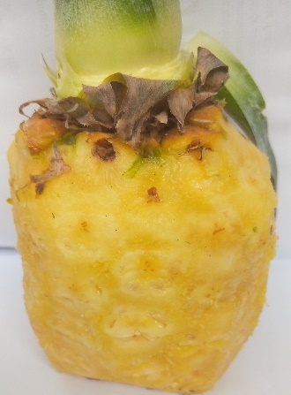  A | 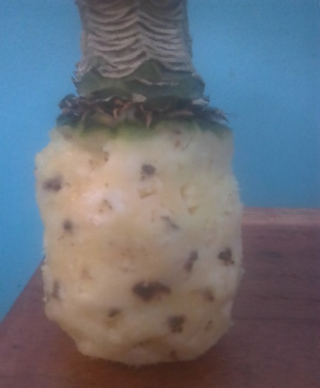  B | 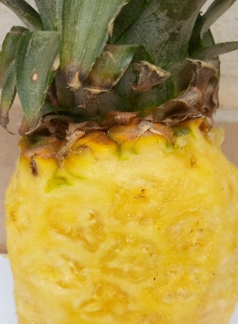 | 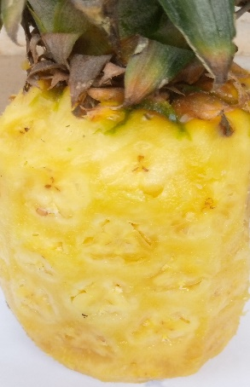  C  D
Fig. 1. Fruits of treated and inoculated plants

A : PNTNI (untreated and uninoculated plants) ; B : PNTI (untreated plants inoculated with Fusarium moniliforme) ; C : PTMCaNI (plants treated with methyl jasmonate and calliette then not inoculated) ; D : PTMCaI (plants treated with methyl jasmonate and calliette then inoculated with Fusarium moniliforme)

Fig. 2. Black spot rate of fruit in treated and inoculated plants
PNTNI: untreated and uninoculated plants; PNTI: untreated plants inoculated with Fusarium moniliforme; PTMCaNI: plants treated with methyl jasmonate and calliette but not inoculated; PTMCaI: plants treated with methyl jasmonate and calliette but then inoculated with Fusarium moniliforme. Histograms followed by the same letter are not significantly different (Kruskal-Wallis test at 5%).
Les histogrammes suivis d’une même lettre ne sont pas significativement différents (Test de Kruskal-Wallis à 5 %)

3.2. Phenolic compounds identified by semi-preparative HPLC in D leaves of elicited pineapple plants and flower inoculation follow-up
Analysis of Fig.3 of the chromatographic profile of pineapple D leaves shows that the PNTI (untreated and inoculated plants) synthesized four phenolic compounds of very low amplitudes, which are compounds 2, 3, 4 and 6, while the PNTNI (untreated and uninoculated plants) induced eight compounds of low amplitudes, which are: 1, 2, 3, 4, 5, 6, 7 and 8. The PTMCaNI treatment (plants treated with methyl jasmonate and calliette then not inoculated) induced the synthesis of twelve (12) phenolic compounds. The PTMCaI treatment (plants treated with methyl jasmonate and calliette then inoculated) induced the synthesis of thirteen (13) phenolic compounds. The results revealed that in addition to the eight compounds present in the PNTNI (untreated and uninoculated plants), compounds 9, 10, 11 and 12 were synthesized de novo by the leaves of both the PTMCaNI (plants treated with methyl jasmonate and calliette then uninoculated) and PTMCaI (plants treated with methyl jasmonate and calliette then inoculated) plants. However, in addition to compounds 9, 10, 11, and 12, compound 13 appeared de novo in the PTMCaI (plants treated with methyl jasmonate and calliette, then inoculated) compared to the PTMCaNI (plants treated with methyl jasmonate and calliette, then not inoculated). The combined treatment with methyl jasmonate and calliette followed by the inoculation of Fusarium moniliforme thus resulted in an increase in the number of compounds. The results also showed large phenolic peaks in the PTMCaI (plants treated with methyl jasmonate and calliette, then inoculated).

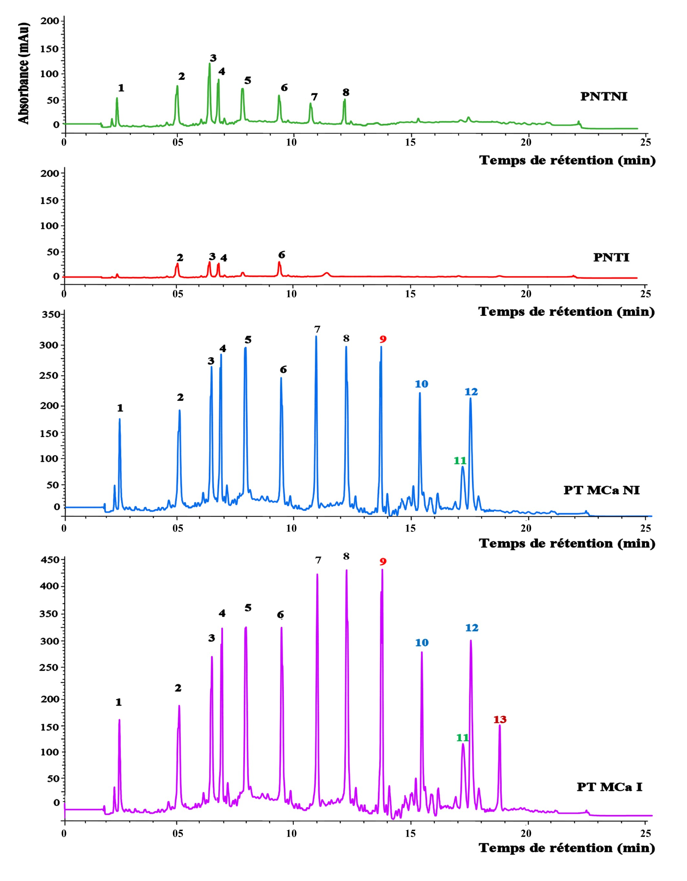
Absorbance (mAu)
Absorbance (mAu)
Fig. 3. Chromatographic profile of phenolic compounds extracted from D leaves of cultivar MD2 as a function of treatment and then inoculation, detected at 284 nm by semi-preparative HPLC
1.Gallic acid (2.667 min) ; 2. Gentisic acid (5.164 min) ; 3. Protocatechuic acid (6.720 min) ; 4. Syringic acid (6.915 min) ; 5. Caffeic acid (8.175 min) ; 6. Sinapic acid (9.599 min) ; 7. Caffeoylquinic acid (11.167 min) ; 8. p-Coumaric acid (12.508 min) ; 9. Ferulic acid (13.838 min) ; 10. Pterosilbene (15.456 min) ; 11. Quercetin (17.530 min) ; 12. Kaempferol (17.701 min) ; 13. Astringin (18.935 min). PNTNI: untreated and uninoculated plants; PNTI: untreated plants inoculated with Fusarium moniliforme; PTMCaNI: plants treated with methyl jasmonate and calliette but not inoculated; PTMCaI: plants treated with methyl jasmonate and calliette but then inoculated with Fusarium moniliforme

3.3. Effect of phenolic compounds extracted from pineapple D leaves on the in vitro growth of Fusarium moniliforme mycelium
Table 1 presents the mycelial growth results of Fusarium moniliforme in the presence of each phenolic compound extracted and identified from pineapple leaves. Among the extracted phenolic compounds, hydroxycinnamic acids, represented by caffeoylquinic acid, p-coumaric acid, and ferulic acid, and pterosilbene, a stilbene, showed a direct and effective antifungal effect on Fusarium moniliforme. Indeed, these molecules completely inhibited the in vitro growth of Fusarium moniliforme (100% inhibition). Furthermore, gentisic acid (-78%), caffeic acid (-70%), sinapic acid (-67%), and quercetin (-52%) had moderate antifungal activity, followed by kaempferol (-45%). Syringic acid (-35%), protocatechuic acid (-25%), and gallic acid (-13%) had weaker antifungal activity against Fusarium moniliforme. The control and astringent (0%) showed no inhibition of Fusarium moniliforme mycelium growth. The effect of caffeoylquinic acid, gentisic acid, astringin and quercetin on mycelial growth in Petrie dishes containing PDA medium was shown in Fig 4.
Table 1: Percentage of inhibition of Fusarium moniliforme in the presence of the 13 phenolic compounds
Family of molécules | Phenolic compounds | Percentage of inhibition compared to the control %
Witness No phenol 0ª
Hydroxybenzoic acids | Gallic acid (1) | -13^{b}
Hydroxybenzoic acids | Gentisic acid (2) | -78^{h}
Hydroxybenzoic acids | Protocatechuic acid (3) | -25^{c}
Hydroxybenzoic acids | Syringic acid (4) | -35^{d}
Hydroxycinnamiques acids | Cafeic acid (5) | -70^{g}
Hydroxycinnamiques acids | Sinapic acid (6) | -67^{g}
Hydroxycinnamiques acids | Cafeoylquinic (7) | -100^{i}
Hydroxycinnamiques acids | p-coumaric acid (8) | -100^{i}
Hydroxycinnamiques acids | Ferulic Acid (9) | -100^{i}
Stilbenes | pterosilbene (10) | -100^{i}
Stilbenes | Astringin (13) | 0ª
Flavonoids | Quercetin (11) | -52^{f}
Flavonoids | Kaempferol (12) | -45e
 | P | 0,021
The values ​​represent the average of three repetitions; within the same column, values ​​followed by the same letter are not significantly different (Kruskal-Wallis test at 5%); P: probability

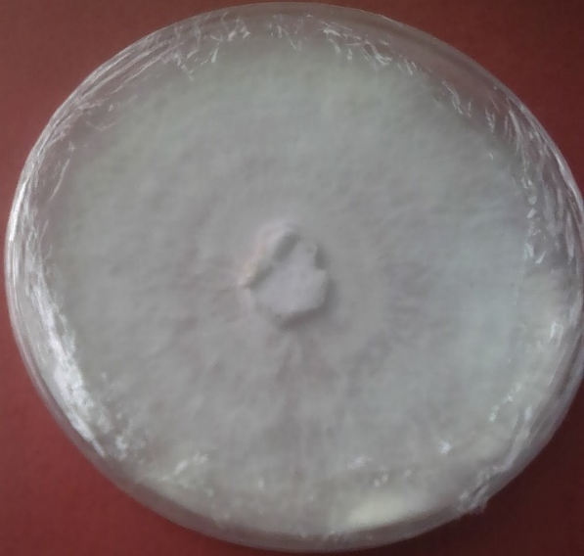
4,5 cm
2 cm
C
A
B

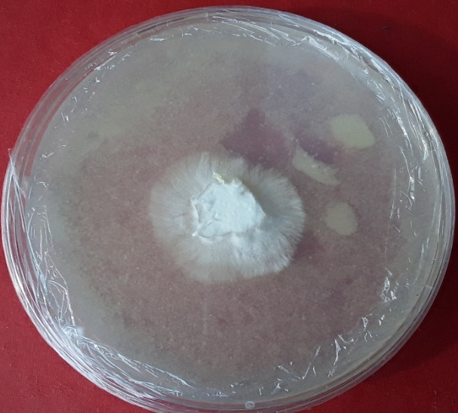  1 cm  2 cm  D | 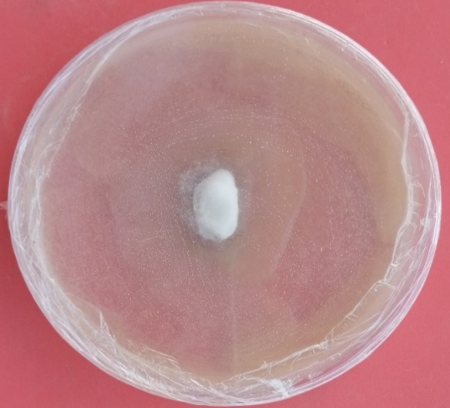  2 cm  E
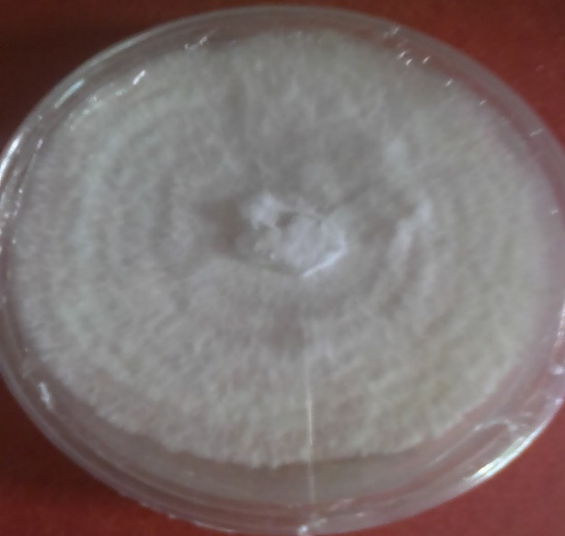  4,5 cm  2 cm | 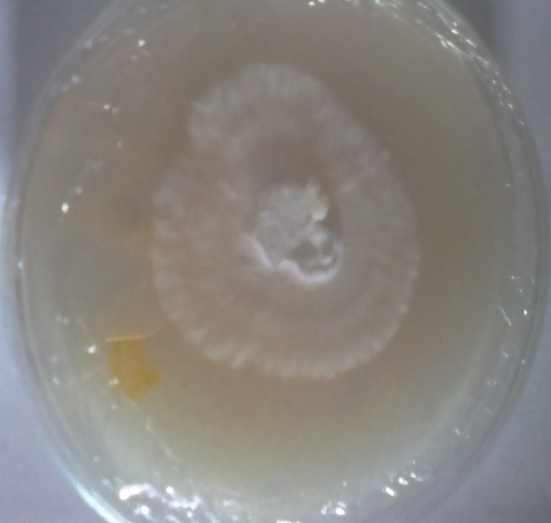  2,2 cm  2 cm
Fig. 4. Macroscopic appearance of the Fusarium moniliforme isolate grown on PDA medium supplemented with different phenolic compounds
PDA : Potato Dextrose Agar ; A : medium without phenolic compounds (witness) ; B : medium containing gentisic acid ; C : medium containing cafeoylquinic acid ; D : medium containing astringin ; E : medium containing la quercetin.
4. Discussion
In this study, co-treated pineapple D leaves with methyl jasmonate and calliette, followed by flower inoculation with Fusarium moniliforme, revealed the same phenolic compounds as in the non-inoculation treatments, with the exception of compound 13 (astringin). This compound was synthesized de novo during the interaction of the co-treatment and Fusarium moniliforme fungal spores, in addition to the other 12. However, the peak amplitudes were much greater after treatment and inoculation with Fusarium moniliforme than after treatment without inoculation. Following inoculation, the fungal spores interact with the receptors of the defense mechanisms (4). The response to this attack leads to complete resistance. This interaction is said to be incompatible and results in the synthesis of the specific molecule, notably astringin, which is specifically directed against Fusarium moniliforme. Furthermore, it is generally associated with the hypersensitive response (HR). In some cases, extremely rapid and robust recognition allows the pathogen to be stopped before the development of resistance (17). This resistance would a priori be the result of the sum of pre-existing and basal resistances: this is systemic acquired resistance (SAR). It has been directed against the pathogen that triggered the defense machinery but also against any pathogen by suppressing the defense (5). Furthermore, according to Ahuja et al. (1) and then Faurie et al. (13), phenolic phytoalexins have beneficial effects on plant protection against pathogens. Furthermore, the amplification of phenolic peaks observed in treated and then inoculated plants could result in a strengthening of physical barriers, including lignin, callose and cuticle, and chemical barriers formed by toxic molecules called phytoanticipins (6; 10). The amplitudes of phenolic peaks in untreated and inoculated plants (PNTI) were low compared to those in untreated and uninoculated plants (PNTNI), suggesting that the pathogen negatively influences plant defenses. The phenomenon of plant tolerance or sensitivity relies on defense substances, primarily phenolic compounds of the phytoalexin type (7). Methyl jasmonate and calliette are thought to have an activating and potentiating effect on defense mechanisms for the production of phenolic compounds (2; 25). The involvement of phenolic compounds in increasing plant resistance to disease has been supported by various authors (36; 29).
Phenolic compounds are known for their antifungal activity (7; 27). The inhibitory activity of phenolic compounds on mycelial growth was investigated. The results showed that the identified phenolic compounds exhibiting the ability to reduce mycelial growth were gallic, gentisic, protocatechuic, syringic, caffeic, and mustard acids, as well as quercetin and kaempferol. Caffeoylquinic acid, p-coumaric acid, ferulic acid, and pterosilbene completely inhibited the growth of Fusarium moniliforme. Similar studies have revealed that plants respond to inoculation by viruses, fungi, or bacteria by accumulating molecules such as phenolic compounds in their tissues, which can block, destroy, or inhibit pathogens (19). Fritig et al. (15) established that phenolic compounds, via the PR protein pathway, exhibit strong antimicrobial activity. These molecules are proteases, lipases, and chitinases capable of degrading the pathogen and its derivatives. Some compounds may not have a direct effect on mycelial growth: this is the case with astringin. It appears that the agar plate test is not suitable for this molecule to demonstrate its potential antifungal activity (34). Its defensive role lies at a level other than direct fungicidal activity. Furthermore, stilbenes play a crucial role in plant defense. They are often phytoalexins whose synthesis is activated in response to pathogen perception in sorghum and grapes (37). This importance has been particularly demonstrated in tobacco. However, stilbenes also exhibit strong antifungal activity, notably inhibiting spore germination and hyphal growth (37). In addition, flavonoids also play a vital role in plant defense, as some of the major phytoalexins are synthesized via flavonols (kaempferol and quercetin) (11; 31). The function of hydroxycinnamic acids in plants appears to be particularly antifungal, particularly in the defense of pineapples, through their direct toxicity to pathogens (33; 32). Hydroxycinnamic acids seem to be the strongest, followed by stilbenes. Benzoic acids have no significant effect, with the exception of gentisic acid, which can completely protect pineapples against Fusarium moniliforme. In reality, the application of elicitors induces or synthesizes numerous phenolic compounds, some of which (caffeoylquinic acid, p-coumaric acid, ferulic acid, and pterosilbenes) have effective antifungal activity against Fusarium moniliforme. However, it is worth noting that under in situ conditions, the synergy of these molecules could have a potentiating effect on pathogen development, as reported by Lambert (24) in grapevines.
5. CONCLUSION
The overall objective was to stimulate polyphenol production in pineapples in order to effectively induce natural resistance against Fusarium moniliforme var. subglutinans. Treating plants with methyl jasmonate and calliette, then inoculating them with the fungal strain, significantly reduced the rate of black spot in the fruit. Furthermore, chromatographic profile analysis revealed the presence of thirteen (13) polyphenols in the leaves, including seven (7) pre-existing polyphenols that were amplified and six (6) newly synthesized polyphenols. The effect of phenolic compounds extracted from pineapple leaves on the direct growth of Fusarium moniliforme significantly reduced mycelial growth. Polyphenols induced by methyl jasmonate and calliette demonstrated their antifungal properties and their ability to inhibit Fusarium moniliforme. Furthermore, the use of these biocontrols in the biological control of black spot disease in pineapple could serve as a biopesticide. Future research should be expanded to include other biocontrols, particularly polysaccharides extracted from the pathogen or the plants.
REFERENCES
1. Ahuja I., Kissen R. & Bones A. M. (2012). Phytoalexins in defense against pathogens. Trends Plant Science, 17 (2) : 73-90. DOI : 10.1016/j.tplants.2011.11.002
2. Agriclean (2008). Efficacy of phosphanates (aluminum ethylphosphonate, or Fosetil-Al, the active ingredient in the fungicides Alliette, Calliète, Mikal) against fungal diseases. Downy mildew of grapevines, Phytophthora of fruit trees, 9 p.
3. Amari L. D. G. E. (2012). Strategies for evaluating and managing banana plants by stimulating their natural defenses against black streak disease caused by Mycosphaerella fijiensis Morelet (Mycosphaerellaceae) in Ivory Coast. Thesis, Félix Houphouët-Boigny University, Abidjan, Côte d'Ivoire, 237 p.
4. Barral B. (2017). Black spot disease of pineapple: study of host-pathogen relationships and understanding of physiological resistance mechanisms. Doctoral thesis. Agricultural Sciences. University of Montpellier, France. 175 p.
5. Belhadj A., Saigne C., Telef N., Cluzet S., Bouscaut J., Corio-Costet M. F. & Mérillon J. M. (2006). Methyl jasmonate induces defense responses in grapevine and triggers protection against Erysiphe necator. Journal of Agricultural and Food Chemistry, 54 (24) : 9119-9125. DOI : 10.1021/jf0618022
6. Belhadj A., Telef N., Saigne C., Cluzet, S., Barrieu F. & Hamdi S. (2008). Effect of methyl jasmonate in combination with carbohydrates on gene expression of PR proteins, stilbene and anthocyanin accumulation in grapevine cell cultures. Plant Physiology and Biochemistry, 46 (4) : 493-499. DOI : 10.1016/j.plaphy.2007.12.006.
7. Bellow S. (2012). Study of phenolic compounds involved in the response of grapevine leaves to downy mildew. PhD thesis, University of Paris-Sud, France, 134 p.
8. Carolina V., Massimo M., Lisete P., José B. (2021). Bromelain, a Group of Pineapple Proteolytic Complex Enzymes (Ananas comosus) and Their Possible Therapeutic and Clinical Effects. foods, 10(10) : 2249. DOI : 10.3390/foods10102249
9. CNRA (2005). National Center for Agronomic Research. Abidjan (Ivory Coast), 4 p.
10. Cruz-Cruz C. A., Ramírez-Tec G., García- Sosa K., Escalante-Erosa F., Hill L., Osbourn A. E. & Pena-Rodriguez L. M. (2010). Phytoanticipins from banana (Musa acuminata cv. Grande Naine) plants, with antifungal activity against Mycosphaerella fijiensis, the causal agent of black Sigatoka. European Journal of Plant Pathology, 126 : 459-463. DOI : 10.1007/s10658-009-9561-9
11. Dixon R. A. (2001). Natural products and plant disease resistance. Nature, 411 : 843-847. DOI : 10.1038/35081178
12. FAO (2024). Food and Agriculture Organization of the United Nations. FAOSTAT (FAO) data. FAO database, the pineapple sector in difficulty in Côte d'Ivoire, published on February 27, 2024.https://www.vivafrik.com/2024/02/27/la-filiere-de-lananas-en-difficulte-en-cote-divoire-a54558.html
13. Faurie B., Cluzert S., Corio-Costet M. F. & Merillon J. M. (2009). Methyl jasmonate/ethephon cotreatment synergistically induce stilbene production in Vitis vinifera cell suspensions but fails to trigger resistance to Erysiphe necator. Journal Interface Science, 43 (2): 99-110. DOI : https://doi.org/10.20870/oeno-one.2009.43.2.800
14. Fournier P., Benneveau A., Hardy C., Chillet M. & Léchaudel M. (2015). A predictive model based on a pluviothermic index for leathery pocket and fruitlet core rot of pineapple cv.‘Queen’. European Journal of Plant Pathology, 142 (3) : 449-460. DOI : 10.1007/s10658-015-0625-8
15. Fritig B., Heitz T. & Legrand M. (1998). Antimicrobial proteins in induced plant defense. Current Opinion in Immunology, 10 (1) : 16-22. DOI : 10.1016/s0952-7915(98)80025-3
16. FruiTop (2023). L'expertise des marchés Fruits et Légumes, date de parution : 12/12/2023, Magazine FruiTrop n°290 https://www.fruitrop.com/media/Publications/FruiTrop-Magazine/2023/fruitrop-290
17. Greenberg J. T. & Yao N. (2004). The role and regulation of programmed cell death in plant-pathogen interactions. Cellular Microbiology, 6 (3) : 201-211. http://dx.doi.org/10.1111/j.1462-5822.2004.00361.x
18. Guérout R. (1974). Black spots on pineapple. Fruits, 29 (7-8): 489-499. https://revues.cirad.fr/index.php/fruits/article/view/34089
19. Jain S. & Kumar A. (2015). The pathogenesis related class 10 proteins in plant defense against biotic and abiotic stresses. Advances in Plants and Agriculture Research, 3 (1) : 1-11. DOI : 10.15406/apar.2015.02.00077
20. Kanga N. M. (2022). Production of pineapple (Ananas comosus L. Merr. var. MD2 (Bromeliaceae)) live plants in Côte d’Ivoire through improved technical approaches: Evaluation of some agrophysiological parameters. Doctoral thesis, Félix Houphouët-Boigny University (Abidjan, Ivory Coast), 196 p.
21. Konan Y. K. F. (2014). Stimulation of natural defenses of cotton (Gossypium hirsutum L., Malvaceae) by methyl jasmonate and ethephon: Effect on the biosynthesis of phenolic compounds and on resistance to Fusarium oxysporum f. sp. vasinfectum, the causative agent of Fusarium wilt. Doctoral thesis, Nangui Abrogoua University, Abidjan, Ivory Coast, 207 p.
22. Kouakou T. H., Koné M., Koné D., Kouadio Y. J., Amani N.G., Teguo W. P., Decendit A. & Merillon J. M. (2008). Trans-resvératrol as phenolic indicator of somatic embryogenesis induction in cotton (Gossypium hirsutum L.) cell suspensions. African Journal of Biochemistry Research, 2 (1) : 15-23. https://doi.org/10.5897/AJBR.9000255
23. Kouakou T. H., Kouadio Y. J., Waffo T. P., Valls J., Badoc A., Decendit A. & Merillon J. M., (2009). Polyphenol levels in cotton (Gossypium hirsutum L.) callus cultures. Acta Botanica Gallica, 156(2) : 223-231. http://dx.doi.org/10.1080/12538078.2009.10516153
24. Lambert C. (2011). Study of the role of stilbenes in the defenses of diseased grapevines against trunk diseases. Doctoral thesis, University of Bordeaux 2, France. 179 p.
25. Mourichon X. (1991). Study of fruit diseases: fruitlet core rot and leathery pocket. Fruits, 46: 390-394. https://agritrop.cirad.fr/405607/
26. N’cho X. E. (2017). Elicitation of banana plants by methyl jasmonate and salicylic acid: impact on phenolic compounds, efficacy against Mycosphaerella fijiensis, responsible for black streak disease. Doctoral thesis, Nangui Abrogoua University, Abidjan, Ivory Coast, 198 p.
27. N’cho A. L. (2019). Diversity of induced defense systems of cotton (Gossypium hirsutum L., Malvaceae) in natura and efficacy against Fusarium wilt. PhD thesis, Nangui Abrogoua University, Abidjan, Côte d'Ivoire, 143 p.
28. N’goran K. D., Koné T., Yao K. B., Adou B. Y. C., Kouadio O. K. S. & Kouakou T. H. (2019). Variation of Phenolic Compounds Following Cotton Elicitation and Inoculation with Fusarium Oxysporum F. Sp. Vasinfectum. European Scientific Journal, 15(3): 336-353. .http://dx.doi.org/10.19044/esj.2019.v15n3p336
29. N’goran K. D. (2019). Regulation of polyphenol biosynthesis by fungal oligosaccharide and mycelial elicitors, effect on the tolerance of cotton [Gossypium hirsutum L. (Malvaceae)] to fusarium wilt. Doctoral thesis at Nangui Abrogoua University, Abidjan, Ivory Coast, 196 p.
30. Statista (2023). Production mondiale d'ananas de 2002 à 2023, date de sortie : Février 2025, données statistiques, FruiTop, https://www.statista.com/statistics/298505/global-pineapple-production/
31. Treutter D. (2005). Significance of flavonoids in plant resistance: a review. Environnement Chemistry Letters 4 : 147-157. DOI : 10.1007/s10311-006-0068-8
32. Von Röpenack E., Parr A. & Schulze-Lefert P. (1998). Structural analyses and dynamics of soluble and cell wall-bound phenolics in a broad spectrum resistance to the Powdery mildew fungus in barley. Journal Biology Chemistry, 272 : 9013-9022. https://doi.org/10.1074/jbc.273.15.9013
33. Wei N. D., Thordal-Christensen C. & Smedegaard P. (1994). Accumulation of a putative guanidine compound in relation to other early defence reactions in epidermal cells of barley and wheat exhibiting resistance to Erysiphe graminis f. sp. Hordei. Physiological of Molecular Plant Pathology, 45 (6) : 469- 484. https://doi.org/10.1016/s0885-5765(05)80043-8
34. Witzell J. W. J. & Martín J. A. (2008). Phenolic metabolites in the resistance of northern forest trees to pathogens-past experiences and futurs prospects. Canadian Journal of Forest Research, 38 (11) : 2711-2727. https://doi.org/10.1139/X08-112
35. Wohi M. (2017). Physical characterization of fruits and biochemical, physicfunctional parameters of flours and starches of fruits of nine local cultivars of banana plantain (Musa sp.) from Côte d’Ivoire. Doctoral thesis, Nangui Abrogoua University, Abidjan, Ivory Coast, 194 p.
36. Yin Z., Sadok A., Sailem H., McCarthy A., Xia X., Li F., Garcia M. A., Evans L., Barr A. R., Perrimon N., Marshall C. J., Wong S.T. & Bakal C. (2013). A screen for morphological complexity identifies regulators of switch-like transitions between discrete cell shapes. Nature Cell Biology, 15 (7) : 860-871. DOI : 10.1038/ncb2764
37. Yu C. K., Springob K., Schmidt J., Nicholson R. L., Chu I. K., Yip W. K. & Lo C. (2005). A stilbene synthase gene (SbSTS1) is involved in host and nonhost defense responses in sorghum. Plant Physiology, 138 (1) : 393-401. DOI : 10.1104/pp.105.059337

