Effect of Soil Type, Chicken Manure, and Urea on the Growth and Yield of Cucumber (Cucumis sativus L.) under Greenhouse conditions

ABSTRACT
Food security has become a worldwide phenomenon, therefore providing solutions to improve vegetable yield and production is urgently needed. This study was carried out at the greenhouse of the Faculty of Natural Resources and Environmental Studies, University of Kordofan, Elobied, Sudan. The aim of this study is to investigate the effect of soil type, chicken manure, and urea on the growth and yield of cucumber (Cucumis sativus) under greenhouse conditions. The experiment consisted three levels of soil types Sand (S), Sandy Clay (Gardud) (G), and Clay (C), two levels of chicken manure (5 ton/ha) (CM1) and (10 ton/ha) (CM2), and urea (207 kg/ha) (1N) as well as control ( no fertilizer) (0). Factorial experiment with twelve treatments arranged as : (S0, SCM1, SCM2, S1N, G0 ,GCM1 , GCM2, G1N, C0, CCM1, CCM2, C1N). The treatments were arranged in a Randomized Complete Block Design (RCBD) with four replications. The parameters measured were: Soil moisture content (MC%), Soil bulk density(g/cm^{3( ,} Porosity of soil (%), Plant height , (cm), leaf area (dcm²), stem diameter (cm), number of leaves/ plant, number of fruits/ plant, fruit yield (kg/ plant) , fruits yield (ton/ha). The findings revealed that there were significant differences (P < 0.05) among the treatments in most characters under study. Chicken manure recorded highest growth, yield, and improved soil properties compared to other treatments. The treatment clay soil with 10 ton/ha chicken manure (CCM2) had highest values of plant height (336.5 cm), leaf area (49.5 dcm²), stem diameter (1.23 cm), number of leaves per plant (49), yield (239.58 ton/ha) , while the lowest values (117.8 cm), (20.75dcm²), (0.65 cm), (21.5), and (83.30 ton/ha) respectively, were obtained in sand soil with no fertilizer (S0). Then, based on these results we recommended that to obtain high growth, yield from cucumber the clay soil with chicken manure of (10 ton/ha) should be applied.

Keywords: Chicken manure, Urea, cucumber, soil type, greenhouse.

1. Introduction
Cucumber (Cucumis sativus L.) is an important vegetable and one of the most popular members of the Cucurbitaceae family as well as economically and nutritionally important (Khatiwad and Adhikari, 2020). The plant is the fourth most important in the world vegetable market after tomato, cabbage and onion in Asia There are three primary varieties of Cucumber namely: Slicing, Pickling and Burp less (Rajawat et al., 2017). It is provided nutrients and is low in fat calories, soduium and cholesterol.The flavor of cucumber is very good though its nutritional value is very popular for salads with small fruits are often pickled. However, it can grow in home gardens or in greenhouses in cool climates (pal et al., 2020). Vegetable plant growth and yield influence by soil type and its properties (Wang, 2021). Therefore, fertile soils significantly affect the quality and yield as well as reduce the nutritional value of the product (Lawal et al., 2019).
Organic residues are a sustainable source of energy and reduce the expenses of inorganic fertilizer for crops (Sharma et al., 2019). Although, organic fertilizers have several benefits by providing nutrients and improving soil permeability and structure (Khan et al., 2017). Conversely application of poultry manure improves soils physical and chemical properties (Agbede and Oyewumi 2022) and poultry manure with doses 10-50 t/ha-1 has positive impact on soil physical attributes such as soil temperature, water holding capacity and improves the number of pores (Mohamed & Hammam, 2019). Additionally, organic manures can sustain cropping systems through better nutrient recycling and improvement of soil physical attributes Nitrogen (N) is an important phytonutrient that is usually required in large amounts, and its deﬁciency generally limits plant growth and development (Labal, 2015). During the last half of the century significant improvement in crop yields was observed using different applications (Salim and Raza, 2020). Effective nutrient organization is a key to achieve sustainable crop yield and sustainable Cucumber production (Shisode, 2021). In most part of Sudan Cucumber is well known and produced due to its nutritional and medicinal values, as well as being a useful component ingredient. However, growing vegetables in a greenhouse is needed in Sudan to provide more food especially in the off-season. Sudan has a big mount of livestock and huge amounts of manure for high and safety vegetables products. The study hypothesis that soil types, chicken manure, and urea influence on growth and yield of cucumber. Therefore, this study aims to assess the effect of soil types, chicken manure and urea fertilizers on cucumber growth and yield under greenhouse conditions. The findings of this study would help in improving and sustaining the production of cucumber in the area.
2. Materials and Methods
2.1 Experimental Site
The experiment was conducted at the greenhouse of the Faculty of Natural Resources and Environmental Studies, University of Kordofan, Elobied, Sudan, during the period of May to November 2025. The study aimed to evaluate the effect of soil type, chicken manure, and urea on the growth and yield of Cucumber under greenhouse.
The experimental site is located in the arid and semi-arid zone of Sudan, (latitude 11 - 15 N and longitude 27 - 32 E). The soil at the site is mainly sandy, with an annual rainfall ranging from 350 to 450 mm, Ahmed, (2009). The maximum daily temperature typically fluctuates between 30°C and 50°C throughout the year.

2.2 Experimental Design
The treatments in this study comprised three levels of soil type Sand (S), Sandy Clay (Gardud) (G), and Clay (C), two levels of chicken manure (5 ton/ha) (CM1) and (10 ton/ha) (CM2), and urea (207 kg/ha) (1N) as well as control ( no fertilizer) (0). Factorial experiment with twelve treatments arranged as: (S0, SCM1, SCM2, S1N, G0, GCM1, GCM2, G1N, C0, CCM1, CCM2, C1N), respectively. The treatments were arranged in a Randomized Complete Block Design (RCBD) with four replications. Seed of Cucumber used in this experiment was obtained from the local market; chicken manure used was collected from farm of Department of Animal Production. Urea (46% N) was applied as the source of nitrogen. The experiment was sown on the 15th of May 2025 (summer). The experimental site was plot leveled and ridged into 70 cm. The size of each experimental unit was 4 x 4 meters consisting of 4 ridges of 4 meters in length. The spaces between experimental units were 70 cm and between replication was 0.7 meter. Sowing was done manually on one side of the ridge and it was done on 15-5-2025 .The crop was irrigated immediately after sowing and then at two days intervals. Each plot was irrigated separately to avoid the chicken manure and nitrogen movement to adjoining plots.

2.3 Studied Parameters
2.4 Soil parameters
2.4.1 Soil moisture content (MC)
Was measured following the method described by Deangelo’s, (2007) on dry base as follow

Where:
M_{w}: weight of water
M_{s}: weight of soil.
2.4.2 Soil bulk density (P_{b})
Was determined according to the method of (Lark et al., 2014) as follows.
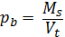
Where,
M_{s}: Mass of soil
V_{t}: Total volume
2.4.3 Porosity of soil (e)
was determined as the method of Hao et al., (2008) as follow
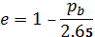
Where,
p_{b} : bulk density

2.4.4 Infiltration rate
The infiltration rate was measured by cylinder method:
f= V/a˟ t

Where
F: infiltration rate
V: volume of water
A: area of the cylinder
T: time
2.5 Growth parameters
During the growth period 10 plants were selected, where growth parameters such plant height, number of leaves per plant, stem diameter, leaf area/plant was measured once a week, and after that the average of 10 plants for each parameter was recorded.

2.6 Yield attributes measurement
At the maturation stage the number of fruits per plant was counted for yield estimation. Conversely, fruit weight was measured to estimate the yield of fruit per plant (kg// plant). Also the fruits from each plot were weighted to estimate the yield of fruits and then transformed into tons/ha.
Yield (Y) estimation per hectare
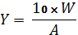
Where:
W: weight of fruits kg/ plot
A: plot area (m²).

2.7 Data analysis
In the present study, all data revealed as the mean values. At least three independent replicates done for each experiment. Data were analyzed with the one-way ANOVA using Sigma Stat computer program. Means of significantly different of the calculated data separated at the 0.05 probability level using Duncan’s Multiple Ranges Test.

3. Results and discussion
3.1 Soil physical analysis
The results revealed that the soil moisture content values were significant. The highest soil moisture content during study period was recorded in clay soil (23.0%) compared to lowest (9.4%) in sandy soil (Table 1). However, the highest bulk density was obtained by Gardud and sandy soils as 1.62 and 1.60 g/cm, respectively while clay soil showed highest porosity 48%, whereas the highest infiltration rate 8.9 cm/hr was reported in sandy soil.
3.2 growth parameters
The effect of soil types, chicken manure, and urea on cucumber growth parameters is shown in Table (2). Plant height data demonstrates considerable differences among the different treatments. The highest plant height was observed in clay soil with (10 ton/ha) chicken manure treatment (CCM2) (336.5 cm) compared to lowest in sand soil with urea (S1N) (177.8cm) (Table 2). However, the similar observation was reported by (Sri Pratiwi Aritonang, 2018) who stated that plant height increase with present of available nutrient. Concerning leaves area and diameter of cucumber data showed significant different among the treatments, the highest leaf area (49.25 cm² and stem diameter 1.23 cm respectively) was recorded in clay soil treated with chicken manure (10 ton/ha) (CCM2), while the lowest leave area and stem diameter was recorded by untreated sand soil (S0) (20.75 cm², and 0.65 cm respectively) (Table 2). These findings similarly reported by Maaz Khan et al., (2017) who confirmed that the leaf area and plant growth increased with increasing doses of poultry manure. Simultaneously, the highest number of leaves per plant was recorded in clay soil which treated with chicken manure (C10 ton/ha) (49) followed by Gardud soil treated with chicken manure (G10 ton/ha) (46), while the lowest was recorded by Gardud soil without treatment (G0) (46). Conversely these findings are in line with Maaz khan et al., (2017) who stated that the number of leaves in particular plant increase with increases of poultry manure in unit area.

Table 1. Effect of soil type on soil physical properties during growing period
Soil Types(( | M.C.% | Bulk density g/cm³ | Porosity% | Infiltration rate
Clay | 23.0a | 1.27b | 48a | 3.39b
Sand | 9.4c | 1.6a | 40b | 8.9a
Sand clay  (Gardud) | 21.5b | 1.62a | 39b | 2.55c
Values in same column share same superscript letter show no significant differences at 0.05 levels.

Table 2. Effect of soil type and fertilizer on cucumber's growth parameters
Number of leaves/p | Stem diameter | Leaf area dcm2 | Plant height cm | Treatment
27^{bcd} | 0.65^{f} | 20.75^{c} | 202.5^{cde} | S(0)
31^{bc} | 0.8^{f} | 26.5^{c} | 201.8^{cde} | SCM1
36^{b} | 0.95^{bcd} | 36.00^{abc} | 207.0^{cde} | SCM2
29^{bc} | 1.03^{abc} | 29.75^{bc} | 177.8e | S1N(Urea)
21.5^{cde} | 1.05^{abc} | 35.25.^{abc} | 198.8de | G(0)
27^{bcd} | 1.18ª | 35.25^{abc} | 245.8^{bc} | G CM1
46ª | 1.13^{ab} | 32.00^{bc} | 272.5^{b} | GCM2
30^{bc} | 0.85^{cde} | 31.00^{bc} | 255.0^{b} | G1N(urea)
22.6^{cde} | 0.83^{def} | 27.00^{c} | 231.3^{bcd} | C(0)
35^{b} | 1.15^{ab} | 31.25^{bc} | 253.8^{b} | CCM1
49ª | 1.23ª | 49.25ª | 336.5ª | CCM2
31^{bc} | 1.08^{abc} | 26.6^{bcd} | 238.0^{bc} | C1N(Urea)
C: clay soil
G: gardud soil
S: sandy soil
Values in the same column share same superscript letter show no significant differences at P < 0.05 level.

3.3 Effect of different treatment on cucumber yield
The yield of each vegetable is significantly influence by application of organic or chemical fertilizer, however, the highest yield kg/plant achieved by clay soil with chicken manure 10 ton /ha (CCM2) (13.88 kg/plant), while the lowest yield kg/plant was recorded by control (S0) (4.63 kg/ plant) in sandy soil (Fig. 1), similarly reported was mentioned by (Radwan and Sultan, 2024). In contrast, the highest yield ton/ha of cucumber was achieved by clay soil treated with chicken manure 10 ton/ha (CCM2) (239.58 ton/ha) compared to lowest yield ton/ha (83.30 ton/ha) in sandy soil with out fertilizer (S0). (Fig. 2). These findings are in line with (Maaz, 2017). The highest fruits number/plant was recorded in clay soil with chicken manure (5ton/ha) (CCM1) (44) followed by clay soil with chicken manure (10 ton/ha) (CCM2) (43) compared to lowest fruits number/plant in control (S0) (25) (Fig. 3), also Okla, (2015) observed that chicken manure enhanced and increased number of fruits and quality of marketable fruits as well as fruit size.
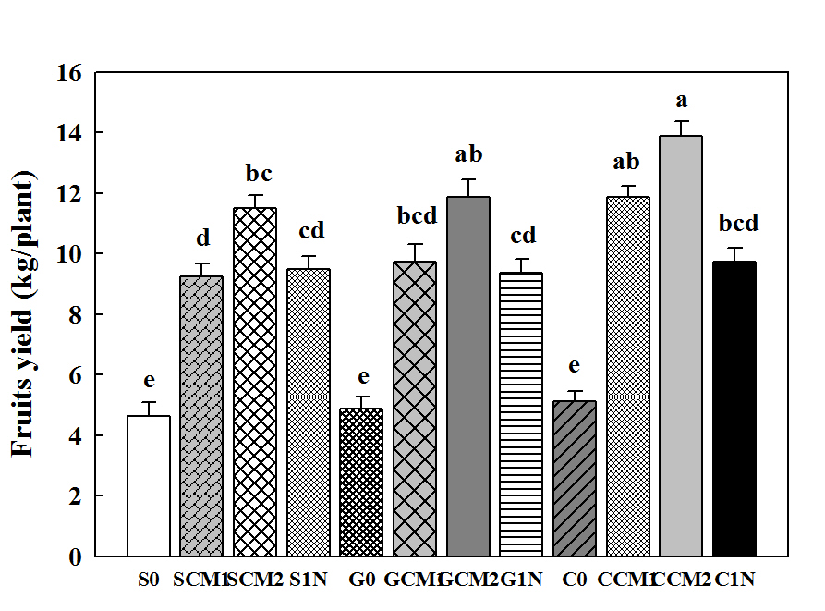
Fig. 1. Effect of soil type, chicken manure, and urea on fruits yield kg/plant in cucumber. Different small letters indicate significant differences between treatments at P < 0.05
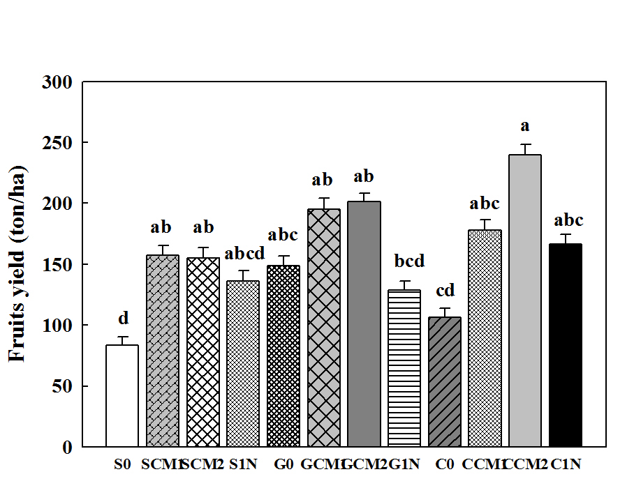
Fig. 2. Effect of soil type, chicken manure, and urea on fruits yield ton/ha in cucumber. Different small letters indicate significant differences between treatments at P < 0.05
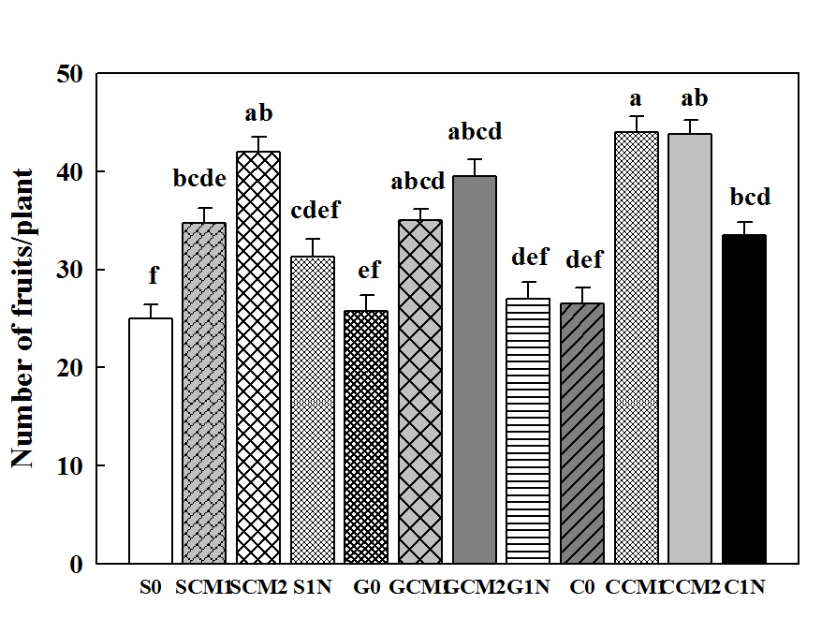
Fig. 3. Effect of soil type, chicken manure, and urea on number fruits /plant in cucumber. Different small letters indicate significant differences between treatments at P < 0.05

4. Conclusion
In general, double doses of chicken manure (10 ton /ha) applied in clay soil resulted in highest cucumber growth, yield and improved soil properties compared to the other treatments used. Based on the findings the study clearly showed that chicken manure is highly recommended to be use to achieve optimal growth and yield of cucumber, however, Future studies are encouraged to investigate the effects of different levels of chicken manure and soil type to further validate and refine these findings.

DISCLAIMER (ARTIFICIAL INTELLIGENCE)
Author(s) hereby affirm that NO generative AI technologies have been used during the writing or editing of this manuscript.

References

Abumere, V. I., Dada, O. A., Adebayo, A. G., Kutu, F. R., & Togun, A. O. (2019). Different rates of chicken manure and NPK 15-15-15 enhanced performance of sunflower (Helianthus annuus L.) on ferruginous soil. International Journal of Agronomy
Agbede, T. M., & Oyewumi, A. (2022). Benefits of biochar, poultry manure and biochar–poultry manure for improvement of soi l properties and sweet potato productivity in degraded tropical agricultural soils. Resources, Environment and Sustainability, 7, 100051.
Agbede, T. M., Adekiya, A. O., & Eifediyi, E. K. (2017). Impact of poultry manure and NPK fertilizer on soil physical properties and growth and yield of carrot. Journal of Horticultural Research, 25(1).‏
Ahmed, A. A. (2009). Effectiveness of screening and hardening methods for drought resistance in sorghum genotype (Sorghum bicolor (L.) Moench), evaluated under arid conditions (PhD thesis). Gazeira University, Sudan.
DeAngelis, K. M. (2007). Measurement of soil moisture content by gravimetric method. American Society of Agronomy, 1-2.
Hao, X., Ball, B. C., Culley, J. L. B., Carter, M. R., & Parkin, G. W. (2008). Soil density and porosity. Soil sampling and methods of analysis, 2, 179-196.
Khan, Maaz, Fazal Ullah1, Bibi Zainub, Muhammad Noman Khan, Amir Zeb, Kabir Ahmad and Inayat ur Rahman Arshad (2017) effects of poultry manure levels on growth and yield ofcucumber cultivar, sci.int.(lahore),29(6),1381-1386
Iabal, N., Umar, S., & Khan, N. A. (2015). Nitrogen availability regulates proline and ethylene production and alleviates salinity stress in mustard (Brassica juncea). Journal of Plant Physiology, 178, 84-91.
Khatiwad, A., & Adhikari, P. (2020). Cucumber (Cucumis sativus L.) is one of the most popular vegetable crop of cucurbitaceae family. Malaysian Journal of Sustainable Agriculture (MJSA), 4(2), 81-85.
Lark, R. M., Rawlins, B. G., Robinson, D. A., Lebron, I., & Tye, A. M. (2014). Implications of short‐range spatial variation of soil bulk density for adequate field‐sampling protocols: methodology and results from two contrasting soils. European Journal of Soil Science, 65(6), 803-814.
Lawal, B. A., Ilupeju, E. A., Ojeleye, A. E., Asafa, R. F., & Akanbi, W. B. (2019). Influence of Different Fertilizer Types on the Growth and Yield of Two Varieties Cucumber (Cucumis melo).
Maaz Khan, E, Fazal Ullah, E, Bibi Zainub, Muhammad Noman Khan, Amir Zeb, Kabir Ahmad, Inayat ur Rahman Arshad (2017). Effects of poultry manure levels on growth and yield of cucumber cultivars. Sci.Int.(Lahore),29(6),1381-1386.
Mohamed, W. S., & Hammam, A. A. (2019). Poultry manure-derived biochar as a soil amendment and fertilizer for sandy soils under arid conditions. Egyptian Journal of Soil Science, 59(1), 1-14. S
Okoli, P. S. O., & Nweke, I. A. (2015). Effect of poultry manure and mineral fertilizer on the growth performance and quality of cucumber fruits. Journal of Experimental Biology and Agricultural Sciences, 3(4), 362-367. ‏

Pal, A., Adhikary, R., Shankar, T., Sahu, A. K., & Maitra, S. (2020). Cultivation of cucumber in greenhouse. Protected cultivation and smart agriculture, 1.
Radwan, G. U., & Sultan, E. A.(2024) The effect of utilizing chicken manure and compost as organic fertilizers on chemical properties and productivity of cucumber grown under a plastic house.
Rajawat, K. S., COLLIS, J. P., Singh, G., Singh, J., & MINZ, R. R. (2017). Varietal Evaluation Studies in Cucumber (Cucumis sativus L.) Genotypes Under Allahabad Agro-Climate Condition. Trends in Biosciences, 10(2), 629-631.
Salim N and Raza A, 2020. Nutrient use efficiency (NUE) for sustainable wheat production: a review. J. Plant Nutr. 43(2): 297–315.
Shisode, N. (2021). Role of Aahar in prameh as a preventive measure and as a treatment-A conceptual study. Journal of Preventive Medicine and Holistic Health, 6(2), 72-75.
Wang, H. (2021). Cucumber Economic Values and Its Cultivation and Breeding.
Wayne, L. S., Jose, L. A. and Keith, S. M. (2011). Cucumber Production in California. University of California, Agriculture and Natural Resources Publication, p: 1 – 8.

