DCC Banks of Chhattisgarh position and share percentage in India with different parameters

Abstract
The study analyzes data related to Chhattisgarh's credit flow using statistical tools to understand shares and patterns. The data shows a significant presence of cooperative societies and individuals in the state's banking sector compared to the national average. The number of office memberships in Chhattisgarh is 292, with 241,148 cooperative society members and 2,327 individual members. The share capital of District Central Cooperative Banks in Chhattisgarh is ₹ 48,071 lakh, with a significant portion coming from cooperatives. The share capital from cooperatives in Chhattisgarh is ₹ 2,256 lakh, accounting for 4.69% of the total share capital in the state. The share capital from individuals in Chhattisgarh is ₹ 426 lakh, making up 0.88% of the total share capital in the state. The total reserve funds and other funds held by these banks are ₹ 21422 lakh, with ₹ 11391 lakh specifically in statutory reserve funds. The deposits from individual accounts in Chhattisgarh are ₹ 697,700 lakh, accounting for 58% of the total deposits. The reserve funds in Chhattisgarh are ₹ 276,553 lakh, showing a strong financial position compared to the national average. The loans disbursed by these banks are ₹ 986,521 lakh, indicating a healthy flow of credit in the region.

Keywords: DCCB, cooperative societies, share capital, reserve funds, deposits
- Introduction

Cooperatives are people-centric enterprises owned, controlled, and run by and for their members to realise their common economic, social, and cultural needs and aspirations (Dhruw et al., 2024). Cooperatives aggregate the power of people who, on their own, would find it difficult to achieve their goals. Cooperatives are thus, unique entities that reduce individual risk in undertaking economic activities through a culture of shared productivity, decision-making, and creative problem-solving (Singh et al., 2007). ‘Cooperation is the ideal strategy for ensuring self-sufficiency of a village; it is the well-spring of an Aatmanirbhar Bharat.’—Prime Minister
Cooperatives promote a sense of community and solidarity among members, fostering a collaborative environment that benefits all involved. By pooling resources and working together, cooperatives empower individuals to overcome challenges and improve their quality of life (Kapre & Soni, 2013). Through cooperation, individuals can access resources and opportunities that may not be available to them individually, ultimately leading to greater economic stability and success. This collaborative approach also helps in building a more resilient and sustainable economy by distributing risks and rewards among members (Angrish & Bansal, 2023). Overall, cooperatives play a crucial role in promoting equality and inclusivity within communities, ensuring that all members have a voice and share in the benefits of collective efforts. By prioritizing cooperation over competition, cooperatives demonstrate the power of working together towards common goals for the betterment of society as a whole (Sakthivel, 2013).

Figure 1: Development milestones for the cooperative movement in India
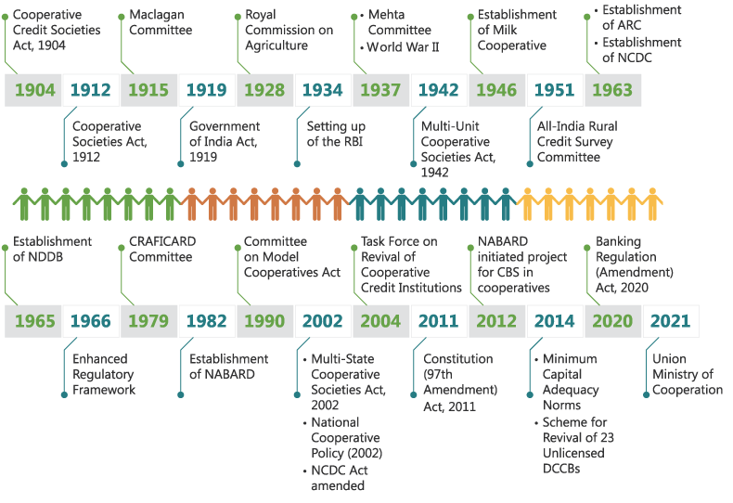
ARC = Agricultural Refinance Corporation, CBS = Core Banking Solutions, CRAFICARD = Committee to Review Arrangements for Institutional Credit for Agriculture and Rural Development, DCCB = District Central Cooperative Bank, NCDC = National Cooperative Development Corporation, NDDB = National Dairy Development Board, RBI = Reserve Bank of India.
SOURCE: WEBSITE https://www.nabard.org/annual-report/cooperatives-tackling-challenges-building-opportunities.html

2. COOPERATIVE SCENARIO IN INDIA

2.1 Sectoral distribution
Credit and banking, fertiliser, sugar, dairy, marketing, consumer products, handlooms, handicrafts, fisheries, housing, and more are all covered by India's cooperatives. Over 54% of all cooperatives in the nation are in the housing sector (24%), dairy sector (17.7%), and PACS–FSS–LAMPS sector (13%), as shown in Figure 2. Additionally, 48% of all cooperative members are connected to PACS-FSS-LAMPS. In India, dairy cooperatives and their federations have achieved remarkable success, fostering the fair development of their members.The dairy sector has also played a crucial role in uplifting rural livelihoods and improving the socio-economic conditions of farmers.

Figure 2: Cooperative societies by sector (number in lakh)
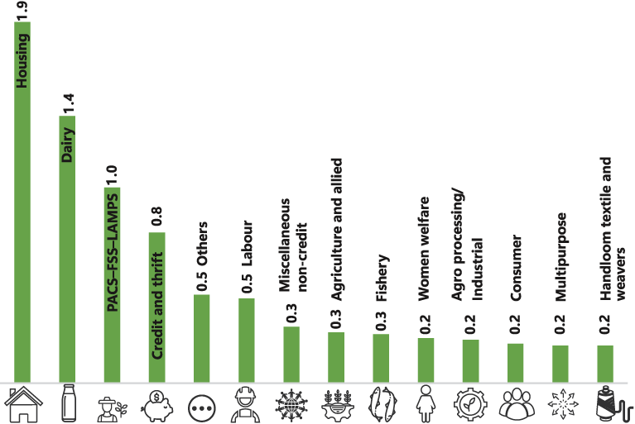
FSS = Farmers’ Service Society, LAMPS = Large Area Multipurpose Cooperative Society , PACS = Primary Agricultural Credit Society.
Note: The PACS and "credit and thrift" societies vary in that the latter rely mostly on member savings to cover their members' credit requirements. PACS were initially thrift-oriented credit organisations, but with the exception of a few states, such as Kerala, they have developed into vehicles for distributing credit through refinance with little focus on deposit mobilisation.
Source: National Cooperative Database, Ministry of Cooperation, Government of India. https://cooperatives.gov.in/en.

Figure 3: Cooperative membership as a percentage of population by state (2023)
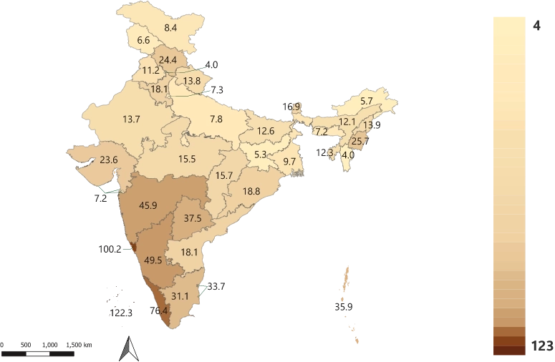
Sources:
- No. of cooperatives and membership data sourced from National Cooperative Database 2023, Ministry of Cooperation, Government of India. https://cooperatives.gov.in/en.
- Estimated population data sourced from Unique Identification Authority of India.

Compared to the eastern and northeastern states, the southern and western states have significantly greater cooperative membership rates as a percentage of their projected total population. Kerala had the highest percentage of cooperative members (77%) compared to Karnataka (50%), while Mizoram had the lowest (4%). The government of India has started a central strategy to create a cooperative society in each of the 18,497 gram panchayats that are still not covered by a PACS.
Objective
- To analyses the determinants of DCC Banks Chhattisgarh vs. All India DCC Banks.
- Share Percentage of DCC Banks Chhattisgarh with respect to all India’s DCC Banks with different parameter.
Method
Since the study is related to financial concerning banks it was obvious to rely on the secondary data on the published form which is extensively used for the purpose of the study in hand. Annual reports 2023, bank publication, circulars, NABARD reports, banks websites link of bank and RBI circular etc.
Statistical Tools
Entire data related to Chhattisgarh's credit flow can be analyzed and interpreted using statistical tools to further understand trends and patterns, allowing for informed decision-making and strategic planning by both banks and policymakers. This data-driven approach can help identify areas for improvement and ensure the continued growth and stability of the region's economy. Financial in nature which required careful scrutiny for which relevant statistical tools have been utilized as per the need of the study-
- Percentage and
- Comparative statement
Result & discussion
Table 1 No. offices and Membership
District Central Cooperative Banks Chhattisgarh vis-à-vis All India March 2023 (Amount in lakh ₹ )
 | No. of Office | Membership |  | Total Membership
 | No. of Office | Cooperative Society | Individual | Total Membership
CG | 292 | 2327 | 241148 | 243475
All India | 13992 | 499209 | 4980186 | 5479395
% all India | 2.09 | 0.47 | 4.84 | 4.44
Source : Basic data on Performance of DCC Bank 2022-23, NABARD Website www.nascob.org/District Central Cooperative/Basic Data on / Performance of DCC Banks 2022-23
District Central Cooperative Banks in Chhattisgarh have a total membership of 243,475, which accounts for 4.44% of the total membership in All India. This indicates a significant presence and participation of cooperative societies and individuals in the state's banking sector compared to the national average. The number of office memberships in Chhattisgarh is 292, with a total of 241,148 cooperative society members and 2,327 individual members. This demonstrates a strong cooperative banking network in the state vis-à-vis the national figures.
Table 2 Paid up Share capital
District Central Cooperative Banks Chhattisgarh vis-à-vis All India March 2023 (Amount in lakh ₹ )
 | Paid up Share Capital |  |  |  | Total Share Capital
 | From Cooperatives |  | From Government | From individual | Total Share Capital
CG | 43389 | 2256 |  | 426 | 48071
All India | 141940 | 327278 |  | 87737 | 1896955
% all India | 30.57 | 0.69 |  | 0.49 | 2.53
Source : Basic data on Performance of DCC Bank 2022-23, NABARD Website www.nascob.org/District Central Cooperative/Basic Data on / Performance of DCC Banks 2022-23

In March 2023, the District Central Cooperative Banks in Chhattisgarh had a total share capital of ₹ 48,071 lakh with a significant portion coming from cooperatives. This represents 30.57% of the total share capital of all District Central Cooperative Banks in India during the same period. The share capital from cooperatives in Chhattisgarh amounted to ₹ 2,256 lakh , accounting for 4.69% of the total share capital in the state. Additionally, the share capital from individuals in Chhattisgarh was ₹ 426 lakh, making up 0.88% of the total share capital in the state.
Table 3 Total Reserve funds and other funds
District Central Cooperative Banks Chhattisgarh vis-à-vis All India March 2023 (Amount in lakh ₹ )
 | Total Reserve funds and other funds |  |  | Total Reserve fund
 | Statutory reserve fund | Agril. Credit Stability fund | Other Reserve | Total Reserve fund
CG | 21422 | 11391 | 100132 | 132945
All India | 717266 | 319129 | 2863559 | 3899954
% all India | 2.99 | 3.57 | 3.50 | 3.41
Source : Basic data on Performance of DCC Bank 2022-23, NABARD Website www.nascob.org/District Central Cooperative/Basic Data on / Performance of DCC Banks 2022-23

In March 2023, the District Central Cooperative Banks in Chhattisgarh had a total of ₹ 21422 lakh in reserve funds and other funds, with ₹ 11391 lakh specifically in statutory reserve funds. This amount represents only 2.99% of the total reserve funds and other funds held by all District Central Cooperative Banks in India during the same period. The Agricultural Credit Stability Fund in Chhattisgarh held ₹ 100132 lakh , while the Other Reserve fund had ₹ 132945 lakh This indicates that Chhattisgarh's District Central Cooperative Banks had a lower percentage of total reserve funds compared to the national average.
Table 4 Total Deposits and Type wise Deposits
District Central Cooperative Banks Chhattisgarh vis-à-vis All India March 2023 (Amount in lakh ₹ )
 | Cooperative | Individual | Local Bodies | Others | Total Deposits | Current | Saving | Fixed | Reserve Funds | Other Deposits
CG | 47665 | 697700 | 27042 | 431952 | 1204359 | 24458 | 886652 | 276553 | 3041 | 13655
All India | 9770889 | 21858701 | 1402275 | 3E+06 | 35974491 | 1960827 | 12725651 | 194501 | 995717 | 842107
% all India | 0.49 | 3.19 | 1.93 | 14.68 | 3.35 | 1.25 | 6.97 | 142.19 | 0.31 | 1.62
Source : Basic data on Performance of DCC Bank 2022-23, NABARD Website www.nascob.org/District Central Cooperative/Basic Data on / Performance of DCC Banks 2022-23

District Central Cooperative Banks in Chhattisgarh had total deposits of ₹ 1,204,359 lakh in March 2023, with a significant portion coming from individual accounts. The deposits from individual accounts in Chhattisgarh were ₹ 697,700 lakh, which accounted for 58% of the total deposits in District Central Cooperative Banks. Additionally, the reserve funds in Chhattisgarh were ₹ 276,553 lakh, showing a strong financial position of these banks compared to the national average. Furthermore, the loans disbursed by District Central Cooperative Banks in Chhattisgarh amounted to ₹ 986,521 lakh, indicating a healthy flow of credit in the region. This highlights the crucial role these banks play in supporting the local economy and promoting financial inclusion. Moreover, the high loan disbursement reflects the confidence of these banks in the economic activities of Chhattisgarh, contributing to its growth and development. Overall, the strong financial position and active role in providing credit showcase the significant impact District Central Cooperative Banks have on the region's financial landscape.
Table 5 Total loan from SCB/NABARD
District Central Cooperative Banks Chhattisgarh vis-à-vis All India March 2023 (Amount in lakh ₹ )
 | Borrowing from SCB/NABARD |  |  |  | others | Total loan from SCB/NABARD
 | Agricultural |  | Non-Agricultural |  | others | Total loan from SCB/NABARD
 | Short term | Medium term | Short term | Medium term | others | Total loan from SCB/NABARD
CG | 77749 | 4167 | 0 | 20 | 0 | 81936
All India | 6756220 | 1181192 | 685874 | 615247 | 595400 | 98834021
% all India | 1.15 | 0.35 | 0 | 0.0033 | 0 | 0.08
Source : Basic data on Performance of DCC Bank 2022-23, NABARD Website www.nascob.org/District Central Cooperative/Basic Data on / Performance of DCC Banks 2022-23
In March 2023, District Central Cooperative Banks in Chhattisgarh borrowed a total of ₹ 81,936 lakh from SCB/NABARD, with agricultural loans at 77,749 lakh Rs and non-agricultural loans at ₹ 4,167 lakh, this represents a small percentage compared to the total borrowing by all District Central Cooperative Banks in India during the same period. Compared to the All India figures, Chhattisgarh's borrowing from SCB/NABARD is relatively low at 1.15% for agricultural loans and 0.35% for non-agricultural loans.

Table 6 Total Borrowing
District Central Cooperative Banks Chhattisgarh vis-à-vis All India March 2023 (Amount in lakh ₹ )
 | Total Borrowing |  |  |  | Total Borrowing
 | Total loan | loan from |  | Cash credit and overdraft | Total Borrowing
 | Total loan | Government | Commercial | Cash credit and overdraft | Total Borrowing
CG | 81936 | 14 | 0 | 0 | 81950
All India | 9834021 | 117925 | 20549 | 103049 | 10075544
% all India | 0.83 | 0.01 | 0 | 0 | 0.81
Source : Basic data on Performance of DCC Bank 2022-23, NABARD Website www.nascob.org/District Central Cooperative/Basic Data on / Performance of DCC Banks 2022-23
The District Central Cooperative Banks in Chhattisgarh accounted for 0.83% of the total borrowing in India as of March 2023. While they did not have any loans from cash credit and overdraft, their total borrowing amounted to ₹81,950 lakh. This indicates that the District Central Cooperative Banks in Chhattisgarh have a relatively small share of the total borrowing in the country. It is important to monitor these trends to understand the financial health and performance of these banks in comparison to others across India.
Table 7 Total Borrowing
District Central Cooperative Banks Chhattisgarh vis-à-vis All India March 2023 (Amount in lakh Rs.)
 | Details of investment |  |  |  |  | Total Investment
 | In Government | Debentures of LDBS | Other trustee Security | Fixed deposits | other investment | Total Investment
CG | 330340 | 0 | 623 | 755995 | 9289 | 1096247
All India | 8183885 | 34113 | 410402 | 9027285 | 1276833 | 18932518
% all India | 4.04 | 0.00 | 0.15 | 8.37 | 0.73 | 5.79
Source : Basic data on Performance of DCC Bank 2022-23, NABARD Website www.nascob.org/District Central Cooperative/Basic Data on / Performance of DCC Banks 2022-23
Chhattisgarh District Central Cooperative Banks have invested a total of 3,303.40 lakh Rs. in various avenues, with a percentage of 4.04 compared to the All India total investment. District Central Cooperative Banks in Chhattisgarh have a total investment of ₹1,096,247 lakh , which is 5.79% of the total investment made by all District Central Cooperative Banks in India as of March 2023. This indicates a strong focus on secure and stable investment options by these banks. The majority of the investment is in fixed deposits and other securities, reflecting a diverse portfolio strategy. This indicates a significant contribution from CG DCCBs towards the overall investments made by DCCBs in the country. 0.73
Table 8 Total Loan & Advances, Loan & outstanding and Balances (Overdue)
District Central Cooperative Banks Chhattisgarh vis-à-vis All India March 2023 (Amount in lakh ₹)
 | Total Loan & Advances | Loan & outstanding | Balances (Overdue)
CG | 4936203 | 295097 | 147531
All India | 27631055 | 288281169 | 6091090
% all India | 17.86 | 0.10 | 2.42
Source : Basic data on Performance of DCC Bank 2022-23, NABARD Website www.nascob.org/District Central Cooperative/Basic Data on / Performance of DCC Banks 2022-23

Chhattisgarh's District Central Cooperative Banks have a total deposit of ₹ 4,936,203 lakh which is 17.86% of the total deposits in all of India. This indicates a significant contribution from Chhattisgarh to the overall cooperative banking sector in the country. The amount of ₹ 295,097 lakh in advances by Chhattisgarh's District Central Cooperative Banks represents 0.10% of the total advances in India, showing a smaller proportion compared to deposits. However, the figure of ₹ 147,531 lakh in investments still accounts for a substantial 2.42% share at the national level.
Table 9 Cost of Management, Working Capital and % of COM to Working Capital
District Central Cooperative Banks Chhattisgarh vis-à-vis All India March 2023 (Amount in lakh ₹ )
 | Cost of Management |  |  | Total No. of Employees | COM Per Employee | Working Capital | % of COM to Working Capital
 | Salaries | Other Expenses | Total
CG | 16978 | 24955 | 41933 | 2347 | 17.33 | 1599566 | 2.62
All India | 543007 | 562677 | 1105684 | 77667 | 14.24 | 53012638 | 2.09
% all India | 3.13 | 4.43 | 3.79 | 3.02 | 121.70 | 3.02 | --
Source : Basic data on Performance of DCC Bank 2022-23, NABARD Website www.nascob.org/District Central Cooperative/Basic Data on / Performance of DCC Banks 2022-23

District Central Cooperative Banks in Chhattisgarh have a lower cost of management per employee compared to the national average in March 2023. Despite this, the percentage of cost of management to working capital is slightly higher in Chhattisgarh than the national average.

Conclusion and Suggestion
Cooperative banks in Chhattisgarh play a crucial role in providing financial services to a significant portion of the population. To enhance their impact, efforts should be made to increase awareness about cooperative banking benefits, encourage more individuals to join, promote financial literacy programs, and expand their reach in rural areas. The data shows a strong reliance on cooperatives for share capital in Chhattisgarh's District Central Cooperative Banks. To strengthen financial stability, it may be beneficial to increase individual contributions to share capital, increase reserve funds, and implement strategies to boost statutory reserve funds. Chhattisgarh's borrowing from SCB/NABARD is significantly lower than the national average, indicating potential for growth and increased access to credit for agricultural and non-agricultural sectors. Policymakers should explore ways to enhance cooperative bank lending to support economic development and financial inclusion. Diversifying investment options and exploring new growth avenues could further strengthen the cooperative banking sector in Chhattisgarh.

COMPETING INTERESTS DISCLAIMER:
Authors have declared that they have no known competing financial interests OR non-financial interests OR personal relationships that could have appeared to influence the work reported in this paper.

Reference
- National Cooperative Database, Ministry of Cooperation, Government of India. https://cooperatives.gov.in/en.
- Basic data on Performance of DCC Bank 2022-23, NABARD Website www.nascob.org/District Central Cooperative/Basic Data on / Performance of DCC Banks 2022-23
- Dhruw, B., Jain, B. C., Choudhary, V. K., Bhagat, R. K., & Kaushal, R. (2024). An Analysis of Current Scenario and Future Prospects for District Central Cooperative Bank Raipur, Chhattisgarh, India. Asian Journal of Current Research, 9(3), 95-105.
- Singh, A. K., Koshta, A. K., & Chandrakar, M. R. (2007). Economic Performance of District Central Co-operative Bank in Raipur (Chhattisgarh). Finance India, 21(2).
- Kapre, A. K., & Soni, A. K. (2013). A Comparative Study of Regional Rural Banks in Chhattisgarh State. International Journal of Economics, Commerce and Research, 3(1), 79-86..
- Angrish, A. K., & Bansal, S. K. (2023). Cooperative Banks: Tracing, Tracking, and Treating the Failures. In Cooperatives as a Catalyst for Sustainability: Lessons Learned from Asian Models (pp. 195-226).
- Sakthivel, G. (2013). Financial performance of district central cooperative Banks in India: An evaluation. ZENITH International Journal of Business Economics & Management Research, 3(7), 23-28.

