Original Research Article
Geospatial Assessment and Mapping of Soil Nutrient Status in Mizoram for Sustainable Agricultural Planning

Abstract
Soil health management (SHM) is a central component in Integrated Nutrient Management (INM) proposed to improve the productivity of the Ministry of Agriculture's National Mission for Sustainable Agriculture (NMSA). This paper is based on GIS, and GPS to depict soil fertility status in Mizoram. From 273 villages (20,991 soil samples) thematic maps of pH, OC, Nitrogen (N), Phosphorus (P) and Potassium (K) were mapped through Inverse Distance Weighted (IDW) interpolation. The results show that the soils of Mizoram are mostly non-saline but acidic and the macronutrient level is mostly in the medium range. These high-resolution maps help in making decisions on sustainable crop planning and regional agricultural assessments.
Keywords: Soil fertility map, Soil Health Card, GIS, GPS, Mizoram
1. Introduction
Sustainable farming development is primarily based on good soil fertility management. This is most effectively done by Site-Specific Nutrient Management (SSNM), which recognizes the fact that the nature of soil parameters inherently differs across different sites, and to mitigate the risk of inefficient or deleterious over-application of fertilizers. Maximizing nutrient delivery, focusing on the relative variability in available concentrations of nutrients based on individual locations can be done in relation to the demand in crops (Dobermann and Cassman, 2002). Soil testing is the most suitable and widely applied different methods of soil evaluation to identify viable agricultural lands and subsurface conditions. It generates critical quantitative data regarding the availability of nutrients, that serves as a foundation for fertilizer recommendations that protect economic production (Khadka et al., 2019). Soil analysis is therefore inherently related to sustainable soil management (Panda, 2010). Soil characteristics in different landscapes are explained by intrinsic (climate, parent materials, physiography) and extrinsic (management techniques, cropping intensity, crop rotation) factors (Cambardella and Karlen, 1999).
Historically, the management of this variability has been a challenging task however Global Positioning Systems (GPS) and Geographic Information Systems (GIS) have made it possible to represent soil fertility with high resolution thematic maps. Such maps have to be matched with accurate GPS positioning for a soil sample to be collected (Mishra and Saren, 2013; Rathore et al., 2023; Sheoran et al., 2024). GIS subsequently serves as an essential analytical tool and can interpolate point data to produce spatial surfaces that span entire blocks or districts (Jena et al., 2015; Sood et al., 2009; Singh et al., 2024). This platform enables the access to large datasets and manipulation of that data and is important to characterize the spatial distribution of soil properties (Mandal and Sharma, 2009; Reza et al., 2016; Ratre et al., 2024).
In India a national initiative, the National Mission for Sustainable Agriculture (NMSA) aims at improving productivity, particularly in rainfed areas of the country through Soil Health Management (SHM). One important piece of this mission is the Soil Health Card (SHC) program that the Ministry of Agriculture has introduced. SHC provides farmers: SHC provides a report for 12 parameters (such as pH, EC, OC, macro and micronutrients), and further advice on dosage of fertilizer and soil amendments. The SHC gives essential information based on a point (latitude and longitude) data, and nutrient management is most effective when nutrients are mapped out on different spatial variability maps. (P. T. Das et al. 2022) proved the effectiveness of the technique when it produced fertility maps of Meghalaya using SHC portal. Their analysis showed that the soils are high in organic carbon (88.22%) but also acidic mainly, with 69.61% being slightly acidic and 27.25% moderately acidic (Das et al., 2022). That is why such maps are pivotal decision-support tools for sustainable agriculture (Iftikar, 2010). While recent mapping initiatives in neighboring states such as Meghalaya, Arunachal Pradesh and Sikkim (NESAC, 2021; NESAC 2023; Das et. al, 2025) have proved to be successful, detailed information on the spatial variability of soil fertility parameters for Mizoram is still lacking. This is a state that needs high-resolution spatial data to go from general recommendations to precision agriculture. Thus, the existing study to map and evaluate soils fertility status in Mizoram to support an appropriate site-based nutrients management was carried out. Despite extensive studies in this area, little attention has been given to [specific gap]. This study addresses this limitation by investigating [specific focus], thereby contributing to a deeper understanding of [field
2. Materials and Methods
2.1 Data Acquisition and Pre-processing
The soil health records at Mizoram were captured and filed to the official SHC portal (https://soilhealth.dac.gov.in). Village-level datasets were extracted from the dashboard, audited for consistency and converted into GIS formats. With the help of ArcGIS Pro, a complete geospatial database was designed, producing a point layer based on the geospatial coordinates of each soil sample. It combined 20,991 soil samples from 273 villages in Mizoram.
2.2 Spatial Interpolation and Mapping
Five soil fertility parameters critical for crop planning, are soil reaction (pH), organic carbon (OC), available nitrogen (N), available phosphorus (P), and available potassium (K). In order to predict the nutritional content on an unsampled region, the Inverse Distance Weighted interpolation method was used through the Spatial Analyst tool in ArcGIS. IDW considers the value of an unvisited point as the distance-weighted mean of neighboring observed points, making it an appropriate choice for regional soil fertility modelling, since local variability depends on topography. The systemic workflow, from data ingestion through generation of thematic fertility maps until it finally works out is described in methodology flowchart (Figure 1).
2.2 Geospatial Processing
Data downloaded was processed in its GIS space using ArcGIS 10.8.1 software. Using the locations of sample soils (latitude and longitude), a point layer was created where sample numbers are added, village names are included, and analyses are taken.
2.3 Spatial Interpolation
Thematic maps for pH, OC, and available N, P, and K were created using the Spatial Analyst tools available in ArcGIS. A technique for Inverse Distance Weighted (IDW) interpolation was applied to predict values at unknown locations based on the known sample points. The details of the methodology are shown in Figure 2.
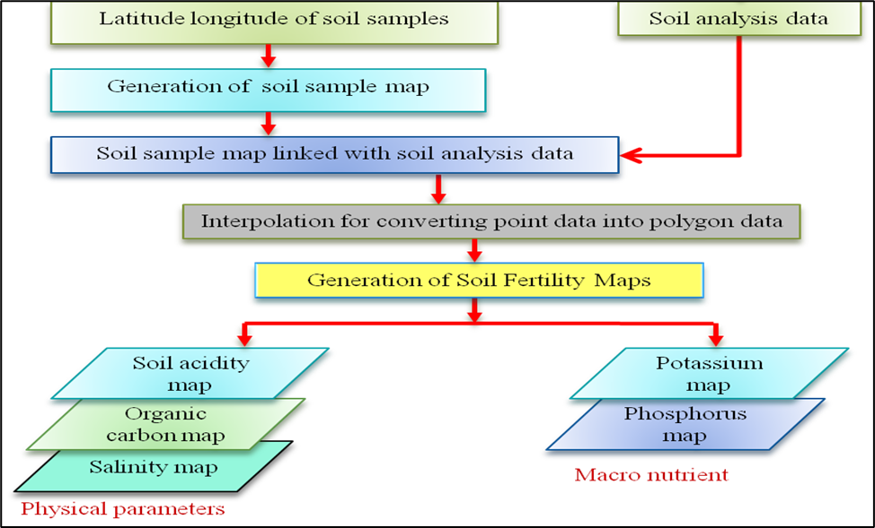
Figure 1: Systematic workflow for the generation of thematic soil fertility maps
3. Results and Discussion
Geospatial analysis produced five thematic fertility maps for Mizoram, showcasing spatial distribution of pH, Organic Carbon (OC), and available N, P and K across the state. The quantitative distribution of these parameters over different classes of fertility is summarized in Table 1.
3.1 Soil Reaction (pH) and Salinity
According to the study, Mizoram soils are predominantly non-saline and acidic in nature. A large part of the state, 62.64% (1,319,679.13 ha), belongs to that of an acidic (Slightly Acidic; pH 5.5–6.5); 34.85% (734,190.93 ha) to moderate acid, pH 4.5–5.5. Only a small proportion (0.17%) are under the position of neutrality. This widespread acid is due to the high-rainfall hilly land in the North East Region, which generates acid (leaching of base cations) from the ground.
3.2 Organic Carbon (OC)
Soil Organic Carbon, a key marker of soil health and microbial activity, was high in moderate amounts in most of the state. The OC levels are in the medium (0.50%–0.75%) values within 54.75% area while 31.05% of the region of observed was Low OC (<0.50%). The high organic carbon content was limited to about 12.19% of the total area, probably in areas with more forestized areas or with little farming to disturb soil (Fig. 2).
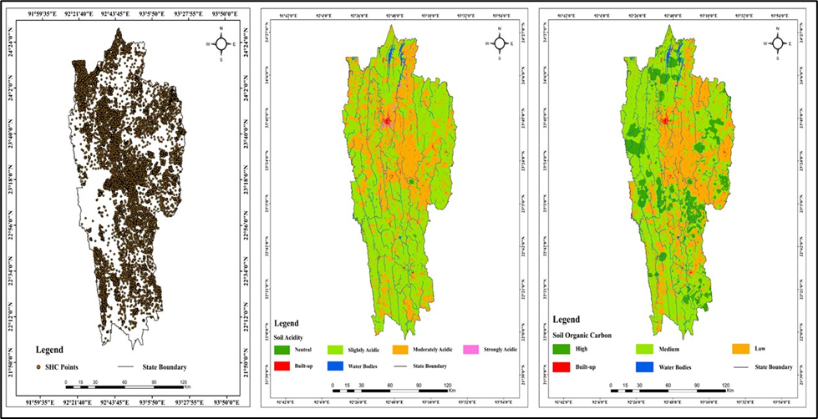
Figure 2: Spatial distribution of SHC points, soil acidity and Soil organic carbon
3.3 Available Macro-nutrients (N, P, K)
The availability of primary macro-nutrients follows a highly uniform "Medium" distribution pattern across Mizoram (Figure 3).
Available Nitrogen (N): The vast majority of the state (91.21%) contains Medium Nitrogen (280–560 kg/ha). Low nitrogen availability was observed in 6.78% of the area, with no regions recording "High" nitrogen status.
Available Phosphorus (P): Phosphorus availability is similar to Nitrogen in 90.71% of the area it is classified as Medium (10–25 kg/ha). Minor portions of 4.69% and 2.59% of the soil coverage are low and High phosphorus, respectively.
Available potassium (K): Potassium status is overwhelmingly Medium (120–280 kg/ha) in 93.05% of the state. In only 4.45% of the soils there were high potassium levels (>280 kg/ha).
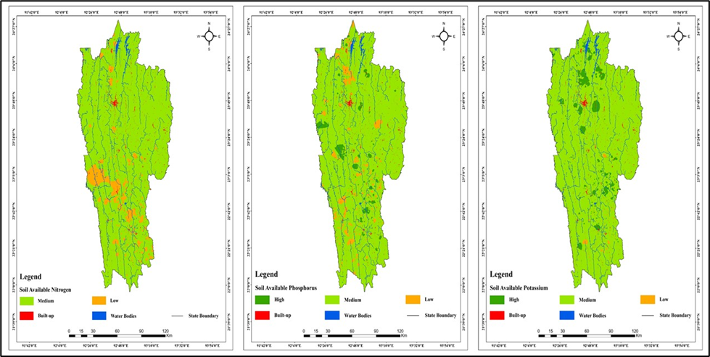
Figure 3. Spatial distribution of macro nutrients in Mizoram
Table 1: Spatial Distribution of Soil Fertility Classes in Mizoram
Parameters | Class | Area (ha) | % Area
pH | Strongly Acidic (<4.5) | 6,980.06 | 0.33
pH | Moderately Acidic (4.5–5.5) | 734,190.93 | 34.85
pH | Slightly Acidic (5.5–6.5) | 1,319,679.13 | 62.64
pH | Neutral (6.5–7.5) | 3,563.19 | 0.17
OC (%) | Low (<0.50) | 654,284.95 | 31.05
OC (%) | Medium (0.50–0.75) | 1,153,775.60 | 54.75
OC (%) | High (>0.75) | 256,769.48 | 12.19
N (kg/ha) | Low (<280) | 142,853.99 | 6.78
N (kg/ha) | Medium (280–560) | 1,922,152.89 | 91.21
N (kg/ha) | High (>560) | - | -
P (kg/ha) | Low (<10) | 98,906.59 | 4.69
P (kg/ha) | Medium (10–25) | 1,911,347.33 | 90.71
P (kg/ha) | High (>25) | 54,576.13 | 2.59
K (kg/ha) | Low (<120) | 10,438.05 | 0.50
K (kg/ha) | Medium (120–280) | 1,960,656.58 | 93.05
K (kg/ha) | High (>280) | 93,735.41 | 4.45
Most soils in Mizoram fall under medium nutrients, especially nitrogen and potassium, according to soil fertility status analysis. This pattern is attributed largely to the humid tropical environment and hilly country. The Mizoram region is a region of high annual rainfall (more than 2000 mm), leading in the most part to highly leaching soluble nutrients from the layer, which reduces the nutrient build-up in the upper soil. In addition, the soils are very strongly acidic, and severely weathered soils such that the saturation of the base as well as fixation of phosphorus by iron and aluminum oxides are low, which limits its availability to plants. The steep slopes and poor hill ecosystem also promote soil erosion and runoff, which lead to the removal of nutrient-rich topsoil and moderate fertility status. Furthermore, shifting cultivation (jhum), which occurred for shorter periods of time in the fallows, leads to the natural regeneration of soil organic matter and nutrient pools being lost. Similar findings have also been reported in some studies from Northeast India, where soil fertility under hill agro-ecosystems and shifting cultivation systems often is moderate due to nutrient losses from leaching, erosion and land-use changes (Kenye et al., 2019; Ovung et al., 2021; Manpoong et al., 2020). In addition, investigations of soil signatures and contaminant transport further emphasize how subsurface conditions and external pollutants can exacerbate nutrient leaching and soil degradation. These insights align with the observed acidic and nutrient-moderate soils in Mizoram. This indicates that sustainable land management in the form of soil conservation measures, organic matter addition and better fallow management processes are required to improve and sustain soil fertility in the hill ecosystem in Mizoram.
4. Conclusion
This study presents the first comprehensive high-resolution spatial assessment (1:50,000) on soil fertility of the state of Mizoram based on Soil Health Card (SHC) data. Results demonstrate the broad trend of medium nutrient availability throughout the hilly state topography, with over 91% of the region being of medium Nitrogen, 90.71% medium Phosphorus, and 93.05% medium Potassium. Although soils are relatively non-saline, the high-rainfall tropical climate has resulted in general acidity across the territory, with 97.49% of the area categorized as mildly or moderately acidic. The results reinforce that the soil status currently characterizes the soil for traditional agriculture and that the transition to intensive commercial crops (such as expansion of Oil Palm) will necessitate appropriate nutrient management. The baseline results for this GIS based interpolation are an important decision-support tool for Department of Agriculture, Government of Mizoram to make targeted interventions on the village level and block level.

References
- Cambardella CA, Karlen DL. Spatial analysis of soil fertility parameters. Precision Agriculture. 1999.
- Chouhan D, Awasthi MK, Nema RK, Sharma SK, Singh M, Patle D. Spatial assessment of soil fertility using GIS techniques in Shahdol district, Madhya Pradesh. International Journal of Research in Agronomy. 2025;8(5):183–188.
- Das PT, Lakiang T, Saikia B. Soil fertility mapping using GIS in Meghalaya plateau. International Journal of Current Microbiology and Applied Sciences. 2022;11(3):71–79. Available:https://doi.org/10.20546/ijcmas.2022.1103.009
- Das PT, Passah MES, Saikia B, Handique BK, Sarma KK, Aggarwal SP. Soil fertility mapping using geospatial technology for sustainable agriculture in Sikkim. In: Bio-Based Resource Management. ISBN: 978-93-48070-31-9; 2025.
- Dobermann A, Cassman KG. Plant nutrient management for enhanced productivity in intensive grain production systems. Applied Soil Ecology. 2002.
- Jena RK, Duraisami VP, Sivasamy R, Shanmugasundaram R, Krishnan R, Padua S, Bandyopadhyay S, Ramachandran S, Ray P, Deb Roy P, Singh SK, Ray SK. Spatial variability of soil fertility parameters in Jirang block of Ri-Bhoi district, Meghalaya. Clay Research. 2015;34(1):35–45.
- Khadka D, et al. Soil fertility evaluation and mapping of different regions using GIS techniques. 2019.
- Kenye A, Sahoo UK, Singh SL, Gogoi A. Soil organic carbon stock of different land uses of Mizoram, northeast India. AIMS Geosciences. 2019;5(1):25–40.
- Manpoong C, Hauchhum R, Tripathi SK. Soil fertility and root carbon exudation in Tephrosia candida hedgerows under sloping agricultural land technology in Mizoram. Journal of Tropical Agriculture. 2020;58(1).
- Mishra A, Das D, Saren S. Preparation of GPS and GIS based soil fertility maps for Khurda district, Odisha. Indian Agriculturist. 2013;57(1):11–20.
- NESAC. Mapping of soil fertility in Meghalaya using geospatial technology and Soil Health Card data. Project Report No. NESAC-SR-259-2021. North Eastern Space Applications Centre (NESAC), Umiam, Meghalaya, India; 2021.
- NESAC. Soil fertility mapping of Arunachal Pradesh using geospatial technology. Project Report No. NESAC-SR-292-2023. North Eastern Space Applications Centre (NESAC), Umiam, Meghalaya, India; 2023.
- Ovung EY, Tripathi SK, Brearley FQ. Changes in soil exchangeable nutrients across different land uses in steep slopes of Mizoram, northeast India. Journal of Applied and Natural Science. 2021;13(3):995–1003.
- Panda SC. Soil management and organic farming. Agrobios (India); 2010.
- Rathore AS, Sharma YM, Tagore GS, Nagwanshi A, Jayaraman S. Soil fertility mapping using GPS and GIS in Jhabua district, Madhya Pradesh, India. Journal of the Indian Society of Soil Science. 2023;71(3):276–286.
- Sheoran D, Garhwal RS, Sharma M, Karuna. Assessment and mapping of nutrients in soils using GIS techniques. International Journal of Plant & Soil Science. 2024;36(7):720–732.
- Singh SK, Tagung T, Kumar A, Singh KK. Geospatial analysis of soil fertility in Muzaffarpur district, Bihar using GPS and GIS technologies. Journal of Advances in Biology & Biotechnology. 2024;27(7):1083–1093.
- Ratre GK, Thakur DS, Ayam GP, Savu RM. Soil fertility mapping using geo-spatial techniques for agricultural land management. International Journal of Plant & Soil Science. 2024;36(8):177–186.
- Sood A, Sharma PK, Tur NS, Nayyar VK. Micronutrient status and their spatial variability in soils of Muktsar district of Punjab – A GIS approach. Journal of the Indian Society of Soil Science. 2009;57(3):300–306.
- Iftiker W, Chattopadhyay GN, Majumdar K, Sulewski GD. Use of village-level soil fertility maps as a fertilizer decision support tool in the red and lateritic soil zone of India. Better Crops. 2010;94:10–12.

