Journal Name: | Asian Journal of Soil Science and Plant Nutrition
Manuscript Number: | Ms_AJSSPN_154869
Title of the Manuscript: | Copper Sulfate Nanoparticle Mediated Alleviation of Salinity Induced Yield Losses in Tomato (Solanum lycopersicum L.)
Type of the Article | Research Article

PART 1: Comments
 | Reviewer’s comment | Author’s Feedback (It is mandatory that authors should write his/her  feedback here)
Please write a few sentences regarding the importance  of this manuscript for the scientific community. A minimum of 3-4 sentences may be required for this part. | The subject of the study presented by the authors is interesting and topical, with scientific and practical importance.
Is the title of the article suitable?  (If not please suggest an alternative title) | The title of the article is appropriate, in relation to the topic addressed.
Is the abstract of the article comprehensive? Do you  suggest the addition (or deletion) of some points in this section? Please write your suggestions here. | The article Abstract is comprehensive and the keywords are representative of the article topic.
Is the manuscript scientifically, correct? Please write here. | The subsections and structure of the manuscript are appropriate, in accordance with the General Guideline for Authors.  Scientifically, the article has a correct approach.
Are the references sufficient and recent? If you have suggestions of additional references, please mention them in the review form. | The bibliographical sources are adequate, but they are rather few. More extensive documentation would be appropriate for the article.

Is the language/English quality of the article suitable for scholarly communications? | The English language and the quality of the article are suitable for academic communications, and the article is accessible to readers.
Optional/General comments | 1.  In some cases, certain characters are not visible.  e.g. print screen:  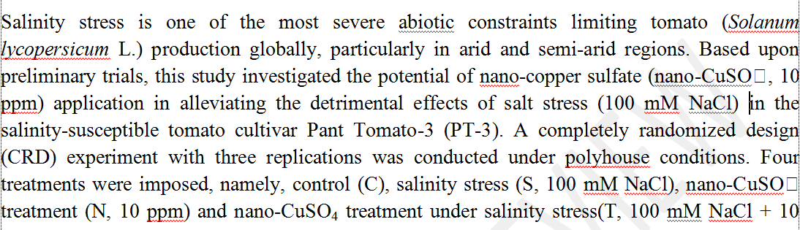  It is recommended to edit the content of the article accordingly, to make it accessible to readers. It is recommended to check the entire content of the article and make corrections, as necessary.  2.  In some cases "et al." is written in italics when citing bibliographical sources, and in other cases "et al." is written in regular form. It is recommended to write according to the recommendations for Authors.  It is recommended to check the entire content of the article and make corrections, as necessary.  3.  “nano-CuSO₄” instead of “nano-CuSO4”  It is recommended to check the entire content of the article and make corrections, as necessary.  4.  Discussing the results with other bibliographic sources on the field of study would be appropriate.  5.  More extensive documentation would be appropriate for the article.  The subject of the study is interesting and topical, with high scientific and practical importance. The introduction is presented correctly, in accordance with the subject.  Methodology of the study was clearly presented, and appropriate to the proposed objectives.  The obtained results are important. Discussing the results with other bibliographic sources on the field of study would be appropriate. More extensive documentation would be appropriate for the article.  I appreciate that the article can be accepted for publication after minor corrections.

PART 2:
 | Reviewer’s comment | Author’s Feedback (It is mandatory that authors should write his/her  feedback here)
Are there ethical issues in this manuscript? | (If yes, Kindly please write down the ethical issues here in detail)  Not identified, not the case.

Reviewer details:

Florin Sala, University of Life Sciences “King Mihai I” from Timisoara, Romania

