Eco-Friendly Utilization of Lac Processing Waste for Formulation of Organic Plant Growth Promoter

Abstract

Background
The lac industry generates substantial waste during the scraping, washing, and processing of raw lac, which is often discarded or burned, causing environmental pollution and resource loss. Considering its rich organic and resinous composition, lac waste holds potential as a sustainable soil amendment. This study explores the eco-friendly conversion of lac processing waste from Lac Processing Industry into a nutrient-enriched organic sustenance, promoting circular economy principles in lac-based industries.
Methodology
Lac processing waste (lac mud) was subjected to controlled composting and nutrient fortification using rice husk ash (RHA), and fly ash. Seven treatments were prepared, including control soil and chemical fertilizers. Physico-chemical parameters (pH, EC, organic carbon), NPK content, and micronutrients were analyzed. Pot culture experiments were conducted using Solanum lycopersicum to evaluate germination percentage, plant height, root length, leaf number, chlorophyll content, and biomass. Statistical analysis (ANOVA) assessed treatment significance.
Results
Among all treatments, T4 (Lac Mud + RHA) showed superior performance. It recorded the highest mean soil pH (8.04 ± 1.25), moderate EC (2.50 dS m⁻¹), and elevated organic carbon (1.12%). Nutrient enhancement was significant (N: 0.091%, P: 0.041%, K: 0.52%). Germination rate was highest (mean 90%), with maximum leaf number (140.66) and plant height (9 cm). Compared to chemical fertilizers, T4 significantly improved soil fertility, microbial activity, and plant growth parameters.
Conclusion
Lac processing waste can be effectively converted into a nutrient-rich bio-organic fertilizer. The integrated application of lac mud and rice husk ash (T4) demonstrated superior soil conditioning and crop growth performance over chemical fertilizers. This approach offers a cost-effective, eco-friendly alternative for sustainable agriculture while reducing industrial waste and promoting circular economy practices.
Introduction
The lac industry plays a vital role in the rural economy of India, particularly in the states of Madhya Pradesh, Jharkhand, Chhattisgarh, and West Bengal. India is one of the leading producers of lac, a natural resin secreted by the insect Kerria lacca. Lac and its derivatives are extensively used in varnishes, surface coatings, food glazing, pharmaceuticals, cosmetics, adhesives, and dye industries due to their biodegradable and non-toxic nature (Sharma et al., 2018).
Processing of raw stick lac involves several mechanical and physical steps such as scraping, washing, crushing, and filtration, to obtain seed lac and shellac. During this process, approximately 15-25% of the raw material remains as residue, commonly referred to as lac waste or lac refuse (Saha & Sen, 2016). Traditionally, this waste is either burned or dumped in open areas, leading to environmental concerns including particulate emissions, localized pollution, and loss of potentially valuable organic biomass. Improper disposal not only contributes to environmental degradation but also represents a missed opportunity for resource recovery and value addition.
In recent years, sustainable waste management and circular economy approaches have emphasized the conversion of agro-industrial residues into value-added agricultural inputs. Organic fertilizers derived from biodegradable industrial wastes improve soil structure, enhance microbial activity, increase nutrient availability, and promote sustainable crop productivity (Bernal et al., 2009). Microbial activity quantification using alkali-trap methods is widely applied in soil respiration studies (Agase et al.,2025). Composting is widely recognized as an efficient bioconversion technique that stabilizes organic matter, reduces phytotoxic compounds, and enhances nutrient mineralization (Lim et al., 2016). Agro-industrial wastes such as sugarcane bagasse, press mud, rice husk, and fruit peels have been successfully converted into nutrient-rich composts, demonstrating improvements in soil fertility and crop yield (Hargreaves et al., 2008).
Lac waste contains substantial amounts of organic carbon, residual plant fibers, insect secretions, wax, and natural pigments. Its high carbon content and biodegradable composition make it a promising substrate for composting and organic fertilizer formulation. While previous studies have primarily focused on the extraction of lac dye and wax from processing residues, limited attention has been given to its potential application as a soil amendment (Saha & Sen, 2016). Organic amendments rich in carbon are known to enhance soil aggregation, improve moisture retention, and stimulate beneficial microbial populations, thereby contributing to long-term soil health (Lal, 2015).
Therefore, the transformation of lac processing waste into organic growth promoter represents an eco-friendly strategy that integrates waste management with sustainable agriculture. Such an approach aligns with circular bioeconomy principles, reduces environmental hazards associated with open disposal, and provides an additional income-generating avenue for rural lac-producing communities. The present study aims to evaluate the eco-friendly utilization of lac processing waste for the formulation of an organic promoter and to assess its effects on soil fertility, nutrient availability, and plant growth performance. This work seeks to bridge the gap between industrial waste valorization and sustainable agricultural input development.
Materials and Methods
Collection of Lac Processing Waste
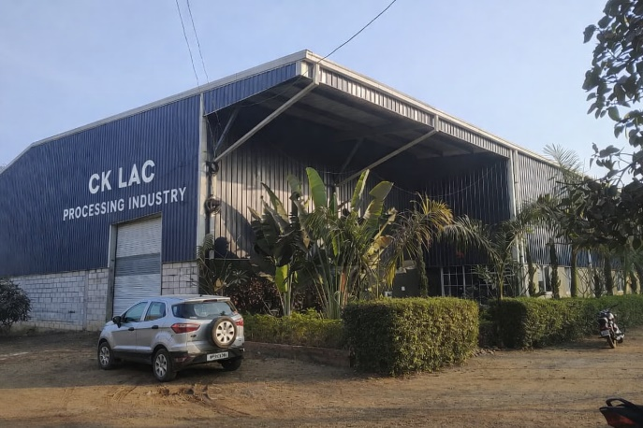
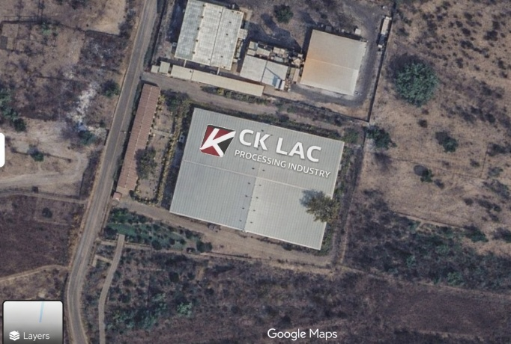
Lac waste was collected from the C.K. Lac Processing Industry, Kera, Balaghat, Madhya Pradesh. The waste comprised residue from scraping and washing of stick lac, containing fibrous material, dust, spent resin, and insect remnants. The waste was air-dried, manually cleaned to remove non-biodegradable impurities, and ground to a uniform particle size for efficient composting.
Fig. 1 C.K. Lac Processing Industry, Kera, Balaghat (Sampling Site)

Experimental Design
The experiment was conducted to evaluate the potential of lac mud (lac waste) as an organic growth promoter in comparison with normal soil, inorganic fertilizers, and ash amendments. Soil, lac mud, rice husk ash (RHA), and fly ash were used to prepare seven treatments: T1 (100% Soil - Control), T2 (50% Soil + 50% Lac Mud), T3 (100% Lac Mud), T4 (50% Soil + 25% Lac Mud + 25% RHA), T5 (50% Soil + 25% Lac Mud + 25% Fly Ash), T6 (Soil + Urea), and T7 (Soil + DAP). After preparation of treatment mixtures, potting and planting were carried out under controlled conditions. Growth performance was monitored through analysis of physicochemical properties of the test soils and by recording germination percentage, germination time, plant height, root length, number of leaves, and chlorophyll content. The recorded data were subjected to statistical analysis to assess the comparative effectiveness of lac mud-based treatments against control and inorganic fertilizer treatments.
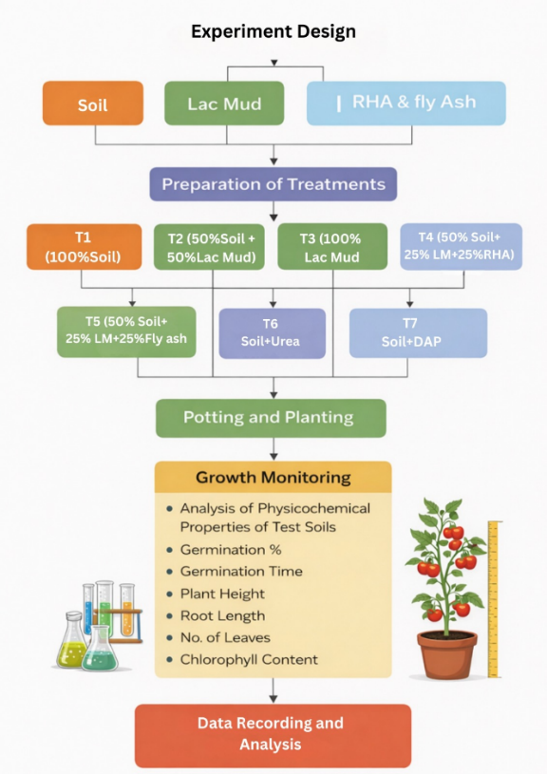

Fig.2 Experimental Design
Plant Materials
Tomato (Solanum lycopersicum) was selected as the test plant due to its sensitivity to soil nutrient status. Tomato seeds were obtained from a local agricultural supplier and surface-sterilized with 0.1% mercuric chloride (HgCl₂) for 1 minute, followed by thorough rinsing with sterile distilled water. Five seeds were sown in each box, and light irrigation was applied to facilitate germination. All pots were maintained under ambient greenhouse conditions with temperatures ranging from 25–30°C, relative humidity of 60–70%, and natural sunlight exposure for 10–12 hours per day. Irrigation with tap water was provided every alternate day to maintain adequate moisture, and no external fertilizers or pesticides were applied during the experiment.
Soil and Substrate Analysis
Before sowing, each treatment substrate (T1 to T7) was subjected to a detailed physicochemical analysis to determine its suitability for plant growth. The parameters assessed included soil texture, pH (Piper,1950), electrical conductivity (Piper, 1950), organic carbon content (Walkley and Black, 1934), available nitrogen (Kjeldahl, 1883), available phosphorus (Olsen, 1982), available potassium (Hosseinpur andZarenia, 2021), and other micronutrients (Singh and Prasad, 2022).
Plant Growth Parameters
Tomato plant growth was assessed at seven-day intervals for a total duration of 55 days after sowing, and a range of growth parameters was recorded to evaluate the impact of different treatments. The parameters measured included germination percentage, germination time, shoot length (cm), root length (cm), number of leaves per plant, and leaf chlorophyll content using spectrophotometric method (Sumanta et al., 2014).
Statistical Analysis
All data were processed using ANOVA under CRD. Means were compared using Tukey’s HSD test at p < 0.05 to determine significant differences among treatments.
Results
Characteristics of Lac Processing Waste
The lac processing waste collected from the C.K. Lac Processing Industry, Kera, Balaghat, was found to contain significant amounts of insect remnants, dust particles, dye, and spent resin. After drying, cleaning, and grinding, the waste showed a uniform particle size, making it suitable for composting and soil amendment.
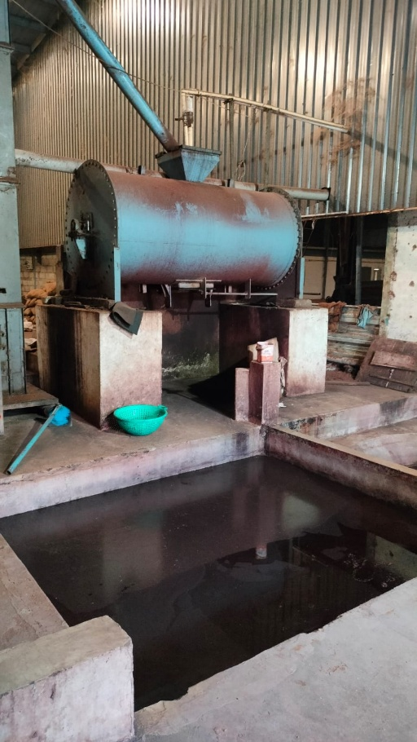
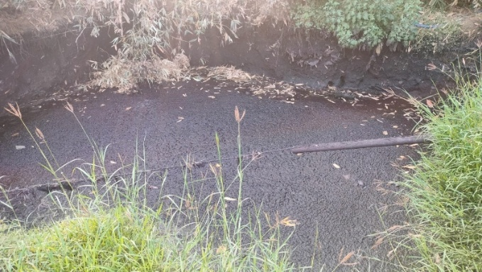
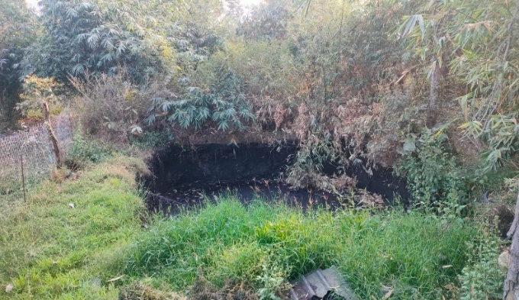
Fig. 3 Lac Processing Waste
Soil pH
Soil pH increased significantly in treatments amended with lac mud combined with RHA and fly ash (T4 and T5), indicating alkaline ash effects. The lowest pH was observed in 100% lac mud (T3). Fertilizer (urea and DAP) treatments (T6 and T7) showed moderate pH elevation compared to the control.
Table 1. Soil pH variation under different treatments
Sample | pH1 | pH2 | pH3 | Mean pH | SD
T1 | 6.8 | 7.2 | 7.9 | 7.3 | 0.556776
T2 | 6.5 | 7.1 | 7.4 | 7 | 0.458258
T3 | 6.1 | 6.5 | 6.8 | 6.466667 | 0.351188
T4 | 6.6 | 8.6 | 8.91 | 8.036667 | 1.253808
T5 | 6.4 | 8.3 | 8.66 | 7.786667 | 1.214304
T6 | 6.9 | 7.3 | 8.7 | 7.633333 | 0.945163
T7 | 6.7 | 7.51 | 8.93 | 7.713333 | 1.128819

Fig. 4 Soil pH variation under different treatments
Soil EC
Soil EC increased significantly in treatments containing T3, T5, and T6 compared to the T1 (control soil). The highest EC was observed in the T3 (100% lac mud) treatment, indicating higher soluble salt content. In T5 (RHA) moderated EC values compared to T6 (fly ash) suggesting its stabilizing effect on soil salinity.
Table 2. Soil EC variation under different treatments
Sample | EC₁ | EC₂ | EC₃ | Mean EC (dS m⁻¹) | SD
T1 | 0.45 | 0.56 | 0.10 | 0.37 | 0.24
T2 | 1.25 | 3.66 | 1.20 | 2.04 | 1.40
T3 | 2.40 | 7.97 | 2.30 | 4.22 | 3.20
T4 | 1.60 | 4.30 | 1.60 | 2.50 | 1.56
T5 | 1.90 | 6.20 | 2.40 | 3.50 | 2.19
T6 | 1.20 | 6.60 | 1.30 | 3.03 | 3.09
T7 | 1.49 | 7.60 | 1.80 | 3.63 | 3.10

Fig. 5 Soil EC variation under different treatments

Soil Organic Carbon
The highest soil organic carbon was recorded in T3 (100% lac mud) treatment due to its rich organic and resinous composition. Combined treatments with RHA and fly ash enhanced carbon stabilization, while chemical fertilizers (urea and DAP) showed minimal contribution as they supply nutrients without organic matter addition.

Fig. 6 Soil Organic Carbon variation under different treatments

Soil NPK
The nutrient analysis of different treatments revealed considerable variation in nitrogen, phosphorus, and potassium content. Nitrogen content ranged from 0.045% in T1 to the highest value of 0.11% in T6, followed by T3 (0.098%) and T4 (0.091%). Phosphorus concentration was maximum in T7 (0.065%), while the lowest was recorded in T1 (0.012%). Potassium content showed the highest level in T4 (0.52%), followed by T3 (0.44%) and T5 (0.41%), whereas T1 recorded the lowest value (0.18%). Overall, T3, T4, T6, and T7 exhibited comparatively higher macronutrient levels.

Table. 3 Soil Organic Macronutrients variation under different treatments
Treatment | Nitrogen (%) | Phosphorus (%) | Potassium (%)
T1 | 0.045 | 0.012 | 0.18
T2 | 0.082 | 0.026 | 0.32
T3 | 0.098 | 0.034 | 0.44
T4 | 0.091 | 0.041 | 0.52
T5 | 0.088 | 0.039 | 0.41
T6 | 0.11 | 0.021 | 0.2
T7 | 0.075 | 0.065 | 0.22

Fig. 7 Soil Organic Macronutrients variation under different treatments
Soil Micronutrients
Lac mud treatments (T2–T5) significantly enhanced micronutrients due to organic matter enrichment and improved chelation. Fly ash increased Fe, Mn, Ca, and Mg. RHA improved Ca and Mg availability while stabilizing micronutrients. Urea and DAP showed minimal impact on micronutrient enrichment.

Table. 4 Soil Organic Micronutrients variation under different treatments
 | S (mg kg⁻¹) | Zn (mg kg⁻¹) | B (mg kg⁻¹) | Mn (mg kg⁻¹) | Cu (mg kg⁻¹) | Fe (mg kg⁻¹) | Ca (cmol kg⁻¹) | Mg (cmol kg⁻¹)
T1 | 8.5 ± 0.6 | 0.48 ± 0.05 | 0.32 ± 0.03 | 12.4 ± 1.1 | 0.62 ± 0.06 | 18.6 ± 1.5 | 3.1 ± 0.3 | 1.4 ± 0.2
T2 | 14.2 ± 1.1 | 0.76 ± 0.08 | 0.48 ± 0.04 | 19.8 ± 1.6 | 0.88 ± 0.07 | 26.4 ± 2.1 | 4.6 ± 0.4 | 2.2 ± 0.3
T3 | 18.9 ± 1.4 | 1.05 ± 0.09 | 0.66 ± 0.05 | 25.6 ± 2.0 | 1.14 ± 0.09 | 34.8 ± 2.8 | 5.8 ± 0.5 | 2.9 ± 0.3
T4 | 16.8 ± 1.2 | 0.92 ± 0.08 | 0.61 ± 0.05 | 23.4 ± 1.9 | 1.02 ± 0.08 | 31.6 ± 2.5 | 6.4 ± 0.6 | 3.2 ± 0.4
T5 | 17.4 ± 1.3 | 0.98 ± 0.09 | 0.58 ± 0.05 | 27.8 ± 2.3 | 1.08 ± 0.09 | 38.2 ± 3.1 | 6.9 ± 0.6 | 3.5 ± 0.4
T6 | 9.6 ± 0.7 | 0.52 ± 0.05 | 0.34 ± 0.03 | 14.6 ± 1.2 | 0.66 ± 0.06 | 20.8 ± 1.7 | 3.3 ± 0.3 | 1.5 ± 0.2
T7 | 10.8 ± 0.8 | 0.58 ± 0.06 | 0.36 ± 0.03 | 15.9 ± 1.3 | 0.70 ± 0.06 | 22.4 ± 1.8 | 3.6 ± 0.3 | 1.6 ± 0.2

Germination Performance
Germination performance varied significantly among different treatments. The highest germination was observed in T4 (Lac Mud + RHA), indicating that the combined application of lac mud and rice husk ash created the most favorable conditions for seed emergence. This treatment showed superior performance compared to all other treatments.

Fig. 8 Mean Germination variation under different treatments

Growth Parameters
The growth parameters (plant height, leaf counts) of tomato plants showed a consistent increase across all treatments over time. A significant variation was observed among the lac mud treated group. The highest growth was recorded in T4 (Lac Mud + RHA) throughout the observation period, with a sharp increase by 9 February, indicating superior vegetative performance. Treatments T3 (100% Lac Mud) and T1 (100% Soil) also showed steady and comparatively higher growth after 30 January. Moderate growth was observed in T5 (Lac Mud + Fly Ash) and T7 (DAP), while T6 (Urea) and T2 (50% Lac Mud) exhibited relatively lower growth increments. Overall, lac mud-based treatments, particularly when combined with rice husk ash, significantly enhanced plant growth compared to sole chemical fertilizer applications.

Fig. 9 Mean Germination variation under different treatments

Fig. 10 Mean Leaf count variation under different treatments

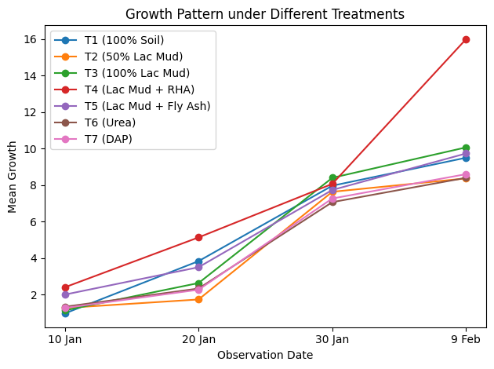

Fig. 11 Growth pattern under different treatments
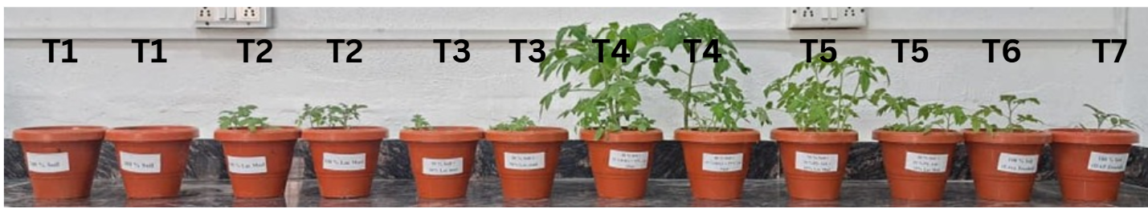

Fig. 12 Pot culture experiment under different treatments (T1 to T7)
Chlorophyll Content
The graph shows that total chlorophyll (Chl-T) content is highest in treatment T4, closely followed by T5. Chlorophyll-b (Chl-b) is consistently higher than Chlorophyll-a (Chl-a) across all treatments. Treatments T6 and T7 show a noticeable decline in total chlorophyll compared to earlier treatments. Overall, moderate variation in chlorophyll content is observed among the different treatments.
Table 5 Chlorophyll Content of plants under different treatments
Treatment | A₆₆₄ | Ch-a (mg/ml) | A₆₄₉ | Ch-b (mg/ml) | Ch-T (mg/ml)
T1 | 1.738 | 14.32 | 1.714 | 32.9 | 47.22
T2 | 1.670 | 13.66 | 1.666 | 32.13 | 45.79
T3 | 1.668 | 13.58 | 1.676 | 32.42 | 46
T4 | 1.689 | 14.78 | 1.691 | 33.66 | 48.44
T5 | 1.694 | 13.96 | 1.708 | 33.6 | 47.56
T6 | 1.679 | 14.2 | 1.586 | 29.87 | 44.07
T7 | 1.673 | 14.54 | 1.504 | 27.66 | 42.2
(Ch-a=13.36A₆₆₄ – 5.19 A₆₄₉, Ch-b=27.43A₆₄₉ – 8.12 A₆₆₄)

Fig. 13 Chlorophyll Content of plants under different treatments
Discussion
The present study evaluated the effect of lac processing waste and its combinations with soil and amendments on tomato growth under seven treatments (T1–T7). The results clearly demonstrate that substrate composition significantly influenced germination, vegetative growth, chlorophyll content, and biomass accumulation.
The control treatment (T1: 100% soil) provided baseline growth, reflecting inherent soil fertility without amendment support. Incorporation of lac waste at 50% (T2) improved germination and vegetative parameters compared to T1, indicating that moderate organic enrichment enhances soil structure, moisture retention, and nutrient availability. Organic amendments increase soil aggregation and cation exchange capacity, thereby improving nutrient uptake efficiency (Brady & Weil, 2016).
In T3 (100% lac waste), growth performance declined relative to T2, suggesting that excessive organic residue may lead to poor aeration, temporary nitrogen immobilization, or accumulation of undecomposed resinous compounds. Similar inhibitory effects of high organic loading have been reported in industrial by-product applications where incomplete decomposition reduces seedling vigor (Hargreaves et al., 2008).
The combined treatments T4 (lac waste + RHA) and T5 (lac waste + fly ash) showed superior performance, particularly T4, which recorded the highest growth and chlorophyll content. Rice husk ash likely improved aeration and provided silica, enhancing stress tolerance and nutrient balance. Fly ash contributed micronutrients such as Fe and Mn, supporting chlorophyll synthesis. Previous studies indicate that ash amendments improve soil physicochemical properties and micronutrient availability when applied in balanced proportions (Adriano et al., 2000; Pandey & Singh, 2010).
Chemical fertilizer treatments showed contrasting responses. T6 (urea) enhanced vegetative growth initially due to rapid nitrogen availability but did not sustain superior performance, possibly because sole nitrogen application without organic matter reduces soil structural stability. T7 (DAP) improved phosphorus availability but showed moderate overall growth compared to integrated organic treatments. Integrated nutrient management approaches combining organic and inorganic sources are widely recognized for sustaining soil fertility and crop productivity (Mahajan et al., 2008; Agegnehu et al., 2017).
Overall, the results confirm that lac waste has significant potential as an organic soil amendment. However, its effectiveness is maximized when blended with soil and complementary materials such as RHA or fly ash rather than applied alone. These findings support the concept of recycling agro-industrial residues within sustainable agricultural systems.
Conclusion
The study confirms that lac processing waste can be effectively utilized as an organic amendment for tomato cultivation when applied in balanced proportions. Among all treatments (T1–T7), integrated applications—particularly lac waste combined with soil and rice husk ash (T4)—produced the best results in terms of germination, vegetative growth, chlorophyll content, and biomass. Moderate incorporation (T2) also improved soil fertility and plant performance compared to control (T1). However, 100% lac waste (T3) was less effective, indicating the need for blending or composting. Overall, lac waste shows strong potential for sustainable agriculture and eco-friendly waste management.

References
Adriano, D. C., Page, A. L., Elseewi, A. A., Chang, A. C., & Straughan, I. (2000). Utilization and disposal of fly ash and other coal residues in terrestrial ecosystems: A review. Journal of Environmental Quality, 9, 333–344.
Agegnehu, G., Bass, A. M., Nelson, P. N., & Bird, M. I. (2017). Benefits of biochar, compost and biochar–compost for soil quality and crop performance. Agriculture, Ecosystems & Environment, 240, 1–13.
Agase Durgesh, Sheefa Khan, Madhvi Bisen, and Harsh Tiwari. (2025). “Colorimetric Quantification of CO₂ in a Modified Alkali-Trap Soil Respiration Assay”. International Journal of Plant & Soil Science 37 (11):525-35.
Bernal, M. P., Alburquerque, J. A., & Moral, R. (2009). Composting of animal manures and chemical criteria for compost maturity assessment. Bioresource Technology, 100(22), 5444–5453.
Brady, N. C., & Weil, R. R. (2016). The nature and properties of soils (15th ed.). Pearson Education.
Hargreaves, J. C., Adl, M. S., & Warman, P. R. (2008). A review of the use of composted municipal solid waste in agriculture. Agriculture, Ecosystems & Environment, 123(1–3), 1–14. https://doi.org/10.1016/j.agee.2007.07.004
Hosseinpur, A., & Zarenia, M. (2021). Determination of available potassium in soil using ammonium acetate extraction method. Journal of Soil Science and Plant Nutrition, 21, 1234–1242.
Kjeldahl, J. (1883). Neue Methode zur Bestimmung des Stickstoffs in organischen Körpern. Zeitschrift für Analytische Chemie, 22, 366–382.
Lal, R. (2015). Restoring soil quality to mitigate soil degradation. Sustainability, 7(5), 5875–5895. https://doi.org/10.3390/su7055875
Lim, S. L., Wu, T. Y., Clarke, C., & Wang, C. (2016). A potential of composting and vermicomposting for organic solid waste management. Bioresource Technology, 222, 443–452. https://doi.org/10.1016/j.biortech.2016.09.084
Mahajan, A., Bhagat, R. M., & Gupta, R. D. (2008). Integrated nutrient management in sustainable rice–wheat cropping system. Indian Journal of Agricultural Sciences, 78, 913–917.
Olsen, S. R. (1982). Estimation of available phosphorus in soils by extraction with sodium bicarbonate (USDA Circular No. 939). United States Department of Agriculture.
Pandey, V. C., & Singh, N. (2010). Impact of fly ash incorporation in soil systems. Journal of Environmental Management, 91, 603–611. https://doi.org/10.1016/j.jenvman.2009.09.013
Piper, C. S. (1950). Soil and plant analysis. University of Adelaide.
Saha, D., & Sen, K. (2016). Lac culture in India: Present status and future prospects. Indian Journal of Natural Resins and Gums, 29(1), 1–7.
Sharma, K. K., Jaiswal, A. K., & Kumar, K. K. (2018). Lac production, processing and value addition in India. Current Science, 114(5), 983–990.
Singh, R., & Prasad, R. (2022). Assessment of available micronutrients status in the soils of Macuata Province of Fiji. International Journal of Plant & Soil Science, 34(23), 1792–1797. https://doi.org/10.9734/ijpss/2022/v34i2331463
Sumanta, N., Haque, C. I., Nishika, J., & Suprakash, R. (2014). Spectrophotometric analysis of chlorophylls and carotenoids from commonly grown fern species by using various extracting solvents. Research Journal of Chemical Sciences, 4(9), 63–69.
Walkley, A., & Black, I. A. (1934). An examination of the Degtjareff method for determining soil organic matter and a proposed modification of the chromic acid titration method. Soil Science, 37, 29–38.

