Case report

Primary Localised Urinary Bladder Amyloidosis: A mimicker of Malignancy Clinicians Should Know

Abstract:

Aim:

To study clinical features of primary urinary bladder amyloidosis, to identify it, to differentiate it from urinary bladder malignancy and to treat the disease.

Case Presentation
We present a case of 51-year-old gentleman presented with painless gross hematuria who was a known case of Nonalcoholic SteatoHepatitis (NASH) associated chronic liver disease. Ultrasound revealed a large blood clot without any evidance of mass or lesion. Cystoscopy revealed a flat lesion near trigone and biopsied. Lesion completely respected and surprisingly histopathology turned out to be localised amyloidosis which was confirmed with immunohistochemistry (IHC) profile. With in 6 months patients had recurrence and repeat trans urethral resection was performed. After that patients remained asymptomatic for 18 months and still under follow up with out recurrence.
Discussion
The aetiology of bladder amyloidosis is poorly understood. There are two different schools of thoughts. Most researchers think that it is abnormal metabolism of protein which causes amyloidosis. While others think that it is a sequela of chronic urinary tract infection or repeated inflammation of mucosa and submucosa. Investigation protocol includes basic blood investigations, urine for cytology, ultrasound and CT-IVP and cystoscopic resection and Histopathological examination conclude the diagnosis. As the recurrence is known phenomenon, strict cystoscopic follow up is necessary.
Conclusion:
Primary urinary bladder amyloidosis mimics bladder malignancy clinically. Thus it is of utmost importance to distinguish between both of them and to treat them accordingly.

Keywords:
Primary urinary bladder amyloidosis, painless hematuria, trans urethral resection

1. INTRODUCTION
Amyloidosis is a group of heterogeneously acquired or hereditary entity that results from the abnormal deposition of beta-sheet fibrillar protein called amyloid protein in various tissues.(Zhao et al., 2017) It was first described by Solomon et al. (Gomha et al., 2018) Amyloidosis can either be primary or secondary. Primary amyloidosis also known as AL is associated with lymphoplasmacytic cell abnormalities while secondary amyloidosis (AA) is a result of long-standing infections, inflammation, or neoplastic insults. This disease has tendency to be localised or to become systemic disease with amyloid accumulating in the spleen, liver, kidney, blood vessels and nerves. Patient presents with painless gross hematuria without other LUTS. Amyloidosis of the bladder is a rare benign condition, and accounts for around 1–2% of all bladder tumour aetiology with less that 400 reported cases worldwide.(Gomha et al., 2018) As malignancy of the bladder also present with similar complaints, of is of utmost importance to diagnose amyloidosis and to rule out systemic amyloidosis with poses poor prognosis.We hereby present a case of primary bladder amyloidosis with a known case of chronic liver disease who initially presented as painless gross hematuria with passing of blood clots and n transurethral resection diagnosed as amyloidosis of urinary bladder.

2. CASE PRESENTATION
A 51-year-old gentleman who was a known case of NASH associated chronic liver disease with painless gross hematuria with passage of blood clots in urine without any other LUTS like dysuria, urgency or frequency. On presentation, patient had low platelet count (37000/dl), which initially was thaught to be the cause of hematuria. On ultrasound examination, there was a 36x21mm blood clot inside the urinary bladder. After adequately preparing the patient, cystoscopy was done which showed a large blood clot with Flat lesion near bladder trigone which was resected and send for Histopathological examination (HPE). On, HPE it turned out to be localised amyloidosis of urinary bladder with positive special stains like, CONGO RED and THIOFLAVIN T. (Figure 1)
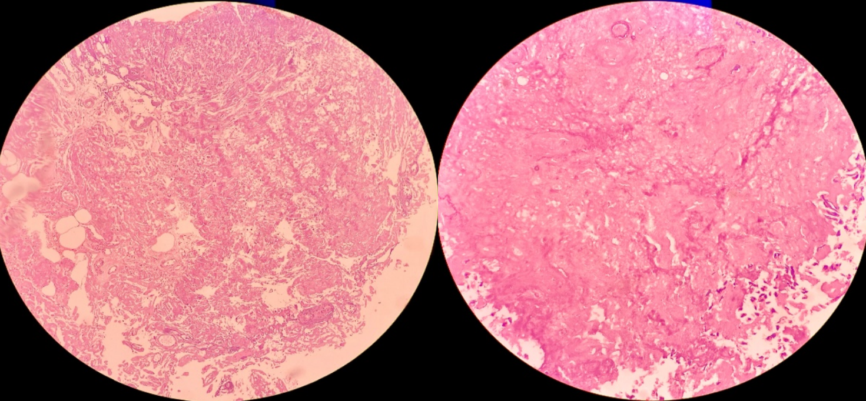
Figure 1- Amorphous eosinophilic amyloid material in the bladder wall on H&E stain suggestive of amyloidosis –(original image)
Patient was thoroughly investigated for other sites of amyloidosis but no other primary site of amyloidosis could be identified. Thus, diagnosis of primary amyloidosis was confirmed. Patient was then kept on active surveillance every 3 months. After 6 months patient again presented with similar complaints i.e, painless hematuria and urinary bladder clot. On ultrasonography, 26x17x20 mm blood clot was seen. No other abnormality was detected on ultrasound. On repeat cystoscopy, a 09mm x 05 mm size sessile growth at right lateral wall was identified and completely resected. Histopathology again had similar findings of amyloidosis. This time IHC markers were done which showed mildly over-expressed KAPPA chain than Lambda. Post operatively there was no episodes of hematuria. Patient was discharged with stable vitals and no active hematuria. Patient is asymptomatic at present after a close 3 monthly follow up reaching 24 months.

3. DISCUSSION
The aetiology of bladder amyloidosis is poorly understood. There are two different schools of thoughts. Most researchers think that it is abnormal metabolism of protein which causes amyloidosis. While others think that it is a sequela of chronic urinary tract infection or repeated inflammation of mucosa and submucosa. (Pan & Na, 2011) According to one theory, chronic inflammation of the bladder causes an influx of lymphoplasmacytic cells into the submucosa of the bladder. These cells become monoclonal cells that secrete an abnormal light chain type immunoglobulin. (Gomha et al., 2018) It’s a rare disease with less then 400 reported cases worldwide till date. Initial presentation varies patient to patient from painless gross hematuria being the most common presentation to dysuria, frequency like irritative symptoms being others. Investigation protocol includes urine analysis, urine culture, urine for cytology and radiological evaluation in the form of Ultrasound and CT-IVP. Confirmation of the disease was given by histopathological examination of the tissue after transurethral resection of the lesion. The primary treatment of primary urinary bladder amyloidosis is transurethral complete resection of the lesion. After initial resection of the tumour, a surveillance protocol in the form of check cystoscopy at 3, 12 and 24 months post transurethral resection should be made. (Pyrgidis et al., 2021) Our patient also presented with recurrence within 6 months of first presentation. If the operation is difficult because of the location of the lesion like juxta bladder neck or at the dome of the bladder, partial cystectomy can be performed. Dimethyl sulfoxide (DMSO) bladder perfusion is another modality of treatment which can be used to treat or prevent recurrence. Few reports suggest synergistic effect of cephalexin together with bladder infusion of DMSO. However, whether to use DMSO perfusion to prevent recurrence remains controversial. Use of oral colchicine is also mentioned in literature however, their clinical application remains unclear. (Gomha et al., 2018) Primary urinary bladder amyloidosis shows a high rate of recurrence. Tirzaman et al. followed 31 patients with localised bladder amyloidosis and observed that in 25% of patients the condition resolved, and the patients became disease-free, 21% had persistent disease and 54% showed recurrence. (Tirzaman et al., 2000) In our case, patient had a recurrence within 6 months of primary reaction which was again resected and now the patient is kept on strict follow up surveillance.
4. CONCLUSION
Primary urinary bladder amyloidosis is a rare clinical entity which may present with symptoms that mimic malignancy. Thus, one should keep in mind while evaluating such patients. Sometimes it may be the only manifestation of systemic amyloidosis and thus thorough check for systemic amyloidosis should be done. Transurethral resection remains the mainstay of the treatment even in cases of recurrence. As this disease is prone for recurrence long term follow up is recommended.

Declarations:
Conflicts of interest: none
Ethical Approval: Not applicable
Patient Consent: Obtained

COMPETING INTERESTS DISCLAIMER:
Authors have declared that they have no known competing financial interests OR non-financial interests OR personal relationships that could have appeared to influence the work reported in this paper.

References:
- Zhao, L., Jin, L., Quan, J., Pan, X., Zhou, L., Peng, J., ... & Lai, Y. (2017). Primary amyloidosis of the urinary bladder: a case report. Urology Case Reports, 13, 1-2.
- Gomha, F. S., Smain, A. M., Sohail, N., Yousif, A. A., Abdelrahman, K. M., Amir, E., & Bhatti, K. H. (2018). Primary localised amyloidosis of the urinary bladder: a recurrent and progressive disease. Journal of Taibah University medical sciences, 13(4), 398-401.
- Pan, D. L., & Na, Y. Q. (2011). Amyloidosis of the unilateral renal pelvis, ureter and urinary bladder: a case report. Chinese Medical Sciences Journal, 26(3), 197-200.
- Pyrgidis, N., Mykoniatis, I., Pegios, V. F., Sokolakis, I., Hatzichristodoulou, G., Bourdoumis, A., ... & Sountoulides, P. (2021). Amyloidosis of the urinary bladder: a systematic review and a proposed management algorithm. Urology, 156, e12-e19.
- Tirzaman, O., Ahner-Roedler, N. L., Malek, R. S., Sebo, T. J., Li, C. Y., & Kyle, R. A. (2000, December). Primary localized amyloidosis of the urinary bladder: a case series of 31 patients. In Mayo Clinic Proceedings (Vol. 75, No. 12, pp. 1264-1268). Elsevier.

List of abbreviation:
NASH - Nonalcoholic SteatoHepatitis
IHC- immunohistochemistry
LUTS- Lower Urinary Tract Symptoms
HPE- histopathological Examination
CT-IVP- CT scan- Intra Venous Pyelography
DMSO- Dimethyl Sulfoxide

