Original Research Article
Isolation, Purification and characterization of β-1,3 glucan binding protein in the serum of mole crab Emerita asiatica

Abstract:
Β-1,3glucan binding protein (β GBP) has been identified in the Emerita asiatica, mole crab serum and βGBP, which is the potential hemagglutination inhibitor was purified from serum with the use of precipitation of laminarin and the affinity chromatography on laminarin (β GBP) -Sepharose 6B.Current work shows that hemagglutination, hemagglutination inhibition, bacterial agglutination and bacterial inhibition exhibit defense mechanism of mole crab, Emerita asiatica against assays. Also, the purified proteins’s carbohydrate binding specificity is reconfirmed, and electrophoresis and immunological properties of the purified protein are also investigated. It agglutinates baker’s yeast, bacteria, improved prophenoloxidase(proPO) and erythrocytes of the serum in dosage dependentmanner. The purified-βgbp found as the single band in the nativePAGE where determination of molecular weight was performed and the HPLC confirm the purity. Further the purified β GBP has been observed as a single band in isoelectric focussing and has characteristic activity of serine protease but nil β13glucanase activity. These outcomes suggested that serum β GBP of the mole crab Emerita asiatica has been observed to be an recognition molecule for β -1,3-glucan on the microbial cell wall surface. The recognitiona nd binding activates the prophenoloxidase cascade mediated by the characteristic activity of serine protease β GBP. The existence of agglutinating activity and the serine protease activity depicted that the β GBP is bifunctional. Such findinds are being discussed with the view of importance of this protein that implicates the evolutionary links with similar proteins in the other invertebrates.
Keywords: Agglutin activity; Affinity chromatography; βGBP.Emerita asiatica;
1. Introduction:
Purification of protein from its native state is the major process done before defining its specific sugar binding affinity and molecular characterization. Purification of agglutinin can be done effectively if the agglutinin sugar specificity is reasonably established using affinity chromatography. Sialo-conjugates on the pathogenic bacterial cell surface are the diversified form of β-1,3 glucan linked via glycosidic linkage with adjacent sugars in sialo epitopes and human cancer (Ravindranath et al., 1984) Hence potential library could be formed as a diagnostic tool by defining the specificity of different forms of β-1,3 glucan and its glycosidic linkages in identifying the sialyl-epitopes of malignant tumor cells and pathogenic bacteria.Work on β-1,3 glucan specific protein is so scarce among. Although phylogenetically mole crustaceans are closely related to macura and brachyura crustaceans, the perusal of literature shows that very little studies have been undertaken for the characterization of agglutinins in moles (Murali et al., 1999). Agglutinins are potentially important class of recognition proteins in invertebrates (Vasta, 1983). The binding affinity is influenced by physico-chemical factors of the medium during reversible binding of agglutinin to interacting sugars. Apart from certain compounds isolated from certain species, about 60% of anticancer drugs available currently are discovered from marine species (Cragg et al., 1997). These drugs plays a significant role in the cancer chemotherapy in solid tumors and hemotological to the clinical armamentarium in oncology. The present study aims in evaluating the property of β-1,3 glucan in Emerita asiatica, serum agglutinin has been isolated using affinity chromatography using β-1,3 glucan coupled agarose. The carbohydrate binding specificity of the purified protein is reconfirmed, and the electrophoretic and immunological properties of the purified protein are also investigated. Also, an attempt has been made to survey the existence of agglutinins in the mole crab hemolymph for selecting further detailed study. Non self identification comprise pattern recognition proteins which identifies and responds to the mocrobial invaders. They lack the antibodies specificity and binds to certain polysaccharides classes.Isolation of serum agglutinin utilising affinity chromatography with β-1,3 glucan linked agarose is the main objective of this work, which is to assess the characteristics of βgbp found in Emerita asiatica serum. Examining and validating the purified protein's electrophoretic and immunological characteristics as well as its carbohydrate binding selectivity. This study aims to find out whether βgbp, which is taken from the serum of mole crabs (Emerita asiatica), has anti-cancer properties and whether it has anti-proliferative properties, which will be evaluated using MTT assay. In conjunction with hemocytes, agglutinins are a particular type of proteins that aid crustaceans' immune systems in effectively immobilising pathogens. These proteins stimulate phagocytosis, nodulation, and encapsulation, which in turn aid to initiate cellular immunological responses in crayfish and blue crab. Several studies have identified and characterised isoforms of agglutinin, and these forms can be distinguished from one another by changes in mass. Injecting bacteria into invertebrates, particularly crustaceans, has been found to significantly lower serum agglutinin levels, suggesting that these organisms can generate altered states of defensive reactivity (Ottaviani et al., 2006). A wide range of creatures, including both vertebrates and invertebrates, produce antimicrobial proteins as part of their non-specific innate immune response. Peptides with a high proline and glycine content are another type of peptide that is prevalent in insects, crustaceans, and mammals. Rather than bacteriolytic action, these gram-positive peptides display bacteriostatic activity by inhibiting bacterial growth. Some animals, like crayfish and blue crabs, have agglutinins that help with cell identification and set off processes like phagocytosis, nodulation, and encapsulation. Many biological processes rely on these agglutinins, including cell aggregation, embryonic development, metamorphosis, wound healing, and glucose transport. Prior to determining its unique sugar binding affinity and molecular characterisation, the primary step is to purify the protein from its natural condition. Successful agglutinin purification requires reasonable determination of the agglutinin's sugar specificity by affinity chromatography. In pathogenic bacteria, Sialoconjugates can be found on their cell surfaces. These are a variety of β-1,3 glucan that are connected to neighbouring sugars in sialo epitopes and have been studied in relation to human cancer (Ravindranath et al., 1985; Kawai et al., 1991; Ravindranath et al., 1984). Hence, a possible diagnostic tool might be created by determining the sensitivity of various β-1,3 glucan forms and their glycosidic linkages in recognising the sialyl epitopes of harmful bacteria and cancerous tumour cells. Research on proteins that are unique to β-1,3 glucan is quite limited. According to (Murali et al. 1999), there has been less research on mole agglutinin characterisation, despite the fact that mole crustaceans are intricately linked to macura and brachyura crustaceans phylogenetically. The earliest attempts at partial protein purification from invertebrates were by (Söderhäll et al. 1988) and (Ochiai et al. 1988), using insect serum (Blaberus craniifer) and silkworm (Bombyx mori) respectively. The researchers demonstrated that the hemocyte proPO system was activated through peptidases by this isolated serum component. Afterwards, a plethora of researchers set out to isolate these proteins from invertebrate tissues. The majority of these investigations have isolated this protein using the affinity precipitation approach. The researchers have utilised a variety of column chromatography methods, including laminarin-coupled affinity matrices, in at least 19 species. On top of that, nearly every investigator has used a multistep purification strategy that includes various types of chromatography and the usage of affinity matrix with several ligands such as laminarin, heparin, zymosan, or antibodies produced against the serum proteins precipitable by laminarin, was employed in up to fourteen research". The level of purification fold attained ranges from I to 730, but only three or four researchers have explicitly stated it in these investigations. Surprisingly, a multistep process involving Dextran Sepharose affinity chromatography and twice gel filtration on Sephacryl S-300 columns I and Il resulted in a purification of 150, 228 and 730 folds, respectively, in crustaceans and insects, and in one species of Limulid (Tachypleus tridentatus). There is a lack of comprehensive data regarding the native and subunit molecular mass of β GBP isolated from these animals. Consequently, there was no evidence of non-uniformity in the data pertaining to the physical properties and subunits of β GBP molecules that were derived from invertebrates.

2. Review of Literature:
Many previous studies have demonstrated the presence of opsonins or lectins in the bivalve crustacean circulating fluid (Mullainadhan et al., 1986; Asokan et al., 1997), but neither the presence nor the functional characterisation of β -l,3 glucan binding proteins from crustaceans have been reported. Here, prior research on P. viridis found that laminarin, a β -l,3 glucan polymer, dose-dependently activated the proPO system in serum and hemocytes (Asokan et al., 1997; Asokan et al., 1998). This activation aided the phagocytic response of hemocytes against yeast cells. The early attempts to classify bivalve hemocytes utilised a wide range of methods, which led to inconsistent results and the adoption of a plethora of technologies for hemocyte characterisation (Hine, 1999). These polysaccharides, interestingly, are first recognised and bound by a class of proteins called βgbp that has specificity for β -1,3 glucans. This protein has also been shown to play vital immunological roles, in terms of coagulation, recognition and enhancement of defense reaction, in arthropods (Chen et al., 1998) βGBP has been detected in a variety of arthropods including insects and crustaceans and have been either implicated in a variety of cellular functions such as phagocytosis, encapsulation, nodule formation etc., or directly involved in phagocytosis (Cerenius et al., 1994). On the other hand, βGBP in crustaceans activates this system by stimulating prophenol oxidase activity (Cerenius et al., 2008; Jiravanichpaisal et al., 2006). Various studies on this aspect revealed the importance of hemocoel dispersing several antigens via cellular and humoral immune system. Invertebrate serum is known to contain variety of factors which trigger various immune responses against invading foreign materials. Prophenol oxidase(proPO) is also another major component in crustacean as well as arthropods immune system. This is a unique immune system found in both insects and crustaceans. But in crustaceans the activity of this system is exerted by βGBP by inducing the activity of prophenol oxidase (Cerenius et al., 2008; Jiravanichpaisal et al., 2006).Actual process of immune response in crustacean includes phagocytosis or encapsulation of invasive organisms including tumour cells in research of human along with other damaged cells or tissues of its own surrounding cells (Vogt et al., 1996; Cerenius et al., 2008; Ottaviani, 2006). Research into crustacean serum could yield a number of antibacterial agents and proteins due to the high protein content of this fluid. The respiratory protein, βGBP, makes up the majority of the proteins in crustacean serum, accounting for around 60-95% of the total (Balaji et al., 1989; Noga, 2000), with the clottable protein following closely behind. Because serum permeates all of the body's tissues and cells, it makes sense that the profiles of the different components of serum would show how the internal environment has changed as a result of harmful physiological, pathological, or environmental factors. Results from qualitative analyses of serum proteins βGBP in mole crab Emerita asiatica are few, in contrast to the numerous research that concentrated on quantitative analyses (Rameshthangam et al., 2005; Pais et al., 2007). An important component of aerobic respiration for the majority of metazoans is the transfer of carbon dioxide and oxygen. According to (Bonaventura et al. 1980), certain respiratory pigments, including hemoglobins, hemerythrins, and βGBPs, are proteins that contain metals and have developed to aid in this function. In hemoglobins, one oxygen-binding site is a single iron atom bound to a heme group; in hemerythrins, two iron atoms are bound by amino acid side chains; and in βGBPs, two copper atoms are bound directly to side chains. In all three types of respiratory proteins, the oxygen-binding site is completely different. Mangum (1997) and Hodgson et al. (2001) found that βGBPs are present in a large variety of arthropod and crustacean taxa. Onychophorans, myriapods, chelicerates, and crustaceans are the four groups of arthropods that have βGBP. It is worth noting that the presence of βGBP in the blood of both adult and nymph Perla marginata stone fly insects has been proven (Hagner-Holler et al., 2004). It seems that Amphineura, Gastropoda, and Cephalopoda are the crustacean classes where this respiratory protein is present, however Scaphopoda and Lamellibranchiate do not. So, βGBP is found in many different kinds of invertebrates and is used as an example of a protein to study how huge multi-subunit proteins are assembled and the links between their individual functions. The two qualities likely sparked natural curiosity among physiologists, comparative biochemists, and zoologists, who planned to conduct a comprehensive study to understand the structural and functional properties of βGBP. Many kinds of crustaceans have also been the subject of substantial research on βGBPs. A hexameric protein with a molecular mass of 450 kDa has been described for the majority of decapod crustaceans studied (Gaykema et al., 1984; Jaenicke et al., 2007). According to Guan et al. (2003), the number of monomers in non-decapod crustaceans can vary from 2 to 6, and in exceptional cases even up to 17, with sizes being slightly variable. In addition, the βGBP found in the serum of a small number of decapod crustaceans can be found in two forms: hexameric and dodecameric. The dodecameric form is likely the result of the aggregation of two βGBP units, as shown by (Fernando et al. 2008). The βGBP protein is famous for transporting oxygen, but it also has an impressive role as an osmolyte (Paul et al., 1998; Fernando et al., 2008). The binding of heavy metals like iron by βGBPs of crustaceans has been documented in multiple in vitro investigations (Guary et al., 1980). The macrofauna of these intertidal sandy beaches may see variations in their biology, frequency, and nature as a result of changes in the hydrographic state. Macrofauna survival rates are likely to be organism-specific and defined by biology and strategy. Pattern recognition protein is one kind of protein that aids in the eradication of pathogenic germs like fungi, bacteria, and viruses. This is because these proteins bind to certain polysaccharides but do not have specific receptors. The interaction between hemocytes and the cellular immune response is influenced by βGBP, which is also known as β glucans and β-1,3 glucan binding protein. In crustaceans, the immunological response is successfully induced by β-1,3 glucan binding protein (βGBP). Serum β-1,3 glucan binding protein is induced when marine crabs eat microalgae and fungi.

- Materials and Methods

  - Isolation of βGBP precipitable substance from serum
The technique outlined in Duvic et al., (1990) was used to isolate the βGBP precipitated protein, also known as the βgbp. In a nutshell, the serum was spun at 25,000 x g for 15 minutes at 4⁰C. After that, 20 ml of the resulting (supernatant I) has been combined with laminarian. Separate tubes were used for the purpose of collecting the supernatant (supernatant II) after ultracentrifugation (25,000 x g, 15 min, 4⁰C) of the aforementioned mixture. In 1 millilitre of TBS-Ill, the pellet was dissolved. The same buffer was used to thoroughly dialyse both the dissolved pellet and the supernatant II, ensuring that both passed the MW exclusion limit of less than 14,000 Da. After that, the hemagglutination, yeast agglutination, and PO boosting activities of each of these fractions were examined. Whenever necessary, the pellets obtained from different preparations were pooled, processed as described above and then lyophilized.

  - Preparation of βGBP - Sepharose affinity column
Immobilising laminarin to Sepharose 6B, as described by Chen et al. (1999), was the first step in preparing the affinity matrix. Just a quick rundown: 1.5 g of epoxy-activated Sepharose 6B were left to swell in 20 ml of double-distilled water with 0.02% NaN3 for 12 hours at room temperature. The 5 ml of wet gel was rinsed with a mixture of 100 mM NaOH and double distilled water. One millilitre of 100 mM NaOH containing 80 mg of laminarin was added to the gel right after decanting the NaOH solution. The mixture was then shaken and incubated at 45⁰C for 16 hours. Following this, the gel was thoroughly rinsed with 0.9% saline, 100 mM borate buffer (pH 8.4), and 100 mM acetate buffer-II (pH 4.0), all of which included 500 mM NaCl. After the gel was ultimately adjusted with TBS-I, it was moved to a polypropylene column measuring 0.8 x 12.0 cm.

  - Purification of βgbp from serum of Emerita asiatica
Serum was isolated from a serum sample taken from Emerita asiatica following the procedures outlined. To provide agglutination titer of 16 against trypsinised yeastcells, the serum was diluted with an equal volume of TBS-I. To confirm that the yeast agglutinating activity had bound to the matrix, the sample was run through a laminarin-Sepharose 6B (0.8 x 12.0 cm) column at a flow rate of 3 ml/hr at 25⁰C. The effluent was then tested for agglutinating activity against trypsinised yeast cells. By washing the column with TBS-I until the effluent absorbance at 280 nm nearly reverted to zero, the unbound serum components were eliminated. After that, the bound components were extracted using acetate buffer-III, which had a pH of 4.5 and contained 2.5 M MgC1₂ and 1 M D-glucose. The components exhibiting 280 nm absorbance were gathered and subjected to prolonged dialysing against TBS-I at 10⁰C with a M W exclusion limit of less than 14,000 Da. If needed, the lyophilised fractions containing the agglutinating activity were combined and kept at -10⁰C until needed. We used trypsinised yeast cells to test the effluents (one ml fractions) collected during adsorption, washing, re-equilibration, and elution for agglutinating activity. The flow rate for all the chromatographic processes was 3 ml/hr. The laminarin-Sepharose 6B column was regenerated after βGBP elution by thoroughly washing it with M MgCl₂ and then re-equilibrating it with TBS -I.

  - Electrophoretic analysis of purified βGBP
Maurer’s method was used for electrophoretic process of eluted β-1,3 glucan binding protein in discontinuous PAGE. SDSPAGE obtained proteins were stained with silver nitrate.

  - HPLC analysis of purified βGBP
A HPLC system developed by Shimadzu (Model: SPD 10A UVeVisible) was employed to verify the consistency of the purified β-1,3 glucan binding protein. The pure β-1,3 glucan binding protein was analysed using a LKB 2117 multiphore equipment coupled with a LKB 2197 constant power supply.

  - Circular dichroism spectroscopy of purified βGBP
JASCO j-715 spectropolarimeter was used for obtaining CD spectra in an average of 3 seconds with mean deviation less than 2%.

  - Collection of mammalian blood samples
We recruited departmental volunteers to donate blood, which included A, B, and O blood types. The blood samples of sheep, goats, oxen, and buffalo were obtained from the Government abattoir in Perambur, Chennai. Our laboratory's rabbits, rats, and mice were used as blood donors. After being drawn into Alsever's solution via a venous or heart puncture, all of the blood samples were promptly utilised within five days after collection and kept at 10⁰C.

  - Preparation of RBC suspension
Blood for hemagglutination assay was obtained by heart puncture (Rat) or venipuncture of the ear (rabbit), or forearm (man, dog, cow, and buffalo), or neck (horse and donkey) or from slaughterhouse (pig, sheep, and goat). Erythrocytes were directly collected in modifiedAlsevier's medium. Suspended erythrocytes were washed three times with ten volumes of Tris-buffered saline and resuspended in TBS as 5% suspension.

  - Hemagglutination Assay of purified βGBP
25 µl of protein was diluted with TBS-BSA and mixed with 25 µl of 10.5% of erythrocyte suspension. Serum, β-1,3 glucan -precipitable substances (pellet) and affinity-purified β-1,3 glucan (53 mg/ml as initial concentration) were utilized for performing hemagglutination, yeast and bacterial agglutination assays. Test substances were diluted in TBS-II for performing agglutination assays.

  - Hemagglutination inhibition assay of purified βGBP
25 µl of inhibitors were diluted with 25 µl TBS-BSA and 25 µl of purified βgbp solution was added to inhibitor-dilution with 4 HA titer value. This solution was incubated at room temperature for an hour and mixed with 25 µl of 105% of erythrocytes suspension. Test samples were diluted with purified β-1,3 glucan binding proteins and incubated for an hour and was again added with trypsinized yeast cells and further incubated for 3 hours.

  - Preparation of yeast cell suspension
About 100 mg of baker’s yeast was heat inactivated using autoclave. Later the cells were resuspended in TBS-I as 0.5% suspension after washing with 0.9% of saline. The suspension underwent centrifugation at 400 × g for 5 minutes at room temperature and was thoroughly washed with saline. The yeast was then resuspended in the original medium. To heat-inactivate the cells, the yeast suspension was autoclaved for 15 minutes at 15 psi. After cooling to room temperature, the inactivated yeast cells were rinsed with 0.9% saline and subsequently resuspended in 0.5% TBS-I (v/v).

  - Yeast cells Trypsinization
Yeast cells were trypsinized by suspending it in 1 ml of TBS-II containing trypsin and incubated at room temperature for an hour. To achieve a final concentration of 0.5%, 5 μl of washed yeast cells were suspended in 1 ml of TBS-I containing 0.5% trypsin. The mixture was incubated at 37°C for one hour with occasional gentle shaking. Following incubation, the yeast cells were centrifuged at 400 × g for 5 minutes at room temperature to remove any residual trypsin. The pellet was then resuspended in TBS-I to a final concentration of 0.5% (v/v).

  - Yeast agglutination assays of purified βGBP
The yeast cells of S. cerevisiae were cultured in a 100 ml bacterial medium with 2% Difco peptone for 16 hours at 37 °C with stirring. The cells were isolated by spinning a 100 ml tube with saline in distilled water at 1500 x g for 10 minutes. For the agglutination titre, we heated the cells using a Bunsen burner and then collected the heat-killed yeast. In V-bottom microtiter plates, 25µl of serum sample was diluted serially with an equivalent amount of TBS-I. After diluting the yeast cell suspension, 25µl was added to each well and left to incubate at 26°C for 45 minutes. Afterwards, the cells were examined under a 40X microscope to record the agglutination titers, which represent the value for the maximum dilution of the sample when written in reverse.

  - Preparation of Bacterial Suspension
The Serum was injected into TBS-I and left to incubate for 6 hours. Next, the broth cultures were spun in a centrifuge for 10 minutes at 5,000 xg. After collecting the pellet, it was centrifuged three times with TBS-I to wash it. Prior to usage, the concentration was fine-tuned in TBS-I to 1x10⁸ cells ml⁻¹. Serum samples were serially diluted in TBS-I two times. Next, a bacterial suspension of 25 µl was treated with 25 µl of each serum dilution. The combination undergoes incubation for 1 hour. The next step was to use a 40x microscope to document the presence of bacterial aggregates. Equal parts bacterial suspension and TBS-I made up the negative controls.

  - Bacterial inoculum preparation
To make active cultures, cells from stock cultures were moved from nutrient agar, where they were kept at 4°C, to nutrient broth that already contained bacteria. The experiment was conducted using the agar disc diffusion technique.

  - Bacterial agglutination assays of purified βGBP
Five different types of bacterial cells were centrifuged at 1500 rpm for 10min and suspended in solution containing phosphate buffers and 100ml of distilled water and tested in 96 well plates with TBS. The heat killed bacteria was used for bacterial agglutination titer.

  - Antibacterial activity of purified βGBP
Standard disc diffusion technique was used to perform in vitro anti-bacterial assay. Biospecific adsorption and affinity chromatography was used in permeating serum, clarified extract and βGBP in Whatman No.1 filter paper discs (6 mm diameter). Muller Hinton agar plates sown with test bacterial cultures was used to place impregnated discs. Positive control containing standard antibiotic (streptomycin) and negative control were placed on same plate. Antibacterial activity was determined after incubating at 37⁰C for 24 hours.

  - Preparation of Fungal Suspension
The Serum was mixed with TBS-I and left to incubate for 6 hours. Next, the broth cultures were spun in a centrifuge for 10 minutes at 5,000 xg. After collecting the pellet, it was centrifuged three times with TBS-I to wash it. Prior to usage, the concentration was fine-tuned in TBS-I to 1x10⁸ cells ml⁻¹. Serum samples were serially diluted in TBS-I two times. Next, a fungal suspension of 25 µl was treated with 25 µl of each serum dilution. The combination undergoes incubation at a temperature for 1 hour. The next step was to use a 40x microscope to document the presence of fungal aggregates. Equal parts fungal suspension and TBS-I made up the negative controls.

  - Fungal inoculum preparation
Preparation of active cultures was made by transferring stock culture cells which were maintained at 4°c in nutrient agar, to nutrient broth containing fungus. Agar disc diffusion method was followed to perform the assay.

  - Antifungal activity of purified βGBP
This method was used to determine in vitro anti-fungal activity. Spread plate method using 0.1 ml of 72 hours old culture, maintained in mycological broth were used to inoculate 3 different species of fungal pathogens. Whatman No.1 filter paper (6 mm) discs impregnated with test sample purified βgbp and a positive control which contained a standard antibiotic disc (fluconazole) and a sterile disc as negative control were placed on the same plates. After incubation at 37⁰C for 2-4 days, antifungal activity was measured in terms of their zone of inhibition.

  - Phenoloxidase (PO) activity in different fractions of serum
200 µl serum, supernatant I or supernatant II were incubated with 100 µl of 100 µg laminarin for 10 min at 25⁰C. Sodium hydroxide buffer (0.25 M, pH 6.5) was used as a control. After adding 2 millilitres of 5 mM L-DOPA to 300 microlitres of each incubation mixture, the mixture was incubated at 25⁰C for an additional 5 minutes. Spectrophotometric measurements were taken at 480 nm for the optical density of the control and experimental samples using a UV-160A Shimadzu instrument. In accordance with Söderhäll and, the outcomes of this and all future studies were presented as units.min-1.mg protein-1, unless otherwise noted. An enzyme is considered active when its concentration increases absorbency at 480 nm by 0.001 during a 5-minute period.

  - Phenoloxidase-enhancing activity of purified βGBP precipitable substances
100ml of β-1,3 glucan precipitable substances were mixed with 200ml of β-1,3 glucan of serum and effluent from affinity column. The samples were incubated at 25°C for 10 minutes after 100 ml of a 0.1% βgbp was added to them and incubated. At 480 nm, the phenoloxidase activity was measured using photometry.

  - Dose dependent effect of purified βGBP precipitable substances on the enhancement of POactivity
The following mixtures were incubated at 25⁰C for 10 minutes: 200 µl of supernatant II, 100 µl of laminarin (100 µg), and various quantities of 100 µl of laminarin — compounds that precipitate (0, 5, 10, 15, or 20 µg). In the control group, tris-HCl buffer (0.25 M, pH 6.5) was used instead of laminarin precipitable substances. As previously stated, 2 millilitres of 5 mM L-DOPA was added to 400 microlitres of each of these incubation solutions, and the PO activity was then measure.

  - Assay for serine protease activity of purified βGBP
To ascertain the serine protease activity in the isolated β-1,3 glucan binding protein. The mixture was incubated at 25°C for 15 minutes with 300 ml of purified β-1,3 glucan binding protein (5.3 mg/ml) and 100 ml of β-1,3 glucan (mg/ml). Accompanying the mixture, 200 ml of 0.25 BAPNA was added and incubated at 37°C for 30 minutes. To stop the process, 100 ml of 50% acetic acid was added to the liquid. The sample's para-nitroanilide release was monitored at 405 nm using a Shimadzu (UV160A) spectrophotometer.

  - Determination of β-1,3glucanase activity in purified βGBP
A reaction mixture comprising β-1,3 glucan and purified βGBP was incubated for 15 minutes at 37 °C. An aliquot was water diluted, treated with copper reagents and neo-cuproine, then heated for 8min. Absorbance at 450 nm was spectrophotometrically measured, and expressed results as optical density.
  - Cations and EDTA treatment of purified βGBP
The HA experiments were conducted in TBS (pH 8) depending on whether Ca2+, Mg2+, and Mn2+ ions were present or not. Prior to adding the erythrocyte solution, the β-1,3 glucan binding protein was pre-incubated for 1 hour at a specified concentration of cations. The β-1,3 glucan binding protein was subjected to specified concentrations (0-50 mM) of EDTA for one hour prior to the addition of erythrocyte solution in order to examine the impact of EDTA.

  - Cross Adsorption tests of purified βGBP
The adsorption assays were carried out following the method of Hall et al., (1974) and Mercy et al., (1992).

  - pH and Thermal stability of purified βGBP
The hemagglutination test included pre-incubating the serum at certain pH (5-10) or temperature (10 °C - 50 °C) for one hour prior to adding the erythrocyte suspension. This allowed for the measurement of the pH and temperature dependency of agglutinin.

- Results

  - Isolation and Purification of protein from the serum of mole crab Emerita asiatica
The goal of employing laminarin conjugated epoxy activated Sepharose 6B as the affinity matrix in an affinity chromatography experiment to isolate β-l,3 glucan binding protein (βGBP) was to follow the findings of carbohydrate inhibition studies on the serum's agglutinating ability against yeast cells". Figure 1 shows an example of an elution profile that is often used to isolate βGBP from Emerita asiatica serum. A total of 25.86 mg of protein in about 10 ml of serum that had been diluted one-fold and had an agglutination titer of 16 against trypsinised yeast was run down the column. After washing the matrix with TBS-I, the effluent did not show any agglutinating activity against the trypsinised yeast. All of the serum's agglutinating activity was adsorbed to the affinity matrix, as shown by this. After passing a solution down the column of 0.1 M acetate buffer (pH 4.5) with 2.5 M MgCl₂ and 1 M D-glucose, an absorbance peak at 280 nm and a peak of agglutinating activity (titer = 256) against trypsinised yeast (about 6 ml) were seen in the affinity matrix. Table 1 summarises the results showing that the particular yeast agglutinating activity was 90 times higher after chromatographic separation of βGBP using laminarin-Sepharose 6B compared to the baseline sample.

Table 1: Purification of β-1,3 glucan binding protein

S. No | Sample | Volume  (ml) | Protein  (mg) | Hemagglutination (titer) | Total activity | Specific activity | Purification
1 | Serum | 50 | 130 | 8 | 1.8x10⁴ | 1.3x10² | 1
2 | Effluent | 5 | 0.118 | 32 | 4.8x10³ | 3.8x10⁴ | 256

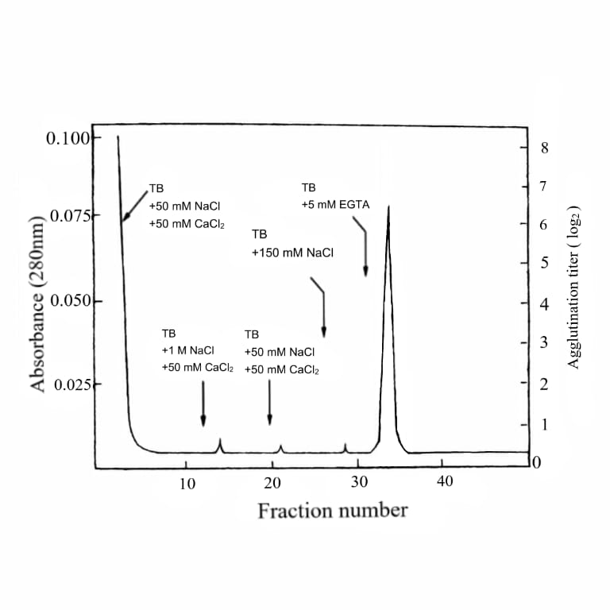
Fig 1: Purification of β-1,3 glucan binding protein in the serum

  - Analysis of isolated βGBP in native and SDS-PAGE
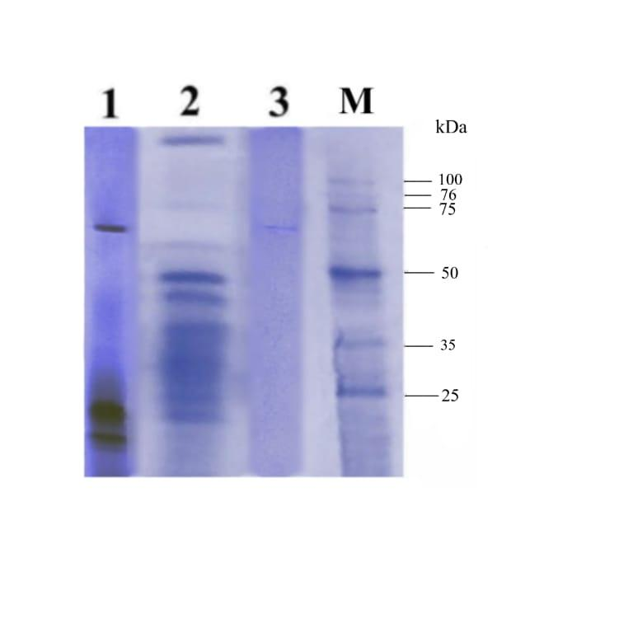
The βGBP isolated from the serum was analysed under non-denaturing conditions in discontinuous PAGE (Native PAGE) and it gave a single protein band on staining the gel with silver nitrate (Fig. 2, Lane I).Using discontinuous SDS-PAGE, we examined the subunit structure of the serum GBP that had been extracted. Figure 2, Lane III shows that βGBP was seen as five protein bands under non-reducing conditions (i.e., without β-ME). However, when subjected to reduction with βME, the protein separated into nine bands, with a total subunit molecular mass estimate of 510 kDa.

(M: Molecular markers; 1: 5µl of serum sample; 2: 10µl of serum sample; 3: 50µg (1.660 µg =1 KDa)

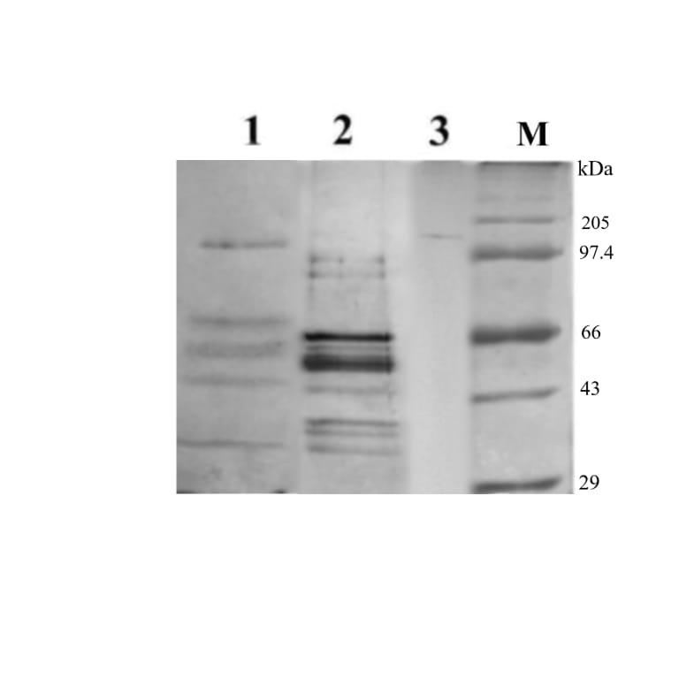
(M: Molecular markers; 1: 5µl of serum sample; 2: 10µl of serum sample; 3: 20µg (1.660 µg =1 KDa)

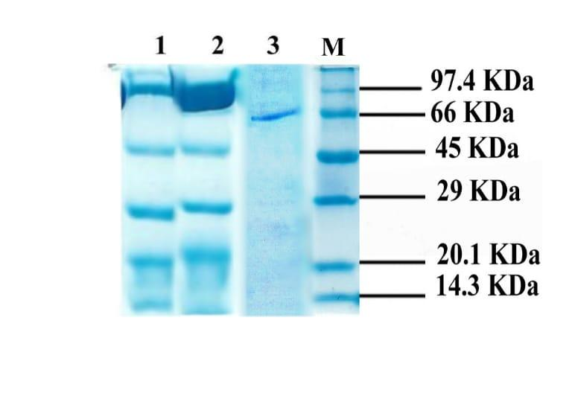
(M: Molecular markers; 1: 5µl of serum sample; 2: 10µl of serum sample; 3: 66 KDa)
Fig 2: Native and SDS PAGE analysis

  - HPLC analysis of purified βGBP
The degree of purity of the isolated βGBP was analysed using a reversed phase HPLC with C 18 column and the isolated protein emerged as a single, large, and symmetric peak with a retention time of 27.93 min. This clearly shows the high degree of purity of the protein (Fig. 3).
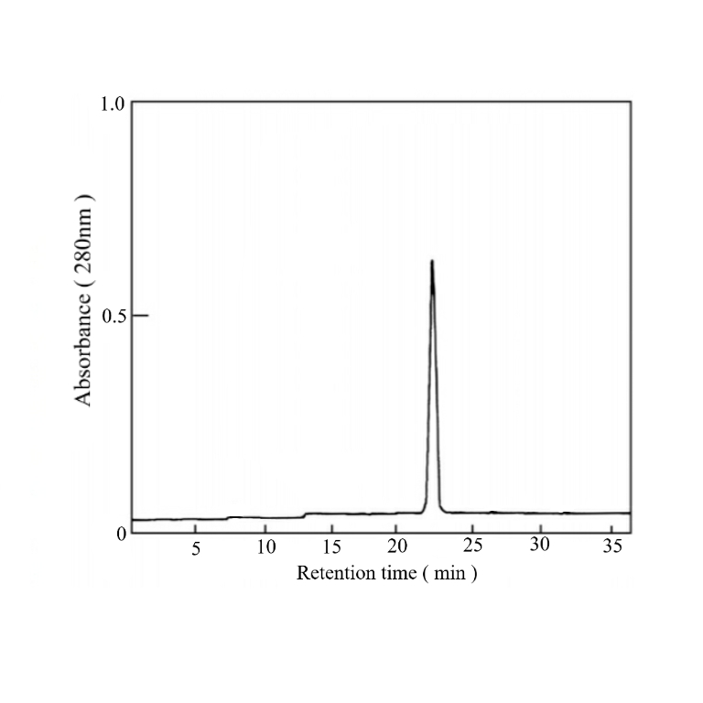
Fig 3: HPLC Analysis of βGBP

  - Circular dichroism assay of purified βGBP
Figure 4 shows that proteins with unordered segments have low positive ellipticity values below 205 nm, whereas proteins with b-sheet structures have wide negative minimums ranging from 217 to 227 nm.

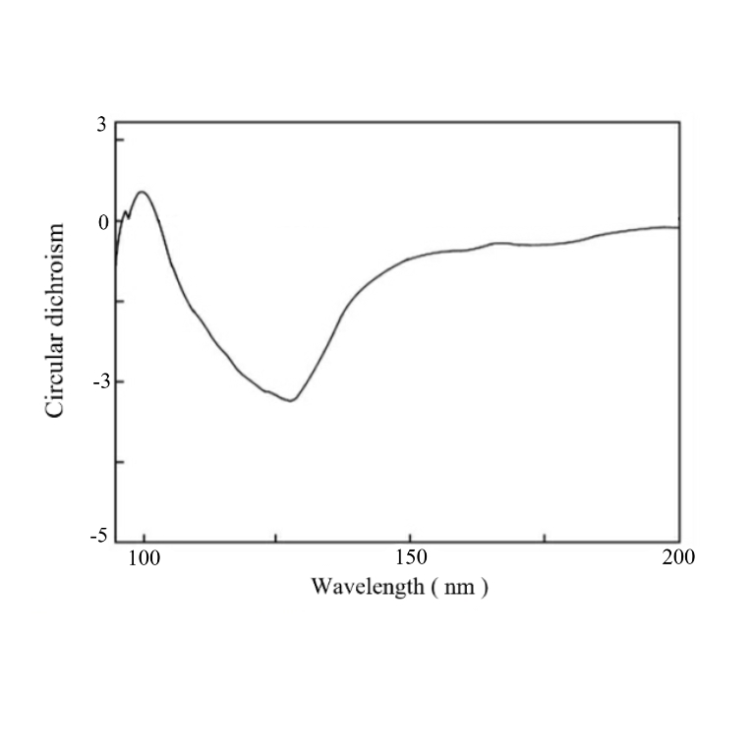
Fig 4: Circular dichroism spectroscopy

4.5. Hemagglutination profile of the purified βGBP
Table 2 shows that the two agglutinins isolated from E. asiatica serum were selectively tested for their hemagglutinating activity against six different types of mammalian RBCs: buffalo, rat, human A, B, O, and horse RBCs. This was done because the whole serum of E. asiatica demonstrated higher to moderate activities against these RBC types. In terms of agglutinating titers, the mole crab agglutinin showed a maximum of 128 with rat and buffalo RBC, followed by a titer of 64 with mice, human A, B, horse, or human O RBC. The exact quantity of agglutinin needed to completely clump buffalo red blood cells was determined to be 0.127 µg. This isolated agglutinin had a titer of 32 with buffalo, rat, and human B RBC, according to the HA profile. It was followed by a titer of 16 with human A, O, and horse erythrocytes. It was determined that 0.031 µg of agglutinin was the minimum quantity needed to completely agglutinate buffalo RBC. The RBCs of buffalo, Human B type, mice, and rats were agglutinated by the hemagglutinating activity of β-1,3 glucan binding protein at a concentration of 53 mg/ml, but no other RBS types were agglutinated. Both the original yeast cells (64 total) and the trypsinized yeast cells (256 total) exhibited a high agglutination titre at a concentration of 53 mg/ml for the purified β-1,3 glucan binding protein. It is worth noting that five different kinds of bacteria were agglutinated by pure β-1,3 glucan binding protein.
Table 2: Hemagglutination titer of purified β-1,3 glucan binding protein

S.NO | ERYTHROCYTES | TITER
1 | BUFFALO | 128
2 | RAT | 128
3 | MICE | 64
4 | HUMAN O | 64
5 | HUMAN B | 64
6 | HUMAN A | 64
7 | HORSE | 64
8 | SHEEP | 32
9 | OX | 16
10 | RABBIT | 8
11 | GOAT | 4

4.6. Hemagglutination-inhibition assays of purified βGBP
Table 3 shows that, with the exception of mannan (at 0.125 mg/ml) and β-1,3 glucan binding protein, none of the carbohydrates examined, including various mono- and polysaccharides, inhibited the HA activity of the agglutinin comparable to native serum in the hemagglutination-inhibition by carbohydrates procedure. Hexoses and hexosamines, in contrast to native serum, reduced the HA activity of the agglutinin at doses ranging from 100 to 25 mM. At quantities comparable to native serum, N-acetylated hexosamines and NANA reduced HA activity. Mannan (0.25 mg/ml) decreased the HA activity among the polysaccharides that were examined, and β-1,3 glucan binding protein absorbed it. Just like native serum, the extracted agglutinin showed selectivity for mannan (0.25 mg/ml) and β-1,3 glucan binding protein (64/8). Mannan inhibited the HA activity of the isolated agglutinin at a minimal concentration of 0.25 mg/ml, in contrast to what was found with its natural counterpart. Nevertheless, when tested on the crabs' entire serum, the β-1,3 glucan binding protein (1 mg/ml) was inhibiting. As was the case with the crude serum samples, neither dextran T70 nor dextran T500 inhibited the serum HA activity. Of the several glycoproteins that were examined, β-1,3 glucan binding protein and fetuin were the only ones that successfully blocked the HA activity of the isolated agglutinins. No carbohydrate, regardless of concentration (up to 200 Mm), was able to suppress the agglutinating activity of the isolated βGBP in an agglutination-inhibition experiment using mole carbs. The agglutinating activity of the isolated βGBP could be inhibited at concentrations as low as 0.25 mg.ml-l by just one of the polysaccharides laminarin of the eight that were evaluated. The others were mannan, dextran T70, dextran T500, inulin, and colominic acid.

Table 3: Hemagglutination inhibition titer of purified β-gbp

S.NO | Substances tested | Maximum concentration tested | Minimum inhibitory concentration
N-acetyl aminosugars (Mm)
1 | N-acetylglucosamine | 200 | 25
2 | N-acetylgalactosamine | 200 | 25
3 | N-acetylmannosamine | 200 | 6.25
Polysaccharides (mg/ml )
4 | Mannan | 1 | 0.25
5 | β-1,3 glucan (laminarin) | 1 | 0.25
6 | Lipopolysaccharide (LPS) | 1 | 0.25
7 | Colominic acid | 10 | 2.5
Sialic acid (mM)
8 | N-acetylneuraminic acid | 20 | 10
Glycoproteins (mg/ml )
9 | Bovine submaxillary mucin | 10 | 0.039
10 | Fetuin | 10 | 0.156
11 | Porcine thyroglobulin | 10 | 0.156

4.7. Yeast agglutination assay of purified βGBP
Titer value for agglutination of trypsinized yeast was 64 and native yeast was 32 (Table 4).

Table 4: Yeast Agglutination Assay of purified β-gbp

S.No | Yeast | Titer
1 | Trypsinized | 64
2 | Native | 32

4.8. Bacterial agglutination assays purified βGBP
The agglutination profile of the two isolated agglutinins against six bacterial species obtained from the infected is depicted in Table 5. Among these microbes tested, the agglutinin from Streptococcus pyrogens showed bacterial agglutination titer: 8 whereas the agglutinin from agglutinated Bacillus subtilis at a titer of 8 (Fig 5). Salmonella paratyphii was agglutinated by the isolated agglutinins at a titer of 8 (Fig 6). However, in the isolated agglutinins showed negligible agglutinating activity against other microbes tested including Pseudomonas aeruginosa , Staphylococcus aureus and E. coli (Fig 6) (Fig 7).

Table 5: Bacterial Agglutination Assay-purified βgbp
CULTURES | AGGLUTINATION
Bacillus subtilis | 8
Streptococcus pyrogens | 8
Salmonella paratyphi | 8
P.aeruginosa | 4
E.coli | 4
S.aureus | 4

Bacillus subtilis

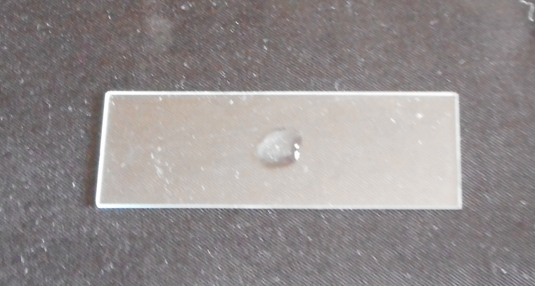

Streptococcus pyrogens
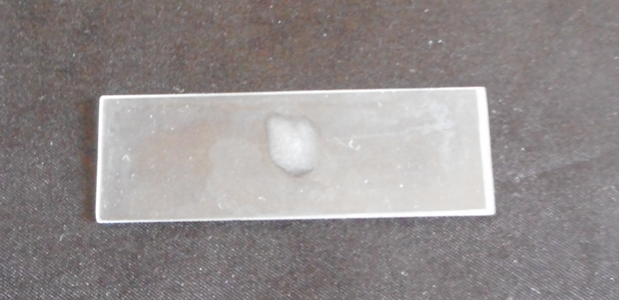

Fig 5: Bacterial agglutination of Bacillus subtilis and Streptococcus pyrogens

Salmonella paratyphi
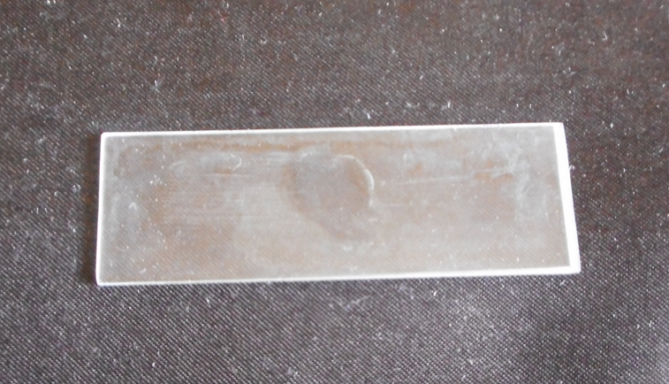

Pseudomonas aeruginosa
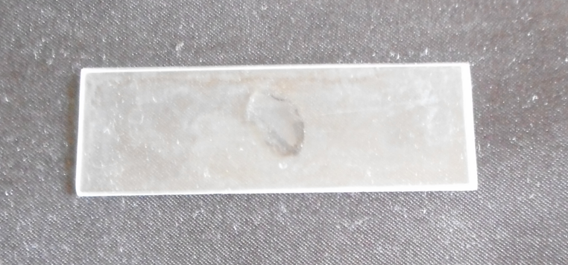

Fig 6: Bacterial agglutination Salmonella paratyphi and Pseudomonas aeruginosa

E.coli
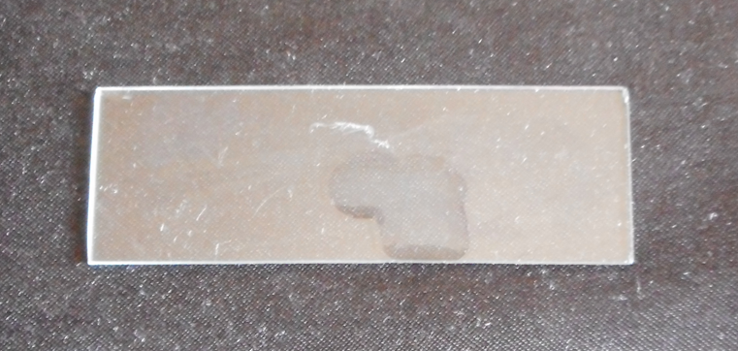

S.aureus
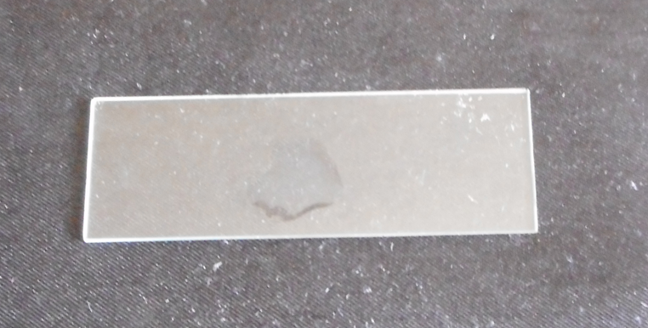

Fig 7: Bacterial agglutination E.coli and S.aureus

4.9. Antibacterial activity of purified βGBP
The growth of S. paratyphi (8 mm), P. aeruginosa (8 mm), E. coli (10 mm), S. aureus (10 mm), B. subtilis (15 mm) and S. pyrogens (10 mm) were inhibited by β-1,3 glucan binding protein in the following table and figure.

Table 6: Antibacterial Assay-purified βgbp
Microorganisms/Sample | Zone of Inhibition in mm
Microorganisms/Sample | 20 µl | 40 µl | 60 µl | 80 µl | Streptomycin  (20µg)
Serum
E.coli | 8 | 9 | 10 | 11 | 19
Staphylococcus aureus | 8 | 9 | 10 | 11 | 17
Salmonella paratyphi |  | 8 | 9 | 10 | 26
Pseudomonas aeruginosa |  | 8 | 9 | 10 | 15
Bacillus subtilis |  |  | 10 | 12 | 15
Streptococcus pyrogens |  |  | 10 | 12 | 22

Escherichia coli
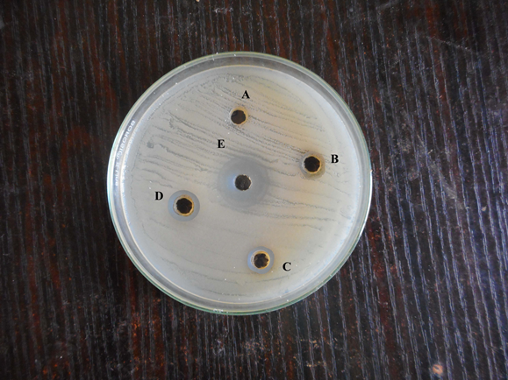

Staphylococcus aureus
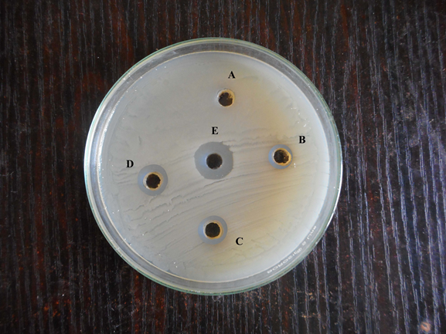

Fig 8: Antibacterial activity of Escherichia coli and Staphylococcus aureus
, ZONE E: 20 µg of Streptomycin)

Salmonella paratyphi
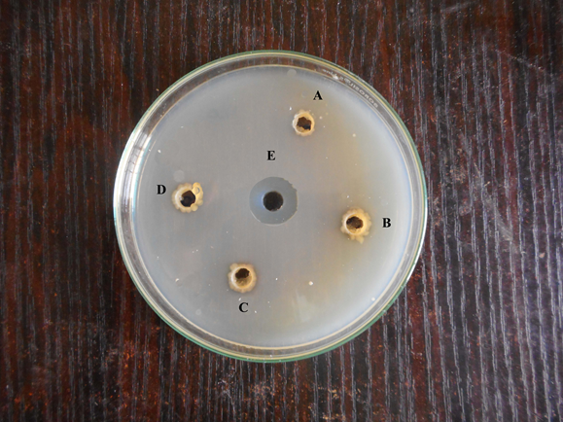

Pseudomonas aeruginosa
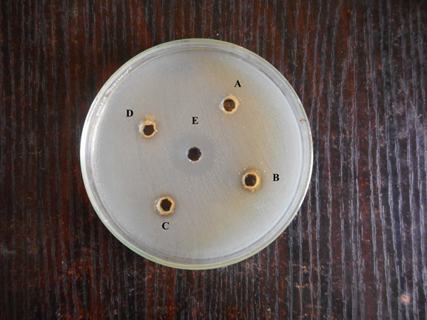

Fig 9: Antibacterial activity of Salmonella paratyphi and Pseudomonas aeruginosa
ZONE E: 20 µg of Streptomycin)

Bacillus subtilis
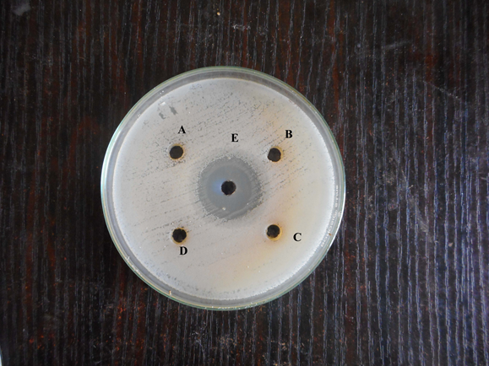

Streptococcus pyrogens
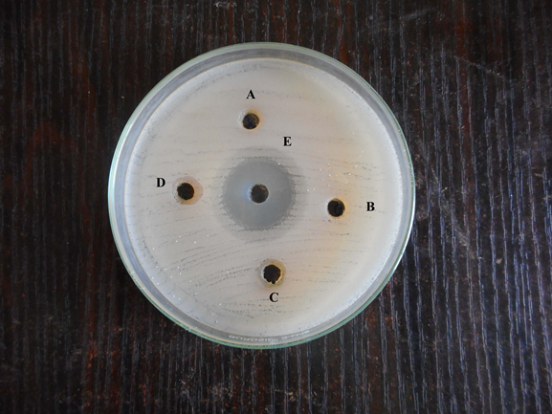
Fig 10: Antibacterial activity of Bacillus subtilis and Streptococcus pyrogens
ZONE E: 20 µg of Streptomycin)

4.10. Antifungal activity of purified βGBP
β-1,3 glucan binding protein demonstrated a maximum zone of inhibition against the fungal pathogens A. flavus (12 mm), A. niger (15 mm) and A. fumigatus (12 mm) (Table 7) (Fig 11) (Fig 12) (Fig 13).

Table 7: Antifungal activity-purified βgbp
Microorganisms/Sample | Zone of Inhibition in mm
Microorganisms/Sample | 20 µl | 40 µl | 60 µl | 80 µl | ketocanzole  (20µl)
Serum
Candida albicans | 8 | 9 | 10 | 11 | 15
Aspergillus niger | 8 | 9 | 10 | 11 | 17
Mucor sp. |  | 9 | 10 | 11 | 26
Rhizopus sp. |  | 9 | 10 | 11 | 17
Aspergillus flavus |  | 9 | 10 | 12 | 19
Aspergillus fumigatus |  | 9 | 10 | 12 | 23

Candida albicans

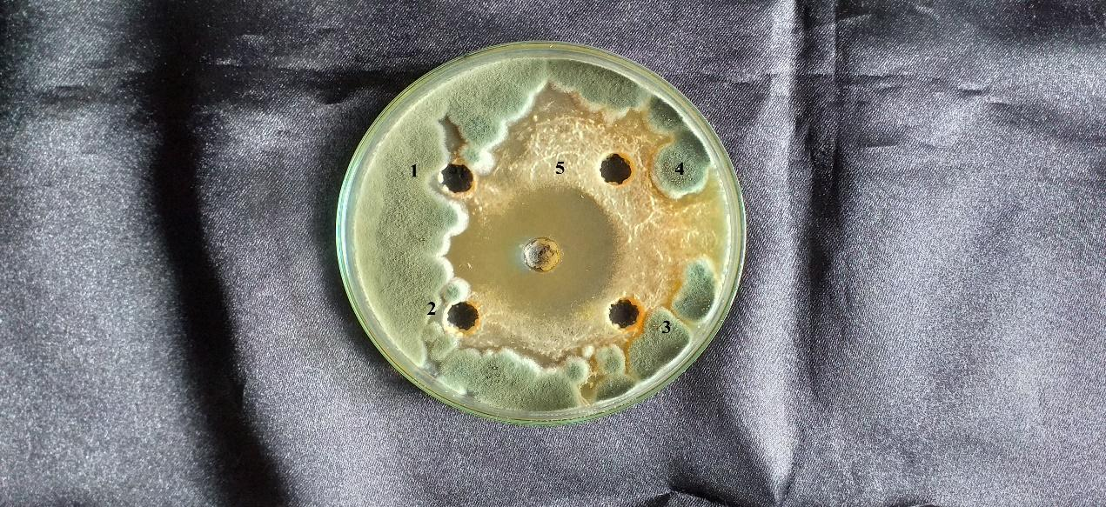

Aspergillus niger
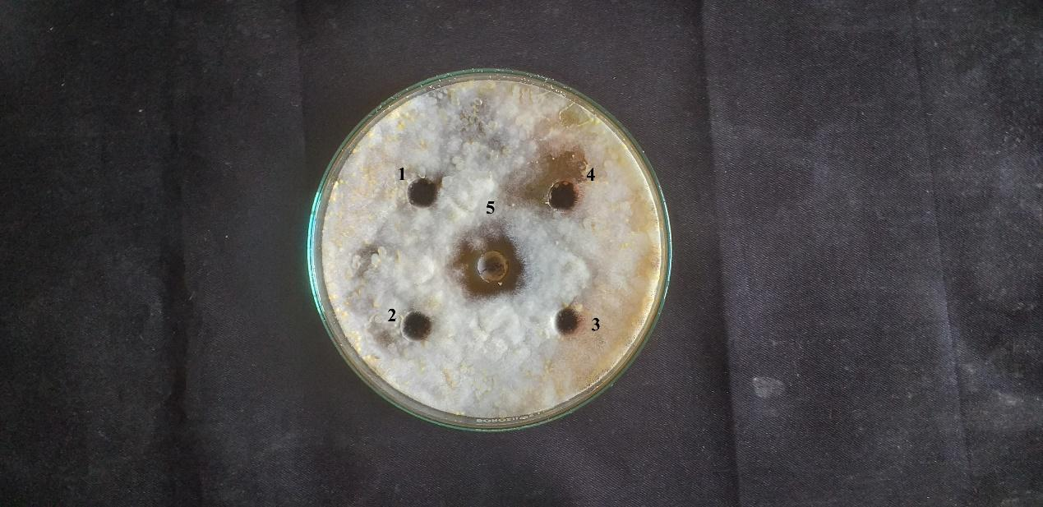

Fig 11: Antifungal activity of Candida albicans and Aspergillus niger
ZONE 5: 20 µL of ketocanzole)

Mucor sp
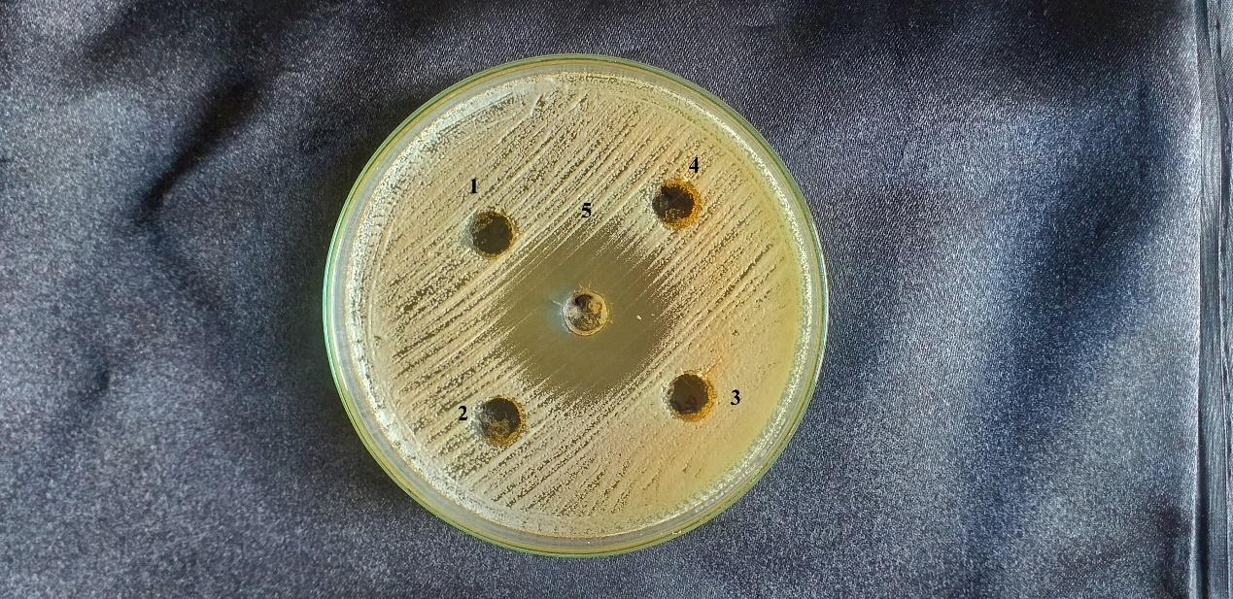

Rhizopus sp
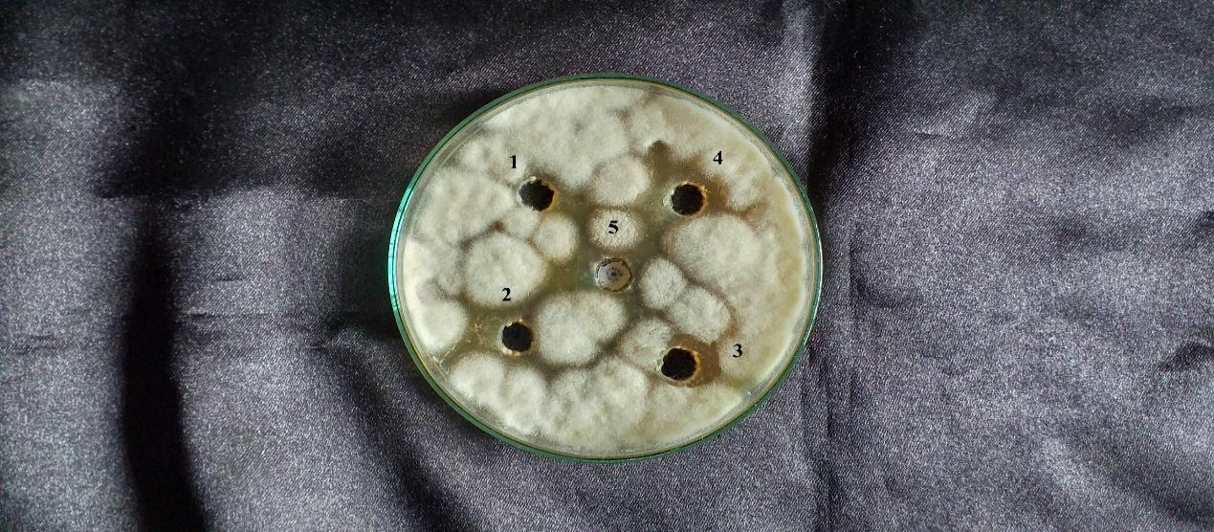

Fig 12: Antifungal activity of Mucor sp. And Rhizopus sp.
ZONE 5: 20 µL of ketocanzole)

Aspergillus flavus
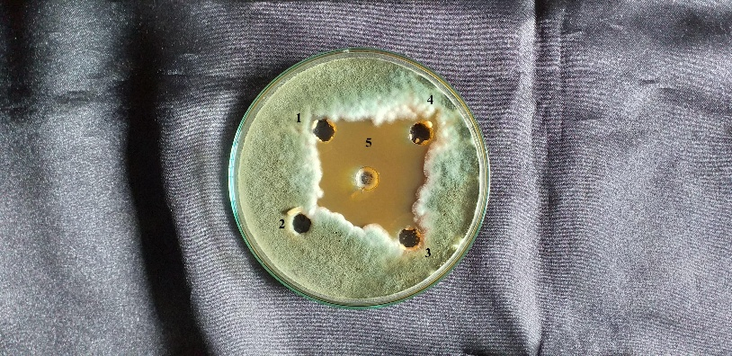

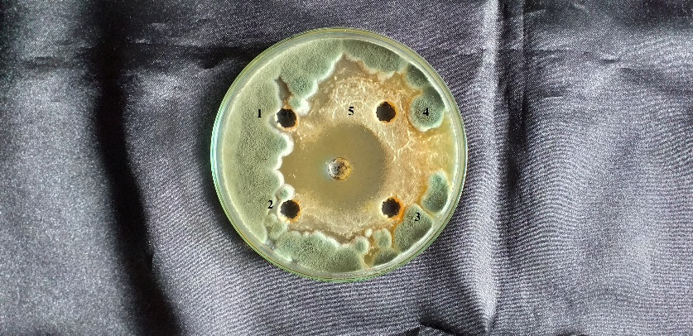
Aspergillus fumigatus

Fig 13: Antifungal activity of Aspergillus flavus and Aspergillus fumigatus

ZONE 5: 20 µL of ketocanzole)

4.11. Pro Phenoloxidase(PO) enhancing activity of purified βGBP
When compared with effluent alone, PO activity was enhanced by purified βgbp considerably (p < 0.001) (Table 8). Also, PO activity of β-1,3 glucan binding protein containing effluent was increased (r = 0.789) due to increase in the concentration of purified βgbp from 5 to 20µg .

Table 8: Effect of β gbp on the activation of ProPO
Sample tested | Activation of proPO
Serum | 0.019+0.013
β-1,3 glucan binding protein | 0.033+0.021

4.12. Serine protease and β-1,3 glucanase activity of the purified βGBP
The serine protease activity of purified βGBP was tested with or without 100 µg laminarin. The results indicate that the serine protease activity of purified βGBP.

Table 9: Activity of Serine protease in the purified βgbp
Sample | Serine-protease activity
Serum | 1.3+1.16
Serum+β-1,3 glucan | 5.87+4.87

Table10:β-1,3 glucanase-activity in the purified βgbp
Sample | βGBP activity
Serum | 0.028+0.017
βgbp | 0.044+0.024

4.13. EDTA sensitivity and Divalent Cation dependency of purified βGBP
Extensive dialysis of serum samples against divalent cation-free buffer resulted in reduction of their HA titers from 64 of the dialysates tested in the same buffer against buffalo RBC . Upon addition of 10 mM of Ca²⁺, Mg²⁺ or Sr²⁺(as chloride salts) to the assay buffer, the titers increased to 64 respectively, with a profound enhancement in serum agglutinating activity observed with Ca²⁺ on both of the crabs. Dialysis of the two serum samples against the buffer containing 10 mM CaCl₂ did not affect their HA activity. Similar results were obtained with both the serum samples dialysed against divalent cation chelator (Table 11).

Table 11: Divalent cation dependency of purified-βgbp
Serum samples | Divalent cations tested | Hemagglutination titer
βgbp | CaCl₂ | 64
divalent cation | CaCl₂ | 64
 | MgCl₂ | 64
 | SrCl₂ | 32
TBS + 10 mM CaCl₂ | CaCl₂ | 32
 | MgCl₂ | 32
 | SrCl₂ | 32
TBS + 50 mM EDTA | CaCl₂ | 16
 | MgCl₂ | 16
 | SrCl₂ | 16

4.14. Ca²⁺ dependency and EDTA/EGTA sensitivity of purified βGBP
The HA titer of the isolated agglutinins assayed with TBS was 32 against buffalo RBC for both the agglutinins (Table 12). When tested against TBS containing 50 mM EDTA, the HA activity of the agglutinin was abrogated to a HA titer of 2, while it was partially reduced with agglutinin isolated (HA titer: 8). Further, upon testing against TBS containing 10 mM EGTA, the HA activity was reduced to a HA titer of 4 while it was partially reduced to a HA titer of 8.

Table 12: Ca²⁺ dependency of purified βGBP
Treatment of agglutinin | HA TITER
Agglutinin +50MmCaCl₂ | 32
Agglutinin +50Mm EDTA | 8
Agglutinin +50Mm EGTA | 4

4.15. Cross adsorption assay of purified βGBP
Single agglutinin in the serum was present in the cross-adsorption assay whereas agglutinin was lost after fourth round of adsorption during hemagglutination assay (Table 13).

Table 13: Cross adsorption test on purified βGBP against RBC types examined

Serum  absorbed | Human-A | Human-B | Human-O | O x | Buffalo
None | 32 | 32 | 32 | 64 | 64
Human-A | 0 | 0 | 2 | 0 | 8
Human-B | 0 | 0 | 2 | 0 | 8
Human-O | 0 | 0 | 0 | 2 | 4
Ox | 0 | 0 | 0 | 0 | 2
Buffalo | 0 | 0 | 0 | 4 | 0

4.16. Purified βGBP - Thermal stability and pH
The HA serum activity collected from mole crabs was found to be high and stable at pH range 7-8 and between the temperature 20-30°C (Fig 14).

Fig 14: pH And Thermal Stability

5. Discussion
Emerita asiatica, is familiarised in India as a replacement for disease resistance shrimp have increased in the production but remains more susceptible to the bacterial outbreaks. The species encounters the Indian microbes with variable immune response that highlights the requirement for studyng the defense mechanisms.The present findings depict bacterial agglutination and inhibition as the defense strategies. The protein exposed the copper staining bands, that includes βGBP and phenoloxidase, that declines during infection.SDS analysis detected three βGBP bands, with the protein levels decreases by ~44% at improved infection stages. These changes results from the degradation of the protein, hemolymp dilution and tissue sequestration that underscores βGBP’s role in immunity.In the present experiment we made an attempt to find out the physio chemical characterization of hemagglutinins and Bacterial agglutinins from the serum is noted (Jayaraj et al., 2010).In the hemagglutinin the value of 4 depict high agglutination, 32 as moderate agglutination, 64 as least agglutination 128 as very least agglutination and the yeast show 128 as hemagglutination control. Bacterial agglutination at the value of 4 high agglutination, 8 as moderate agglutination, 16 as least agglutination and the yeast show 16 as bacterial agglutination control. In the Bacterial inhibition in the volume of 20µl at the zone of 6 mm detects high bacterial inhibition, volume of 40µl at the zone of 7 mm detects moderate inhibition, volume of 60µl at the zone of 10 mm detects the least inhibition and streptomycin (20 µg) at the minimum zone of inhibition 15 mm as bacterial inhibition control. Evidently, agglutinin has a specific recognition role in pathological process. For examining the agglutinins in the Emerita asiatica, the calcium dependent proteins binds bacterial polysaccharides that supports defense. EDTA chelation decreased the activity depicting the reversible calcium sensitivity.This study provides all the necessary information sought for the purpose of purifying the agglutinin using affinity chromatography. Further characterization of this agglutinin is possible only after its purification and isolation from the hemolymph of Emerita asiatica. The homogeneity of protein was a unique feature among crabs as evidenced by a 36 kDa protein from Cancer antennarius (Ravindranath et al., 1984). Isolation of total RNA from the serum of mole crab Emerita asiatica, used in the experiments was preceded by a check for purity by means of RNA isoplus reagent and a run on a 1% agarose gel. The cDNA was then measured, and its purity was verified using absorbency values. Evidence from the βGBP I gene suggests that relative amount rises steadily as protein progresses. In this investigation, the target gene was specifically multiplied using electrophoretic analysis of PCR products on the melting-curve and agar analysis.Therefore, the findings demonstrated that Purified βGBP causes distinct responses from each of the three βGBP genes. Although many investigators have attempted to isolate and purify βGBP from the serum, hemocytes or tissues of 19 species of invertebrates, including helminths, an annelid, crustaceans, insects, and a xiphosuran, only very few investigators have reported the percentage recovery and purification fold achieved from the isolation protocol adopted by them. In majority of these studies, the purification fold achieved was ranging from 1-83.7, while only in one study with Tachypleus tridentatus, the investigators have achieved 730-fold purification. However, these authors have reported a recovery of only 57% of βGBP from the hemocyte lysate of this xiphosuran (Tamura et al., 1996). It may also be noted that all these studies employed multi-step chromatographic procedure (involving at least 3-5 steps) to obtain such levels of enrichment and recovery of βGBP from the blood or other tissues of the invertebrates. In the study, the study protein was successfully extracted using onestep affinity chromatorgrphy obtaining ninety fold purification with 87% recovery. The silver nitrate staining observed one band in the native-PAGE that has been confrmed by reversed phase IEF and HPLC that depicted homogeneity at pH 5.3. This described that yeast agglutination activation could be purified for homogeneity with the use of βGBP-Sepharose6B.
Further identification of sialic acid agglutinins highlight adaptive immune characteristics in the crustaceans.These outcomes revealed the distinct aggluntins that underscores the roel in the pathogen stress and defense response with cellular similarities among the semi granular, hyaline and granular cells that suggets the differentiation phases.
For example, granular cells have a moderate to high level of immune reactivity, whereas hyaline cells are still in the early functional maturation and have a poor ability to express vital cellular immune reactions. Regardless, the results show that Emerita asiatica hemocyte populations were purified using the cell separation method without compromising their inherent immunoreactivities in vitro. This kind of hemocyte morphotype separation is ideal for studying cellular immunity in its many forms, including, but not limited to, the immune response's use of specific receptor binding sites on each hemocyte type and the mechanisms by which each hemocyte type avoids self-recognition. Although the isolation procedure (single step discontinuous density gradient of Percoll) demonstrated lower viability compared to the total hemocytes (90%) in the trypan blue exclusion test with isolated hemocyte morphotypes (table 4), the variation observed with all three morphotypes—hyaline (74%), semi-granular (85%), and granular (88%), remained over 75%. Viability testing of hemocytes with propidium iodide in flow cytometry further confirmed that the majority of cells remained alive during three hours of incubation in the lab. Purified βGBP upon SDS treatment emerged as five clear bands. However, under denaturing conditions (SDS and β-mercaptoethanol) electrophoretic separation of the purified βGBP is resolved into nine protein bands with varying molecular mass (92, 83, 62.5, 60, 55, 47.5, 40, 37.5 and 32.5 kDa) totalling an estimate of 510 kDa for the native molecular mass.

- Summary and Conclusions

- A study on βGBP isolated from the serum / serum of higher invertebrates including insects and crustaceans.The native β-1,3glucan binding proteins depicts extensive variation with MW that ranges from 62 to 520 kDa. The reports represents the variations in the subunit numbers and subunit size that complicates the uniform mass estimating in the higher invertebrates.βGBP has been identified in the serum and efficiently purified through one step affinity-chromatography.
- However, by comparing amino acid sequences and composition, it was found to be remarkably same to β GBP of B.discoidalis, an insect that has molecular mass of 520 kDa
(Chen et al., 1998). This research would be interesting to see how it evolved in relation to other invertebrate β-l,3 glucan binding proteins. Initially, the agglutination response seen against native and trypsinised yeast cells verified the existence of βGBP in the serum of Emerita asiatica during this investigation. In consistent with this finding, the purified βGBP from the mussel serum gave a high agglutination titer against trypsinized yeast cells(titer = 256). Electrophoresis revealed that the agglutinins from the two migrated at different velocities, confirming their identity, purity, and electrophoretic homogeneity.
- This suggests that the agglutinin was concentrated by affinity purification since the protein bands of the separated agglutinins match the weak band seen in the entire serum during contemporaneous electrophoresis. To substantiate and elucidate the defensive role of agglutinins in anomuran crabs, selection of a model anomuran was a pre-requisite for purification and molecular characterization of the agglutinin.
- All of the anomuran species that were examined have agglutinins in their serum. Nevertheless, the agglutination experiment revealed that their HA titer varied among species and types of vertebrate erythrocytes. The agglutinin found in Emerita asiatica may clump a number of distinct types of erythrocytes together, but it has a particular preference for horse erythrocytes. When tested with horse erythrocytes that carry 4-o-acetyl NeuAc, the serum of Emerita asiatica strongly clumped together.
- Initial stage of immune response initiation is for the hemocytes in recognising non-self-cells or tissues, as well as foreign invaders, via receptors connected to the surface membrane. Although only a small fraction of the receptors found in gastropod crustacean hemocytes have undergone molecular characterisation, many have been discovered by functional testing or cross-reactivity with different anti-receptor antibodies. Hemocyte receptors may be broadly classified into the following for the sake of this discussion: The following groups of proteins are involved: lectins, integrin-related proteins, and receptors that resemble growth factors, hormones, or cytokines (Humphries et al., 2003).
- The immunological and defensive systems of crustaceans are advanced and complex, including cellular and humoral components. The capacity of cells to detect foreign antigens (via pattern recognition) and trigger suitable responses is fundamental to any immune system. When it comes to crustacean immunity, the whole ''recognition-to-response'' procedure is dependent on intricate intracellular signal transduction networks. Future research into the specific functional factor that identifies the receptor binding sites for isolated β-GBP could benefit from a better understanding of how β-GBP binds to surface receptors through cDNA synthesis, cloning, and characterisation. Because mole crabs are so easily protein, an alien species from the Pacific Ocean called Emerita asiatica has just been brought to India for commercial cultivation. While it has improved output, it has not been able to halt the spread of infectious illnesses, particularly bacterial ones. Because it is originally from the Pacific, this mole crab has reacted differently to the bacteria it has found in Indian waters.
- Therefore, it is important for the mole crab's immune system to recognise bacterial proteins correctly (India). In addition to its well-known role in respiration, new research in crustaceans suggests that βGBP expresses a number of defense-related functions, such as phenol oxidase activity, hemolytic activity, antiviral activity, and antibacterial activities (Decker et al., 2007)and the physiochemical characterisation of hemagglutinins and bacterial agglutinins from the serum (Jayaraj et al., 2010). For hemagglutinin, a value of 4 indicates strong agglutination, 32 indicates moderate agglutination, 64 indicates low agglutination, 128 indicates exceptionally low agglutination, and 128 is the control value for yeast. Bacterial agglutination is characterised by a value between 4 and 16, with 16 being the control for bacterial agglutination and 8 being moderate agglutination. With a volume of 20µl at a 6 mm zone, high bacterial inhibition is detected; with a volume of 40µl at a 7 mm zone, moderate inhibition is detected; with a volume of 60µl at a 10 mm zone, the least inhibition is detected; and as a control for bacterial inhibition, streptomycin (20 µg) is added to the minimum zone of inhibition at 15 mm.
- The extended studies reveled precise mechanism of the βGBP subunits and their corresponding role in the non –specific immunity. One of our earlier investigations used native PAGE to look at the mole crab serum protein profile. All save the slow-moving proximal bands tested positive for βGBP when the gel was treated with the staining agent known to bind copper-containing proteins.
- The single bands that were shown to be positive for βGBP proteins that contain copper. These proteins include βGBP and prophenoloxidase, all of which are present in the serum of mole crab. Since βGBP makes about 90–95% of the total proteins in the bloodstream, the thick band that was stained positive was definitely βGBP. As βGBP progresses, this band becomes prominent. "When we tested Emerita asiatica in our lab, we got the same findings. Because of this, we investigated the changes that occur in the related gene which contains βGBP. The existence of three protein bands was shown by SDS-analysis of isolated βGBP in mole crab.

COMPETING INTERESTS DISCLAIMER:
Authors have declared that they have no known competing financial interests OR non-financial interests OR personal relationships that could have appeared to influence the work reported in this paper.

7. References
- Balaji, R., P. Mullainadhan & M. Arumugam. 1989. In vivo binding of exogenous copper to serum fractions of estuarine crab Scylla serrata (Forskal). J. Exp. Mar. Biol. Ecol., 128: 241 - 255.
- Chen, C., A.F. Rowley, R.P. Newton & N.A. Ratcliffe. 1999. Identification, purification, and properties of a β-l ,3-glucan-specific lectin from the serum of the cockroach, Blaberus discoidalis which is implicated in immune defense reactions. Comp. Biochem. Physiol., 122B: 309-319.
- Chen, C., Rowley, A.F. and Rateliffe, N.A. 1998. Insect Biochem. Mol. Biol., 28: 721-731.
- Cragg Gordon M, Newmann David J and Snader and Kenneth M (1997). Natural products in drug Endean, R.; Duchemin, C.; McColm, D.; Fraser, E.H. A study of the biological activity of toxic material derived from nematocysts of the cubomedusan Chironex fleckeri. Toxicon. 6: 179-204.
- Decker, H., Schweikardt, T., Nillius, D., Salzbrunn, U., Jaenicke, E., & Tuczek, F. (2007). Similar enzyme activation and catalysis in hemocyanins and tyrosinases. Gene, 398(1-2), 183–191.
- Duvic, B. and Söderhäll, K., 1990. J. Biol. Chem., 256: 9327-9332.
- Hall, J. L., and Rowlands, Jr. D. T. (1974a) Heterogeneity of lobster agglutinins.I. Purification and physicochemical characterization. Biochemistry 13: 821-827
- Jayaraj, S. S., Thiagarajan, R., Arumugam, M., & Vincent, S. (2010). Physico-chemical characterization of bacterial and hemagglutinins from the serum of the mud crab Scylla serrata. Invertebrate Survival Journal, 7(1), 79-88.
- Jiang, G. 2010. Comparison of defense ability against the white spot syndrome virus between Fenneropenaeus chinensis and Marsupenaeus japonicus. Aquacult. Res., 41: 1322 - 1330.
- Kawai, T., Kato, A., Higashi, H., Kato, S., and Naiki, M. (1991) Quantitative determination of N-glycolyl neuraminic acid expression in human cancerous tissues and avian lymphoma cell lines as tumor associated β-1,3 glucan by gas chromatography- mass spectrometry. Cancer Res. 51: 1242-1247
- Lee, S., B. Lee & K. Söderhäll. 2003. Processing of an antimicrobial peptide from hemocyanin of the freshwater crayfish, Pacifastacus lenuisculus. J. Biol. Chem., 278: 7927-33.
- Mercy, P. D., and Ravindranath, M (1992) An agglutinin with unique residues of thyroglobulin Scylla serrata (Forskal). Experentia 48: 498-500.
- Murali, S., P. Mullainadhan & M. Arumugam. 1994. A lipopolysaccharidebinding hemagglutinin with specificity for acetylated aminosugars in the serum of hermit crab Diogenes affinis (Henderson). J. Invertebr. Pathol., 64 : 221 - 227.
- Murali, S., Mulainadhan P. and Arumugam, M (1999) Purification and characterization of a natural agglutinin from the serum of the hermit crabs Diogenes affinis, Biochimica et Biophysica Acta 1472: 13-24
- Noga, E.J. (2000) Fish Disease: Diagnosis and Treatment. Iowa State University Press, Ames.
- Ravindranath, M. H. and Cooper, E. L. (1984) Crab proteins: receptor specificity and biomedical applications. Prog Clin. Biol. Res. 157: 83-96
- Ravindranath, M. H., Higa, H. H., Cooper, E, L., and Paulson, J.C. (1985) Purification and characterization of a 0-acetyl β-1,3 glucan specific protein from a marine crab Cancer antennarius. J. Biol. Chem. 260: 8850-8856
- Taylor J., L. Vinatea, R. Ozorio, R. Schuweitzer, E.R. Andreatta (1985), Minimizing the effects of stress during eyestalk ablation of Litopenaeus vannamei females with topical anesthetic and a coagulating agent, Aquaculture 233:173-179.
- Vasta, G. R., and Marchalonis, J.J. (1983) Immunobiological significance of invertebrate proteins. J. Comp. Physiol. B160: 119-126
- Zhang, Y. L., F. Yan, Z. Hu, X. L. Zhao, S.Y. Min, Z. H. Du, X. Q. Ye &Y.Y. Li. 2009. ΒGBP from shrimp Litopenaeus vannamei shows hemolytic activity. Fish Shellfish Immunol., 27: 330-35.
- Ottaviani E. (2006) Molluscan immunorecognition. Invertebr Survival J: 3:50–63.
- Söderhäll, K., W. Rögener, l. Söderhäll, R.P. Newton & N.A. Ratcliffe. 1988. The properties and purification of a Blaberus craniifer plasma protein which enhances the activation of haemocyte prophenoloxidase by a βl ,3-glucan. Insect Biochem., 18: 323-330.
- Ochiai, M. & M. Ashida. 1988. Purification of a β-l,3-glucan recognition protein in the prophenoloxidase activating system from the hemolymph of silkworm, Bombyx mori. J. Biol. Chem., 263: 12056-12062.
- Mullainadhan, P. and Renwrantz, L., 1986. Immunobiol., 171:
263-273.
- Asokan, R., Arumugam, M. and Mullainadhan, P. 1997. Dev. Comp. Immunol., 21: 1-12.
- Asokan, R., Arumugam, M. and Mullainadhan, P. 1998. Comp. Biochem. Physiol., Part A, 120: 753-762.
- Hine P. M. 1999. The inter-relationships of bivalve haemocytes. Fish Shellfish Immunol., 9: 367–385.
- Cerenius, L., Liang, Z., Duvic, B.K., Keyser, P., Hellman, U., Palva, T., Iwanaga, S. and Söderhäll, K. 1994. J. Biol. Chem., 269: 29462-29467.
- Cerenius L, Lee BL, Söderhäll K. (2008) The proPO system: pros and cons for its role in invertebrate immunity. Trends Immunol, 29:263– 71.
- Jiravanichpaisal P, Lee BL, Söderhäll K. (2006) Cell-mediated immunity in arthropods: hematopoiesis, coagulation, melanization and opsonization. Immunobiology, 8.
- Vogt G, Rug M. (1996) Granulomatous hepatopancreatitis: immune response of the crayfish Astacus to a bacterial infection. Freshwater Crayfish; 11:451–64.
- Rameshthangam, P. & P. Ramasamy. 2005. Protein expression in white spot syndrome virus infected Penaeus monodon Fabricius. Virus Res., 110: 133 - 141.
- Pais, R., M. Shekar & I. Karunasagar. 2007. Haemagglutinating activity and electrophoretic pattern of serum proteins of Penaeus monodon and Macrobrachium rosenbergii to white spot syndrome virus injection. Aquaculture, 270: 529 - 534.
- Bonaventura, J., & S. C. Wood. 1980. Respiratory pigments: overview. Am. Zool., 20: 5-6
- Mangum, C. P. 1997. Invertebrate blood oxygen carriers. In ‘Handbook of Physiology, section 13, Comparative Physiology (Ed. W. H. Dantzler), pp. 1097–1131. Oxford University Press, New York.
- Hodgson, E. & J.I. Spicer. 2001. Subunit compositions of crustacean βGBPs are species-specific: evidence from non-decapod species. Comp. Biochem. Physiol., 128A: 873-88.
- Hagner-Holler, S., A. Schoen, W. Erker, J.H. Marden, R. Rupprecht, H. Decker & T. Burmester. 2004. A respiratory βGBP from an insect. Proc. Nat. Acad. Sci., 101: 871-74.
- Gaykema, C.M., Alday-Sanz, V., Wille, M., Sorgeloos, P.., Pensaert, M.B., Nauwynck, H.J., (1984) A review on the morphology, molecular characterization, morphogenesis and pathogenesis of white spot syndrome virus, Journal of Fish Diseases 31, 1–18.
- Jaenicke J.M., Anton, L.S., Soto, M.A., (2007), Effect of chronic Taura syndrome virus infection on salinity tolerance of Litopenaeus vannamei, Diseases of Aquatic Organisms: 65, 75–78.
- Fernando, H.H., Li, W.F., Xu, Z.R., Kil, Z.S., (2008), Effect of hyperthermia on the replication of white spot syndrome virus (WSSV) in Procambarus clarkii. Diseases of Aquatic Organisms: 71, 175–178.
- Paul, O.M., Pirrow, C.B., Aranguren, F., Brock, J.A.., Salazar, M., (1998), A profound effect of hyperthermia on survival of Litopenaeus vannamei juveniles infected with white spot syndrome virus, Journal of the World Aquaculture Society:32, 364–372.
- J.C. Guary, R. Negrel. (1980), Plutonium and iron association with metal-binding proteins in the crab Cancer pagarus, Journal of Experimental Ecology: 42: 87-98.
- O'Shea, C. J., O'Doherty, J. V., Callanan, J. J., Doyle, D., Thornton, K., & Sweeney, T. (2016). The effect of algal polysaccharides β-1,3 glucan and fucoidan on colonic pathology, cytokine gene expression, and Enterobacteriaceae in a dextran sodium sulfate-challenged porcine model. Journal of nutritional science, 5, e15.
- Song, K., Xu, L., Zhang, W., Cai, Y., Jang, B., Oh, J., & Jin, J. O. (2017). β-1,3 glucan promotes anti-cancer immunity by the maturation of dendritic cells. Oncotarget, 8(24), 38554–38567.
- Shang, H. S., Shih, Y. L., Chen, C. P., Lee, M. H., Lu, H. F., Chou, P. Y., Liao, N. C., Chen, Y. L., Hsueh, S. C., & Chung, J. G. (2018). β-1,3 glucan Promotes Immune Responses and Normalizes Glutamic Oxaloacetic Transaminase and Glutamic Pyruvic Transaminase Levels in Leukemic Mice In Vivo. In vivo (Athens, Greece), 32(4), 783–790.
- Saito, H., Y. Yoshioka, N. Uehara, J. Aketagawa, S. Tanaka & Y. Shibata. 1991. Relationship between conformation and biological response for (1→3)-β-D-glucan in the activation of coagulation factor G from Limulus amebocytes lysate and host-mediated antitumor activity. Demonstration of single-helix conformation as a stimulant. Carbohydr. Res., 217: 181-190.
- Tataki, Y., Seki, N., Kawabata, s.l., Wanaga, s.l. and Muta, T. 2002. Duplicated binding sites for (1-+3)-β-D-glucans in the horseshoe crab coagulation factor G. Implications for a molecular basis of the pattern recognition in innate immunity. J. Biol. Chem., 277: 14281.
- Kraus, J. & G. Franz. 1992. Immunomodulating effects of polysaccharides from medicinal plants. In "Microbial infections" (H. Friedman, T.W. Klein & H. Yamaguchi, Eds.), pp. 299-308, Plenum Press. New York.
- Jamas, S., D.D. Jr. Easson, G.R. Ostroff & A.B. Onderdonk. 1991.
- Agundis, C., A. Pereyra, R. Zenteno, C. Brassart, C. Sierra, L. Våzquez & E. Zenteno. 2000. Quantification of lectin in freshwater prawn (Macrobrachium rosenbergii) hemolymph by ELISA. Comp. Biochem. Physiol., 127B : 165 - 172.
- Duvic, B. & K. Söderhäll. 1992. Purification and partial characterization of a β-1,3-glucanbinding proteins from blood cells of the crayfish Pacifastacus leniusculus. Eur. J. Biochem., 207: 223–228.
- Fragkiadakis, G. A., and Stratakis, E. M. (1997) The protein from the crustacean Liocarcinus depurator recognizes O-acetyl β-1,3 glucan s. Comp. Biochem. Physiol. 117 B (4): 545-552
- Maghil, D. (2001) Purification, characterization, and biological role of a sialic acid specific lectin from the serum of the freshwater crab Paratelphusa jacquemontii (Rathbun). Ph.D. Thesis Manonmanian Sundaranar University India
- Humphries, J. E & Yoshino, T. P. 2003. Cellular receptors and signal transduction in molluscan hemocytes: connections with the innate immune system of vertebrates Integr. Comp. Biol., 43: 305–312.
- Yoshino, T. P., X. J. Wu, L. A. Gonzalez & C. H. Hokke. 2013. Circulating Biomphalaria glabrata hemocyte subpopulations possess shared schistosome glycans and receptors capable of binding larval glycoconjugates. Exp. Parasitol., 133: 28–36.
- Meiyalagan, V., & Arumugam, M. (2015). Detection and preliminary characterization of antibacterial protein (s) in the serum of mud crab, Scylla serrata. Invertebrate Survival Journal, 12(1), 287-295.

