MULTI-ENVIRONMENTS EVALUATION OF ELITE MUTANT LINES OF IMPROVED GINGER FOR YIELD STABILITY AND SELECTION

ABSTRACT:
Multi-environment evaluations of 15 improved elite ginger mutant lines were conducted in 2023 and 2024 cropping seasons across 10 states in Nigeria. The states were Abia, Bauchi, Benue, Borno, Cross River, Kaduna, Nasarawa, Osun, Plateau and FCT.(Abuja) .The objective of the study was field evaluation of the improved ginger mutant lines across some ginger producing areas to ascertain the yield potential, yield stability, adaptability and selection of superior genotypes .The experiment was laid out in Randomized Complete block Design with 3 replications. Data collection was carried out on the following parameters; plant height, number of tillers per plant, number of rhizome fingers, rhizome length and rhizome yield. The combined analysis of variance showed Genotype , Environment, Genotype by Environment Interaction(GEI) and Years to be significant at P< 0.01 and P< 0.05 for all yield related traits but no significant difference in G xY interaction and GEI (Genotype environment interaction) in rhizome yield . The Data set was also subjected to Multivariate analysis( AMMI and GGE biplots) to identify stable and high yielding ginger mutant lines. The general observation from AMMI analysis of variance showed high level of environmental effect which accounted for higher percentage of the total variation for all the yield components. The GGE biplot analysis was used to visualize the relationship between tester environment and the ginger mutant lines to determine Which-Won-Where portion which reveals the stability of genotypes. The GGE biplot explained 88.2% of the total variation in rhizome yield which was due to genotype and GE interactions. The E4 (Cross River) and E10 ( Abia) were the most discriminatory environment for rhizome yield. The polygon view of the GGE biplot for rhizome yield indicated the best genotypes for an environment and the result showed G13(UG2-5-49) as winner in a mega environment of E4(Cross River) and E10(Abia). Two environments E1(Bauchi),E7(FCT) favors UG2-5-04, UG2-5-52,UG2-9-01 ,UG1-13-02) while the environment E2 (Benue),E3(Borno),E5(Kaduna),E8(Osun) and E9(Plateau) favors UG1-11-07, UG1-5-31 and UG2-5-48. From the multiple environments testing, five best performing genotypes with relative stability on each of the yield attributes were identified and selected. These genotypes are UG1-11-03, UG1-13-02, UG2-5-04, UG2-5-49 and UG2-9-01. These genotypes will be recommended for registration and release to farmers.

Keywords: Environment, Genotypes, Interactions, Mutants, Stability ,Variations,Biplots

INTRODUCTION
Ginger (Zingiberofficinale.Rosc.) is a monocotyledonous perennial herb in the family Zingiberaceae, grown mainly for its spicy and aromatic rhizomes (Peter et al., 2007). Ginger is valued as a medicinal crop and has been used as a spice for over 2000 years. It is cultivated in many tropical and subtropical countries (Ashraf et al., 2014). Ginger is used in the treatment of diarrhoea, nausea, asthma, and respiratory disorders (Medova et al., 2009). It has been reported to aid digestion, boost the immune system and reduce cholesterol level (Yakubu, 2007). It can be steeped in boiling water to make ginger tea (Govindarajan, 2004). It can also be made into candy or used as flavouring for cookies and cakes (Macrae et al., 2002). Powdered ginger is used in the preservation of meat, soup and beverages (Jakes and Susan 2007). In most Nigerian homes, the ginger is mainly used as a spice for flavouring a variety of dishes and drinks such as stew, rice, pap, "kunu", "zobo" and "burukutu". Globally, ginger is available in different forms such as raw ginger, dry ginger, bleached dry ginger, ginger powder, ginger oil, ginger candy and ginger beverage.
Ginger is cultivated in more than 25 countries in the world, but India, Nigeria, Nepal, China, Indonesia, Thailand, Korea, Philippines, Australia and Malaysia are the main growing countries. India is the largest producer of ginger up to 1.8 Million metric tons accounting to about 42.67% global production while Nigeria produced 734.3 thousand metric tons accounting for only 16.99% globally (Doris, 2022). Nigeria is the largest producer and exporter of ginger in Africa and ranks second in the world. Ginger is an important cash crop in Nigeria due to its essential oils and Oleoresin contents (Ezeagu, 2006). The production trend of ginger in Nigeria tends to be low due to its non-commensurable poor yields, averaging between 2 and 5 t ha⁻¹ under local farmers’ fields. The yield is low when compared with other export crops like cocoa and coffee. The low yield is hugely attributed to the lack of improved varieties (Iwo and Amadi, 2012). In Nigeria, there are only two cultivars which are indigenous landraces. These landraces are known as UGI (yellow ginger or Taffin Giwa) and UGII (Black ginger or YatsunBiri) (Asumugha et al., 2006). However, the existing landraces have been transformed to many ginger lines through gamma-ray irradiation process (Iwo et al., 2013) in the Department of Crop Science, University of Calabar in collaboration with NRCRI, Umudike. The improved ginger lines have high yielding capacity of 22.0 – 38.7 t ha⁻¹ with corresponding high oleoresin content (Abua et al., 2020). The improved ginger lines have been tested on-station under research environment condition but needed to be further tested multiple environments for stability and selection. According to Thanki et al. (2010), genotype and its interaction with prevailing environment is the basic factor, which determine the final yield. Adaptability of a given cultivar or genotype is defined as the inherent genetic ability of a cultivar to be stable or high yielding in various environments . Adaptation of a cultivar is affected by factors that vary from one location to another. The effects of these factors are usually reflected in their yields. Under a set of environmental conditions, genotypes with better adaptation will produce more yield than those that are less adaptable. The adaptability of a cultivar over different environment is usually tested by its degree of interaction with the different environments. The maximum yield potential from a particular crop variety can only be released if suitable environment is provided. It is, therefore, necessary to determine the environment that may allow full expression of genes controlling the quantitative traits such as yield. The newly developed ginger mutant lines need to be tested in multi-environments for identification and selection of genotypes with superior performance and stability across the environments. Therefore, the purpose of the work was to evaluate the newly developed improved ginger lines across the major producing areas in Nigeria to ascertain the yield potentials, yield stability, adaptability and selection for onward on-farm test before registration and release as varieties to farmers.

Materials and methods
Experimental site:
The multi-environments field evaluation of the improved ginger mutant lines were carried out in 10 states across the six geopolitical regions of Nigeria, during 2023 and 2024 cropping seasons (April -December). The States are Abia, Cross River, Benue, Bauchi, Borno, Kaduna, Nasarawa, Plateau, Osun, and FCT Abuja. Research collaborators were selected from each of the ten States for effective implementation of the field trials. The description of environments and geographical coordinates used to evaluate the mutant lines are presented in Table 1. The Figure.1.is the map of Nigeria indicating each location and geo-political zone of the country.
Table 1. The geographical coordinates of the environments ( States)
S/N | ENVIRONMENTS (States ) | LATITUDE | LONGITUDE
1 | Abia | 5.4167^{0 N} | 7.5000^{0 E}
2 | Cross River | 6.3333^{0 N} | 8.5000^{0 E}
3 | Kaduna | 10.3333^{0N} | 7.7500^{0 E}
4 | Benue | 7.3333^{0 N} | 8.7500^{0 E}
5 | Bauchi | 10.3333^{0 N} | 9.8333^{0 E}
6 | FCT (Abuja) | 9.0600^{0 N} | 7.4953^{0 E}
7. | Borno | 12.0000^{0 N} | 13.1667^{0 E}
8. | Osun | 7.5000^{0 N} | 4.5000^{0 E}
9 | Nasarawa | 8.5333^{0 N} | 8.3000^{0 E}
10 | Plateau | 9.1667^{0 N} | 9.7500^{0 E}

Planting Materials and Experimental Design:
The planting materials consisted of 15 improved ginger mutant lines obtained from the National root Crop Research Institute (NRCRI), Umudike. These are UG1-5-35, UG1-5-22, UG1-5-31, UG1-11-03, UG1-7-24, UG1-5-18, UG1-13-02, UG1-11-07,UG2-5-04,UG2-5-35,UG2-5-38,UG2-5-48,UG2-5-48, UG2-5-52,UG2-9-01 . After land preparation as specified for the trials, the experiment was laid out in a Randomized Complete Block Design (RCBD) maintained in three replications. Each ginger mutant line was planted on a two rows plot of 0.8 x 5m (4.m² ) with inter-row and intra-row spacing of 0.4 x 0.4m respectively..
Data collection:
Pre-harvest field data on plant height and number of tillers were collected during the active physiological growth stage of the ginger on the field while the post-harvest data such as the rhizome fingers, rhizome length and total rhizome yield were collected after the final harvest at the end of December 2023 and 2024.
Data Analysis:
The data collected during the 2023 and 2024 cropping seasons were analyzed using statistical model to provide the two years evaluation using GenStat package version of 8.1 and separation of treatment means using Duncan multiple Range Test (DMRT) at 5% level of significance. Application of AMMI Model and GGE Biplot model were used for the analysis of GEI. The environmental factors were formulated using ten locations and two years (2023 and 2024) to give twenty environments; E1(Bauchi ), E2 (Benue ), E3 (Bornu), E4(Cross River), E5( Kaduna),E6( Nasarawa), E7(FCT),E8 (Osun),E9(Plateau),and E10(Abia State). The genotype by Environment Interaction was analysed using Genotype and Genotype by Environment (GGE) biplot model according to Yan (2001) as follows:
Y_{ij}- µ - ß = α_{i} + j_{ij}
and the Additive Main Effects and Multiplicative Interaction (AMMI) model according to Gauch (1992) as follows;
Y_{ij} - µ- ß_{j} - α_{j} = j_{ij}
Where Y_{ij} is the measure of the ith genotype in the jth environment; u is the grand mean ,α_{i} is the main effect of the ith genotype; β_{j} is the main effect of the jth environment; j_{ij} is the interaction between the ith genotype and jth environment. The performances of each improved ginger mutant line across the locations are indicated on the analyzed data.
Genotype stability ranking in these studies was calculated using the formula by purchase (1997) as follows:
√ SSIPCA1 ( IPCA 1Score)² + (IPCA 2 Score)²
ASV = SSIPCA2
Where :
ASV = AMMI stability value; SSIPCA = Interactive Principal Component Analysis sum of squares 1 and 2.
IPCA 1 and 2 score = Interactive principal Component Analysis 1 and 2 scores
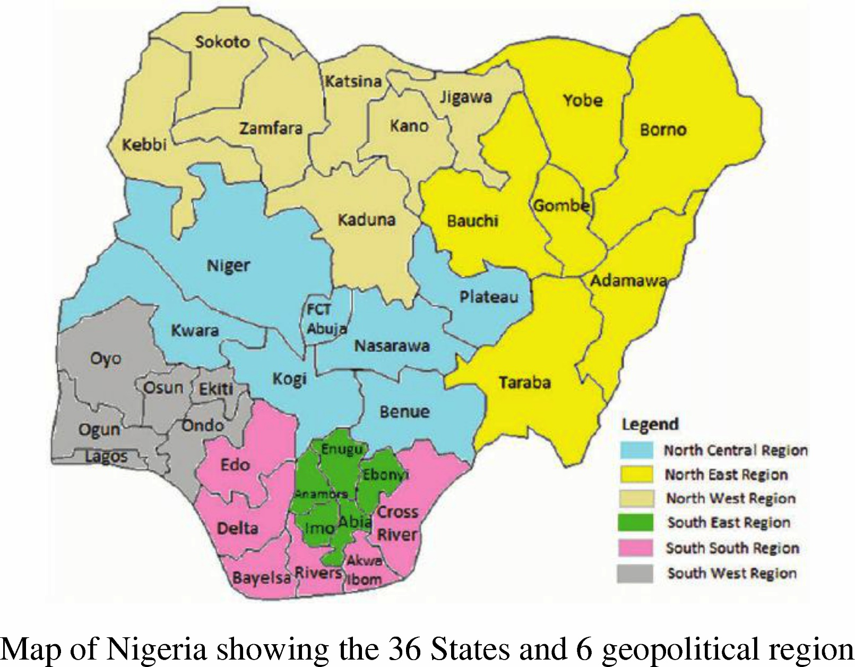

Fig 1. Map Nigeria showing the 36 states and 6 geopolitical region.

RESULTS
The combined analysis of the two years evaluation of 15 improved ginger mutant lines across 10 states in Nigeria is presented in Table 2. The analysis of variance showed Genotypes, Environments, Genotype x Environment Interaction (GEI) and Years to be significant at P< 0.01 and P<0.05 for all yield related traits including plant height, number of tillers, number of rhizome fingers per plant, rhizome length and the total rhizome yield. However, there was no significant difference in G xY interaction and GEI (Genotype Environment Interaction) in rhizome total yield. The negative interaction between genotype x environment indicated that there was genotype discrimination against location. The environment specific to superiority of some of the mutant lines underscores their suitability for the targeted environments whereas those with broad adaptability across multiple environments will enhance productivity regardless of resilient environmental conditions. The positive relationship of genotypes interaction with environment (GEI) for plant height, number of tillers, rhizome fingers, rhizome length and rhizome yield showed differences in the performance of ginger mutant lines at each environment. This led to strategic identification of genotypes that gives high productivity and stable performance across the diverse agro-ecological zones.

Table 2: Mean squares from combined ANOVA for yield and growth parameters of fifteen selected ginger genotypes over ten environments
Sources of variation | Degree of freedom | Plant height (Cm) | No of Tillers | No of Rhizome fingers/plant | Rhizome length (Cm) | Total Rhizome Yield (t/ha)
Year | 1 | 4410.66*** | 101.48* | 700.583*** | 511.070*** | 0.2075ns
Genotype | 14 | 179.31*** | 40.91** | 27.689*** | 7.578** | 2.4746**
Environment | 9 | 17005.54*** | 1881.02*** | 1484.416*** | 449.069*** | 78.8748***
GY | 14 | 47.33ns | 18.77ns | 8.890ns | 5.160ns | 0.7864ns
EY | 9 | 1699.04*** | 239.83*** | 177.481*** | 145.533*** | 2.7461***
GE | 126 | 111.40*** | 24.05* | 21.898*** | 7.371*** | 0.4493ns
GEY | 126 | 74.51** | 18.17ns | 15.787*** | 5.193*** | 0.5172ns
Error | 600 | 51.06 | 18.74 | 7.603 | 3.743 | 0.9548
* *And * = significant level at P<0.01 and P<0.05 respectively; ns=not significant, GY=Genotype Year interaction, EY= Environment Year interaction; GEI = genotype environment interaction, GEY; Genotype Environment and Year interaction

3.1.2 STABILITY ANALYSIS OF YIELD AND YIELD COMPONENTS
Multivariate analyses using AMMI and GGE biplots were performed to identify stable and high yielding ginger mutant lines. The additive main effect and multiplicative interaction (AMMI) and the genotype plus genotype by environment (GGE) biplot models help to evaluate the genotype by environment (GE) interactions and stability parameters of the improved ginger mutant lines across the 10 locations (States in Nigeria) in two years. The characters analyzed are yield and yield- related traits such as total rhizome yield, number of rhizome finger, rhizome length, plant height and number of tillers.
Table 3: Additive Main effect and Multiplicative Interaction (AMMI) Analysis of Variance for plant height (cm), number of tiller, number of rhizome finger per plant, Rhizome length (cm) and total rhizome yield (t/ha)
 |  | Plant Height (cm) |  |  | Number of Tiller |  |  | Number of Rhizome fingers |  |  | Rhizome Length (cm) |  |  | Total Rhizome Yield (t/h)
SV | Df | MS | Explained variation % |  | MS | Explained variation% |  | MS | Explained variation% |  | MS | Explained variation% |  | MS | Explained variation%
Total | 899 | 256 |  |  | 40.7 |  |  | 28.3 |  |  | 10.98 |  |  | 1.610
Treatment | 149 | 1138** | 98.74 |  | 137.8** | 76.11 |  | 110.3** | 89.77 |  | 34.07** | 51.42 |  | 5.189** | 53.42
Genotype | 14 | 179* | 12.09 |  | 40.9 | 10.56 |  | 27.7* | 11.52 |  | 7.58** | 14.07 |  | 0.475* | 20.45
Environment | 9 | 17006** | 66.55 |  | 1881.0** | 46.26 |  | 1484.4** | 52.43 |  | 449.07** | 40.95 |  | 78.875** | 49.10
Blocks | 20 | 117** | 1.02 |  | 10.8 | 0.59 |  | 9.5 | 0.75 |  | 5.57 | 1.12 |  | 7.628 | 10.54
Interaction | 126 | 111 | 20.10 |  | 24.1** | 18.28 |  | 21.9** | 10.83 |  | 7.37* | 9.41 |  | 0.449** | 15.91
IPCA1 | 22 | 284** | 2.71 |  | 95.0** | 5.77 |  | 68.3** | 5.90 |  | 15.67** | 3.49 |  | 2.019** | 8.06
IPCA2 | 20 | 122 | 8.14 |  | 22.6 | 3.23 |  | 27.4** | 2.15 |  | 10.11 | 2.04 |  | 0.293 | 3.41
Residual | 84 | 64 | 2.33 |  | 5.8 | 1.33 |  | 8.4 | 2.77 |  | 4.54 | 3.87 |  | 0.075 | 0.43
Error | 730 | 80 | 25.23 |  | 21.7 | 43.29 |  | 12.0 | 34.47 |  | 6.41 | 47.43 |  | 0.714 | 36.03
*p≤0.05; **p≤0.01; Df = degree of freedom; MS = Mean square; SV = Source of variation; IPCA = Interactive Principal Component Analysis

The AMMI analysis of variance for rhizome yield and yield related components tested at 10 locations for 2 years are presented in Table 3. The observed variations in plant height, number of tillers, rhizome fingers, rhizome length and total rhizome yield showed that the performances of the ginger mutant lines were influenced by environment (E), genotypes (G) and genotype by environment interaction ( GEI). The AMMI analysis for plant height showed significant differences for treatment, genotype, and environment except interaction (GEI). The genotype, environment and their interaction (GEI) accounted for 12.09, 66.55 and 20.10% of the treatment sum of squares respectively. The interaction sum of squares was partitioned into IPCA1 and IPCA2 and residuals. The IPCA1 andIPCA2 jointly accounted for 10.85 of the total variation due to interaction, with IPCA1 being significant. The environment contributed largely to variations in plant height (Table 3). The numbers of tillers showed that the genotypes, environment and GEI were also significant and each of the variations accounted for 10.56, 46.26 and 18.28% respectively. The environmental effect was high with moderate interaction. The interaction partitioned into IPCA1 and IPCA2 jointly accounted for 9.0% with IPCA1 being significant. AMMI analysis for rhizome fingers showed that G ,E, GEI effect accounted for 11.52, 52.43 and 10.83% treatment sum of squares. The IPCA1 and IPCA2 accounted for 8.05% of the variations due to interaction. Considering rhizome length , the G, E, and GEI were significant and accounted for 14.07, 40.95 and 9.41% of the variations. The IPCA1 and IPCA2 counted for 5.53% of the variations due to interactions. The AMMI analysis of variance for total rhizome yield showed that G, E, and GEI were significant and this accounted for 20.45, 49.10 and 15.91% of the variations. The effect of GEI was less indicating stability of rhizome yield in most of the environment. From the analysis the IPCA1 and IPCA2 jointly captured 8.06 and 3.41% of sum of squares interaction respectively.
The general observations from the AMMI analysis of variance showed high level of environmental effect which accounted for higher percentage of the total variation for all the yield components. This underscores the influence of agro-ecological factors such as temperature, rainfall and soil types. The AMMI stability values (ASV) from the interaction principal components axis (IPCA1 andIPCA2) explain the magnitude of genotype x environment interaction (GEI) in which the lower values of interaction depict greater stability in tested yield components.

AMMI Biplot Analysis for the yield components:
AMMI-1 biplot provides a visual expression of the relationship between the interaction principal axis (IPCA) and the mean performance of genotypes and environment. The AMMI estimate for environment and genotypes using AMMI-1 biplot shows the relative mean performance of the genotypes and environments for plant height. The Figure 2, shows the relative mean performance of genotypes and environments for plant height. The biplot indicated G1(UG1-11-03) G4(UG1-5-18, G9(UG2-5-04) and G10(UG2-5-35) as the best performing genotypes for plant height while G6(UG1-5-31) was the worst. E8 produced the tallest plants while E1 and E3 produced the shortest plants.
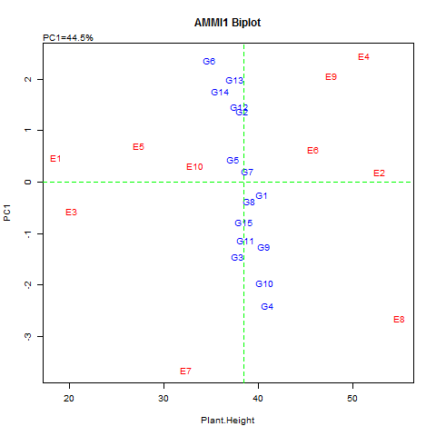
Key: G1=UG1-11-03, G2=UG1-11-07,G3=UG1-13-02, G4=UG1-5-18, G5 = UG1-5-22, G6=UG1-5-31, G7=UG1-5-35, G8=UG1-7-24, G9=UG2-5-04, G10=UG2-5-35, G11=UG2-5-38, G12=UG2-5-48, G13=UG2-5-49, G14=UG2-5-52, G15=UG2-9-01
E1=Bauchi, E2=Benue, E3=Borno, E4=Cross River, E5=Kaduna, E6=Nasarawa, E7=FCT(Nyanya), E8=Osun, E9=Plateau E10=Abia (Umudike)
Fig.2. AMMI-1 biplot showing the relative mean performance of genotypes and environments for the plant height.

The AMMI-biplot analysis for the numbers of tillers per plant is presented in Fig.3 which shows the relative mean performance of the genotypes and environment for numbers of tillers per plant. The Figure 3, indicated G13 (UG2-5-49) and G9 (UG2-5-04) to be the highest tillering ginger mutant lines favoured by E4 (Cross River) and E8 (Osun) and E2 (Benue) environment. The worst environment for tillering were observed on E6(Nasarawa), E7 (FCT) and E1(Bauchi) states.

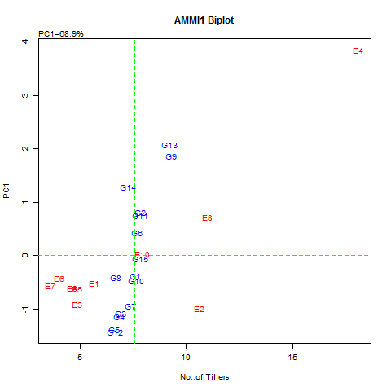
Key: G1=UG1-11-03, G2=UG1-11-07,G3=UG1-13-02, G4=UG1-5-18, G5 = UG1-5-22, G6=UG1-5-31, G7=UG1-5-35, G8=UG1-7-24, G9=UG2-5-04, G10=UG2-5-35, G11=UG2-5-38, G12=UG2-5-48, G13=UG2-5-49, G14=UG2-5-52, G15=UG2-9-01
E1=Bauchi, E2=Benue, E3=Borno, E4=Cross River, E5=Kaduna, E6=Nasarawa, E7=FCT(Nyanya), E8=Osun, E9=Plateau E10=Abia (Umudike)
Fig.3. AMMI-1 biplot showing the relative mean performance of genotypes and environments for the number of tillers per plant

The AMMI-biplot analysis for the rhizome fingers is presented in Fig.4 which shows the relative mean performance of the genotypes and environment for rhizome fingers per plant. The biplot indicated that the genotypes; G3 (UG1-13-02), G9 (UG2-5-04) and G15(UG2-9-01) are the best performing genotypes for rhizome fingers while the environment E2(Benue), E8 (Osun) and E10 (Abia) were indicated as the best environment for this trait. The worst performer in terms of rhizome fingers per plant are G6 (UG1-5-31), G2 (UG1-11-07) on environment such as E4(Cross River), E5 (kaduna) and E7(Benue).

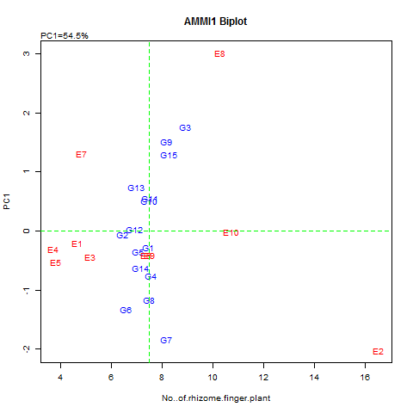
Key: G1=UG1-11-03, G2=UG1-11-07,G3=UG1-13-02, G4=UG1-5-18, G5 = UG1-5-22, G6=UG1-5-31, G7=UG1-5-35, G8=UG1-7-24, G9=UG2-5-04, G10=UG2-5-35, G11=UG2-5-38, G12=UG2-5-48, G13=UG2-5-49, G14=UG2-5-52, G15=UG2-9-01
E1=Bauchi, E2=Benue, E3=Borno, E4=Cross River, E5=Kaduna, E6=Nasarawa, E7=FCT, E8=Osun, E9=Plateau E10=Abia
Fig.4. AMMI-1 biplot showing the relative mean performance of genotypes and environments for number of rhizome fingers per plant

The AMMI-1 biplot showing the relative mean performance of the ginger genotypes and environment for rhizome length is presented in Fig.5. Two locations; E4 (Cross River) and E8 (Osun) were the environments that favored the development of rhizome length among the ginger genotypes; G3 (UG1-13-07), G10 (UG2-5-35 and G9 (UG2-5-04). The least favorable environment for rhizome length development was E7 (FCT). Most of the genotypes exhibited little interaction with the environment because of being close to the origin of the biplot. These included G2 (UG1-11-07), G11 (UG2-5-35), G14 (UG2-5-52), and G1(UG1-11-03). These genotypes tend to have a negative interaction with the environment which shows discriminatory performance
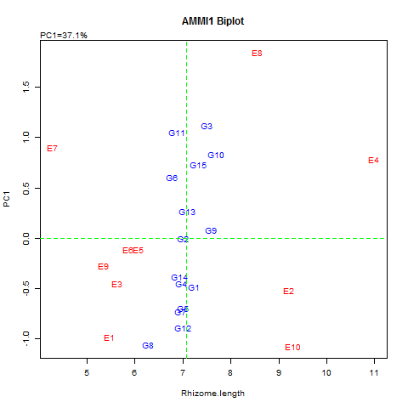
Key: G1=UG1-11-03, G2=UG1-11-07,G3=UG1-13-02, G4=UG1-5-18, G5 = UG1-5-22, G6=UG1-5-31, G7=UG1-5-35, G8=UG1-7-24, G9=UG2-5-04, G10=UG2-5-35, G11=UG2-5-38, G12=UG2-5-48, G13=UG2-5-49, G14=UG2-5-52, G15=UG2-9-01
E1=Bauchi, E2=Benue, E3=Borno, E4=Cross River, E5=Kaduna, E6=Nasarawa, E7=FCT, E8=Osun, E9=Plateau E10=Abia.
Fig.5. AMMI-1 biplot showing the relative mean performance of genotypes and environments for rhizome length.

The relative mean performance of the ginger genotypes and environment for rhizome yield using AMMI-1 biplot showed G3(UG1-13-02), G13 (UG2-5-49), G1 (UG1-11-03),and G9 (UG2-5-04) as the best performing genotypes in terms of rhizome yield while the other genotypes showed no variations in rhizome yield. The environment E4(Cross River) and E10(Abia) were regarded as the best environment while other environments (Locations) tend to have high interaction with the genotypes (Fig.6)
.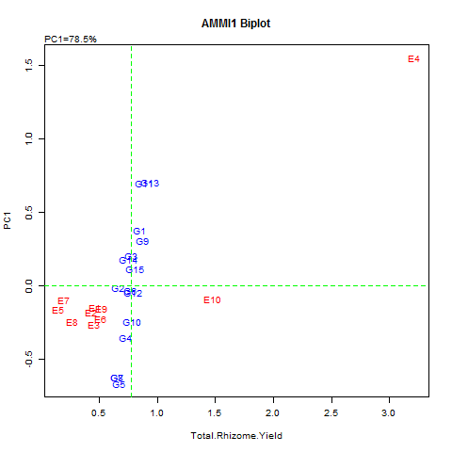
Key: G1=UG1-11-03, G2=UG1-11-07,G3=UG1-13-02, G4=UG1-5-18, G5 = UG1-5-22, G6=UG1-5-31, G7=UG1-5-35, G8=UG1-7-24, G9=UG2-5-04, G10=UG2-5-35, G11=UG2-5-38, G12=UG2-5-48, G13=UG2-5-49, G14=UG2-5-52, G15=UG2-9-01
E1=Bauchi, E2=Benue, E3=Borno, E4=Cross River, E5=Kaduna, E6=Nasarawa, E7=FCT, E8=Osun, E9=Plateau E10=Abia
Fig.6. AMMI-1 biplot showing the relative mean performance of genotypes and environments for total rhizome yield.

3.1.3. GGE BIPLOT ANALYSIS FOR RHIZOME YIELDS (t/ha)
The GGE biplot analysis was used to visualize the relationship between tester environment and the ginger mutant lines to determine which -Won-Where portion and this reveals the stability of genotypes. The genotypes located near the biplot origin are considered as widely adapted while those located far are considered as being specifically adapted. The biplot shows the relationship among the test environment as well as their discriminating ability which depends on the length of their vectors. The GGE biplot explained 88.2% of the total variation in rhizome yield was due to genotype and GE interactions. The PC1 axis explained 78.6% while the PC2 axis explained 9.6%. This is presented in Figure 7 which displays the GGE biplot environment vector view for rhizome yield (t/ha). The E4 (Cross River) had the longest vector, the most discriminating environment for yield followed by E10 (Abia ).
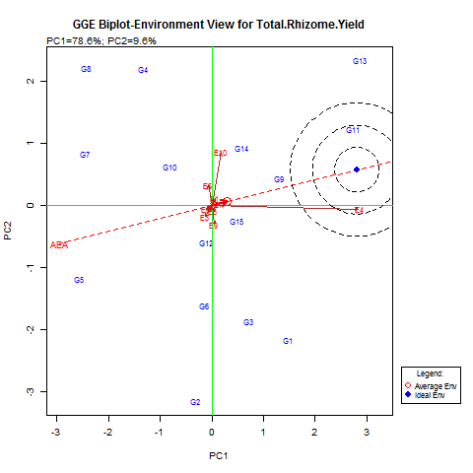
Fig.7. GGE biplot environment view showing representativeness and ranking of environment for rhizome yield(t/ha)

The GGE biplot for genotype ranking view for both mean performance and stability of rhizome yield across the locations is presented in Figure 8. Desirability is indicated in terms of both mean performance and stability. The genotype G13 (UG2-5-49) is indicated as the best performing genotype followed by G11(UG2-5-38). They are relatively stable for rhizome yield and thus ranked closest to the ideal genotype. Two genotypes G5 (UG1-5-22) and G7 (UG1-5-35) had the poorest mean yield with high interactions. In ranking of the genotypes; G13 (UG2-5-49 and G11 (UG2-5-38) were ranked closest to the ideal genotype. Other genotype such as G9 (UG2-5-04), G1 (UG1-11-03), G14 (UG2-5-52) and G15 (UG2-9-01) were averagely stable with average mean yield performance.

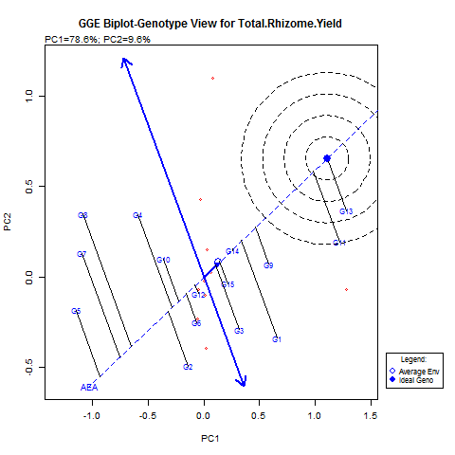
Key: G1=UG1-11-03, G2=UG1-11-07,G3=UG1-13-02, G4=UG1-5-18, G5 = UG1-5-22, G6=UG1-5-31, G7=UG1-5-35, G8=UG1-7-24, G9=UG2-5-04, G10=UG2-5-35, G11=UG2-5-38, G12=UG2-5-48, G13=UG2-5-49, G14=UG2-5-52, G15=UG2-9-01
E1=Bauchi, E2=Benue, E3=Borno, E4=Cross River, E5=Kaduna, E6=Nasarawa, E7=FCT, E8=Osun, E9=Plateau E10=Abia
Fig.8: GGE biplot genotype ranking view for both mean performance and stability for rhizome yield (t/ha)

The polygon view of the GGE Biplot for rhizome yield indicates the best genotypes for an environment. The genotypes located on the vertex of a polygon are the ones that gave the highest yield for the environment that falls within the quadrant for rhizome yield. The vertex genotype in each sector is the best genotype at the environment whose markers fall into the respective sector. Figure 9, shows the “What-Won-Where”GGE biplot for rhizome yield. The result among the mutant lines showed G13 (UG2-5-49) as the winner in a mega environment of E4 (Cross River) and E10 (Abia State). Other genotypes include G11(UG2-5-38) and G1(UG1-11-03).Two environments; E1 (Bauchi), E7 (FCT) favours G9 (UG2-5-04), G14( UG2-5-52),G15 (UG2-9-01) and G3(UG1-13-02). Three genotypes thrive favorably in five different environments which included E2 (Benue), E3(Borno), E5(Kaduna), E8 (Osun) and E9 (Plateau state). The genotypes are G2(UG1-11-07) G6(UG1-5- 31) and G12 (UG2-5-48). However, the performance of G8 (UG1-7-24), G7 (UG1 -5-35) and G5 (UG1-5-22) were low across the environment
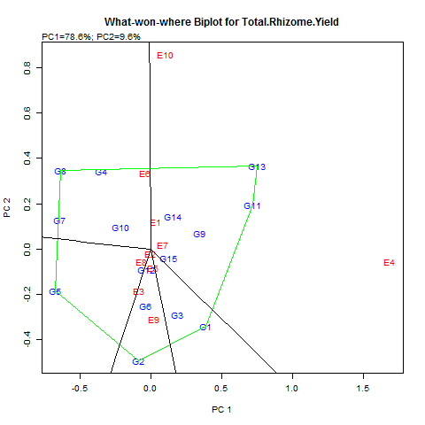
Key: G1=UG1-11-03, G2=UG1-11-07,G3=UG1-13-02, G4=UG1-5-18, G5 = UG1-5-22, G6=UG1-5-31, G7=UG1-5-35, G8=UG1-7-24, G9=UG2-5-04, G10=UG2-5-35, G11=UG2-5-38, G12=UG2-5-48, G13=UG2-5-49, G14=UG2-5-52, G15=UG2-9-01
E1=Bauchi, E2=Benue, E3=Borno, E4=Cross River, E5=Kaduna, E6=Nasarawa, E7=FCT(Nyanya), E8=Osun, E9=Plateau E10=Abia (Umudike)
Fig.9: “What-Won-Where” GGE biplot for rhizome yield (t/ha)

DISCUSSION
Crop varieties diffesr genetically in their stability across different environments and the production potential of an environment is the ability of the environment to support agronomic performance of superior genotypes(Diana-Abasi et.al,2018, Finlay & Wilkinson,1963). In conducting a multi- environment evaluation of advanced lines of any crop for yields , the superiority of the genotypes should be assessed over a wide range of environments. In other words the variation of a genotype across locations is a measure of its adaptability. Ginger is an important aromatic and spicy crop which have gained global attention for its high potential for enhanced food security and human health. Hence identification of stable and high yielding cultivars across diverse environment holds great promise for sustainable agriculture.
The combined analysis of the two years evaluation of 15 improved ginger mutant lines across 10 states in Nigeria showed significant differences in all the yield related traits . These variations are attributable to inherent genetic characteristics of ginger mutant lines. The ginger mutant lines were significantly different in their mean performances (Abua et al, 2021 and 2024). The analysis for Genotype, Environment, Genotype by Environment interaction (GEI0 and years showed significant differences in all yield related traits but no significant difference in G x Y interaction and GEI (Genotype x Environment interaction) for the total rhizome. The negative interaction between genotype and environment for rhizome yield indicated genotype discrimination against location. The inconsistency observed among all the genotypes was an indication of adaptation to specific environment (Iwo et al, 2002) .However, the positive relationship of genotypes with environment (GEI) for plant height, number of tillers, rhizome fingers, rhizome length, showed differences in performance of ginger mutant lines at each environment. According to Alghamdi (2004) , significant genotype by environment interaction across different locations showed that some genotypes are more stable than the others. This is also in line with the report of Ghaffari and Depae (2005) that yield differences attributed to environment is relevant to genotype evaluation. The evaluation of genotypes in different environment across years is important in determining their desirability and also to identify genotypes with average performance across environment with wide range of adaptation (Edugbo, et. al, 2015).
Multivariate analysis using AMMI and GGE biolot were performed to identify stable and high yielding ginger mutant lines. The ginger mutant lines exhibited different levels of stability for the yield and yield related characters evaluated in this study. The AMMI analysis of variance showed high level of environmental effect which accounted for higher percentage of variation for the entire yield components. The AMMI stability values from the interaction principal components axis (IPCA1 and IPCA2) explained the magnitude of genotype x environment interaction (GEI) in which the lower values of interaction depicted greater stability in tested yield components. According to Yan and Tinker (2006) positive interaction between genotype and environment indicate specific adaptation of the genotype to that environment which suggest a more favorable environment for the cultivation of the genotype. AMMI-1 biplot provides a visual expression of the relationship between the interaction principal axis (IPCA) and the mean performance of genotypes and environment. The AMMI-1 biplot shows the relative mean performance of the genotypes and environment for plant height which showed UG1-11-03, UG1- 5-18, UG2-5-04 and UG2-5-35 as the best genotypes for this trait under the favorable environment of Osun State while Bauchi and Borno States were the observed as the worst environment for plant height. The relative mean performance of the genotypes and environment for numbers of tillers per plant showed UG2-5-49 and UG2-5-04 to be the highest tillering ginger mutant lines favoured by cross River, Osun, and Benue environments. The mean performance of genotypes and environment for rhizome fingers per plant showed UG1- 13- 02, UG2-5-04, and UG2-9-01 as the best performing genotypes for this trait under ideal environment of Benue , Osun, and Abia States. According to Karimizadehi et.al(2013) an ideal genotype should have the highest mean performance and must be stable. This agrees with the report of Abua et al, (2020) that UG2- 9-01 and UG1-13-02 were genotype of choic with respect to stability and performance in rhizome finger and rhizome length. Two locations ; Cross River and Osun states favours the development of rhizome length on three genotypes; UG1-13-07, UG2-5-35 and UG2-5-04. The least favorable environment for rhizome length was FCT (Abuja). Most of the genotypes exhibited little interaction with the environment because of being close to the origin of the biplot. These genotypes tend to have a negative interaction with the environment which shows discriminatory performance. Test environments that are both discriminatory and representative are good for selecting well adapted genotypes. The relative mean performance of the ginger mutant lines and the environment for rhizome yield using AMMI -1 biplot showed UG!-13-02, UG2-5-49, UG1-11-03 as the best performing genotypes in terms of rhizome yield . Two environments ; Cross River and Abia were regarded as the best environments.
The GGE biplot analysis for the rhizome yield showed the visualized relationship among the test environment as well as their discriminating ability which depends on the length of their vectors. It explained 88.2% of the total variation in rhizome yield was due to genotype and genotype by environment interaction (GEI). In this study Cross River State was considered the most discriminating environment for rhizome yield followed by Abia State. In ranking the genotypes for both mean performance and stability of rhizome yield across the locations UG2-5-49 and UG2-5-38 were ranked as ideal genotype but other genotypes such as UG2-5-04, UUG1-11-03 and UG2-9-01 were averagely stable. This report conformed with the report of Abua et al (2020) . The polygon view of the GGE biplot for rhizome yield which indicated the best genotypes for an environment with the vertex genotype in each sector is the best genotype at that environment. The Which –won-Where polygon view shows which genotypes win in which environment with specific adaptation and environmental interaction for rhizome yield. The genotype UG2-5-04 won in E4( Cross River )and E10( Abia State). The biplot identified Bauchi (E1) and FCT(E7) as mega environment for UG2-5-04, UG2-5-52, UG2-9-01 and UG1-13-02. Mega environment grouping allow a breeder to recommend genotypes which are good for a particular environment (Gasura et.al,2025).According to Yan and Tinker(2006) mega environment is a group of locations that consistently share best genotypes. From the multiple environmental testing, five best performing genotypes with relative stability on each of the yield attributes were identified and selected. These genotypes are UG1-11-03, UG1-13-02, UG2-5-04, UG2-5-49, and UG2-9-01. This report support the earlier report of Abua et.al,2020 on muti- location trial of the same ginger mutant lines in Cross River State. In view of these findings, genotypes adapted to specific locations and broad or wide locations should be selected.
CONCLUSION:
The essence of multi-environment evaluation of newly developed crop genotypes is the identification of genotypes with superior performance and stability across diverse agro-climatic conditions. In study, the strategic identification of ginger mutant lines that simultaneously gives high productivity and stable performances in diverse locations is a major key to ginger breeding. The superiority of some ginger mutant lines over a wide range of environment was the basis of the trial and the variation of genotypes across location was a measure of its adaptability. Genotypes adapted to specific location or has broad stability across different environment should be selected. From the multi-environment testing, five best performing ginger mutants lines with relative stability on yield; UG1-11-03, UG1-13-02, UG2-5-04, UG2-5-49 and UG2-9-01 were observed to be the best performing ginger mutant lines based on studied traits, therefore these genotypes should be selected.

REFERENCES
Abua, M. N., Ittah, M. A., Obok, E. E, Iwo, G. A., Edugbo, R. E and Amadi, C. O. (2020a). Nutritional
qualities of ginger mutant lines grown in the humid tropical agroecology of Nigeria. Asian Journal of
Advances in Agricultural Research, 12 (2): 35 -42.

Abua, Mary Njei, Iwo, Godfrey Akpan, Ittah Macauuley Asim, and Obok Ekemini Edet (2020b).GGE biplot analysis of multi-location yield trial of ginger (Zingiber officinale Rosc)genotypes in South- Eastern Nigeria.Asian journal of Agriculture and Rural Development, Vol.10(1)485-503.
Abua, M.N., Ittah, M.A. and Iwo, G.A, (2021)Application of AMMI biplot model to evaluate some ginger (Zingiber officinaleRosc.) genotypes for adaptation and stability. Journal of Agricultural and Crop Research, 9(5):121-133.
Abua.M.N, Obok.E.E, Usen.M.J, and Iwo.G.A(2024).Comparative evaluation of growth and yield indices in some mutant lines of ginger (Zingiber officinale Rosc). African journal of Agriculture, Technology and Environment, Vol..13(1):12-17
Ashraf, K.; Ahmad, A.; Chaudhary, A.; Mujeeb, M.; Ahmad, S.; Amir, M. & Mallick, N. (2014) Genetic diversity analysis of Zingiber Officinale (Roscoe) by RAPD collected from subcontinent of India. Saudi Journal of Biological Sciences. 21: 159-165
Alghamdi S.S(2004).Yield stabilityof some soybean genotypes across diverse environments. Pakistan journal of Biological Science, Vol.7(12)2109-2114.
Asumugha, G.N.; Anayaegbunam, H.N. &Ezulike, N. (2006). Ginger Production and Marketing in Nigeria. Extension guide. National Root Research Institute Umudike 7:1-4.
Diana-Abasi Udoh,Soren. K.Rasmussen, Sven-Erik Jacobsen, Godfrey.A.Iwo, and Walter de Milliano(2018).
Yield stability of sweet sorghum genotypes for Bioenergy production under contrasting temperete and Tropical environments. Journal of Agricultural Science, Vol. 10 (12)42-53.
Edugbo R.E, Nwofia.G.E and Fayeun.L.S(2015).An asseement of soybean (Glycine max L.Merril) yield in different environment using AMMI and GGE biplot model in humid rainforest fringes of Nigeria. Agricultura Tropica et Subtropica, Vol. 48(3)82-90
Ezeagu, W. (2006). Ginger Export. A paper presented at 3-day National Workshop on massive cassava and ginger production and processing for local industries and export, held at FatiMuasu Hall, National Centre for Women development, Abuja.
Finlay.K.W and Wilkinson.G.N(1963).The analysis of adaptation in a plant breeding programme..Australian journal of Agricultural Research, Vol.14:742-754.
Gasura.E, Setmela.P.S and Souta.C.M(2015).Evaluation of the performance of sorghum genotypes using GGE biplot. Canadian Journal of Plant Science, Vol.95:1205-1214.
Ghaffari.A.A and Depao.E(2005).Agro-climatic zoning ofiranian cold drylands. In proceding.of 2006 Iranian crop science congress.Pp 42-48
Govindarajan, V.S. (2004). Ginger - chemistry, technology, and quality evaluation: Part 1.Crit. Rev. in Food Sci. &Nutr. 17:1-96.
Iwo,G.A, Idowu.A.A and Ochigbo.A.A(2002).Evaluation of Sesame (Sesamum indicum L.)genotypes for yield stability and selectionin Nigeria. Nigeria Agricultural Journal,Vol.33:76-82.
Iwo.G. A. and Amadi, C. O. (2013). Evaluation of advanced M₄ mutant lines of ginger for selection. Nigerian
Journal of Genetics, 27: 151 -156
Iwo, G. A., Amadi, C. O., Eleazu, C. O. and Ukpabi, J. U. (2013). Induced mutagenesis on ginger for
improved yield components and oleoresin content. Canadian Journal of Plant Breeding, 1(3): 90 – 95.
Jake .D and Susan.J(2007).Beverage of Champions.Journal of chemistry,101(1)148-153.
Karimizadeh.R.,Mohammadi.M,Sabaghni.N,Mahmoodi.A.A,Roustami.B.,Seyyedi.F and kbari.F(2013).GGE
biplot analysis of yield stability in muti-environment trials of lentil geonotypes under rainfed
condition.Notulae Scientia Biologicae,5(2)256-262.
Macrae .R, Robinson.R.K and Sadler,M.J (2002). Encyclopedia of food science. Food Technology and
nutrition(2nd)Longman group,London Pp 52-54.
Mary.N.Abua, Godfrey .A.Iwo, Macauley. A.Ittah, Ekemini.E.Obok, Richmond.E.Edugbo(2021). Growth
and yield performance of mutant ginger (Zingibe officinale Rosc)linesin South-Eastern Nigeria . Journal of Applied Biology and Biotechnology.Vol1.:1-14.
Medova, G.N.; Egal, A. &Oldewage A. (2009). Nutritional value and antioxidant capacity of lunch meals consumed by elderly people of Sharpeville, SouthAfricaFoodChemistry 115(1)260-264.
Peter, K.V.; Ravindran, P.N.; Divakaran, M. & Babu, K.N. (2007). Horticulture: Vegetable, Tuber and Spice
Crops p 69.
Purchase J.L (1997).Parametric analysis analysis to describe genotypes x environment interaction and yield
stability in winter wheat (Ph.D Thesis)Department of Agronomy, Faculty of Agriculture, University of Free State Bloemfontein, Soth Africa.
Thanki, H. P., Sawargaonkar, S. L., &Linge, S. (2010). Path coefficient analysis in Pigeon pea. Electronic Journal of Plant Breed. 1(4): 936-939.
Yakubu, Y. (2007). Briefs on Ginger Processing: Proceeding of the National Workshop on Ginger Promotion, Processing, Utilization and Marketing in Nigeria. Held on the 12th -17th November, 2007 at the Kaduna State Agricultural Development Programme (KADP) Skill Development Center, Kafanchan, Kaduna State.pp30-32.
Yan.W.K(2001).GGE biplot. A windows application for graphical analysis of multi-environment trial data
and other types of two-way data. Agronomy Journal ,Vol.93:1111 -1118.
Yan W.K and Tinker N.A(2006).Biplot analysis of multi-evironment trial data: Principles and Application.
Canadian Journal of Plant Science, Vol.86:623-645.

