Comparative efficacy of Amprolium and Sulphaquinoxaline, commonly used anticoccidial drugs in Kashmir, in the treatment of coccidiosis: Assessment based on oocyst output and lesion score

ABSTRACT
Coccidiosis, caused by protozoan parasites of the genus Eimeria, is a major concern in livestock management. Control of coccidiosis has relied primarily on the chemotherapy. This experimental study evaluates the comparative efficacy of amprolium and sulphaquinoxaline, commonly used anticoccidial drugs, in controlling coccidiosis. Broiler birds (Cobb-strain) were infected with 10⁵ mixed sporulated oocysts at 2 weeks of age and therapeutic medication commenced after the development of infection and continued for 5 days. Efficacy was assessed on the basis of lesion scoring and by comparing the oocyst output per gram of faeces before and after the treatment. Both the drugs exhibited limited efficacy in controlling the infection; however, sulphaquinoxaline demonstrated significantly greater efficacy than amprolium in reducing oocyst output and lesion severity. The findings highlight the potential benefits of using sulphaquinoxaline over amprolium in coccidiosis treatment regimens. However, considerations such as potential resistance development should also be taken into account.
Keywords: Amprolium, Anticoccidial efficacy, Coccidiosis, Lesion score, Oocyst output, Sulphaquinoxaline

INTRODUCTION
Coccidiosis, a parasitic disease caused by protozoan parasites of the genus Eimeria, significantly impacts the health and productivity of livestock, particularly poultry. The infection is associated with considerable destruction of epithelial cells arising from repeated host-cell invasion, lysis, and subsequent reinvasion by Eimeria parasites. The clinical manifestations of this condition encompass bloody diarrhoea, enteritis, and necrosis, which collectively result in diminished growth performance and compromised feed utilization in the affected hosts. These adverse effects contribute to significant losses in production and an increased mortality rate (Blake, 2015). The global cost of coccidiosis in chicken is estimated to have been approximately USD 13.68 billion in 2016, which includes costs for prophylaxis and treatment, as well as losses during production (Blake et al., 2020). Subclinical coccidiosis is a significant concern within the poultry industry, as it primarily manifests through substantial reductions in performance and decreased feed efficiency which consequentially contribute to notable economic losses on a global scale. In cases of coccidiosis exhibiting greater severity, the symptoms may resemble those of lighter infections but will include more pronounced manifestations, such as varying degrees of intestinal haemorrhage and an increased risk of mortality (Williams, 2005).
Coccidiosis has been recognized as universally important and most often reported health issue in poultry (Adams et al., 2021). The rapid development cycle of avian coccidia, along with its monoxenous life cycle, significantly contributes to the widespread prevalence of coccidiosis. Despite extensive research, this globally recognized protozoan infection remains inadequately understood and poses challenges to the growth of the poultry industry (Conway and McKenzie, 2007). Addressing this issue is crucial for enhancing the overall productivity and sustainability of poultry operations (Taylor et al., 2007). In the realm of poultry production, chemotherapeutics are established as the principal curative methodology for the management of coccidiosis, particularly following the introduction of sulfa medications, which have catalysed significant growth within the industry that would not have been achieved without the use of anticoccidial drugs. A number of pharmacological agents have been sanctioned for the treatment of coccidiosis in poultry species. While this advancement has substantially contributed to the proliferation of the livestock sector, it has concurrently intensified selection pressure on the majority of anticoccidial agents and elicited concerns regarding the potential toxicity associated with drug residues in meat and various poultry products. Furthermore, prolonged use of anticoccidial medications has resulted in the evolution of drug-resistant strains, reducing the effectiveness of these medications (Hur et al., 2005; Chapman, 2014).
The apprehensions within the community regarding the consumption of drug-treated meat, exacerbated by escalating costs related to the development of novel therapeutics and the alarming emergence of drug resistance have markedly diminished commercial endorsement for the establishment of new anticoccidial drugs (Noack et al., 2019). Moreover, numerous anticoccidial treatments necessitate protracted duration of administration and exhibit efficacy limited to specific developmental stages of the parasites. Consequently, it is imperative to undertake regular evaluations of the efficacy of these medications, as such assessments can furnish critical insights into the timing of oocyst reappearance and the resistance profile of the Eimeria population. In Kashmir Valley, anticoccidial drugs such as amprolium and sulphaquinoxaline are commercially available and widely used to control coccidiosis. Amprolium, a thiamine analogue, interferes with the parasite’s thiamine metabolism, while sulphaquinoxaline, a sulfonamide derivative, inhibits folic acid synthesis.
Despite their use, the comparative efficacy of these drugs remains a topic of interest. This study aims to evaluate and compare the efficacy of amprolium and sulphaquinoxaline based on oocyst output and lesion scores.
MATERIALS AND METHODS

Ethics Approval

The broiler chicken utilized in this study were subjected to procedures in accordance with International Ethical Standards and received approval from the Institutional Animal Ethics Committee of SKUAST-Kashmir (Regst. No.: 1809/GO/ReBiS/Rel/15/CPCSEA) under the Committee for the Purpose of Control and Supervision of Experiments on Animals (CPCSEA), thereby authorizing the researchers to undertake the study.
Study design
A randomized controlled trial was conducted over a period of 35 days with Cobb-strain broiler chicken divided into four groups: a negative control (uninfected, untreated), a positive control (infected, untreated), an amprolium-treated group, and a sulphaquinoxaline-treated group. The animals were maintained in conformity with established standard conditions, encompassing precise parameters such as temperature, ventilation and lightening of rooms. They were provided with a designated feed and had continuous access to water as required. Prior to challenge, it was ascertained that all animals were free of Eimeria infection.
Collection of material
The infective material was collected randomly from the sites of natural outbreak of coccidial infection and processed for sporulation of Eimeria oocysts by incubating in 2.5% potassium dichromate solution at a temperature of 28±2° C. Animals were infected with a mixed Eimeria species inoculum containing 10⁵ mixed sporulated oocysts per animal at 2 weeks of age. The inoculum contained seven Eimeria species viz., Eimeria acervulina, E. brunetti, E. maxima, E. mitis, E. necatrix, and E. tenella identified because of the morphological characteristics of oocysts (Edgar and Siebold, 1964; Soulsby, 1982) and confirmed using COCCIMORPH software for Eimeria oocyst morphometry (Castañón et al., 2007).
Drug administration
After the development of infection i.e., 5-6 days after experimentally challenging the birds with infection, treatment with experimental drugs was commenced. The selection of anticoccidial drugs was made on the basis of the preliminary investigation that showed amprolium and sulphaquinoxaline being the widely used anticoccidial drugs throughout the Kashmir valley. The treatment regimen followed was as per the recommendation of veterinarians.
Amprolium: Administered at a dose of 1g/l in the drinking water for duration of 5 consecutive days.
Sulphaquinoxaline: Administered at a dose of 1g/l in the drinking water for duration of 5 consecutive days.
Efficacy parameters
Oocyst output measurement
Fecal samples were collected before, during and after the treatment i.e., from day 19th to day 27th. Oocyst counts were determined using the McMaster technique, with results expressed as oocysts per gram (OPG) of feces (Soulsby, 1982). OPG on day 19th i.e., 6th day post-infection was taken as before treatment count and that of 20th to 24th was considered during treatment measurements and 25th to 27th as post-treatment OPG count.
Lesion scoring
At the 7th day post-infection, representative numbers of birds from each group were humanely euthanized, and intestinal tissues were dissected into four parts and processed for microscopic lesion scoring staining the histopathological sections with haemotoxylin and eosin stain (Khorrami et al., 2022). The lesions in dissected parts viz., duodenum, jejunum, ileum and caecum were scored separately on the basis of extent of tissue damage in the form of villi fragmentation, sloughing of tunica serosa and thickening of tunica muscularis. Lesion scores were assigned based on the Johnson and Reid scoring system (1970), which evaluates lesions on a scale from 0 (no lesions) to 4 (severe lesions) where 0 = Normal, 1= Minimal, 2= Mild, 3= Moderate, 4= Marked.
Statistical analysis
Comparisons between groups were made using one-way ANOVA followed by Least Significant Difference (LSD) post-hoc test. The difference between group means was considered statistical significance at P<0.001.
RESULTS
Oocyst output
The data presented in Table 1 illustrates the OPG counts for different experimental groups. The oocyst output was highest at 21st day of age in positive control i.e., 10100 ± 17 followed by amprolium-treated group (6880 ± 14.9) and was comparatively lower in sulphaquinoxaline-treated group (5040 ± 17.3). Animals treated with sulphaquinoxaline exhibited a significantly lower oocyst output (370 ± 16.9) compared to those treated with amprolium (P<0.001) at 23rd day of age. There was a significant reduction in the mean OPG count of birds during treatment and it reduced to zero at 24th day as compared to positive control (9250 ± 24.5); however, it was still higher (2040 ± 21.3) in amprolium-treated group (Figure 1). The negative control group remained free from coccidial infection throughout the experimental trial.
Lesion scores
The extent of tissue damage in the form of villi fragmentation, sloughing of tunica serosa and thickening of tunica muscularis was recorded in separate parts of intestine. In case of sulphaquinoxaline-treated group, mild blunting of villous was observed in duodenum; jejunum and ileum revealed mild fragmentation and fusion of villi; whereas in caecum, thickening of tunica muscularis with cellular infiltration was observed. In amprolium-treated group, duodenum revealed mild blunting of villi; in jejunum villi fragmentation and sloughing of serosal layer was recorded; ileum showed thickening of tunica muscularis returning to normal, signifying the resolution of the inflammation and in caecum, moderate thickness in the tunica muscularis with fusion of villi was observed. In positive control group, thickened muscularis with severe fragmentation of villi was observed in duodenum; jejunum revealed denudation of tunica serosa with fragmentation of villi; ileum demonstrated denudation of serosal layer with severe fragmentation and fusion of villi; and caecum revealed moderate thickness in the tunica muscularis with fusion of villi (Figure 2).
Lesion scores were notably lower in the sulphaquinoxaline-treated group compared to the amprolium-treated group (Table 2). The average lesion score in the sulphaquinoxaline treated group was 1.25, compared to 2.25 in the amprolium treated group (Table 2). Highest lesion score (3.5) was recorded in positive control group. The negative control group exhibited normal architecture of all the four segments of intestinal tissues (Figure 3).
Comparison with control
Both treated groups showed significant improvements over the control group in terms of both oocyst output and lesion scores (P<0.01).
Age (in days) Mean OPG counts in different treatment groups

 | Group 1  Amprolium | Group 2  Sulphaquinoxaline | Group 3  Infected,  Untreated | Group 4  Uninfected,  untreated
 | 8250 ± 22.1^{g} | 8240 ± 14.6^{g} | 8160 ± 19^{h} | 0 ± 0^{w}
Day 19
Day 20 | 7120 ± 12^{k} | 7050 ± 9.89^{l} | 8950 ± 20^{f} | 0 ± 0^{w}
Day 21 | 6880 ± 14.9^{m} | 5040 ± 17.3^{n} | 10100 ± 17ª | 0 ± 0^{w}
Day 22 | 4860 ± 14.3º | 2630 ± 16.1^{q} | 9780 ± 14.1^{b} | 0 ± 0^{w}
Day 23 | 3140 ± 20.9^{p} | 370 ± 16.9^{u} | 9440 ± 23.9^{c} | 0 ± 0^{w}
Day 24 | 2040 ± 21.3^{r} | 0 ± 0^{w} | 9250 ± 24.5^{d} | 0 ± 0^{w}
Day 25 | 649 ± 22.8^{s} | 0 ± 0^{w} | 9040 ± 17.1e | 0 ± 0^{w}
Day 26 | 448 ± 19.8^{t} | 0 ± 0^{w} | 7970 ± 11.5^{i} | 0 ± 0^{w}
Day 27 | 135 ± 8.49^{v} | 0 ± 0^{w} | 7750 ± 19.7^{j} | 0 ± 0^{w}

Table 1. Mean oocyst per gram (OPG) counts in different treatment groups (Mean ± S.E.M)

P-value | Treatment | <0.001
P-value | Day | <0.001
P-value | T×D¹ | <0.001
Values are means ± SEM, n = 3 per treatment group.
^{a-w}Means in a row without a common superscript letter differ (P < 0.05) as analyzed by two-way ANOVA and the LSD test.
¹T × D = Treatment × Day effect.

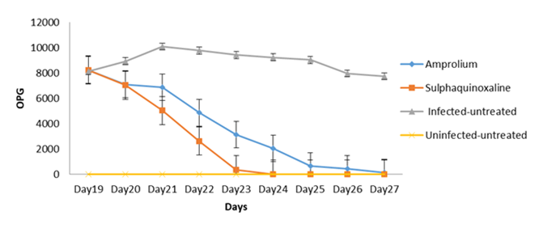
Figure 1. Mean oocyst per gram (OPG) counts in different treatment groups
Table 2. Lesion scores in different experimental groups

Experimental  Group | Duodenum | Ileum | Ceacum | Jejunum | Average
Amprolium | 2^{b} | 1^{b} | 3^{b} | 3ª | 2.25^{b}
Sulfaquinoxaline | 1^{c} | 1^{b} | 2^{c} | 1^{b} | 1.25^{c}
INC | 4ª | 3ª | 4ª | 3ª | 3.5ª
NNC NNC | 0 | 0 | 0 | 0 | 0

^{a-c}Means in a column without a common superscript letter differ significantly (P<0.05) as analyzed by two-way ANOVA and the LSD test

Group I: Infected and treated with amprolium at 1g/litre of water

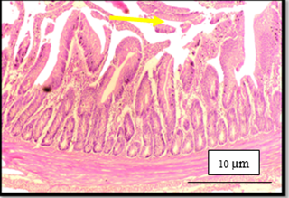  Score-2: Photomicrograph of duodenum revealing mild blunting of villi (Arrow) | 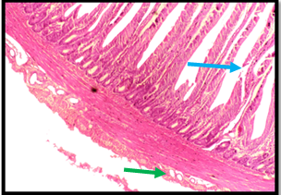  Score-1: Photomicrograph of jejunum revealing villous fragmentation and sloughing of serosal layer
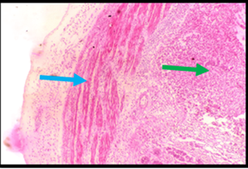  Score-3: Photomicrograph of caecum revealing moderate thickness in the tunica muscularis with fusion of villi | 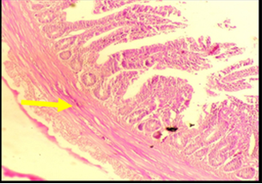  Score-3: Photomicrograph of ileum revealing thickness of tunica muscularis returning to normal, signifying the resolution of the inflammation
Group II: Infected and treated with sulphaquinoxaline at 1g/litre of water
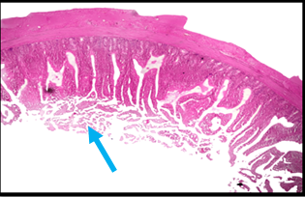  Score-1: Photomicrograph of duodenum revealing mild blunting of villous | 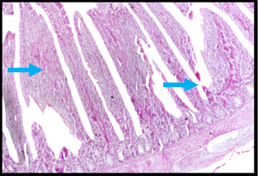  Score-1: Photomicrograph of jejunum revealing mild fragmentation and fusion of villi
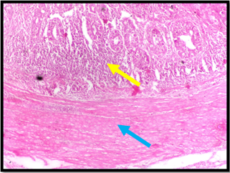  Score-2: Photomicrograph of caecum revealing thickness in the tunica muscularis with cellular infiltration | 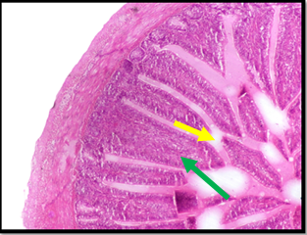  Score-1: Photomicrograph of ileum revealing mild fused and fragmented villi
Group III: Infected , Non Medicated Control

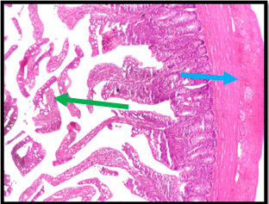  Score-4: Photomicrograph of duodenum revealing thickened muscularis with severe fragmentation of villi | 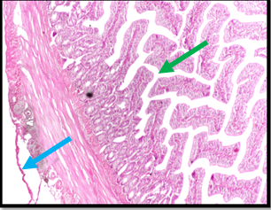  Score-3: Photomicrograph of jejunum revealing denudation of tunica serosa with fragmentation of villi
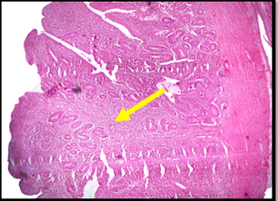  Score-4: Photomicrograph of caecum revealing moderate thickness in the tunica muscularis with fusion of villi | 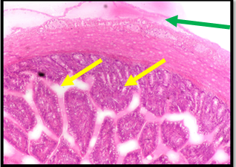  Score-3: Photomicrograph of ileum revealing denudation of serosal layer with severe fragmentation and fusion of villi

Figure 2. Lesion scoring criteria in terms of inflammatory and other pathological changes in intestine of the coccidiosis infected broiler chickens in the experimental trial.
Lesion Score : 0 = Normal, 1= Minimal, 2= Mild, 3= Moderate, 4= Marked

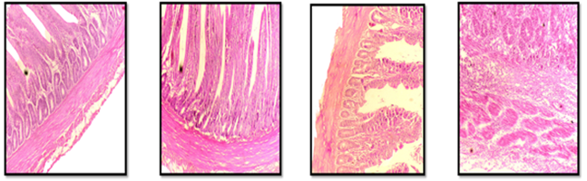
Section of duodenum revealing normal architecture of tunica muscularis and serosa | Section of jejunum revealing normal architecture of villi | Section of ileum revealing normal structure of tubular glands | Section of caecum revealing normal architecture of intestinal glands
Figure 3. Transverse sections of uninfected intestinal tissues showing normal structure
(Haematoxylin and Eosin Staining, 400X)
DISCUSSION
Coccidiosis presents a significant challenge in poultry production, leading to substantial economic losses. The economic deficits arising from coccidiosis are attributable to both clinical and sub-clinical disease presentations, alongside the associated expenditures for preventive measures. In the 1940s, the poultry industry commenced the utilization of prophylactic in-feed anticoccidial medication as a method of preventive control following their discovery (Reid, 1990). In the period spanning the 1980s and the early 1990s, sulphaquinoxaline, nitrofurans, and amprolium constituted the prevailing pharmaceutical interventions used within India for the purpose of managing poultry coccidiosis. Prophylactic chemotherapy, although considered an optimal strategy for addressing this formidable threat is facing a serious problem due to widespread resistance of Eimeria parasites to commonly used anticoccidial drugs (Long and Rose, 1982; Daugschies et al., 1998; Abbas et al., 2011; Kraieski et al., 2021).
Studies pertaining to the efficacy of interventions are pivotal in shaping and refining strategies for the control and management of diseases. The investigation was conducted to evaluate and compare the efficacy of commercially available synthetic drugs in experimentally infected chicken. Both the drugs are in use for a prolonged period of time in the area. The findings indicate that the administration of sulphaquinoxaline exhibited superior efficacy in reducing oocyst output and lesion scores, implying its enhanced effectiveness in managing coccidiosis compared to amprolium. A statistically significant reduction in the OPG count was observed in the sulphaquinoxaline-treated group, however; the OPG count of amprolium treated group was not significantly reduced. This observation aligns with the study conducted in Ethiopia to assess the efficacy of amprolium and sulfadimidine drugs in the treatment of poultry coccidiosis on the basis of fecal oocyst count. The study revealed that sulfadimidine treatment resulted in significant reduction in OPG count thus showed better efficacy; however, no statistically significant difference in OPG count was recorded in amprolium treated group before and after the treatment indicating the presence of resistance to this drug (Hunduma and Kebede, 2016). Furthermore, lesion scoring demonstrated the mildest lesions in chicken treated with sulphaquinoxaline as compared to amprolium. Amer et al. (2010) conducted a similar study in Egypt to evaluate anticoccidial efficacy of some commonly used anticoccidial drugs (amprolium, sulphaquinoxaline, and toltrazuril) in broiler chicken against mixed coccidial infection and showed that toltrazuril was more effective in eliminating the infection in chicken on the basis of lesion score and histopathological studies as compared to amprolium and sulfaquinoxaline.
Given the lower oocyst output and reduced lesion severity, sulphaquinoxaline may help achieve better clinical outcomes and reduce the need for repeated treatments. This could be due to differences in drug mechanisms, pharmacokinetics, or the specific Eimeria species targeted. Amprolium acts by blocking thiamine uptake, which is crucial for coccidian metabolism, while sulphaquinoxaline inhibits folic acid synthesis, a critical component in nucleic acid and protein synthesis. The effectiveness of sulphaquinoxaline may be attributed to its impact on an essential biochemical pathway for parasite survival.
The previous studies have indicated reduced efficacy of the drugs under investigation. Panda et al. (1973), in a groundbreaking investigation carried out in India, evaluated the drug resistance of the coccidiostats sulphaquinoxaline and bifuran (nitrofurazone 25% and furazolidone 3.6%). According to their results, the development of resistant strains of Eimeria species resulted in a decrease in the effectiveness of both bifuran and sulphaquinoxaline when administered for three years. In a separate study conducted by Chapman in 1989, an evaluation was performed on the efficacy of toltrazuril, sulphaquinoxaline/pyrimethamine, and amprolium/ethopabate against Eimeria tenella field isolates in chicken. The findings indicated that toltrazuril exhibited superior efficacy in comparison to sulfaquinoxaline/pyrimethamine and amprolium/ethopabate. Limited efficacy of amprolium has been investigated in a study conducted in Nigeria by Anosa et al. (2011) that has documented a diminished efficacy of amprolium against Eimeria species in comparison to toltrazuril. This decline has been attributed to the prolonged and continuous use of the former drug for a period exceeding a decade, resulting in the development of resistant strains. Recently, Shahininejad et al. (2024) conducted a study to compare the effect of natural products, anticoccidial drugs and vaccine on the prevention and treatment of coccidiosis in broilers experimentally challenged with mixed coccidial infection. The results of the study demonstrated that herbal medicines and commercial anticoccidial drug, monensin improved intestinal health and increased production efficiency in broilers hence were effective in controlling the infection. The majority of studies have reported the loss of sensitivity or emergence of resistance in coccidiostat chemical drugs in contrast to ionophores/coccidiocidal drugs that are known to disrupt the ion gradients across the parasitic cell membrane resulting in killing of parasites (Abdelhady et al., 2021). However, no ionophore drug has been introduced yet to control poultry coccidiosis in Kashmir valley.
CONCLUSION
The study provides evidence that sulphaquinoxaline is more effective than amprolium in controlling coccidiosis, as demonstrated by lower oocyst output and less severe lesions. These findings suggest that sulphaquinoxaline may be a preferable choice for treatment, although further research is needed to validate these results under different conditions and explore long-term efficacy and resistance patterns.

Future Research
This study was conducted over a short period and in a controlled environment. Long-term efficacy, safety, and potential resistance development should be investigated in field settings. Further studies could also explore the effects of combining these drugs or using them in rotation/shuttle program along with the introduction of ionophores to mitigate the emergence of resistance.

COMPETING INTERESTS DISCLAIMER:
Authors have declared that they have no known competing financial interests OR non-financial interests OR personal relationships that could have appeared to influence the work reported in this paper.

REFERENCES
Abbas RZ, Iqbal Z, Blake D, Khan MN, Saleemi MK. 2011. Anticoccidial drug resistance in fowl coccidia: the state of play revisited. World's Poultry Science Journal, 67(2): 337–350.
Abdelhady AY, El-Safty SA, Hashim M, Ibrahim MA, Mohammed FF, Elbaz AM, Abdel-Moneim AME. 2021. Comparative evaluation of single or combined anticoccidials on performance, antioxidant status, immune response, and intestinal architecture of broiler chickens challenged with mixed Eimeria species. Poultry Science, 100: 101162.
Adams DS. 2021. Novel methods for controlling and diagnosing avian coccidiosis. North Carolina State University.
Amer MM, Awaad MHH, Abo-Elezz NM, El-Khateeb RM, Sherein-Said A, Ghetas MM, Kutkat MA. 2010. Experimental study on the efficacy of some commonly used anticoccidial drugs in controlling of coccidiosis with mixed field isolates in broiler chickens. World Applied Sciences Journal, 9(4): 359–366.
Anosa GN, Obetta VC, Okorie-Kanu CO, Eze JI. 2011. Comparative efficacy of toltrazuril, amprolium and embazine fort® against mixed Eimeria species infection in broilers. Nigerian Veterinary Journal, 32(3).
Blake DP. 2015. Eimeria genomics: where are we now and where are we going? Veterinary Parasitology, 212(1–2): 68–74.
Blake DP, Knox J, Dehaeck B, Huntington B, Rathinam T, Ravipati V, Ayoade S, Gilbert W, Adebambo AO, Jatau ID, Raman M. 2020. Re-calculating the cost of coccidiosis in chickens. Veterinary Research, 51: 115.
Castañón CA, Fraga JS, Fernandez S, Gruber A, Costa LDF. 2007. Biological shape characterization for automatic image recognition and diagnosis of protozoan parasites of the genus Eimeria. Pattern Recognition, 40(7): 1899–1910.
Chapman HD. 1989. Chemotherapy of caecal coccidiosis: efficacy of toltrazuril, sulphaquinoxaline/pyrimethamine and amprolium/ethopabate, given in drinking water, against field isolates of Eimeria tenella. Research in Veterinary Science, 46(3): 419–420.
Chapman HD. 2014. Milestones in avian coccidiosis research: a review. Poultry Science, 93(3): 501–511.
Conway DP, McKenzie ME. 2007. Poultry coccidiosis: diagnostic and testing procedures. John Wiley & Sons.
Daugschies A, Gässlein U, Rommel M. 1998. Comparative efficacy of anticoccidials under the conditions of commercial broiler production and in battery trials. Veterinary Parasitology, 76(3): 163–171.
Edgar SA, Seibold CT. 1964. A new coccidium of chickens, Eimeria mivati sp. n. (Protozoa: Eimeriidae) with details of its life history. The Journal of Parasitology, 50(2): 193–204.
Hunduma A, Kebede B. 2016. Comparative study on the efficacy of amprolium and sulfadimidine in coccidia infected chickens in Debre-Zeit agricultural research center poultry farm, Bishoftu, Ethiopia. SOJ Veterinary Sciences, 2(2): 1–5.
Hur SN, Molan AL, Cha JO. 2005. Effects of feeding condensed tannin-containing plants on natural coccidian infection in goats. Asian-Australasian Journal of Animal Sciences, 18(9): 1262–1266.
Johnson J, Reid W. 1970. The pathology of coccidiosis. Veterinary Pathology, 7(4): 260–273.
Khorrami P, Gholami-Ahangaran M, Moghtadaei-Khorasgani E. 2022. The efficacy of pomegranate peel extract on Eimeria shedding and growth indices in experimental coccidiosis in broiler chickens. Veterinary Medicine and Science, 8(2): 635–641.
Noack S, Chapman HD, Selzer PM. 2019. Anticoccidial drugs of the livestock industry. Parasitology Research, 118: 2009–2026.
Johnson J, Reid WM. 1970. Anticoccidial drugs: lesion scoring techniques in battery and floor-pen experiments with chickens. Experimental Parasitology, 28: 30–36.
Kraieski AL, Salles GBC, Muniz EC, Nascimento DVJ, Neto AL, Santos IL, Madeira AMBN. 2021. Sensitivity of field isolates of Eimeria acervulina and E. maxima from three regions in Brazil to eight anticoccidial drugs. Poultry Science, 100(8): 101233.
Long PL, Rose ME. 1982. Prospects for the control of coccidiosis by immunization. World's Poultry Science Journal, 38(2): 85–96.
Panda NC, Pradhan HK, Mitra A, Parichha SN. 1973. Drug resistance of coccidia exposed to a single type of coccidiostat. Indian Veterinary Journal, 50: 22–26.
Reid WM. 1990. History of avian medicine in the United States. X. Control of coccidiosis. Avian Diseases, 34(3): 509–525.
Shahininejad H, Rahimi S, Torshizi MAK, Arabkhazaeli F, Ayyari M, Behnamifar A, Abuali M, Grimes J. 2024. Comparing the effect of phytobiotic, coccidiostat, toltrazuril, and vaccine on the prevention and treatment of coccidiosis in broilers. Poultry Science, 103596.
Soulsby EJL. 1982. Helminths, arthropods and protozoa of domesticated animals. 7th ed. Baillière Tindall, London, 809 pp.
Taylor MA, Coop RL, Wall RL. 2007. Parasites of poultry and gamebirds. In: Veterinary Parasitology. 3rd ed. Blackwell Publishing, pp. 459–557.
Williams RB. 2005. Intercurrent coccidiosis and necrotic enteritis of chickens: rational, integrated disease management by maintenance of gut integrity. Avian Pathology, 34(3): 159–180.

