Journal Name: | Asian Journal of Research and Reports in Neurology
Manuscript Number: | Ms_AJORRIN_154334
Title of the Manuscript: | Congenital Facial Paralysis with Microtia Grade 3 in a 13-Year-Old Male
Type of the Article | Case Report

PART 1: Comments
 | Reviewer’s comment | Author’s Feedback (It is mandatory that authors should write his/her feedback here)
Please write a few sentences regarding the importance of this manuscript for the scientific community. A minimum of 3-4 sentences may be required for this part. | The paper reported a case Congenital Facial Paralysis with Microtia. It reported its investigation. It also reported the management of the case.
Is the title of the article suitable?  (If not please suggest an alternative title) | Yes
Is the abstract of the article comprehensive? Do you suggest the addition (or deletion) of some points in this section? Please write your suggestions here. | Yes
Is the manuscript scientifically, correct? Please write here. | Yes
Are the references sufficient and recent? If you have  suggestions of additional references, please mention them in the review form. | Yes

Is the language/English quality of the article suitable for scholarly communications? | No
Optional/General comments | There are some errors in the scientific writing and language of the paper. Please check carefully.  Please add reference numbers to the text of introduction and discussion sections in accordance with the matching sentences.  Please add a brief patient’s management outcome to the abstract.  Please add the A, B, C, D, to each image figure.  If possible, you can also add a photo of the patient during follow-up. ear  You can add the following with its reference:  The external ear develops from the first pharyngeal cleft. The middle ear arises from the tubo-tympanic tubular of the first pharyngeal pouch. The ear ossicles arise from the first and second pharyngeal arches; the malleus and incus from the first arch and the stapes from the second arch (Figures 1, 2) (Hegazy, 2014).  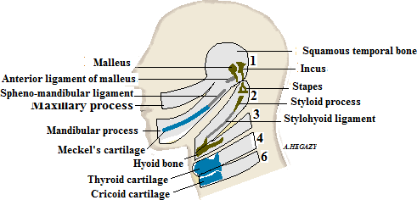  Figure 1. Skeletal derivatives of pharyngeal arches (Hegazy, 2014)  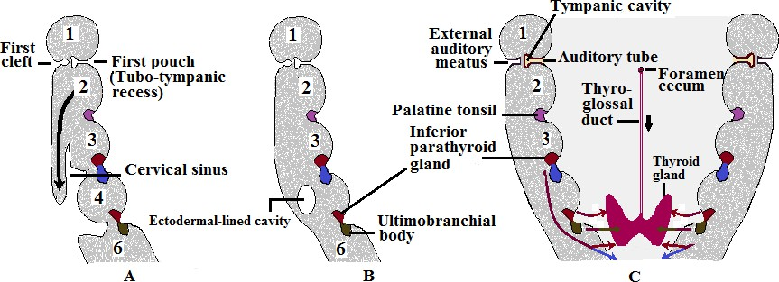  Figure 2. Sections in side wall of developing pharynx; A)Descent of second pharyngeal arch,  B) Stage of cervical sinus, C) floor of pharynx and derivatives of pharyngeal pouches and clefts (Hegazy, 2014).  Hegazy A. Clinical embryology for medical students and postgraduate doctors. Lap Lambert Academic Publishing; 2014.  You can add the above figures. This is my agreement to add them. It's my book.

PART 2:

 | Reviewer’s comment | Author’s Feedback (It is mandatory that authors should write his/her feedback here)
Are there ethical issues in this manuscript? | (If yes, Kindly please write down the ethical issues here in details)

Reviewer details:

Abdelmonem Awad Hegazy, Zagazig University, Egypt

