Effects of Fertilizers Made from Natural Phosphate of Tahoua (NPT) on Millet Yield

Abstract
The productivity of millet-cereal cropping systems is threatened by soil degradation, which necessitates the supply of nutrients that can promote plant growth and development. The objective of this study is to evaluate the performance of different fertilizers—simple superphosphate (SSP), improved simple superphosphate (SSPA), and improved diammonium phosphate (DAPA)—made from natural phosphate of Tahoua (NPT) and Tahoua natural phosphate powder, on millet yield. To determine the physicochemical parameters of the cultivated soil, it was noted that the soils studied had a silty-sandy texture and low levels of organic matter, total phosphorus, water-soluble phosphorus, and cation exchange capacity. We then harvested the millet. After applying fertilizers to, we found The grain yield of millet crops recorded were: PNT (520 kg/ha), DAPA (1355 kg/ha), SSP (1029 kg/ha), and SSPA (1589 kg/ha). Biomass yields were also observed for PNT (2607 kg/ha), DAPA (6507 kg/ha), SSP (5989 kg/ha), and SSPA (7018 kg/ha). Finally, The application of phosphorus-rich fertilizers increased post-harvest millet yields, but the yield was even higher with the application of improved superphosphate fertilizer.
Key : Fertilizers, Natural Phosphate, Millet Yield
I. Introduction
The world's population numbers over 8 billion and will reach 9.5 billion by 2050. Feeding this population will require an increase in food supply, which can only be met through intensified agricultural activity (Salla Moreto et al., 2025). Furthermore, population growth is always accompanied by a decrease in arable land and, consequently, increased pressure on available land. It appears that the fertility of agricultural soils is declining, and with it, agricultural yields (Mando, 1998). This necessitates addressing the problems affecting agricultural production while simultaneously managing and preserving the world's natural resources. Agriculture in sub-Saharan African countries is characterized by its low productivity, according to the FAO report (1984). These low crop yields in Niger are often attributed to unfavorable rainfall patterns, naturally low soil nutrient levels, and limited fertilizer use (Amos Minigou et al., 2020). Indeed, the production of phosphate-based fertilizers helps address soil nutrient deficiencies. Among these nutrients, phosphorus is essential for plants. Phosphorus is the eleventh most abundant element in the Earth's crust (Centre R, 2008). Almost entirely derived from the weathering of calcium phosphates in Earth's surface rocks, phosphorus is a component of tissues where it plays a crucial role in energy storage and transfer. It is essential for human, animal, and plant life on Earth. Unlike other important biogeochemical cycles (nitrogen, sulfur, oxygen, carbon, and water), the phosphorus cycle does not involve a significant gaseous component and has virtually no impact on the atmosphere. Its availability is linked to rock weathering. Phosphorus is often one of the limiting factors for plant growth, such as photosynthesis, root development, and energy storage (Aurélien et al., 2016). Its limited availability as a soil nutrient is one of the main causes of low agricultural yields in sub-Saharan Africa (SOMA Dohan Mariam, 2010). It is one of the most limiting factors for agricultural production. The concentration of phosphate ions in the soil solution is low and does not allow for adequate phosphate nutrition of crops (Compaoré et al., 2001). An agricultural practice is considered unsustainable whenever the bioavailability of phosphorus limits the yields essential for meeting food needs (Pieri, 1991). Faced with this situation, the use of organic amendments remains one of the effective solutions to improve soil fertility, increase crop yields and overall agricultural production in a sustainable way; it is necessary not only to increase the phosphorus content of the soils but also to improve their bioavailability in the soils.
II. Materials and Methods
II.1. Materials
II.1.1. Laboratory Equipment
The equipment used during this work included:
❖ SWISS Quality Precisa 205A balance;
❖Stirrer;
❖Glassware;
❖ Oven set to 110°C
II.1.2. Study Area
The work was carried out next to the garden of the Faculty of Agronomy at Abdou Moumouni University of Niamey, located between latitude 13°29’57’’6 North and longitude 2°05’24’’2 East. The map is shown in Figure 1.
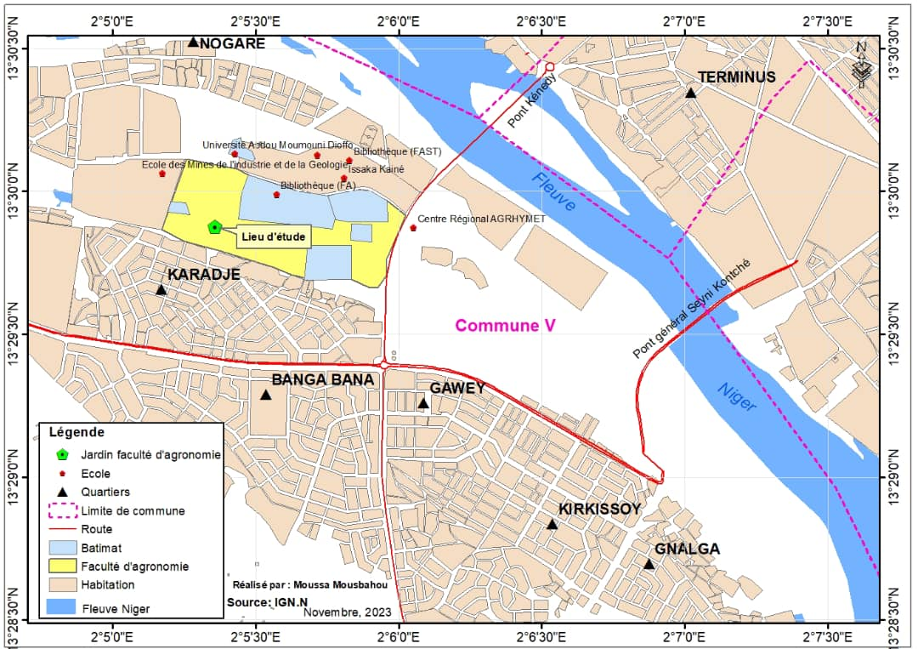
Figure 1: Location of the study site (Mousbahou M, 2023)
The trial site is located within the Faculty of Agronomy at Abdou Moumouni University, in Commune 5 of Niamey. The site is characterized by sandy soil, on which woody vegetative growth and herbaceous vegetation have developed.
II.1.3. Soil Samples and Analyses
Soil samples collected for these studies were taken from a depth of 0-30 cm. They were collected at the beginning of the season, before planting the experiments, and at harvest time. Samples were taken at three different points along the diagonal. Soil analyses were carried out at the ABU (Ahmadou Bello University) Central Multi-User Scientific Research Laboratory in Zaria, Nigeria, and focused on physicochemical parameters.
II.2. Method
Trials of previously prepared products, such as simple superphosphate, improved simple superphosphate, improved diammonium phosphate, and Tahoua merchant phosphate, were conducted during the rainy season on 21 m² plots. To ensure good reproducibility of the results, we performed three replicates (one 2 g spoonful per planting hole) of fertilizer application (SSP, SSPA, DAPA) and PMT in millet cultivation to evaluate yield components (grain and dry straw weight).
II.2.1. Preparation of Fertilizer Samples (SSP, SSPA, DAPA, and PMT)
After processing the phosphate rock sample, we treated the ground rock with acid solutions. Fifty grams of Tahoua phosphate were carefully weighed using a Précisa 205 A precision balance. Commercially available sulfuric acid (H₂SO₄) was diluted. Varying masses of diluted H₂SO₄ were then mixed with varying amounts of H₃PO₄. The resulting solutions were added to the phosphate powder, and the mixtures were stirred using a glass stirrer (Table I). The samples were handled carefully and placed in an oven set at 80°C for one hour.
Table I: Prepared Fertilizers
Samples | Compositions
SSP | 54g PM g | 16mL H₂SO₄
SSP | 54g PM g | 16mL H₂SO₄ | 6 mL H₂O
SSPA | 54g PM g | 10 mL H₂SO₄ | 6 mL H₃PO₄
DAPA | 90g PM g | 10g DAPS
PMT | 54g PM µm

The work was carried out in two phases. The first phase consisted of developing the various phosphate fertilizers, while the second was dedicated to applying the resulting products to the crops. Before testing, we conducted a soil analysis of the cultivated site to determine its physicochemical parameters, allowing us to compare the soil's existing nutrient content with the added nutrients.
II.2.2. Preparation of Phosphate Improved by Synthetic DAP
We synthesized diammonium phosphate using analytical-grade reagents by partially neutralizing dilute phosphoric acid with a dilute ammonia solution. The neutralization of phosphoric acid by gaseous ammonia is an exothermic reaction. We carried out the experiment by stirring the mixture until it reached a pH value close to 8 at room temperature. The resulting products were then dried in an oven at 60°C and stored in a desiccator. Next, samples of commercial phosphate from Tahoua were mixed with the product obtained in varying quantities to determine the dissolved P2O5 concentration using spectrophotometry.
II.2.3. Parameter Determination
We evaluated the yield components (grain and dry straw weight). Harvesting is carried out by completely cutting the millet plants. After a few days of drying, the ears are cut and then hulled (Ousmane M S, 2018). Grain yields are then assessed. The agronomic effectiveness of these treatments was determined using the formula below.
$$EA (\%) =\frac{yield with fertilizers - control yield (PMT)}{control yield (PMT)}$$
III. Results and Discussion
III.1. Influence of Fertilizers Made from Natural Products on Millet Yield
III.1.1. Soil Characterization at the Study Site
After collecting a soil sample at the experimental site before planting, the soil sample was analyzed to determine its physicochemical parameters. The various findings from the sample analysis allowed us to compile the following table.
Table II: Physicochemical Properties of Soils (0-30 cm Depth)
Physical Characteristics |  |  |  | Chemical Characteristics
Depth | Clays % | Silts % | Sands % | pH | Organic matter |  | Phosphorus mg/kg |  | Exchangeable bases méq/100g |  |  |  | CEC
 |  |  |  |  | C | N | Psol | Ptot | Ca | Mg | K | Na | CEC
0-15cm | 2,99 | 19,02 | 77,99 | 6,8 | 0,21 | 0,02 | 5,91 | 18,05 | 5,98 | 3,8 | 0,02 | 0,03 | 11
15-30cm | 4,09 | 24,89 | 71,02 | 7,3 | 0,24 | 0,02 | 6,69 | 20,89 | 6,69 | 3,8 | 0,02 | 0,03 | 12,22
According to this table, we reveal that the soil has a texture dominated by sand followed by silt, indicating a silty-sandy texture. Furthermore, chemically, parameters such as organic matter and phosphorus are very low, and its pH is almost neutral. The cation exchange capacity is low, and the exchangeable bases are surpassed by calcium and magnesium. In this sense, this soil degradation could be due to the depletion of nutrients in the soil. This progressive depletion of soil nutrients and the acidity generally associated with it cannot be permanently corrected by the application of water-soluble phosphate fertilizers (Kasongo, R. et al., 2012) in order to enhance and/or increase agricultural productivity.
III.1.2. Effect of Treatments on Millet Production
III.1.2.1. Comparative Effects of Fertilizers on Millet Production
The Figures 2 to 5 illustrate photographs of the treatments after 50 days of experimentation. Heading appeared after 37 days of using phosphate fertilizers, namely simple superphosphate (SSP), improved simple superphosphate (SSPA), and improved diammonium phosphate (DAPA), and it occurred on day 43 after the application of natural phosphate from Tahoua. The height of the millet at maturity in the phosphate fertilizer treatments was greater than in the treatment with commercial phosphate from Tahoua. This could be related to the effect of the added phosphate fertilizers. These fertilizer inputs should be noticeable in terms of straw and grain biomass. A significant difference in straw size was observed following the different fertilizer applications. Therefore, the observed increase in yields is due to the improvement in the soil's nutritional status resulting from the different fertilizer inputs. However, the products used did not induce any significant variation in the length and diameter of the ears compared to the average daily weight (ADW) of millet. These results obtained from the analysis of variance showed that a high degree of variability in the crops was observed; that is, the higher the amount of phosphorus, the greater the growth and development of the millet plant. This improvement resulted in good plant nutrition, hence the increase in yields. Regarding the micro-dose, its performance is thought to be linked to the concentration of nutrients at the root system level, improving accessibility and efficiency of use (Muehlig V, B, Buerkert A, Bationo A., 2003). This could be linked to plant growth and development. Spencer and Sivakumar (1987) showed that growth is mainly due to the increased phosphate content in fertilizers, meaning that genetic and technical improvements have had the expected effects on agricultural productivity. Indeed, previous studies have confirmed that adding phosphorus to crops directly impacts plant growth and development (Tabo R, et al., 2007; Fatimata S, et al., 2017). Furthermore, micro-dosing fertilizer application increases yields of dried cereal crops, such as millet. Demonstration trials of micro-dosing fertilizer application conducted by the Sahelian center ICRISAT in Niger, Mali, and Burkina Faso showed that sorghum and millet yields were 44% to 120% higher with micro-dosing compared to the previous fertilization practices recommended by research (Fatimata S, et al., 2017). The micro-dosing fertilizer technique aims to improve soil yields, whether the soil is degraded or not, by meeting the phosphorus requirements of deficient soils. The results obtained from this study show greater significance than the results obtained through the practices of farmers in their crops.
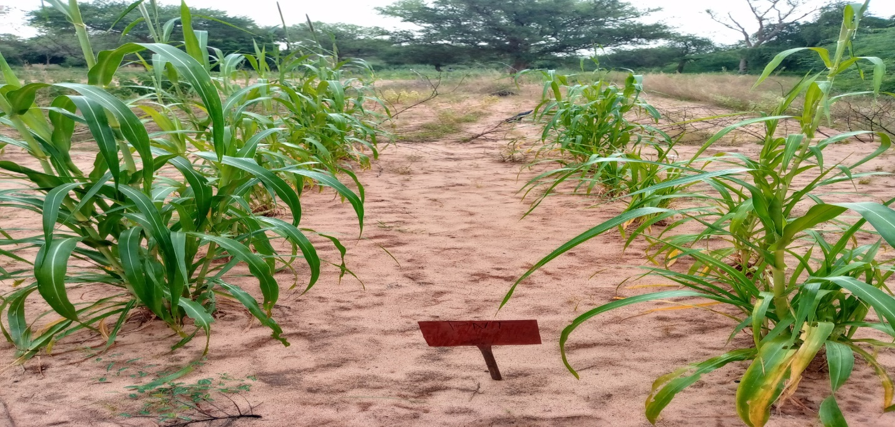
Figure 2: Photograph of treatments with natural phosphate from Tahoua after 50 days of sowing
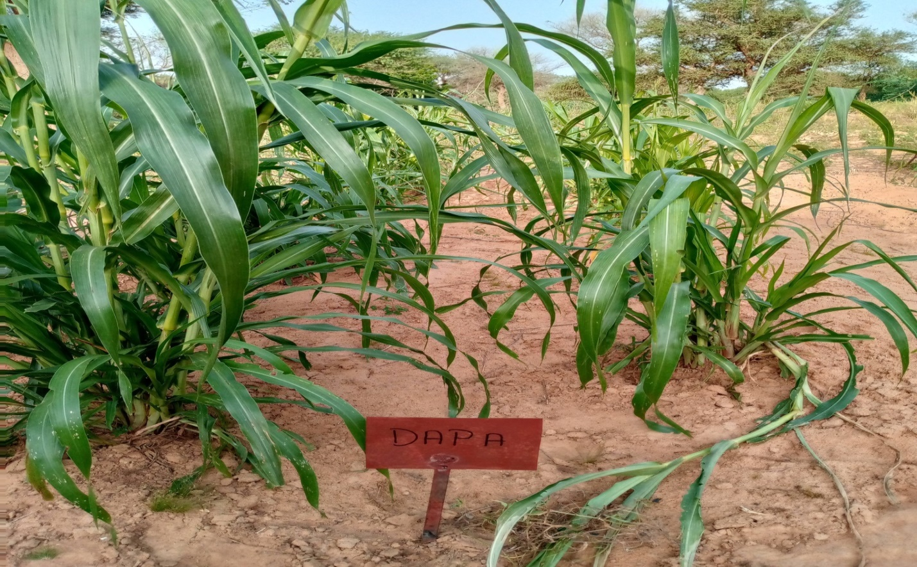
Figure 3:Photograph of treatments with improved diammonium phosphate (DAPA) after 50 days of seeding
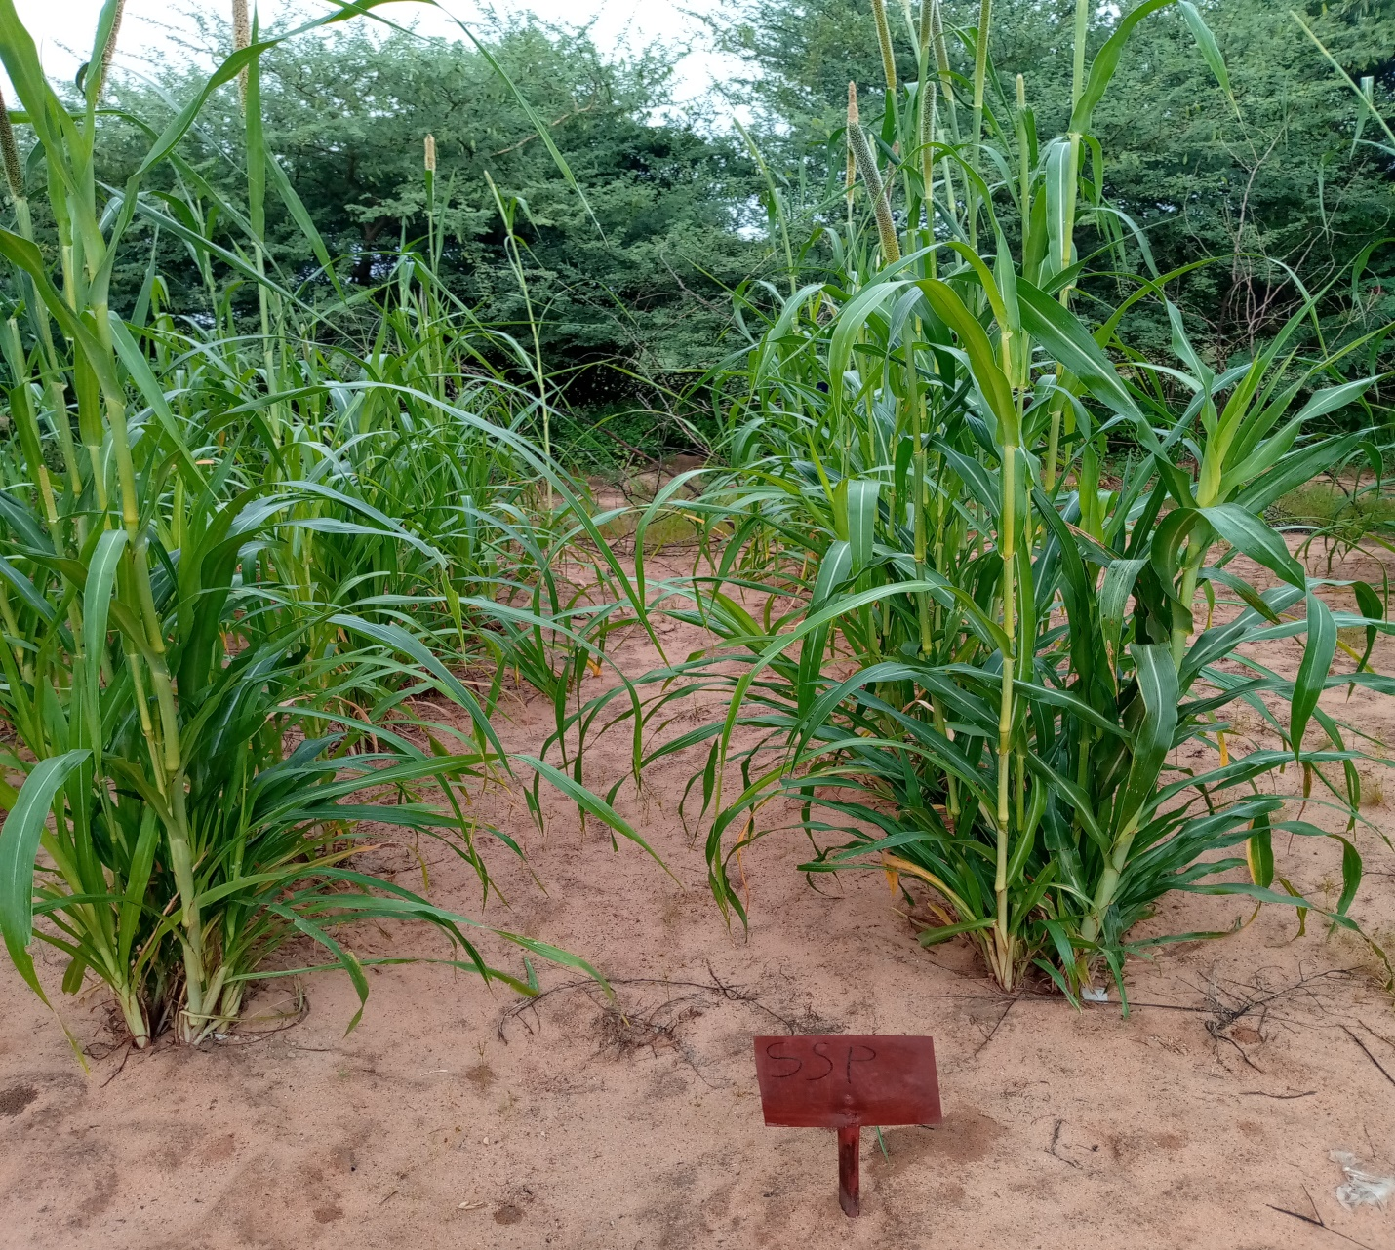
Figure 4: Photograph of treatments with simple superphosphate (SSP) after 50 days of seed
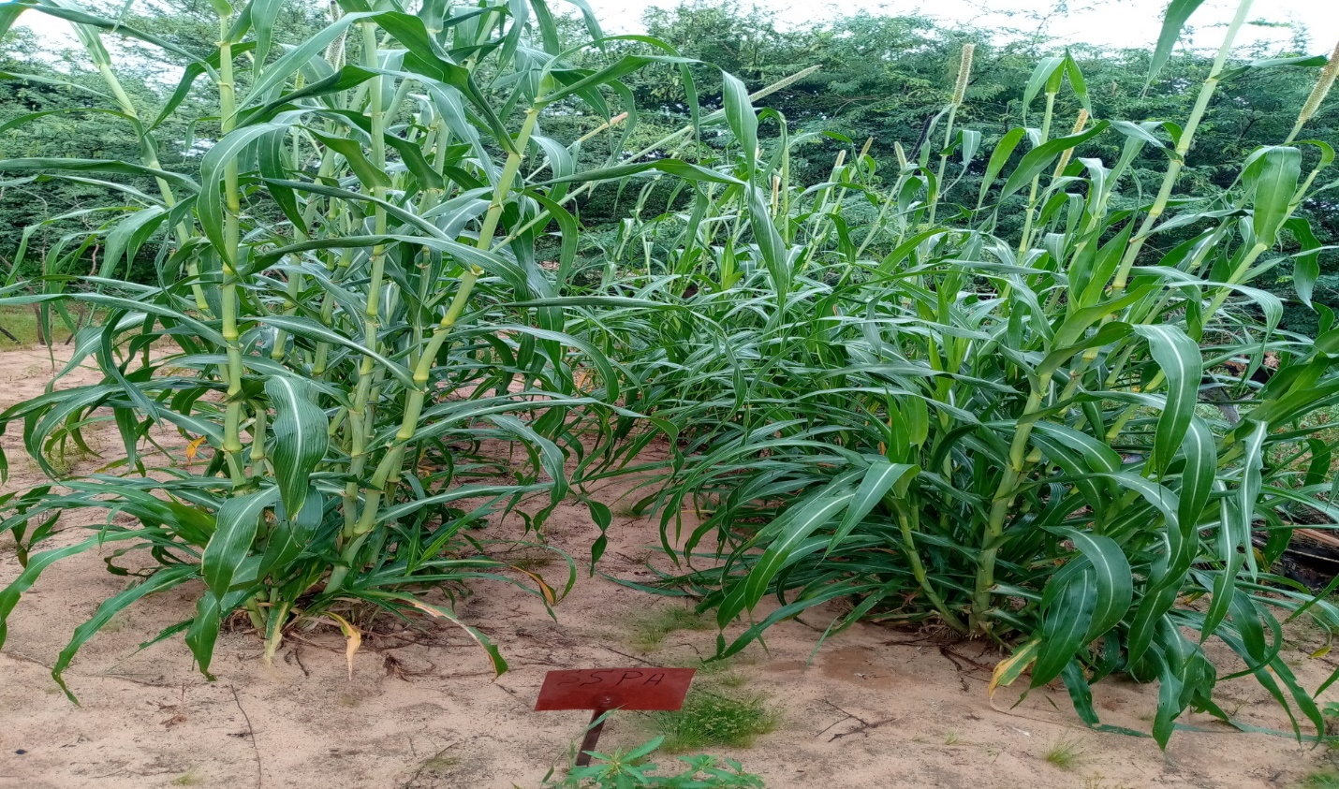
Figure 5:Photograph of treatments with improved simple superphosphate (SSPA) after 50 days of seeding
After 92 days of millet sowing, the harvest took place. The average grain and dry straw yields for each treatment are shown in the table below.
Table III: Millet Grain and Biomass Production
Treatments | Grain yields kg/ha | Biomass yield kg/ha
PNT | 520 | 2607
DAPA | 1355 | 6507
SSP | 1029 | 5989
SSPA | 1589 | 7018
The doses of phosphate fertilizers applied directly to millet production had significant effects on total biomass and grain yields. The results are shown in Figure 6.

Figure 6: Grain and Biomass Yields of Different Treatments
This figure illustrates the different phosphate fertilizer treatments on cultivated plants. These results, obtained after harvest, show grain and biomass yields for PNT (520 kg/ha and 2607 kg/ha), DAPA (1355 kg/ha and 6507 kg/ha), SSP (1029 kg/ha and 5989 kg/ha), and SSPA (1589 kg/ha and 7018 kg/ha), respectively. We observed that the superphosphate fertilizer resulted in the highest yield. This higher nutrient content therefore promoted better leaf and root growth in the millet under the treatments. The grain and biomass yields of millet could be linked to the efficiency of the nutrients used. In other words, these results could be explained by the high phosphorus content of these fertilizers. In this study, the number of millet grains obtained with SSPA fertilizer (1589 kg/ha) is similar to that obtained by Ousmane, MS, (2018) for millet plants grown with different doses of compost. It is important to note that millet is the most widely cultivated crop in West Africa, which is why we focused our study on millet. Millet is cultivated primarily for grain production in Niger, which is by far its most significant use.
Conclusion
During this study, we conducted a physicochemical analysis of cultivated soil. The results showed that the soil structure was silty-sandy, with low levels of nitrogen, carbon, total phosphorus, water-soluble phosphorus, and cation exchange capacity. The addition of phosphate fertilizers PNT, DAPA, SSP, and SSPA promoted improved leaf, root, and grain growth. At the end of the study, it was observed that the highest yields were obtained with the application of improved superphosphate, while yields were lower with the application of natural phosphate from Tahoua. Therefore, improving the productivity of arable land for sustained and sustainable agricultural production is a major challenge in Niger.
Disclaimer (Artificial Intelligence)
Author(s) hereby declare that NO generative AI technologies such as Large Language Models (ChatGPT, COPILOT, etc) and text-to-image generators have been used during writing or editing of this manuscript.
Competing Interests
Authors have declared that no competing interests exist.
COMPETING INTERESTS DISCLAIMER:
Authors have declared that they have no known competing financial interests OR non-financial interests OR personal relationships that could have appeared to influence the work reported in this paper.
References
Amos MININGOU*, Vanessa GOLANE, Appolinaire Sy TRAORE and Hyacinthe KAMBIRE, (2020). Determination of the optimal dose and date of mineral fertilizer application on sesame (Sesamum indicum L.) in Burkina Faso. Institute of Environment and Agricultural Research (INERA) / CREAF, 01 BP: 476 Ouagadougou 01, Burkina Faso. DOI: https://dx.doi.org/10.4314/ijbcs.v14i9.3
Aurélien Roger1,2, Sylvain Pluchon2, Jean-Claude Yvin2, Mohammed Benbrahim3, Laurent Kremer3 and Sokrat Sinaj1 1Agroscope, (2016). Effects of a new phosphate fertilizer on wheat nutrition and yield. Institute of Plant Production Sciences IPV, 1260 Nyon, Switzerland. 2 ROUILLER Group – World Innovation Center, 35800 Dinard, France. 3 RITTMO Agroenvironment, ZA Biopôle, 68000 Colmar, France. Information : Sokrat Sinaj,
Quebec Reference Center for Agriculture and Agri-food, (2008). Phosphorus Mobility: From Soil to Watercourse, www.craaq.qc.ca
Compaoré E., Fardeau J.C., Morel J., Sedogo M. P. (2001). Bioavailable Soil Phosphorus: One of the Keys to Sustainable Agriculture in West Africa. Cahiers Agricultures, 10.Issue (2). P 81-5
FAO. (1984). Fertilizer and Plant Nutrition Guide 1984. FAO Fertilizer and Plant Nutrition Bulletin 9. Rome, 18p.
Fatimata SABA, Sibiri Jean Baptiste TAONDA, Idriss SERME, Alimata A. BANDAOGO, Augustin P. SOURWEMA, and Adama KABRE. (2017). Effects of microdose on cowpea, millet, and sorghum production as a function of toposequence. Institute of Environment and Agricultural Research (INERA), Burkina Faso. 3023-IJBCS.DOI: https://dx.doi.org/10.4314/ijbcs.v11i5.12
Kasongo, R. K., Van Ranst, E., Kanyankogote, P., Verdoodt, A., and Baert, G. (2012). Response of soybean (Glycine max) to the application of Kanzi phosphate and Kimpese pink dolomite on sandy soil in the Democratic Republic of Congo. Can. J. Soil Sci. 92: 905-916
Mando A. (1998). Mulch and termites improve nutrient release and crop performance on crusted Sahelian soils. Arid soil rehabilitation and research, 8: 269-278.
Mousbahou Moussa Harouna, (2023). Study site location map, source: IGN
Muehlig-Versen B, Buerkert A, Bationo A, Roemheld V. (2003). Phosphorus placement on acid arenosols of the West African Sahel. Exp. Agric., 39: 307-325.
OUSMANE, MS, (2018). Physicochemical characterizations and improvement of agronomic efficiency through phosphocomposting of natural phosphates from Niger. Doctoral thesis in Inorganic Chemistry, Abdou Moumouni University of Niamey. 132 pages;
Pieri C. (1991). Phosphorus balance and sustainable agriculture in Africa. In: Tiessen H., Frossard E. eds. Phosphorus Cycles in terrestrial and aquatic ecosystems. Regional workshop 4: Africa SCOPE/UNEP. March 18-22. Nairobi, Kenya (Africa), 1991. pp. 44-72.
Soma Dohan Mariam, (2010). Effect of repeated applications of various sources of organic amendments in a leached tropical ferruginous soil (Saria, Burkina Faso) on phosphorus bioavailability and sorghum production. Advanced Studies Diploma in Soil Science from the Polytechnic University of Bobo-Dioulassa. Page 47
SALLA Moreto; DIOMANDE Souleymane; KOUADIO Aka Niangoran Marie-Stephanie; SORO Kouhana; DIARRASSOUBA Mohamed, (2025), Comparative effects of organic and mineral inputs on the growth and yield of tomato (Solanum Lycopersicum L.) in Daloa (Côte d’Ivoire). African Agronomy 2025, 37 (2), pp 1-14.
SPENCER D.S.E., SIVAKUMAR M V.K., (1987). Pearl millet in African agriculture. In: International Pearl Millet Workshop, J.R. Witcombe ed., Patancheru, India, ICRISAT, p. 19-31
Tabo R, Bationo A, Gerard B, Ndjeunga J, Marchal D, Amadou B, Garba MA, Sogodogo D, Taonda JBS, Hassane O, Diallo MK, Koala S. (2007). Improving cereal productivity and farmers income using a strategic application of fertilizers in West Africa. In: Advance in Integrated Soil Fertility Management in Sub-Saharan Africa,

