Soxhlet Extraction and Quantification of Gallic Acid and Quercetin from Moringa oleifera Leaves by HPLC

Abstract
Moringa oleifera is a nutritionally and medicinally important plant widely recognized for its rich phytochemical composition, particularly phenolic acids and flavonoids. This study aimed to evaluate the extraction efficiency and quantify major antioxidant markers gallic acid and quercetin in methanolic and aqueous leaf extracts. Soxhlet extraction was carried out using methanol and distilled water, yielding 12.56% for the methanolic extract (MO-M) and 10.21% for the aqueous extract (MO-A). The total phenolic content (TPC), determined using the Folin–Ciocalteu method, was higher in MO-M (25.85 ± 0.62 mg GAE/g) than in MO-A (17.21 ± 0.55 mg GAE/g). Likewise, the total flavonoid content (TFC), measured by the AlCl₃ assay, was greater in MO-M (6.47 ± 0.43 mg QE/g) than in MO-A (3.85 ± 0.22 mg QE/g). High-Performance Liquid Chromatography (HPLC) analysis confirmed the presence of gallic acid and quercetin in both extracts. The methanolic extract exhibited higher concentrations of gallic acid (2.4 µg/mL) and quercetin (1.4 µg/mL) compared to the aqueous extract, which contained 1.3 µg/mL and 0.48 µg/mL, respectively. Retention times showed precise agreement with standard references, validating chromatographic accuracy and specificity.
Overall, the findings demonstrate that methanolic extraction is more efficient than aqueous extraction for isolating phenolic and flavonoid compounds from Moringa oleifera leaves. These results highlight the strong antioxidant potential of Moringa oleifera, supporting its application in nutraceutical, herbal, and pharmaceutical formulations.
Keywords: Moringa oleifera; Soxhlet extraction; Total phenolic content; Total flavonoid content; Gallic acid; Quercetin; HPLC analysis; Antioxidants; Phytochemicals; Methanolic extracts.

1. Introduction
Moringa oleifera, widely known as the drumstick tree, is a nutritionally and medicinally significant species belonging to the family Moringaceae. It grows extensively in tropical and subtropical regions and is valued for its rich phytochemical profile (Anwar et al., 2007). Medicinal plants used in the Hathwa region show significant ethnopharmacological value, attributed to their abundant phytochemicals. This reinforces the importance of Moringa leaves as a natural source of therapeutic compounds (Ahmad, 2016). Among all plant parts, the leaves contain the highest concentration of bioactive compounds, including phenolic acids, flavonoids, vitamins, minerals, carotenoids, and essential amino acids (Saini et al., 2016). Ethnomedicinal surveys from Bihar highlight that many leafy plants exhibit potent wound-healing and antibacterial activity. This supports the therapeutic use of Moringa leaf extracts in traditional medicine for managing topical infections (Ram & Ahmad, 2020). These constituents contribute to its diverse pharmacological properties such as antioxidant, anti-inflammatory, antimicrobial, antidiabetic, and antihyperlipidemic effects (Leone et al., 2015).
Traditional climbers and twiners used in rural healing systems possess notable anti-inflammatory and wound-healing properties due to their rich phenolic content. Such ethnobotanical evidence strengthens the medicinal significance of Moringa leaves in treating inflammation and infections (Baitha & Ahmad, 2019).
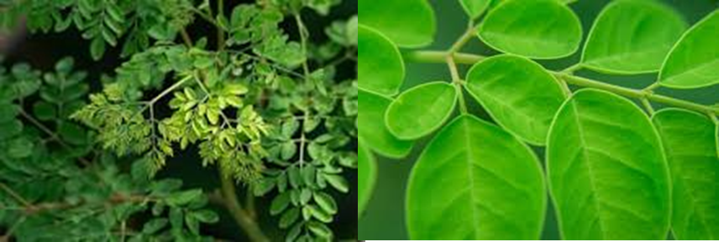
Fig. 1. Moringa oleifera leaves
Phenolic and flavonoid compounds, particularly gallic acid and quercetin, are key antioxidant markers known for their free radical–scavenging potential and role in reducing oxidative stress (Sreelatha & Padma, 2009). Their yield depends on solvent polarity, extraction technique, and environmental conditions affecting plant biochemistry. Environmental conditions such as soil pH, moisture, and organic matter content significantly influence secondary metabolite accumulation in plants. Such ecological variation contributes to differences in phenolic content, similar to patterns observed in Moringa leaves (Sharma et al., 2023).
Soxhlet extraction is considered highly efficient for isolating these phytochemicals, with methanol often outperforming water in phenolic recovery due to its intermediate polarity (Vergara et al., 2017). For accurate quantification, High-Performance Liquid Chromatography (HPLC) serves as a gold-standard method, enabling precise identification of gallic acid and quercetin using their characteristic retention times (Hossain et al., 2017). Quantification of bioactive phenolic markers using HPLC is essential for evaluating the pharmacological quality of medicinal plants. Similar chromatographic precision is reported for L-Dopa estimation in Mucuna pruriens, supporting the analytical reliability of the present Moringa study (Srivastava et al., 2024).
Following the analytical approach used in the Hibiscus reference study, this work evaluates the TPC, TFC, and HPLC profile of methanolic and aqueous extracts of Moringa oleifera leaves, reinforcing their significance in nutraceutical and pharmaceutical applications (Siddiquee & Ahmad, 2021).

2. Materials and Methods
2.1 Plant Material Collection and Preparation
Fresh leaves of Moringa oleifera were collected from local cultivation sites and thoroughly washed to remove surface impurities (Ahmad, 2016). The leaves were shade-dried at room temperature to preserve heat-sensitive phytochemicals and then ground into a fine powder using a sterile mechanical grinder. The powdered material was stored in airtight containers until extraction (Rodríguez et al., 2015)

2.2 Soxhlet Extraction
Approximately 5 g of shade-dried Moringa oleifera leaf powder was subjected to Soxhlet extraction using two different solvents methanol and distilled water to ensure efficient solubilization of phytoconstituents (Zhao & Zhang 2013). Each extraction was performed for 6 hours, followed by concentration of the solvent fractions using a rotary evaporator under reduced pressure, after which the extracts were dried to a constant weight (Baitha & Ahmad, 2019). The percentage extraction yield for both solvent systems was determined gravimetrically using the formula:
% yield = (weight of extract after dry / dry weight of the sample) × 100.
Methanol primarily extracts moderately polar bioactive compounds such as phenolics and flavonoids, whereas water dissolves a broader spectrum of hydrophilic constituents including polysaccharides, tannins, proteins, and water-soluble phenolics (Zou et al., 2024). Due to this difference in solvent polarity, aqueous extracts generally show higher extraction yields, while methanolic extracts often contain a more concentrated profile of pharmacologically active metabolites. The yields obtained from both methanolic and aqueous extracts were recorded and utilized for subsequent determination of Total Phenolic Content (TPC), Total Flavonoid Content (TFC), and HPLC-based quantification of gallic acid and quercetin. Sequential solvent extraction enhances the recovery of moderately polar phytochemicals, especially phenolics and flavonoids. This observation supports the superior extraction efficiency of methanol found in the present Moringa study (Kumari & Singh, 2020).
2.3 Determination of Total Phenolic Content (TPC)
The Total Phenolic Content (TPC) of Moringa oleifera leaf extracts was determined using the widely accepted Folin–Ciocalteu colorimetric method, following the protocol described by Hossain et al., (2017). For the analysis, 0.1 mL of the extract (1 mg/mL) was mixed with Folin–Ciocalteu reagent, followed by the addition of sodium carbonate solution to initiate the color development reaction. The mixture was incubated for 1.5 hours in the dark to allow complete formation of the chromophore complex. The absorbance was measured at 765 nm using a UV–Visible spectrophotometer. A standard calibration curve was prepared using gallic acid at different concentrations, and the phenolic content of each extract was quantified based on this curve. Final results were expressed as milligrams of Gallic Acid Equivalent per gram of extract (mg GAE/g), indicating the total concentration of phenolic compounds present in the sample.
2.4 Determination of Total Flavonoid Content (TFC)
The Total Flavonoid Content (TFC) of Moringa oleifera leaf extracts was determined using the AlCl₃ colorimetric method, a widely used procedure for flavonoid quantification in plant extracts (Chang et al., 2002). For the assay, 1 mg/mL of the extract was mixed with methanol, followed by the addition of 10% aluminum chloride (AlCl₃), 1 M potassium acetate, and distilled water. The reaction mixture was allowed to incubate at room temperature for 30 minutes, enabling the formation of a stable flavonoid–AlCl₃ complex. After incubation, absorbance was measured at 415 nm using a UV–Visible spectrophotometer. A calibration curve was prepared using quercetin as the standard flavonoid, and the flavonoid content of each extract was calculated accordingly. Final results were expressed as milligrams of Quercetin Equivalent per gram of extract (mg QE/g), reflecting the total flavonoid concentration in the sample.

2.5 Determination of Gallic Acid in the Moringa oleifera Extracts

2.5.1 Preparation of Mobile Phase
For the quantification of gallic acid in Moringa oleifera extracts, a mobile phase consisting of Water: Acetonitrile (80:20, v/v) was used. The pH was adjusted to 3.00 using O-phosphoric acid. The prepared mobile phase was degassed in an ultrasonicator for 15 minutes prior to use to remove dissolved gases and ensure stable chromatographic performance.

2.5.2 Preparation of Standard Stock Solution
A standard stock solution of gallic acid was prepared by dissolving 1 mg of the reference standard in 1 mL of methanol. Working standard solutions were prepared through appropriate serial dilutions to obtain concentrations of 40 μg/mL, 20 μg/mL, and 10 μg/mL. These standards were used to generate a calibration curve for quantification (Sawant et al., 2010).

2.5.3 Preparation of Sample Extract
The dried methanolic and aqueous extracts of Moringa oleifera were dissolved in methanol to obtain a 1 mg/mL stock solution. From this, a 100 μg/mL working concentration was prepared using methanol. The solutions were sonicated for 10 minutes to ensure complete solubilization and subsequently filtered through a 0.2 μm, 13 mm nylon membrane filter before injection into the HPLC system.

2.5.4 Chromatographic Conditions
Table 1. Chromatographic Conditions for the Quantification of Gallic Acid Using Agilent TC-C18(2)® HPLC Column.
S. No. | Parameter | Condition
1 | Stationary phase | Agilent TC-C18(2), 4.6 × 250 mm, 5 μm
2 | Mobile phase | Water : ACN (80:20); pH 3.00 adjusted with O-phosphoric acid
3 | Detection wavelength | 272 nm
4 | Flow rate | 1 mL/min
5 | Injection volume | 10 μL
6 | Temperature | Ambient
7 | LC system | Agilent HPLC system with OpenLab CDS 2 software

2.7 Determination of Quercetin in the Moringa oleifera Extracts

2.7.1 Preparation of Mobile Phase
For the quantification of quercetin in Moringa oleifera extracts, a mobile phase consisting of Acetonitrile : Methanol (40:60, v/v) was prepared. The mobile phase was degassed in an ultrasonicator for 15 minutes to eliminate air bubbles and ensure stable baseline performance during chromatographic analysis.

2.7.2 Preparation of Standard Stock Solution
A standard stock solution of quercetin was prepared by dissolving 1 mg of the quercetin standard in 1 mL of methanol. From this stock, working standard solutions were prepared by appropriate dilution to obtain concentrations of 20 μg/mL, 10 μg/mL, and 5 μg/mL, which were used to construct the calibration curve for quantification (Guideline 2005).

2.7.3 Preparation of Sample Extract
The concentrated methanolic and aqueous extracts of Moringa oleifera leaves were dissolved in methanol to form a 1 mg/mL stock solution. A working solution of 100 μg/mL was prepared from this stock. The sample solutions were sonicated for 10 minutes to ensure complete dissolution and filtered through a 0.2 μm, 13 mm nylon membrane filter prior to HPLC injection.

2.7.4 Chromatographic Conditions
Table 2. Chromatographic Conditions for the Quantification of Quercetin Using Agilent TC-C18(2)® HPLC Column.
S. No. | Parameter | Condition
1 | Stationary phase | Agilent TC-C18(2), 4.6 × 250 mm, 5 μm
2 | Mobile phase | ACN : Methanol (40:60)
3 | Detection wavelength | 317 nm
4 | Flow rate | 1 mL/min
5 | Injection volume | 10 μL
6 | Temperature | Ambient
7 | LC system | Agilent HPLC system with OpenLab CDS 2 software

3. Results
3.1 Extractive Yield (%)
The extractive yield of Moringa oleifera leaves was calculated based on the dried weight of the methanolic and aqueous extracts obtained after Soxhlet extraction. The percentage yield was determined using the formula:
% yield = [weight of extract (after evaporation solvent and freeze drying) / dry weight of the sample] × 100
The extraction results showed that the methanolic extract (MO-M) produced a higher yield (12.56%) compared to the aqueous extract (MO-A) (10.21%). Methanol is an effective solvent for extracting moderately polar phytoconstituents such as phenolics, flavonoids, and other bioactive compounds, which may contribute to its comparatively higher extraction efficiency. In contrast, the aqueous extract yielded slightly less material, as water primarily dissolves highly hydrophilic constituents such as tannins, sugars, proteins, and organic acids.

Table 3. Yield obtained from samples after extraction.
S. No. | Sample Code | Yield Content (%)
1 | MO-M | 12.56
2 | MO-A | 10.21

These results clearly indicate that methanolic extraction produced a higher yield than aqueous extraction, which aligns with previously reported findings for many plant leaf extractions where alcohol-based solvents often enhance extraction efficiency.

3.2 Total Phenolic Content (TPC)
The Total Phenolic Content (TPC) of Moringa oleifera leaf extracts was determined using the Folin–Ciocalteu method, and results were expressed as milligrams of Gallic Acid Equivalent per gram of extract (mg GAE/g). The methanolic extract (MO-M) exhibited a higher phenolic concentration compared to the aqueous extract (MO-A). This is consistent with previous findings indicating that methanol, due to its intermediate polarity, is more efficient in extracting phenolic compounds from plant matrices. Phenolics are major contributors to antioxidant activity because of their strong hydrogen-donating ability and free radical–scavenging potential. Polyphenols exhibit potent antioxidant activity by donating hydrogen atoms and neutralizing free radicals, thereby preventing oxidative cellular damage. Such mechanisms explain the high DPPH and FRAP activity exhibited by Moringa methanolic extracts (Alhakmani et al., 2020). The higher TPC value observed in MO-M suggests that methanol selectively extracts more antioxidant-rich secondary metabolites, whereas water extracts a broader but less phenolic-dense profile of hydrophilic components.

Table 4. Total Phenolic Content of Moringa oleifera Extracts.
S. No. | Sample Code | TPC (mg GAE/g)
1 | MO-M | 25.85 ± 0.62
2 | MO-A | 17.21 ± 0.55
These results indicate that the methanolic extract contains significantly higher phenolic content than the aqueous extract, confirming its suitability for further antioxidant and HPLC-based analyses.
3.3 Total Flavonoid Content (TFC)
The Total Flavonoid Content (TFC) of Moringa oleifera leaf extracts was determined using the AlCl₃ colorimetric method, and the values were expressed as milligrams of Quercetin Equivalent per gram of extract (mg QE/g). Similar to the phenolic content, the methanolic extract (MO-M) demonstrated a higher flavonoid concentration compared to the aqueous extract (MO-A). This can be attributed to the enhanced solubility of flavonoids in methanol due to its intermediate polarity, which facilitates greater extraction of quercetin-type and other polyhydroxylated flavonoid structures. Flavonoids are known for their strong antioxidant capacity, metal-chelating behavior, and free radical–neutralizing potential . Therefore, the higher TFC value obtained in the methanolic extract suggests that methanol is more effective in isolating flavonoid-rich phytoconstituents essential for antioxidant and pharmacological activity.

Table 5. Total Flavonoid Content of Moringa oleifera Extracts.
S. No. | Sample Code | TFC (mg QE/g)
1 | MO-M | 6.47 ± 0.43
2 | MO-A | 3.85 ± 0.22
These findings confirm that the methanolic extract contains a significantly higher flavonoid content than the aqueous extract, supporting the use of methanol for extracting antioxidant-rich compounds from Moringa oleifera leaves.

3.4 Quantification of Gallic Acid

Table 6. HPLC Determination of Gallic Acid Content in Methanolic and Aqueous Extracts of Moringa oleifera.
S. No | Sample Code | RT (min) | Concentration
S. No | Sample Code | RT (min) | (µg/mL)
1 | MO-A | 3.25 | 1.3
2 | MO-M | 3.25 | 2.4

The HPLC chromatographic analysis of Moringa oleifera extracts confirmed the presence of gallic acid in both the aqueous (MO-A) and methanolic (MO-M) fractions. Sharp and well-resolved peaks were recorded at a retention time of 3.250 minutes, matching the reference gallic acid standard and confirming compound identity.
Quantitative analysis revealed that the methanolic extract (MO-M) contained a higher concentration of gallic acid (2.4 µg/mL) compared to the aqueous extract (MO-A) (1.3 µg/mL). The increased gallic acid content in MO-M highlights the superior extraction efficiency of methanol for phenolic acids owing to its intermediate polarity and greater solvation capacity. These findings are consistent with previously reported studies indicating enhanced phenolic recovery using methanol-based extraction systems.
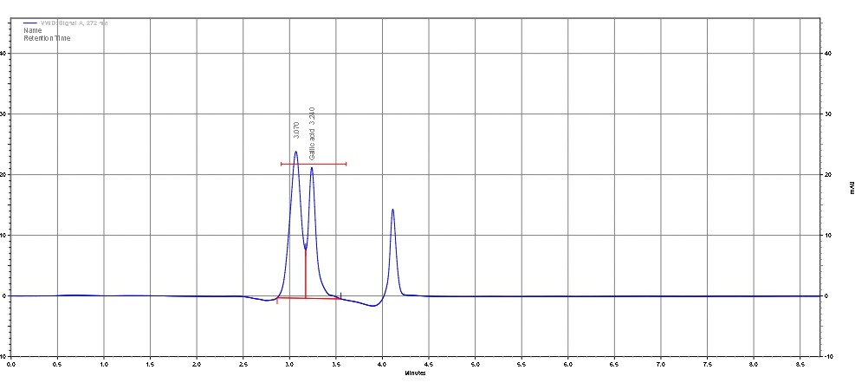
Figure 2. HPLC chromatogram showing the gallic acid standard peak.
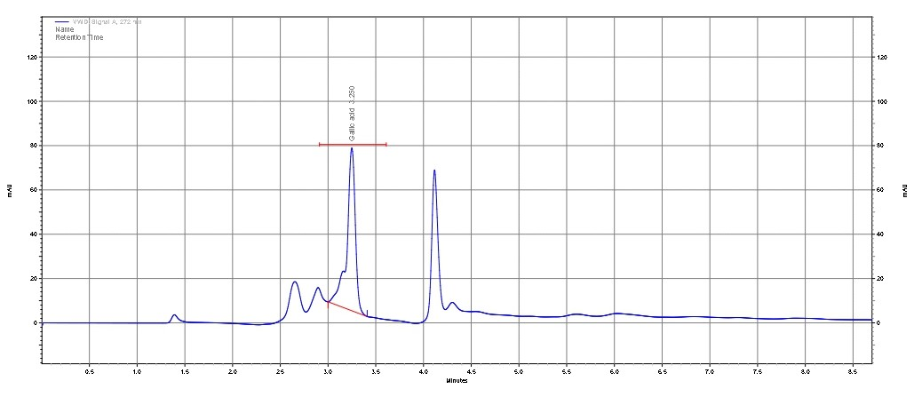
Figure 3. HPLC chromatogram showing the gallic acid peak in MO-A.
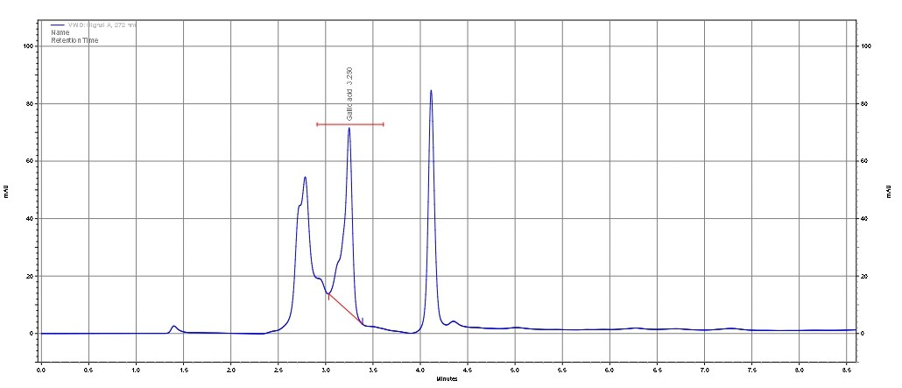
Figure 4. HPLC chromatogram showing the gallic acid peak in MO-M.
After examining the chromatograms (Figures 2–4), the retention time of gallic acid in both extracts showed perfect alignment with the standard, confirming chromatographic specificity and identity. The higher gallic acid content in the methanolic extract further supports the well-established advantage of methanol for phenolic compound extraction from plant materials.

3.5 Quantification of Quercetin

Table 7. HPLC Determination of Quercetin Content in Methanolic and Aqueous Extracts of Moringa oleifera.
S. No | Sample Code | RT (min) | Concentration(µg/mL)
1 | MO-A | 3.103 | 0.48
2 | MO-M | 3.1 | 1.4
The quantification of quercetin in the methanolic (MO-M) and aqueous (MO-A) extracts of Moringa oleifera was performed using High-Performance Liquid Chromatography (HPLC). Chromatographic separation was achieved on a C18 reverse-phase column (4.6 × 250 mm, 5 μm) using a mobile phase of acetonitrile : methanol (40:60, v/v), which provided sharp and well-resolved peaks for quercetin. Detection was carried out at 317 nm, the characteristic absorption maximum of quercetin.
Distinct and well-defined quercetin peaks were observed in both extracts at retention times of 3.103 minutes (MO-A) and 3.100 minutes (MO-M), closely matching the retention time of the quercetin standard and confirming the compound’s identity. Quantitative results showed that the methanolic extract contained a higher quercetin concentration (1.4 µg/mL) compared to the aqueous extract (0.48 µg/mL). This difference reflects the enhanced solubility of quercetin in methanol and corresponds with the higher Total Flavonoid Content (TFC) previously recorded for the methanolic fraction.
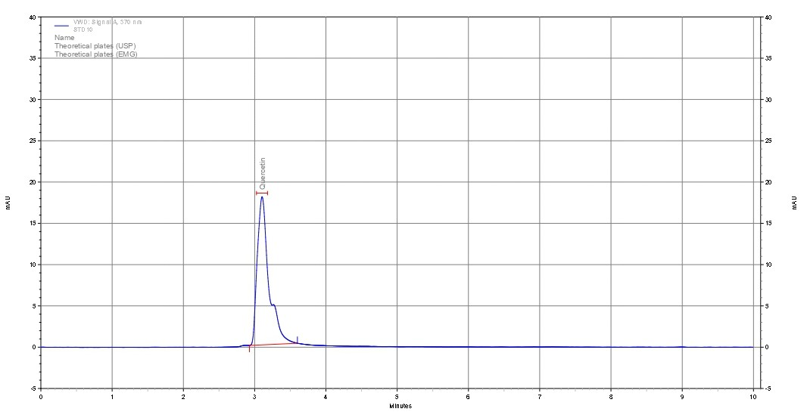
Figure 5. HPLC chromatogram showing the quercetin standard peak.
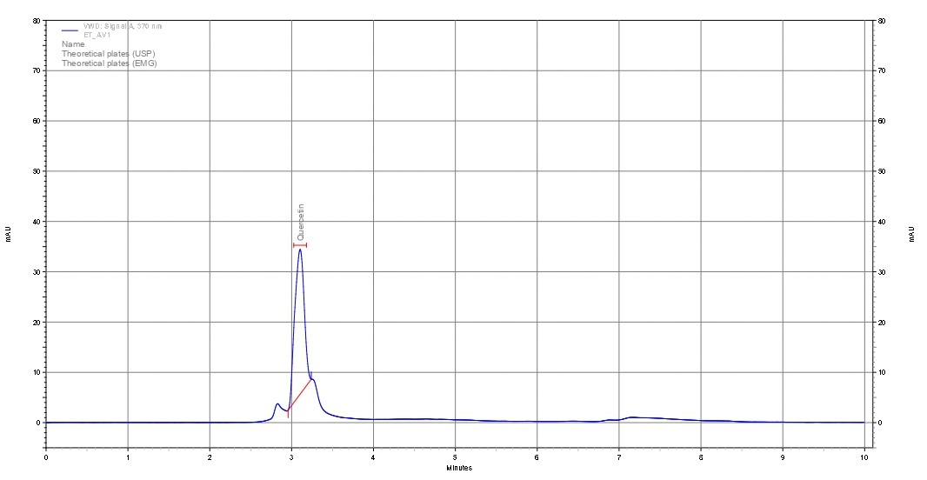
Figure 6. HPLC chromatogram showing the quercetin peak in MO-A.
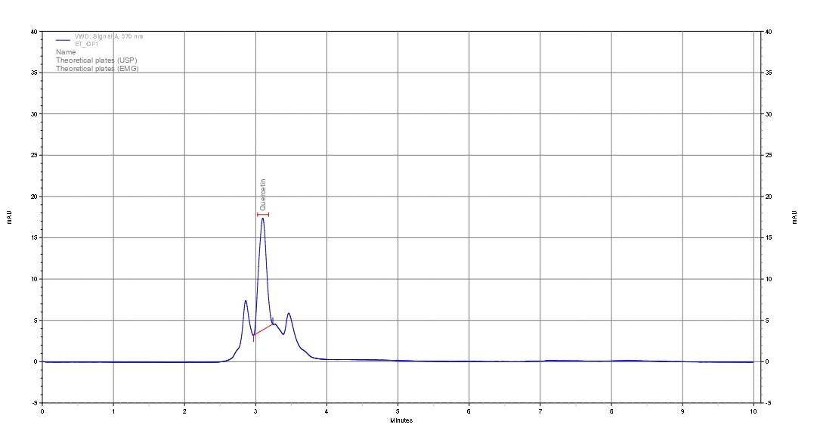
Figure 7. HPLC chromatogram showing the quercetin peak in MO-M
After reviewing the chromatograms (Figures 5–7), the retention time of quercetin in both extracts showed excellent alignment with the standard peak, confirming chromatographic specificity and accurate identification. The higher quercetin concentration in the methanolic extract reinforces the superior extraction ability of methanol for flavonoid compounds. This is attributed to the intermediate polarity of methanol, which enhances the solubility of polyhydroxylated flavonoids such as quercetin. These findings are consistent with earlier phytochemical reports that methanol is one of the most efficient solvents for flavonoid extraction from plant matrices.

4. Discussion
The present study investigated the solvent-dependent extraction efficiency and phytochemical composition of Moringa oleifera leaves, focusing on the quantification of key antioxidant markers gallic acid and quercetin. The findings clearly demonstrate that methanol is a superior extraction solvent compared to water for isolating phenolics and flavonoids.
The extractive yield showed a slight advantage for the methanolic extract (12.56%) over the aqueous extract (10.21%). Although aqueous solvents often exhibit higher mass yields due to the extraction of sugars, proteins, and hydrophilic compounds, the present results indicate that methanol preferentially extracts bioactive secondary metabolites rather than bulk hydrophilic content. This trend is further supported by the TPC and TFC results.
The methanolic extract exhibited significantly higher Total Phenolic Content (25.85 ± 0.62 mg GAE/g) compared to the aqueous extract (17.21 ± 0.55 mg GAE/g). Phenolic compounds are typically more soluble in solvents with intermediate polarity, which explains the enhanced phenolic recovery in methanol. A similar pattern was observed for Total Flavonoid Content, where MO-M (6.47 ± 0.43 mg QE/g) showed nearly double the flavonoid concentration of MO-A (3.85 ± 0.22 mg QE/g). These results align strongly with previous studies reporting improved extraction of polyphenolic and flavonoid compounds from plant matrices using methanol due to its ability to break hydrogen bonds and penetrate plant tissues more effectively. Recent studies on medicinal legumes show that higher phenolic and flavonoid concentrations directly correlate with stronger antioxidant capacity. This relationship parallels the elevated TPC and TFC observed in Moringa methanolic extracts (Bharti et al., 2024).
The HPLC analysis confirmed the presence of gallic acid and quercetin in both extracts, with retention times precisely matching the standard reference compounds, indicating chromatographic specificity and method accuracy. Quantitatively, the methanolic extract contained higher concentrations of both gallic acid (2.4 µg/mL) and quercetin (1.4 µg/mL), compared to 1.3 µg/mL and 0.48 µg/mL in the aqueous extract, respectively. These findings correspond with the TPC and TFC data, reinforcing that methanol extracts a greater proportion of antioxidant constituents. Many leaf extracts demonstrate broad-spectrum antibacterial activity, with methanolic fractions showing the highest inhibition zones . This aligns with the greater antimicrobial effectiveness of Moringa methanolic extracts against pathogenic organisms (Rao et al., 2021). The higher levels of gallic acid and quercetin in MO-M suggest a stronger antioxidant potential, since both compounds are well-known free radical scavengers with established pharmacological benefits .
Overall, the study demonstrates a clear solvent effect on the extraction of phenolics and flavonoids from Moringa oleifera leaves. Methanol proved more effective in isolating bioactive phytochemicals, which is consistent with earlier phytochemical investigations. The combined TPC, TFC, and HPLC results confirm that Moringa oleifera leaves are a rich source of antioxidant compounds and support their continued use in nutraceutical, therapeutic, and functional food applications.

5. Conclusion
The present study successfully demonstrated the influence of solvent polarity on the extraction efficiency and phytochemical composition of Moringa oleifera leaves using Soxhlet extraction followed by TPC, TFC, and HPLC analyses. Methanolic extraction proved to be more effective than aqueous extraction, yielding higher levels of phenolic and flavonoid compounds, as evidenced by the elevated TPC (25.85 mg GAE/g) and TFC (6.47 mg QE/g) values. HPLC quantification further supported these findings, with the methanolic extract exhibiting greater concentrations of gallic acid (2.4 µg/mL) and quercetin (1.4 µg/mL) compared to the aqueous extract.
The alignment of retention times with standard references confirmed the accuracy and specificity of the analytical methods used. Collectively, the results highlight that methanol is a superior solvent for extracting bioactive antioxidant compounds from Moringa oleifera leaves. The significant presence of gallic acid, quercetin, and other phenolics underscores the plant’s strong antioxidant potential and validates its applications in nutraceutical, herbal, and pharmaceutical formulations.
Overall, this study reinforces Moringa oleifera as a valuable natural source of health-promoting phytochemicals and provides a reliable basis for future research on its therapeutic, functional food, and industrial applications.

Reference
- Ahmad, M. S. (2016). Documentation and folklore use of medicinal plants of Hathwa (Gopalganj), Bihar. The Biobrio, 3(1–2), 153–160.
- Alhakmani, F., Kumar, S., & Khan, S. A. (2020). Antioxidant activity of fresh and dry leaf extracts of selected medicinal plants. Antioxidants, 9(7), 785.
- Anwar, F., Latif, S., Ashraf, M., & Gilani, A. H. (2007). Moringa oleifera: A food plant with multiple medicinal uses. Phytotherapy Research, 21(1), 17–25.
- Baitha, R. R., & Ahmad, M. S. (2019). Study of few climbers and twiners used to cure inflammatory diseases of District West Champaran. The Biobrio, 6(1–2), 370–377.
- Bharti, R., Siddiquee, A., Baitha, R. R., & Ahmad, M. S. (2024). Phytochemical profiling and antioxidant evaluation of selected medicinal legumes. Indian Journal of Applied & Pure Biology, 39(2), 1057–1064.
- Chang, C., Yang, M., Wen, H., & Chern, J. (2002). Estimation of total flavonoid content in propolis by two complementary colorimetric methods. Journal of Food and Drug Analysis, 10, 178–182.
- Guideline, I. H. T. (2005). Validation of analytical procedures: text and methodology. Q2 (R1), 1(20), 05.
- Hossain, A., Khatun, M. A., Islam, M., & Huque, R. (2017). Enhancement of antioxidant quality of green leafy vegetables upon different cooking method. Preventive Nutrition and Food Science, 22(3), 216–222.
- Kumari, S., & Singh, R. (2020). Assessment of bioactive potential in selected medicinal plant extracts. Journal of Medicinal Plants Research, 14(3), 112–118.
- Leone, A., Spada, A., Battezzati, A., Schiraldi, A., Aristil, J., & Bertoli, S. (2015). Cultivation, genetic, ethnopharmacology, phytochemistry and pharmacology of Moringa oleifera. International Journal of Molecular Sciences, 16(6), 12791–12835.
- Ram, A. K., & Ahmad, M. S. (2020). Traditional medicinal plants of Gopalganj (Bihar) and their potential to heal wounds. BEPLS, 9(4), 74–87.
- Rao, P., Mishra, S., & Nayak, V. (2021). Antibacterial activity of different solvent extracts of medicinal plant leaves. International Journal of Phytomedicine, 13(2), 150–158.
- Rodríguez-Pérez, C., Quirantes-Piné, R., Fernández-Gutiérrez, A., & Segura-Carretero, A. (2015). Optimization of extraction method to obtain a phenolic compounds-rich extract from Moringa oleifera Lam leaves. Industrial Crops and Products, 66, 246-254.
- Saini, R. K., Sivanesan, I., & Keum, Y.-S. (2016). Phytochemicals of Moringa oleifera: A review of their nutritional, antioxidant and antimicrobial properties. Food Chemistry, 211, 40–46.
- Sawant, L., Prabhakar, B., & Pandita, N. (2010). Quantitative HPLC analysis of ascorbic acid and gallic acid in Phyllanthus emblica. J. Anal. Bioanal. Tech, 1(2).
- Sharma, R. K., Jha, A. K., Siddiquee, A., & Ahmad, M. S. (2023). Assessment of physico-chemical parameters of wetland soils in relation to agricultural productivity. The Biobrio, 10(3-4), 1017–1022.
- Siddiquee, A., & Ahmad, M. S. (2021). Study of few exotic/alien plant species of dicot families and their economic importance. The Biobrio, 8(3–4), 676–687.
- Sreelatha, S., & Padma, P. R. (2009). Antioxidant activity and total phenolic content of Moringa oleifera leaves in two stages of maturity. Plant Foods for Human Nutrition, 64(4), 303–311.
- Srivastava, M. L., Siddiquee, A., Baitha, R. R., & Ahmad, M. S. (2024). Somatic embryogenesis and quantification of L-Dopa in Mucuna pruriens. Indian Journal of Applied & Pure Biology, 39(2), 1057–1064.
- Vergara-Jimenez, M., Almatrafi, M., & Fernandez, M. (2017). Bioactive components in Moringa oleifera leaves protect against chronic disease. Antioxidants, 6(4), 91.
- Zhao, S., & Zhang, D. (2013). Supercritical fluid extraction and characterisation of Moringa oleifera leaves oil. Separation and Purification Technology, 118, 497-502.
- Zou, C., Zhang, X., Xu, Y. and Yin, J., 2024. Recent advances regarding polyphenol oxidase in camellia sinensis: Extraction, purification, characterization, and application. Foods, 13(4), p.545.

