Short communication

Permafrost Investigations in the Western Pamir: Preliminary Results from Electrical Resistivity Tomography, Hydrochemical, and Isotopic Analyses

.
ABSTRACT
This study presents first systematic results on mountain permafrost in the Western Pamir (Tajikistan) and investigates its interactions with the hydrochemical and isotopic characteristics of surface waters in a climatically and geomorphologically heterogeneous high-mountain environment. The research is based on a field campaign conducted in 2023 in the catchment of the Vanj River and its southern tributary, the Langar River. Permafrost occurrence was assessed using Electrical Resistivity Tomography at seven sites representing different elevations, slope gradients, aspects, and active versus inactive sections of a rock glacier. Complementary hydrochemical analyses were carried out on 21 water samples from rivers, tributaries, and springs, while stable isotope analyses (δ¹⁸O, δ²H) were performed on 33 samples to evaluate water quality and source contributions.
The results give evidence of pronounced spatial variability in permafrost distribution that cannot be explained by elevation alone. In addition to altitude and aspect, slope gradient emerged as a key controlling factor for permafrost occurrence. Active rock glacier sections showed very high electrical resistivity values, more than 50 kΩm, indicating substantial ice content beneath a 3–4 m debris layer, whereas inactive sections were largely ice-free. Hydrochemical results revealed generally low heavy metal concentrations; however, locally elevated iron and aluminium levels were detected, particularly in the middle and lower Vanj Valley, suggesting possible anthropogenic influences. Isotopic signatures indicate that differentiation and potential quantification of glacier meltwater, precipitation, and permafrost-related contributions are feasible.
The integrated geophysical, hydrochemical, and isotopic approach provides a robust framework for analyzing permafrost-hydrology interactions and forms a solid basis for future monitoring and modelling studies. To fully account for the climatic heterogeneity of the Western Pamir, future investigations will be extended to the Ravmed and Shakhdara valleys.

Keywords: permafrost, ERT, hydrochemistry, isotopes, hydrology, Western Pamir, Tajikistan

1. INTRODUCTION
Climate change represents one of the most pressing global challenges of our time. Its multifaceted impacts threaten not only natural ecosystems but also economic stability and the livelihoods of future generations. In mountain regions in particular, rising air temperatures and changing precipitation patterns are accelerating permafrost degradation, glacier retreat, and the frequency of climate-related natural hazards. Effective adaptation to these changes requires reliable data on climate-sensitive processes.
Permafrost is a key variable in this context, functioning both as a natural climate archive and as a sensitive indicator of temperature change. While polar permafrost regions are comparatively well studied, mountain permafrost, accounting for approximately one-third of the global permafrost area, remains insufficiently investigated. Its pronounced spatial variability, controlled by topography, exposure, vegetation cover, and lithology, limits the transferability of existing models. This is particularly evident in Central Asia, where mountain permafrost constitutes a major component of high-mountain landscapes, yet data availability remains fragmentary.

The Pamir Mountains, with peaks exceeding 7,000 m a.s.l., pronounced microclimatic gradients and complex geomorphological structures, represent both an ideal and challenging study area. Early systematic investigations conducted in the 1970s and 1980s in the Lake Karakul, Lake Rangkul, and Lake Shorkul catchments still form the basis of regional permafrost mapping, which largely focusses on the Eastern Pamir (Hoelzle et al., 2019). In recent years, international collaborations have intensified permafrost research in the region. Notably, the project PAMIR – From Ice to Microorganisms and Humans (since 2022) established a comprehensive mountain permafrost database integrating borehole measurements, temperature data, and geophysical surveys. Complementary initiatives such as Cryospheric Observation and Modelling for Improved Adaptation in Central Asia (CROMO-ADAPT) have further improved the data base through additional boreholes and geophysical investigations. Recent studies (Mathys et al., 2025) successfully combined Electrical Resistivity Tomography (ERT) and Refraction Seismic Tomography (RST) to model subsurface composition.

Despite these advances, nearly all existing studies focus on the Eastern Pamir. The Western Pamir remains largely unexplored, although it hosts approximately 90 % of the population of the autonomous Gorno-Badakhshan region and is intensively used for agriculture.

Climatically, both regions differ considerably. The Eastern Pamir is characterized by a cold, arid Central Asian climate (e.g., Murgab station: 65 mm annual precipitation (Pogodaiklimat.ru, n.d.), with precipitation concentrated in the cool summer and minimal snowfall during the severe winter. In contrast, the Western Pamir exhibits a West Asian climatic regime with maximum precipitation during the cold season. Annual precipitation ranges from about 287 mm (Khorog station, (Pogodaiklimat.ru, n.d.)) to up to 1122 mm (Fedchenko Glacier, (Pogodaiklimat.ru, n.d.)), with most precipitation occurring as winter snowfall. Summers are moderately warm, and winters are moderately cold but snow-rich. These climatic contrasts are reflected in vegetation, soil development, and land use: extensive pastoralism dominates in the east, whereas irrigated agriculture, including fruit and vegetable cultivation on alluvial fans and valley floors, prevails in the Western Pamir. The stark climatic-ecological gradients strongly influence the regional water balance and determine the relative contributions of permafrost, glaciers, and seasonal snow cover to water availability. In the densely populated valleys of the Western Pamir, where irrigation agriculture is widespread, detailed knowledge of permafrost conditions and dynamics is crucial for sustainable water management.

Existing research activities in the Tajik Pamir cover only part of the region. Due to the geomorphological and climatic heterogeneity, findings from the Eastern Pamir cannot be directly transferred to the Western Pamir. Systematic investigations of permafrost distribution, thermal regime, and ice content, as well as their relationships with hydrochemistry, are largely lacking.
Hydrochemical and isotopic studies in the Western Pamir are also limited. Recent hydrochemical investigations (Normatov et al., 2021, Normatov et al. 2022; Yapiyev et al., 2021) focus mainly on the Panj River or the broader High Asia region without specifically addressing headwater catchments and the influence of the cryosphere on hydrochemistry. Similarly, existing isotopic studies (Saidaliyeva et al., 2023; Liu et al., 2015; Meier, 2020), as well as GNIP precipitation data, primarily address atmospheric circulation patterns and moisture sources, rather than the composition of surface waters in the Western Pamir.

In 2023 a first field campaign was conducted in the Western Pamir. The results presented in this study provide a database for characterizing permafrost in this previously understudied region. The aim of this study is to assess permafrost occurrence considering the climatic and morphological heterogeneity of the Western Pamir in order to provide a first evaluation of water quality and hydroecological conditions through hydrochemical analyses, and to assess the potential of stable isotopes for identifying surface water sources.

2. material and methods
2.1 Study area and field campaign
This study is based on field investigations conducted in 2023 in the Vanj River valley and its southern tributary, the Langar River, in the Northwestern Pamir (Tajikistan). The Vanj catchment extends from 1,600 m a.s.l. to a maximum elevation of 5,992 m a.s.l. and is bounded by the eastern spurs of the Darvas and Vanj ranges and the southern extension of the Academy of Sciences range. The valley is approximately 90 km long and flows northeast-southwest toward its confluence with the Panj River.
Up to elevations of ~2,300 m a.s.l., efficient traditional irrigation systems enable intensive agricultural and horticultural land use. Cultivated crops include potatoes, fruits (apples, apricots, berries), vegetables, cereals, legumes, and walnuts for self-consumption and regional markets. The population of the Vanj valley increased from approximately 26,000 in 2015 (JAMBI, 2025) to 30,727 in 2022 (TAJSTAT, 2025). This relatively high population density is closely linked to the moderate elevation and favorable agro-climatic conditions.

2.2 Geophysical investigations
Permafrost occurrence was investigated using ERT at seven sites selected to represent different geomorphological settings with potential permafrost conditions. Five sites were located between 3,400 and 3,800 m a.s.l., including west- and eastfacing slopes. Two additional profiles were located on a rock glacier to verify debris thickness and to distinguish between visually identified active and inactive sections.
Profiles were 48 m long with 25 electrodes arranged in a Wenner-Schlumberger configuration, achieving a maximum investigation depth of approximately 8 m. Data were acquired using a 4point light 10W instrument (Schwab Research Technology). Quality control included optimized instrument settings, post-acquisition inspection, and removal of erroneous measurements. Data were processed using Res2Dinv (Geotomo Software), including topographic correction and inversion modeling. Resistivity values were classified according to typical ranges for ice, water, and unconsolidated material based on previous studies (e.g., Lentschke, 2013). Geophysical results were spatially linked to morphometric parameters (elevation, slope, aspect) derived from 30 m SRTM data.

2.3 Hydrochemical analyses
A total of 21 water samples were collected to characterize the hydrochemistry of the Vanj River and its tributaries, including potentially permafrost-influenced springs. Sampling sites were categorized into: (i) main river (Vanj), (ii) tributary (Langar River), (iii) glacier- and rock glacier-fed tributaries, (iv) non-glacier tributaries, and (v) springs. Sampling followed ISO 5667-5 guidelines.
In situ measurements of temperature, pH, electrical conductivity, dissolved oxygen, and turbidity were obtained using a portable multiparameter meter (Hanna Instruments HI98194). Samples were filtered through 0.45 μm membranes and acidified with 1 % 2M HNO₃ for analysis of major ions (Ca, Mg, Na, K, SO₄²⁻, HCO₃⁻, Cl⁻) and heavy metals (Pb, Cd, Cr, Cu, Zn, Co, Ni, Fe).
To assess particulate-bound metal fractions, both filtered (0.45 μm) and unfiltered acidified samples were analyzed.

2.4 Stable isotope analyses
Stable water isotopes (δ¹⁸O, δ²H) were analyzed in 33 samples to determine the origin and composition of surface waters. Samples were filtered (0.45 μm) and acidified prior to laboratory analysis. Deuterium excess (d-excess) was calculated to evaluate fractionation processes. Based on satellite imagery and field mapping, samples were classified according to catchment characteristics into: (i) firn fields, (ii) springs, (iii) main rivers, (iv) glacier- or rock glacier in the catchment area, and (v) non-glacier in the catchment area.

3. RESULTS AND DISCUSSION
3.1 Geophysical investigations of permafrost distribution
The ERT measurements indicate that permafrost occurrence is strongly controlled by local topographic conditions. In addition to elevation and exposure, slope gradient emerged as a decisive factor. At a site located above 4,000 m a.s.l., no resistivity values indicative of permafrost were detected despite the high elevation, which is attributed to the low slope gradient. In contrast, a steep slope situated approximately 200 m lower exhibited clear evidence of frozen ground (Fig. 1). These findings highlight the influence of slope-dependent temperature fluxes on the thermal regime of the subsurface.
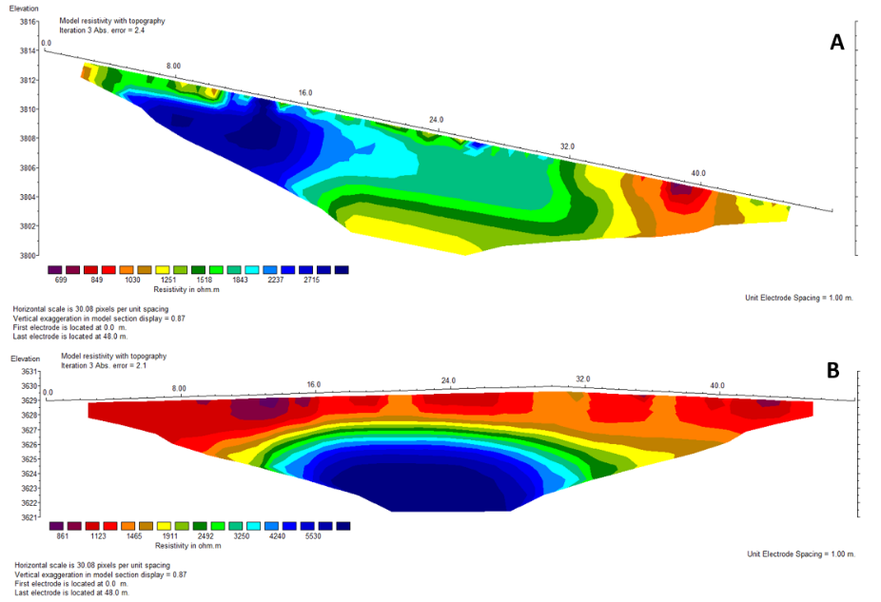
ERT profiles acquired on an active rock glacier revealed very high electrical resistivity values (>50 kΩm) in the frontal, dynamically active section, indicating substantial ice content beneath a debris cover approximately 3-4m thick. In contrast, an inactive upper section of the same rock glacier displayed significantly lower resistivity values and no evidence of ground ice. Surface displacement measurements indicate an advance rate of approximately 90 m over the past 50 years, underscoring the pronounced internal heterogeneity of this landform.
Fig. 1 ERT images of profiles at 3,800 m a.s.l. (A) and 3,600 m a.s.l. (B) located on east exposed slope on alpine pastures at slope inclinations of 10 degree (A) and 45 degree (B) respectively (number of electrodes = 25, profile length = 48 m), profiles shown in figures not corresponding to actual field situation partly parallel to inclination, Profile B shows high resistance values (>6,000 Ωmeter) starting 4 m below surface which can be interpreted as permafrost.

3.2 Hydrochemical characteristics
To assess potential harmful contamination, maximum permissible concentrations according to the German Drinking Water Ordinance (FMHG, 2023) were applied as reference values. The majority of the analyzed water samples exhibited major ion and trace element concentrations well below European threshold values for drinking water (EPCEU, 2020). However, nine of the 21 samples showed markedly elevated concentrations of aluminium (up to 40 times above the limit value) and iron (up to 70 times above the limit value). Among these nine samples, eight also exhibited elevated manganese concentrations, while one sample each showed elevated magnesium, nickel, and sulfate concentrations (Fig. 2).
The affected samples originate from all five sampling categories, indicating that no dominant control by permafrost, rock glaciers, or glaciers can be clearly identified. One of the contaminated samples, although only slightly exceeding the threshold values, is directly used for irrigation of agricultural land. Elevated concentrations were also detected in the middle and lower reaches of the Vanj River, where water is likewise used for irrigation purposes. The extent of potential contamination of soils and agricultural products will be investigated during the next field campaign. At present, the source of contamination remains unclear; however, anthropogenic influences (e.g., fertilizers, human activities, transportation) appear more plausible than purely geogenic causes.

Overall, elemental concentrations in the Vanj River tend to increase from the upper to the middle reaches, in some cases substantially.
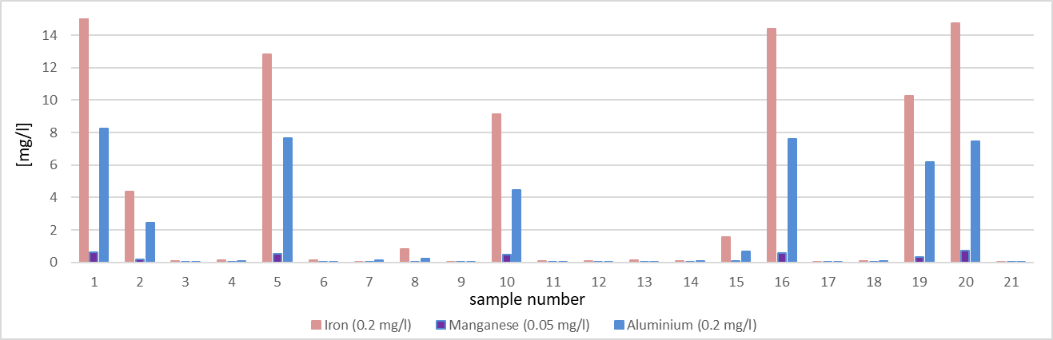
Fig. 2 Concentrations of iron, manganese and aluminum in water samples (European threshold values for drinking water quality intended for human consumption (EPCEU, 2020))

Major ion compositions plotted in a Piper diagram indicate that most samples can be classified as calcium-bicarbonate to calcium-sulfate dominated water types, reflecting the influence of carbonate and sulfate-bearing lithologies. No systematic differences were observed between sub-catchments with and without glaciers, suggesting complex and locally variable flow paths and water-rock interactions.
Physicochemical parameters confirm this heterogeneity. Measured pH values ranged from 6.2 to 8.3, indicating generally neutral conditions. Electrical conductivity varied between 180 and 280 μS cm⁻¹, with two outliers at 87 and 850 μS cm⁻¹. The lowest water temperatures (4–6°C) were recorded in spring samples, as expected.

Comparison of filtered and unfiltered samples revealed higher metal concentrations in unfiltered, acidified samples. This indicates that at higher pH values, dissolved trace metals are partly associated with suspended particles and are removed during filtration. For nearly all analyzed elements, concentrations were higher in unfiltered acidified samples, where acidification dissolved particulate-bound fractions prior to laboratory filtration and analysis. These findings emphasize the importance of standardized sampling and sample preparation procedures when assessing trace metal concentrations in high-mountain catchments.

3.3 Stable isotope analyses
Overall, the results demonstrate that stable water isotopes are well suited to distinguish between different water sources and to identify permafrost-related influences in the Western Pamir. Group (i) exhibits the lowest δ¹⁸O and δ²H values and is clearly separated from the other sample groups. Within the Vansh River catchment, differences between groups (iv) and (v) are only weakly expressed; only two strongly glacier-fed samples of group (iv) show more distinct isotopic signatures. No downstream isotopic enrichment was observed for group (iii), which is likely attributable to varying tributary characteristics and the relatively short river length, limiting significant evaporative fractionation. Springs (group ii) form two clearly separated isotopic subgroups, with higher isotopic values associated with confirmed permafrost areas, as supported by ERT and ground temperature data.

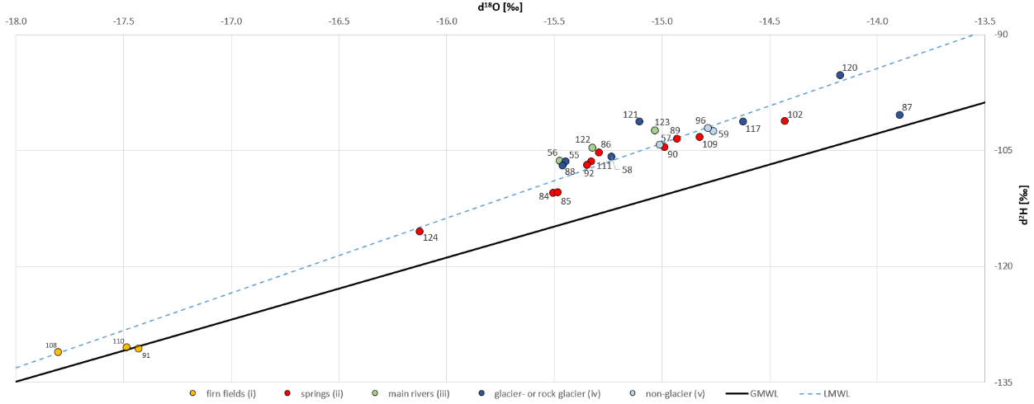
The isotopic analyses confirm the potential to estimate the relative contributions of firn fields, glacier meltwater, permafrost thaw, and tributary inflows to streamflow composition. These findings, together with additional results from investigations in the Vansh and Vakhsh River catchments (Abdushukurov et al., 2024), provide the foundation for a new research initiative aimed at modelling small-scale surface water cycles in the Western Pamir.
Fig. 3 Classified δ¹⁸O-δ²H diagram showing the isotope values of the Vansh River and its tributaries, as well as the Langar River, in comparison with the Global Meteoric Water Line (GMWL) and the Loval Meteoric Water Line (LMWL).

The results of this study demonstrate that permafrost distribution in the Western Pamir is controlled to a much greater extent by small-scale topographic conditions than currently represented in regional models. In particular, the ERT measurements reveal that, in addition to elevation and exposure, slope angle constitutes a key controlling factor for permafrost occurrence. The absence of permafrost in high-elevation but gently inclined terrain highlights the importance of slope-dependent controls on the subsurface thermal regime.
Gently sloping areas may experience enhanced warming due to prolonged solar radiation exposure, reduced snow accumulation, and increased thermal conduction within near-surface unconsolidated material, thereby inhibiting permafrost formation. Comparable relief-dependent relationships have been reported from the Tien Shan (Fischer et al., 2013), supporting the transferability of these processes to high-alpine, semi-arid mountain environments in Central Asia. The present findings suggest that incorporating slope-dependent parameters could substantially improve existing permafrost models for the Pamir.
Investigations of rock glaciers reveal pronounced internal heterogeneity. While dynamically active frontal zones exhibit high electrical resistivities indicative of significant ground-ice content, inactive or relict sections show no evidence of frozen ground. This distinction is critical for estimating potential long-term water storage under ongoing glacier retreat. In many Pamir valleys, rock glaciers likely function as transient water reservoirs, yet their contribution to runoff regimes remains poorly quantified.

Hydrochemical results indicate a complex interplay of geogenic and anthropogenic influences. Locally elevated concentrations of iron, aluminum, and manganese may reflect both natural water-rock interactions, for example within sulfide-bearing lithologies, and anthropogenic inputs related to agriculture and settlements. The observed downstream increase in metal concentrations along the Vanj River supports the assumption of additional anthropogenic influences, particularly given the intensive irrigation practices in the valley.

Stable isotope analyses provide complementary insights into water origin and dynamics. The isotopic signatures indicate complex mixing between glacier meltwater and summer precipitation. Springs located in permafrost-affected areas display distinct isotopic patterns, suggesting a contribution of permafrost thaw to the local water balance. These findings are particularly relevant for water resource management in the Western Pamir where seasonal shifts in runoff directly affect traditional irrigation systems.

Methodologically, the comparison between immediately acidified samples and those treated in the laboratory revealed significant differences in measured heavy metal concentrations, underscoring the importance of standardized sampling and preparation procedures in highalpine catchments.
The integration of geophysical, hydrochemical, and isotopic approaches proves highly effective for characterizing permafrost occurrence, assessing hydroecological conditions, and quantifying surface water composition. The combined methodological framework is well suited for analyzing permafrost-hydrology interactions and should be applied in future monitoring and modelling studies.

4. Conclusion
The present study provides the first systematic insight into the distribution and characteristics of mountain permafrost in the Western Pamir. The results reveal pronounced spatial variability in permafrost occurrence as well as in hydrochemical and isotopic signatures.
Geophysical investigations demonstrate that topographic micro-conditions play a key role in controlling permafrost presence, particularly slope angle and exposure. Hydrochemical analyses indicate locally elevated heavy metal concentrations, some of which may be influenced by anthropogenic inputs and therefore require further investigation. The isotopic data show that streamflow is sustained by a complex mixture of glacier meltwater and precipitation, and that, given a sufficiently robust dataset, the relative contributions of these sources can be quantitatively constrained.
To comprehensively capture the climatic and geomorphological heterogeneity of the Western Pamir, future research will be extended to the Ravmed Valley (central Western Pamir) and the Shakhdara Valley (Southwest Pamir). In addition, further ERT measurements under controlled laboratory conditions using sediment samples with varying degrees of water saturation, as well as field-based RST surveys, will be conducted to better quantify the ground-ice and water content of permafrost bodies.

References

Abdushukurov, D.A., Lentschke, J., Azimov, S., & Shaimuradov, F. (2024): Water cycle in the system of the upper reaches of Vaksh river. In: Preservation of glaciers and sustainable use of water resources of Сenteral Аsia. International scientivic conference, 9–10 October 2024 in Dushanbe, Tajikistan, Donish Publish House, 108-111.

EPCEU - European Parliament and the Council of the European Union (2020). Quality of water intended for human consumption. Directive (eu) 2020/2184 of the European Parliament and of the Council, Official Journal of the European Union. https://eur-lex.europa.eu/legal-content/EN/TXT/PDF/?uri=CELEX:32020L2184. last accessed: 12-02-2026

Fischer, T., Lentschke, J., Haas, F., Baume, O., Becht, M., & Schröder, H. (2013). High-mountainous permafrost under continental-climatic conditions: actual results of different mapping methods and an empirical-statistical modeling approach for the Northern Tien Shan (SE Kazakhstan). In: Geophysical Research Abstracts, vol. 15, EGU2013-13074.

FMHG - Federal Ministry of Health of Germany (2023). Ordinance on the Quality of Water Intended for Human Consumption. https://www.gesetze-im-internet.de/englisch_trinkwv/ index.html. last accessed: 12-02-2026

Hoelzle, M., Barandun, M., Bolch, T., Fiddes, J., Gafurov, A., Muccione, V., Saks, T., & Shahgedanova, M. (2019). The status and role of the alpine cryosphere in Central Asia. In: S. Xenarios, D. Schmidt-Vogt, M. Qadir, B. Janusz-Pawletta, & I. Abdullaev (Eds.), The Aral Sea Basin: Water for Sustainable Development in Central Asia (pp. 100-121). London and New York : CRC Press, Taylor & Fracis Group. DOI: https://doi.org/10.4324/9780429436475-8

JAMBI - Jamoat-level basic indicators (2025). Statistical dataset for the Republic of Tajikistan. Dushanbe. https://untj.org/jambi-project/index.php/maps-statistics-eng/demography-eng. last accessed: 12-02-2026

Lentschke, J. (2013). Bewertung des Gefährdungspotenzials von Muren infolge der Klimaänderung im Siedlungsraum des Ile Alatau (Südostkasachstan). Mensch und Buch Verlag, Berlin. https://www.geographie.hu-berlin.de/de/Members/lentschke_jan/dateianhae nge-bilder/Bewertung%20des%20Gefaehrdungspotenzials%20von%20Muren%20infolge %20der%20Klimaaenderung%20im%20Siedlungsraum%20des%20Ile%20Alatau%20-Suedostkasachstan.pdf, last accessed: 12-02-2026

Liu, Q., Tian, L.D., Wang, J.L., Wen, R., Weng, Y.B., Shen, Y.P., Vladislav, M., & Kanaev, E. (2015). A study of longitudinal and altitudinal variations in surface water stable isotopes inWest Pamir, Tajikistan. Atmospheric Research 153, 10-18. DOI: https://doi.org/10.1016/j.atmosres.2014.07.029

Mathys, M., Azimshoev, M., Bektursunov, Z., Hauck, C., Hilbich, C., Duishonakunov, M., Kayumov, A., Kassatkin, N., Kapitsa, V., Martin, L. C. P., Mollaret, C., Navruzshoev, H., Pohl, E., Saks, T., Silmonov, I., Musaev, T., Usubaliev, R., & Hoelzle, M. (2025). Quantifying permafrost ground ice contents in the Tien Shan and Pamir (Central Asia): A Petrophysical Joint Inversion approach using the Geometric Mean model. The Cryosphere, 19, 6591-6628. DOI: https://doi.org/10.5194/tc-19-6591-2025

Meier, C. (2020). Multiple-tracer based characterisation of a river catch-ment in the Pamir Mountains. Halle, Dissertation. DOI: http://dx.doi.org/10.25673/33899

Normatov, Sh., Goncharuk, V.V., Amirgaliev, N.A., Madibekov, A.S., & Normatov, A.I. (2021). Hydrochemistry of the Pyandzh Transboundary River Upstream, Middle and Downstream and the Criterion Its Use for Irrigation. News of the National Academy of Sciences of the Republic of Kazakhstan, Series of Geology and Technical Sciences Volume 1, Number 445, 114-120. DOI: https://doi.org/10.32014/2021.2518-170X.16

Normatov, P.I., Normatov, I., Karimzoda, A., Eshankulova, R., Normatov, A., & Nurmakhmad, Sh. (2022). Hydrochemistry of high-mountain pamir rivers: formation, changes and influence on the chemical composition of irrigation water. Journal of Environmental Science and Sustainable Development, 5(1), 19-47. DOI: https://doi.org/10.7454/jessd.v5i1.1086

Pogodaiklimat.ru (n.d.). Temperature and precipitation by month and year: Khorog, Murgab, and Fedchenko Glacier. Available at: https://www.pogodaiklimat.ru/history/38878_2.htm. last accessed: 12-02-2026

Saidaliyeva, Z., Shahgedanova, M., Yapiyev, V., Wade, A.J., Akbarov, F., Esenaman uulu, M., Kalashnikova, O., Kapitsa, V., Kasatkin, N., Rakhimov, I., Satylkanov, R., Sayakbaev, D., Semakova, E., Severskiy, I., Petrov, M., Umirzakov, G., & Usubaliev, R. (2023). Precipitation in the mountains of Central Asia: isotopic composition and source regions. Atmospheric Chemistry and Physics, 24 (21), 12203-12224. DOI: https://doi.org/10.5194/egusphere-2023-2030

TAJSTAT - Agency on statistics under the President of the Republic of Tajikistan (2025), Number of constant population, Dushanbe. https://view.officeapps.live.com/op/view.aspx?src=https%3A%2F%2Fwww.stat.tj%2Fwp-content%2Fuploads%2F2024%2F06%2Fnumber_of_constant_population-2.xlsx&wdOrigin=BROWSELINK. last accessed: 12-02-2026

Yapiyev, V., Wade, A.J., Shahgedanova, M., Saidaliyeva, Z., Madibekov, A., & Severskiy, I. (2021). The hydrochemistry and water quality of glacierized catchments in Central Asia: A review of the current status and anticipated change. Journal of Hydrology: Regional Studies, 38, 100960, 1-19. DOI: https://doi.org/10.1016/j.ejrh.2021.100960

