Original Research Article
Assessment of Above-Ground Carbon Stock in Large-Girth Trees of Gubbalamangamma Sacred Grove, Telangana, India

Abstract
Sacred groves represent traditionally protected forest patches that serve as important reservoirs of biodiversity and carbon storage in tropical landscapes. The present study assessed the above-ground carbon (AGC) stock of large-girth trees in the Gubbalamangamma Sacred Grove, Kannaigudem (S), Bhadradri-Kothagudem district, covering an area of approximately 1,376 ha. A targeted inventory approach was employed to document 122 large trees with a girth at breast height (GBH) ≥ 1 m, representing 27 species belonging to 17 families. For each tree, GBH and height were measured, and above-ground biomass was estimated using allometric equations incorporating wood specific gravity. Carbon stock was calculated using a standard carbon fraction of 0.47 of biomass. The recorded trees exhibited considerable structural variation, with GBH ranging from 101 cm to 531 cm and height ranging from 8 m to 30 m, indicating the presence of mature and old-growth individuals. The total above-ground carbon stock stored by the recorded trees was estimated at 236.85 Mg C. Species such as Mangifera indica, Xylia xylocarpa, Terminalia paniculata, Schleichera oleosa, Pongamia pinnata, and Careya arborea contributed substantially to the overall carbon pool. The highest carbon storage per individual tree was recorded in Ficus religiosa (0.5998 Mg C) followed by Mangifera indica (0.5579 Mg C). Carbon storage increased markedly with increasing tree girth, highlighting the disproportionate role of large-diameter trees in forest carbon sequestration. The findings demonstrate that the sacred grove functions as an important localized carbon reservoir and underscore the ecological significance of conserving sacred groves for biodiversity conservation and climate change mitigation.
Keywords: Biomass, Carbon stock, large trees, Sacred grove, Telangana
- Introduction
Forests play a fundamental role in the global carbon cycle by acting as major terrestrial carbon sinks that store large quantities of carbon in vegetation, soils, and organic matter. Forest ecosystems collectively contain vast carbon reserves and are therefore critical for regulating atmospheric carbon dioxide levels and mitigating climate change. It has been estimated that the total carbon stored in forest vegetation exceeds 350,000 teragrams (Tg), highlighting the immense role forests play in the global carbon balance (Dixon et al., 1994). Globally, forests are estimated to hold approximately 862 gigatons (Gt) of carbon in live and dead vegetation and soils, of which about 42% is stored in above- and below-ground biomass (Pan et al., 2011). Furthermore, studies indicate that forests collectively removed nearly 30% of global fossil fuel emissions between 2009 and 2018, demonstrating their importance as a natural climate regulation mechanism (Friedlingstein et al., 2019).
Accurate quantification of forest carbon stocks is therefore essential for understanding ecosystem carbon dynamics and supporting climate change mitigation strategies. Various methods have been developed to estimate forest carbon stocks, including allometric equations, remote sensing techniques, destructive sampling, and non-destructive field measurements. Among these, non-destructive field-based methods using tree biometric parameters are widely used because they allow reliable estimation of biomass and carbon without damaging the forest ecosystem (Brown, 1997; Chave et al., 2005). These methods typically utilize measurements such as girth or diameter at breast height (DBH/GBH), tree height, and wood density to estimate above-ground biomass through empirically derived allometric models.
Among the structural components of forests, large-diameter trees play a disproportionately important role in carbon storage and ecosystem functioning. Large trees accumulate biomass over long periods and therefore contribute substantially to forest carbon stocks. Studies have demonstrated that trees exceeding 60–70 cm in diameter account for a significant proportion of above-ground biomass in tropical forests (Luyssaert et al., 2008; Lutz et al., 2018). In fact, trees larger than 60 cm in diameter constitute approximately 41% of the world’s above-ground live tree biomass (Lutz et al., 2018). Similarly, Stephenson et al. (2014) demonstrated that the rate of carbon accumulation increases continuously with tree size, indicating that large trees sequester significantly more carbon than smaller individuals. This relationship underscores that forests cannot achieve their full above-ground carbon storage potential without maintaining a sufficient population of mature and large-diameter trees. Consequently, the conservation of large trees has been increasingly recognized as a key strategy for maintaining forest carbon stocks and ecosystem stability (Lindenmayer et al., 2014; Lutz et al., 2018; Moomaw et al., 2019). In addition to large natural forests, sacred groves represent important traditional forest conservation systems that contribute to biodiversity preservation and ecosystem stability. Sacred groves are patches of natural vegetation protected by local communities due to religious beliefs and cultural traditions. These groves often represent remnants of primary or old-growth forests within human-dominated landscapes and frequently harbour high species diversity and mature tree populations. Due to long-term protection and minimal anthropogenic disturbance, sacred groves can function as important reservoirs of biomass and carbon storage. Several studies have highlighted the ecological importance of sacred groves in maintaining biodiversity, conserving endemic species, and regulating local ecosystem processes.
The Bhadradri-Kothagudem district of Telangana is known for its rich floristic diversity and numerous sacred groves associated with local tribal communities. Among these, the Gubbalamangamma Sacred Grove, located within the Kawadigundla Reserve Forest, represents an ecologically significant forest patch characterized by mature vegetation and diverse tree species. However, systematic studies focusing on the carbon storage potential of large-girth trees within this sacred grove are lacking. Therefore, the present study aims to estimate the above-ground carbon stock of large trees (GBH ≥ 1 m) in the Gubbalamangamma Sacred Grove. By measuring girth at breast height (GBH) and tree height of large-girth individuals and applying established allometric biomass models, this study quantifies the carbon storage potential of mature trees within the grove. The results provide baseline information on the role of sacred groves as localized carbon reservoirs and highlight the ecological significance of conserving large trees in traditional forest landscapes for biodiversity conservation and climate change mitigation.
- Material and Methods
  - Study area
The Gubbalamangamma Sacred Grove is a natural forest patch located in Kawadigundla village, Bhadradri Kothagudem district, Telangana (17°20'39.47"N, 81°18'14.08"E) at an altitude of 248 m above msl. Covering approximately 13.76 km², it forms part of the Kawadigundla Reserve Forest under the Paloncha Forest Division, Aswaraopet Range. The grove holds significant historical, cultural, and spiritual importance and is dedicated to Goddess Gubbalamangamma, regarded as an incarnation of Goddess Kali. According to local belief, the deity appeared in a tribal leader’s dream, instructing the protection of the forest. Conserved by local communities for centuries, it is now officially recognized as a sacred site and serves as a centre for religious activities, meditation, and spiritual practices, also believed to have healing properties.
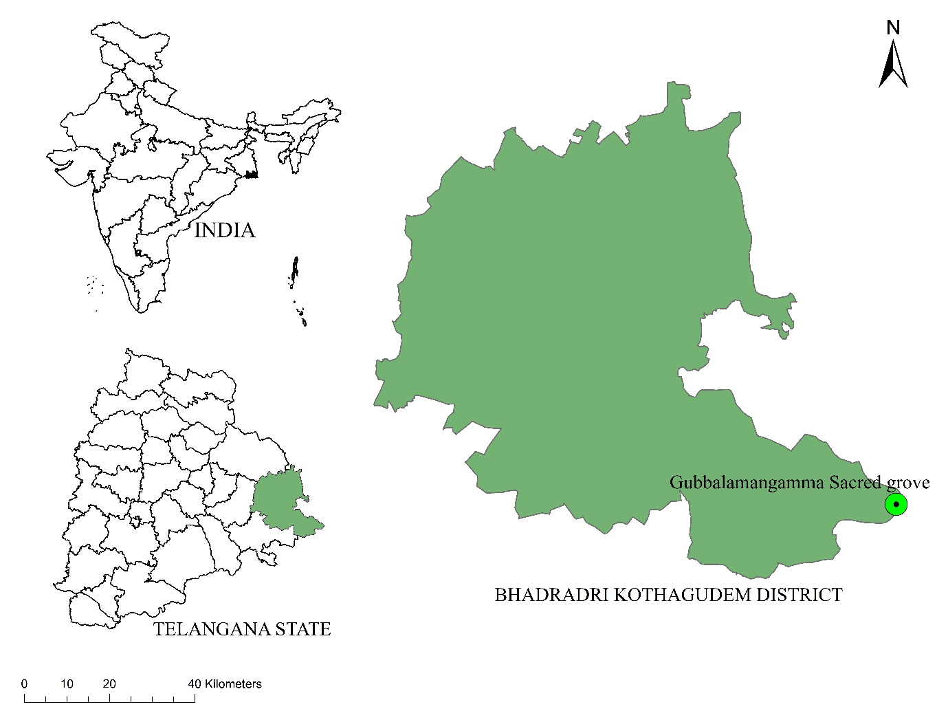
Figure 1: Map Showing the Gubbalamangamma Sacred Grove

This figure should be referenced in the text, according to: “Tables & figures should be placed inside the text. Tables and figures should be presented as per their appearance in the text. It is suggested that the discussion about the tables and figures should appear in the text before the appearance of the respective tables and figures. No tables or figures should be given without discussion or reference inside the text.”
See: https://reviewerhub.org/general-guideline-for-authors/
2.2 Study Design and Tree Selection
The present study was conducted in the Gubbalamangamma Sacred Grove, situated within the Kawadigundla Reserve Forest of the Paloncha Forest Division in Bhadradri-Kothagudem district, Telangana, India. Sacred groves represent traditionally protected forest patches conserved through indigenous cultural and religious practices, often harbouring old-growth vegetation and significant biodiversity (Gadgil & Vartak, 1976; Ormsby & Bhagwat, 2010). Such ecosystems provide valuable opportunities for assessing biomass accumulation and carbon storage in relatively undisturbed forest stands.
Field investigations were carried out between 2023 and 2025 through systematic surveys covering different parts of the sacred grove (Figure 2). The study employed a targeted inventory approach, focusing specifically on large-girth trees rather than using conventional quadrat or plot-based sampling methods commonly applied in forest inventories. This approach was adopted because large-diameter trees are widely recognized as key contributors to forest biomass and carbon storage, often accounting for a disproportionate share of total above-ground carbon in tropical forests (Stephenson et al., 2014; Lutz et al., 2018).

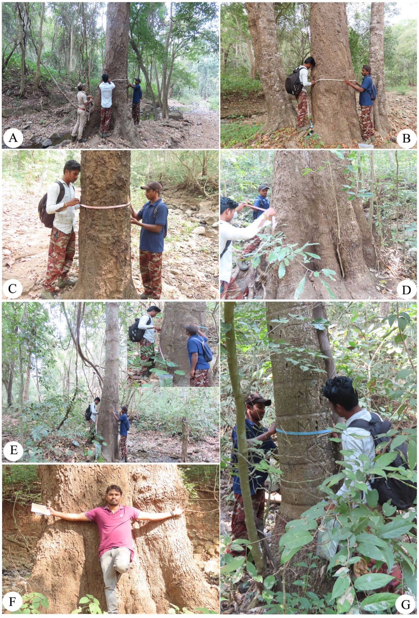
Figure 2: A–G – Field data collection across the Gubbalamangamma Sacred Grove

In this figure, I recommend including an explanation of the A-G sequence in its legend, or providing an explanation of the same sequence in the text.

See: https://reviewerhub.org/general-guideline-for-authors/

Tree selection was based on a predefined size threshold, where only individuals with a girth at breast height (GBH) ≥ 1 m (100 cm) were included in the study. During field surveys, all trees meeting this GBH criterion were located and documented throughout the grove. Each tree was measured and recorded individually to avoid duplication and ensure accurate biometric measurements. In total, 122 large trees satisfying the GBH threshold were identified and included in the analysis. Species identification was carried out in the field using standard taxonomic keys and regional floras, including Flora of the Presidency of Madras (Gamble & Fischer, 1915–1935), Flora of Telangana (Pullaiah, 2015), and Flora of Telangana State (Reddy & Reddy, 2016). Doubtful specimens were cross-verified with available herbarium descriptions and taxonomic literature.
The inventory documented 27 tree species belonging to 17 families, indicating notable floristic diversity within the sacred grove despite the study focusing exclusively on large-girth individuals. For each tree, girth at breast height (GBH) and total height were recorded as primary biometric parameters. These measurements were subsequently used for estimating above-ground biomass and carbon stock using established allometric models widely applied in tropical forest carbon studies (Brown, 1997; Chave et al., 2005). By concentrating on large-girth trees, the present study specifically evaluates the carbon storage contribution of mature and old-growth individuals, which typically store a substantial proportion of forest biomass and play a crucial role in long-term carbon sequestration (Lindenmayer et al., 2014; Lutz et al., 2018). The resulting dataset provides baseline information on the carbon storage potential of large trees within sacred groves and highlights their ecological significance in climate change mitigation and forest conservation.
2.3 Biomass and Carbon Estimation
Above-ground biomass (AGB) was estimated using non-destructive allometric equations that relate girth at breast height (GBH) and tree height to biomass. Species-specific or generalized models from established literature (Chave et al., 2005; Brown, 1997) were used to calculate biomass for each tree. Carbon stock was estimated by applying a standard carbon fraction of 0.47 to the above-ground biomass, following IPCC guidelines. This non-destructive approach is widely accepted for large, mature, and protected trees, allowing reliable estimation of biomass and carbon without destructive sampling. The carbon stock was further converted into carbon dioxide equivalent (CO₂) using the molecular weight ratio. The equations used are as follows:
C = AGB × 0.47
CO₂ = C × 3.67
- Results and Discussion
3.1 Tree Composition and Structure
A total of 122 individual trees representing 27 species distributed across 17 families were documented from the Gubbalamangamma Sacred Grove. The floristic composition revealed a clear dominance of a few taxonomic groups in terms of both species’ representation and individual abundance. Among the recorded families, Fabaceae was the most dominant, comprising six genera and 46 individuals, accounting for 37.7% of the total tree population. This dominance reflects the ecological adaptability of leguminous tree species in tropical dry deciduous ecosystems and their important role in nitrogen fixation and nutrient cycling. The Anacardiaceae family ranked second, contributing four genera and 23 individuals (18.9%), followed by Combretaceae, which included two genera and 21 individuals (17.2%). Collectively, these three families accounted for over 73% of the total tree population, indicating their major contribution to the structural composition and biomass accumulation within the sacred grove. Moderately represented families included Lecythidaceae (8 individuals), Sapindaceae (6 individuals), and Dilleniaceae (4 individuals). The remaining families Burseraceae, Moraceae, Sapotaceae, Ulmaceae, Myrtaceae, Rubiaceae, Cannabaceae, Arecaceae, Bignoniaceae, Ebenaceae, and Malvaceae were represented by one to three individuals each, contributing to the overall species richness and structural heterogeneity of the grove (Figure 3).
The predominance of Fabaceae and Anacardiaceae suggests that leguminous and resin-producing tree species play a major ecological role in shaping the forest structure and supporting nutrient cycling processes. At the same time, the presence of several less dominant families enhances functional diversity and ecological resilience, characteristics often associated with traditionally protected forest patches such as sacred groves. The measured trees exhibited considerable variation in structural parameters. GBH ranged from 101 cm to 531 cm, while tree height varied between 8 m and 30.5 m, indicating the presence of well-established mature and old-growth individuals. Such structural characteristics reflect the long-term protection and minimal anthropogenic disturbance within the sacred grove ecosystem.

Figure 3. Top ten family-wise genera richness of the Gubbalamangamma Sacred Grove
3.2 Above-Ground Biomass and Carbon Stock
Above-ground biomass (AGB) and carbon stock of individual trees were estimated using non-destructive allometric relationships incorporating girth at breast height (GBH), tree height, wood specific gravity, and biomass expansion factors, following widely accepted tropical forest biomass estimation approaches (Brown, 1997; Chave et al., 2005). Considerable variation in biomass and carbon storage was observed among individual trees, reflecting differences in species morphology, trunk diameter, height, and wood density.
The estimated carbon stock per individual tree ranged from approximately 0.0027 Mg C to 0.5998 Mg C, demonstrating substantial variability in carbon sequestration potential across species and size classes. The highest carbon storage per individual tree was recorded in Ficus religiosa (0.5998 Mg C), followed by Mangifera indica (0.5579 Mg C) and Diospyros melanoxylon (0.3411 Mg C). These species possess relatively large trunk diameters and greater structural biomass, which significantly enhance their carbon storage capacity.
Analysis of individual tree contributions revealed that a relatively small number of large-diameter trees accounted for a disproportionately large share of the total carbon pool. Species such as Mangifera indica, Xylia xylocarpa, Terminalia paniculata, Schleichera oleosa, Pongamia pinnata, and Careya arborea collectively contributed a substantial proportion of the above-ground carbon stock due to their combined dominance in both abundance and structural size. The dataset also revealed a clear relationship between tree size and carbon accumulation. Trees with GBH values exceeding 300 cm stored substantially greater biomass and carbon compared with medium-sized individuals. This finding is consistent with previous studies demonstrating that large-diameter trees exert a disproportionate influence on forest carbon storage and ecosystem functioning (Stephenson et al., 2014; Lutz et al., 2018). Large trees have been shown to account for a significant fraction of above-ground carbon in mature forests and play a central role in regulating the global terrestrial carbon cycle (Pan et al., 2011).
The presence of numerous mature trees with high carbon storage potential indicates that the Gubbalamangamma Sacred Grove functions as an important localized carbon reservoir. Long-term protection through traditional cultural practices has likely enabled trees to attain large diameters and advanced ages, thereby enhancing long-term biomass accumulation. Sacred groves therefore serve as valuable micro-refugia for biodiversity conservation and carbon storage, contributing to ecosystem stability and climate change mitigation at the regional scale.
Table 1: Top fifteen individual trees with the highest above-ground carbon storage recorded in the Gubbalamangamma Sacred Grove, Telangana, India.
Sl. No. | Species Name | Family | Common Name | Carbon Storage  (Mg C)
1 | Ficus religiosa | Moraceae | Peepal | 0.5998
2 | Mangifera indica | Anacardiaceae | Mango | 0.5579
3 | Diospyros melanoxylon | Ebenaceae | Beedi leaf tree | 0.3411
4 | Schleichera oleosa | Sapindaceae | Kusum | 0.3043
5 | Schleichera oleosa | Sapindaceae | Kusum | 0.3031
6 | Schleichera oleosa | Sapindaceae | Kusum | 0.3029
7 | Schleichera oleosa | Sapindaceae | Kusum | 0.2934
8 | Holoptelea integrifolia | Ulmaceae | Indian Elm | 0.2922
9 | Schleichera oleosa | Sapindaceae | Kusum | 0.2908
10 | Terminalia paniculata | Combretaceae | Kindal | 0.2710
11 | Pongamia pinnata | Fabaceae | Kanuga chettu | 0.2600
12 | Bombax ceiba | Malvaceae | Silk Cotton Tree | 0.2499
13 | Mangifera indica | Anacardiaceae | Mango | 0.2342
14 | Mangifera indica | Anacardiaceae | Mango | 0.2329
15 | Mangifera indica | Anacardiaceae | Mango | 0.2209
Note* Multiple entries represent individual trees of the same species

- Conclusions
The present study demonstrates that large-girth trees in the Gubbalamangamma Sacred Grove play a crucial role in above-ground carbon storage, contributing significantly to ecosystem-level carbon sequestration.
The observed dominance of a few key species and the strong positive relationship between tree girth and carbon accumulation clearly emphasize the disproportionate contribution of mature and large-diameter trees to the overall carbon pool. These findings reinforce the ecological importance of retaining old-growth individuals within forest ecosystems.
The relatively high carbon stock recorded in the sacred grove can be attributed to long-term protection, minimal anthropogenic disturbance, and traditional conservation practices followed by local communities. Such conditions allow trees to attain larger sizes and greater biomass, thereby enhancing long-term carbon accumulation. In addition to carbon storage, the grove also supports considerable floristic diversity, indicating its dual role as both a biodiversity refuge and a carbon reservoir.
Therefore, sacred groves represent ecologically significant landscape elements that contribute to climate change mitigation, biodiversity conservation, and ecosystem stability at the regional scale. Integrating these traditional conservation systems into broader forest management and climate policies could further strengthen their role in sustainable ecosystem management.
Future studies may focus on below-ground carbon, soil carbon dynamics, and long-term monitoring to provide a more comprehensive understanding of carbon sequestration potential in sacred groves.

References
- Brown, S. (1997). Estimating biomass and biomass change of tropical forests: A primer (FAO Forestry Paper No. 134). Food and Agriculture Organization of the United Nations.
- Chave, J., Andalo, C., Brown, S., Cairns, M. A., Chambers, J. Q., Eamus, D., Fölster, H., Fromard, F., Higuchi, N., Kira, T., Lescure, J. P., Nelson, B. W., Ogawa, H., Puig, H., Riéra, B., & Yamakura, T. (2005). Tree allometry and improved estimation of carbon stocks and balance in tropical forests. Oecologia, 145(1), 87–99.
- Chave, J., Coomes, D., Jansen, S., Lewis, S. L., Swenson, N. G., & Zanne, A. E. (2009). Towards a worldwide wood economics spectrum. Ecology Letters, 12(4), 351–366.
- Dixon, R. K., Brown, S., Houghton, R. A., Solomon, A. M., Trexler, M. C., & Wisniewski, J. (1994). Carbon pools and flux of global forest ecosystems. Science, 263(5144), 185–190.
- Friedlingstein, P., Jones, M. W., O'Sullivan, M., Andrew, R. M., Hauck, J., Peters, G. P., Peters, W., Pongratz, J., Sitch, S., Le Quéré, C., et al. (2019). Global carbon budget 2019. Earth System Science Data, 11, 1783–1838.
- Gamble J.S. & Fischer C.E.C. 1915‒1935. Flora of the Presidency of Madras. Allard & Sons, London.
- Gadgil, M., & Vartak, V. (1976). Sacred groves of the Western Ghats in India. Economic Botany, 30(2), 152–160.
- Intergovernmental Panel on Climate Change (IPCC). (2006). 2006 IPCC guidelines for national greenhouse gas inventories. Institute for Global Environmental Strategies (IGES).
- Jain S.K. and Rao R.R. 1977. A Handbook of Field and Herbarium Methods. Today and Tomorrow Printers and Publishers, New Delhi, Pp.1- 157.
- Lindenmayer, D. B., Laurance, W. F., & Franklin, J. F. (2014). Global decline in large old trees. Science, 338(6112), 1305–1306. https://doi.org/10.1126/science.1231070
- Lutz, J. A., Furniss, T. J., Johnson, D. J., Davies, S. J., Allen, D., Alonso, A., … Zimmerman, J. K. (2018). Global importance of large-diameter trees. Global Ecology and Biogeography, 27 (7), 849–864. https://doi.org/10.1111/geb.12747
- Luyssaert, S., Schulze, E. D., Börner, A., Knohl, A., Hessenmöller, D., Law, B. E., Ciais, P., & Grace, J. (2008). Old-growth forests as global carbon sinks. Nature, 455, 213–215.
- Moomaw, W. R., Masino, S. A., & Faison, E. K. (2019). Intact forests in the United States: Proforestation as a climate solution. Frontiers in Forests and Global Change, 2, 27.
- Pan, Y., Birdsey, R. A., Fang, J., Houghton, R., Kauppi, P. E., Kurz, W. A., et al. (2011). A large and persistent carbon sink in the world’s forests. Science, 333(6045), 988–993.
- Ormsby, A., & Bhagwat, S. A. (2010). Sacred forests of India: A strong tradition of community-based natural resource management. Environmental Conservation, 37(3), 320–326.
- Pullaiah T, 2015. Flora of Telangana, the 29th State of India. –Regency publications, New Delhi. Pp.1-1306.
- Reddy K.N. and Reddy C.S. 2016. Flora of Telangana State, India. –Bishen Singh Mahendra Pal Singh, Dehra Dun. Pp. 1-824.
- Stephenson, N. L., Das, A. J., Condit, R., Russo, S. E., Baker, P. J., Beckman, N. G., … Zavala, M. A. (2014). Rate of tree carbon accumulation increases continuously with tree size. Nature, 507(7490), 90–93. https://doi.org/10.1038/nature12914

