Short Communication

FIRST RECORD OF BRACHYPONERA OBSCURANS (WALKER, 1859) (HYMENOPTERA - FORMICIDAE) FROM SOUTHERN INDIA

ABSTRACT

The first record of Brachyponera obscurans (Walker, 1859) from southern India, specifically Kolli Hills, Namakkal District, extending its known distribution beyond northern states (Himachal Pradesh, Punjab, Uttar Pradesh). Previously documented from tropical/subtropical East Asia and Sri Lanka, this Ponerinae ant now shows expanded presence in underrepresented southern regions of India.

Key words: Brachyponera obscurans, Ponerinae, new distribution, Southern India, Kolli hills, Tamil Nadu, Ants, range expansion, Hymenoptera, Formicidae, Ponerini.

INTRODUCTION
The genus Brachyponera Emery, 1900, was originally established as a subgenus of Euponera and later elevated to full generic status by (Bingham, C. T. 1903), with placement in the tribe Ponerini. Workers of Brachyponera are small to medium-sized ants, typically measuring 3-7 mm in length, This includes detailed descriptions, images, and precise measurements of key morphological characters for species identificationand exhibit carnivorous or scavenging habits; they construct nests in soil or decaying wood (Leong, C. M. 2017). This genus has a broad distribution spanning Africa, southern Asia, and Australia, with the highest species diversity concentrated in Southeast Asia (Schmidt, C.A. & Shattuck, S.O. 2014). Currently, 28 valid species and subspecies are recognized worldwide and six species are recorded from India (Bharti, H., Guénard, B., Bharti, M., Economo. E. P., 2016) and (Rameshkumar et. al., 2025).

MATERIALS AND METHODS

Ant specimens were collected from Kolli Hills, Solakkadu (11.3096° N, 78.3494° E), Namakkal District, Tamil Nadu, India, for hand-picking methods from suitable microhabitats, such as soil and under rocks in forested areas, and immediately preserved in 70% ethanol to maintain structural integrity. detailed morphological examination under a stereo zoom microscope, the specimens were deposited in the Marine Biology Regional Centre, Zoological Survey of India, Chennai, Tamil Nadu, India.

RESULTS AND DISCUSSIONS

In the present study, we provide a comprehensive review of Brachyponera obscurans, including new distribution records from southern India. This includes detailed descriptions, images, and precise measurements of key morphological characters for species identification. These new records extend the known range of B. obscurans southward, highlighting potential gaps in prior surveys and underscoring the need for continued ant biodiversity assessments in the region.

Key to the Indian Brachyponera species based on the worker caste:
The distinction between the six Indian Brachyponera species, is principally based on Karavaiev, V. 1925, Bingham, C. T. 1903 and Chen, C., Yu, Y., Yi, C. 2025.

- head shorter and squarer; the eyes very much smaller and located in front of lateral margin of head; body color reddish brown……………………..……B. jerdonii (Forel)

- head longer than broad; Eye medium in size and located in front of lateral margin of head; body color dark brown, mandible, flagellar segments, and legs deep yellowish brown…………………………………………………………B. obscurans (Walker)

- flagellar segments 1 and 2 as long as broad or broader than long; Body black and mandible, antennae flagellum, tibiae, tarsus, end of gaster reddish brown………………………………………………………………..B. luteipes (Mayr)

- flagellar segments gradually increase in size toward the end; body color dark brown, mandible, flagellar segments, and legs deep yellowish brown….B. obscurans (Walker)

- high dome-shaped epinotum in lateral view; with the petiole scale broader above and less ovoid; Coloration Yellowish rust-brown, occasionally matching the light tones of antennae, mandibles, and legs…………………B. luteipes continentalis (Karavaiev)

- propodeum nearly straight and slope; Petiolar node flat oval; body color dark brown, mandible, flagellar segments, and legs deep yellowish brown…B. obscurans (Walker)

- Petiolar node crescent-shaped; mesosoma smooth, pronotum finely punctate, and propodeum finely rugose; Body black, appendages yellowish brown.................................................................................................B. nigrita (Emery)

- Petiolar node flat oval; mesosoma, petiole and gaster finely punctate; body color dark brown, mandible, flagellar segments, and legs deep yellowish brown…………………………………………………………B. obscurans (Walker)

- Posterior margin of head in in full-face view strongly concave; eye relatively large; petiole a high and thick node with a straight; Dark brown to blackish brown, antennae, tibiae and tarsi reddish...............................................................B. sennaarensis (Mayr)

- posterior margin of the head in full-face view is typically weakly concave; Eye medium in size; Petiolar node flat oval; body color dark brown, mandible, flagellar segments, and legs deep yellowish brown…………………………………B. obscurans (Walker)

Brachyponera obscurans (Walker, 1859)

Materials examined: 6 workers, INDIA, Tamil Nadu, Namakkal Dist, Solakkadu (11.3096° N, 78.3494° E), Kolli Hills, 06 exs, 28.xii.2024, Coll. D. Nagarajan., ZSI Regd. No. ANT/INS/021.

Worker Diagnosis: body color dark brown and mandible and legs yellowish color. In full face view the head is longer and broader, roughly trapezoidal, posterolateral corners of head narrowly rounded. Mandible triangular with nine teeth and without long attenuated teeth. Antenna 12 segmented scape exceeds posterolateral corner; flagellar segments gradually increase in size toward the end. Eye medium size and present in lateral margin of the head. Mesosomal profile discontinuous, Metanotal groove strongly developed. Dorsum of propodeum nearly straight and longer than downward slope, posterodorsal corner of propodeum broadly rounded. Petiolar node as high as propodeum, upright, nearly trapezoidal; subpetiolar process forms a wedge and dorsal view petiolar node flat and oval. Mandible densely punctate; head densely punctate; mesosoma, petiole and gaster finely punctate. Dorsum of body with abundant standing hairs and densely sub-decumbent hairs; upper part of propodeum with densely sub-decumbent hairs

Queen: unknown
Male: Unknown

The discovery of Brachyponera obscurans (Fig. 1 & Fig. 2) in Kolli Hills, Namakkal District, State of Tamil Nadu, represents the first confirmed record from southern India, extending its known range southward by over 2,000 km from previous northern localities in Himachal Pradesh, Punjab, and Uttar Pradesh (Fig. 3). Earlier checklists up to 2016 documented only northern distributions, likely due to biased sampling in northern India and under-explored southern biodiversity hotspots like the Eastern Ghats. This finding indicates B. obscurans adaptability to varied elevations and microhabitats, from northern plains to southern forested hills at approximately 1,000 m, aligning with its native tropical East Asian origins.

CONFLICT OF INTEREST
No conflict of interest.

REFERENCES

Bharti, H., Guénard, B., Bharti, M., Economo. E. P., 2016. An updated checklist of the ants of India with their specific distributions in Indian states (Hymenoptera, Formicidae). ZooKeys, 551, 1-83.

Bingham, C. T. 1903. The fauna of British India, including Ceylon and Burma. Hymenoptera, Vol. II. Ants and Cuckoo-wasps. London: Taylor and Francis, 506 pp.

Chen, C., Yu, Y., Yi, C. 2025. Revision of the Chinese species of the genus Brachyponera Emery, 1900 (Hymenoptera, Formicidae), with a key to the world species of the genus. ZooKeys 1230: 247-286.

Karavaiev, V. (1925) Ponerinen (Fam. Formicidae) aus dem Indo-Australischen Gebiet. (Fortsetzung). Konowia, 4, 115–131.

Leong, C. M. 2017. Biological notes on the colony of Brachyponera obscurans (Hymenoptera: Formicidae) in Macau. Taiwanese Journal of Entomological Studies. 2(1):10-12.

Rameshkumar, A, S. Sheela, P. Girish Kumar, Rajmohana, K, S. Sardar, P.C. Mazumdar, A. Barua, D. Ghosh, B. Majumder, N. Anand, S. Dey, B. Chattopadhyay, P. Mandal, N. Basak, A. Mandi, R. Debnath, S. Patra and Theertha, PV. (2025). Checklist of Fauna of India: Arthropoda: Insecta: Hymenoptera. Version 2.0. Zoological Survey of India.

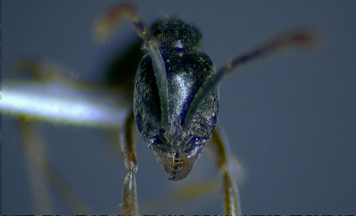
Schmidt, C.A. & Shattuck, S.O. 2014. The higher classification of the ant subfamily Ponerinae (Hymenoptera: Formicidae), with a review of ponerine ecology and behavior. Zootaxa 3817, 1–242.

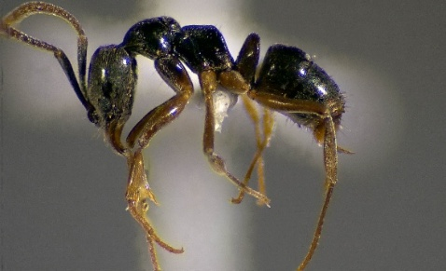

Fig. 1. B. obscurans worker (Head, Frontal view) Fig. 2. B. obscurans worker (Profile view)

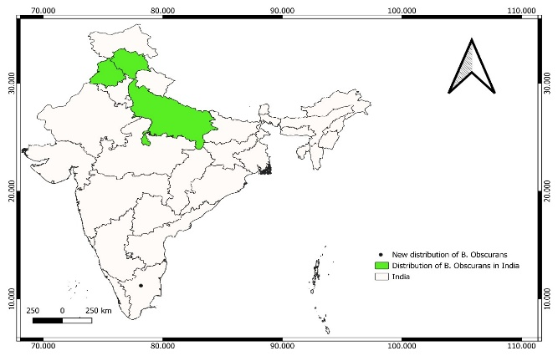

Fig. 3: Distribution Map of Brachyponera obscurans (Walker, 1859) in India (Bharti, H., Guénard, B., Bharti, M., Economo. E. P., 2016), and locality of specimens examined for this study.

