Effect of NPK Fertilizer and Plant Density on the Growth and Yield of Eggplant Crop (Solanum melongena) in Sandy Soil

Abstract
The eggplant plant (Solanum melongena L.) is the annual vegetable grown in the warm regions and consider one of the important vegetable crops in the world, due to the highly nutritive values, and medicinally benefits. One of the strategies to enhance production is through the improvement of cultivation techniques. The Research was conducted at the Nursery of Department of Crop Science, Faculty of Natural Resources and Environmental Studies, University of Kordofan. Elobeid, Sudan. The aim of this research is to determine the effect of NPK fertilizer and plant density and to find the best dose and density on the growth and yield of eggplant. Six treatments in two seasons were used: 1 plant 0g of NPK, 2 plants 0g of NPK, 1 plant 5g of NPK, 2 plant 5 g of NPK, 1 plants 10 g of NPK, 2 plants 10g of NPK. The treatments were arranged in a Randomized Complete Block Design (RCBD) with four replicates. Parameters studied included number of leaves/plant, leaf length (cm), Leaf width (cm), stem length (cm) Number of branches/plant, Number of flowers/plant, fruit length (cm), fruit width (cm), and fruits yield (ton/feddan). In the first and second season the statistical analysis of the data showed significant differences between the treatments on the number of leaves per plant, leaf length, leaf width, stem length, number of branches per plant, number of flowers per plant, fruit length, fruit width, and fruits yield. the results showed that the application dose of 10g of NPK and density 2plant/hole gives good and effective results compared to a dose of 5g NPK either with one or two plant.

Keywords: Plant density, compound fertilizers NPK, growth, yield, egg plant

1. Introduction
Eggplant (Solanum melongena L.(, The Arabic name is Bazanjan, which is a significant horticultural commodity that is widely cultivated in various tropical regions, including Sudan, the English name is Eggplant, and in the Sudan it is metaphorically called black, but it has been proven that there are many varieties of different color, including the white color, it is origin may be India and some studies refer to southern China (Muhammed, 2010).The shape and color of eggplant fruit itself is quite varied, from white, green to purple. The shapes are round, large oval, or oval with sharp edges (Putri, 2016). It is preferable to sawing eggplant in sandy loamy lands than heavy land because the light lands warm early Eggplant, is one of the important vegetable crops in the world, due to the highly nutritive values, and medicinally benefits (Albaheidi, 1989). Eggplant plants need adequate nutrients for growth; rising nutrients can be done by supplying inorganic fertilizer (Waskito et al., 2018). The proper use of NPK fertilizer can have a positive impact on plant yield (Hakim & Saragih, 2019), (Lambat et al., 2024). Appropriately applied of NPK fertilizer can also make a positive role to soil quality (Dariah et al., 2015).
Farmers neglected the application fertilizers and the importance of using compound fertilizers and a good cultural practices lead to high growth and high production of Eggplant crop in sandy soils (Lambat et al., 2020). Egg plant plays an important role in human nutrition, and local economic there is a crucial need for appropriate cultural practices methods of sowing and plant density especially in sandy soil. This study was carried to settlement the cultivation of Eggplant in sandy soil in North Kordofan State. The objectives of this study were to recognize the effect of adding compound fertilizers NPK and plant density on the growth and yield of eggplant crop in sandy soil.

2. Materials and Methods
2.1 Field Trials and materials:
This study was conducted at the Nursery of Department of Crop Science, Faculty of Natural Resources and Environmental Studies, University of Kordofan, El-Obeid, Sudan, in the two seasons 2023 and 2025. The materials include local variety seeds and compound fertilizers NPK were obtain from the El Obeid local market.
2.2 Research methodology:
Twenty four plots (1 m²) were prepared with two furrow in each plot for transplanting seedling of eggplant that grown in one plot, the spacing between intra rows 70 cm and between seedling 40 cm, used density of transplanting one plant/hole or two plants/hole. Compound fertilizers of NPK (5 and 10g) applied after two weeks from transplanting according the treatments. Irrigation and weeding carry out every 5 - 7 days.
2.3 Experimental treatments and design:
Six treatments were applied for the study namely: One plant with 0g of NPK, Two plants with 0g of NPK, one plants with 5g of NPK, Tow plant with 5g of NPK, One plant with 10g of NPK, Two plant with 10g of NPK were laid out in a Randomized Completely Block Design (RCBD) with four replications.
2.4 The following parameters were measure include
2.4.1 Stem length (cm)
Was measured as average from five plant per plot, using a graduated meter rule, measuring from the base of stem to the growing tip of the plant.
2.4.2 Number of branches/plant
The number of branches was measured by counting the number of branches on every five-plant stem and after that the average number of number of branches per plant was recorded.
2.4.3 Leaf length (cm)
Measured by ruler among the midrib as average number of the five plant from each plot.
2.4.4 Leaf width (cm)
Calculated using ruler among the middle surface of the leaf as average of five plants from each plot.
2.4.5 Number of leaves /plant
It was recorded by calculating all leaves of five randomly chosen plants that had fully opened then the average number of leaves per plant was determined.
2.4.6 Number of flowers /plant
Calculated by counting the number of all flowers from the five plants in each treatment and after that the average number of flowers per plant was recorded.
2.4.7 Fruit length (cm)
Measured from randomly five plants by the ruler from the base to apex, and then the average fruits length was recorded.
2.4.8 Fruit width (cm)
Was measured from randomly five plants using the caliper from the middle of the fruit, and after that the average fruits width was determined.
2.4.9 Fruits yield (ton/feddan)
Productivity tons/fed calculated by counting all fruits in each treatment, and then the average of fruits weighed in ton/feddan was calculated.
2.5 Statistical analyses
Data were analyzed using the one-way ANOVA using SPSS (SPSS Inc, Chicago, IL). Significantly different means of the measured data separated at the 0.05 probability level using Duncan’s Multiple Ranges Test.
3. Results and discussion
3.1 Number of leaves/plant
The statistical analysis of the data showed significant differences between the treatments in the number of leaves in the first years 2023 (Table 1). The highest number of leaves were shown in the treatment two plants and 10 g NPK, whereas the lowest number were obtained in the treatment one plant and 5g NPK (84, 10) respectively. In the year 2025 The statistical analysis of the data for the number of leaves showed that there were significant differences between treatments on the 2nd week The highest number (82) was found in the treatment of the 2 plants and 0g NPK, whereas the least number (21) in the treatment of 1plant and 10g NPK. The application of plant population and NPK fertilizer had a positive effect on both the growth and yield of eggplant during the vegetative and generative phases. The increase in leaves number is largely attributed to nitrogen. Nitrogen (N) enhances protein and chlorophyll synthesis, which are crucial for photosynthesis and thus promote leaf development. Meanwhile, phosphorus (P) plays a role in stimulating early root development(Upadhyay et al., 2024). Based on these factors, the proper application of plant population and NPK fertilizer supports optimal vegetative growth, both morphologically and physiologically. In general, the application of NPK its nitrogen content induces the formation of new organs such as leaves. As the number of leaves increases supported by adequate nitrogen supply from fertilization photosynthesis becomes more efficient, enabling the plant to produce more food (Salsalia etal, 2025)
3.2 Leaf length
The statistical analysis of the data showed significant differences between the treatments in the length of leaf in the two years 2023 and 2025 (Table 1) this was because the growth of the eggplant plant response to the application of NPK fertilizer. Eggplant requires a large quantity of fertilizers (Hakim & Saragih, 2019). The same results were shown by Lucky, et al., (2024) who found that the appropriate use of NPK fertilizer can have a positive impact on plant productivity. Similar results were reported in correctly applied NPK fertilizer can also make a positive contribution to soil quality (Dariah et al, 2015).
3.3 Leaf width
The statistical analysis of the data showed significant differences between the treatments in the means of leaf width in the first and second years 2023, 2025 (Table 1). The highest leaf width was shown in the treatment one plants and 0g NPK, whereas the lowest number was shown in the treatment one plant and 10 g NPK (16, 5cm) in 2023 were in 2025 was shown in two plant 0 NPK and one plant 10 NPK (17.75, 5.7) respectively, NPK did not effect in leaves width the main effect by plant density. In the year 2023, the statistical analysis showed no significant differences between all treatments due to high temperature during the growth and increase of irrigation intervals due to lack of water and spreading of insects and some diseases.
3.4 Stem length
The statistical analysis of the data demonstrated significant differences between the treatments in the mean length of stem in the two years 2023 and 2025 (Table 2). The highest length of stem in 2023 was shown in the treatment 2 plants and 0g NPK, whereas the lowest length of stem was shown in the treatment one plant and 10g NPK (66.5, 39.2cm) respectively. In the year 2025, the statistical analysis showed significant differences between all treatments (Table 2). this was because the growth of the eggplant plants shows a response to the application of NPK fertilizer, this shows that NPK fertilization provides a nutrient contribution which is needed by eggplant plants to increase the growth of eggplant plant cells in the vegetative phase. The need for nutrients is very important for plant growth, whether given directly or indirectly, so that it can increase growth, increase production and plant quality. The increase in plant height is thought to be due to the high levels of nitrogen given to plants for cell formation and growth. Apart from that, the presence of micro nutrients also plays a role in increasing nutrient absorption. This is in accordance with the opinion of Napitupulu & Winarto, 2010 who stated that the application of nitrogen can increase plant growth, stimulate the formation of chlorophyll, and cause the color of the leaves to be greener, so that the shoot-to-root ratio increases. Therefore, applying nitrogen can increase the rate of plant growth.
3.5 Number of branches/plant
The statistical analysis of the data showed significant differences between the treatments in the mean number of branches in the second years 2025 (Table 2). The highest number of branches was shown in the treatment 2 plants and 0g NPK, whereas the lowest was shown in the treatment 1 plant and 10g NPK (11, 3) respectively. In the year 2023, the statistical analysis showed no significant differences between all treatments (Table 2) (Lambat & Lambat, 2024).
Table (1): Effect of fertilizer (NPK) and plant density on number of leaves\ plant, leaf length (cm), and leaf width (cm) in the two years, (2023 and 2025) in egg plant
 | Number of leaves/plant |  | Leaf length(cm) |  | Leaf width(cm)
Treatments | 2023 | 2025 | 2023 | 2025 | 2023 | 2025
1pt 0NPK | 20b | 45c | 6.8e | 19.25b | 16a | 8.25c
2pt 0NPK | 16c | 82a | 8d | 14.10c | 11c | 17.75a
1pt 5g NPK | 12d | 73b | 22.25b | 23.6a | 7.5d | 10.5b
2pt 5g NPK | 20b | 43d | 24.3a | 10.07d | 14b | 9d
1pt10g NPK | 10e | 21f | 13.7c | 9.8d | 5e | 5.7e
2pt 10g NPK | 84a | 39e | 21.2b | 8.3e | 12.2c | 8.75c
LSD | 21.15 | 18.62 | 1.94 | 1.38 | 2.19 | 2.43
CV% | 2.66 | 11.3 | 4.11 | 3.25 | 4.10 | 8.85
Different small letters in the same column refer to significant differences between treatments at P < 0.05 level

Table (2): Effect of fertilizer (NPK) and plant density on stem length (cm) and number of branches\ plant in the two years, (2023 and 2025) in egg plant
 | Stem length (cm) |  | Number of branches/plant
Treatments | 2023 | 2025 | 2023 | 2025
1pt 0NPK | 48.2b | 15.25f | 6b | 4e
2pt 0NPK | 66.5a | 23.5a | 6b | 11a
1pt 5g NPK | 41e | 17.5e | 3d | 8b
2pt 5g NPK | 47c | 21.25b | 9a | 6c
1pt10g NPK | 39.2f | 20.25c | 2e | 3f
2pt 10g NPK | 44.8d | 18.5d | 4c | 5d
LSD | 6.21 | 9.7 | 4.56 | 5.07
CV% | 3.60 | 2.25 | 5.56 | 2.11
Different small letters in the same column refer to significant differences between treatments at P < 0.05 level

3.6 Number of flowers:
The statistical analysis of the data appeared considerable differences between the treatments in the number of flowers in the two years 2023 and 2025 (Fig.1).
3.7 Fruit length
The statistical analysis of the data demonstrated significant differences between the treatments in the fruit length in the two years 2023 and 2025 (Fig. 2).
3.8 Fruit width
The statistical analysis of the data showed significant differences between the treatments in the fruit width in the two years 2023 and 2025 (Fig.3).
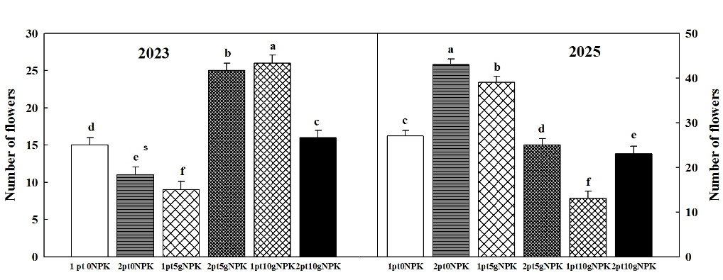
Fig. 1. Effect of fertilizer (NPK) and plant density on number of flowers in the two years, (2023 and 2025) in egg plant. Different small letters indicate significant differences between treatments at P < 0.05 level
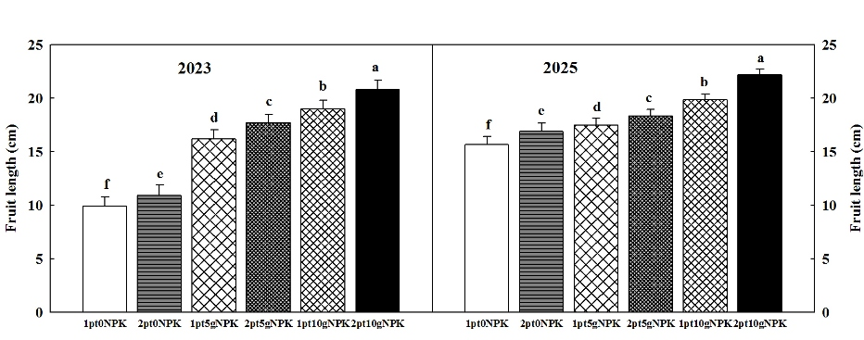
Fig. 2. Effect of fertilizer (NPK) and plant density on fruit length in the two years, (2023 and 2025) in egg plant. Different small letters indicate significant differences between treatments at P < 0.05 level
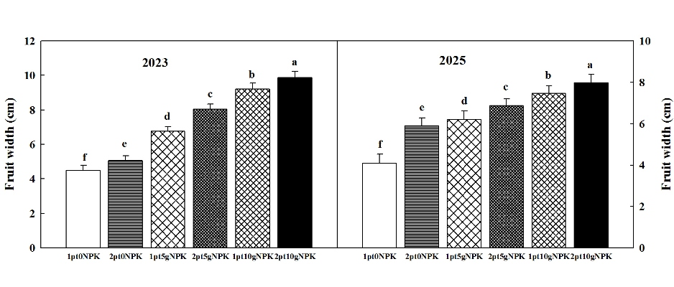
Fig. 3. Effect of fertilizer (NPK) and plant density on fruit width in the two years, (2023 and 2025) in egg plant. Different small letters indicate significant differences between treatments at P < 0.05 level

3.9 Fruits yield
The statistical analysis of the data demonstrated significant differences between the treatments in the yield of fruits (ton/feddan) in the two years 2023 and 2025 (Fig. 4).
The parameter of length, width and number of fruits showed that the application dose of 10g and density of 2 plant/hole gives good and effective results compared to a dose of 5g either with one or two plant. This is in line with previous study represented by (Ruhukai, 2011) who found the plants need more than other nutrients to form the important ingredients chlorophyll and carbohydrates in the photosynthesis process, so that they will stop the growth process and increase the number of fruit. The average yield is influenced by the fertilizer dose of N, P, and K (Padwad et al., 2025). The function of the macro nutrient primary element N is to support vegetative growth and the formation of chlorophyll. The nutrient P is for plant maturation and root growth, and K is an element that builds cell walls, regulates the opening and closing of guard cells in leaf stomata, and the strength of plant stalks and stems, as well as resistance to disease attacks (Nurtika, 2009).If these three nutrients are not available or are available too slowly, or are not in balance, plant development will be hampered

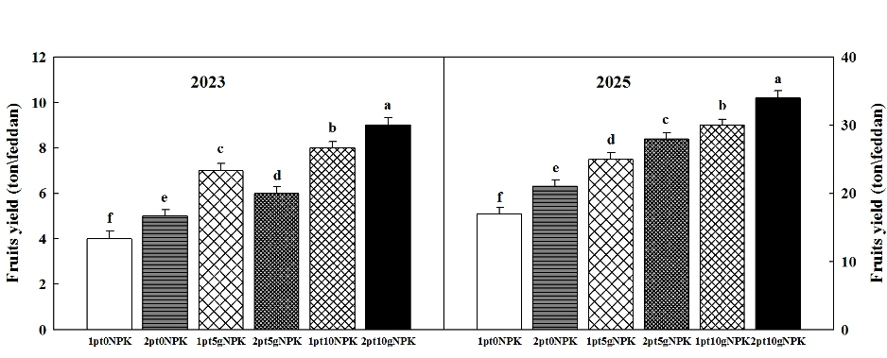
Fig. 4. Effect of fertilizer (NPK) and plant density on fruits yield in the two years, (2023 and 2025) in egg plant. Different small letters indicate significant differences between treatments at P < 0.05 level

4. Conclusions
The results of this study obviously confirmed that the application of NPK fertilizer and plant density significantly enhanced growth parameters and fruits yield of Eggplant. Dose of 10g of NPK and density 2plant/hole recorded highest growth parameters and enhanced fruits yield. Based on these findings, it is suggested that10g of NPK and density 2plant/hole should be employed. More future investigating study with different dose of NPK fertilizer and eggplant density is recommended.

References:
Albaheidi, M.A., et al. (1989). Performance of Eggplant (Solanum melongena L.) varieties in the Central Region of Saudi Arabia. Journal of Agricultural Sciences, 1(2), 123–130.
Dariah, A, Sutono, S., Nurida, N. L., Hartatik, W., & Pratiwi, E. (2015). Soil conditioners to increase agricultural land productivity. Journal of Land Resources, 9(2), 67–84.
Hakim, L., & Saragih, R. (2019). The influence of brand image, price perception, and product quality on consumer purchasing decisions for NPK Mutiara at UD. Barelang Tani Jaya, Batam. Ecobisma (Journal of Economics, Business, and Management), 6(2), 37–53.
Lambat P., Lambat A. (2024)"Impact of climate change on crop patterns and agricultural sustainability: A case study of Nagpur District, Maharashtra, India" . International Journal of Botany Studies, Volume 9, Issue 11, 2024, Pages 31-33. www.botanyjournals.com ISSN: 2455-541X Received: 15-10-2024, Accepted: 14-11-2024, Published: 30-11-2024.
Lucky, Laurensius Tobing, Kia Petronila (2024): Effect of NPKc fertilizer on the growth and yield of eggplant (Solanum melongena) in Yellow Red Podzolic Soil. Maylani, Faculty of Agriculture, Keling Kumang Institute of Technology, Sekadau, Indonesia. Article Info.
Muhammed, A. (2010). Effect of the irrigation regimes on yield and water use efficiency of eggplant (Solanum melongena L.). Journal of Agricultural Sciences, 15(2), 123-130.
Napitupulu, D., & Winarto, L. (2010). Effect of N and K fertilizer application on the growth and production of shallots. Journal of Horticulture, 20(1), 1367-83.
Nurtika, N. (2009). Response of tomato plants to the use of NPK 15-15-15 compound fertilizer in latosol soil during the dry season. Journal of Horticulture, 19(1).
P A Lambat and A P Lambat, Fruits, seeds at elevated co2 in cotton & tur in Nagpur district, International Journal of Botany Studies, ISSN: 2455-541X; Impact Factor: RJIF 5.12, Received: 26-10-2020; Accepted: 10-11-2020: Published: 27-11-2020, www.botanyjournals.com, Volume 5; Issue 6; 2020; Page No. 263-265.
Putri, D. D. (2016). Identification of Qualitative and Quantitative Characteristics of Several Eggplant Varieties (Solanum melongena L.).
Ruhukai, N. L. (2011). The Effect of EM4 Cultivated in Bokashi and Inorganic Fertilizer on Peanut (Arachis hypogaea L.) Production in Wanggar Village, Nabire Regency. Journal of Agroforestry VI (2), 114–120.
Salsalia Corry Nurintan S, Suhardjono, H., Pribadi, D.,U. (2025). Effect of Dekamon Plant Growth Regulator Concentration and NPK Phonska Plus Fertilizer Dosage on the Growth and Yield of Purple Eggplant (Solanum melongena L.). Engineering and Technology Journal, 10 (6), 5377-5381
Sonali V. Padwad and Ashish P. Lambat (2024) Biocontrol Efficacy of Indigenous Trichoderma spp. Against Fusarium oxysporum in Soybean Rhizosphere Soils of Vidarbha Region, Maharashtra, India. (2024). African Journal of Biomedical Research, 27(4S), 15670-15677. https://doi.org/10.53555/AJBR.v27i4S.7832
Upadhyay, N. D. A., Lambat, N. D. A., Lambat, N. D. M. P., & Borthakur, N. D. M. (2024). Secondary metabolite production in plants: in response to biotic and abiotic stress factors. Journal of Advanced Zoology, 45(S1), 55–59. https://doi.org/10.17762/jaz.v45is1.3402, https://jazindia.com/index.php/jaz/article/view/3402

Waskito, K., Aini, N., & Koesriharti, K. (2018). The effect of planting medium composition and nitrogen fertilizer on the growth and yield of eggplant (Solanum melongena L.). Journal of Crop Production, 5 (10), 1586–1593.

