Original Research Article

Study on Agriculture–Livestock Linkages, Irrigation Access, and Income Variability in Canal-Irrigated Villages of Central India

Abstract
The main challenge to the income diversity of Indian smallholder farmers is the continued reliance on mono-crop for most Indian farmers, coupled with the lack of irrigation and limited access to employment outside the farm. To improve rural development and agricultural expansion programmes in India, we need to understand how agriculture, livestock, and irrigation work together to generate household income. The link between the agricultural system, livestock holdings, access to irrigation and household income is analysed using data collected from 195 households representing 18 villages in the Patan block of Chhattisgarh in central India through a structured survey. Descriptive statistical methods, together with comparative analysis, are used to quantify the variability of household income from own resources. The results show that agriculture is the main source of income for the majority of households; however, combining agriculture with livestock or other business activities provides households with more stable income. Households have a higher income level if they have access to guaranteed irrigation. Livestock provide households with both an additional source of income and a means to reduce income variability. The results show that there is a strong need to develop a more integrated approach to agricultural extension services, providing farmers with access to farm support, support for the development of diverse agricultural systems and also fair and equitable access to irrigation to improve their income security.
Keywords: Agricultural livelihoods; Livestock ownership; Irrigation access; Income variability; Extension services; India

1. Introduction
Most Indian rural households still rely on agriculture to make a living; however, the nature of farm incomes makes it increasingly difficult for farmers to plan for a stable income from farming. Changing weather conditions, rising costs of agricultural inputs, fluctuating production prices and limited access to inputs have created a number of problems for small and marginal farmers. Without these important inputs (land and wages) available to them, the incomes of farmers are likely to fluctuate or become very unpredictable. This is particularly true for farmers living in mono-crop regions and those whose main occupation is seasonal (World Bank 2008).
To alleviate the uncertainty faced by rural Indian families, many of them have adopted various adaptation methods, including diversifying their livelihoods away from agriculture or mono-cropping towards other forms of farming (e.g. livestock). Through diversification, rural families hope to reduce the risk of production and marketing by creating a more balanced portfolio of diversified production, with more income streams. The literature on agriculture supports the idea that diversification stabilises farm incomes and increases the resilience of households to the effects of climate change on both crop production and future income by providing a variety of income sources to support their livelihoods (Ellis 1998).
Livestock play a key economic and functional role in a diversified agricultural system. Livestock provide various income sources for rural households, including regular cash income from dairy and meat products, water for crops and manure fertilisation; as a liquid asset in times of economic downturn. For most poor rural households, livestock is not a business opportunity but rather a safety net or buffer to stabilise their consumption and cushion them against the effects of crop failures or reduced incomes (Thornton, 2002). International development organisations have therefore recognised the multifunctional role of livestock as an important tool to reduce poverty and improve livelihoods in rural areas (Food and Agriculture Organization of the United Nations, 2012).
Access to irrigation is also an important factor affecting agricultural productivity and the sustainability of household incomes, especially in water-intensive crops-dominated areas. Reliable irrigation allows farmers to plant their cool-season crops several times a year, reducing dependence on unpredictable rainy season and encouraging the adoption of higher yielding crop varieties and innovative crop management techniques. Although most canal irrigated areas are generally richer than rain-fed areas in terms of infrastructure, there is considerable variability within the region as regards the availability, reliability and efficient management of canal irrigation systems.
This type of intra-regional variation leads to very different levels of income for farmers in the same irrigation basin or management area (World Bank, 2008). In general, how well diversified and integrated the livelihoods, the integration of the livestock and irrigation systems will work is closely linked to the quality and scope of the availability of farm extension services. As such, the extension schemes serve as a channel for providing farmers with knowledge of good practices, inputs sources, capital and markets for their products. Most conventional models of expansion still focus on crop production targets rather than on integrated farming systems, livestock management or the development of businesses in rural areas. Due to their narrow focus, extension services are limited in their ability to implement a holistic and integrated approach to improving income stability and reducing household income insecurity (Hazell and Rahman 2014).
In recent years, an increasing body of literature has explored the effects of diversification, livestock-based livelihoods and irrigation on different levels (i.e. national and regional), but there is a lack of micro-level evidence on canal irrigated villages, particularly in the central region of India. It is important to conduct studies at the village level because the resulting outcomes of a household’s livelihood are determined by how the households interact with their local resources, infrastructure and institutions in relation to socio-economic conditions; this local interaction is not typically represented in aggregated analyses (Ellis 1998; Thornton, 2002).
The present study of agriculture‐livestock linkages, the access of irrigation, and the income variability of selected Canal irrigated villages of Patan Block, Chhattisgarh, is being conducted against the background of previous research. This paper addresses four main questions related to the study of primary household level data collected through a survey:
(i) The degree to which the diversification of livelihoods has an impact on household level income outcomes;
(ii) The role that livestock ownership plays in enhancing the stability of household level incomes;
(iii) The way that irrigation access impacts on income variability between and among villages;
(iv) The implications of the relationships between these factors for the formulation of agricultural extension and other rural development policies.
The study is designed to provide village level evidence that is informed by an agricultural economics and extension perspective. It aims to further develop a more detailed and dynamic understanding of the rural economy of the village and to provide evidence for the development of integrated extension strategies that will help improve livelihood resilience for smallholder households.
2. Conceptual Framework
The farming systems and agricultural livelihood economics framework provided the foundation for developing this study. This framework explains the income of a rural household as an aggregation of production resources, livelihood strategies and support systems through a number of interrelated variables or the interaction of the productive resources support systems and to the livelihood strategies used. In agrarian economies, including those that are irrigated by canals, there are various other sources of income that farmers have access to. The production of crops alone does not explain the variability in income attained by these farmers; therefore, the Integrated Crop-Livestock-Resources Systems (ICRLS) perspective must be used to understand how other resources may have influenced these farmers’ incomes (Ellis 1998; Hazell and Rahman 2014).
Agriculture is the main source of income and food security for many rural households, but at the same time is subject to climate uncertainty, price fluctuations and production risk. Therefore, to manage these risks, many rural households turn to various livelihood diversification strategies to try to stabilise income and reduce their vulnerability (Ellis 1998).
The ownership of livestock is another way to provide for a family. Livestock can provide income through multiple outlets, including income generated from milk or other products, the use of animals for agricultural production, manure as fertilizer, and as an option to convert to cash if needed. Evidence shows that dairy production leads to greater stability, resiliency, and self-sufficiency among smallholder farmers as opposed to simply generating greater total income (Thornton, 2002). Additionally, supra-regional, agricultural, and overseas development organizations see livestock as a key strategy in alleviating poverty and creating safety nets for rural economies (FAO, 2012).
Access to irrigation, as an enabling element, has a strong effect on the ability to produce a variety of crops. It increases crop production intensity (more crops grown in the same area), decreases reliance on the monsoon for rainfall, and affords farmers the ability to grow new, improved, productive crop varieties, improve crop culture and produce are offset by differences in access, reliability, and management of canal-irrigated systems. Farmers with consistent, reliable irrigation infrastructure are positioned to reinvest in their livestock and related agricultural production capabilities, therefore improving income stabilization through investments in productive agricultural production, and consequently enabling farmers to improve their income levels.
Furthermore, the model includes agricultural extension and varying degrees of institutional access as contributing factors. Therefore, Extension Services contribute to knowledge transfer; adoption and implementation of better methods for farming; how to integrate crops with livestock and water supply for effective resource use. Evidence suggests that where Extension Systems focus solely on crop production, the overall opportunity for the combined potential of integrated farming systems and diversified rural livelihoods may be hindered (Hazell & Rahman 2014). Thus, it is crucial that Extension Services be effective in converting resource access into increased income.
These variables (agriculture, livestock ownership, irrigation access, and extension support) depict the composite of a household's total income and the economy's fluctuations. They are the basis for measuring outcomes of the study. The model supports the premise that Income Stability within Rural Canal-Irrigated Systems is based on activities associated with Integrated Livelihoods, as opposed to just one sector or group of activities that exist separately from all others.In summaries, the conceptual framework posits that:
- Agriculture provides the foundational livelihood base.
- Livestock ownership enhances income stability and resilience.
- Irrigation access enables productivity gains and diversification.
- Extension services mediate effective integration of farming system components.
- The interaction of these factors determines household income outcomes and variability.
This framework guides variable selection, analytical design, and interpretation of results in the present study and forms the basis for deriving policy and agricultural extension implications.

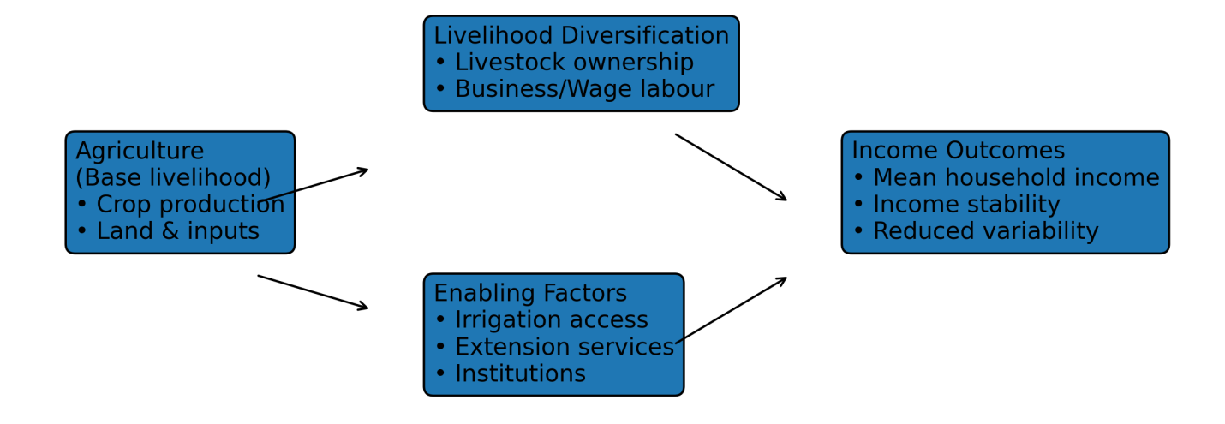
Figure 1. Conceptual framework illustrating the interactions among agriculture as the base livelihood, livelihood diversification through livestock and allied activities, enabling factors such as irrigation and extension services, and resulting household income outcomes in canal-irrigated farming systems.
3. Methodology

3.1 Area of Research
The selected villages for this research were in Durg District within the Patan Block of Chhattisgarh (India) and used canal irrigation for agricultural purposes. The region is an example of an ordinary, or typical, central India agrarian environment. These villages principally grow rice crops and rely on canals for their irrigation; furthermore, these rural areas have limited job opportunities beyond agricultural activities.Also, while agriculture dominates the local economy (and as such) is the primary source of income for most households in these villages, livestock raising provides a supplemental form of income for many.The inter-village differences in irrigation access/index, livelihood diversification, and income levels make this an ideal region for exploring agriculture-livestock relationships and income variability.
3.2 Research Design
This research used a cross-section descriptive design to evaluate the livelihood characteristics and income outcomes at a particular point in time. This method is used frequently within agricultural economics and agricultural extension research, as it does not involve experimental manipulation (Ellis, 1998). Because of this, it is well suited to evaluate the relationships between agriculture and livestock ownership and access to irrigation, as well as the variability of income across different villages in the Durg District.
3.3 Sampling Framework and Village Selection (Section 3.3)
The sampling frame consisted of all villages within the canal-irrigated area of Patan Block as compiled from the block-level administrative records. An 18-village random sample was generated from the sampling frame, which allowed for equal probabilities of selecting villages and also reduced bias when selecting. The advantages of a random sample include allowing for comparative analysis of results by village regarding income and resource access.
3.4 Determining Household Size
To calculate the sample size of households, the sample size was estimated using the formula developed by Taro Yamane in his 1967 book on statistical methodologies used to conduct sociodemographic and agrarian studies. Yamane's formula assumes that the population size is known.
Taro Yamane Formula:
$$n= \frac{N}{1+Ne^{2}}$$
Where
- n = required sample size
- N = total population
- e = level of precision (sampling error)
Based on the most recent population estimates available for the area, the required sample size was calculated with a precision level of 8%, which was determined to be the minimum sample size needed. To provide a more accurate representation of the population and compensate for population growth since the last census, the final sample size was adjusted to include 195 households. Increasing the sample size beyond the minimum requirement is a recommended practice in village-level livelihood studies, because it improves both the representativeness of the sample and the robustness of the results.
3.5 Selection of Households
Initially, 195 households were surveyed in each of the villages selected, and the total number of households included in the survey was based on the size of the population for each village. The sample households were then randomly selected from updated listings of households within each of the villages. Household heads or actively farming members of the household who generate income from farming activity were interviewed. This process provided accurate data on both livelihoods and income for the households in question.
3.6 Data Collection
Data were collected from respondents by means of semi-structured interviews, using a questionnaire for each interview; questions were asked to obtain information regarding demographic characteristics (such as the sex of the head of the household), educational status (i.e., what level of education has the head of the household reached), occupation (i.e.; is the head of the household a farmer), cropping pattern (i.e., what crops are grown), accessibility to irrigation systems (if applicable), livestock ownership (if applicable), annual household income, and which agricultural extension services or government schemes are accessed by the household. Semi-structured interviews were conducted to provide better understanding of the responses given by the respondents, especially in those villages where there was a difference in literacy levels (high-low). For contextual purposes and to provide support for primary data interpretation of the primary data and findings of the study, secondary data were gathered from Census of India reports, block-level agricultural records, and from other literature published since the mid-1990s.
3.7 Variables and Data Processing
The following key variables were measured for use in our analyses: (a) Livelihood Characteristics (i.e. occupation type, livestock ownership), (b) Resource Access (i.e. irrigation type [canal, borewell, combined]), (c) Outcome Variable (i.e. mean annual household income), and (d) Contextual Variables (i.e. education and extension access). Household-level income data were aggregated across all participating households in each village to calculate an overall village-wide mean annual household income and mean annual household income based on livestock ownership, occupation, and irrigation type. Data were cleaned to eliminate data entry errors caused by inconsistent village names and missing values prior to analysis.
3.8 Data Analysis
Descriptive and comparative statistical techniques were used to analyse the data collected from this study. Frequencies, percentages and means were calculated to both describe the structure of each livelihood type and assess patterns of income. Comparative statistical analyses were conducted to examine differences in average household income by village, irrigation type, occupation and livestock ownership status. The analyses were presented in tabular format and graphical representation (i.e. bar graphs and line curves) to ease interpretation of variability in household income and relationships among the various livelihood types.
3.9 Ethical Considerations
Voluntary participation was a fundamental component of the study. Before being interviewed, participants were given an overview of the research design and goals. Personal identifiers, including names, were excluded from the data to assure confidentiality. Data collected as a result of this research will only be utilised for academic research.

4. Results
The section outlines how the results of this study relate back to its stated aims, i.e. an understanding of the structure of households' livelihoods, the types and links between the agricultural and livestock sectors, and an understanding of access to irrigation and variability of household incomes across canal-irrigated villages within the Patan Block. The results have been presented in a descriptive and comparative format, both based upon individuals surveyed, as well as on a village level.
4.1 Occupational Composition and Structure of Livelihoods
Of the surveyed population, agriculture remains the dominant source of livelihood for many surveyed families and illustrates the continuing agrarian character of the research area. Although many families are wholly dependent upon the production of crops to support their livelihoods, a number of other livelihood strategies have evolved to support their families' financial well-being, e.g. through wage work and/or entrepreneurial activity, or through animal husbandry, etc.
A comparison of the income generated from each category of occupation, as demonstrated by Table 1. The average annual income of surveyed agricultural households was less than the average annual income of households engaged in both agriculture production and business activities combined. Among the surveyed families, those households engaged in agriculture production and business activities had, on average, the highest level of income among the surveyed families.

Table 1: Occupation-wise Mean Annual Household Income
S.No | Category | Mean Annual Income (₹/household)
 | Agri | 57,019
 | Agri + buisness | 85,000
 | Agri + govt | 80,000
 | Agri + govt job | 50,000
 | Agri + livestock + driver | 60,000
 | Agri + pvt job | 64,000
 | Agri + vendor | 60,000
 | Agri + wage | 85,000
 | Agri+ pvt job | 65,000
 | Agri+Business | 51,429
 | Agri+Govt Job | 45,000
 | Agri+Govt. Job | 56,250
 | Agri+Live Stock | 70,000
 | Agri+Shop | 40,000
 | Agri+Tent | 80,000
 | Agri+Wage | 56,875
 | Agri+wage | 40,000

Therefore, it can be concluded that, while agriculture remains the primary economic activity within the region, diversification of the household's livelihood will have a significant impact on the economic performance of households.

4.2 Distributions of Income and their Differences Between Villages
There is a large difference in the average annual income per household among the 18 villages surveyed. Line graphs (Figure 2) for each of the 18 villages illustrate the disparity in household incomes across villages.
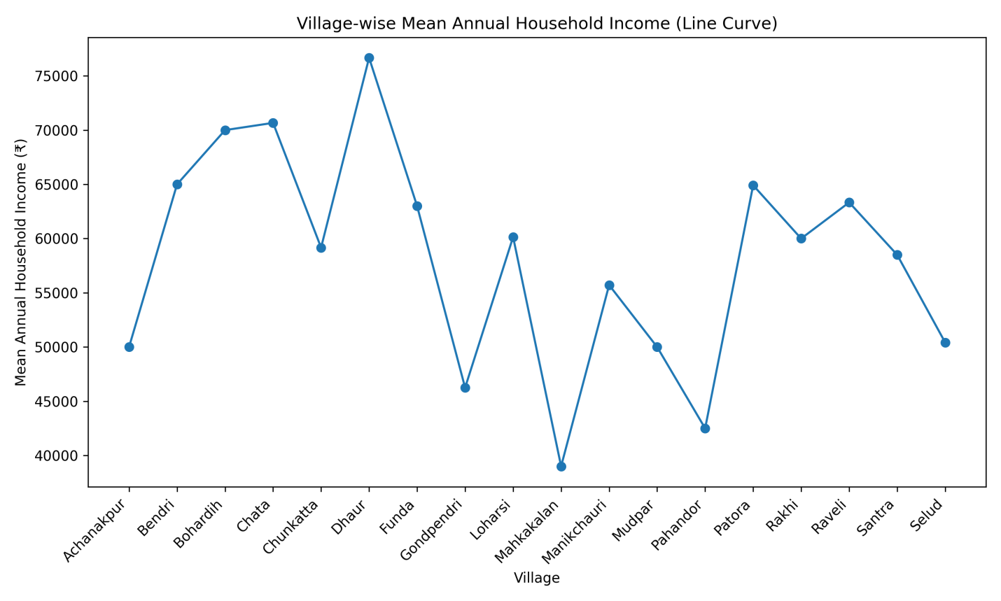
Fig 2: Village wise Mean Annual Household Income
Higher incomes in a village correlated with access to irrigation, the number of diversified livelihood options available to residents of the village, and greater overall level of irrigation. Villages with lower-income levels had fewer alternative sources of income (agriculture being the primary source of income) and were, therefore, more dependent on agriculture for their livelihoods. The differences in income across villages depicted in Figure 2 exemplify the uneven availability of productive resources and income opportunities for residents of the canal irrigated region.
4.3 The Role of Irrigation Access in Improving Income Levels
Access to irrigation had a significant role in determining the levels of income generated by households participating in agricultural production. The mean annual income attributed to households using three categories of irrigation (see Table 2) illustrates a clear connection between income and access to irrigation.

Table 2: Irrigation-wise Mean Annual Household Income
S.No. | Category | Mean Annual Income (₹/household)
1 | Canal irrigation | 58,058
2 | Canal + Borewell | 60,000
3 | Borewell only | 85,000
4 | Rainfed / limited | 53,000

Households with borewell irrigation or those that are using a combination (mixed) of canal irrigation and borewells have generated higher annual incomes than households relying solely upon canal irrigation. Households with limited or no reliable irrigation access reported the lowest income levels. The data shows how assured access to irrigation helps to increase farmers' agricultural productivity and provide stability in income generation due to the higher amounts of agricultural crops produced within the three categories of irrigation discussed.
4.4 Income Outcome with Livestock Ownership
Ownership of livestock has been recorded by about 33% of respondents of the survey. Households that own livestock and those that don't have been represented graphically by Figure 3.
Figure 3
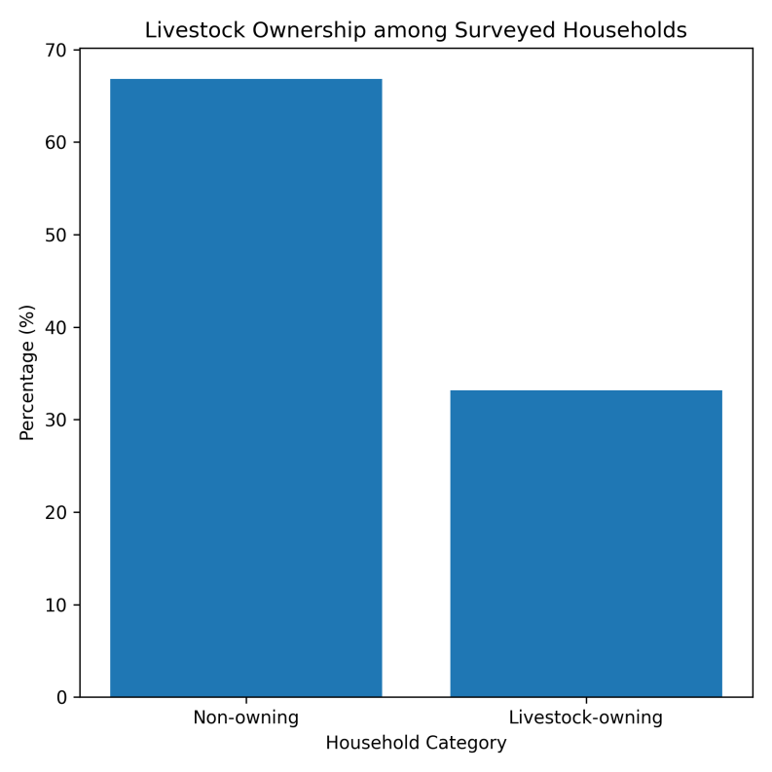
When comparing the incomes of livestock-owning and non-livestock-owning households, the average annual income difference was evident (as shown in Table 3). Households with livestock accumulated an overall higher average income than those without livestock. This suggests that in the study area, livestock provides some level of supplemental income for household production.
4.5 Social Inequalities in Income Disparities:
A caste-wise examination of the household incomes indicates that there are significant differences in household incomes within the different castes (as shown in Table 1). Even though differences have been noted between the different caste categories, none of the caste groups have consistently dominated the income outcomes of each village within this study. Rather, the income differentials mentioned are the results of the various ways in which social identities interact with access to land and irrigation and with the availability of livelihoods.
4.6 Summary of Results in Relation to Study Objectives
The growth of household income in villages with canal irrigation is influenced by many aspects of an interrelated nature. For example, the primary means of producing income for most families living in these areas is through agriculture. Diversifying your income by agriculture alone is generally insufficient to sustain an agricultural lifestyle. In addition, families have a much higher income if they have access to irrigation, and by having livestock on their farms.
Disparities between villages indicate that variations in income levels exist across all regions due to differences in local access to resources and opportunities.

These findings confirm the model used in the study to explain how a number of interrelated factors influence household income, providing a basis for further consideration of potential policies and extension opportunities in the next section of the report.
5. Discussion
The empirical data derived from this study indicate that household income outcomes in villages that use canal irrigation are created by the interaction of access to resources (including access to irrigation), ownership of assets (including livestock), and livelihood diversification. The following discussion of these results is accompanied by a review of other recent literature, as well as a discussion of potential mechanisms through which these relationships exist, and the potential effects of these findings on the development of extension practice and local policy interventions.
5.1 Irrigation and productivity: heterogeneous effects in the local context
This study endorsed the view that a household’s access to a potable supply of irrigation (either through borewells or through other types of irrigation systems) has an impact on household income. This finding is consistent with a growing body of research on the impacts of irrigation infrastructure investments on agricultural output and wealth within villages. Research conducted by Blakeslee et al. (2022) used high-resolution spatial data to analyse the effect of irrigation on agricultural production and wealth at the village level throughout India. The authors found that, although irrigation generates an increase in the agricultural output and wealth of villages, irrigation may also generate varying impacts on the non-farm economies of villages. Our study suggests that in the case of assured irrigation, the increase in irrigation-related income may provide for increased investment in complementary activities (including livestock, small enterprise, etc.) that subsequently increase household income. In contrast, as Blakeslee et al. argue, the impacts of irrigation are mediated by local access to markets, land ownership patterns and constituents’ ability to convert an increase in agricultural production into marketable cash income, which may explain the differences in income levels found within the aforementioned villages.
5.2 Livestock as a resilience and smoothing asset (rather than as an income source only)
The relationship we found with our research findings indicates a positive correlation between a household's ownership of livestock and its level of income, as also reported in recent Indian studies which consider livestock to be multi-functional as a livelihood asset (Sarkar, 2020; Hegde, 2019). Livestock not only generates direct income through the consumption of milk, meat, hides etc., but also helps maintain household resilience by providing inputs (e.g. manure/draft power) and acting as a temporary buffering resource in times of crisis. The findings further indicate that livestock owned by individuals or households typically provide a means of creating greater relative levels of household income and a greater degree of consistency in this income than do other forms of income received by the individual or household, especially in households which combine livestock ownership with other sources of income (as shown in sectoral analyses which highlight the role of livestock in smoothing consumption and decreasing vulnerability; FAO, 2012; Livestock Census, 2019).
5.3 Livelihood diversification: synergies & regional limitations
Diversifying into activities such as business and wage labor combined with farming provides mean incomes significantly higher than income earned from farming alone. This evidence supports other research which describes diversification as a risk management and income-increasing strategy (Patidar & Chothodi, 2021; Ellis, 1998). Diversifying does present costs, as one must develop access to networks, credit, access to markets, and possibly skills to be successful; thus, regions with limited access to formal markets or institutions will limit the ability of individuals to diversify and contribute to creating the spatial distribution of low-income villages in our sample.
5.4 Extension services: the integrator missing from the equation
While there is no formal causal test of the effectiveness of traditional crop-focused extension within our dataset, our results indicate that crop-focused extension cannot address everything - particularly when it comes to irrigation and livestock supporting both farm income stability and enabled financial growth. There have been recent policy discussions emphasizing the importance of integrated extension services addressing crop-livestock systems together with water management and enterprise development (Hazell & Rahman, 2014; NITI Aayog micro irrigation studies, 2023). Combining technical advice with market facilitation, veterinary services and credit linkages creates better opportunities for smallholders to capitalise on biophysical advantages and increase their durable revenue potential.
5.5 Social equity and differential access to assets
Social Equity and Access to Resources In relation to income based on caste and village in our study (the results were similar for India), there are large differences in access to resources and services. The patterns that we see here confirm the findings from the research done across India showing that an individual's social identity and local society inflict access to resources and influence a person's livelihood decisions (Patidar & Chothodi 2021; Mondal 2023). Therefore, productivity boosting policies (those designed to increase overall productivity) without taking into consideration the access inequalities will likely increase access inequality within a region. The targeted remedial measures such as directed microcredit or targeted micro irrigation for marginalised groups or targeted extension service outreach to marginalised hamlets are necessary complements to the growth-focused productivity investments.
5.6 Practical Implications for Extension Programming
From Extension's standpoint, three main practical priorities are identified.
- The first priority is developing integrated advisory packages. Extension modules should combine crop advisories with livestock management (nutrition and health), water-use efficiency (micro-irrigation) and basic enterprise training since evidence shows integrated approaches to be more effective in promoting farm resilience than providing crop-specific advice alone [FAO, 2012, Hazell & Rahman, 2014].
- The second practical priority relates to targeting and sequencing of local interventions. Priority should be given to households and villages that have limited assets (no livestock, limited irrigation) and the sequencing of investments should ensure that improvements in access to water and/or markets occur prior to or alongside diversification efforts to reduce the risk of having stranded investments.
- The third practical priority is in relation to providing market and value-chain support. Market linkages and collective actions (producer groups, dairy cooperatives, self-help groups) will help to facilitate a linkage between an increase in production (as a result of irrigation and/or livestock) and an increase in stable and significant incomes.
5.7 Limitations and Future Research Directions
Two key limitations are addressed here. The cross-sectional data structure limits the potential for causal claims made using these data, thus any regression or impact claim will be explorative in nature and should be viewed with caution. Also, the way we measure livestock in this study is primarily through ownership (a binary outcome) as opposed to the more quantitative ways we can measure economic scale, including but not limited to herd value and milk produced. This restricts us from being able to separate commercial and buffering benefits of livestock. Future research should try to fill these two gaps in causal estimation with panel data, more resourceful metrics of livestock and the use of quasi-experimental designs to estimate the causal return on investments of irrigation and livestock.
6. Conclusion
Using household-level data, the study examined the agricultural and livestock interconnections, access to irrigation and income variability in the canal- irrigated villages of the Patan block in Chhattisgarh, India. The findings show that although agriculture remains the main livelihood activity for all households, the income results depend not only on the amount of land used for farming, but also on whether or not this land is included in the overall family living strategy. The analysis showed that households combining their agricultural production with livestock production or other income-generating activities consistently had higher average incomes than households operating only agricultural activities. Livestock, in addition to being an income-generating activity, also provides households with a stabilising asset which can increase their resilience in times of uncertainty about both agricultural production and market prices. As in the case of livestock production, access to reliable irrigation - not only providing water for agriculture, but also, when supplemented by boreholes, allowing for increased crop intensification and diversification - has been found to be a significant enabling aid for families and farmers, both in terms of increasing crop intensification, diversification and reducing income variability. However, the persistence of social and economic inequalities at village level and within specific social groups suggest that the benefits of irrigation and crop diversification are not equally distributed to all agricultural households and reflect differences in access to and opportunities at the abovementioned levels of affluence, institutional and local.
This research focuses on how rural Economic Development and Agricultural Extension have an Impact on Village Income Based on How Resources, Livelihood Strategies, and a Supportive Institutional Framework Will Affect Individual Villages That Utilised Similar Canal-Irrigated Agricultural Systems Within Their Immediate Geographic Areas. Based on this research, there is ample evidence to conclude that by utilising only productivity-oriented intervention strategies you cannot provide income stability without developing Integrated Farming Systems and providing Supporting Livelihood Diversification Strategy Options.
From a Policy Extension Perspective: The Need to Expand the Focus of the Soil and Crop Strategy Beyond Just Crop Centric Strategies. There Is a Need to Incorporate and Develop Extension Strategies for the Integrated Management of Crops, Livestock, Efficient Use of Irrigation and the Development of Small Enterprises. By Enhancing the Availability, Access, and Utilisation of Extension Program Outreach, Providing Access, Educating and Promoting Crop-Livestock Integration Will Develop Greater Income Stability and Resilience for Smallholder Farmers.
Despite the cross-sectional design, the evidence indicates a solid foundation of empirical evidence to support an understanding of how income is differentiated in Rural Canal Irrigation Rural Systems. Future Research can expand upon this research by incorporating a Longitudinal Design that includes an Expanded Measurement of Asset-Based Variables to clarify the Dynamic Transition of Livelihoods. The research also demonstrates that the sustainability of income enhancement in the Agrarian sector does not result from a stand-alone sectoral intervention but rather through the collaboration of Coordinated Multi-Sectoral Strategies integrating Agriculture, Livestock, Water Resources and Extension Services within a Locally Responsive Development Framework.

References

Blakeslee D, Dar A, Fishman R, Malik S, Pellegrina HS, Bagavathinathan., Irrigation and the spatial pattern of local economic development in India,Journal of Development Economics,Volume 161,2023,102997,ISSN 0304-3878,
https://doi.org/10.1016/j.jdeveco.2022.102997.
Ellis, F. (1998). Household strategies and rural livelihood diversification. The Journal of Development Studies, 35(1), 1–38. https://doi.org/10.1080/00220389808422553
FAO. Livestock sector development for poverty reduction. FAO Animal Production and Health Paper. 2012. (https://www.fao.org/4/i2744e/i2744e00.pdf)
Government of India. Livestock Census 2019. Department of Animal Husbandry & Dairying, Ministry of Fisheries, Animal Husbandry & Dairying. 2019. (official report; no DOI) https://www.pib.gov.in/PressReleaseIframePage.aspx?PRID=1813802&reg=3&lang=2,(https://www.dahd.gov.in/sites/default/files/2024-10/LS4449.pdf)
Hazell P, Rahman A. New directions for smallholder agriculture. IFPRI Discussion Paper. 2014. https://api.pageplace.de/preview/DT0400.9780191003561_A23539352/preview-9780191003561_A23539352.pdf
Manas Mondal, Sayantani Paul, Adrika Mukhopadhyay, Pintu Mandal, Uday Chatterjee, Shyamal Santra, Subhasis Bhattacharya, Suman Paul, Evaluating rural poverty and livelihood diversification in the context of climate-induced extreme events in coastal area: Insights from Indian Sundarban, Regional Studies in Marine Science,Volume 67,2023,103191,ISSN 2352-4855, https://doi.org/10.1016/j.rsma.2023.103191.
NITI Aayog / Government reports on micro-irrigation and water-use efficiency (2023). (policy brief) (https://www.niti.gov.in/sites/default/files/2023- 03/Efficiency%20of%20Micro- Irrigation%20in%20economizing%20water%20use%20in%20India%20Learning%20from%20potential%20and%20under%20explored%20states.pdf)
Patidar, H. and Chothodi, S. (trans.) (2021) “Livelihood Diversification in Rural India”, Space and Culture, India, 9(3), pp. 32–44. doi:10.20896/saci.v9i3.1206.
Sarkar, A. (2020). Role of Livestock Farming in Meeting Livelihood Challenges of SC Cultivators in India. Indian Journal of Human Development, 14(1), 23-41. https://doi.org/10.1177/0973703020923863 (Original work published 2020)
Thornton, P.K.; Kruska, R.L.; Henninger, N.; Kristjanson, P.M.; Reid, R.S.; Atieno, F.; Odero, A.N.; Ndegwa, T. 2002. Mapping poverty and livestock in the developing world. 124p. Nairobi (Kenya): ILRI.
“World Bank. 2007. World Development Report 2008: Agriculture for Development. © World Bank. http://hdl.handle.net/10986/5990 License: CC BY 3.0 IGO.” https://doi.org/10.1596/978-0-8213-6807-7
Yamane T. Statistics: An introductory analysis. 2nd ed. New York: Harper and Row; 1967.

